Anonymous user and logged in user home page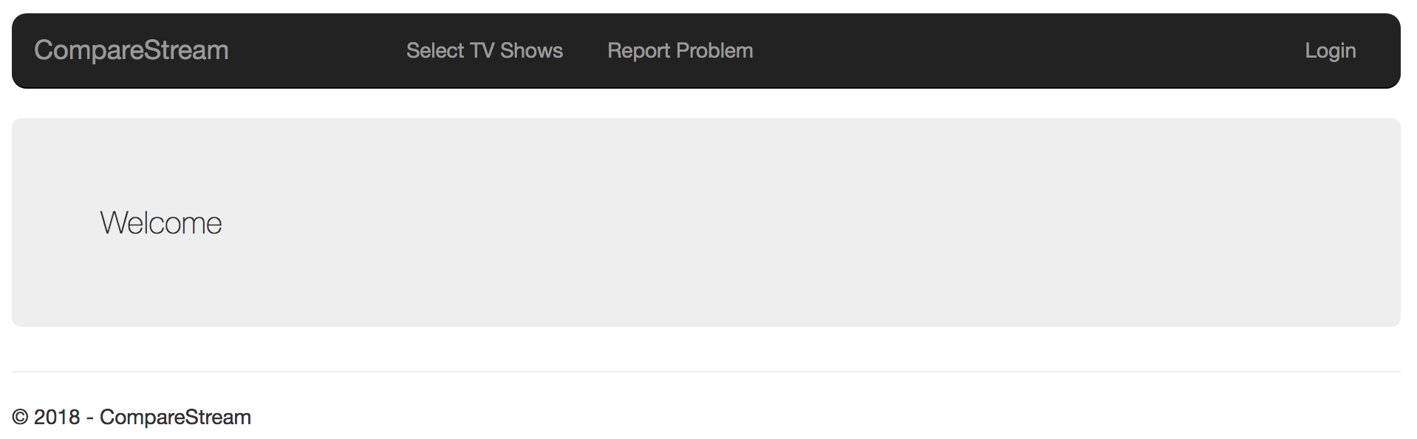

Admin user home page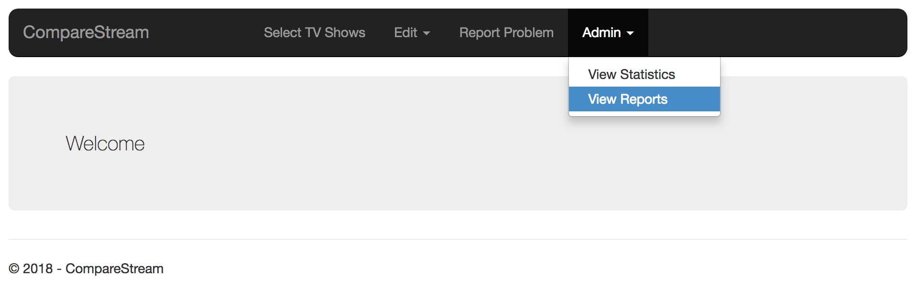

Select TV Shows page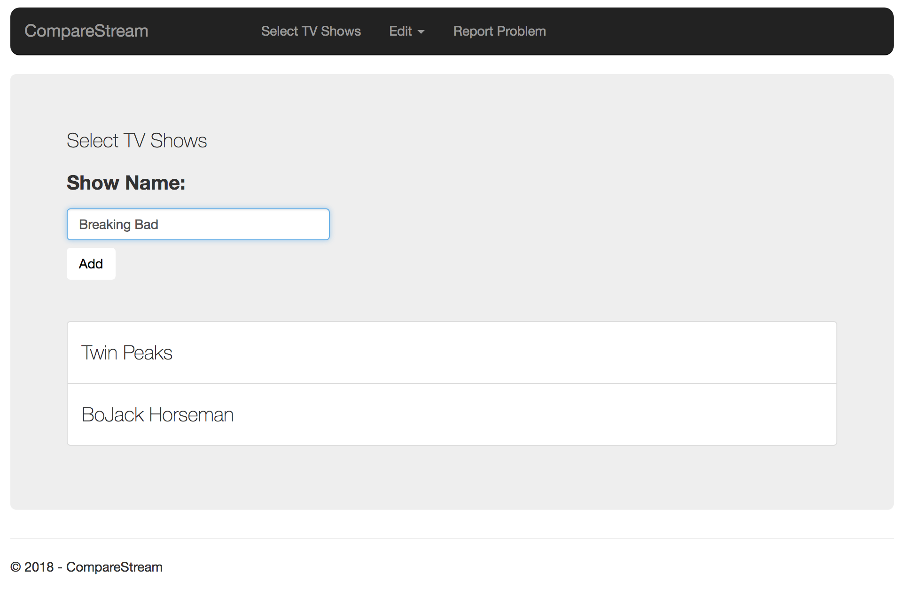

Add TV Show page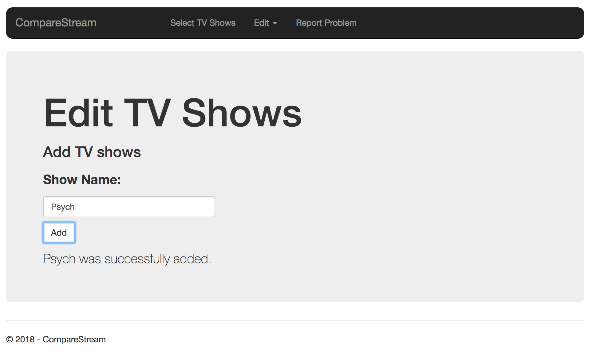

Add Streaming Service page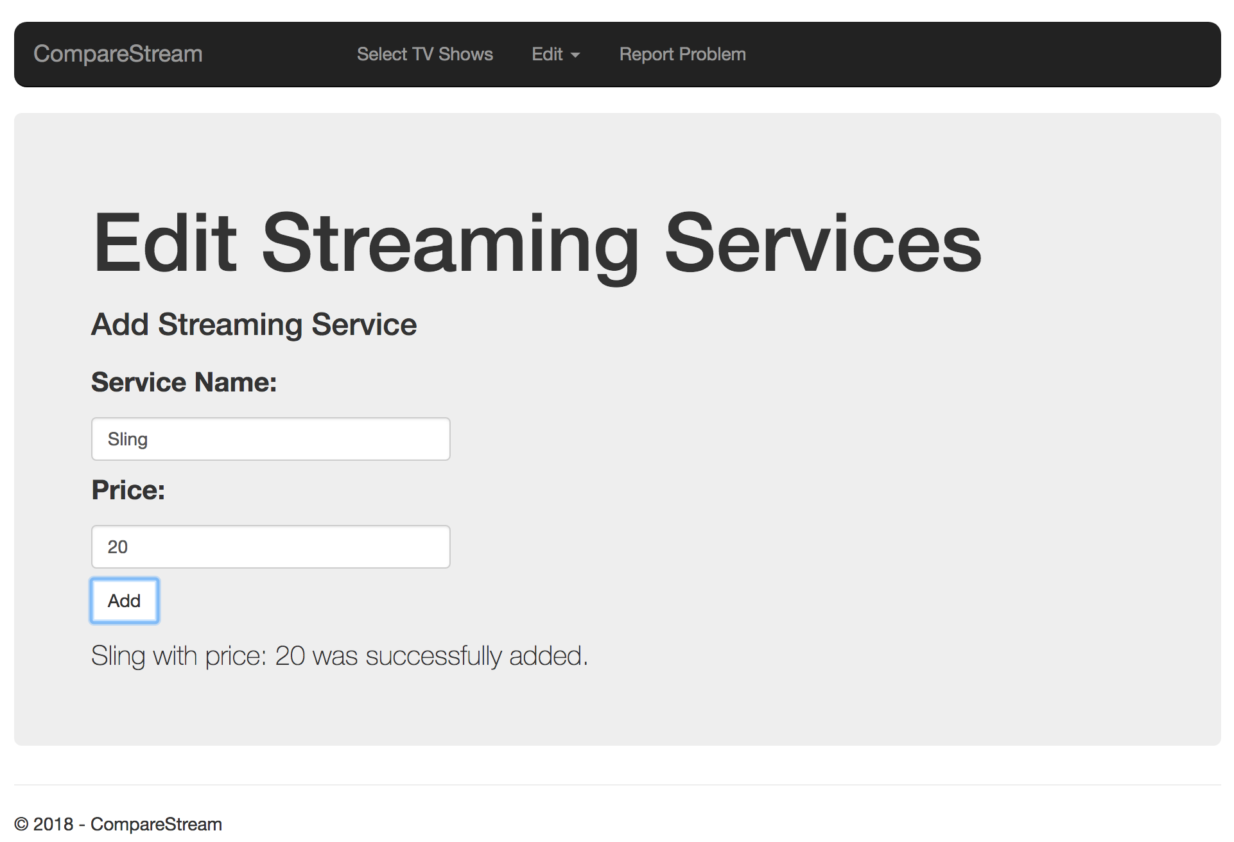

Login page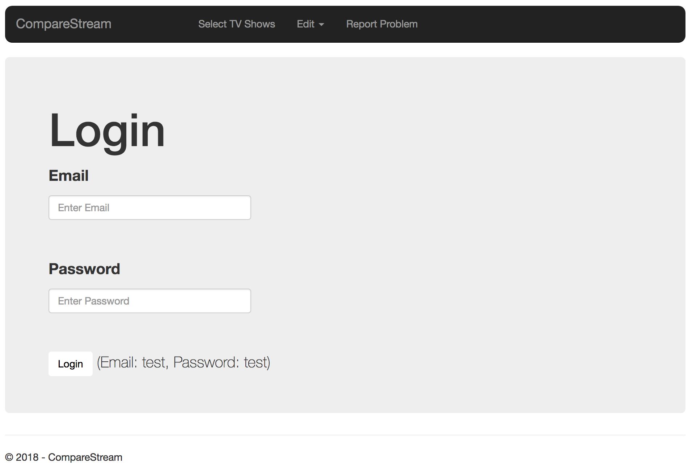

Report problem page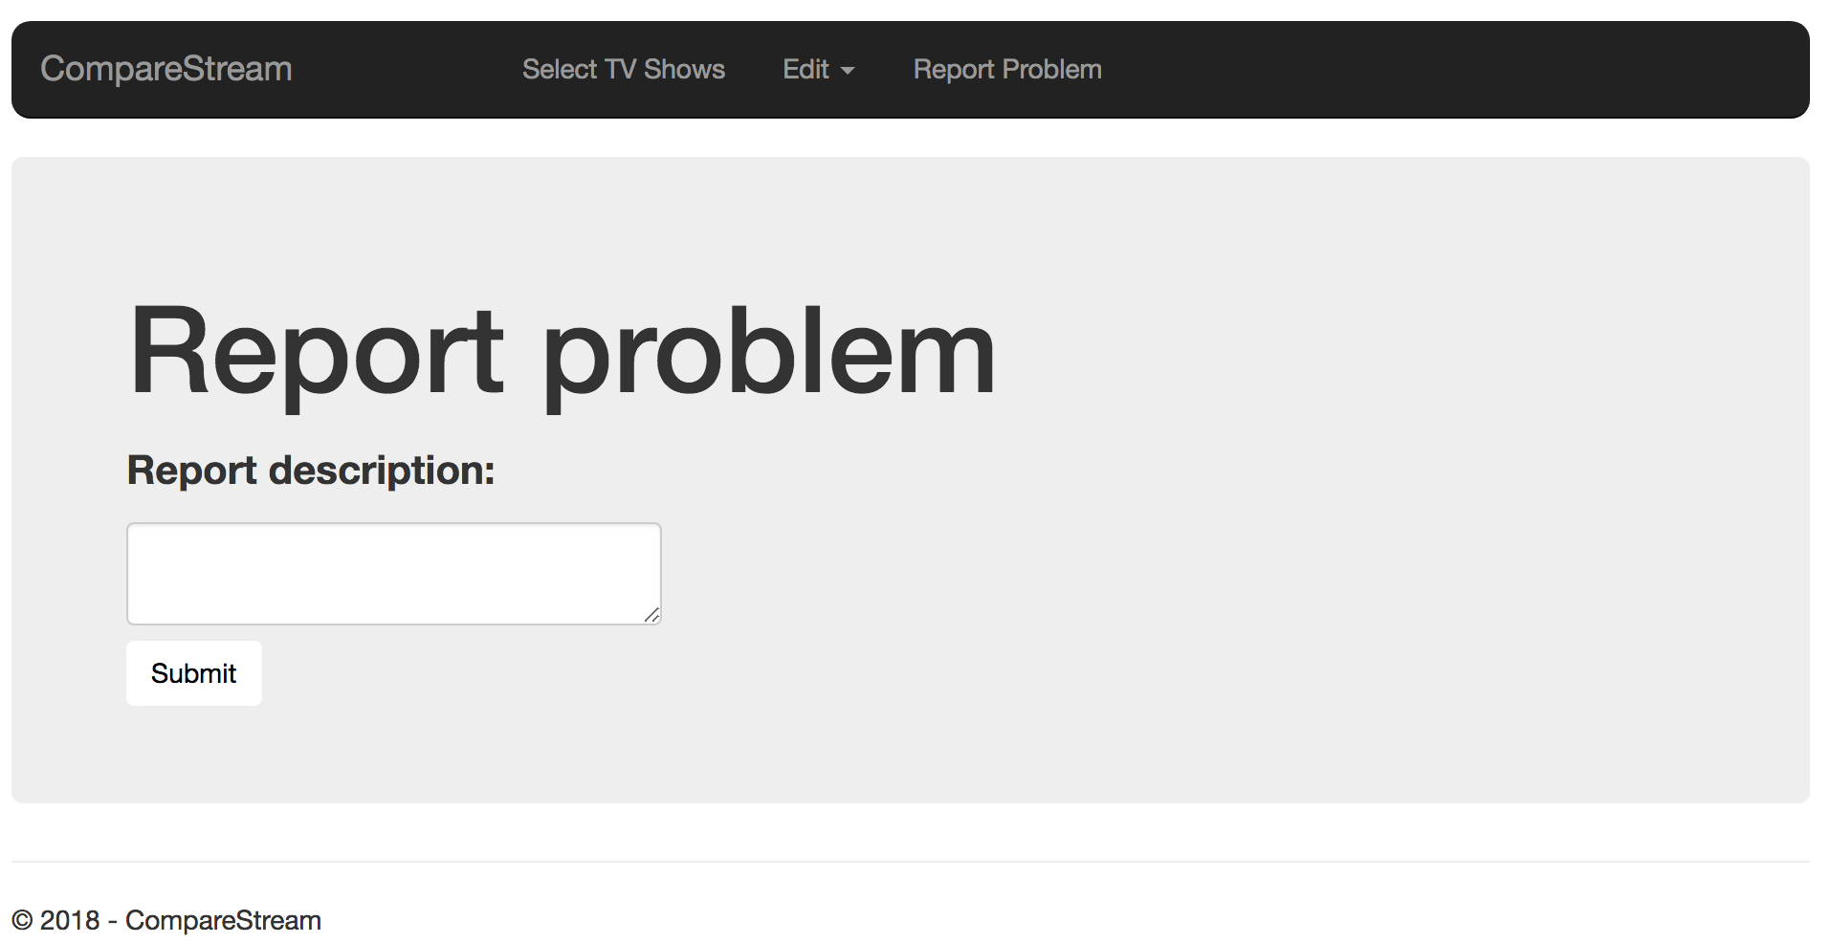

Pages not currently set up:

* View reports
* View statistics
* Add/edit networks
* Best deal page based on selected TV Shows
* Admin page to view user account information