**Process view**

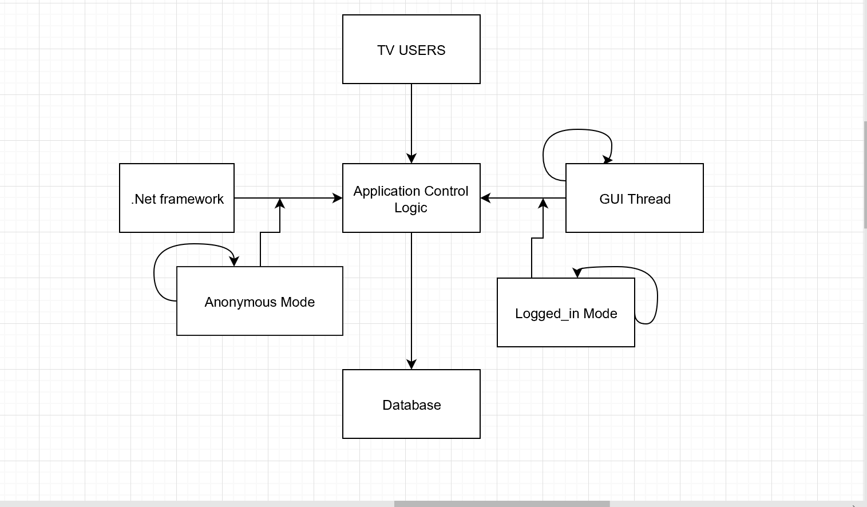

Each loop represents a thread of control. The anonymous Mode only allow users search shows and type of services. The Logged_in Mode allow the users can view the best option for their favorite shows.