Title: Airport Status Tracker

Report: Due to unpredictable and adverse weather conditions some times airports might be closed or may be expecting some delays. The Airport Status Tracker app provides realtime dynamic status of each and every airpot in United States. The information is obtained from the Fedaral Aviation Adminstration’s website.

The user has to enter the 3 letter airport code in the text box and click on the “cick for Airport Status” button .

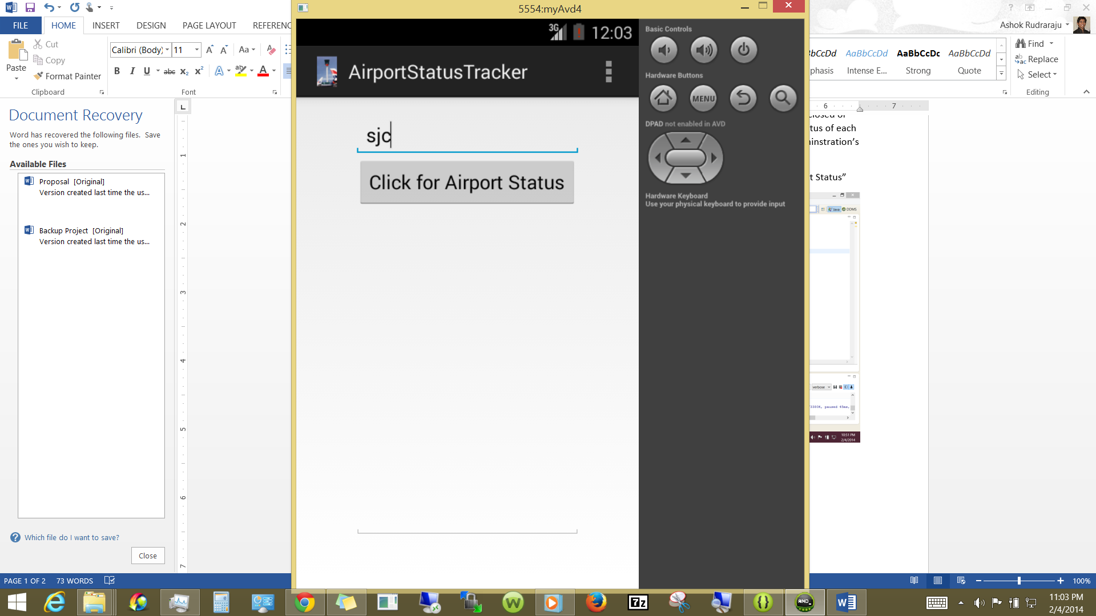

As soon as the user clicks on the button the user can see the information about the Airport Status, Wind speed and the present weather conditions. Bases on the information available the user can decide if he/she wants to go to the airport to catch the flight or if its too risky.

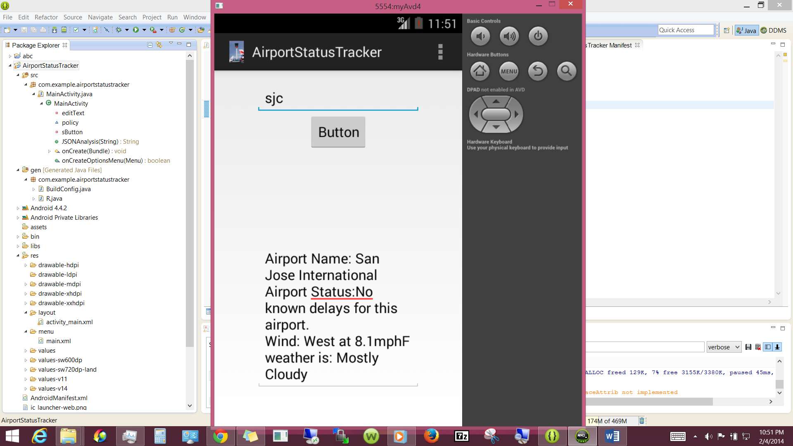

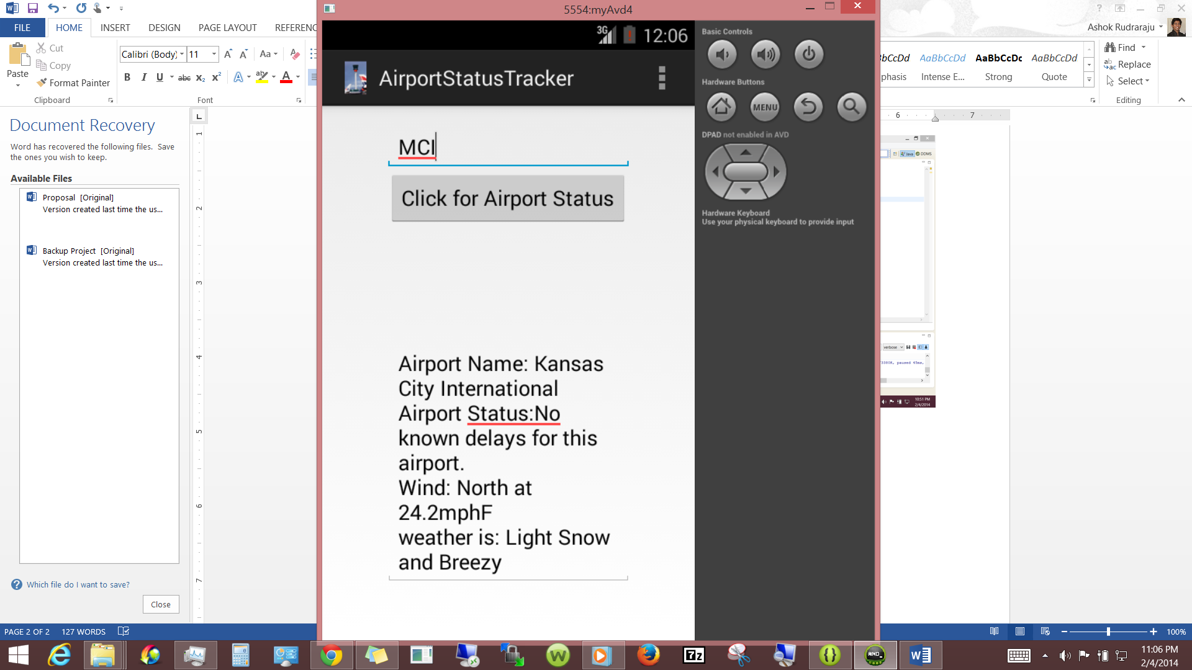

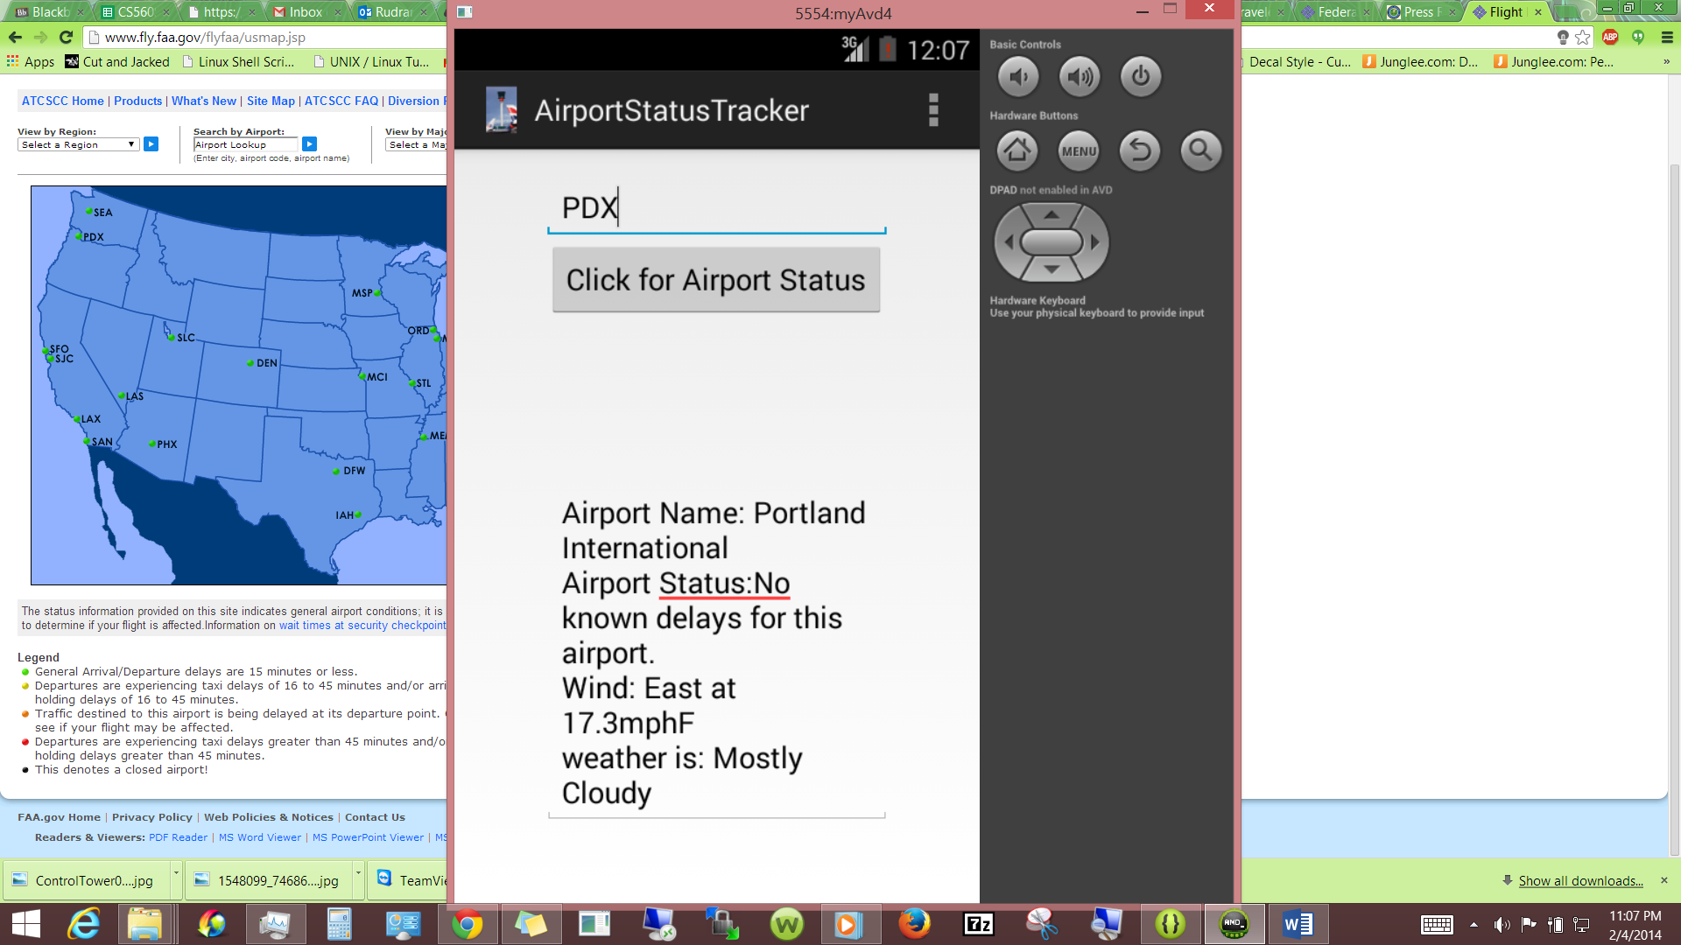

Technology used: Android, Java and json.

Web services used: <http://services.faa.gov/>

Bibliography:

<http://stackoverflow.com/>,

<http://services.faa.gov/>,

<http://jsonmate.com/>,

Tutorials presented in class,

Example provided on blackboard,