**Title:** Car Sales Data Classifier

**Part1:** Cloudera/Mahout/Solr

I downloaded my training data from <http://focus2move.com/item/1000-best-selling-cars-in-europe-top-100-ranking>. It consists of the car sales data of top 100 cars

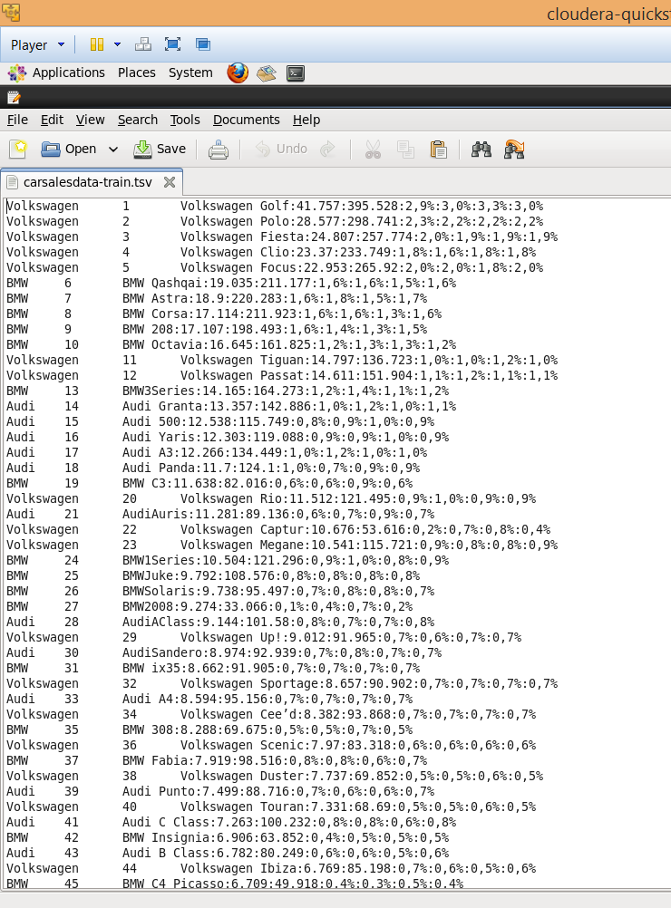

Then I generated my own testing data. It consists of the id numbers and car descriptions, using the Mahout Naïve Bayes I successfully identified which company each and every car belonged.

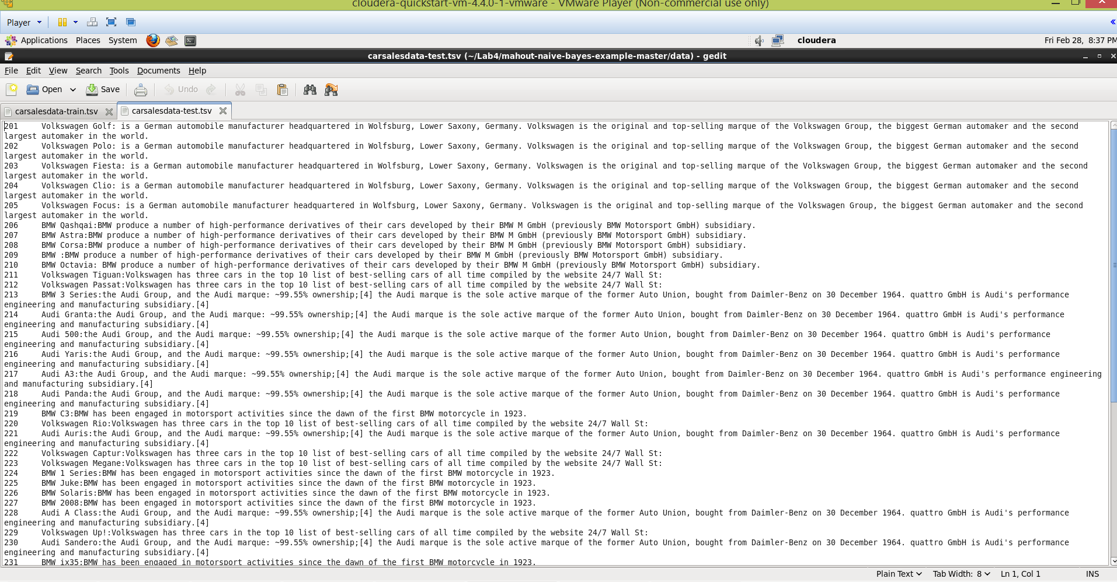

To keep the process simple and to get maximum accuracy I only picked cars that belonged to 3 major companies

1. Audi
2. BMW
3. Volkswagen

And I used the above mentioned company names as the classifiers.

The below screen shot shows my results after running the naïve bayes on my Training data

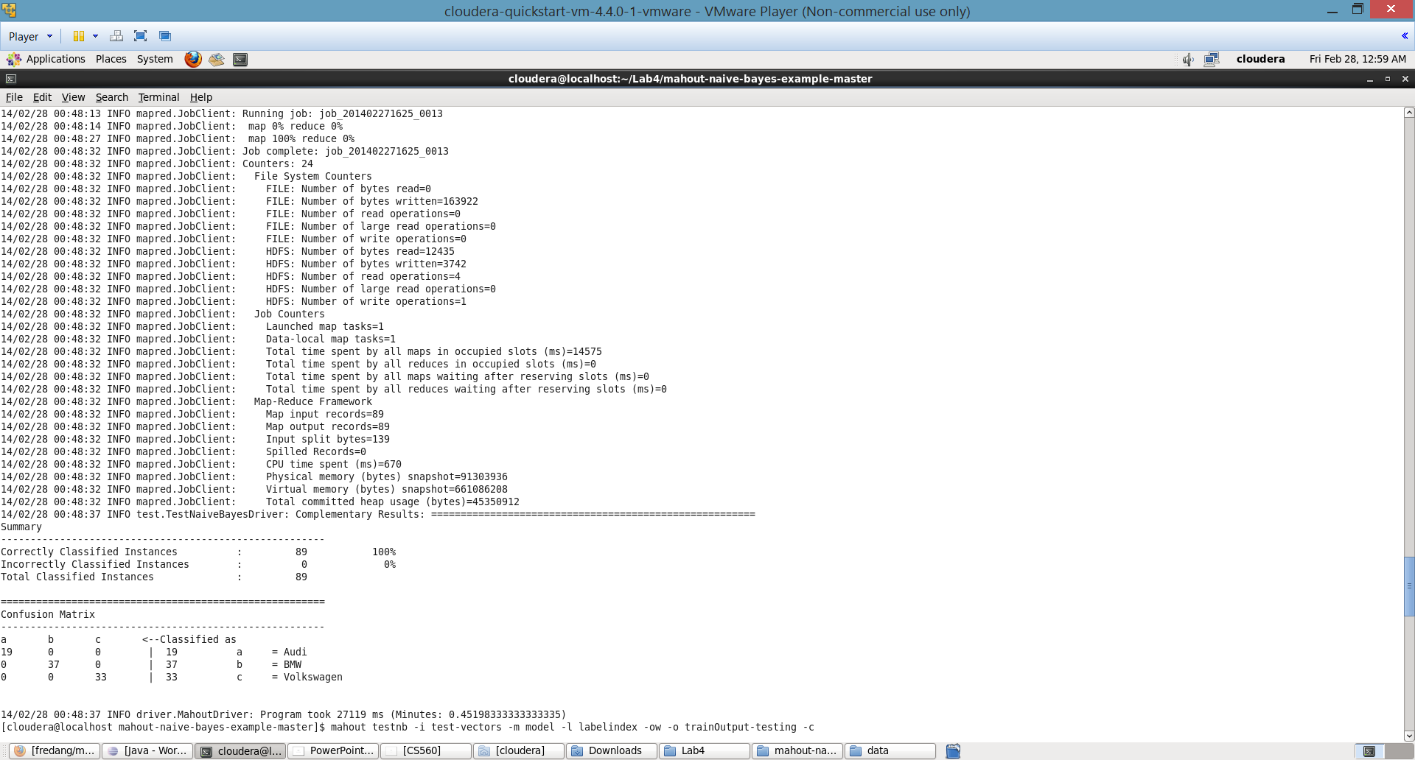

The following screenshot shows my results after running naïve bayes on my testing data

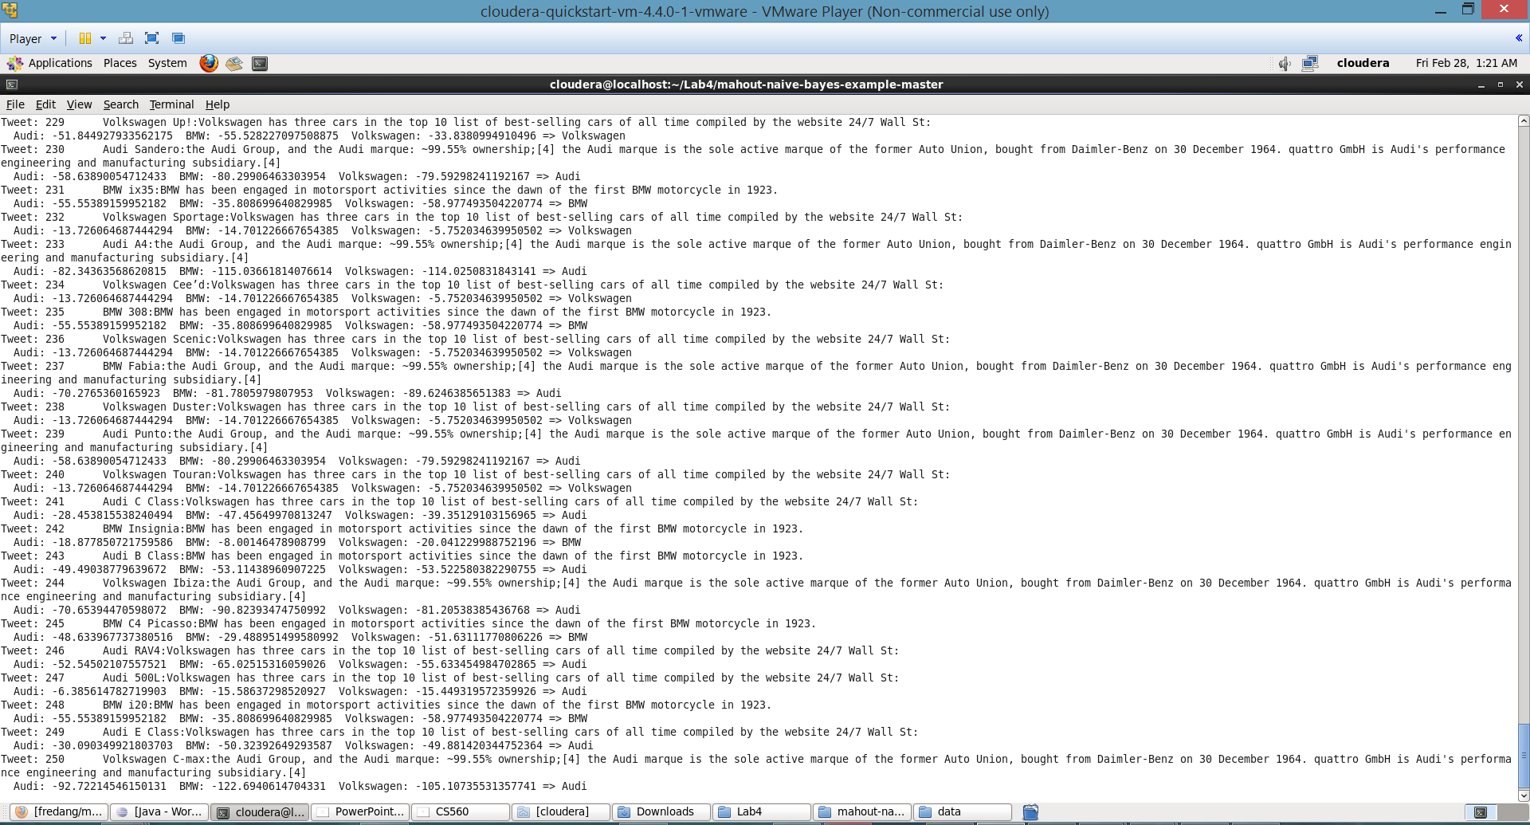

The following screen shot shows pushing data to solr

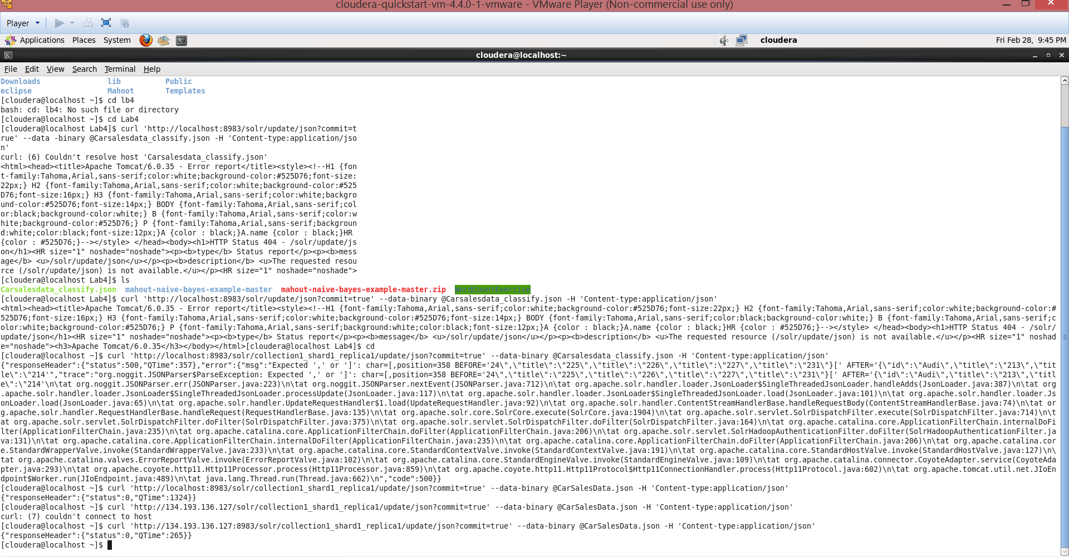

The following screen shot shows the output for my query after successfully pushing it to solr

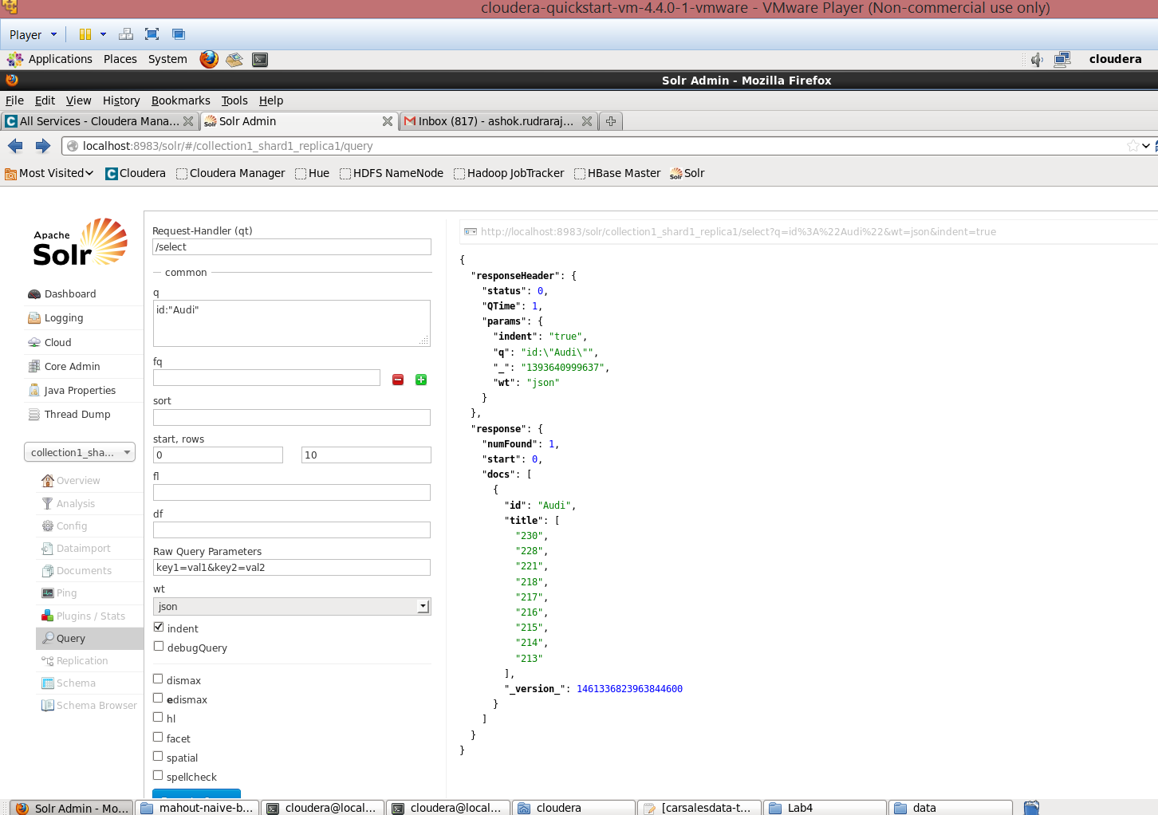

The following screen shot shows the result after I successfully accessed my solr data in Json format from my windows machine.

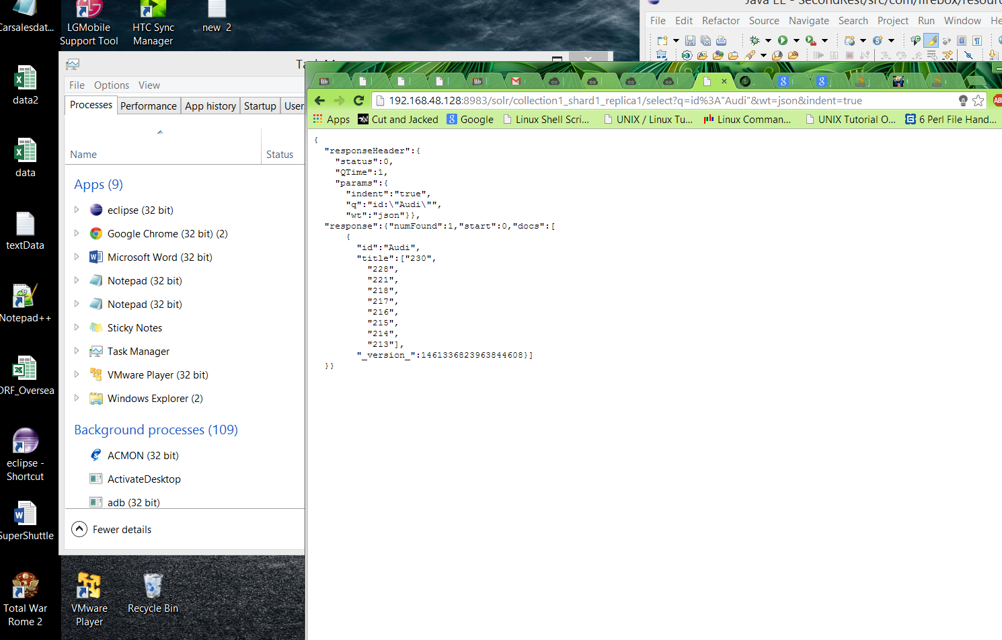

**Part2:** Mobile Application

I created an application in jsfiddle which would ping the query string (<http://192.168.48.128:8983/solr/collection1_shard1_replica1/select?q=id%3A%22Audi%22&wt=json&indent=true>) and display the results in a tabular format.

I analyzed the Json using jsonmate as shown in the below screenshot.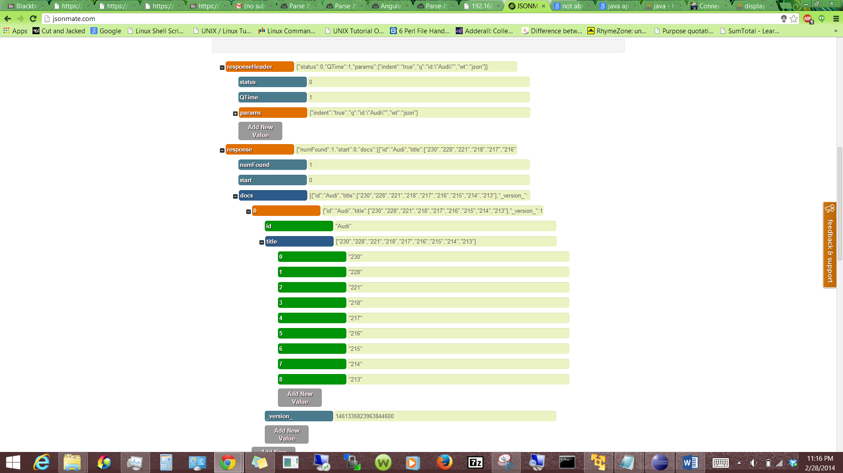

I could not parse the Json for un known reasons as shown in the below screen shot

