Er Diagram :

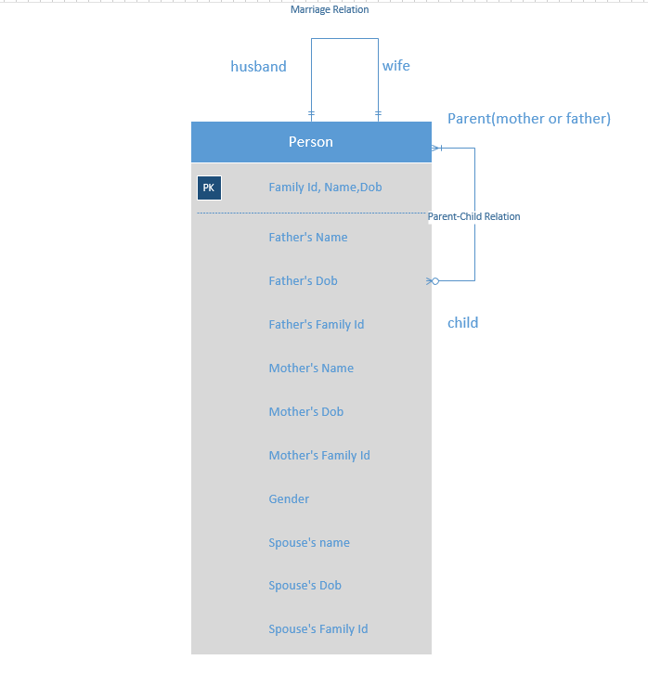

Person is an entity and I have assumed that even a husband, wife or a child will technically be a person.

Thus a husband and wife has a **1 to 1 marriage relation**, a Parent and child has a **1 or many to 0 or many relation**. Also when we say Parent child relation it covers both father child and mother child relation.

I have used composite primary keys to identify each and every single person entity.

UML Class Diagram:

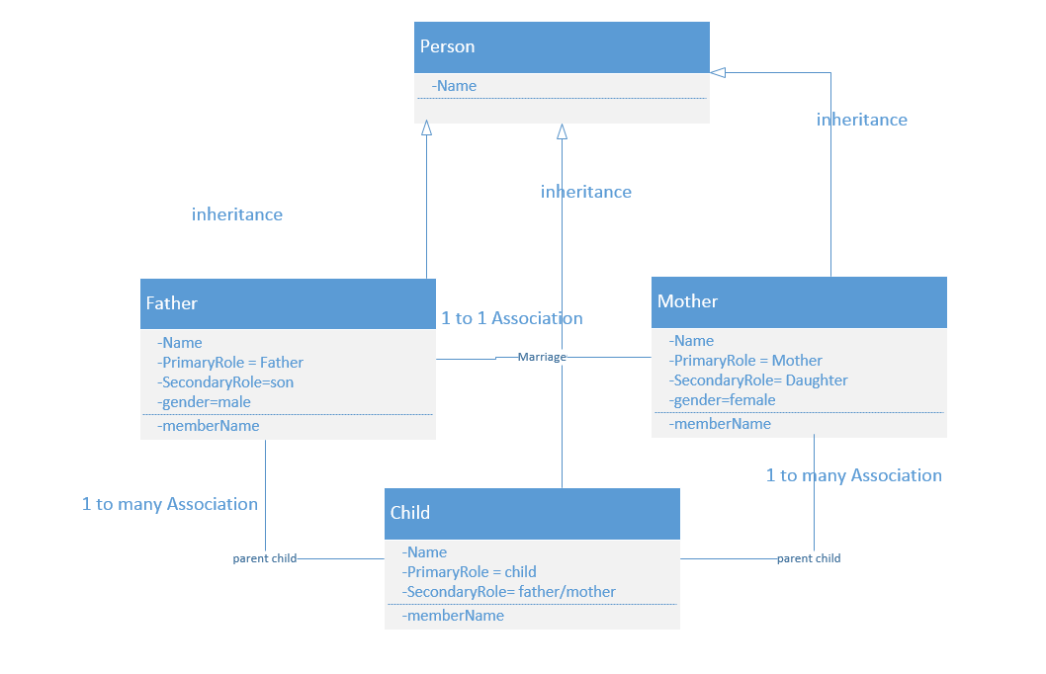

In the above UML Class diagram I have assumed that the Person Class is the super class and the rest of the three classes are child classes thus they have a **Generalization** relation. The Father and Mother class have a **1 to 1 Association**. Both the Father and Mother Class has a **1 to many Association** with the Child class.

Scrum do:

The following screen shot shows the creation of an Iteration

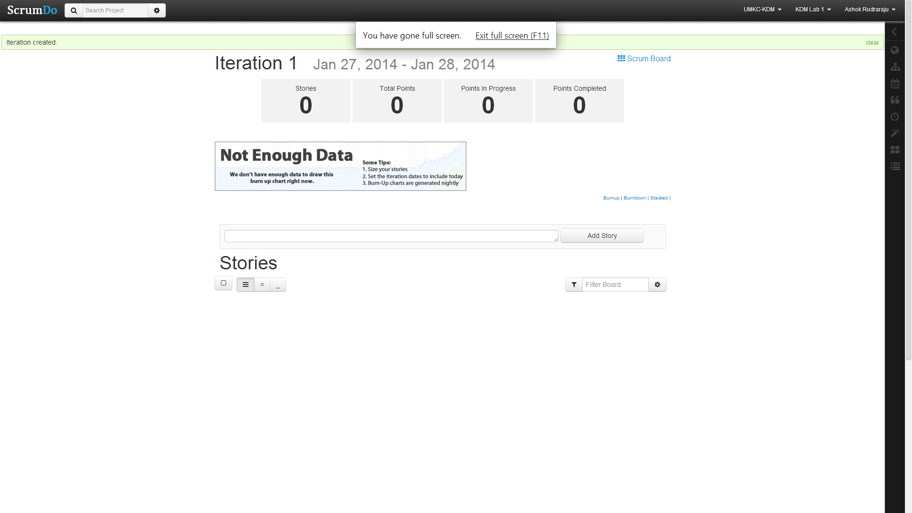

The following screen shot shows the creation of stories

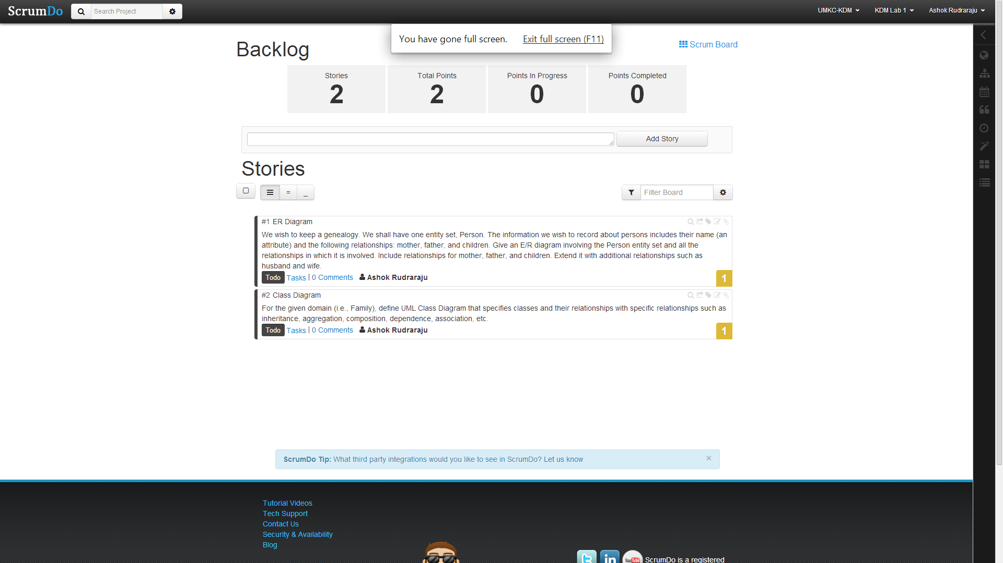

The following screen shot shows Iteration planning.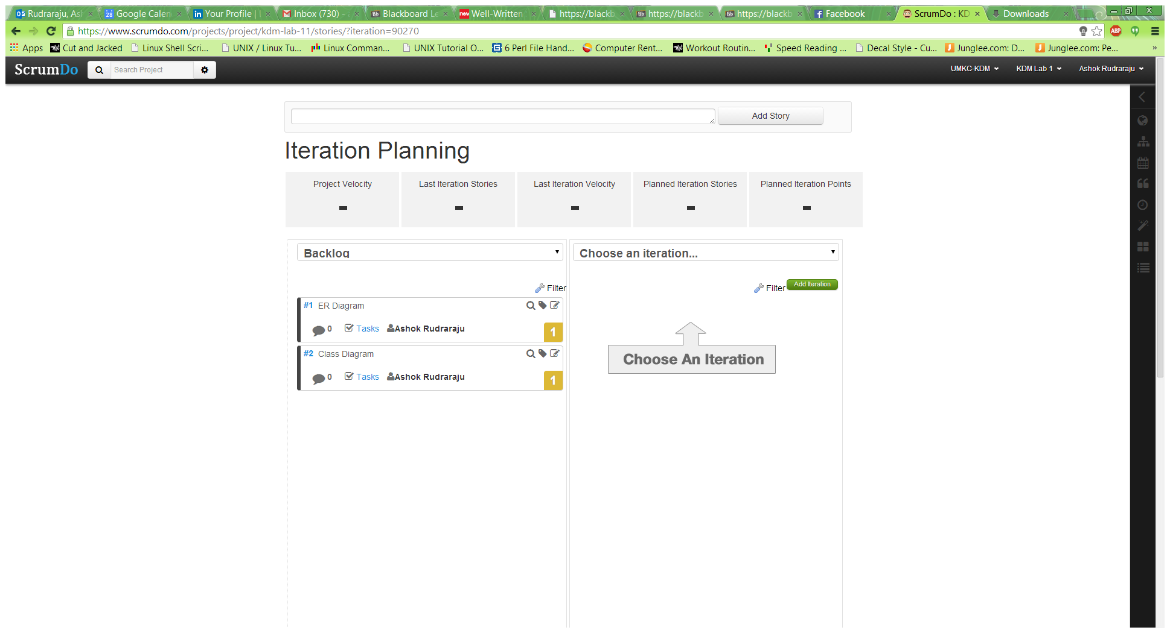

The following screen shot shows the scrum board of Iteration1

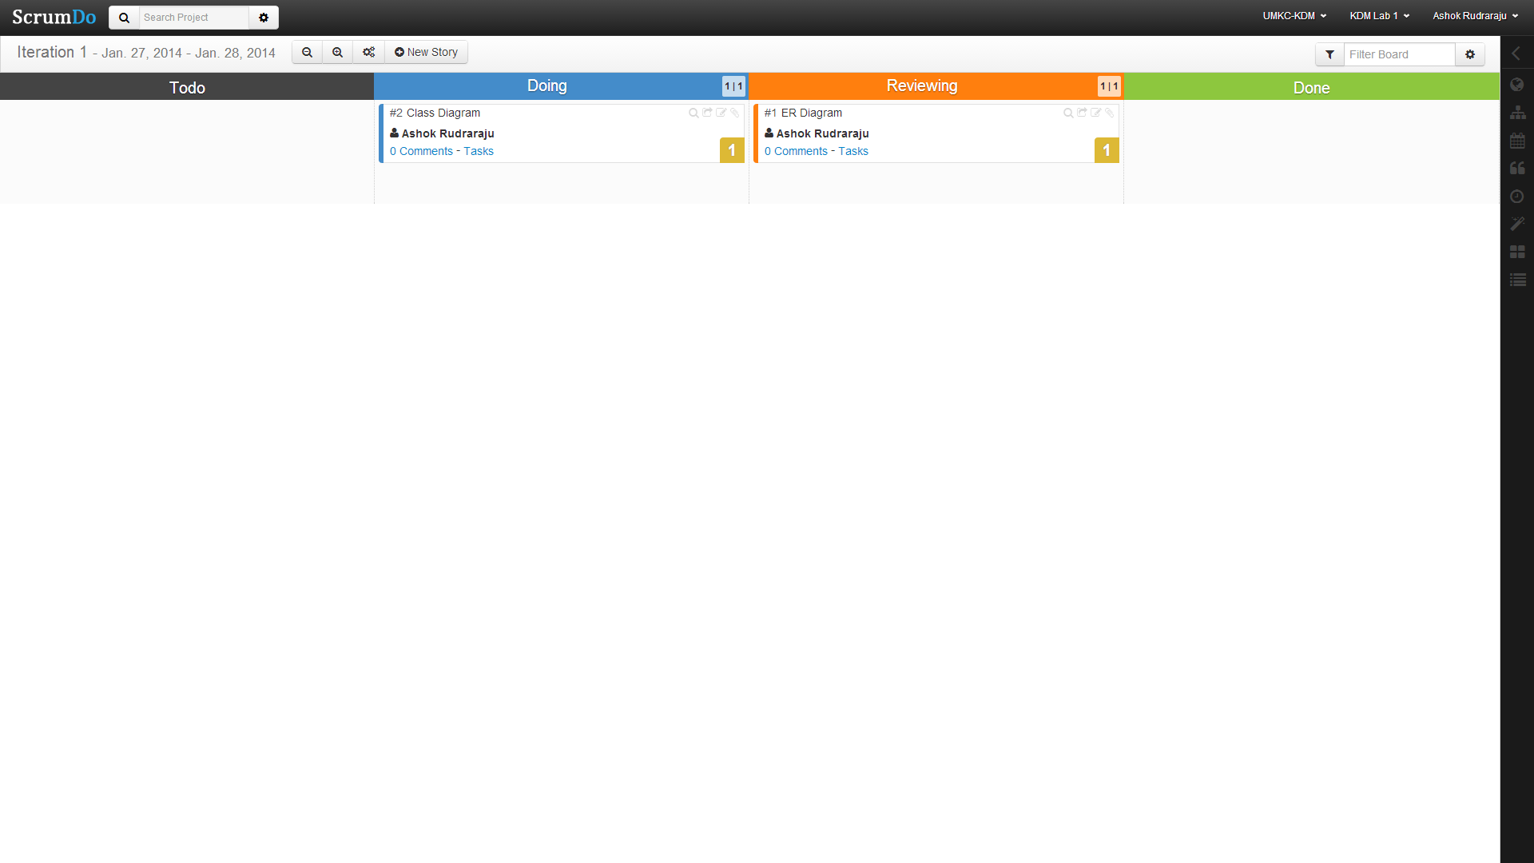

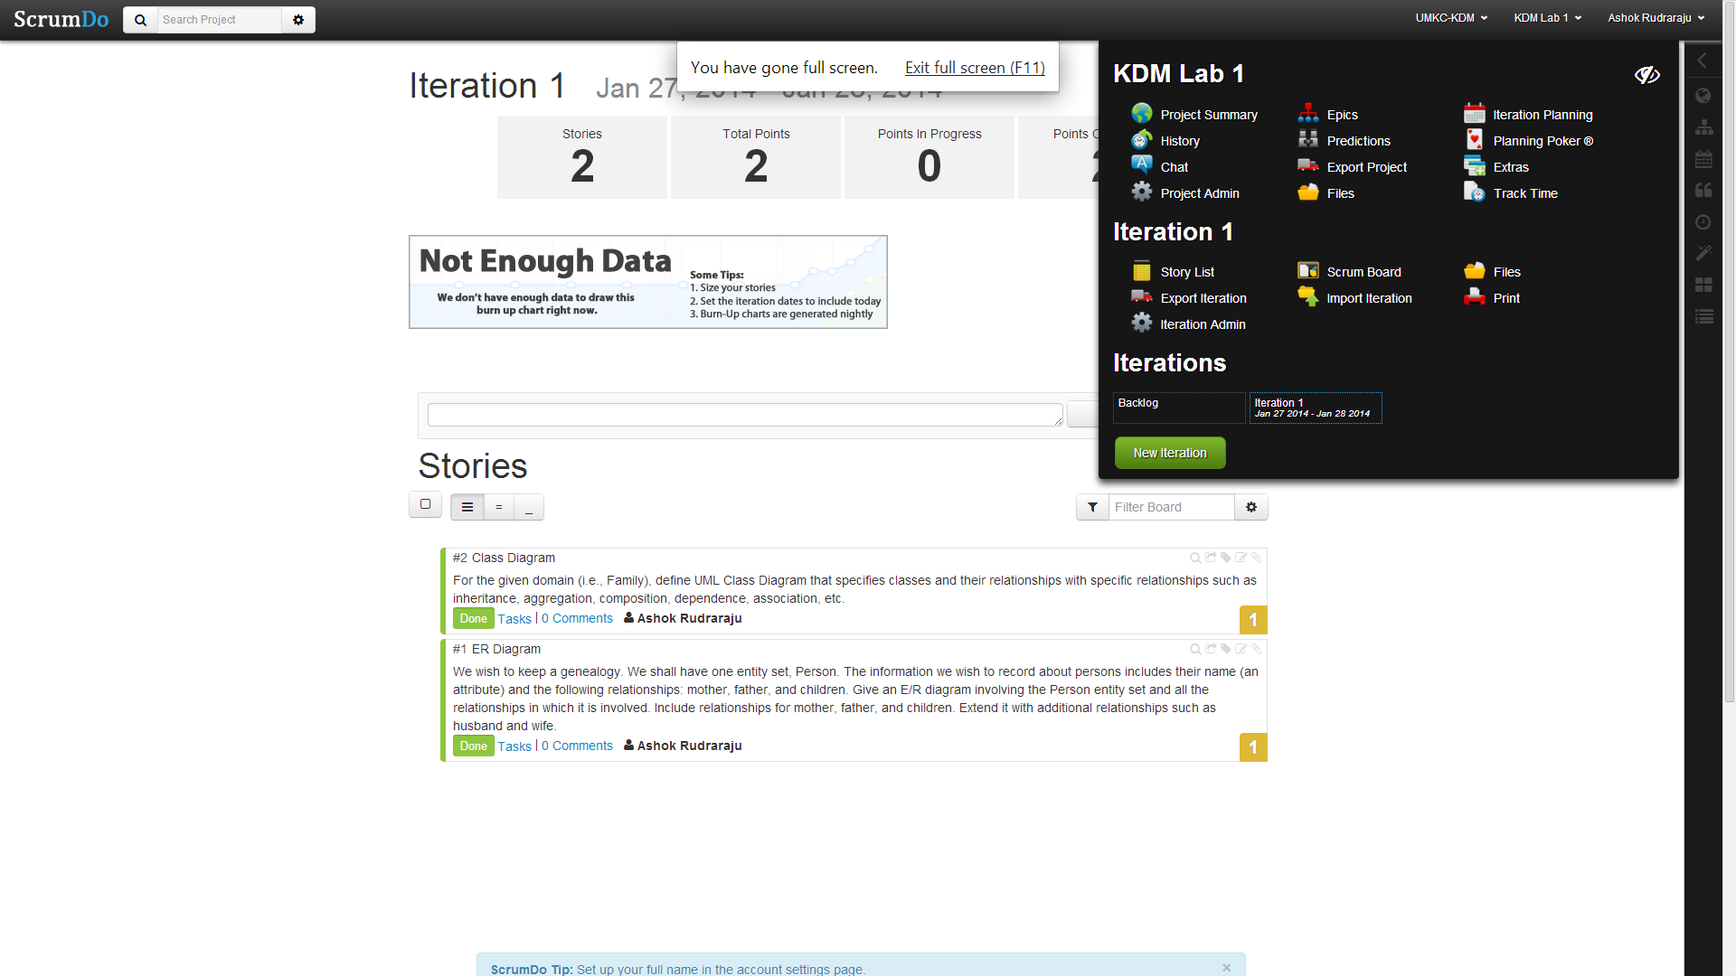

Github :

Created a new organization by the name UMKC-KDM.

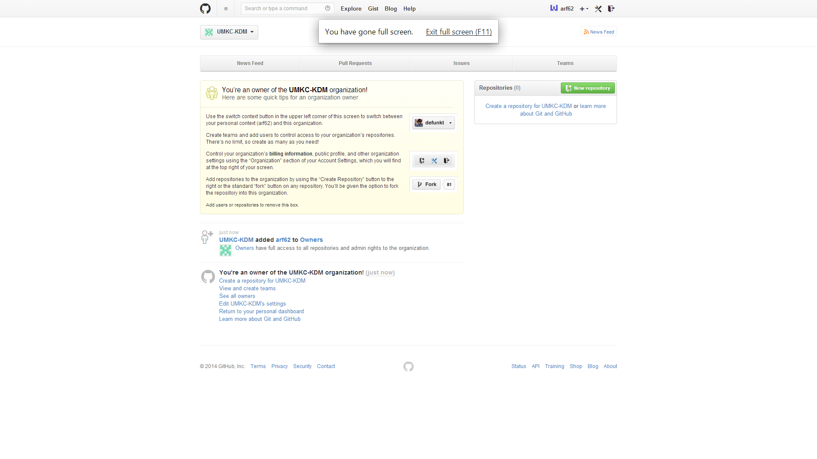

Creating a new repository by the name Lab1.

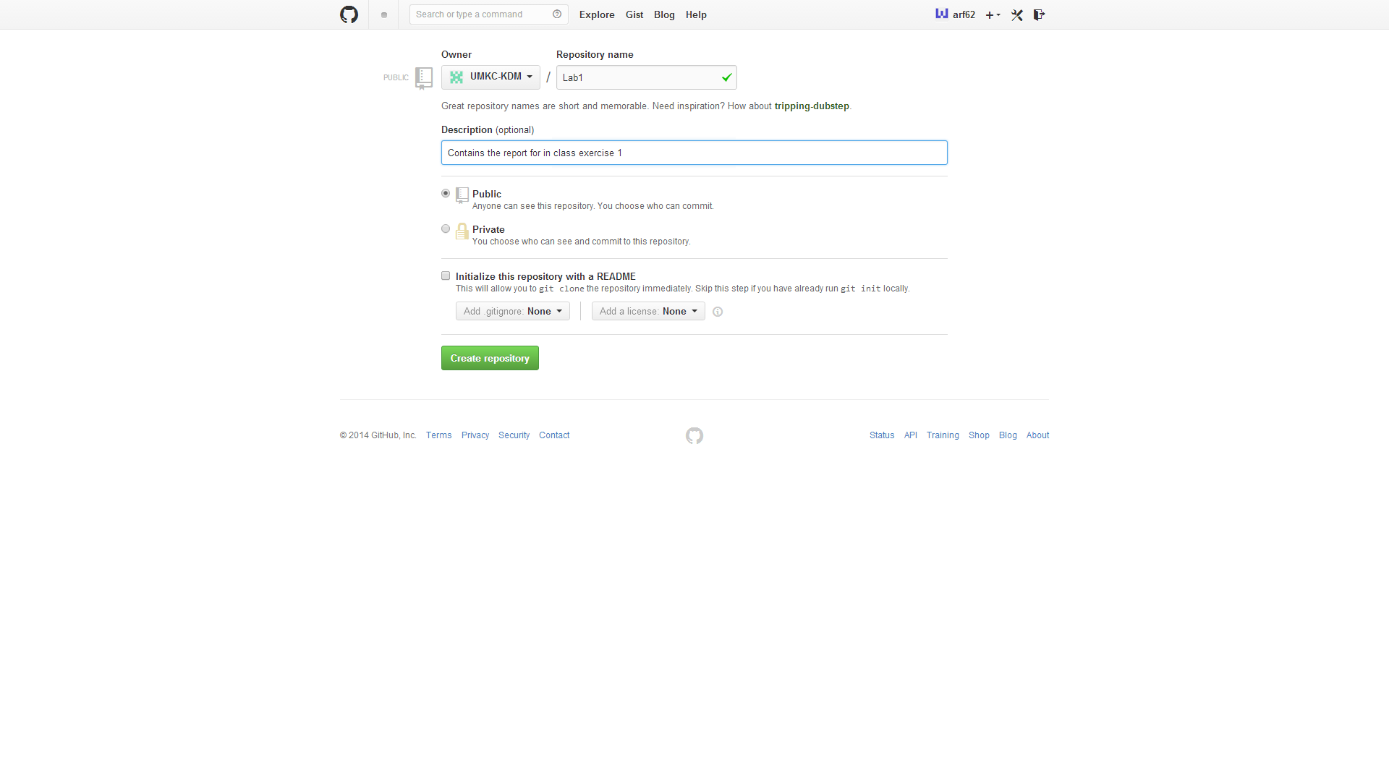

Repository created in the local machine

