CS551 Advanced Software Engineering

First Increment Report
Due Date: October 4 (F) 2013, 11:59PM

- Import Existing Services/API

API's used:
- Yahoo Weather API
- Google Maps API

Services Implemented:
- Weather Services
- Navigation Services

- Detail Design of Services

  - Write User Stories /Use Case (Using ScrumDo)
Story #2: As a team we want to develop and test weather services so that it can be integrated with the seGuRo Drive App.
This story is completed and is moved to the done phase.

Story #3:As a team we want to develop and test weather services so that it can be integrated with the seGuRo Drive App.
This story is partially completed hence moved to the doing phase.

  - Sequence diagram (using Visio)

Navigation Services: 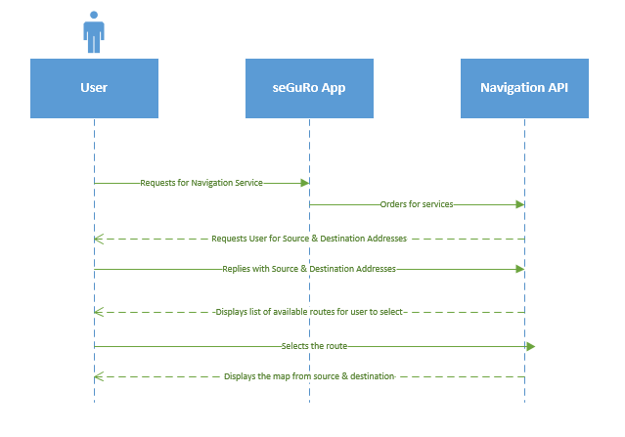

Weather Services:

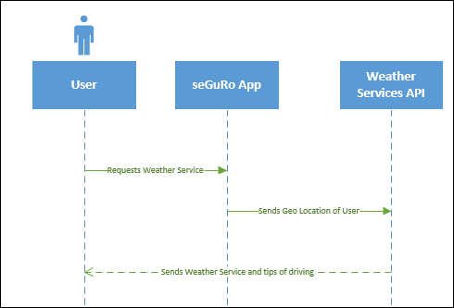

  - Class diagram (using Visio)

Navigation Services:
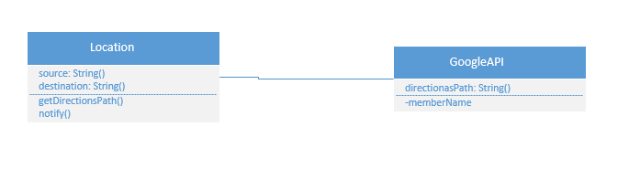

Weather Services:

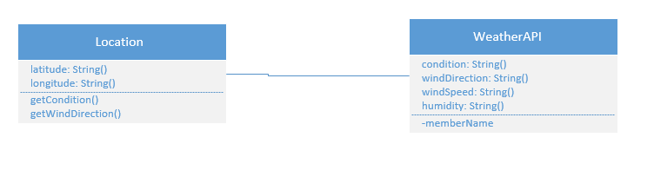

- Implementation
  - Implementation of services
  - Implementation of user interface (Mobile Apps)
  - Implementation of test cases

- Report:

Here is the home screen of seGuRo Drive:
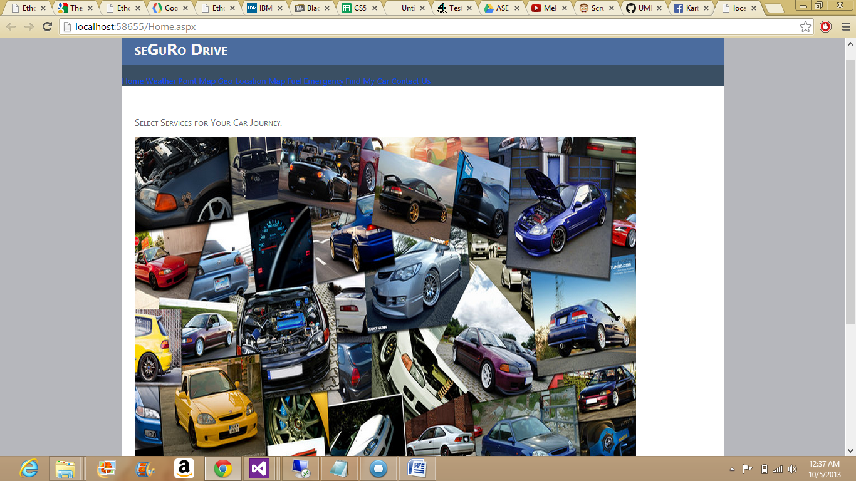

Weather Services:
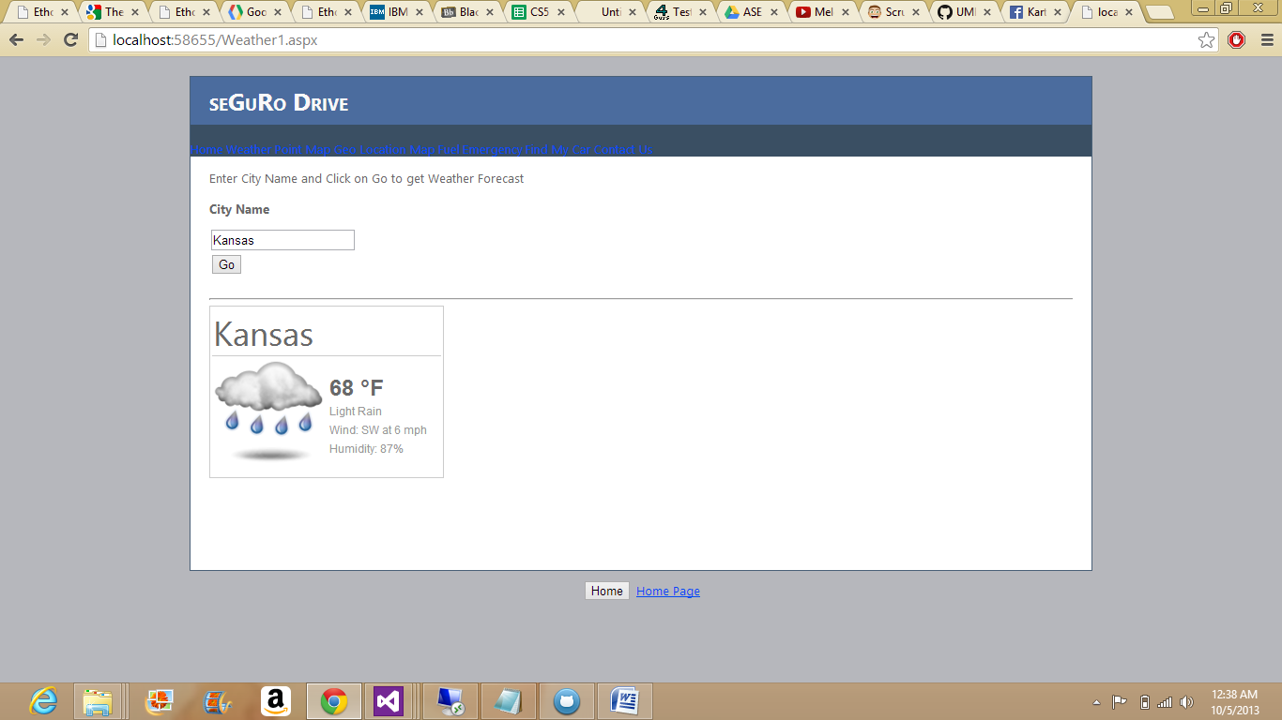

Navigation Services:
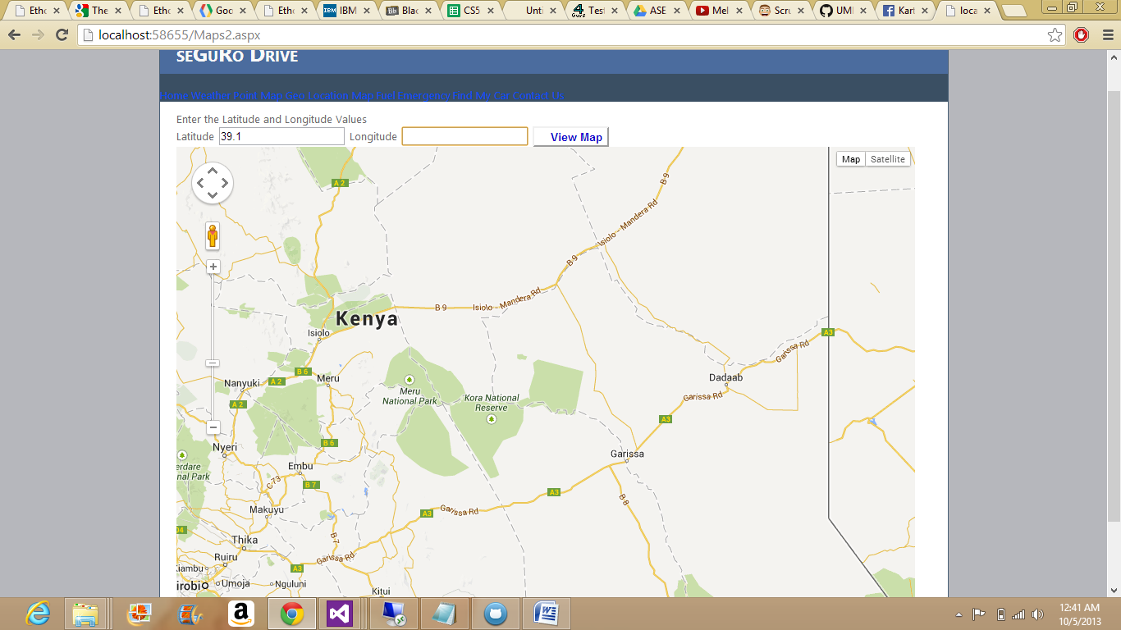

Route from Source to Destination:
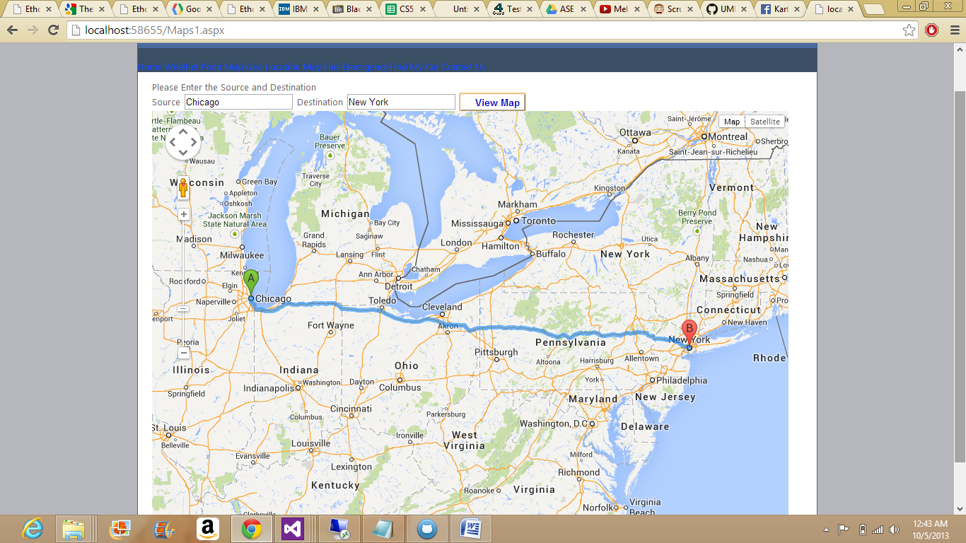

- Project Management:

Before Increment 1:
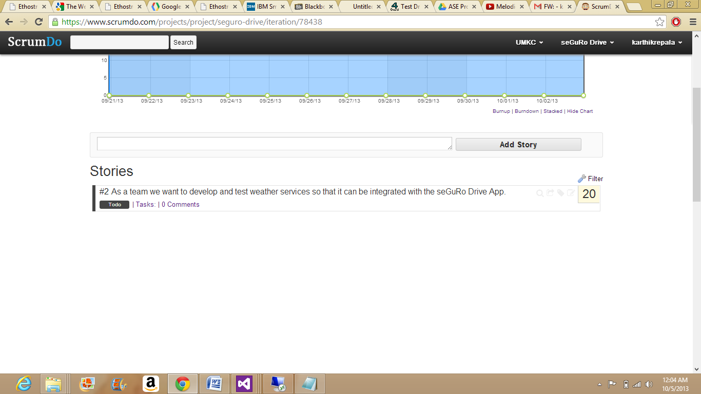
After Increment 1:
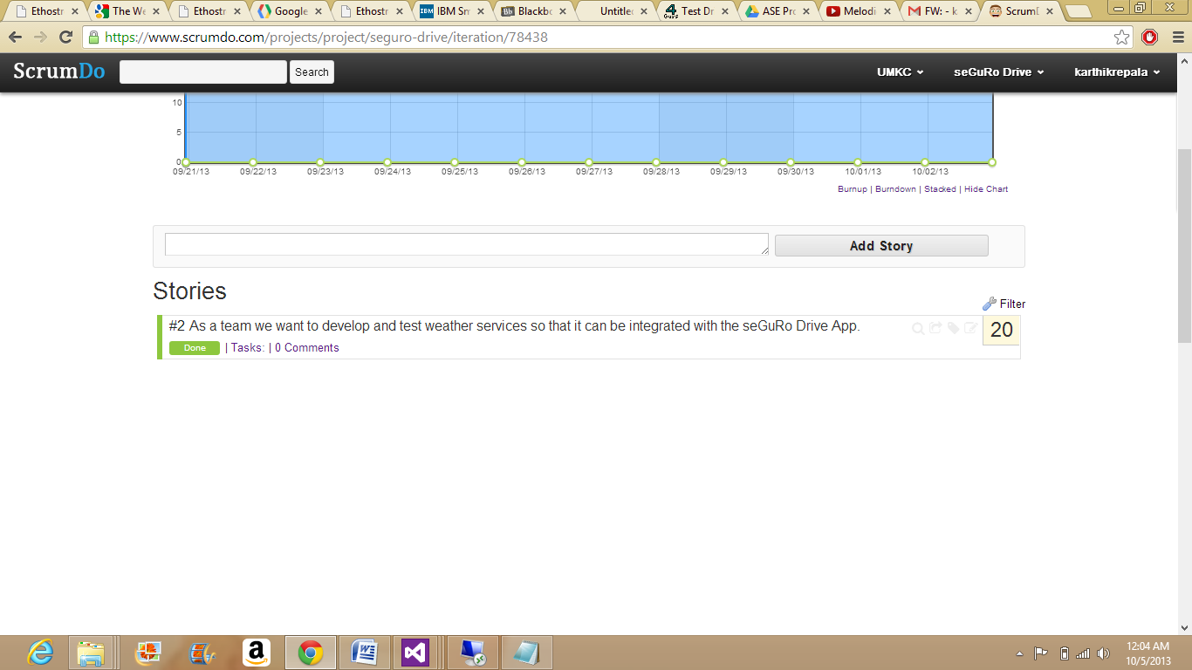

seGuRo Drive project stories scenario:
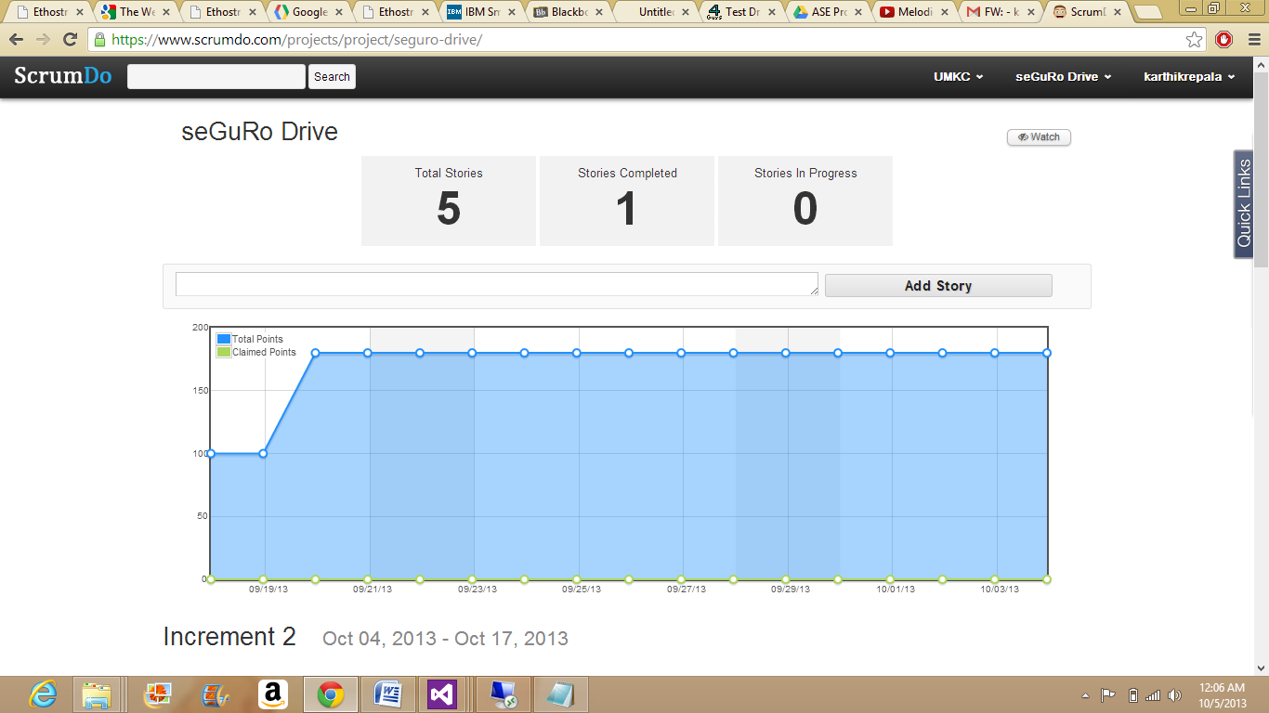
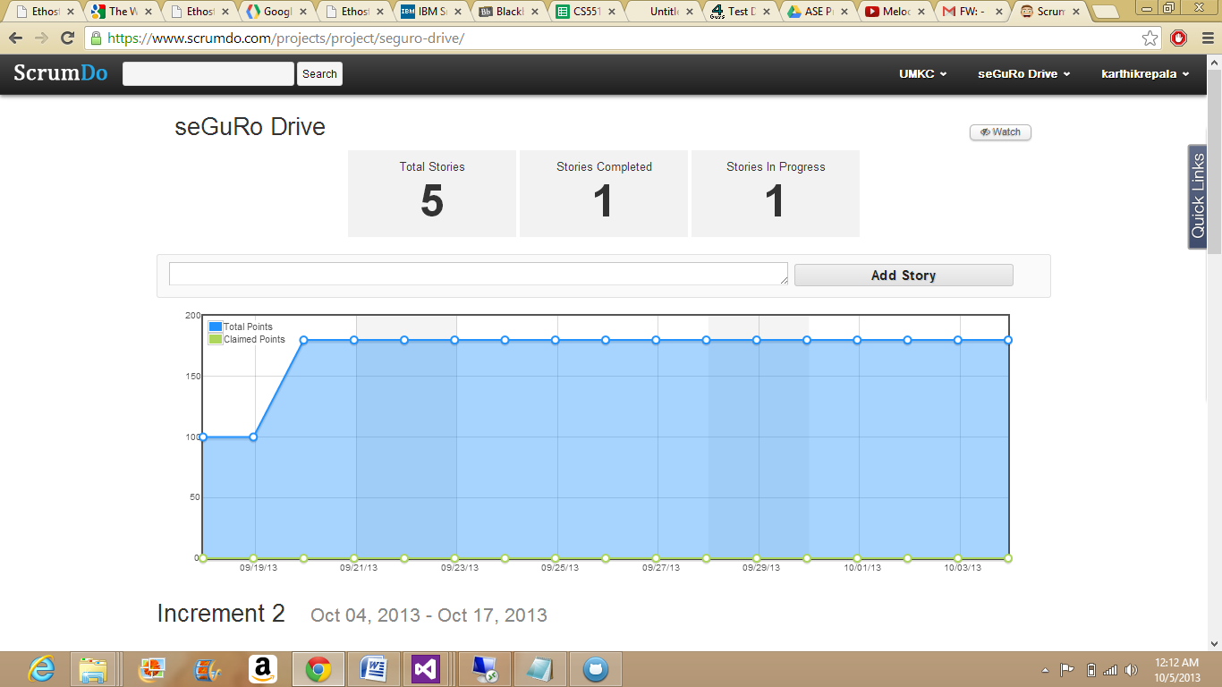

  - Implementation status report
    - Work completed:
      - Weather Services and Navigation Services
      - (Weather,Karthik)
      - (Navigation,Karthik)
      - Time taken (40 hours)
    - Work to be completed
      - Fuel Monitoring, Emergency Services and Finding Car.
      - Responsibility (Fuel , Shiva)(Emergency, Karthik)(Find Car, Surendra)
      - Time to be taken (estimated #hours)
    - Issues/Concerns:
- Front End should be designed as we progress to the end.
- The code is not getting deployed in the cloud instance.
- It is showing configuration error.
- Testing needs to be performed.

