Terrence Jay
Github: https://github.com/UMKCTJ/CS-Solitaire
Video:https://youtu.be/9fYsksuFr4M

Source Code Summary
Source code file name | Production code or test code? | # lines of code
Gui.py | Production Code | 129 Lines
Logic.py | Production Code | 250 Lines
Xunit_test.py | Test code | 200 Lines
Main.py | Production Code | 11 Lines
 | Total | 590 Lines

User Stories (Sprint 2)
ID | User Story | Description | Priority | Estimated Time
1 | Board Size | As a developer, I want to make two board sizes so that I can add different styles of play | Low | 2 Hours
2 | Board Type | As a player, I want to choose the board type (e.g., English, Hexagon, or Diamong) before starting a game so that I can play the variation of solitaire that best suits my skill level and preferences. | Low | 1 Hour
3 | Start new game of board size and type | As a developer, I want to start a new game with a chosen size and type so that the player can easily start a fresh game. | High | 2 Hours
4 | Make a move in game | As a player, I want to move a peg by jumping it over an adjacent peg into an empty hole so that I can remove pegs from the board and progress toward winning the game. | High | 4 Hours
5 | Game is over | As a developer, I want the game to detect when no valid moves remain so that I know the game has ended.. | Low | 1 Hour

Acceptance Criteria (Sprint 2)
User Story ID & Name | AC ID | Description of Acceptance Criterion | Status
- Board Size | 1.1 | Given the game is opened, when a number is inputted, then the size of the board will change | Done
 | 1.2 | Given the game is opened, when an invalid number or character is given, then revert back to the previous valid number | Done
- Board Type | 2.1 | Given the player is on the game setup screen, when the player selects a board type, then the system highlights the selected type and shows a preview of the corresponding board layout. | Done
 | 2.2 | Given the player has selected a board type, when the player starts a new game, then the system creates a board that matches the chosen layout, with the correct number of holes and pegs and the correct empty starting position. | Done
 | 2.3 | Given the player has not explicitly chosen a board type, when the player starts a new game, then the system uses a default board type (e.g., English) and tells the player which type is in use. | Done
 | 2.4 | Given a game is currently in progress, when the player attempts to change the board type, then the system asks the player to confirm that the current game will be abandoned before applying the change. | Done
- Start new game of board size and type | 3.1 | Given the board type and size are selected, when a new game is started, then initialize the board state, size and type. | Done
 | 3.2 | Given a game has been started, when new game is clicked once more, then wipe the current board state and start from a fresh game | Done
 | 3.3 | Given the board type and size are selected, when autoplay is clicked, then let the computer play with a randomized set of moves. | To-Do
 | 3.4 | Given a new game has not started yet, when “record game” is checked then the game will memorize each valid move until the game ends. | To-Do
- Make a move in game | 4.1 | Given the player has selected a peg, when the player chooses a highlighted empty hole two positions away in a straight line, with a peg in the hole between, then the system moves the selected peg to the destination, removes the jumped peg, and updates the board and peg count. | Done
 | 4.2 | Given the player has selected a peg, when the player chooses an invalid destination (e.g., an occupied hole, a diagonal jump on a board that does not allow it, a jump over an empty hole, or a location off the board), then the system rejects the move, leaves the board unchanged, and displays a message explaining why the move is not allowed. | Done
 | 4.3 | Given the player has selected a peg, when the player clicks the same peg again or selects an empty area, then the system deselects the peg and clears all highlighted destinations. | Done
 | 4.4 | Given the player has just completed a valid move, when the board is updated, then the system checks whether any legal moves remain and, if none do, ends the game and shows the final result. | Done
- Game is over | 5.1 | Given a game is started, when one marble remains or no valid moves are available, then switch the game state to being over. | Done
 | 5.2 | Given the game is finished, when any further action on the board is taken, then reject the action until a new game is started | Done
 | 5.3 | Given the game is finished, when the game recognizes that the game has concluded, then count the number of marbles and give a rating | In-Progress

Production Code
User Story ID & Name | AC ID | Class Name(s) | Method Name(s) | Status
- Board Size | 1.1 | SolitaireGame, SolitaireGUI | SolitaireGame.set_size, SolitaireGUI.on_size_change | Done
 | 1.2 | SolitaireGame, SolitaireGUI | SolitaireGame.set_size, SolitaireGUI.on_size_change | Done
- Board Type | 2.1 | SolitaireGame, SolitaireGUI | SolitaireGame.set_board_type, SolitaireGUI.on_type_change, SolitaireGUI.draw_board | Done
 | 2.2 | Board, EnglishBoard, HexagonBoard, DiamondBoard | create_board, Board.new_game, is_on_board | Done
 | 2.3 | SolitaireGame, SolitaireGUI | SolitaireGame.__init__, SolitaireGame.new_game, SolitaireGUI.refresh | Done
 | 2.4 | SolitaireGame, SolitaireGUI | SolitaireGame.is_in_progress, SolitaireGUI.confirm_abandon | Done
- Start new game of board size and type | 3.1 | SolitaireGame, Board | SolitaireGame.new_game, create_board | Done
 | 3.2 | SolitaireGame, SolitaireGUI | SolitaireGame.new_game, SolitaireGUI.on_new_game | Done
 | 3.3 |  |  | Not Complete
 | 3.4 |  |  | Not Complete
- Make a move in game | 4.1 | SolitaireGame, Board, SolitaireGUI | SolitaireGame.click, SolitaireGame.get_highlighted_destinations, Board.make_move, SolitaireGUI.on_click, SolitaireGUI.draw_board | Done
 | 4.2 | SolitaireGame, Board | Board.get_move_error, Board.is_valid_move, SolitaireGame.click | Done
 | 4.3 | SolitaireGame | SolitaireGame.click | Done
 | 4.4 | SolitaireGame, Board | SolitaireGame.check_game_over, Board.is_game_over | Done
- Game is over | 5.1 | SolitaireGame, Board | Board.get_valid_moves, Board.is_game_over, SolitaireGame.check_game_over | Done
 | 5.2 | SolitaireGame | SolitaireGame.click | Done
 | 5.3 | SolitaireGame, Board | Board.peg_count, Board.get_rating, SolitaireGame.check_game_over | Not Complete

Summary: Logic.py is responsible for all game logic, and GUI.py handles the interface. The user stories are followed for each method to help implement logic and funcitonality

Automated Test

User Story ID & Name | AC ID | Class Name(s) | Method Name(s) | Status
1. Board Size | 1.1 | TestBoardSize | valid_size_changes_board | Pass
 | 1.2 | TestBoardSize | invalid_number_reverts_to_previous_size & invalid_character_reverts_to_previous_size | Pass
2. Board Type | 2.1 | TestBoardType | selecting_type_shows_that_layout | Pass
 | 2.2 | TestBoardType | english_board_has_correct_holes_pegs_and_empty_center & diamond_board_has_correct_holes_and_empty_center | Pass
 | 2.3 | TestBoardType | default_type_is_english_and_player_is_told | Pass
 | 2.4 | TestBoardType | game_in_progress_needs_confirmation | Pass
3. Start new game of board size and type | 3.1 | TestStartNewGame | new_game_uses_chosen_size_and_type | Pass
 | 3.2 | TestStartNewGame | new_game_again_wipes_the_board | Pass
 | 3.3 |  |  | Pass
 | 3.4 |  |  | Pass
4. Make a move in game | 4.1 | TestMakeMove | Valid_move_jumps_and_removes_peg, valid_diagonal_move | Pass
 | 4.2 | TestMakeMove | Jump_over_empty_hole_is_rejected_with_reason & wrong_distance_is_rejected_with_reason & off_board_and_occupied_are_rejected | Pass
 | 4.3 | TestMakeMove | clicking_same_peg_deselects & clicking_empty_area_deselects | Pass
 | 4.4 | TestMakeMove | game_ends_after_last_possible_move | Pass
5. Game is over | 5.1 | TestGameOver | New_game_is_not_over & one_marble_left_is_game_over & no_valid_moves_is_game_over | Pass
 | 5.2 | TestGameOver | actions_rejected_after_game_over | Pass
 | 5.3 | TestGameOver |  | Pass

Summary: Test follows acceptance criteria and users story even closer, ensuring that each test passes. If a test fails, we go back to the original code and double check them to refactor until the test passes successfully.

Screenshots
Using Claude Sonnet 5.5
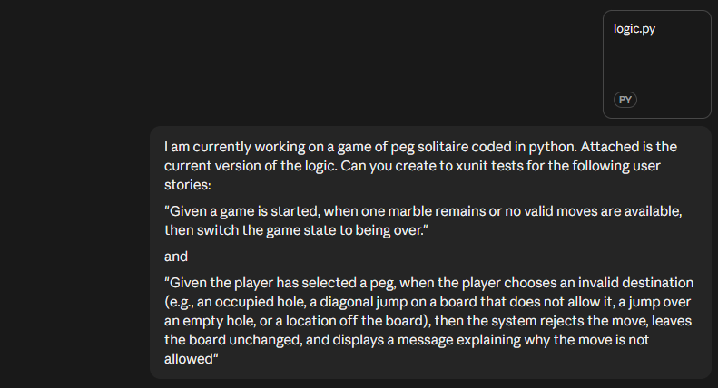
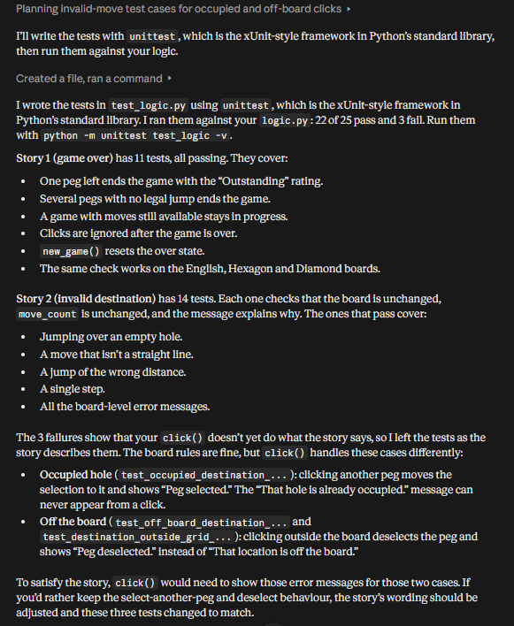
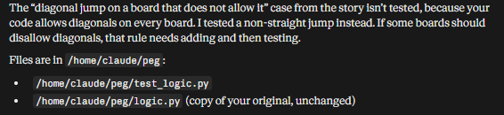
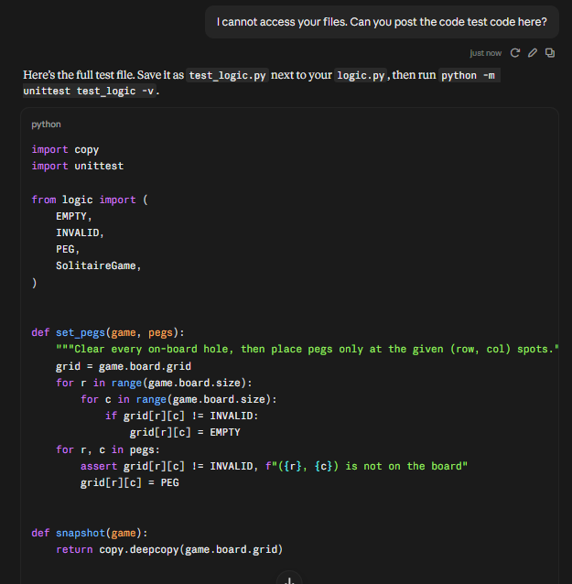
[Lot of code…]
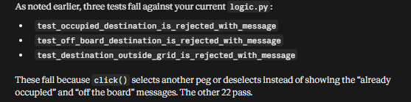

Fixes:
- Some of the test cases given were already made, so a lot of the generated test cases given were discarded
- Of the test cases generated, “jump_over_empty_hole_is_rejected_with_reason” and “actions_rejected_after_game_over” were kept.
- The AI also made a complex method to clear the board for testing. This was replaced with a much similar function, “clear_board”.

