

UML Rocket Telemetry Companion App User Guide

**Viewing Flight Data:**

1. To start the companion app run TelemetryCompanionApp.exe location in *CompanionAppCode\TelemetryCompanionApp\TelemetryCompanionApp\bin*
2. Then click the “Start” button on the main menu. 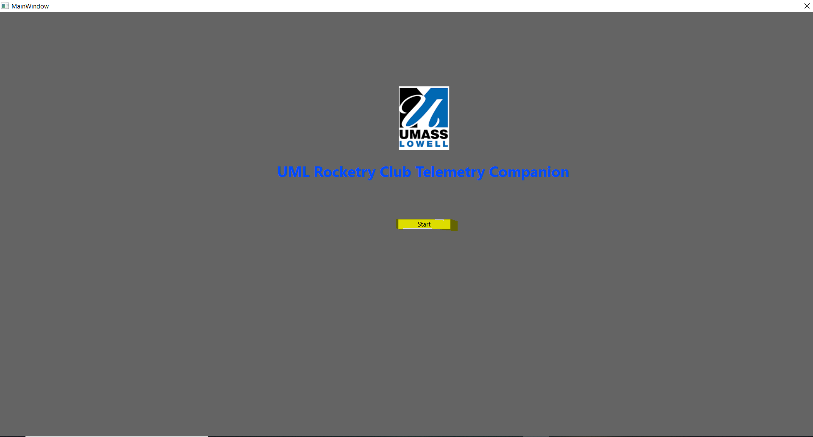
3. Click the “Select Flight” button to open file explorer and select the flight file you want to view.

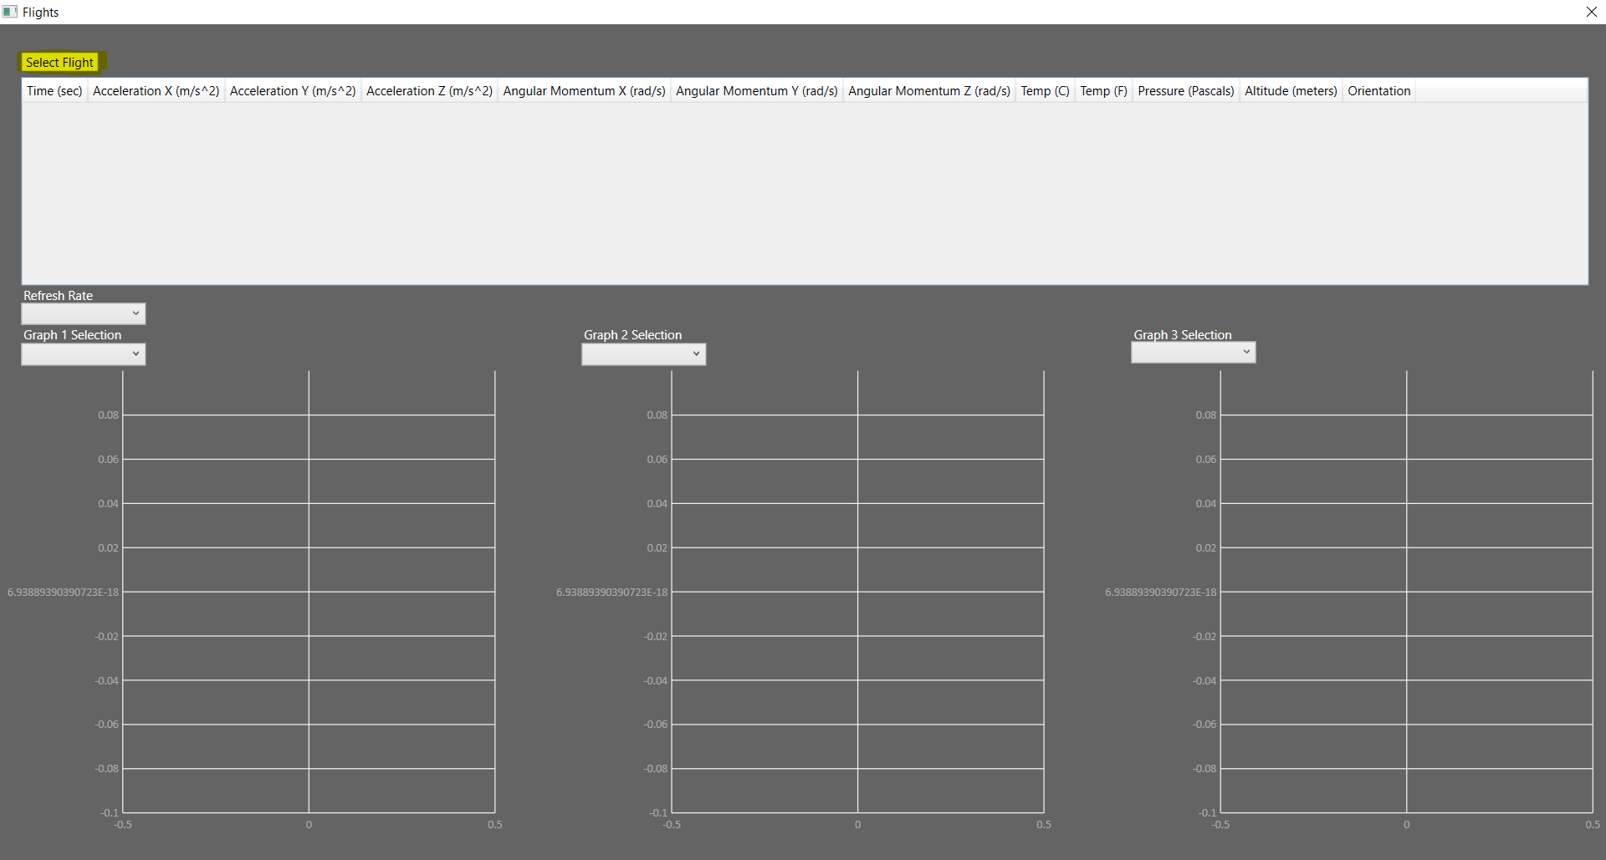

1. Once you have selected a flight the Table should populate with values.

To populate graph with a measurement over Time use a dropdown menu.

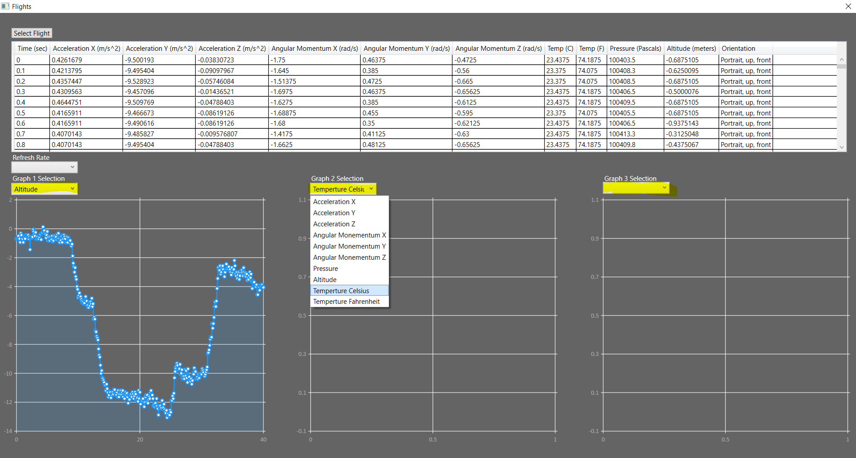

For data to display a refresh must occur. By default, the refresh rate is static. Once a measurement has been selected simply set the refresh rate to a non-static value and it will populate the graph with that measurement data on refresh. If you wish to change the measurement, simply repeat this process.

