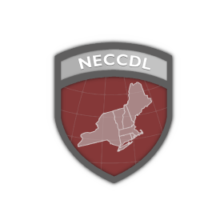

ChefOPs
Cyber Security Team Blue Team 05

Recipient:
[SENDER]
ChefOPs
Date: Month Day, 2026
Subject: Incident Response #

Month Day, 2026

Dear [SENDER],

Must contain a description of what occurred (including source and destination IP addresses, timelines of activity, passwords cracked, access obtained, damage done, etc), a discussion of what was affected, and a remediation plan.

This report details red team activity on our [Linux / Windows / Kubernetes] systems, first identified at [TIME FOUND]. The incident is [under investigation / ongoing / fully resolved] as of [TIME REMEDIATED].

This was a [Minimal / Moderate / Severe / Catastrophic] incident. The attackers obtained [remote access / root access / data access] to our systems. We were [fully / partially / not] able to recover control of the affected systems.

Executive Summary
Text

Business Impact
Text

[Incident Name]

Systems Affected
System | Component | Notes

Indicators of Compromise

[Insert Figure/Screenshot Here]
Figure #: [Figure Caption]

[Insert Figure/Screenshot Here]
Figure #: [Figure Caption]

Root Cause of the incident

[Insert Figure/Screenshot Here]
Figure #: [Figure Caption]

[Insert Figure/Screenshot Here]
Figure #: [Figure Caption]
Remediation

[Insert Figure/Screenshot Here]
Figure #: [Figure Caption]

[Insert Figure/Screenshot Here]
Figure #: [Figure Caption]

Lessons Learned
Text

