There are three major parts of this register.

1. Sale Items
2. Transaction Info
3. 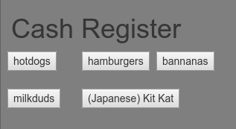Cashier Info

**Sale Items:**

All items available for sale appear as buttons,

clicking a button adds one instance of the product in question to the pending transaction.

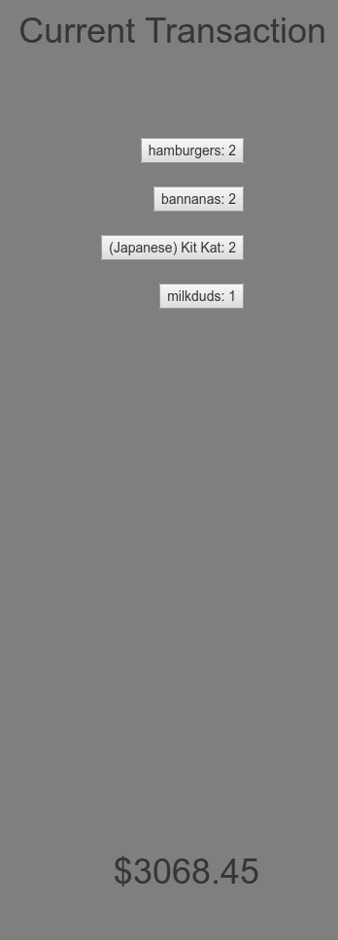**Transaction Info:**

The transaction table enables viewing of the transaction followed by

the quantity of the item to be purchased. Cashiers may

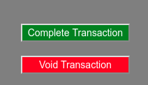remove a single quantity of an item by clicking on its corresponding button. The total cost of the order is listed at the bottom.

Furthermore, there are two buttons at the bottom of the page,

the first button ‘Complete Transaction’ completes the transaction,

updating the database to reflect the new quantities, in addition to displaying a popup with receipt info. The second button ‘Void Transaction’ clears the pending transaction, removing all the items that were to be purchased.

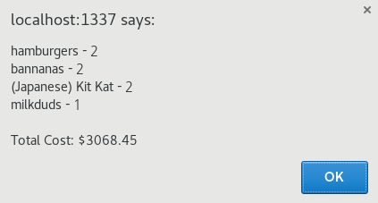

**Cashier Verification**

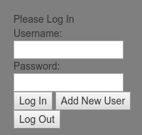

The Login function prevents guests from interacting with the system. In order to add a new user, a verified user must already be logged in. Manually querying the database enables creation of a user without a currently existing user. The till buttons will not function unless a verified cashier is logged into the system. Once logged in, the user’s username is displayed above the login area.

**WARNING: DO NOT UTILIZE SENSITIVE PASSWORDS.**

The current system stores passwords in plain text, unencrypted and lacking any security measures whatsoever. Be careful!

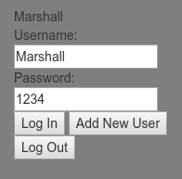The system tracks the cashier logged in for any given transaction. This information is stored in the database tables till_sales and user_sales. These tables also contain timestamp information for orders.