Predicting CI/CD Pipeline Failures Using Build and Test Logs

Introduction
The concept of continuous integration/continuous deployment (CI/CD) pipelines enables software testing and delivery to be automated and provides teams with an opportunity to release code as quickly as possible and with a certain degree of consistency in the modern DevOps setup. These automated systems have the disadvantage of being vulnerable to every now and then breakdown due to misconfigurations, unstable code or environmental inconsistencies despite their benefits. These failures may post thought and waste engineering time.
This assignment deals with a dataset of CI/CD pipeline logs that is to be prepared and analysed and with the aim of revealing patterns that result in these failures. The exercise represents the step of Data Pipeline of the MLOps workflow, during which information is gathered, processed, and converted into a usable format later used to create machine-learning in Task 2. The end result of this step is a clean feature-rich dataset that can be modelled and monitored.

Dataset Identification and Relevance
The dataset applicable in this research is the AI-Driven CI/CD Pipeline Logs Dataset, which was acquired in Kaggle. It contains 800 records across 11 attributes, each representing a task execution within a CI/CD pipeline. Core variables include:
Table 1 Data Features
Feature | Description
timestamp | Date and time of pipeline execution
pipeline_id | Unique identifier for each pipeline run
stage_name, job_name, task_name | Hierarchical workflow components
status | Execution outcome (success, failed, running, skipped)
user | Triggering user or automation agent
environment | Execution context (e.g., development, staging, production)
The data set was chosen due to the fact that it gives an actual picture of automated software delivery systems and their working conditions. It records various phases of CI/CD process- Build, Test, Deploy and Analysis, which is critical in the diagnosis of the point and time of failure.

Justification of Dataset Selection
The dataset utilized was presented as justified in this section.
The data set was chosen due to the fact that it gives an actual picture of automated software delivery systems and their working conditions. It records various phases of CI/CD process- Build, Test, Deploy and Analysis, which is critical in the diagnosis of the point and time of failure.
Moreover, the dataset is a combination of categorical, textual, and temporal data, and provides the possibilities of various preprocessing and feature engineering:
- Predicting pipeline failure likelihood;
- Detecting anomalous behaviour during builds or tests;
- Analysing time-of-day effects on pipeline stability.
The comprehensive nature and significance of the data makes it possible to quickly use this data as a continuation of the Task 2, where predictive models will be implemented in an MLOps system.

Data Cleaning and Preprocessing

Initial Data Quality Assessment
The initial preliminary exploration showed that there were two columns with a large number of missing values: user (49.6 ) and environment (77.4 ). No duplicate rows were found. Status variable was uneven with the most frequent being: skipped and running then the next place was the failed and success category.
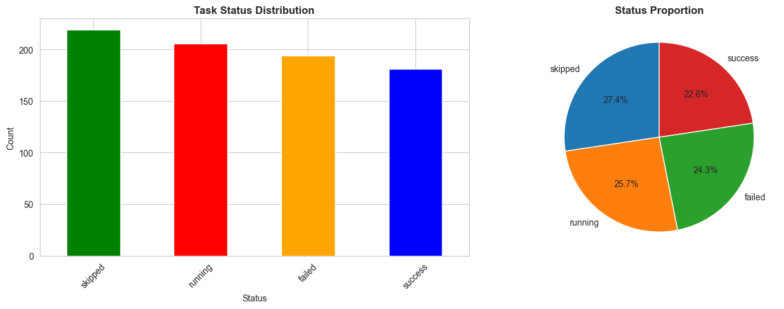
Figure 1 Proportion of success, failure, running, and skipped tasks.

Cleaning Steps
The following cleaning actions were performed:
Table 2 Data Cleaning Steps
Step | Operation | Outcome
1 | Filled missing user entries with “automated” | Represents machine-triggered builds
2 | Filled missing environment values with “not_specified” | Preserves row completeness
3 | Converted timestamp to datetime | Enables temporal feature extraction
4 | Checked and removed duplicates | 0 duplicates found
After cleaning, the dataset maintained 800 records and all columns were complete.

Feature Engineering
To enhance analytical depth, several new features were derived:
- Temporal Variables: hour, day_of_week, and month were extracted from timestamps to identify time-based patterns.
- Target Variable: A binary column is_failure was created, assigning 1 to “failed” records and 0 to all others (24.25 % failures).
- Categorical Encoding: stage_name, job_name, task_name, and environment were encoded using LabelEncoder.
- Feature Scaling: Numerical attributes were standardised with StandardScaler to prepare for model training.
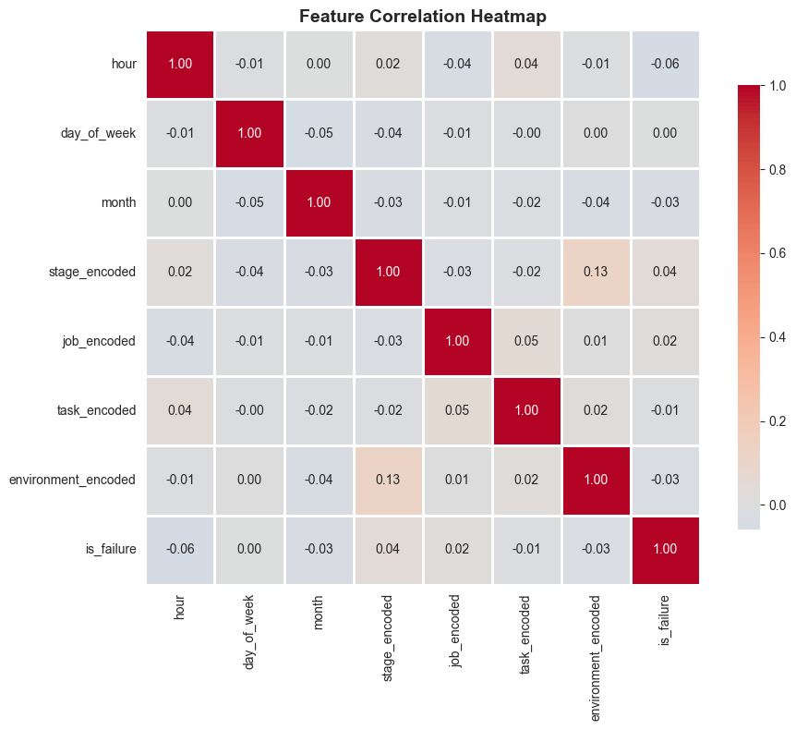
Figure 2 Feature correlation with the binary failure target.

Failure Pattern Analysis
The cleaned dataset was in turn searched to discover recurring trends of failure. There were relative even distributions of failures between the four stages of pipeline or Build, Test, Deploy, and Analysis with each stage contributing about a quarter of all failures. The processes that had the highest number of errors, at the job level were run unit tests (46 failures), run integration tests (42) and deploy to dev (42).
Environment analysis revealed that majority of failures were encountered in the not specified environment meaning that there might have been loopholes in managing configuration or logging. The temporal analysis showed the highest occurrences of failures between 8 a.m to midnight, which indicated that the problem is found during the unattended or automated time.
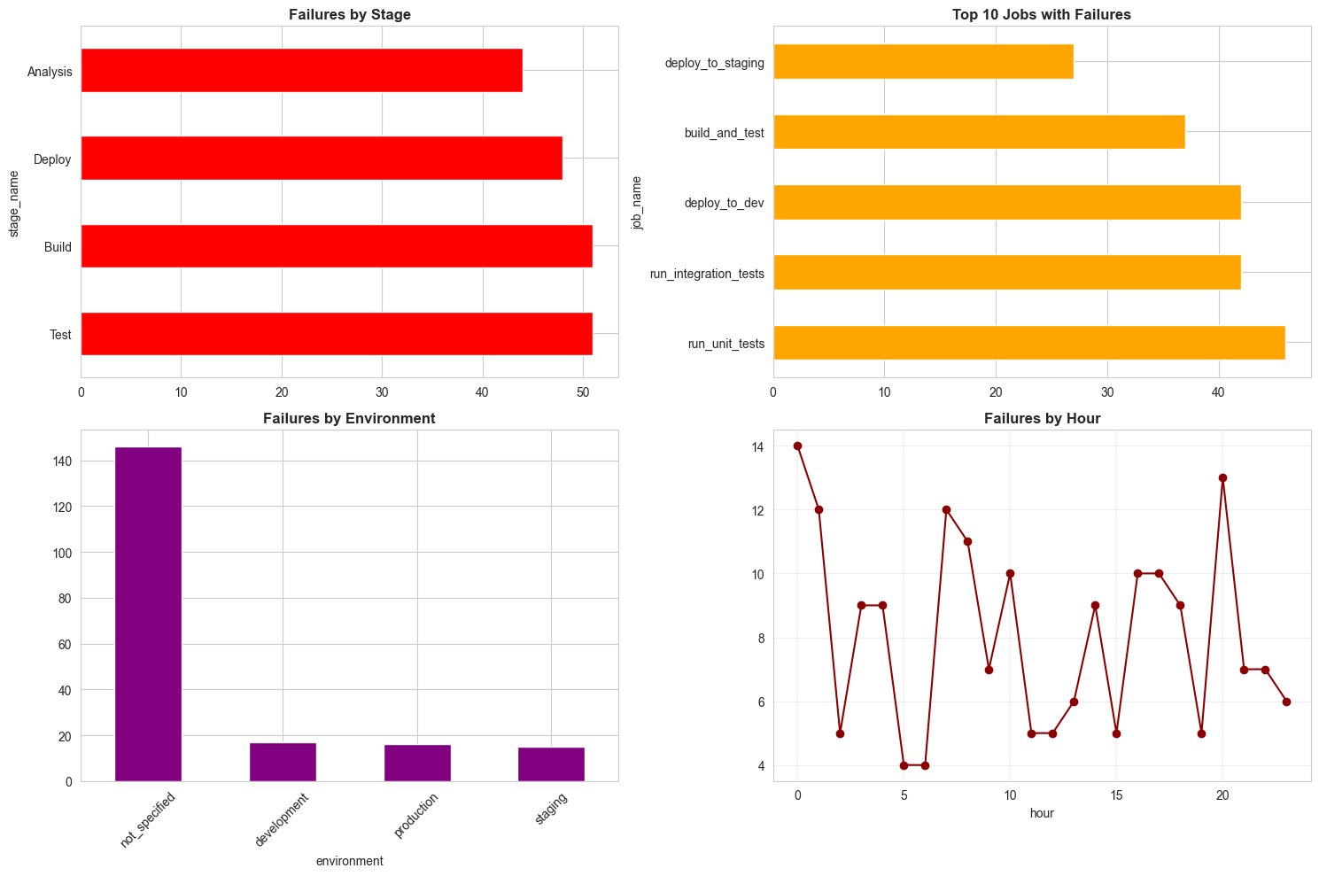
Figure 3 Distribution of failure events across operational contexts.

Feature Scaling and Correlation Insights
Correlation analysis performed after scaling has shown weak direct links between individual features and the target variable is failure. In place of this as an illustration, stage00:036 with stage encoded, temporal variables of hour and month displayed weak negative correlations. This finding indicates that the problem of pipeline breakdown is caused by a complicated multi-factor feedback and not the presence of a particular characteristic, which again supports the necessity of the machine-learning models to grasp these minor interdependences.

Final Dataset Summary
The preparation of the data made the data set have 19 columns instead of 11 but the number of records was 800. The reformed data is now a full time and category representation, which can be analyzed in detail. The important metrics are summarised below:
Table 3 Overview of cleaned and transformed CI/CD dataset.
Metric | Value
Date Range | 2024-01-01 to 2024-12-31
Unique Pipelines | 800
Unique Branches | 778
Unique Users | 399
Failure Rate | 24.25 %

This polished information is completely compatible with downstream processes like predictive modelling and reliability control. It is MLOps compliant with the data lineage, reproducibility, and CI/CD integration readiness in analytical processes.

Conclusion
The data set associated with the CI/CD logs was processed using the systematic data cleaning, feature engineering, and exploratory analysis, and converted into a high-quality and structured data set to be used in machine-learning applications. The experiment showed important observations like time-of-day failure patterns and environmental specific anomalies can be used to uncover optimization of DevOps even pre-predictive modelling.
The resultant dataset is considered an example of Data Pipeline step of MLOps since it ensures consistency of data, traceability and scalability of data in subsequent experimentation. In the second stage (Task 2), this data will be trained, deployed, and monitored to develop models that are able to predict pipeline failures and enhance the overall performance of the whole process.

