Enterprise Database Architecture & Governance
Final Project Solution Report

Course: Database Administration and Security | Date: April 28, 2026
Project: Final | Instructor: Faig Nasirli
Repository: GitHub (Scripts & Configs included) | Team Size: 3 Members
Authors: Sevinj Rustamova, Vefa Gafarzade, Umman Mammadov

Executive Summary
This report details the implementation of an Enterprise Database Architecture designed for high availability, security, and performance. The solution is distributed across two SQL Server 2022 instances deployed via Docker Compose to ensure strict network isolation. The architecture encompasses advanced schema design, tiered backup strategies, near-real-time replication, automated maintenance workflows, resource governance, and comprehensive security auditing. To adhere to modern deployment standards, all T-SQL scripts and infrastructure configurations (YAML) have been committed to the accompanying GitHub repository, rather than being statically embedded within this document.

1. Infrastructure Deployment & Connections
The environment was bootstrapped using Docker Compose, provisioning a Primary Node (localhost:14333) and a Secondary Node (localhost:14344). This ensures a consistent and reproducible architecture.
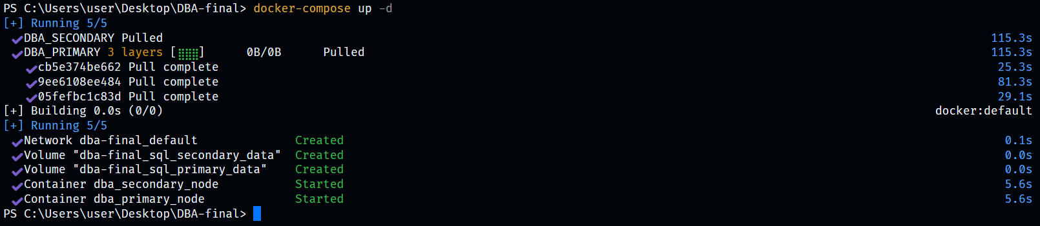
Fig 1.1: Docker Compose deployment executing successfully in the terminal.

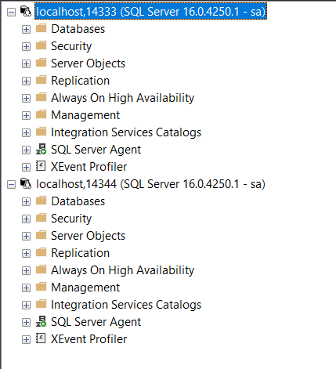
Fig 1.2: SSMS Object Explorer showing successful active connections to both isolated SQL Server nodes.

2. System Configuration & Schema Design
CoreDB and StagingDB were hosted on the Primary Instance to handle transactional workloads, while ReportDB was deployed to the Secondary Instance to offload analytical queries. The HR schema and Employees table were initialized in CoreDB. To facilitate intelligent storage and disaster recovery planning, Extended Properties were applied to classify data criticality (Hot, Cold, and Archive). Consequently, Recovery Models were mapped accordingly: Full recovery for Hot data to enable point-in-time restoration, and Simple recovery for Cold/Archive data to minimize transaction log overhead.
The Primary node databases (CoreDB and StagingDB) configured with their respective Hot/Full and Cold/Simple metadata mappings:
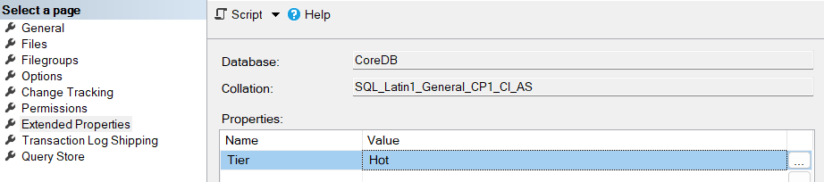
Fig 2.1: CoreDB Extended Properties configured as Tier = Hot.

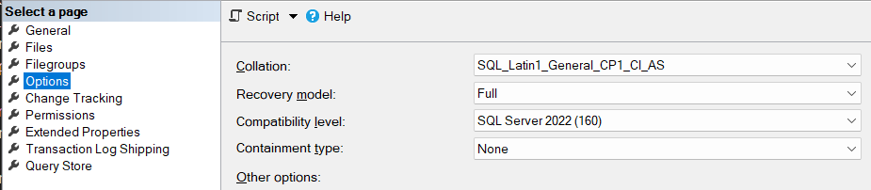
Fig 2.2: CoreDB Recovery Model set to Full.

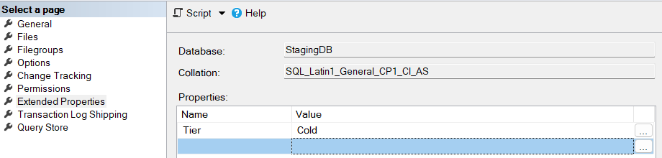
Fig 2.3: StagingDB Extended Properties configured as Tier = Cold.

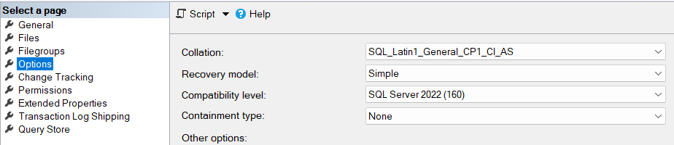
Fig 2.4: StagingDB Recovery Model set to Simple.

The Secondary node database (ReportDB) configured as the Archive tier:

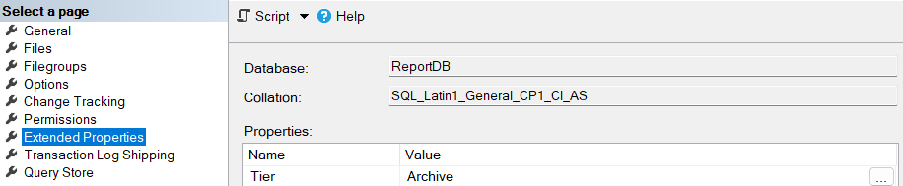
Fig 2.5: ReportDB Extended Properties (Tier = Archive).

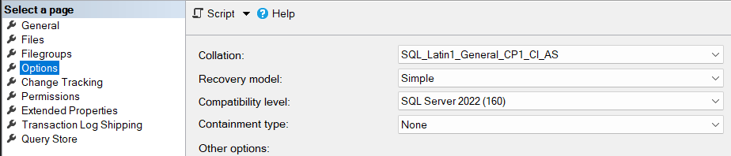
Fig 2.6: ReportDB Recovery Model set to Simple.

3. Backup Strategy & Workflow
A robust, multi-tiered backup strategy was automated using SQL Server Agent Jobs. The Hot tier (CoreDB) requires strict RPO, implemented via Daily Full, Daily Differential, and 15-minute Transaction Log backups. The Cold tier (StagingDB) utilizes a Weekly Full and Differential cycle. The Archive tier (ReportDB) relies on Monthly Full backups to optimize long-term storage.
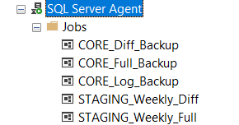
Fig 3.1: SQL Server Agent Jobs scheduled on the Primary Node for the Hot and Cold tiers.


Fig 3.2: Monthly Archive backup job scheduled on the Secondary Node.

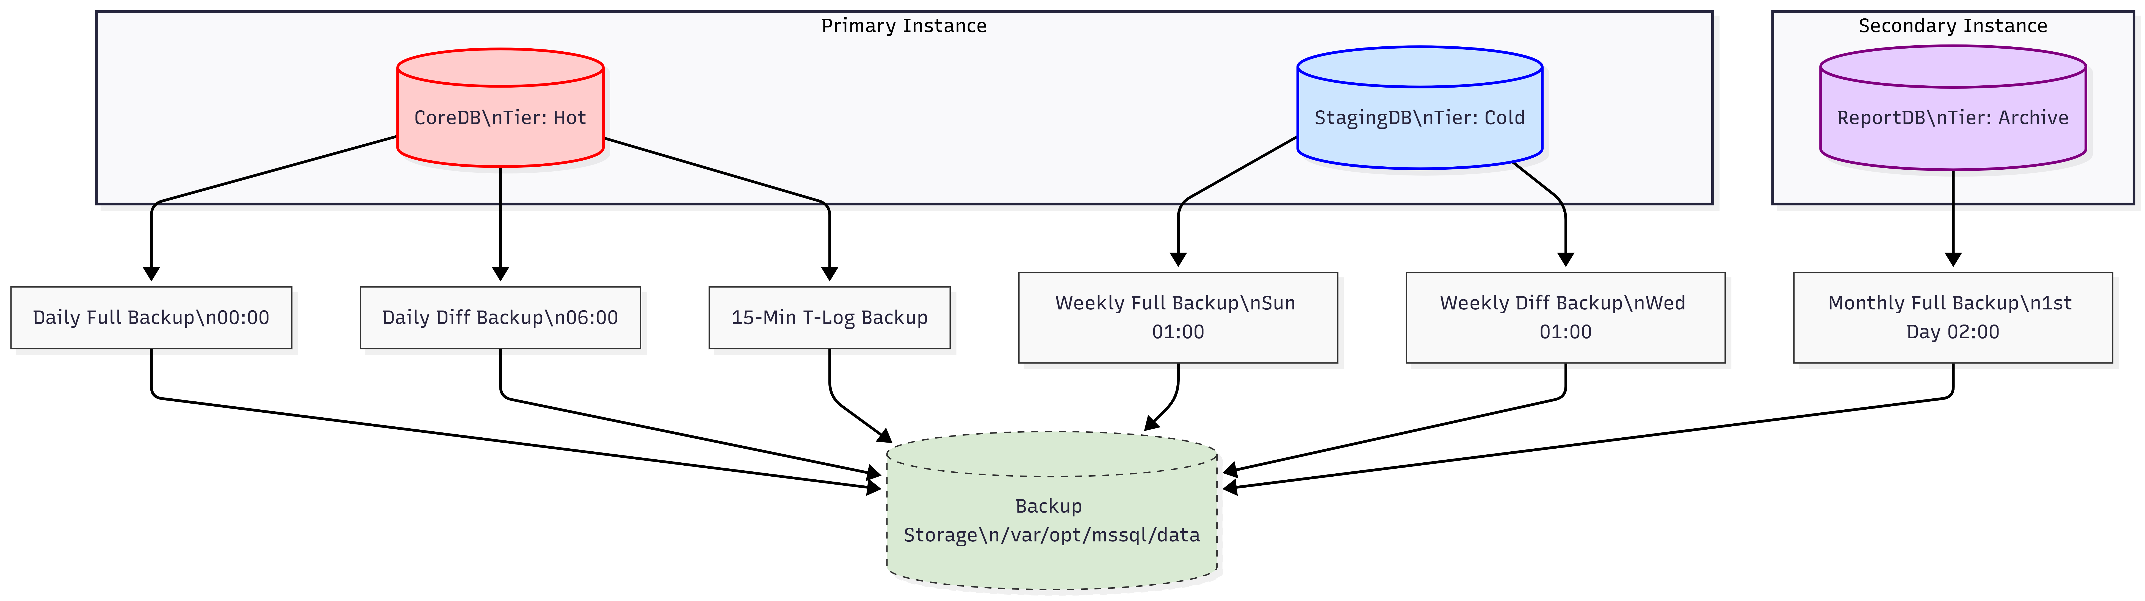
Fig 3.3: Visual Backup Workflow Diagram illustrating the tiered storage topology.

4. Automated Maintenance Plan
To maintain optimal query execution plans and physical structural integrity, an automated maintenance plan was scheduled to execute during off-peak weekend hours (midnight). The job executes a sequential pipeline to prevent resource contention: DBCC CHECKDB for physical integrity, Index Reorganization to combat page fragmentation, Statistics Updates for the query optimizer, and historical cleanup to manage system database bloat.
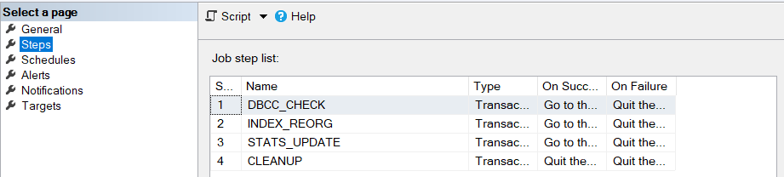
Fig 4.1: The sequential steps of the WEEKLY_DB_MAINTENANCE SQL Agent Job.

5. Replication & Analytical Data Flow
To support Business Intelligence workloads without impacting transactional latency, an analytical data pipeline was established between the nodes. A 30-minute high-frequency replication job synchronizes CoreDB data to ReportDB via Linked Servers. A midnight batch process simulates complex analytical transformations on the Secondary Node, followed by a reverse synchronization to push aggregated metrics back to the Primary Node for executive dashboards.
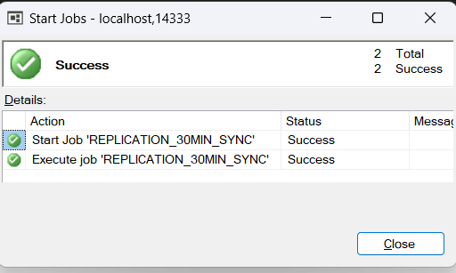
Fig 5.1: Successful execution history of the 30-Minute High-Frequency Sync Job.

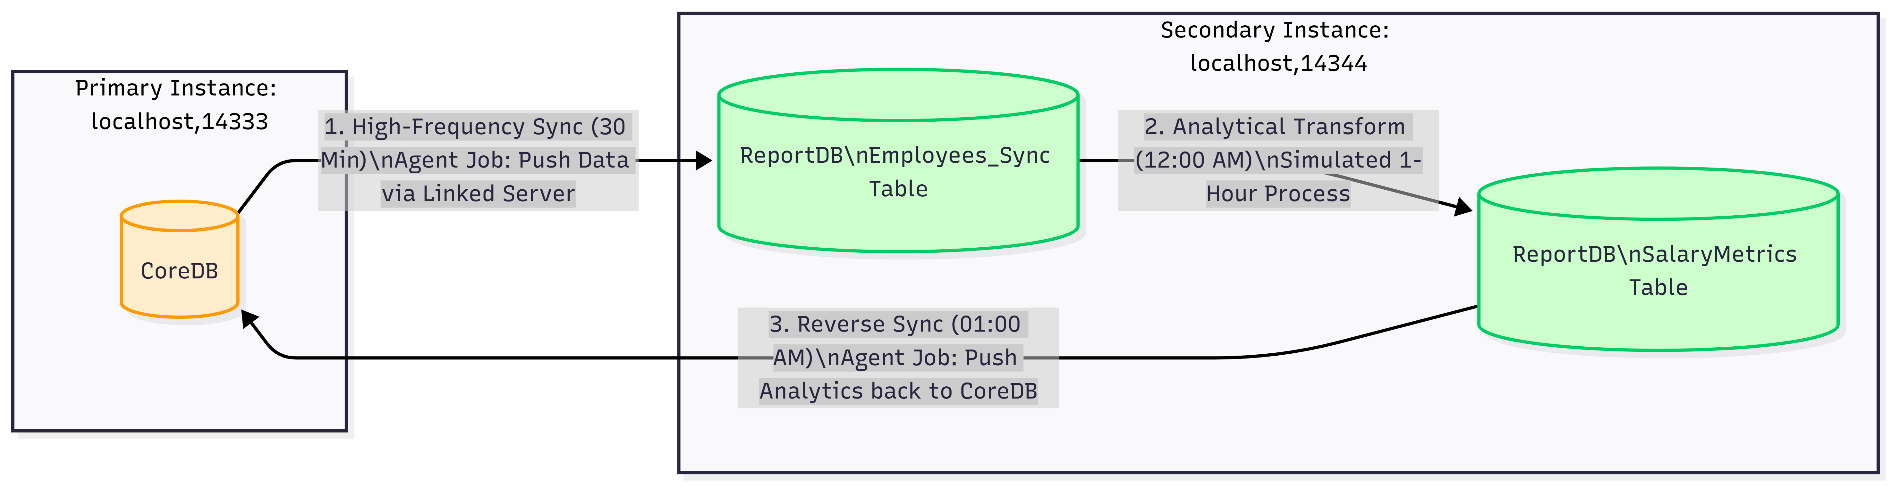
Fig 5.2: Replication Architecture Diagram mapping the bi-directional data flow.

6. Resource Governance & Session Tracking
Resource Governor was deployed on the Secondary Node to prevent analytical reporting queries from consuming excessive system resources. A dedicated Resource Pool and Workload Group were instantiated to strictly cap CPU and Memory utilization at 20% for the designated "deploy_user". A classifier function evaluates the login and dynamically enforces these limits during the operational window.
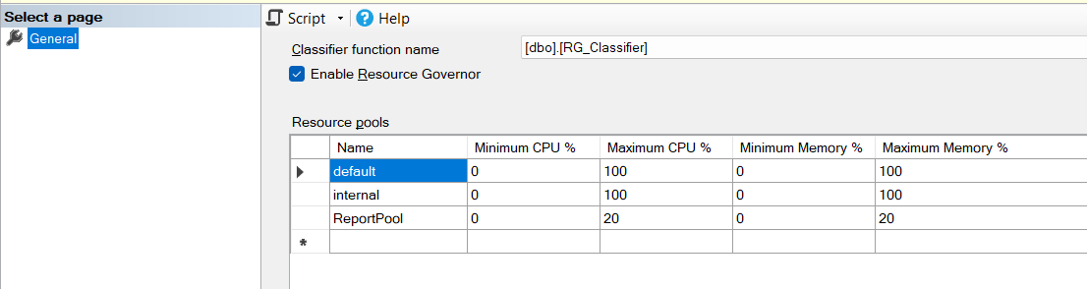
Fig 6.1: Resource Governor configuration showing the limits applied to the ReportPool and DeployGroup.

7. Advanced Monitoring, Alerting & Backup Audit
Proactive monitoring infrastructure was configured utilizing Database Mail connected securely via a Brevo SMTP relay. SQL Server Agent Alerts were established to automatically notify the DBA Team distribution list upon detecting Deadlocks or Blocked Processes. Blocked processes are tracked via Extended Events configured with a strict 5-second latency threshold. Furthermore, a custom stored procedure was developed to audit the operational status (Success/Failure) of all backup jobs into a centralized log table.
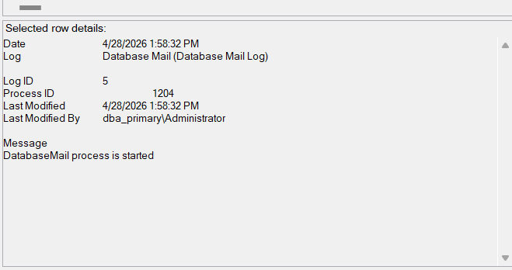
Fig 7.1: Database Mail Log confirming successful SMTP transmission capabilities.

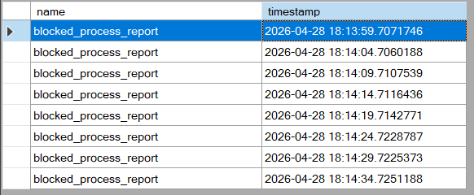
Fig 7.2: Extended Events Live Data viewer capturing a simulated blocked process.

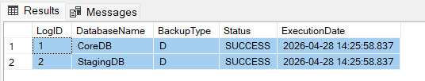
Fig 7.3: The BACKUP_AUDIT_LOG table displaying successfully tracked backup operations.

8. Security, Auditing & Encryption
A defense-in-depth security posture was enforced across the architecture. An automated self-healing script verified that all user databases are strictly owned by the "sa" principal. To achieve compliance, granular SQL Server Audits were enabled to trace and permanently log all SELECT operations executed against the sensitive HR.Employees table. Data-at-rest protection was implemented by encrypting the Salary column utilizing Symmetric Keys and Certificates. Finally, a comprehensive privilege report was generated to audit server-level and database-level roles.
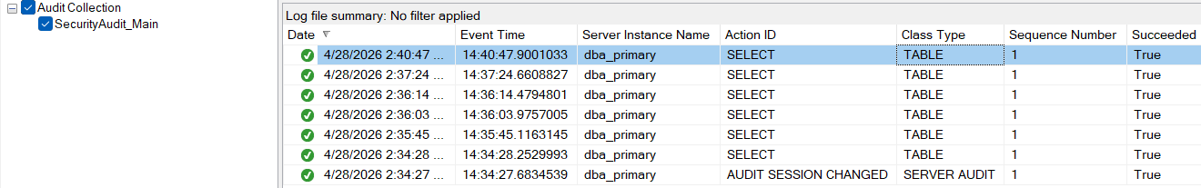
Fig 8.1: SQL Server Audit Logs capturing a SELECT query against the HR schema.

Fig 8.2: Query results demonstrating the Symmetric Key encryption of the Salary column (Ciphertext).

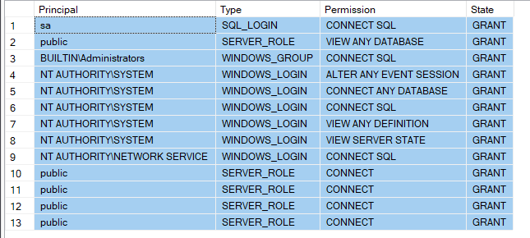
Fig 8.3: Output of the Comprehensive Security and Privilege Audit script.

