**Assignment 4 – Advanced Design Patterns by Umme Athiya**

**PART A: - CoR Pattern**

**(Part A: - Screenshot 1.1)**

**(Part A: - Screenshot 1.2)**

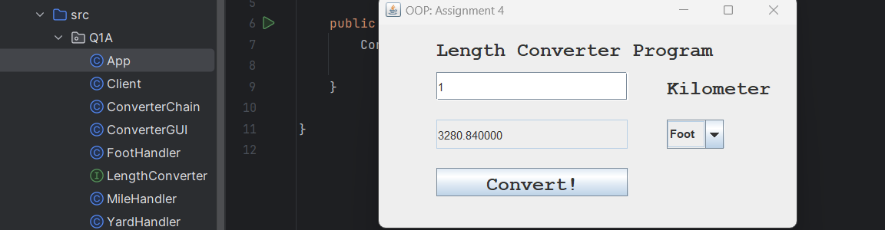

**(Part A: - Screenshot 1.3)**

**(Part A: - Screenshot 1.4) – “Input taken as String”.**

**(Part A: - Screenshot 1.5) – “Null input is specified”.**

**(Part A: - Screenshot 1.6) – “Negative value input is specified”.**

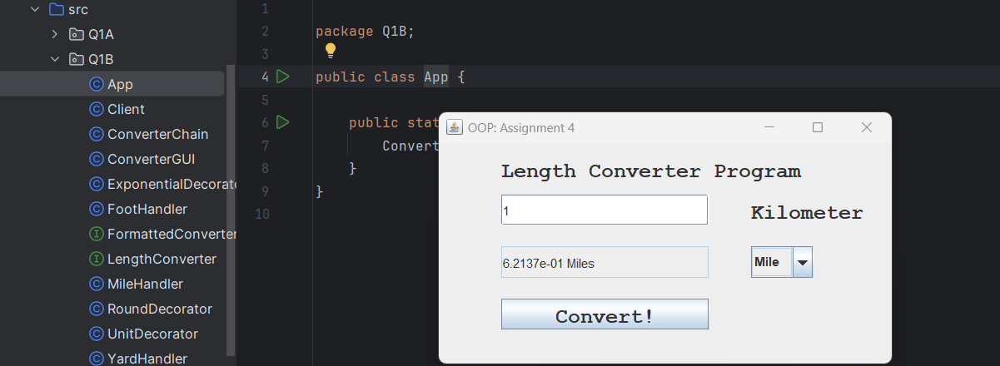**PART B: - Decorator Pattern**

**(Part B: - Screenshot 2.1)**

**(Part B: - Screenshot 2.2)**

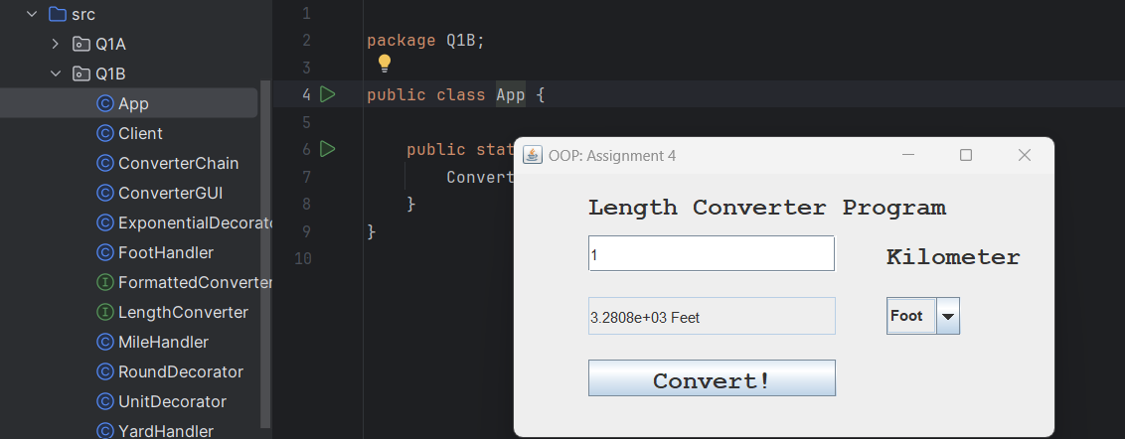

**(Part B: - Screenshot 2.3)**

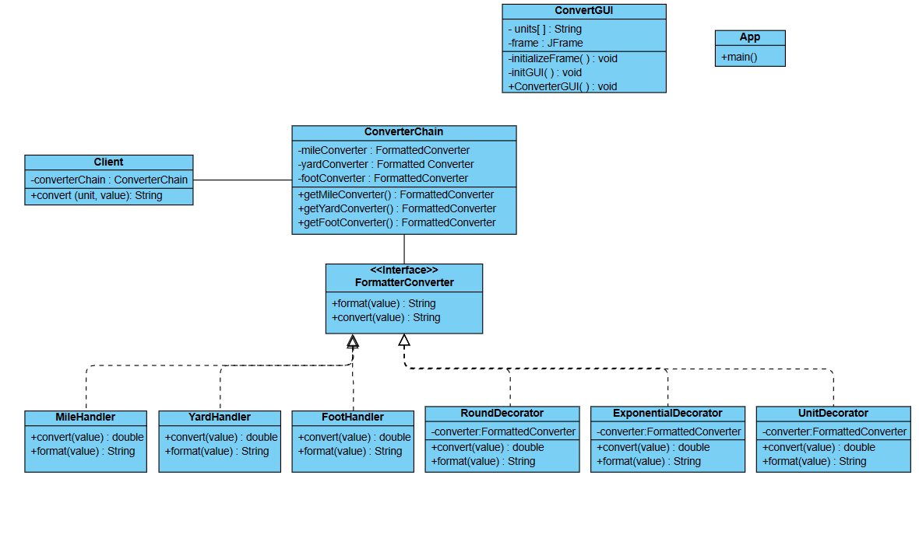**UML Diagram**