A comparative analysis of design patterns for concurrent and parallel programming in object-oriented programming.

Umme AthiyaCollege of Digital Media & Computing  
DePaul University  
 Chicago, Illinois, USA  
 uummeath@depaul.edu

ABSTRACT

A comparative analysis of design patterns is presented in this paper within the context of object-oriented programming (OOP). Understanding the nuances of design patterns is essential for developing scalable, responsive, and efficient software systems as multicore processors and distributed architectures become more prevalent. The study examines design patterns commonly used in concurrent and parallel programming, exploring their strengths, weaknesses, and suitability within an object-oriented paradigm. In our comprehensive review, we illustrate how patterns such as Singleton, Factory Method, Observer, and Active Object can be adapted or extended to address concurrent and parallel challenges. As a result of this analysis, insights into the pragmatic application of these design patterns in real-world scenarios are provided, including modularity, scalability, and synchronization. Ultimately, this comparative analysis aims to help practitioners develop robust, high-performance software by selecting appropriate design patterns for concurrent and parallel programming in object-oriented systems.

CCS CONCEPTS  
• Software and its engineering - Object-oriented programming.   
• Software and its engineering - Concurrency control.  
• Software and its engineering - Parallel programming.  
• Software and its engineering - Design patterns.  
• General and reference - Comparative evaluation.

KEYWORDS

Concurrent Programming, Parallel Programming, Object-Oriented Programming, Design Patterns, Comparative Analysis, Software Engineering, Multi-Core Processors, Distributed Systems, Scalability, Modularity.

1 Introduction

In today’s changing world of software development, it has become increasingly important to use concurrent and parallel programming. This is especially true, with the use of core processors and the growing popularity of distributed computing systems. Object oriented programming (OOP) is an approach in software engineering. Greatly influences the architecture and design of modern applications. In this context it is crucial to explore and compare design patterns that are specifically designed for parallel programming within an object-oriented paradigm.

This paper provides an analysis of design patterns that are specifically tailored to address the challenges faced in parallel programming within an object-oriented environment. As software systems strive to meet the needs for scalability, responsiveness and efficient resource utilization selecting and adapting design patterns becomes vital. Through an approach we aim to provide insights into the strengths and weaknesses of design patterns, like Singleton, Factory Method, Observer and Active Object when applied to parallel programming.

The investigation involves considering aspects such, as modularity, scalability, synchronization, and other important factors that affect the use of these design patterns. By shedding light on the ways in which these patterns are adjusted or expanded upon this analysis aims to provide insights for professionals navigating the complex world of concurrent and parallel programming, in object-oriented software design. As we embark on this exploration our goal is to contribute to the understanding of how design patterns can be utilized to tackle the challenges and complexities presented by parallel programming.

1.1 Role of Design Patterns

Design patterns are tools when it comes to developing concurrent and parallel systems within the object-oriented paradigm. They play a role, in promoting modularity addressing synchronization challenges supporting scalability fostering flexibility and optimizing resource utilization. By utilizing design patterns developers can navigate the complexities of parallel programming and contribute to the creation of software solutions that are robust, responsive, and scalable.

* + 1. Modularity and Abstraction: -

Design patterns greatly enhance the modularity by encapsulating concurrent and parallel concerns into well defined components. They promote abstraction by allowing developers to isolate and manage the intricacies of parallelism within modules.

1.1.2 Concurrency Control and Synchronization: -

Design patterns such as Singleton and Observer play a vital role in tackling concurrency control and synchronization challenges. The singleton pattern ensures a point of control reducing contention issues while the Observer pattern facilitates communication minimizing the need for explicit synchronization.

**1.1.3 Scalability and Adaptability: -**

Design patterns like Factory Method and Active Object are instrumental in achieving scalability. The Factory Method enables creation of instances that can adapt to varying workloads, in parallel environments.

**1.1.4 Optimizing Resource Utilization: -**

The careful application of design patterns, in programming, like the Active Object pattern helps optimize resource usage. By handling tasks this pattern ensures efficient allocation of resources avoiding conflicts and improving the overall performance of the systems.

1.2 Design Patterns in Concurrent Programming

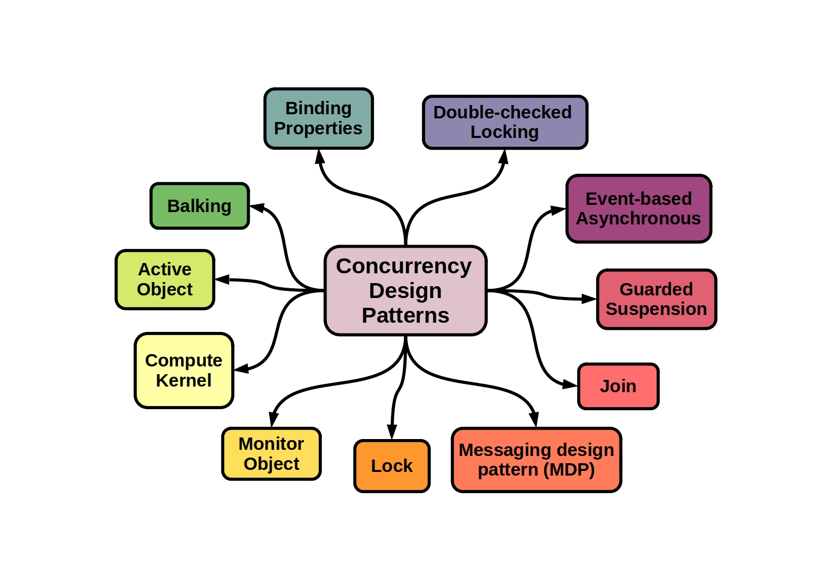Concurrent Programming involves handling the execution of tasks which presents unique challenges such as race conditions, deadlocks, and resource contention. Design patterns offer proven solutions to these challenges providing an approach to developing systems that are scalable, responsive, and maintainable. In the realm of concurrency programming there are design patterns that address issues and contribute to the creation of robust and efficient software.

**Figure 1.2a: - Design patterns in Concurrent Programming**

**associated with object-oriented programming concepts.**

**Figure 1.2b: - Concurrent Programming workflow execution.**

* + 1. Singleton Pattern: -

The main purpose of the Singleton Pattern is it ensures that a class has one instance and provides a point of access to it. It basically prevents the creation of instances in a threaded environment by addressing concerns related to shared resources and ensuring a single point of control.

* + 1. Observer Pattern: -

The main purpose of the Observer Pattern is it defines one to many dependencies between objects so that when one object changes state all its dependents are notified and updated automatically. It basically facilitates communication between components by decoupling event sources and observers. It is valuable for handling events without introducing coupling.

* + 1. Producer Consumer Pattern: -

The main purpose of the Producer Consumer pattern is it coordinates the activities of two types of objects. One that produces data and another that consumes it. It basically enables communication and coordination, between threads engaged in generating and utilizing data guaranteeing operation of the system without any inconsistencies in the data.

1.3 Design Patterns in Parallel Programming

When it comes to parallel programming, which involves executing tasks simultaneously to enhance performance and efficiency there are challenges that arise in terms of coordination, synchronization, and load balancing. To address these challenges developers, rely on design patterns that provide solutions. These design patterns help create efficient and maintainable parallel systems. In the realm of programming, design patterns tackle common issues and contribute to the development of robust and high-performance software.

**Figure 1.3a: - Parallel Programming workflow execution.**

**1.3.1 MapReduce Pattern: -**

The MapReduce pattern breaks down a task into subtasks processes them independently in parallel and then combines the results. Thus, it basically allows for the processing of datasets by distributing tasks across multiple processing units. This pattern is particularly effective for data applications.

**1.3.2 Master Worker Pattern: -**

The Master Worker pattern divides a task into subtasks. Assigns them to multiple worker processes that are coordinated by a master process. Thus, it basically facilitates task parallelization by distributing the workload across processing units. This approach improves resource utilization and simplifies the orchestration of computations.

**1.3.3 Pipeline Pattern: -**

The Pipeline pattern involves chaining a series of processing stages where each stage performs an operation on data before passing it along, to the next stage. The role of programming is to facilitate the division of a task into separate stages that can be executed independently. By doing it allows for processing improving overall efficiency and productivity.

1.4 Comparative Analysis

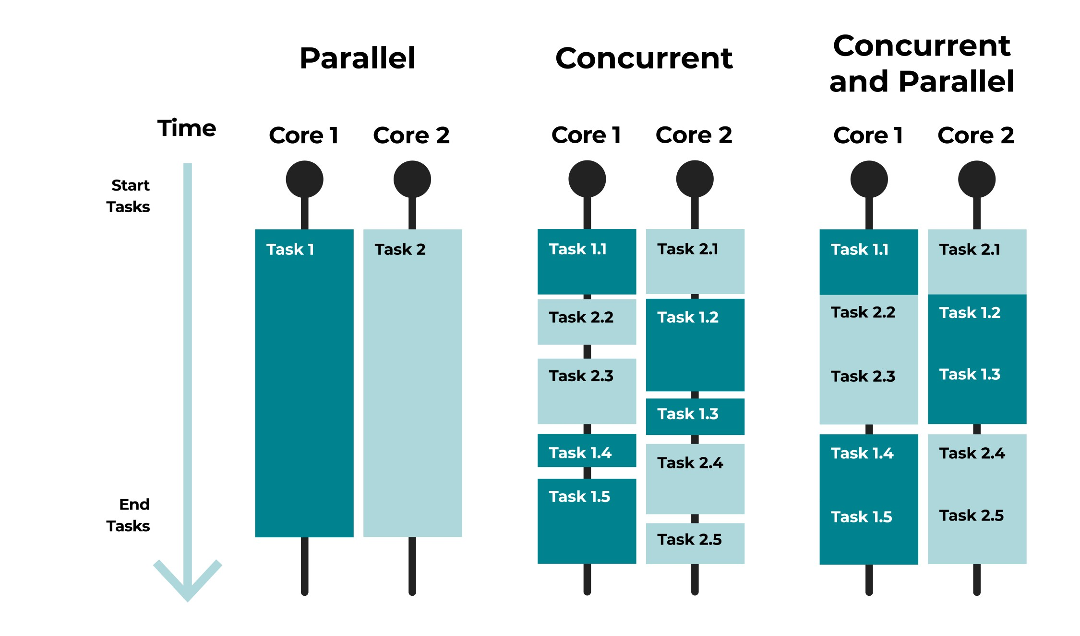Concurrent and parallel programming both aim to enhance system performance by executing tasks. However, these two programming paradigms present challenges, which require design patterns. In this analysis we will delve into. Compare the design patterns used in parallel programming to gain a better understanding.

**Figure 1.4a: - Parallel Programming workflow execution.**

A few commonalities noticed here are as follows: -

**1.4.1 Observer Pattern: -**

In Concurrent Programming, the Observer Pattern enables communication, between components reducing coupling. While in Parallel Programming, the Observer Pattern promotes modularity by decoupling event sources and observers allowing for parallel event handling.

**1.4.2 Singleton Pattern: -**

In Concurrent Programming, the Singleton Pattern ensures a point of control to address shared resource contention issues. While in Parallel Programming the Singleton Pattern supports control to prevent instances and ensure consistency across parallel tasks.

There are quite a few divergences as follows: -

**1.4.3 Object Pattern: -**

In Concurrent Programming, the Active Object Pattern manages tasks independently to prevent blocking and facilitate concurrent execution.While in Parallel Programming, the Active Object Pattern enables the parallelization of tasks maximizing resource utilization in environments.

**1.4.4 MapReduce Pattern: -**

In Concurrent Programming the MapReduce pattern is less applicable due to its focus on distributed data processing in environments. While in Parallel Programming the MapReduce pattern divides tasks into subtasks. Processes them independently in parallel. This approach is particularly effective for data applications.

**1.4.5 Synchronization Mechanisms: -**

In Concurrent Programming, the Checked Locking pattern reduces lock acquisition costs by testing locking criteria before acquiring locks.While in Parallel Programming this pattern is often used in scenarios where acquiring locks may introduce overhead. It ensures execution, in threaded environments.

1.5 Modern Software Development

Modern software development relies heavily on parallel programming to achieve performance, scalability, and responsiveness. To tackle the challenges and opportunities presented by parallel programming, software development practices incorporate various methodologies, tools, and design principles. Here's an overview of the elements that define software development in this context.

**1.5.1 Embracing Concurrency and Parallelism: -**

In threading models, the modern software designs utilize threading models to enable execution. Multithreading is an adopted approach that allows tasks to run concurrently within a process.

Async/Await and Concurrency Libraries, asynchronous programming paradigms, like the async/await syntax in languages such as Python, JavaScript and C# have gained significant popularity. Concurrency libraries like Javas completable future or Pythons asyncio simplify the management of tasks.

Parallel Processing Frameworks, where developers leverage frameworks like Apache Hadoop, Apache Spark or CUDA (Compute Unified Device Architecture) to design systems that distribute tasks across processing units, for parallelism. By incorporating these aspects into their development practices modern software developers can effectively harness the potential of parallel programming.

**1.5.2 Using Concurrency Design Patterns: -**

In software development there is a focus, on utilizing design patterns that are specifically designed for concurrent programming. These patterns include the Active Object pattern, which enables task handling and the Immutable Object pattern, which ensures thread safety.

**1.5.3 Incorporating Parallel Design Patterns: -**

Parallel programming greatly benefits from incorporating design patterns such as MapReduce, Master Worker and Fork Join. These patterns provide solutions, for distributing, coordinating and combining tasks.

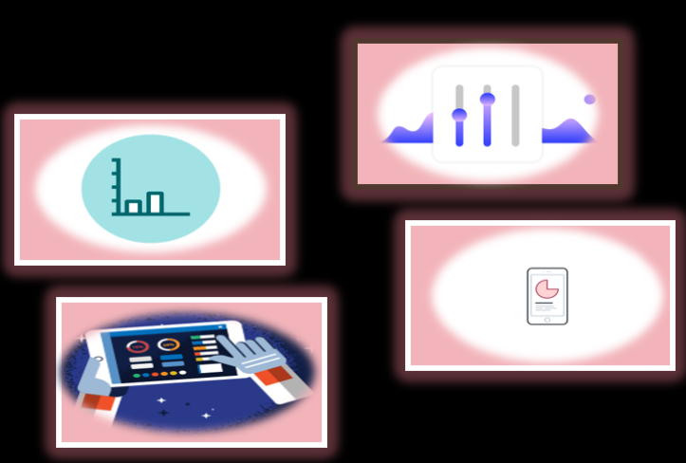

ACKNOWLEDGMENTS

Insert paragraph text here. Insert paragraph text here. Insert paragraph text here. Insert paragraph text here. Insert paragraph text here. Insert paragraph text here. Insert paragraph text here. Insert paragraph text here. Insert paragraph text here. Insert paragraph text here. Insert paragraph text here.

REFERENCES

[1] Patricia S. Abril and Robert Plant, 2007. The patent holder's dilemma: Buy, sell, or troll? *Commun. ACM* 50, 1 (Jan, 2007), 36-44. DOI: <https://doi.org/>10.1145/1188913.1188915.

[2] Sten Andler. 1979. Predicate path expressions. In *Proceedings of the 6th. ACM SIGACT-SIGPLAN Symposium on Principles of Programming Languages (POPL '79)*. ACM Press, New York, NY, 226-236. DOI:https://doi.org/10.1145/567752.567774

[3] Ian Editor (Ed.). 2007. *The title of book one* (1st. ed.). The name of the series one, Vol. 9. University of Chicago Press, Chicago. DOI:https://doi.org/10.1007/3-540-09237-4.

[4] David Kosiur. 2001. *Understanding Policy-Based Networking* (2nd. ed.). Wiley, New York, NY..

Conference Name:ACM Woodstock conference

Conference Short Name:WOODSTOCK’18

Conference Location:El Paso, Texas USA

ISBN:978-1-4503-0000-0/18/06

Year:2018

Date:June

Copyright Year:2018

Copyright Statement:rightsretained

DOI:10.1145/1234567890

RRH: F. Surname et al.

Price:$15.00