Pre-quiz Name

What kinds of variables are you interested in sensing?

What is this? 

What programming experience do you have?

Have you ever worked with microcontrollers before?

Can you draw a Bode plot for a bandpass filter with corner frequencies at 100 Hz and 1 kHz? If so, please do. If not, do you have any idea what this might be?

Are you familiar with the IP or NEMA rating systems? If so, what is meant by IP 68 or NEMA 4X, and are they roughly the same?

Do you know how an LED works, and if so, can you describe it briefly?

Please label the electronic components in this diagram and, if you know what this circuit does, please say what that is.

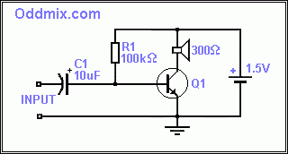

**Don’t Panic!**