**Performing Second Level Analyses with the RandomEffects_central batch script**

The RandomEffects_central script works in a different fashion than the FirstLevel script. You should never need to modify the RandomEffects_central script itself. Instead, there are 3 other files (or 2 files and 1 variable) that need to be created to tell the RandomEffects_central script what analyses to run.

The first file is an options file. This file will be a text file with the .m (matlab script) extension. The contents of the file should be as follows:

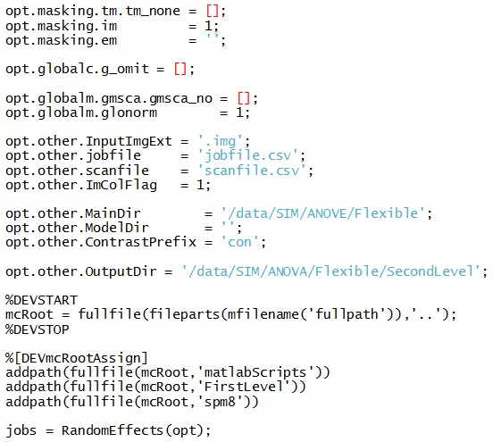

These settings are explained below:

**Masking:** These settings define any implicit, explicit, or threshold masks to apply to the data.

**.im** should either be a 1 or a 0 depending on whether you want implicit masking or not.

**.em** should be blank for no explicit mask, or contain the path and filename of the mask to use

**.tm** is a bit more complicated:

**.tm.tm_none** = [] means no threshold masking

**.tm.tma.athresh** = N sets an absolute threshold mask equal to N

**.tm.tmr.rthresh** = N set a relative threshold mask equal to N (N should be between 0 and 1 and represents a percent value)

**Global Calculation:** This controls global calculation options – this should be set to global.g_omit = [] for fMRI data.

**Global Normalization:**  These settings control the global normalization of your analyses.

**.globalm.glonorm** sets whether you want to use no (1) or proportional (2) global normalization.

**.globalm.gmsca** sets grand mean scaling options

**.globalm.gmsca.gmsca_no** = [] uses no grand mean scaling

**.globalm.gmsca.gmsca_yes.gmscv** = N sets grand mean value to N

**other.InputImgExt** – extension for images to be processed; either ‘.img’ or ‘.nii’

**other.jobfile** – set to the filename of the jobfile (described below)

**other.scanfile** – set to the filename of the scanfile (described below)

**other.ImColFlag** – This setting controls how the ImCol column in the jobfile is interpreted. When set to 1, ImCol refers to the actual image numbers. When set to 0, ImCol refers to the column in the scanfile that holds the image number.

**other.MainDir** – set to the location of the subjects’ First Level analysis folders

**other.ModelDir** – set to the name of the model folder (within each subject) to grab images from

**other.ContrastPrefix** – set to the filename prefix of images to use (typically ‘con’)

**other.OutputDir** – set to the destination for the second level results

The other lines in the options file should not be edited.

The jobfile and scanfile work together to fully specify each analysis to run. The scanfile contains information about subjects (1 per line) and the jobfile contains information about second level models (1 per line).

Scanfile (ImColFlag = 0):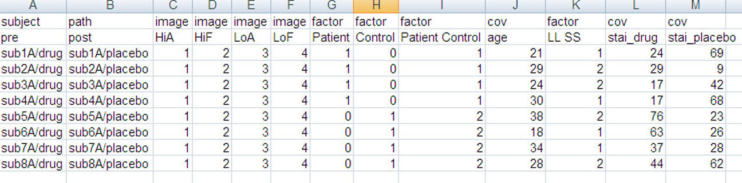

Jobfile (ImColFlag = 0):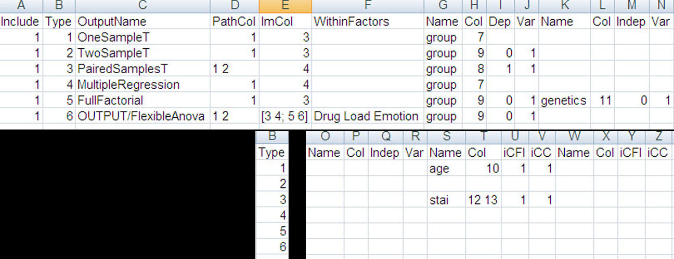

In each case, the first row contains column headers which should reflect the data contained in that column. The columns for the scanfile can appear in any order, but the order (and presence) of columns in the jobfile must not change from the template.

The contents of the second row in the scanfile allow you to set descriptive titles for the information contained in that column. In many cases this information is used to label the information in your analysis (i.e. factor names from a Two-Sample T-test are used to name the contrasts, or if OutputName is left blank or ends with a slash in your jobfile, the output folder will be named based on the path, image, and factor column headers).

Each subsequent row in the scanfile represents a single subject. A path (or subject) column should contain the folder name for that subject (existing within other.MainDir from the options file). An image column should contain the number of a contrast image. A factor column will depend on which test you’re using it for. For a One-sample or Paired T-test, Multiple Regression, a factor column should contain only 0’s and 1’s. Zeros will be subjects that are not included in that analysis, and 1’s will be included. For a Two-sample T-test it should contain only 0’s, 1’s, and 2’s. Again, 0’s are not included, 1’s are the first group, and 2’s the second group. For a Full or Flexible Factorial design it should contain 0’s, and then 1-N (where N is the number of levels of your between-group factor). A cov column should contain the values for a single covariate that you may wish to include.

Each row in the jobfile represents a single second-level test. The columns are as follows:

**Include:** 0 or 1, whether to run the test or not

**Type:** 1-6

1: One Sample T-test

2: Two Sample T-test

3: Paired Samples T-test

4: Multiple Regression

5: Full Factorial Design (no within-subject factors)

6: Flexible Factorial Design (repeated measures ANOVA)

**OutputName:** The name of the folder to place the test in (created inside other.OutputDir from the options file). If this is left blank, or ends with a slash, the folder will be created as the combination of the headers from the scanfile based on analysis typeas follows:

1: PathColumn_FactorColumn_ImageColumn (_Cov1_Cov2… if any covariates)

2: PathColumn_Grp1vGrp2_ImageColumn (cov if any)

3: Path1vPath2_FactorColumn_ImageColumn (cov if any)

OR

PathColumn_FactorColumn_Image1vImage2 (cov if any)

4: PathColumn_FactorColumn_ImageColumn (covariates)

5: ‘Full_’PathColumn_Factor1xFactor2xFactor3_ImageColumn (cov if any)

6: ‘Flex_’ FactorNamexWithinnames

**PathCol:** The column number from the scanfile that contains the subject folders for this test

**ImCol:** The column number from the scanfile that contains the contrast number for this test

NOTE: For a Paired Samples T-test either the PathCol or the ImCol should contain 2 numbers, so the pairs will be grabbed either from 2 different subject folders (typically) or 2 different contrast images within the same folder. For a Flexible Factorial design, the PathCol AND ImCol can contain multiple values. This allows for the creation of up to 4 different within-subject factors with any number of levels for each. The example jobfile above includes 3 within-subject factors: 2 levels for PathCol, followed by a 2-dimensional array which creates 2 factors within ImCol. The first row (3 4) is the first level of the second within-subject factor, and the second row (5 6) is the second level. This means that the first column (3 and 5) is the first level of the third within-subject factor, and the second column (4 and 6) is the second level.

NOTE: A two-dimensional array is created here by entering each row, and separating rows with semi-colons. So a 2x2 array would be 1 2;3 4. And a 3x4 array would be entered as 1 2 3 4; 5 6 7 8; 9 10 11 12. This would correspond to a factor with 3 levels, followed by a factor with 4 levels.

NOTE: This column is not needed when opt.other.ImColFlag = 1.

**WithinFactors:** Only used for Flexible Factorial designs. There should be N names in this field where N is the number of within-subject factors you have. The order of the names is PathCol rows, PathCol columns, ImCol rows, ImCol columns.

The next 4 columns represent a single between-subject factor (or simply a grouping variable for tests without any between-subject factors). These 4 columns are repeated 3 times to allow for the creation of up to 3 between-subject factors in a Full Factorial design.

**Name:** The name of the factor

**Col:** the column number from the scanfile that contains the levels for this factor

**Dep:** Is this factor Independent (0) or Dependent (1); column is OPTIONAL, defaults to (0)

**Var:** Does this factor have Equal (0) or Unequal (1) variance; column is OPTIONAL, defulats to (1)

After the 3 sets of factor columns, are sets of 4 columns for regressors. There can be as many sets of these 4 columns as you need to include an arbitrary number of regressors, but each set must have all 4 columns.

**Name:** The name of the covariate

**Col:** The column number from the scanfile that contains the values for the covariate

**iCFI:** Interactions to create between the covariate and your factors. Instead of 1 additional column, this will create N columns in your design matrix (where N is the number of levels of the factor you create the interactions with). Currently, contrasts are not generated for covariate interactions; column is OPTIONAL, defaults to 1

1: No interactions (typical)

2: Interaction with Factor 1

3: Interaction with Factor 2

4: Interaction with Factor 3

**iCC:**  Centering to perform on the covariate. Column is OPTIONAL, defaults to 1

1: Overall mean (typical)

2: Factor 1 mean

3: Factor 2 mean

4: Factor 3 mean

5: No mean centering

The scan and job file below demonstrate what happens when ImColFlag is set to 1. This example produces the same output as the previous one. Notice the scan file no longer requires image columns. Also, the ImCol column in the jobfile directly specifies what image numbers to use. These image numbers should correspond to those in the previous example.

Scanfile (ImColFlag = 1):

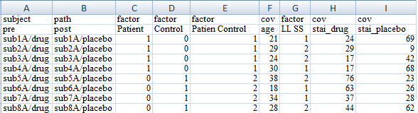

Jobfile (ImColFlag = 1):

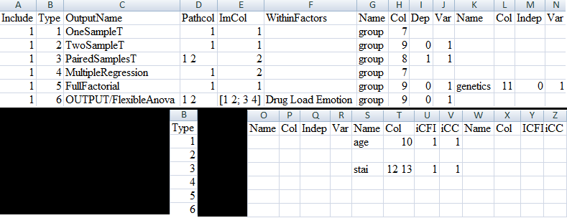

In order to run the RandomEffects_central script, start Matlab and make sure you’re in the same directory as your options file and then call the script as follows:

RandomEffects_central(‘re_options’)

Where ‘re_options’ is the name of your options file. Alternatively, you can also create a variable that contains all the information that should be in the options file as follows:

options.masking.tm.tm_none = [];

options.masking.im = 1;

options.masking.em = '';

options.globalc.g_omit = [];

options.globalm.gmsca.gmsca_no = [];

options.globalm.glonorm = 1;

options.other.jobfile = 'jobfile.csv';

options.other.scanfile = 'scanfile.csv';

options.other.MainDir = '/data/SIM/ANOVA/Flexible';

options.other.ModelDir = '';

options.other.ContrastPrefix = 'con';

options.other.OutputDir = '/data/SIM/ANOVA/Flexible/SecondLevel';

And then call RandomEffects_central like this:

RandomEffects_central(options)