Methods Core: Second Level Documentation

Table of Contents

Introduction

Basic

SecondLevel_mc_template

Job-Scan File Relationship

Scan file

Job file

Advanced

SecondLevel_mc_template

Scan file

Job file

Editing with OpenOffice

Performing a batch

Introduction

The following documentation explains how to use MethodsCore batch system for second level analysis with SPM8. The batch system consists of four files: a central Matlab script and three user specified files. SecondLevel_mc_central.m is the central Matlab script where the batch job is built for SPM8 and is referred as the central file. It should NEVER be edited. SecondLevel_mc_template.m is a template M-file and will be referred as the template file. The variable values within the template file can be edited by the user. These options are used in the central file to help build the batch job for SPM8. The jobfile.csv and scanfile.csv are comma delimited files. You should ALWAYS use Excel to edit these CSV files (if you insist on using OpenOffice, then see Advanced). These files work together to fully specify each analysis run. Explanation of the user specified files for the MethodsCore second level batch is split into basic and advanced. The basic section describes the required options to fill in the three user specified files. The advanced section describes in further detail optional parameters and how they affect the batch system.

Basic

SecondLevel_mc_template.m

SecondLevel_mc_template.m is an options file. The basic options for the template file are displayed in the below frame. The options are edited by changing the variable values. Each variable is heavily commented in the template file to explain its purpose.

%%%%%%%%%% Basic %%%%%%%%%%

%%%%%%%%%%%%%%%%%%%%%%%%%%%%%%%%%%%%%%%%%%%%%%%%%%%%%%%%%%%%%%%%%%%%%%

%%% The file extension for the input images. Either ‘.img’ or ‘.nii’

%%%%%%%%%%%%%%%%%%%%%%%%%%%%%%%%%%%%%%%%%%%%%%%%%%%%%%%%%%%%%%%%%%%%%%

opt.other.InputImgExt = '.img';

%%%%%%%%%%%%%%%%%%%%%%%%%%%%%%%%%%%%%%%%%%%%%%%%%%%%%%%%%%%%%%%%%%%%%%

%%% The file name of the job file. The full path to the job file is %%% needed if the template and job file are in different directories.

%%%%%%%%%%%%%%%%%%%%%%%%%%%%%%%%%%%%%%%%%%%%%%%%%%%%%%%%%%%%%%%%%%%%%%

opt.other.jobfile = 'jobfile.csv';

%%%%%%%%%%%%%%%%%%%%%%%%%%%%%%%%%%%%%%%%%%%%%%%%%%%%%%%%%%%%%%%%%%%%%%

%%% The file name of the scan file. The full path to the scan file is %%% needed if the template and scan file are in different directories.

%%%%%%%%%%%%%%%%%%%%%%%%%%%%%%%%%%%%%%%%%%%%%%%%%%%%%%%%%%%%%%%%%%%%%%

opt.other.scanfile = 'scanfile.csv';

%%%%%%%%%%%%%%%%%%%%%%%%%%%%%%%%%%%%%%%%%%%%%%%%%%%%%%%%%%%%%%%%%%%%%%

%%% The location to the subjects’ first level analysis folders

%%%%%%%%%%%%%%%%%%%%%%%%%%%%%%%%%%%%%%%%%%%%%%%%%%%%%%%%%%%%%%%%%%%%%%

opt.other.MainDir = '/data/SIM/ANOVE/Flexible';

%%%%%%%%%%%%%%%%%%%%%%%%%%%%%%%%%%%%%%%%%%%%%%%%%%%%%%%%%%%%%%%%%%%%%%

%%% The model directory within each subject to find images

%%%%%%%%%%%%%%%%%%%%%%%%%%%%%%%%%%%%%%%%%%%%%%%%%%%%%%%%%%%%%%%%%%%%%%

opt.other.ModelDir = {''};

%%%%%%%%%%%%%%%%%%%%%%%%%%%%%%%%%%%%%%%%%%%%%%%%%%%%%%%%%%%%%%%%%%%%%%

%%% The file name prefix for the images to use, which is typically

%%% ‘con’

%%%%%%%%%%%%%%%%%%%%%%%%%%%%%%%%%%%%%%%%%%%%%%%%%%%%%%%%%%%%%%%%%%%%%%

opt.other.ContrastPrefix = 'con';

%%%%%%%%%%%%%%%%%%%%%%%%%%%%%%%%%%%%%%%%%%%%%%%%%%%%%%%%%%%%%%%%%%%%%%

%%% The directory where to output the results

%%%%%%%%%%%%%%%%%%%%%%%%%%%%%%%%%%%%%%%%%%%%%%%%%%%%%%%%%%%%%%%%%%%%%%

opt.other.OutputDir = '/data/SIM/ANOVA/Flexible/SecondLevel';

The whole path to the images to use in second level analysis is built by concatenating the following variables: /[MainDir]/[Subject]/[ModelDir]/[ContrastPrefix]. Here MainDir, ModelDir, and ContrastPrefix are specified in the template file.

Job-Scan File Relationship

The job file and scan file work together to fully specify each analysis job. The scan file is an inventory of subjects and their corresponding values for an analysis. The job file is a set of instructions that specifies how an analysis is run. The instructions declare what items to include from the scan file in an analysis. This job-scan file relationship is used to build second level second level batch jobs for SPM8. The scan file and job file will now be described in further detail.

Scan file

For the basic tutorial, the scan file assumes the ImColFlag variable in the template file is set equal to the default value which is ‘1’. The scan file works with the job file to fully specify each analysis run. An example scan file is in figure 1. The first two rows in the scan file are the header. The headers can appear in any order and multiple times throughout the scan file. The first row specifies what data is stored in the column. The second row is a user-specified description for the column. Each of the remaining rows represents one subject in an analysis.

When using a basic setup, only four data labels should be used in the first row: **subject**, **path**, **factor**, or **cov**. A **subject** or **path** column lists the subjects in each row for the second level analyses. The **factor** column sets the group for the subject in the second level analyses. Certain values are allowed in a factor column depending on the analysis. For a one-sample or paired t-test and multiple regression, a factor column is allowed to only have value of 0’s or 1’s. Zeros are subjects that are not included in the analysis while 1’s are included. In a two sample t-test, the factor column is allowed to contain only 0’s, 1’s, and 2’s. Zero values are not included in the analysis, 1’s are included in the first group, and 2’s are included in the second group. For a full or flexible factorial design it should contain 0’s and 1-N where N is the number of levels of between-group factor. Table 1 summarizes the allowed factor values for all tests. A **cov** column should contain the values for a single covariate.

**Table 1. Allowed Factor Values**



**Figure 1. A basic example of a scan file.**



**Figure 2. A basic example of a job file.**

Job file

For the basic tutorial, the job file assumes the ImColFlag variable in the template file is set equal to the default value which is ‘1’. The job file works with the scan file to fully specify each analysis run. Figure 2 shows an example job file. The first row in the job file is the header. For a basic analysis, the headers must follow the same order as in figure 2. Each subsequent row lists one type of analysis to perform and can be thought of as a set of instructions. Each column of the job file is now described in further detail:

**Include**: 0 or 1, whether to run the test or not

**Type**: 1-6

1 : One Sample T-test

2 : Two Sample T-test

3 : Paired Samples T-test

4 : Multiple Regression

5 : Full Factorial Design (no withing-subject factors)

6 : Flexible Factorial Design (repeated measure ANOVA)

**OutputName**: The name of the folder to place the test in (created inside other.OutputDir from the options file). If this is left blank, or ends with a slash, the folder will be created as the combination of the headers from the scan file based on analysis type as follows:

1 : PathColumn_FactorColumn_ImageColumn (_Cov1_Cov2…if any covariates)

2 : PathColumn_Grp1vGrp2_ImageColumn (cov if any)

3 : Path1vPath2_FactorColumn_ImageColumn (cov if any)

OR

PathColumn_FactorColumn_Image1vImage2 (cov if any)

4 : PathColumn_FactorColumn_ImageColumn (covariates)

5 : ‘Full_’PathColumn_Factor1xFactor2xFactor3_ImageColumn (cov if any)

6 : ‘Flex_’FactorNamexWithingnames

**PathCol**: The column number from the scan file that contains the subject folders for this test

**ImCol**: The contrast number

NOTE: For a Paired Samples T-test either the PathCol or the ImCol should contain 2 numbers, so the pairs will be grabbed either from 2 different subject folders (typically) or 2 different contrast images within the same folder. For a Flexible Factorial design, the PathCol AND ImCol can contain multiple values. This allows for the creation of up to 4 different within-subject factors with any number of levels for each. The example jobfile in figure 2 includes 3 within-subject factors: 2 levels for PathCol, followed by a 2-dimensional array which creates 2 factors within ImCol. The first row (1 2) is the first level of the second within-subject factor, and the second row (3 4) is the second level. This means that the first column (1 and 3) is the first level of the third within-subject factor, and the second column (3 and 4) is the second level.

NOTE: A two-dimensional array is created here by entering each row, and separating rows with semi-colons. So a 2x2 array would be [1 2;3 4]. And a 3x4 array would be entered as [1 2 3 4; 5 6 7 8; 9 10 11 12]. This would correspond to a factor with 3 levels, followed by a factor with 4 levels.

**WithinFactors:** Only used for Flexible Factorial designs. There should be N names in this field where N is the number of within-subject factors present. The order of the names is PathCol rows, PathCol columns, ImCol rows, ImCol columns.

The next 2 columns represent a single between-subject factor (or simply a grouping variable for tests without any between-subject factors). These 2 columns are repeated 3 times to allow for the creation of up to 3 between-subject factors in a Full Factorial design.

**Name:** The name of the factor

**Col:** The column number from the scanfile that contains the levels for this factor

After the 3 sets of factor columns, are sets of 2 columns for regressors. There can be as many sets of these 2 columns each set, but each set must have both of the columns.

**Name:** The name of the covariate

**Col:** The column number from the scanfile that contains the values for the covariate

Advanced

The advanced section describes additional options avaible for the user specified files. The ImColFlag variable in the template file dictates how the job file and scan file are structured.

SecondLevel_mc_template.m

SecondLevel_mc_template.m is an options file. The advanced options for the template file are displayed in the below frame. The options are edited by changing the variable values. Each variable is heavily commented in the template file to explain its purpose.

%%%%%%%%%% Advanced %%%%%%%%%%

%%%%%%%%%%%%%%%%%%%%%%%%%%%%%%%%%%%%%%%%%%%%%%%%%%%%%%%%%%%%%%%%%%%%%%

%%% Masking option: Only one of these options can appear in a template %%% file.

%%%

%%% opt.masking.tm.tm_none = [] means no threshold masking

%%% opt.masking.tm.tma.athresh = N sets an absolute threshold mask %%% equal to N

%%% opt.masking.tm.tmr.rthresh = N set a relative threshold mask equal %%% to N (N should be between 0 and 1 and %%% represent a percent value)

%%%%%%%%%%%%%%%%%%%%%%%%%%%%%%%%%%%%%%%%%%%%%%%%%%%%%%%%%%%%%%%%%%%%%%

opt.masking.tm.tm_none = [];

OR

opt.masking.tm.tma.athresh = N;

OR

opt.masking.tm.tmr.rthresh = N;

%%%%%%%%%%%%%%%%%%%%%%%%%%%%%%%%%%%%%%%%%%%%%%%%%%%%%%%%%%%%%%%%%%%%%%

%%% The option to specify whether an implicit mask is used;

%%% 1 = use, 0 = do not use

%%%%%%%%%%%%%%%%%%%%%%%%%%%%%%%%%%%%%%%%%%%%%%%%%%%%%%%%%%%%%%%%%%%%%%

opt.masking.im = 0;

%%%%%%%%%%%%%%%%%%%%%%%%%%%%%%%%%%%%%%%%%%%%%%%%%%%%%%%%%%%%%%%%%%%%%%

%%% The file path to the implicit mask; Leave as an empty string if

%%% opt.masking.im = 0

%%%%%%%%%%%%%%%%%%%%%%%%%%%%%%%%%%%%%%%%%%%%%%%%%%%%%%%%%%%%%%%%%%%%%%

opt.masking.em = '';

%%%%%%%%%%%%%%%%%%%%%%%%%%%%%%%%%%%%%%%%%%%%%%%%%%%%%%%%%%%%%%%%%%%%%%

%%% The variable that controls global calculation. This should always %%% be set equal to [] for fMRI data

%%%%%%%%%%%%%%%%%%%%%%%%%%%%%%%%%%%%%%%%%%%%%%%%%%%%%%%%%%%%%%%%%%%%%%

opt.globalc.g_omit = [];

%%%%%%%%%%%%%%%%%%%%%%%%%%%%%%%%%%%%%%%%%%%%%%%%%%%%%%%%%%%%%%%%%%%%%%

%%% Global Normalization Option: Only one of these options can appear %%% in a template file.

%%%

%%% opt.globalm.gmsca.gmsca_no = [] uses no grand mean scaling

%%% opt.globalm.gmsca.gmsca_yes.gmscv = N sets grand mean value to N

%%%%%%%%%%%%%%%%%%%%%%%%%%%%%%%%%%%%%%%%%%%%%%%%%%%%%%%%%%%%%%%%%%%%%%

opt.globalm.gmsca.gmsca_no = [];

OR

opt.globalm.gmsca.gmsca_yes.gmscv = N;

%%%%%%%%%%%%%%%%%%%%%%%%%%%%%%%%%%%%%%%%%%%%%%%%%%%%%%%%%%%%%%%%%%%%%%

%%% Global Normalization Options: Sets whether to use no normalization %%% or proportional global normalization

%%% 1 = none, 2 = proportional global normalization

%%%%%%%%%%%%%%%%%%%%%%%%%%%%%%%%%%%%%%%%%%%%%%%%%%%%%%%%%%%%%%%%%%%%%%

opt.globalm.glonorm = 1;

%%%%%%%%%%%%%%%%%%%%%%%%%%%%%%%%%%%%%%%%%%%%%%%%%%%%%%%%%%%%%%%%%%%%%%

%%% ImColFlag controls how the ImCol column in the job file is

%%% interpreted. When set to 1, ImCol refers to the actual contrast %%% image numbers. When set to 0, ImCol refers to the column in the %%% scan file that holds the image number. This option is deprecated %%% and may be removed in the future.

%%%%%%%%%%%%%%%%%%%%%%%%%%%%%%%%%%%%%%%%%%%%%%%%%%%%%%%%%%%%%%%%%%%%%%

opt.other.ImColFlag = 1;

Scan file

If ImColFlag equals 0 in the template file, the **image** header must appear in the scan file. An image column contains the column number in the jobfile where the contrast image numbers are located. The other headers in the scan file are the same as those that appeared in basic. The headers can appear in any order and multiple times. An example scan file is in figure 3.



**Figure 3. An example scan file. Here the ImColFlag variable in the template file is set equal to 0. The ‘image’ headers must be present.**

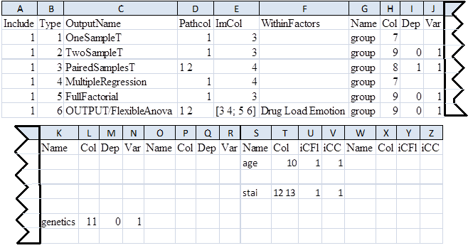

**Figure 4. An example jobfile when the ImColFlag variable in the template file is set equal to 0. The optional headers ‘Dep’, ‘Var’, ‘iCFl’, and ‘iCC’ are also present. This jobfile is set up to use the same images in each test as the one if figure 2.**

Job file

An example job file when ImColFlag = 0 is in figure 4. The additional job file options not listed in basic are as follows:

**ImCol:** If ImColFlag = 1, the image contrast number. If ImColFlag = 0, the column that refers to a subject’s image contrast number. For the job file in figure 4, ImColFlag = 0.

NOTE: For a Paired Samples T-test either the PathCol or the ImCol should contain 2 numbers, so the pairs will be grabbed either from 2 different subject folders (typically) or 2 different contrast images within the same folder. For a Flexible Factorial design, the PathCol AND ImCol can contain multiple values. This allows for the creation of up to 4 different within-subject factors with any number of levels for each. The jobfile in figure 4 includes 3 within-subject factors: 2 levels for PathCol, followed by a 2-dimensional array which creates 2 factors within ImCol. The first row (3 4) is the first level of the second within-subject factor, and the second row (5 6) is the second level. This means that the first column (3 and 5) is the first level of the third within-subject factor, and the second column (4 and 6) is the second level.

NOTE: A two-dimensional array is created here by entering each row, and separating rows with semi-colons. So a 2x2 array would be 1 2;3 4. And a 3x4 array would be entered as 1 2 3 4; 5 6 7 8; 9 10 11 12. This would correspond to a factor with 3 levels, followed by a factor with 4 levels.

**WithinFactors:** Only used for Flexible Factorial designs. There should be N names in this field where N is the number of within-subject factors present. The order of the names is PathCol rows, PathCol columns, ImCol rows, ImCol columns.

The next 4 columns represent a single between-subject factor (or simply a grouping variable for tests without any between-subject factors). These 4 columns are repeated 3 times to allow for the creation of up to 3 between-subject factors in a Full Factorial design.

**Name:** The name of the factor

**Col:** the column number from the scanfile that contains the levels for this factor

**Dep:** Is this factor Independent (0) or Dependent (1); column is OPTIONAL, defaults to (0)

**Var:** Does this factor have Equal (0) or Unequal (1) variance; column is OPTIONAL, defulats to (1)

After the 3 sets of factor columns, are sets of 4 columns for regressors. There can be as many sets of these 4 columns as you need to include an arbitrary number of regressors, but each set must have at least the **Name** and **Col** columns.

**Name:** The name of the covariate

**Col:** The column number from the scanfile that contains the values for the covariate

**iCFI:** Interactions to create between the covariate and your factors. Instead of 1 additional column, this will create N columns in your design matrix (where N is the number of levels of the factor you create the interactions with). Currently, contrasts are not generated for covariate interactions; column is OPTIONAL, defaults to 1

1: No interactions (typical)

2: Interaction with Factor 1

3: Interaction with Factor 2

4: Interaction with Factor 3

**iCC:**  Centering to perform on the covariate. Column is OPTIONAL, defaults to 1

1: Overall mean (typical)

2: Factor 1 mean

3: Factor 2 mean

4: Factor 3 mean

5: No mean centering

Editing with OpenOffice

OpenOffice is not the preferred editor for job or scan files, but it can be done. OpenOffice adds quotation marks around the comma delimited text which causes the MethodsCore second level batch system to function incorrectly. The following steps can be performed with OpenOffice to omit the quotation marks when editing job or scan files:

1. Open a job or scan file. The Text Import window should appear select “OK”.

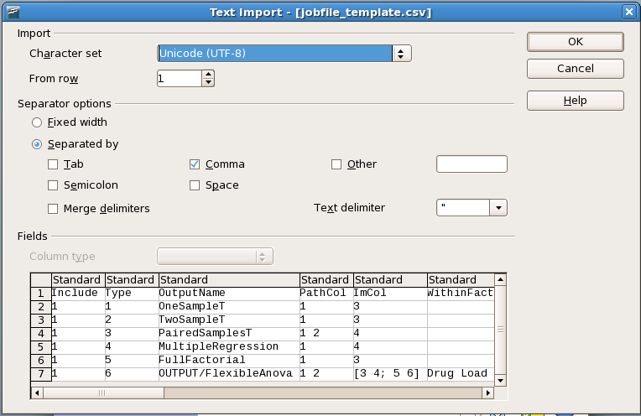

1. Make edits to the job or scan file.
2. When saving, click “File” in the upper left hand corner. Scroll down to and click “Save As…”.

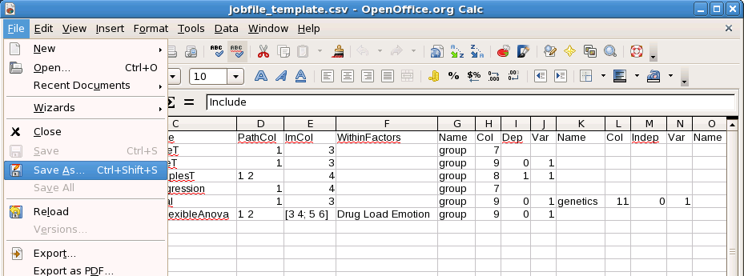

1. At the “Save” window, check “Edit Filter Settings”. Then click “Save.”

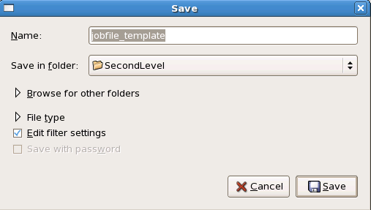

1. If OpenOffice asks to overwrite an already existing file, select “Yes”. If the below dialog appears, select “Keep Current Format”.

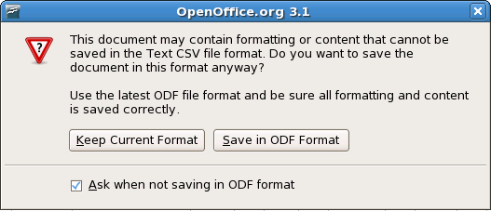

1. The “Export of text files” now appears on the screen. Clear the “Text delimiter field”. Select “OK”.

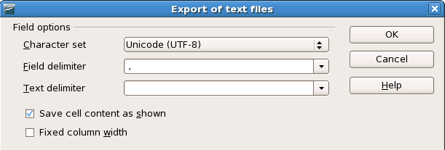

1. The file should have saved properly. To check whether the file saved properly, the job or scan file can be opened with a text editor such as gedit. There should be no quotation marks around the text.

Performing a batch

To run a job, the template must know where the central file is located. This is accomplished by having both the template and central file in the same directory, or the directory that houses the central file can be added to the Matlab path. A job is executed by typing the template file name at the Matlab terminal. Alternatively, the template file can be opened the Matlab text editor. Clicking the green arrow “Run” button starts the second level job.

