**Introduction**

The CheckSlice scripts are a quality checking tool for fMRI images. They are intended to find slice outliers in unprocessed scans. Here scan refers to one three-dimensional volume in a time series of fMRI images. Slice refers to one cross section in a scan which makes it a two dimensional image. The scripts are written in Matlab and include a template and central file like other MethodsCore scripts. The user only needs to set the variable values in the template file to run CheckSlice.

**Template File**

In the template file, each variable includes a description of its purpose so it is self-explanatory. Most of the variables used in the template script are used to create the file path to the images. Only 4D nifti files can be used. The variable “Opt.OutlierText” refers to the text file that will be written which contains all slices labeled as outliers. Detecting outliers is controlled by the variable “Opt.Thresh”. The recommended value is either 3 or 4. A lower threshold value causes more slices to be labeled as outliers. The user is responsible for inspecting slice outliers and determining whether the slice is an actual outlier. CheckSlice comes with the command line tool “checkImages” to aid the user for inspecting bad slices.

**Output**

In each run directory where the 4D nifti file is located, a .mat and .pdf file is generated named sliceMetrics.mat and sliceMetrics.pdf, respectively. sliceMetrics.mat contains all the metrics calculated. It can be loaded into Matlab and inspected. sliceMetrics.pdf displays the metrics graphically in five figures. Table 1 summarizes what is plotted in each figure and example figures are given in figures 1-5.

**Table 1. sliceMetrics.pdf summary**



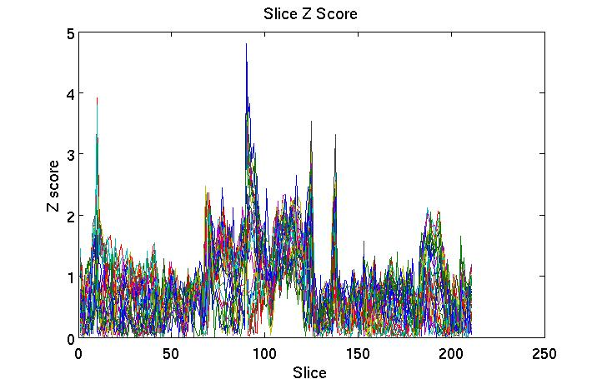

**Figure 1. An example slice z score figure. Each line represents a slice. No extreme outliers can be labeled from this image.**

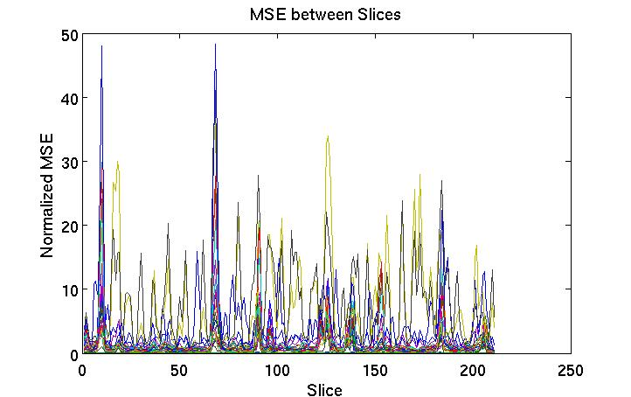

**Figure 2. An example MSE between slices figure. The recommended threshold for outliers is 100. This metric is sensitive to movement.**

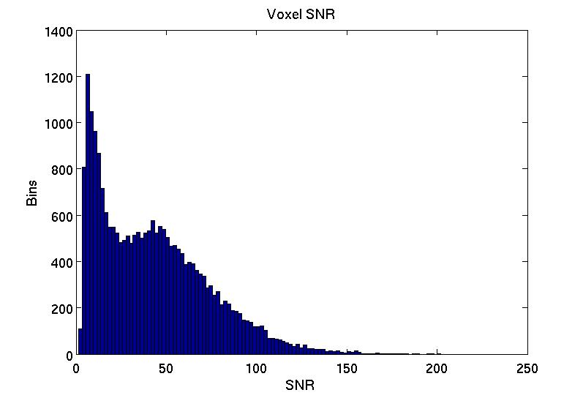

**Figure 3. A histogram of voxel SNR for a masked brain. This may be compared to other histograms to check for any abnormality.**

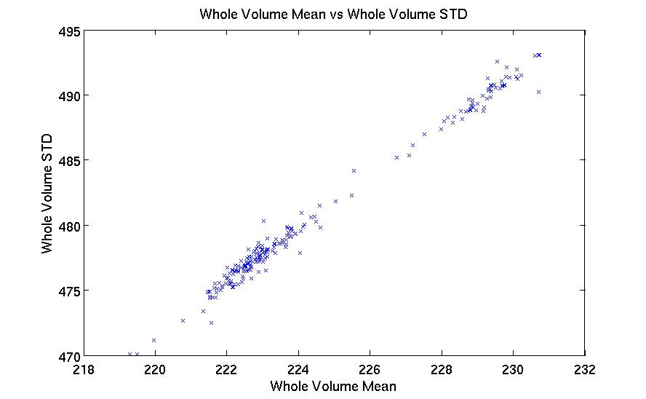

**Figure 4. Whole volume mean vs whole volume standard deviation. Scan outliers can be labeled if a point deviates from the general trend.**

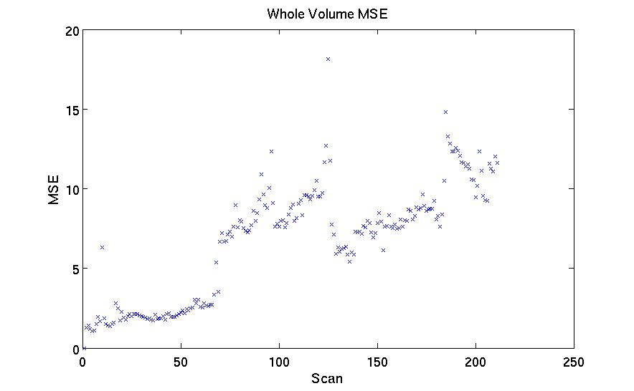

**Figure 5. Mean squared error between scans in an fMRI time course. This metric is sensitive to movement.**

The script also generates a text file which contains the 4D nifti files with outlier slices. The slice locations are included in the text file and are written in FSL voxel coordinates. Z-score and MSE values are written for each slice to help the user to decide what to do with the slice. Higher values indicate the slice is more likely to be corrupted. An example output text file is displayed in figure 6. CheckSlice comes packaged with the terminal script called “checkImages”. It parses the output text file to display each image one by one in FSL, so that the user can easily inspect the images.

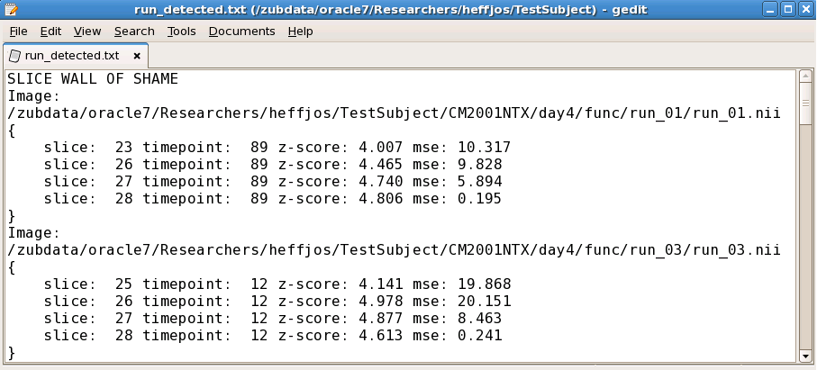

**Figure 6. Sample output text file that contains outlier slices. Each image with slice outliers is written. The outlier locations follow the image name within the brackets.**