**Introduction**

The CheckMotion scripts are a quality checking tool for 4D fMRI images saved in the nifti format. They are intended to summarize subject motion using the motion parameter files generated from the realignment stage in preprocessing. The scripts are written in Matlab and include a template and central file like other MethodsCore scripts. The user only needs to set the variable values in the template file to run CheckMotion.

**Template File**

In the template file, each variable includes a description of its purpose. The variables used to specify path names to files use a standardized format. For help on this, there is a help document here: MethodsCore/Path Template Documentation.pdf.

The remaining variables, shown in figure 1, set the values for the assumptions made when summarizing motion. Generally, these variable values do not need to be changed from the default. The metrics used to summarize motion are Euclidean displacement and frame displacement (FD). For more information about Euclidean displacement, check the file: MethodsCore/matlabScripts/euclideandisplacement.pdf. Frame displacement is used to detect frames exceeding the FDcriteria in a run, which can then be censored in the first level using a regressor. Euclidean displacement is used to summarize subject motion for a whole run. The output metrics can be used to ensure different groups have similar motion which is important for second level analysis.

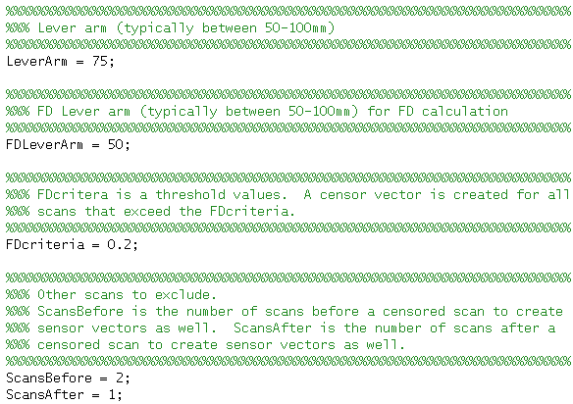

**Figure 1.** **Variables used to set assumptions.**

**Output**

A csv file is output to the location set by OutputPathTemplate variable in the first level script. Figure 2 displays an example csv file. The top row labels what each column is. Each run for a subject is summarized along the remaining rows.

The ‘Space’ and ‘Angle’ columns are calculated through Euclidean displacement. The ‘Space’ columns are calculated using the translational motion parameters while the ‘Angle’ columns are calculated using the rotational parameters. MaxSpace is the maximum relative displacement for a frame. MeanSpace is the mean of the relative displacements for each frame in a run. SumSpace is the sum of all the relative displacements for all frames in a run. This is similar for the ‘Angle’ columns as well.

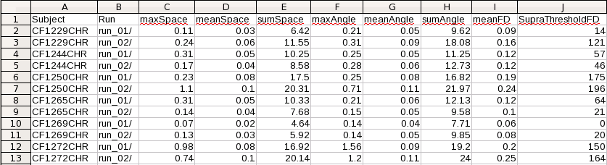

**Figure 2. An example output csv from CheckMotion.**

The final two columns are calculated through frame displacement. A frame displacement metric is calculated for each frame in a run. MeanFD is the mean frame displacement value for all frames in a run. SupraThresholdFD is the number of scans that exceed the FDcriteria set in the template script. SupraThresholdFD is hopefully a small number for a run. In figure 2, subject CF1250CHR in run_01 has a SupraThresholdFD equal to 175 which is not good. For frames that exceed the FDcriteria, a csv file is generated in the corresponding subject’s run directory. The csv file is titled **fdOutliers.csv** and contains regressors that can be used to censor these frames from the first level model.

**Additional Help**

If additional help is required email [methodscore@umich.edu](mailto:methodscore@umich.edu) Youtube videos coming soon!