**Introduction**

The CheckReg suite is tool to check the quality of coregistration between a subject’s overlay and high resolution anatomical images to the fMRI scans. It permits a user to review over multiple subjects with minimal effort due to the template/central file structure.

**Template File**

The user only needs to fill out the variable values in the template file. Each value is commented about its purpose, so the template file is self-explanatory. Once the variable values have been set, a user can run the template file from the matlab prompt.

**Usage**

The central script uses SPM8 Check Reg command to display images from each subject one by one. The displayed images are the subject’s coregistered overlay and high resolution anatomical and the first three scans from the first fMRI as shown in figure 1. This process is automated and the user will be prompted to hit [Return] to continue on to the next subject.

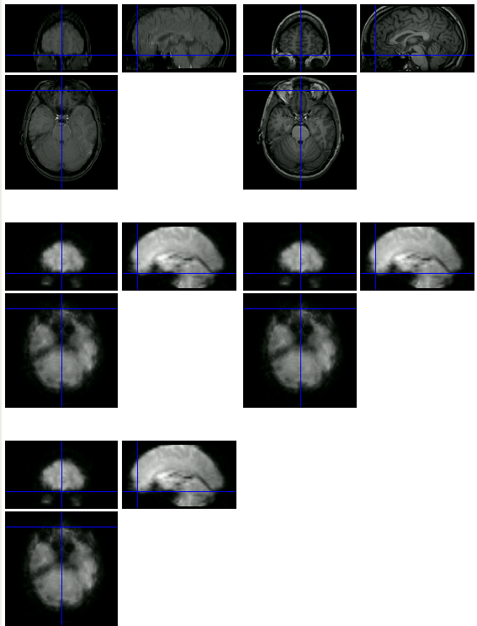

**Figure 1. Example image displayed from the CheckReg script. The quality for the coregistration is good.**

**What to look for?**

A user wants to make sure the functional and higher resolution images are anatomically aligned. Figure 1 is an example of a good coregistration. Figure 2 is an example of not so good coregistration. There is some signal dropout in the orbitofrontal cortex which causes the poor coregistration around the front of the brain.

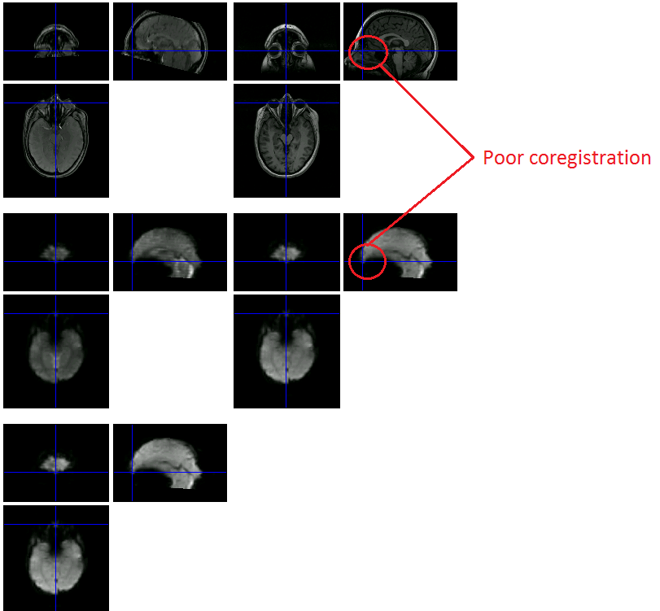

**Figure 2. Example of poor coregistration.**