**Introduction**

The CheckScan scripts are a quality checking tool for 4D fMRI images saved in the nifti format. They are intended to find scan outliers in fully preprocessed scans. Here scan refers to one three-dimensional volume in a time series of fMRI images. The scripts are written in Matlab and include a template and central file like other MethodsCore scripts. The user only needs to set the variable values in the template file to run CheckScan.

**Template File**

In the template file, each variable includes a description of its purpose so it is self-explanatory. Most of the variables used in the template script are used to create the file path to the images. Only 4D nifti files can be used. The variable “Opt.OutlierText” refers to a text file that is generated which contains all scans labeled as outliers. Detecting outliers is controlled by the variable “Opt.Thresh”. The recommended value is either 3 or 4. A lower threshold value causes more scans to be labeled as outliers. The user is responsible for determining whether the scan is an actual outlier.

**Ouput**

In each run directory where the 4D nifti file is located, a pdf file is generated named scanReport.pdf. The report graphically displays calculated metrics for the nifti file in five figures. Table 1 summarizes what is plotted in each figure and example figure are given in figure 1-4. If any scans are labeled as outliers, a csv file is also generated in the run directory. The csv file contains regressors that can be used in the first level analysis to account for the variability caused by the outlier scans. The regressors are set equal to one at the outlier scans and zero for the remaining scans.

**Table 1. scanReport.pdf summary**



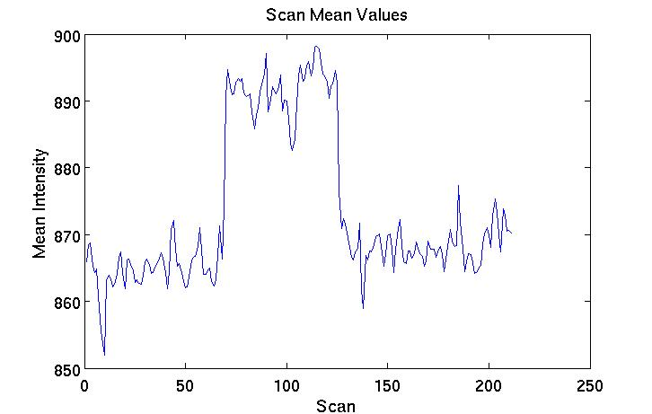

**Figure 1. An example scan mean values figures. The mean voxel intensity should not change greatly between scans.**

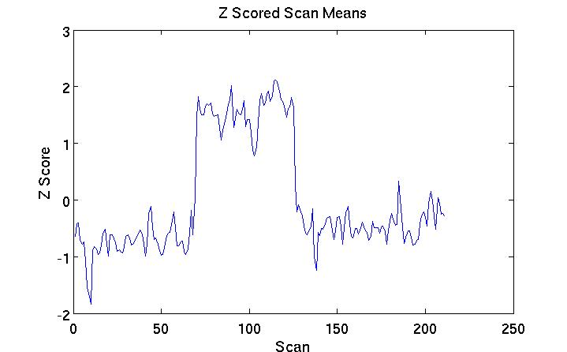

**Figure 2. An example z-scored scan means figure. This can help identify outlying scans in a time series.**

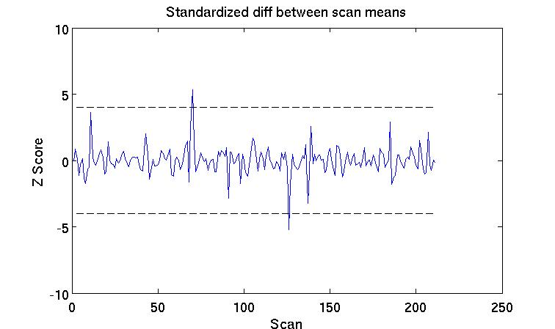

**Figure 3. An example standardized difference between scan means figure. The dashed indicates the threshold value for outlying scans.**

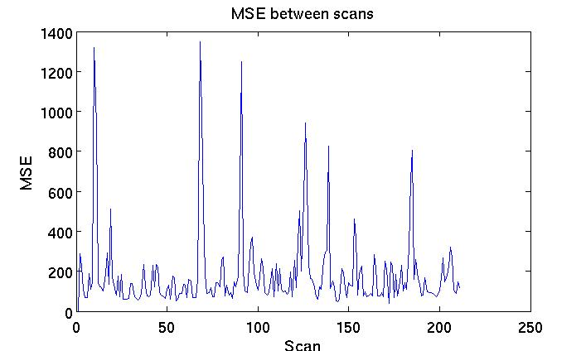

**Figure 4. An example MSE between scan figure. This can help identify scan outliers in a time series. Large spikes indicate possible scan outliers.**

The script also generates a text file which contains all outlying scans found during a run of the CheckScan scripts. The scan locations are included in the text file and are written in SPM voxel coordinates. All metrics calculated for a scan are saved in the text file to help the user decide what to do with the scan. An example output text file is displayed in figure 5.

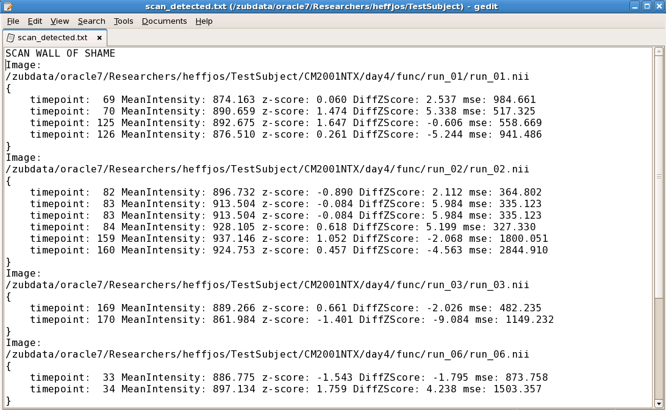

**Figure 5.** **Sample output text file that contains outlier scans. Each image with scan outliers is written. The outlier locations and calculated metrics for the scan follow the image name within the brackets.**