**MethodsCore**

**ROI Scripts Documentation**

**02/10/2013**

**Introduction**

The ROI Scripts suite makes it easy for you to specify ROIs and extract ‘betas’ for your subjects from those ROIs, and store your extracted betas for further analysis.

**Video Tutorials**

We also have a video tutorial for the ROI scripts online. It may be useful for you to review these videos while following along with this document.

ROI Scripts video: <http://youtu.be/tAeJHkCoWy8?hd=1>

**General Help**

If you ever have any questions about how to use these scripts, you can contact [MethodsCoreHelp@umich.edu](mailto:MethodsCoreHelp@umich.edu).

Many of our scripts use a standardized way of specifying paths. For help on this, there is a help document here: Methods Core/Help/Path Template Documentation

**ExtractROI Script**

In the MethodsCore/ExtractionScripts folder/ExtractROI folder, open ‘ExtractROI_mc_template’

First specify your experiment folder and output path in the usual way.

Next specify the type of summary function. As noted in the help section in the script, 'mean' takes the average activation of the voxels in the ROI, while 'eigen1' takes the first principle component of the activation within the ROI. We recommend using ‘eigen1’ as this is what SPM8 uses.

Next specify your ‘jobs’, as in the example shown below. Each row is a job, and each job consists of a second-level SPM.mat and an ROI. The SPM.mat file lists the locations of first-level subjects/images. For each job, the script produces as output the mean or first eigenvariate of the activation within that ROI for each of the first-level images specified in the SPM.mat file.

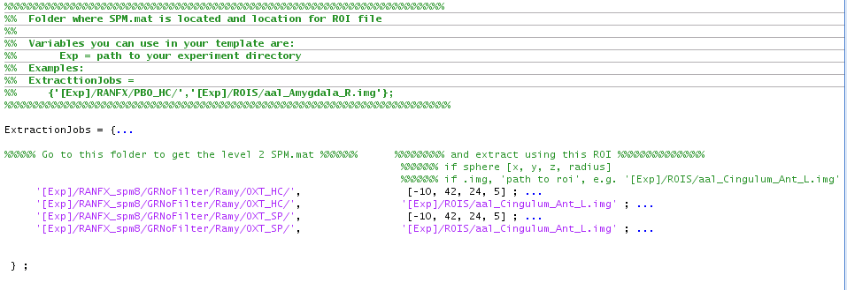

In specifying the path to the SPM.mat, put the full path in the entry in the first column.

You can specify ROIs in two ways:

* Spheres: List the x, y, z coordinates followed by the radius of the sphere in millimeters in the following format: [x, y, z, radius]. Note: You are entering numbers (actually a vector), so do not enclose the entry in quotes.
* Images: Put the full path to an .img ROI image.

After the script runs, the output folder contains a csv file that contains your results. Here is what the csv output looks like from the example above.



The csv output file is formatted as follows. The first column numbers the rows, and the second column is always a header column that lists the names of the subjects/images from the SPM.mat file from the first job you specified. If your jobs include multiple SPM.mat files and they contain different subjects/images (as in the example above), the script will automatically insert multiple header columns. If your jobs involve the same SPM.mat file, but just different ROIs, then the new header column will not be printed. In the example above, we use the same SPM.mat for the first two jobs, and a different SPM.mat for the last two jobs. That’s why there are two subject/image header columns. In short, you can think of it like this: the header row says what was done (what SPM.mat, which ROI, etc…). The header column(s) say to whom it was done.

Note that an SPM.mat that specifies a one sample t-test will have (# of subject) rows, while an SPM.mat specifying a two sample t test will have 2 * (# subjects) rows. An SPM.mat file for an ANOVA will have LOTS of rows, depending on the ANOVA.

Finally, sometimes a person runs a second-level analysis and later moves the first-level folders. The Second-level SPM.mat now contains paths for the first-level subjects/images that are the wrong. If you try to use this SPM.mat to extract betas from an ROI, the script will crash. If that happens, then contact [MethodsCoreHelp@umich.edu](mailto:MethodsCoreHelp@umich.edu) and we can let you know what to do to fix the SPM.mat so that it points to the correct first-level locations.