

Ingenix, Inc.
2525 Lake Park Blvd Salt Lake City UT 84120
(801) 982-3000 ● Fax (801) 982-4000 ● www.ingenix.com

December 16, 2004

Steven Cohn, M.D.
Chief Executive Officer
Universal Medical Records Ltd.
22 The Cross Road
Cortlandt Manor, New York 10567

Dear Dr Cohn,

This letter is in appreciation of your cooperation in troubleshooting, correcting, and maintaining the medical billing codes and descriptions we’ve used in our books over the years. Your generous review and comment on the codes and descriptions included in our ICD-9-CM, CPT, and HCPCS Level II code books provides us a valuable clinical and customer review. While we have other customers comment on this information before publication, you demonstrate the most inherent knowledge and thoughtful examination.

Over the years, your voluntary service has provided us invaluable assistance before our publications are released. You have a knack for seeing things in the codes that even the originators had not considered. Based on your comments, I’m confident Universal Medical Record is truly the archive of the total knowledge from these codes. I cannot express how grateful we are for your comments and look forward to your continuing efforts on our behalf.

Sincerely,

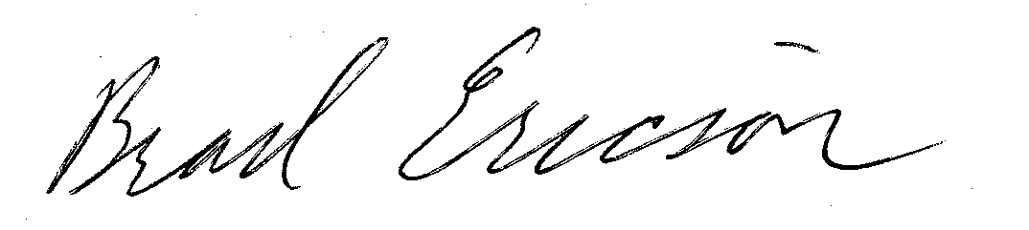

Brad Ericson
Product Manager

