COMP9900

Information Technology Project

2020 Term 3

Project Proposal

**Project 6**: FilmFinder

**Submission Date**: 2020.10.4

**Team Name**: [**COMP9900-H18A-ChongChongChong**](https://webcms3.cse.unsw.edu.au/COMP9900/20T3/groups/22976)

**Team members**

| **Name** | **zID** | **role** |
| --- | --- | --- |
| Yipeng Han | Z5192958 | Scrum Master/Developer |
| Mingyan Yu | z5196418 | Developer |
| Ziwei Li | z5187737 | Developer |
| Kaisen Luo | z5185842 | Developer |

**Background**

In recent years, the film industry has been booming, and advances in film shooting and production technology have allowed the production of films to increase greatly compared to before. Movie lovers may encounter great difficulties when searching for movies. At this time, they yearned for a movie website. This website organizes movie information for them. Including the movie's name, director, genre and other information. More importantly, many movie lovers can publish film reviews and score of movies on the website. This is very attractive to movie lovers who are eager to find movies to watch. First, they save the time of non-stop searching on Google, and secondly, they can get a better user experience, and they can even check the movie reviews before watching the movie to guide whether the movie is worth watching.

We have visited some websites which are trying to achieve this objective. However, the efficiency of these websites is not high enough. First, most movie websites have too many functions. They not only have movie retrieval functions, but also come with a module for buying movie tickets. This is unnecessary for someone who just wants to retrieve and watch movie reviews and scores.

Secondly, the UI of many movie websites is too fancy, not concise, and clear enough, which may cause great difficulties for users when using it. Some misoperations are prone to occur and it is difficult to satisfy users.

Then, many movie websites only support keyword search. If a movie lover is a big fan of George Lucas, he may want to watch all the movies made by George Lucas and their scores, and the scores are sorted from largest to smallest. This is not possible on many websites. Users can only retrieve the movies made by George Lucas but cannot know at a glance which movie is most sought after by fans. Therefore, we will implement this function in the website.

Finally, we found that many movie websites do not have a recommendation function. This makes it difficult for movie lovers to find movies that are highly similar to their favourite movies. Therefore, we will improve this function in the FilmFinder project.

**Objectives**

**System Architecture**

The system contains three layers, frontend, backend, and database. The frontend is the client facing application for users to interact with. The backend handles the application logic for reading and storing data in the database and returning relevant information to the frontend client. And the database is for storing all the application and user data. All our users will be interacting with the application through the frontend client facing application.

We will be using Python and Flask framework to implement the backend. We will also be using PyMySQL which is an object-relational mapper to connect the backend with the database. And we will be using MySQL for the database. For the frontend, we will be using Jinja templates with HTML, CSS, and JavaScript.

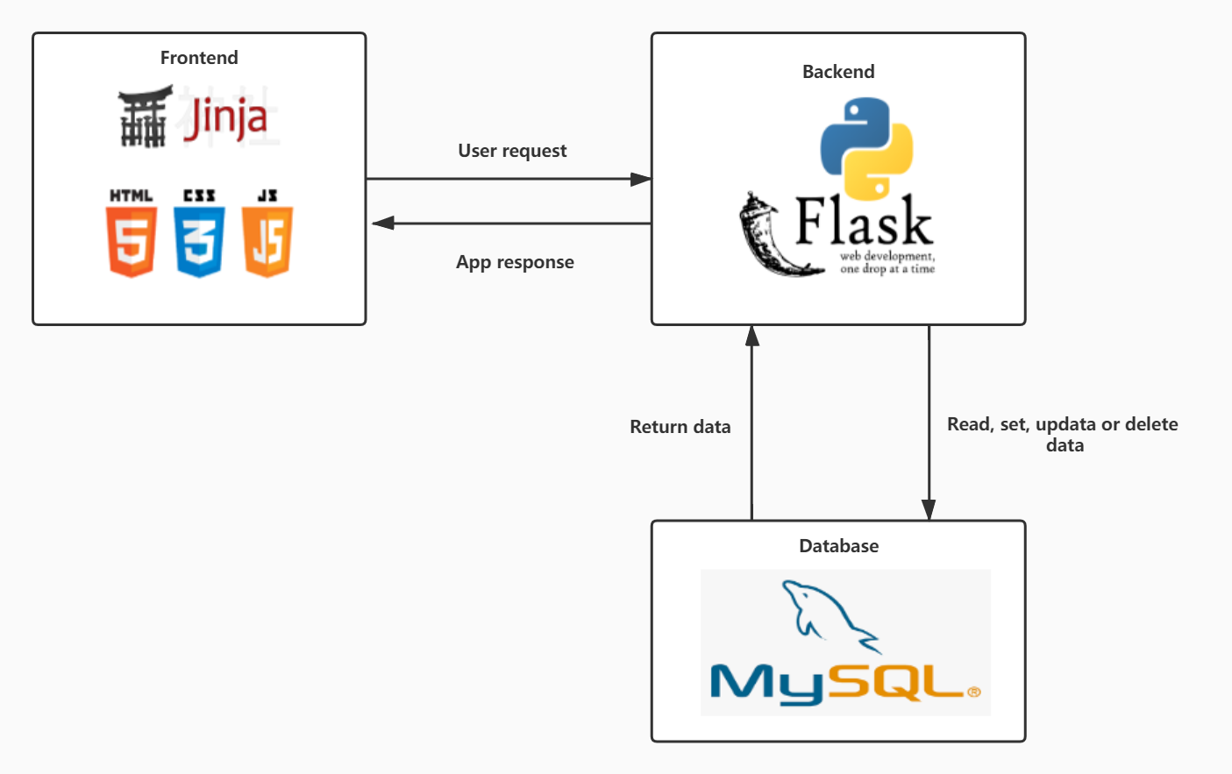

**Group Management**

1. **Daily communication: By using Wechat, Github and Jira**

Our team members will communicate daily to ensure that we are on the right track and can complete the goal on time**.**

1. **Weekly Video Meeting: In lab (through BB Colab), Wechat group video meeting**

Weekly meetings will ensure that we reach our goals and provide us with a good place to evaluate, revise and stick to the plan

**Interface and Flow Diagram**