COMP9900

Information Technology Project

2020 Term 3

Project Proposal

**Project 6**: FilmFinder

**Submission Date**: 2020.10.4

**Team Name**: [**COMP9900-H18A-ChongChongChong**](https://webcms3.cse.unsw.edu.au/COMP9900/20T3/groups/22976)

**Team members**

| **Name** | **zID** | **role** |
| --- | --- | --- |
| Yipeng Han | Z5192958 | Scrum Master/Developer |
| Mingyan Yu | z5196418 | Developer |
| Ziwei Li | z5187737 | Developer |
| Kaisen Luo | z5185842 | Developer |

**Background**

In recent years, the film industry has been booming, and advances in film shooting and production technology have allowed the production of films to increase greatly compared to before. Movie lovers may encounter great difficulties when searching for movies. At this time, they yearned for a movie website. This website organizes movie information for them. Including the movie's name, director, genre and other information. More importantly, many movie lovers can publish film reviews and score of movies on the website. This is very attractive to movie lovers who are eager to find movies to watch. First, they save the time of non-stop searching on Google, and secondly, they can get a better user experience, and they can even check the movie reviews before watching the movie to guide whether the movie is worth watching.

We have visited some websites which are trying to achieve this objective. However, the efficiency of these websites is not high enough. First, most movie websites have too many functions. They not only have movie retrieval functions, but also come with a module for buying movie tickets. This is unnecessary for someone who just wants to retrieve and watch movie reviews and scores.

Secondly, the UI of many movie websites is too fancy, not concise, and clear enough, which may cause great difficulties for users when using it. Some misoperations are prone to occur and it is difficult to satisfy users.

Then, many movie websites only support keyword search. If a movie lover is a big fan of George Lucas, he may want to watch all the movies made by George Lucas and their scores, and the scores are sorted from largest to smallest. This is not possible on many websites. Users can only retrieve the movies made by George Lucas but cannot know at a glance which movie is most sought after by fans. Therefore, we will implement this function in the website.

Finally, we found that many movie websites do not have a recommendation function. This makes it difficult for movie lovers to find movies that are highly similar to their favourite movies. Therefore, we will improve this function in the FilmFinder project.

**Objectives**

FilmFinder is a film information website, for users, called FilmFinders, provide search, recommendation, communication, and other services.

First, as a movie website, a certain amount of movie information is stored in the back-end database. This information will be sorted in the background and provided to customers who come to use the website.

After the user has created an account, the website will provide the user with a function called wishlist, which represents the movies that the user will enjoy. At the same time, users can view each other’s wishlist

Secondly, users can search through the keyword search function provided by the website. When the keywords match the movie name, description and genre in the database, all matching results will be returned to the user. Users can view the names of movies and their corresponding scores in the results.

In addition to the first time, users can write reviews and rate the movies. After the user logs in, users who are dissatisfied with him can be blacklisted. The comments of users who enter the blacklist will no longer be displayed on the webpage, and the average score of the movie will be recalculated.

Finally, the movie will be recommended based on the latest movie reviews with the director or category selected by the user to help users find movies that they may be interested in.

**User Stories and Sprints**

**Sprints**

[S1] Sprint 1: week 4~5 (before lab) Date: 5 Oct – 14 Oct

[S2] Sprint 2: week 5~6 Date: 16 Oct – 25 Oct

[S3] Sprint 3: week 7~8 (before lab) Date: 26 Oct – 8 Nov

[S4] Sprint 4: week 8~9 Date: 9 Nov – 19 Nov

**User Stories**

1. [S1] Register account: My name is Lucas and I am a movie lover. I learned about a movie website called FilmFinder. I found the homepage of this website and registered an account.
2. [S1] Login: My name is Lucas and I logged in to the account after registering.
3. [S1] Search movie: This is Lucas. I am ready to find my favourite movie. I searched the site for Star Wars The Force Awakens.
4. [S1] Access detailed page: This is Lucas. I saw the results after searching, and I successfully found the Star Wars The Force Awakens. After I clicked it, I went to the detailed information page.
5. [S1] View detailed information: I am still Lucas, and I learned the genre, director, and other details of the Star Wars Force Awakens on the detailed information page. It turned out that the director was called George Lucas.
6. [S2] Movie review: My name is Lucas. After I clicked on the details page, I checked other users’ comments on Star Wars The Force Awakens.
7. [S2] Add to wishlist: My name is Lucas, I have confirmed that Star Wars The Force Awakens is the movie I am interested in, and I added him to my wishlist.
8. [S2] Remove from wishlist: My name is Lucas, and I think again and again to remove the Star Wars Principles Awakening from the wishlist, because I know that Disney’s Star Wars is very bad.
9. [S2] Make review and score: My name is Lucas, and I commented and rated the Star Wars Force Awakens,'Trash movie' and 0 point.
10. [S2] Check user's wishlist: My name is Lucas, and I found a person who gave this movie full marks. I clicked on his homepage to view his wishlist.
11. [S3] Search genre: My name is Lucas and I have searched for movie titles before, this time I want to search for horror movies. I typed horror in the search bar.
12. [S3] Search description: My name is Lucas, and I am very interested in movies with cosmic themes. I am going to search according to the description in the search bar, and I enter star
13. [S3] Search by director: My name is Lucas, and I want to see all the movies made by George Lucas in the search bar.
14. [S3] Search by genre: My name is Lucas and I want to view all the movies that are horror in the search bar.
15. [S4] Banned list: I am Lucas. After I searched the Star Wars Force Awakens, I clicked to enter the detailed information page and pulled the first reviewer directly into the banned list.
16. [S4] Recommendation: This is Lucas. After I blocked the person, I clicked to view a movie similar to Star Wars The Force Awakens and went to the detailed information page.

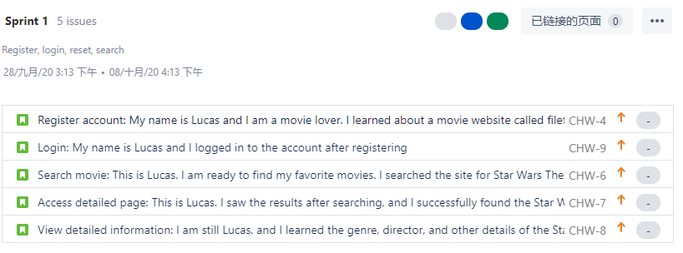

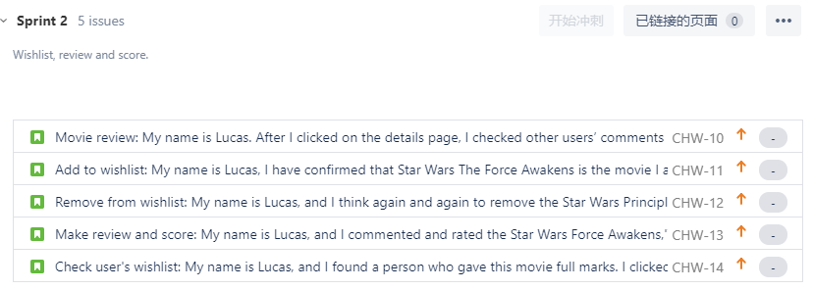

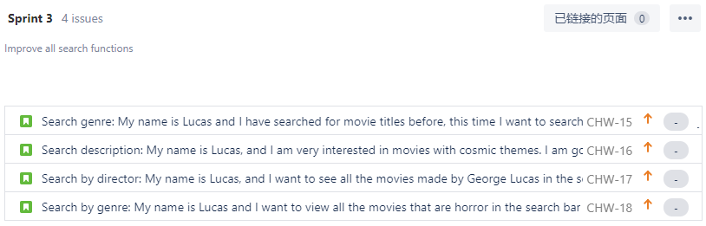

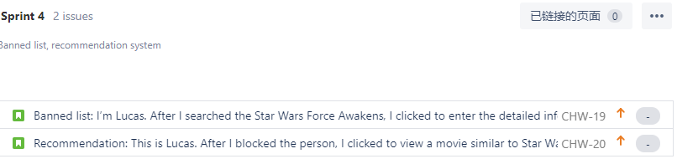

**User Story Analysis**

1. The users have the access to register, login and search movies, which can be satisfied by the related user story 1, 2 and 3. At the same time, the users can access the detailed page of the movies and view detailed information. These two functions are made by the user story 4 and 5. All these functions are based on the requirements in the FilmFinder project description.

2. One of the important features of the FilmFinder is Searching. The FilmFinder, as a platform of searching movies, allows the users search for their favourite movies via name, director, genre and description. The users can also select and view a movie’s full detail from the searching results. These functions are satisfied by user story 3, 4, 5, 11, 12, 13, 14.

3. Another special feature is the wishlist. In FilmFinder, the users can not only add their favourite movie into their own wishlist and remove it later if they want, they also have the access to the other’s wishlist who leaves a review of the given movies. These functions will be satisfied by user story 7, 8 and 10.

4. A popular feature of the FilmFinder is review and marking. The users can post their own ideas about the movie and share it with the other users. Meanwhile, the users can also select simply rating the movie from 0 to 5. These functions will be satisfied by the user story 6 and 9.

5. The FilmFinder also gives the users a chance to ban the other users’ review. This feature will allow the users block all the reviews from the unreliable users in order to make the reviews and rating more credible. This function will be satisfied by the user story 15.

6. We also add a recommendation feature for FilmFinder. For the users, the system will recommend related movies based on their latest review history (latest score) and different attributes selected by the users. For example, the attributes can be genre and director of the movies. The combination of the attributes will make the recommendation much more precise. The users can add those recommended movies into their own wishlist. This function will be satisfied by the user story 16.

**System Architecture**

The system contains three layers, frontend, backend, and database. The frontend is the client facing application for users to interact with. The backend handles the application logic for reading and storing data in the database and returning relevant information to the frontend client. And the database is for storing all the application and user data. All our users will be interacting with the application through the frontend client facing application.

We will be using Python and Flask framework to implement the backend. We will also be using PyMySQL which is an object-relational mapper to connect the backend with the database. And we will be using MySQL for the database. For the frontend, we will be using Jinja templates with HTML, CSS, and JavaScript.

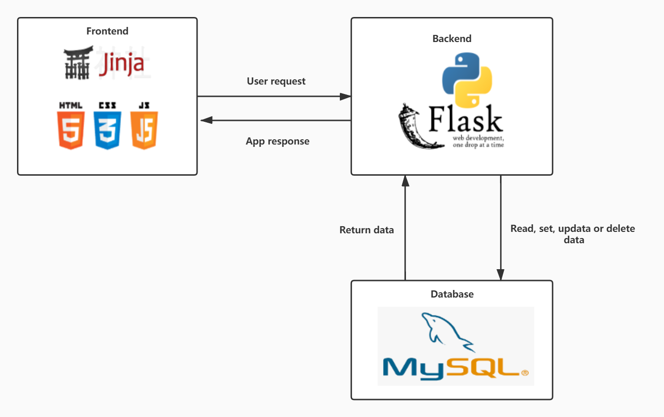

**Group Management**

1. **Daily communication: By using Wechat, Github and Jira**

Our team members will communicate daily to ensure that we are on the right track and can complete the goal on time**.**

1. **Weekly Video Meeting: In lab (through BB Colab), Wechat group video meeting**

Weekly meetings will ensure that we reach our goals and provide us with a good place to evaluate, revise and stick to the plan.

**Interface and Flow Diagram**

First, all users will see the homepage of the website. Currently, they are visitors.

After users register for an account, they have access to all the functions provided by the website. Including blacklist, wishlist function.

After users register for an account, they can view the movies they are interested in in the search bar of the website. Movies that match the search results will be returned as results on the page.

The user can click on the movie on the search results page, which will enter the movie details page.

On the detailed information page, the detailed information of the movie will be listed at the top of the page. At the same time, there will be a recommended section and a film review section below. Users can view similar movies selected by the system in the recommendation section, and in the film review section, users can comment and rate the movies.

When users find dissatisfied users in the comment area, they can be pulled into the blacklist, so that the web page will prompt the user that the operation is successful, and after the operation is performed, the web page is refreshed, and the blacked user comments will no longer be displayed on the web page , And the score will be recalculated.

In addition to keyword search on the homepage, it also provides director name search and genre search. The search results will be ranked from largest to smallest according to the average score. The user can continue the operations described above.

