**Architecture**

**MVC**

**Model:** Business Logic, Database

**View:** Interface

**Controller:** Log In information processing, Main Office

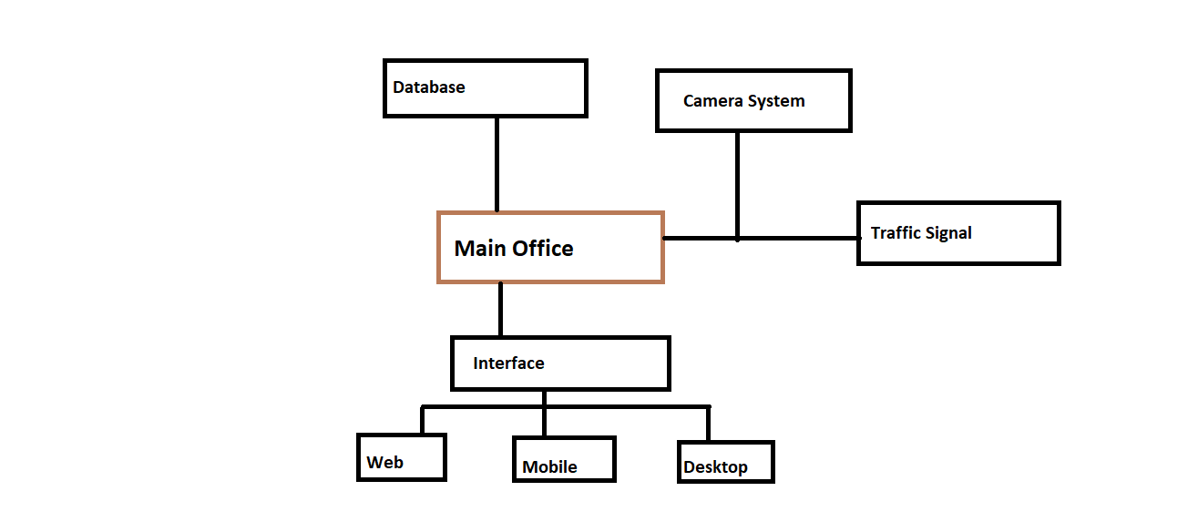

**Database:** This is used to verify log in information of users

**Camera System:** This is used to monitor the various parts of the city for security purposes

**Traffic Signal:** Signals can be controlled from office to make the way easy for security personals to reach at a particular location

**Interface:** This has 3 parts describes as follows

* **Web:** This interface actually to provide online controls to the user
* **Desktop:** This interface will usually be in head office only to provide admin rights to user
* **Mobile:** The mobile application can be installed in police vehicles to keep them updated regarding security. “Mobile here is in terms of mobility”