MSE 360-Fall 2017
Matlab Data Analysis
Week 1 Laboratory Worksheet, Due by the Week 2 lab (Sept 12-14)

The purpose of this lab and assignment is to get hands-on experience in using the MATLAB programing language to understand and analyze experimental results. This assignment is worth 100 points total. All plots and the answers to all questions should be included in a write-up to be turned in at the beginning of next week’s lab. A formal lab report is not required, but the document should be professionally formatted.

1. Figure 1 shows the phase diagram for a binary Pb-Sn alloy, with the composition by weight % (wt%) Sn shown along the x-axis and the temperature, in °C (left) and °F (right), shown along the y-axis.
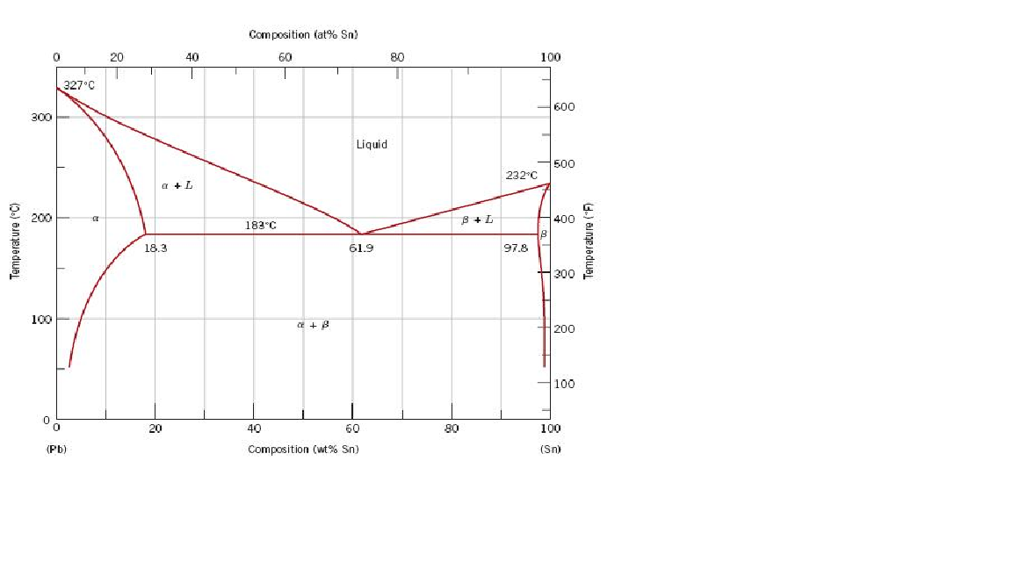
Figure 1. Phase diagram of a binary Pb-Sn alloy

This lab will involve using MATLAB to perform data analysis on (simulated) measurements of the liquidus temperature, T_{L}, of a Pb-Sn alloy with the wt% of Sn varying between 20 and 40 %.

2. To open MATLAB, first click on the CAEN software icon on your desktop. Use the search function to search the list of available software to find ‘MATLAB’. The page that lists the available software may automatically launch when you log in to the CAEN computer. Select the 2017a MATLAB Student Instructional version of MATLAB and click ‘Run’. A new window will launch that is titled ‘Cloudpaging player’. When MATLAB has been completely loaded in the Cloudpaging player window, select ‘MATLAB’ and click ‘Launch’. Contact an instructor if you have trouble opening MATLAB.

3. Load the dataset ‘Sn30Pb70.mat’ into your MATLAB workspace. The data set Sn30Pb70 simulates measurements of T_{L} for a 30/70 Sb-Pb alloy. To open this data set this you will need to download the file ‘Sn30Pb70.mat’ from the MSE course website found on Canvas (https://canvas.umich.edu). Save this file to your current folder in MATLAB. By default this is the …/Documents/MATLAB directory. Once this is done, you can use the load function to load the file into the MATLAB workspace. If you need help using the load function, type ‘help load’ at the command line in the MATLAB command window. If you have loaded the file correctly, you should see Sn30Pb70 1x25 double in your workspace window. By default the workspace window can be found in the upper right corner of the MATLAB window

4 [15 points]. Use the histogram function to plot the distribution of this data. For more instructions on how to use the histogram function, use ‘help histogram’. Include this plot in your write-up.

The histogram should look something like this:

Q1) Explain what values are plotted on the x and y axes of the histogram. How many bins does the histogram function use by default? Should the number of bins change as the number of data points increases/decreases? Justify your answer.

X-axis – range of values for each bin
Y-axis – the number of counts that fall within each bin
The histogram() function uses a number of bins that scales with the number of points being counted. For Sn30Pb70, this is 5 bins. The number of bins should increase as the number of data points increases.

Q2) What is the difference between a histogram and a bar chart?

A histogram shows the number of times (i.e. counts) an event occurs over a different range of values for a single variable. A bar chart compares measurements for different variables against each other.

5. [10 points] Use the histogram function to plot the probability distribution of the data. Instructions on how to do this can be found by using ‘help histogram’. You will need to use the ‘Normalization’ and ‘Probability’ keywords when you call the histogram function. Include this plot in your write-up.

The histogram should look something like this:

Q3) Verify that the sum of the bins of the probability distribution histogram is equal to 1. Explain why this sum is equal to 1.

Each bin individually represents the probability that a given measurement will fall within a certain range of values. Adding two bins together gives the probability that any given measurement would fall this expanded range of data. Adding all the bins together gives the probability that a given measurement would fall within any of the possible ranges of values, which is 100% or 1.

6. [20 points] The Gaussian function describes a peak centered about and takes the form
Eq. (1)

where A controls the height of the peak, and σ controls the width of the peak. Using A = 1, σ = 1, and = 260, plot a Gaussian function in MATLAB. Use a range of x values from 255 to 265, with dx = 0.1. Contact an instructor if you are unsure of how to obtain the values of f(x).

Next, integrate the area under the curve of the Gaussian function. The MATLAB function trapz can be used to perform this calculation. Be careful - depending on how you use the trapz function, you may need to account for the value of dx in your calculation of the integral. After you have done this, divide each point of your original Gaussian function by the area you just calculated. As a result of this operation, the area under the curve of the new Gaussian function will be equal to 1 (verify this!). If done correctly, you will now have a probability distribution function (PDF) similar to the probability distribution histogram you have already made. Include the plot of the PDF in your write-up.

Q4) Compare the PDF described by the Gaussian function against the probability distribution histogram of the Sb30Pb70 data set. How are they similar? How are they different?

The histogram plot has a large central peak similar to the Gaussian PDF, but the probability distribution for the histogram does not smoothly decrease to zero as it does in Gaussian PDF (this description may vary depending on the number of bins used to display the histogram).

7. [10 points] Use the ‘randn’ function in MATLAB to simulate a data set with a sample size, N, of 200, with a mean value of 260 and standard deviation of 1. See ‘help randn’ for an example of how this can be done using the randn function. Use the histogram function to plot the probability distribution of this data. Include this plot in your write-up.

The histogram should look something like this (details will vary due to randn() function):

Q5) Compare the PDF described by the Gaussian function against the probability distribution of this new data set. Does the new probability distribution histogram look more or less similar to PDF described by the Gaussian function? Explain your answer.

Yes, the histogram distribution probability distribution is smoother and more closely resembles the shape of the Gaussian PDF (again the description may vary depending the number of bins used). The answer given should be consistent with the plots provided by the student.

8. [10 points] Use the randn function in MATLAB to simulate a data set with N = 500, 1000, 5000, and 10000. Use the histogram function to plot the probability distributions of these data sets. Include these plots in your write-up.

The histograms should look something like this (again details may vary):

Q6) For a PDF, the term in Eq. 1 corresponds to the mean value of the data. For each histogram, estimate the value of How does change as N increases? If the location ofdoes not appear to change, you may need to increase the number of bins you are using in your histogram.

The value of x-bar for the Gaussian PDF is 260. The expectation is that the difference between the estimated x-bar for the probability distribution histogram and the known x-bar value should decrease as N increases.

Q7) The Gaussian PDF, also commonly referred to as the normal distribution, is a limiting distribution function for samples of multiple measurements with small variations. Why? Justify your answer.

The Gaussian PDF is a limiting function for the probability distribution histogram. As N approaches infinity, the shape of the histogram will approach the shape of the Gaussian PDF.

9. [5 points] The width of the probability distribution function, controlled by the σ term in Eq. 1, is related to a statistical quantity known as the standard deviation. The calculation of the standard deviation will be discussed in a later lesson, but qualitatively it describes how far from the mean a set of values will tend to be distributed. As such, the standard deviation of the normal distribution can be used to make predictions on the range of likely values for a measured quantity.

There is a useful approximation that is called the ‘68-95-99.7’ rule. This refers to the fact that when making multiple measurements of a normally distributed quantity, approximately 68.3% of the measured values fall within one standard deviation of the mean, 95.4% of the measured values fall within two standard deviations of the mean, and 99.7% of the measured values fall within three standard deviations of the mean. This is illustrated in Figure 2.

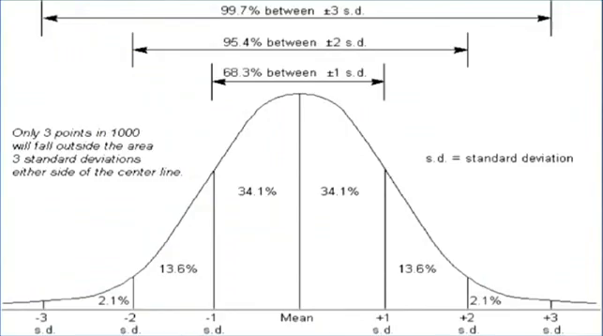

Figure 2. Illustration of the ’68-95-99.7’ rule for a probability distribution function.

Figure 3 shows the plot of two probability distribution functions:
Figure 3. Plot of two different probability distribution functions.

Q8) According to Figure 3, which PDF would have a smaller standard deviation? Is there a parameter and/or calculated quantity that is equal for these two distributions; why or why not? What characteristic(s) of the PDFs did you use to come to this conclusion?

PDF 2 would have a smaller deviation – this conclusion is based on the observation that the width of PDF 1 is smaller than the width of PDF 2. Both distributions have the same mean value – this conclusion is based on the observation that center of both peaks share the same location along the x-axis.

10. [5 points] Calculate and report the mean and standard deviation for the Sn30Pb70 data set. These values can be determined using the mean and std functions in MATLAB.

Mean = 260.2281
Std = 1.0343

Q9) If the you were run this experiment again, assuming no other outside factors change your results, estimate the probability that you would measure T_{L} to be in the range of 260 +/- 1.5 °C. Explain your reasoning behind the estimation.

One possible method:

The mean is approximately 260 and +/- 1.5 C is approximately one and a half standard deviations.

The full area between one and two standard deviations is 13.6%. Through visual inspection, it appears that the area between one and one and half standard deviations is greater than one half, but less than three quarters of the area between one and two standard deviations. Therefore, the probability of a measurement falling in the range of 260 +/- 1.5 C is estimated to be between 2*(34.1 + 0.5*(13.6))% and 2*(34.1 + 0.75*(13.6))%, e.g. in the range of 81.8% to 88.6%.

Alternatively, a more accurate estimation could be made by approximating the area between one and two standard deviations as a trapezoid and then directly calculating the area between one and one half standard deviations using this assumption. Either method of estimation is acceptable. The most important part is that they description of the method they use to estimate the uncertainty, and that the reasoning for the estimation makes sense.

11. [10 points] The measure of uncertainty in experimental observations is often reported in terms of a range of values around the measured mean. One common method is to use a 95% confidence interval, meaning that you are 95% confident that the true mean is within the range of values you report. Applying this method, if you report a T_{L} of 262 +/- 3 °C, you are claiming to be 95% confident that the true value of T_{L} falls within the range of 259 to 265 °C. It is very important to explicitly state the underlying statistics behind your reported uncertainty value to avoid any confusion in how it should be interpreted since there are different methods for generating confidence intervals and uncertainties.

wt% Sn | T_{L} | Uncertainty
20 | 282 | +/- 1.67
25 | 273 | +/- 1.83
30 | 262 | +/- 2.03
35 | 253 | +/- 1.63
40 | 243 | +/- 1.76
When plotting your results, this uncertainty is often expressed using error bars. It should be noted that the name ‘error bar’ does not refer to mistakes made during measurement, but rather to the range of uncertainty in the possible values of the quantity being measured. Often error bars are drawn such that the width of the error bar spans the 95% confidence interval for the measurement.

Table 1 shows a simulated sample of liquidus temperatures for different compositions of a Sn-Pb alloy. The column on left gives the wt % Sn of the Sn-Pb alloy, the column in the middle gives the mean value of the simulated liquidus temperatures, and the column on the right gives the uncertainty of the data within two standard deviations from the mean.
Table 1. Simulated liquidus temperatures for 20-40 wt% Sn in a Sn-Pb alloy.

Plot liquidus temperature vs. wt% Sn using the MATLAB plot command. Make sure each data point is discrete (don’t connect the points with a line). Using the Sn-Pb phase diagram, find a linear approximation for what T_{L} “should be” between 20 and 40 wt% Sn. This linear approximation will serve as the theoretical (i.e. predicted value) for the liquidus temperature of the Sn-Pb alloy. Add this linear approximation for T_{L} to the plot of melting temperature vs. wt% Sn (this should be plotted as a solid line).

Linear approximation should be something close to y = -2x + 320.

Plotting multiple data sets on the same MATLAB plot can be done a couple different ways. Read ‘help plot’ and ‘help hold’ for more information. For this exercise, using the hold function will likely prove to be more useful. Include this plot in your write-up.

Plot should look something like this:

Q10) Looking at this plot what can you say about the accuracy and precision of your data? Does it appear to be in good agreement with the theoretical fit? Can you make any quantitative assertions about your results as currently plotted? Why or why not?

The data is precise (would fit a line well) but not accurate (the line fit would not match the theoretical value). The trend is in agreement with the theoretical values but the data itself is not. [TIM – MODIFY/FILL IN THE REST]

12. [15 points] Add error bars to your plot of the data. Error bars can be added to a plot using the errorbar function (use the errorbar function in place of the plot function).

Plot should look something like this

Q11) Can you make any additional quantitative statements about your results after you have added the error bars? Given that these temperatures were measured by a thermocouple, can you infer anything about the accuracy of the thermocouple based on the plot? Estimate a lower bound for the systematic error in its measurements.

The uncertainty in the measurement cannot account for the discrepancy between the data and the theoretical values. [TIM – MODIFY/FILL IN THE REST]

Q12) What are some of the possible sources of experimental uncertainty in the data? Assuming the reported uncertainties are trustworthy, what is the upper bound for the value for the precision of the thermocouple that was used to measure $T_{L}$?

Systematic ‘error’ in the thermocouple (+3 C) [TIM – MODIFY/FILL IN THE REST]

