# DEMO 3 model

Model in DEMO 1 and DEMO 2 do not allow for any scarcity, i.e. if the available level of supply is lower than the required level of demand (represented by lower bound of water delivered via links to each demand node), both models become infeasible and no solution can be reached. We therefore modify the previous model formulation to allow for water shortage so that infeasibilities are not generated. The available water, even when lower than the target demand, will be distributed to demand nodes with higher priority (cost) first and then to those with lower priority.

To do so, a new decision variable *αit* (i.e. demand satisfaction ration) is introduced and defined for each demand node (set *DEM*) that is equal to one if the demand is fully met and lower than one (with a minimum value of zero), if only a percentage of the target demand is met.

|  |  |
| --- | --- |
| $$0≤α_{i}^{t}≤1 ∀i∈DEM,t∈T$$ | 1 |

The new objective function now becomes:

|  |  |
| --- | --- |
|  | 2 |

In the formulation presented in this report, all decision variables are in capital letters while input data are in lower case. The objective function maximises the level of demand satisfaction for each time-step *t* for all demand nodes (*i*) based on the priorities *pit*. Since we are now dealing with a maximisation problem, the higher *pit* the higher is the priority for each demand node to receive water.

The objective function equation 2 is subject to the constraint equation 1, mass balance for non-storage nodes (Set *NS*) (equation 3), mass balance for storage nodes (set *ST*) (equation 4), and lower and upper bound constraints (equations 5 and 6). With regards to the non-storage nodes, the mass balance equation becomes:

|  |  |
| --- | --- |
|  | 3 |
| ${inflow}_{i}^{t}+\sum_{j}{\left({a_{i,j}}^{t}{X_{i,j}}^{t}-{X_{j,i}}^{t}\right)}+S_{i}^{t}-S_{i}^{t-1}=0 ∀t∈T,i∈S$*T* | 4 |
| $$0≤{{lq}_{i,j}}^{t}≤{X_{i,j}}^{t}≤{{uq}_{i,j}}^{t} ∀t∈T,(i,j)∈CON$$ | 5 |
| $0≤{{ls}_{i}}^{t}≤{S_{i}}^{t}≤{{us}_{i}}^{t} ∀t∈$*T $, i∈S$ T* | 6 |

In the equations above, for each time-step t, ${inflow}_{i}^{t}$ is the inflow incurred for each node, ${X_{i,j}}^{t}$ is the flow to be optimally determined in each link, ${a_{i,j}}^{t}$ is the flow multiplier in each link representing losses in flow due to evaporation, seepage, etc., $d_{i}^{t}$ is the target demand value for each demand node, $S_{i}^{t}$ is the storage capacity in storage nodes, ${{lq}_{i,j}}^{t}$ and ${{uq}_{i,j}}^{t}$ are the lower and upper bound on flows in links respectively, and ${ls}_{i}$ and ${{us}_{i}}^{t}$ are lower and upper bound on storage values respectively.

## Example exercise

This model has been applied to network in the figure below. The network is composed of four demand nodes (i.e. Urb1, Urb2, Ag1, Ag2, and the Endpoint which is of agricultural type), five storage nodes (i.e. SR1, SR2, SR3, SR4, GW1, GW2, Desal1), one hydropower plant (i.e. Hp1), and one waste water treatment plant (i.e. WWTP1). J1, J2, and J3 are junction nodes.

The model is run for each individual time step *t* independently (9 time steps in total). Only the storage ($S_{i}^{t}$) depends on the level of storage at previous time steps according to equation 4. At each time step the models determines the optimal level of allocation of water to the demand nodes, based on pre-defined priorities.

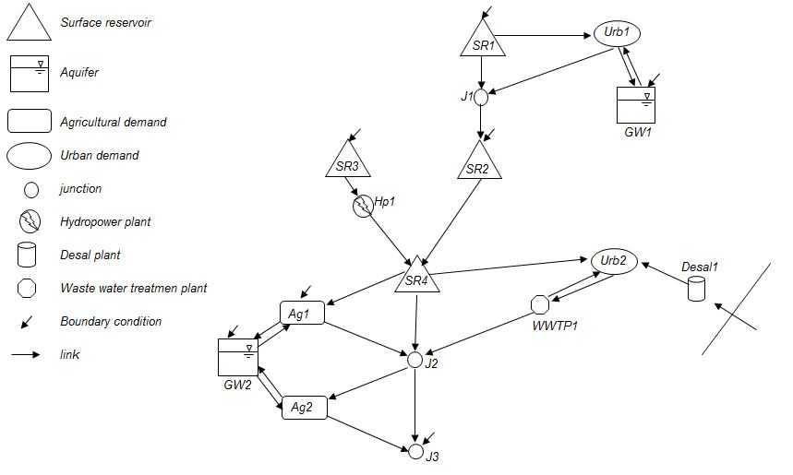

Model input data include priorities of allocation on each demand node, lower/upper bound on the storage capacity, lower/upper bound on flow capacity in each link, flow multiplier for each link, inflow to storage nodes, and target demand levels for each demand node. Two different datasets are presented here to show how Demo 3 model results change based on a diverse set of input data. The first dataset is referred to as ‘non-shortage scenario’ where available supply from storage and groundwater nodes is lower than required demand. In the second dataset, known as ‘shortage scenario’, target demand levels are increased in the second and ninth (last) month to generate scarcity.

Demand data are presented below in CSV (Comma Separated Values) format for nine time steps (months). Table below shows and compares target demand levels for the ‘non-shortage’ and ‘shortage’ scenarios.

|  |  |  |  |  |  |
| --- | --- | --- | --- | --- | --- |
| **Target demand level for non-shortage scenario** | | | **Target demand level for shortage scenario** | | |
| Node | Time-step | Demand level | Node | Time-step | Demand level |
| EndPt | XXXX-01-01 | 15 | EndPt | XXXX-01-01 | 15 |
| EndPt | XXXX-02-01 | 16 | EndPt | XXXX-02-01 | 160 |
| EndPt | XXXX-03-01 | 14 | EndPt | XXXX-03-01 | 14 |
| EndPt | XXXX-04-01 | 15 | EndPt | XXXX-04-01 | 15 |
| EndPt | XXXX-05-01 | 15 | EndPt | XXXX-05-01 | 15 |
| EndPt | XXXX-06-01 | 15 | EndPt | XXXX-06-01 | 15 |
| EndPt | XXXX-07-01 | 14 | EndPt | XXXX-07-01 | 14 |
| EndPt | XXXX-08-01 | 15 | EndPt | XXXX-08-01 | 15 |
| EndPt | XXXX-09-01 | 16 | EndPt | XXXX-09-01 | 160 |
| Urb2 | XXXX-01-01 | 60 | Urb2 | XXXX-01-01 | 60 |
| Urb2 | XXXX-02-01 | 60 | Urb2 | XXXX-02-01 | 600 |
| Urb2 | XXXX-03-01 | 60 | Urb2 | XXXX-03-01 | 60 |
| Urb2 | XXXX-04-01 | 62 | Urb2 | XXXX-04-01 | 62 |
| Urb2 | XXXX-05-01 | 62 | Urb2 | XXXX-05-01 | 62 |
| Urb2 | XXXX-06-01 | 65 | Urb2 | XXXX-06-01 | 65 |
| Urb2 | XXXX-07-01 | 69 | Urb2 | XXXX-07-01 | 69 |
| Urb2 | XXXX-08-01 | 69 | Urb2 | XXXX-08-01 | 69 |
| Urb2 | XXXX-09-01 | 64 | Urb2 | XXXX-09-01 | 640 |
| Urb1 | XXXX-01-01 | 43 | Urb1 | XXXX-01-01 | 43 |
| Urb1 | XXXX-02-01 | 43 | Urb1 | XXXX-02-01 | 430 |
| Urb1 | XXXX-03-01 | 44 | Urb1 | XXXX-03-01 | 44 |
| Urb1 | XXXX-04-01 | 44 | Urb1 | XXXX-04-01 | 44 |
| Urb1 | XXXX-05-01 | 46 | Urb1 | XXXX-05-01 | 46 |
| Urb1 | XXXX-06-01 | 49 | Urb1 | XXXX-06-01 | 49 |
| Urb1 | XXXX-07-01 | 50 | Urb1 | XXXX-07-01 | 50 |
| Urb1 | XXXX-08-01 | 50 | Urb1 | XXXX-08-01 | 50 |
| Urb1 | XXXX-09-01 | 47 | Urb1 | XXXX-09-01 | 470 |
| Ag2 | XXXX-01-01 | 21 | Ag2 | XXXX-01-01 | 21 |
| Ag2 | XXXX-02-01 | 21 | Ag2 | XXXX-02-01 | 210 |
| Ag2 | XXXX-03-01 | 21 | Ag2 | XXXX-03-01 | 21 |
| Ag2 | XXXX-04-01 | 21 | Ag2 | XXXX-04-01 | 21 |
| Ag2 | XXXX-05-01 | 22 | Ag2 | XXXX-05-01 | 22 |
| Ag2 | XXXX-06-01 | 22 | Ag2 | XXXX-06-01 | 22 |
| Ag2 | XXXX-07-01 | 22 | Ag2 | XXXX-07-01 | 22 |
| Ag2 | XXXX-08-01 | 22 | Ag2 | XXXX-08-01 | 22 |
| Ag2 | XXXX-09-01 | 21 | Ag2 | XXXX-09-01 | 210 |
| Ag1 | XXXX-01-01 | 27 | Ag1 | XXXX-01-01 | 27 |
| Ag1 | XXXX-02-01 | 27 | Ag1 | XXXX-02-01 | 270 |
| Ag1 | XXXX-03-01 | 27 | Ag1 | XXXX-03-01 | 27 |
| Ag1 | XXXX-04-01 | 27 | Ag1 | XXXX-04-01 | 27 |
| Ag1 | XXXX-05-01 | 27 | Ag1 | XXXX-05-01 | 27 |
| Ag1 | XXXX-06-01 | 29 | Ag1 | XXXX-06-01 | 29 |
| Ag1 | XXXX-07-01 | 29 | Ag1 | XXXX-07-01 | 29 |
| Ag1 | XXXX-08-01 | 29 | Ag1 | XXXX-08-01 | 29 |
| Ag1 | XXXX-09-01 | 28 | Ag1 | XXXX-09-01 | 280 |

## Input data structure

Hydra can be used as a data management tool for any network modelling problem as in Demo 3. Input data presented in the previous section will be restructured in order to be hydra-compatible. This will also require reformatting some of the syntax of the GAMS code. Input data in section above are re-written in the format shown in figure below. Note that, due to brevity, only part of the reformatted data for the ‘shortage’ scenario is shown in figure below. These data include target demand levels and priorities and are defined over the demand (consumption) nodes. All remaining parameters also follow the same structure.

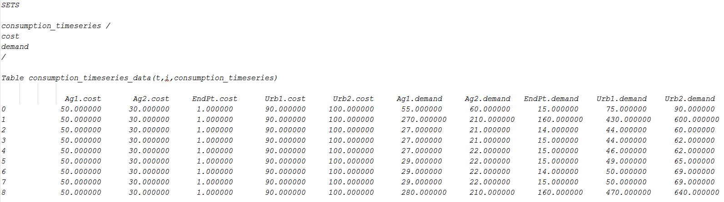

## Results and Discussion

Target demand levels significantly increases in the second and last time step (ten times in magnitude). This increases the chance of scarcity and the level of infeasibility in the modelled system. Demo 3 model can handle scarcity. Demo 3 maximises the level of demand satisfaction $α_{i}^{t}$ for each demand node *i* in each time-step *t*, which is a decision variable varying between zero (target demand is not satisfied) and one (target demand is fully met). Results of applying Demo 3 under the ‘shortage’ scenario are shown below. The ‘shortage’ scenario is identical to the ‘non-shortage’ one except for the higher target demand levels in time steps 2 and 9.

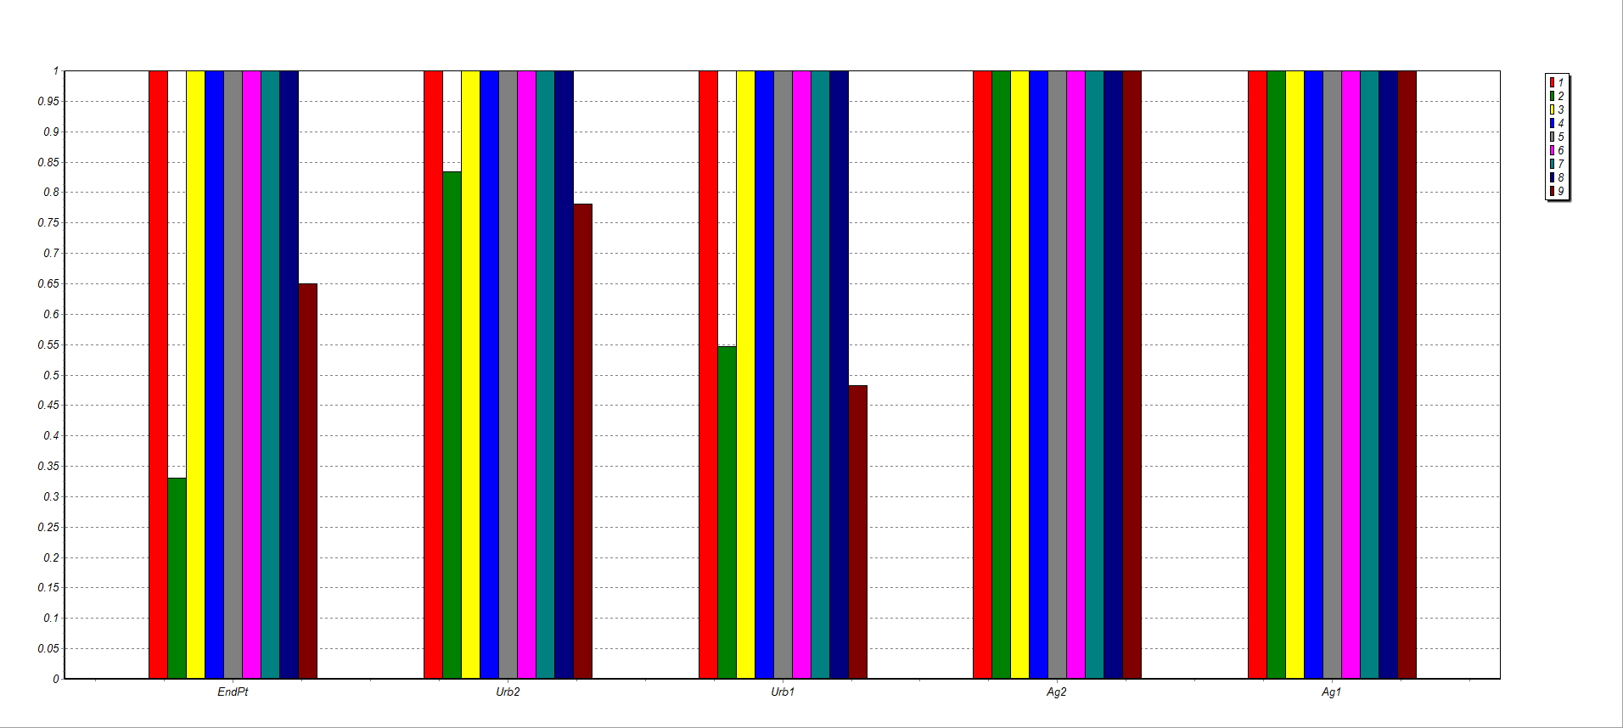

For simplicity, we only show and discuss the value *αit*. With increased amount of target demand for the second and ninth time step, ‘Urb2’ receives more water than ‘Urb1’ and ‘Endpt’ based on priorities. ‘Ag1’ and ‘Ag2’ meet their full demand since the total upper bound capacity on the incoming links is higher than the required level of demand. This is not the case for urban node ‘Urb2’, where upper bounds on links limit the amount of water allocated, even if there is enough supply from storage node ‘Desal1’. The percentage of *αit* for this node is equal to 83% and 78% for time step 2 and 9 respectively. Scarcity also occurs for demand nodes ‘Urb1’ and ‘Endpt’, for which *αit* is equal to 54% and 33% for time step 2 respectively and equal 48% and 65% for time step 9 respectively. The level of demand satisfaction at time step 2 is higher for ‘Urb1’ than ‘Endpt’. This is because ‘Urb1’ has a higher priority than ‘Endpt’. This does not occur at time step 9 because of the lower bound capacity set on storage for node ‘GW1’ (much of the available water is kept to meet the lower bound constraints, i.e. 300).

In summary, Demo 3 model allocates scarce water to demand nodes based on priorities and given limitations on links/storage capacity (upper/lower bound constraints). Such limitations represent possible political, social and environmental restrictions. Another advantage of Demo 3 is that it easily allows assigning priorities: one number for each demand node. On the contrary, in Demo2, priorities were assigned to all links/arcs, and in case of large networks, one would need to specify priorities for large number of links. It would also be difficult to predict how the model would allocate water along all the links (i.e. which one would be the path with total higher priority?).