**Water infrastructure investment planning model formulation**

Assume a network where water is delivered from ‘source nodes’ to destination points called ‘demand nodes’. The network also contains intermediate nodes *junctions* (see ‘*junc1*’ and ‘*junc2*’ in the figure). *Qi,j,t* is a decision variable, for the flow going from node *i* to node *j*  at time t, while *Si,t* is the flow variable for optional nodes *i* at time *t*. Below the model nomenclature.

1. **Input data**

= interest rate

 = discount rate,

 = length of construction period for sources,

 = length of construction period for links,

*ft* = final year of the planning horizon,

con*i,j*= connectivity matrix (network topology)

*sundiscapi*, *lundiscapi,j*= undiscounted capital cost for optional sources and links respectively

 fixed operating costs for sources and links respectively

 variable operating costs for sources and links respectively

water demand at demand node *i*

1. **The objective function**

The objective function minimises the sum of discounted capital costs for new schemes (nodes and links) as well as fixed and variable operating costs for existing and proposed schemes.

** (1)

In the equation above:

* ‘*t*’ = annual time index,
* , = binary decision variables that activate new supply options and new links when they change from 0 to 1 during any particular year *t*,
* , = non-negative decision variables defining the supply from source *i* during year *t* and the flow from node *i* to node *j* during year *t* respectively,
* 
* 

The capital costs for new sources (*scapi*) and links (*lcapi,j*) estimated at the end of the construction period are given by the equations below, where *tt* is a counter variable for the construction period

 (2)

 (3)

1. **The mass balance equation and the capacity constraints**

The following constraints impose the conservation of flow condition at all nodes (equation 4) and the capacity constraints at all nodes (equation 5) and links (equation 6).

  (4)

  (5)

  (6)

In the equations above, *mincapSi,t*and *maxcapSi,t*are respectively the minimum and maximum capacity for nodes *i* at time *t*, while *mincapLi,j,t*and *maxcapLi,j,t*are the minimum and maximum capacity for links *i,j* at time *t*.

**Example 1**

Let us consider a hypothetical regional system below, composed by two water companies. Water Company 1 has one demand node named ‘WRZ1’, node ‘WRZ2’ belongs to Company 2. Existing (in green) and optional future (in red) schemes are represented through nodes (e.g. ‘desal’, ‘red’), interconnected via links to their respective demand nodes. Demand nodes‘WRZ2’ can also receive water from ‘WRZ1’ through an existing link (link ‘WRZ1’-‘junc1’- ‘WRZ2’ in blue) or two optional ones (‘WRZ1’-‘junc2’- ‘WRZ2’ and ‘WRZ1’- ‘WRZ2’).

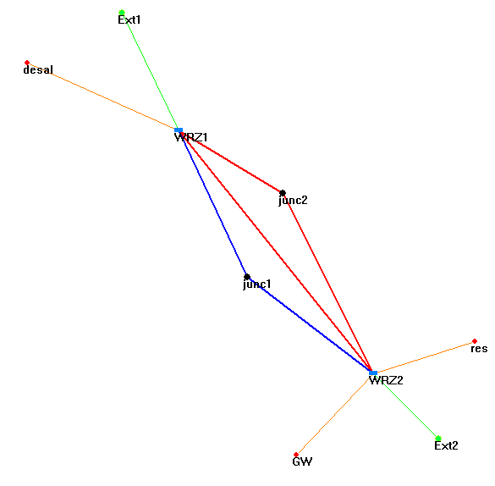

Maxcap= 50

C= 0, Ff= 0.09, Fv= 0.01

C= 2700, Ff= 225, Fv=44 0.01

Maxcap= 6

Dmax=40 [Ml/d]

Maxcap= 14

C= 19000, Ff= 300, Fv= 15

C= 0, Ff= 10, Fv= 0.07

Legend:

C= Capital cost [k£]

Ff= fixed operating cost [k£/t]

Fv= variable operating cost [k£/t]

Maxcap= maximum capacity [Ml/d]

C= 9000, Ff= 10, Fv= 15

Maxcap= 14

Maxcap= 2

Dmax=Max demand required over a planning period of 25 years [Ml/d].

Maxcap= 4

C= 21000, Ff= 250, Fv= 7

Dmax=70 [Ml/d]

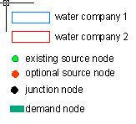

Maxcap= 4

C= 9500, Ff= 630, Fv=4

C= 0, Ff= 0.11, Fv= 0.01

Maxcap= 50

The demand required in nodes ‘WRZ1’ and ‘WRZ2’ is shown in the graph below. The planning period 26 years, from year 2010 to year 2035.

Running the Model from Hydra

This section describes how to run the EBSD tutorial model from within Hydra. It assumes that the network has been loaded to Hydra and opened (see Figure 1)

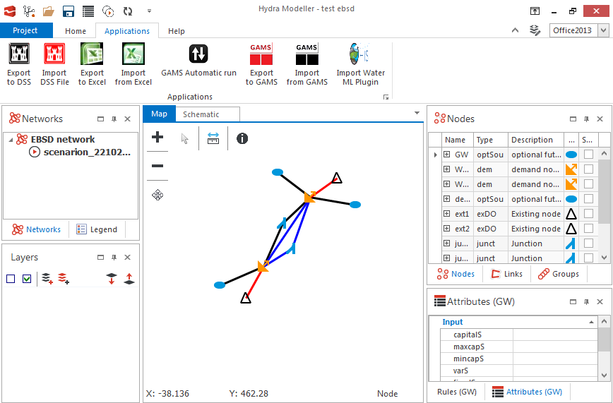

Figure

sThis model requires the GAMS Hydra plugin to be installed. Click on ‘Gams Automatic Run’ from the ‘Applications’ menu. This will open a prompt for the user to choose the network and scenario (Figure 2). Additionally, the user will be required to navigate to the EBSD_tutorial.gms file in the gams-model entry.

Finally, the user must either enter ‘01/01/2010’ as the start time, ‘01/01/2034’ as end time and ‘1 year’ as time step.

Press ‘Run’

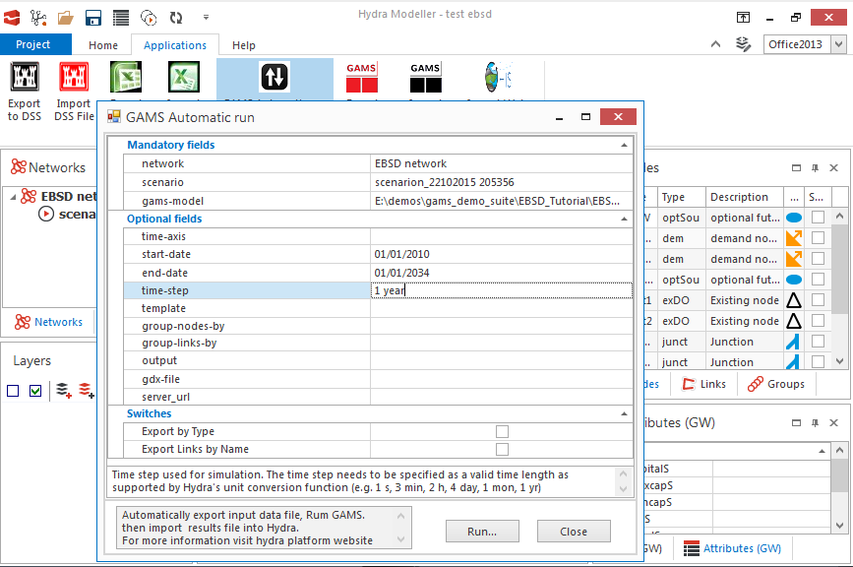

Figure 2

Upon completion, the blue bar at the bottom will be complete and the ‘messsage’ section of the resulting XML will read ‘Run Successfully’ (Figure 3).

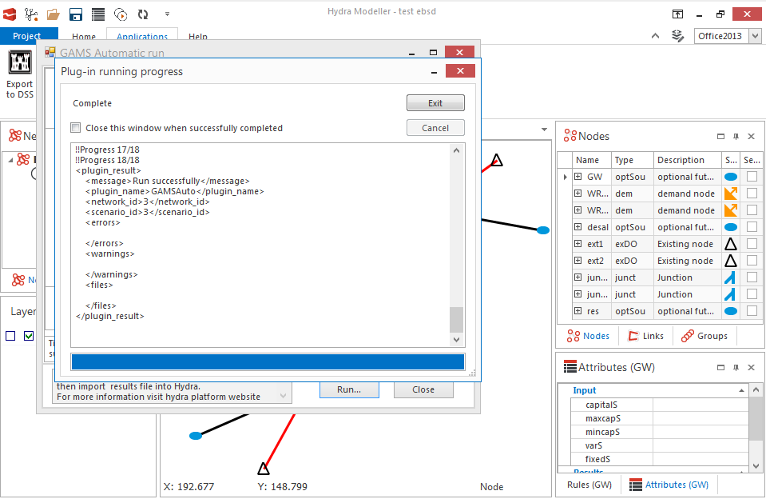

Figure 3

To test that the model has produced a result, the user must click on ‘Scenario Manager’, select the ‘Z’ attribute check-box on the left-hand pane of the scenario manager and then click on ‘Extract Data’ at the top. This will show a scalar value for Z (Figure 4), demonstrating that the Z value has been calculated.

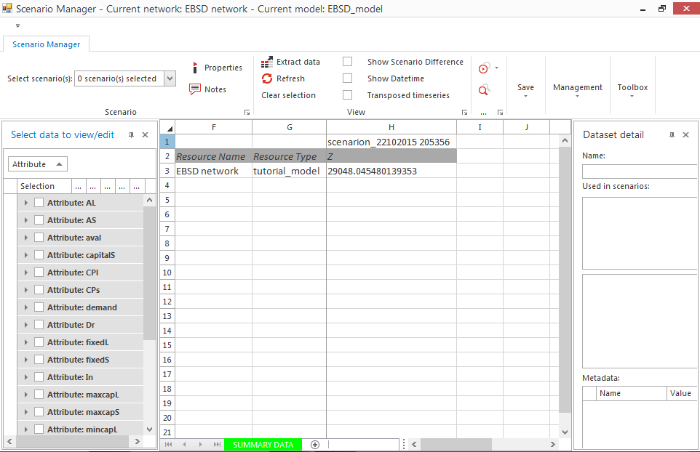

Figure 4