Undergraduate Portfolio System

Project Proposal

April 2013

Team Members

Tim Westbaker
Sam Foster
John Sullivan
Adrien Rahier
Patric Skigen
Mike Botieri
Philip Kolmar
Ben Carlson

Table of Contents

Executive Summary | page 5
Statement of Problem | page 6
Audiences  Students  Faculty  Other Audiences  Administration / Marketing  Prospective Students  Parents  Potential Employers | page 7
Project Objectives | page 12
Solution Overview  Proposed Solution  In-Scope  Out of Scope  Alternative Solutions  Technical Approach  Server side  Client Side  Source Control Management  Coding Standards  Design Approach | page 13
Definitions  Users  Groups of Users  Student Work  User Profile  Collections of Student Work | page 15
Features  User Features  All Features | page 29
Designs  Site Map  User Flow Charts  Wireframes  Storyboards  Class Diagram  Database Schema | page 33

Document To Do

Audiences

- Add Alumni

Technical Approach

- Coding Standards

Solution Overview

- Proposed solution
- Add more details to in scope and convert to paragraph
- Alternative solutions
- Design approach

Designs

- Site map
- User flow charts
- Wireframes
- Storyboards
- Class diagram
- Database schema

Executive Summary

The University of Maine does not have an online portfolio system for undergraduate students. Academic work exists only at the classroom level and students lack the tools and opportunities to share their work with a larger audience. As well, student work originates from a variety of sources including multiple classes, research labs, personal projects, among others. Students also lack tools for organizing and archiving these works.

The proposed project seeks to address these issues and more by developing a system for students to organize, share, and publish their academic work. The system will also support the discovery and sharing of excellent student work by multiple audiences including faculty, alumni, and potential employers and provide evaluation tools for students to solicit feedback from others.

The system will be implemented as a website accessible to all undergraduate students, faculty, and other groups. The remainder of this document outlines the specific reasons, approach, and plan for developing the proposed project.

Statement of Problem

Undergraduate students at the University of Maine currently lack tools for organizing and sharing their academic work during their four years at the university with diverse audiences. While mechanisms for disseminating work exist at the Graduate and faculty levels (such as academic journals and conferences), undergraduate work typically is not seen outside the classroom. Students lack the tools to fully demonstrate their academic excellence and achievement to potential employers, graduate schools, and many others.

As well, although student academic experiences are clearly defined through concrete programs of study, the associated academic work is fragmented and disordered. The academic development of the student after four years is lost and specific projects forgotten. Faculty and departments are also disadvantaged by losing exemplary classroom and student work that could be used for future classes and exciting prospective students.

Audiences

This section describes the various audiences and audience needs for a portfolio system. The primary audience is undergraduate students, followed by faculty as a secondary audience. Tertiary audiences include the administration, prospective students, parents of students, potential employers, and alumni, among others.

Undergraduate Students

Limited discovery paths exist for students to discover work and demonstrate their own work. Students are left without a representation of their academic performance because they lack the tools to present and showcase their work to others. Finding people with similar interests is also difficult, especially in other majors and colleges, however these works can serve as inspiration and motivation for academic excellence and potential collaboration. Research into past work, for example grouped by specific class work, is impossible. Finally, without dissemination avenues, students often find it difficult to demonstrate their work to a wide & diverse audience.

Students currently have limited to no feedback on their academic work except classroom-based feedback. As a consequence, students do not have the tools for evaluating quality work or improving their own work behind limited inspection.

Existing academic work is neither in one place nor organized. As a consequence, student work is fragmented according to individual classroom work and ill representative of the entire academic experience. Students do not have a way of assessing progress over their 4 years because older work is forgotten or lost.

With the existing infrastructure, it is difficult for students to share and collaborate with peers & faculty. Sharing project work requires students to maintain multiple versions of work through email, implement custom team-based software solutions, or implement some other custom solution. As well, discovering potential collaborators (such as existing peer/faculty research opportunities or interested project partners) is often hard and limited to spontaneously discovered opportunities or opportunities & peers within the major. Connecting with peers for project work because of varying schedules and a multitude of device platforms also further compounds the issue.

Faculty

Existing student feedback on work does not extend beyond the classroom or integrate well with external systems. While some feedback tools currently exist, expanding the scope of how work is viewed and the available feedback options will enhance learning and understanding. for example, grading and feedback tends to be limited to instructor responses and not include as much peer feedback. As well, viewing student work outside the classroom provides faculty with an opportunity to recognize and provide different feedback than rubric-based assessment.

Currently communicating student work is mainly accomplished through hearsay within a department. Often times, faculty need or want to demonstrate to their department, prospective students, a new class of students, or other sources excellence within their major or class. As well, sharing this work is difficult as their are no tools or mechanisms in place for maintaining and providing a consistent view of student work.

Currently, faculty networking and collaboration with students is difficult. Finding diverse students to work in a lab, especially students outside the major, is hard, especially without clear work to view. Similarly, finding students for project collaboration outside of students met through classes is hard. Helping connect students to resources (such as potential employers) can also be difficult as tools for recommending and supporting student work do not exist.

It is impossible for faculty to find exceptional student work without archiving class work on their own or networking with other class archivists. However, discovery of this work is difficult and archival and organization non-existent. Organizing, collecting, and showcasing excellent and representative work would strengthen a college's/department's/class's image to various audiences as well as provide a roadmap of a department's transition through the years. As well, faculty advisors would have a tool to track and view the development of a student throughout their time at the university.

Other Audiences

Administration / Marketing

Administration

The primary need concerning the administration audience is to find somebody with special skills (be able to take some beautiful photographs, be able to design an advert for an incoming event...).

Presently people from the administration are forced to send a general email to their different contacts to find the right person. Our system must therefore overcome this problem by proposing a efficient research tool on specific skills. The results of this research should be presented in a way to be able to compare the works of various "candidates". Finally a system of "status" to say if this person is available to do some volunteering work or if she wants to be paid for that has to be implemented. At an implementation level this function could be materialized by a filter among the search criteria. Obviously it should be possible to contact directly this selected student if necessary.

Marketing

The administration always wants UMO to look good. A system of show off repository should be implemented to be able to pick images or stories of good student. These media could potentially be used for marketing events and promotion. Finally the administration could see which departments are actually doing good work.

Prospective Students

As a tertiary audience, perspective students also have many needs that the Portfolio System could facilitate. Presently, perspective students have no window into the work being produced by current students of any level. Access to the Portfolio System would allow these perspective students to see exactly what gets produced in many courses offered within their program of study. This would give them the ability to more accurately assess their interest in the program and understand what paths are available to them. There also is no current system in place that allows for the viewing of work done by faculty. Opening up this channel would allow for prospective students to not only view this work, but also provide a convenient location to contact a faculty member that specializes in their unique interests. This combination of both student and faculty work would allow prospective students to see the major's/department's community as a whole and start to visualize themselves within it. Lastly, being able to see the growth of a current student through the entirety of a program would give a prospective student insight into potential careers upon graduation. Knowledge of the future is one of the primary decisions behind prospective students ultimately choosing a program to follow, thus the Portfolio System should be able to accommodate this need.

Parents of Students

Parents of current and prospective students comprise a peripheral yet important audience for the portfolio system. Currently their access to student work is largely limited to what their child might choose to share with them or what they can glean from various 'featured student' columns throughout the university and department websites.

For parents of current students, the portfolio system provides access to their child’s work while they are away at school. They can view other student's work as well, which will allow them to easily gauge how their child is performing compared with other students in their department or even university-wide. Parents will also be able to track their child's progress over time, and have a better sense of their ongoing development. The portfolio system provides parents an easy way to share their child's work with others for several reasons, from simply showing off as a proud parent to showing work to potential employers or financial assistance sources (i.e. scholarship funds, etc.)

Parents of prospective students would benefit greatly from the portfolio system by having access to a university-wide repository of student work that they could browse. With this tool they could investigate different majors and departments that would help them and their child make informed decisions about where and what they would like to study, and gain a clear idea of the quality of the education and department that their child might enter into.

Potential Employers

Any excellent academic work that might help employers find students (potential employees) is difficult to access at best. This means that it is hard for employers to compare students based on their actual work. The employer can has limited ability to see the level of student motivation and a complete list of their activities. It is also difficult for employers to get a sense of the university community, the level of academic commitment of students on a particular campus and the quality of academic work that is produced from the undergraduate community. This leads to the difficulty of comparing students from university to university, and how their work compares to students at different universities.

While the job market affects what courses and information are important in a given academic path, the process is often delayed. Due to this many potential employees lack the skills that their field is using or is transitioning too. The lack of direct involvement of employers in informing academic paths means that students are not as focused on learning important information in their field as they could be.

It is difficult for employers to views student skills that might apply in the job market. Without seeing these specific skills it can be hard for match students to the jobs that would fit them the best.

Alumni

Alumni are another small but important audience for the portfolio system. Their usage falls in two general categories: previous students that have used the portfolio system and wish to have access to their undergraduate work after graduation, and alumni that can provide feedback for current undergraduate students. The two groups are not mutually exclusive and presumably many alumni would fall in both.

For graduated students who have used the portfolio system during their UMaine career, the portfolio system gives them a useful tool for showing their work to potential employers or graduate programs. Not only can it function to display an alumnus’ best or featured work, it can also show the development of the student through their undergraduate career.

Alumni can be invaluable sources of feedback for undergraduate work. Having graduated from a specific department and area of study, they represent an ideal target for students in this regard. They will have a strong knowledge of the subject matter, an understanding of the demands and expectations of the department/class/field, and in many cases will also have professional experience coming directly from their own related studies.

Project Objectives

So as to address the primary needs of all of the audiences, this project will focus on accomplishing the following objectives:

• Provide access to student academic work
• Network students with other audiences
• Facilitate communities around academic work

Providing access to student academic work entails facilitating the discovery of excellent student work for all audiences. In addition, students need to be able to organize and archive their own work, allowing them to track their progress as well as show exemplary work to the general public. Faculty also need tools to track students and showcase excellent student work such as for a specific class or .

Networking students with other audiences means providing social tools for connecting users to students. Networking may occur in any of a multitude of directions such as students using their portfolio in their resumes for potential jobs, potential employers finding excellent students, or peers finding potential collaborators, etc.

The objective of facilitating communities around academic work is to leverage online tools for strengthening the academic experience. Because student work is on-going, students need tools for sharing work with peers and soliciting specific feedback on works in progress. As well, contributing and exploring works within specific communities enhances learning and academic excellence.

Solution Overview

Proposed Solution

We propose the construction of the Undergraduate Portfolio System, a web application containing the following components:

- An undergraduate student workspace in which they can upload, edit, display and share their academic and personal work online with peers, faculty, administration, parents, potential students, alumni and the general public.
- A publicly viewable catalogue of undergraduate student work that can be browsed and searched based on several criteria including: subject/type of work, department, student profiles, user-created groups, special interests and more.
- A robust networking system that enables students to solicit and receive feedback on their work, fosters collaboration between students, gives faculty a utility to help organize and review classroom and field-based student work, and connects students to other students, faculty, advisors and others via flexible user groups, related work and peer profiles, direct messages, ‘following’, comments, and evaluation systems.

In Scope

- Undergraduate student portfolio system, as defined above
- System integration with other tools like classroom project tools
- Student authentication linked with MaineStreet student account
- Application documentation

Out of Scope

The proposed project will not be providing portfolio functionality for graduate, faculty, or alumni work. As well, sophisticated collaboration tools such as managing project files like Dropbox, planning tools, and other group-based collaboration that is outside of basic sharing for feedback and project viewing will not be included.

Alternative Solutions
The possibility of University of Maine adopting a 3rd party electronic portfolio system such as Behance, Carbonmade or ePortfolio was considered. However, the extensive customization that would be necessary to fully address the specific needs of the University of Maine community are not feasible, leaving any such solution a compromise at best. Additionally, developing in-house represents a substantial cost savings over the purchase or subscription to a 3rd party system.

Technical Approach

The technical decisions were made primarily out of convenience to leverage existing skills and implementations in other projects. Distinct libraries were chosen instead of customizing a content management system to minimize extraneous functionality and ease adoption by new developers. As well, additional libraries can be added to the system with relative ease.

Server Side

The backend will be developed using a LAMP setup http://en.wikipedia.org/wiki/LAMP_(software_bundle). Page requests will be managed by the library Slim http://www.slimframework.com/ and database access will use the active records implementation provided by Paris https://github.com/j4mie/paris. Twig will be used for rendering html templates http://twig.sensiolabs.org/.

Client Side

Twitter bootstrap will be used to ease html structures and JQuery will be used for DOM manipulation where necessary. Other JavaScript frameworks will be explored as needed such as underscore.js and JQueryUI.

Source Control Management

To manage code between developers git will be used to mange the application code. For tutorials see http://sixrevisions.com/resources/git-tutorials-beginners/.

Coding Standards

Design Approach

Users
- (Anonymous) Viewer – Non-registered person who browses work and students
- Registered Member – A registered user who can participate in groups (e.g. Alumni, Parent, graduate student)
- Student – An undergraduate UMaine student
- Faculty – A UMaine instructor
- Group – a collection of people for a common purpose (e.g. feedback, collaboration, viewing work, etc.)

Work
- Media Item – An instantiation of content of a specific type
- Media Set – A collection of media items of the same type
- Project – A collection of media with context
- Portfolio – An individual student’s collection of projects. A student may have multiple portfolios (e.g. job, academic, photography)

Collections
- Private Gallery – A collection of projects within a group that are shared internally; can solicit and provide feedback within the group
Global Terms & Definitions

- Public Gallery – A collection of projects within a group that are shared publically.
- Category – A collection of projects under the same theme (e.g. Design, Photography, Interaction, Programming). Categories are fixed, and may have several sub-categories.
- Bookmarked – Collections of projects marked by a user (e.g. ‘favorites’ or custom ‘folders’)
- Featured Work – Automatically generated project collections generated by specific criteria and presented on the home page
  - ‘Top’ – Highest rated projects
  - ‘Hot’ – Most highly rated in the last day
  - ‘Recent’ – Recently added work

Feedback
- Comment – A textual response to a work
- Rating – A like/appreciation of a project or portfolio
- Evaluation – An assessment of a project in response to a specific solicitation (form)

Users

Users are registered and non-registered individuals who interact with the portfolio system. User types include anonymous, member, undergraduate student, and faculty. Members have all of the same features as an anonymous user and students and faculty have all of the same features as a member. For detailed features associated with users, see the Features > User Features section.

Anonymous
Member
Student(Undergraduate)
Faculty

Anonymous

Anonymous users are users who are not logged into the system, i.e. the general public viewing the website. Publically accessible work and portfolios are available for browsing.

Member

Members are generic, logged in registered users of the portfolio system. Any person from any audience can become a member, such as an alumni, graduate student, potential employer, and parent. All members may participate in groups (for viewing, evaluation and feedback) but only undergraduate students may post work to the system.

Student

A student user is a specialized type of registered user. A student user is a registered member who is also an undergraduate student at the University of Maine. Any other student type (such as a graduate student) cannot become a student user. Students are the primary user group. The primary function of students is to manage their portfolio and works.

Faculty

A faculty user is another specialized type of registered user. A faculty user refers to a professor or instructor at the University of Maine.

Groups of Users

A Group is a set of people who share a common attribute or interest. (See below for different examples of groups).

Intrinsically a group has two sections: on the one hand the “Works In Progress” (Private Gallery) section which is compulsory and by default private. On the other hand, the “Public Gallery” section is optional and as its name indicates is publically visible.

Works in Progress

This section is a dedicated space for members who want to receive feedback on their projects. Works in progress are shared within a private gallery, where only the group’s members can view and interact with them.

Public Gallery

This gallery is designed to show some finished works. It’s public and accessible by anybody.

Synthesis diagram:

Concrete example of group:

In the New media group we have a dedicated section for the work in progress. Only members of the New media group can access this section. Anonymous users can only see the public gallery with fully functional works.

External functioning of a group:
- you can create a group (you will become the admin)
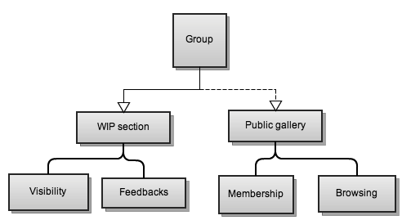
- you can follow a group (ie you will received notification as soon as a public work is published)
- you can invite a member
- you can delete a group (as the admin)
- you can edit the settings of the group

Internal functioning of a group

- you can take part in a group
- kick a member out
- publish work in the WIP section
- add multiple revisions of your works in the WIP section
- publish work in the public gallery (the last revision is the last accessible)
- editing your work
- push some work from the WIP section to the public gallery
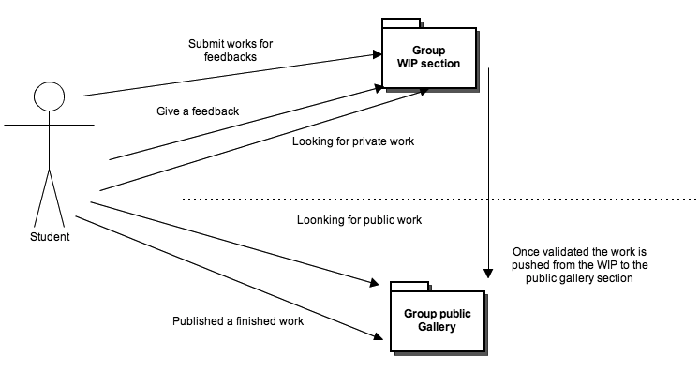
- ask for feedback
- give feedback

By default does each department have their own group?
And furthermore, do other associative groups auto-create groups? (i.e., a student is auto-added to groups for their department, college, work-study jobs, etc.)The notion of open group if accept some new admission or close group (as for example a class group)
Collaborative-work groups (work done with other students, such as research work) is now an attribute.

Do we found in the gallery systematically work from member of this group?

College
  - This group consists of individuals all within the same college.
  - Any member of the college will be able to participate in this group.
  - It functions as a basic grouping for the system.
  - This group does not separate individuals based in the department or major to which they belong.
Department
  - This group contains individuals belonging to a certain department.
  - Any member of the department will be able to participate in the group.
  - This functions as a way of grouping work into similar fields, but not to the degree of specificity of an individual’s major.
  - This group doe snot separate individuals based on their major or the classes they are taking.

Major
  - This group is comprised of individuals in the same major.
  - Any member of said major may participate in this group.
  - This functions to assemble all the students within a major who will have similar work.
  - This level of classification will not differentiate students based on what classes they may be taking.
Class
  - This group is includes individuals in the same class.
  - Any member currently enrolled in the class may participate in this group.
  - This functions as the most specific group as far as academics go. Students may view work that has been done in this class during past terms and may even allow the students to view current student’s work on previous projects.
  - This group does not allow for students to collaborate on projects (see collaborative-work groups) but does allow feedback on projects.
Personal
  - This is not a group, but rather a class of groups. Personal groups are essentially any group that members are able to create and then cater to their needs. If a group is automatically created based on their academic information and current class list.
  - The following lists (Interest, Clubs, Job, and Collaborative-Work) are just templates of settings for group visibility and membership.
  - Most settings should be editable after creation with the exception of interest groups. Interest groups are designed to be community groups where any member can join and make contributions.
  - This group is created by an individual for personal use, such as organizing friends and colleagues of non-academic projects.
  - Since this group is created by the user, the user (who is now the administrator) may choose who participates in the group. This includes the option of allowing users to freely publish work on the groups public gallery, or whether permission must be granted.
Interest
    - An interest group is a group created by the community to showcase a collection of work based on a particular interest.
    - Since these groups are based purely on interest, these groups will completely public meaning any user may join or leave the group at any time.
    - Any individual seeking feedback on a piece of work may post the work-in-progress to the group, where any member may provide feedback on the piece. If a member publishes a work, they may choose to also publish to the interest group, which would be viewable by anyone who chooses to look at the group, regardless of whether or not they are a member of the group.
    - This group is not for private projects or work that a user does not want to be viewed by others.
Clubs
    - Club groups are created by members or leaders of a particular club or other extracurricular group to help organize and facilitate communication among members.
    - Upon creating the group, the administrator may choose to make a group open (like interest groups where members may join or leave at any time) or closed (members request to join and must be approved by a group administrator).
    - When work is finished in a club group, it may be either made available to to the public or only viewable by members.
    - This group is not for classwork or purely for interests even though a club may be formed around an interest (i.e. a photography club).
Job
    - Job groups are for groups of students employed on campus.
    - Only students who are actively employed for a specific job may be members of the group. Or example, only students who are actively employed at ASAP Media Services may be part of this group.
    - Job groups, like other groups, have a private section where members may create projects and other members can provide feedback. When a work is finished, the work has an option to be published so non-members may see the work.
    - This group is not for a club or personal, non-academic, non-job related work.
Collaborative-work
    - A collaborative-work group is formed by a group of students working toward a common goal. This is most typically school work such as a group project, but may have other applications as well.
    - Any student member may create a collaborative-work group and invite others to the group.
    - This group, while shared by the members, is private until the work is published. Most times, the finished work will be published to a different group (such as a class) but published work may also be viewable by the public.
    - This group is not for a single member, but rather several students working on a common project.

Projects

A project is any work created within a specific context. At the most basic level, a single student project is a collection of media (links, audio, images, video, text, interactive apps, and others) and contextual information describing the work. Examples of work include class work, personal projects, photography, employment projects, research, extracurricular work, and so forth.

Project (Student work)
Media Set
Media
Media

Media
Context

Media

Media are the containers for pieces of a student work. Users create media by providing the content for a specific media type, for example by uploading a file or providing a link to other media on the web (such as youtube, vimeo, Flickr, etc.). A single media item is a container for a specific type of content. It may be displayed by itself or multiple medias of the same type may be grouped into a media set.

Media Item

A media item is a container for a specific type of content. Usually a media item is tied to a single file, a link, or some other data provided by the user. Media items also include meta information about the content type, which may include specific technical information like encoding format or more general information such as title and location. Media items are also visual containers for content and display properties and templates are specified for each media item. Example media items include:

- Video
- Image
- Text
- Link
- Audio
- Interactive Widget
- Download file link

Media Set

A media set is a collection of media items of the same type. Example media sets include:

- Image Gallery – a collection of images
- Playlist – A collection of audio files
- Video Gallery – A collection of videos

Contextual Information

Because student works come from a variety of sources, there is a lot of rich information than can be extracted about the time, location, event if applicable, description, type of work, associated groups, collaborators, completion status, and self evaluation. Contextual information that will be collected includes:

- Completion Status (Work in progress, complete)
- Type of work
  - Class Work
    - Capstone/Thesis Details
      - Title, Abstract, Defense Date, is Honors
    - Dept. Name & number
    - Instructor
  - Personal Project
    - Job
      - Client, employer, Job description
    - Extracurricular
      - Whoa
- Date started / finished (semester or date range)
- Description of work (goals, assignment, background information, etc.)
- Other collaborators
- Category(s) work belongs to
- Self-assessment

Published Projects

When work is designated as complete, it may be viewed publically. When work is publically, it is tagged with the following information:
- Number of views
- Ratings
- Comments

Feedback

Feedback functions in two distinct ways:

First, for work in progress, students can solicit other users to provide evaluation for a specific work. Students create custom questions and allow other users to view and evaluate their work using the questions. Summary of responses are available.

For public work, registered members can rate a work with a ‘like’ or ’appreciation’ designation. Ratings form the basis of the ‘Featured Work’ collections along with number of views to rank projects into ‘Top’, ‘Hot’ and ‘Recent’ categories. Additionally, members can leave comments for public work. The owner of the work has permissions to turn off or delete comments for their project if they so choose.

Are there any customized feedback features for faculty?

Portfolio

A portfolio is an individual student’s grouping of one or more of their own projects together for display. A student may have any number of portfolios, arranged for any reason: type of work, subject, academic, personal, for potential employer, etc. Alternately, a student may choose to have just one that holds all of their work.

User Profile

Profiles provide contextual information about a single individual by describing who she is, academic interests, and other defining information. The system can use this information to strengthen search results, suggest similar related people and work, and help contextualize users. Basic profile information for each registered user type are provided below. Note that students and faculty, as specialized member users, will have most of the same information as members.

Member

- Name
- Academic interests
- Description
- Picture
- Type (member only): Alumni, Parent, employer, prospective student, University employee

Student

- Year in school
- Expected graduation
- Majors / Minors
- Availability status (Looking for opportunities)
- working at _____
- Plans after school

Faculty

- Associated Departments
  - Interests/Research
  - Classes Taught

Bookmarking and ‘Following’ Work

There are two user designations of collecting work: bookmarking and ‘following’.

Bookmarked work is collected together by any registered member, and is available to view from the member’s own homepage. (Also can be thought of as ‘starred’ work). Work can be bookmarked at several different levels, from individual projects, to portfolios, to public galleries, groups, categories, portfolios, etc. Bookmarking work does not endow it with any special functionality beyond allowing it to be easily accessed by the member that bookmarked it.

‘Followed’ work is similar, but tied to the system’s notification system. If the ‘followed’ work is edited, upgraded to complete or deleted, the member will receive a notification.

Collections of Student Work

The following*****This section should be reworked?, as they are now a function of categories, groups, bookmarking and ‘following work’. The term ‘collections’ now refers to nothing more than a generic grouping of student work..*****

A collection of student work is a set of work that shares some common similarity. The similarity may be intrinsic to the works, user specified, or group based. Types of collections are a result of a relationship between works and users and groups (see ‘Types’ below). Works are grouped into collections, ultimately, to facilitate browsing, sharing, and feedback.
Types

User Collections
- personally gathered public works
  - A collection of work that a user creates to showcase

- All works by a single student
  - All of the work organized and archived by a student.

- Published works by a student
  - Work from a single student viewable by the general public.

- Favorited collection
  - All the work the user has favorited

Group Collections
- Works that belong to members of a group (publicly visible)
  - A collection of work publically available completed by members of a group. For example, department work, specific class work, major work, etc.

- Works that are shared with a specific group (privately)
  - A collection of work visible to users in a specific group. Users may also solicit feedback from the group.

General Work Collections
- Works grouped by contextual information
  - A collection of work such as extracurricular work or within a specific interests or category.

- Recent, hot, & top work
  - Collections of work that systematically change based on viewership and ratings.

- Media collection
  - All photos, all videos, etc…

Possible Collections
- Personal collection (all of the users work)
- Dept. Collections (all NMD work, all CMJ work, etc)
- Class collections (all NMD 102 work, all CMJ 236 work etc)
- Major collections( all New Media work, all Journalism work, all Marine Bio work, etc)
- Media collections (all photos, all videos, all coding)
- Favorited collection (all the work the user has favorited)
- Top collection (most favorited works)
- Extracurricular collection (any work done outside of class, such as for a job)
- Public collection(all published works)
- Focused collections(all work done for a particular interest, as specified by the context of the work, potentially based on tags)
- Most-recent Collection(most recently uploaded work)
- Suggested collection (user specific collection based on the users interested and what works they favorite)

Collection name

- description
- Collections are formed in a variety of ways. Some are automatically formed, as in the case of group-based collections: each group generates its own collection. Some are formed via context – tags and metadata sort works into collections how does it function? (what does it do?)
- context of use (diagram)
- Who uses it? How does it connect to other users? Groups?
- What does it not do?

Features

User Features

This section describes what features are available to which audiences. Note that students, faculty, and members all have access to anonymous features and students and faculty have access to member features.

Anonymous User Features

- Browse student work in collections
- View student profiles
- Browse groups? Collections? -> What specifically and how?
- Search for students, work, or group
- Register account
- Flag content as inappropriate
- Like with Facebook, G+

Member Features

- Join/Create groups
- Create profile
- View private work shared with group
- Comment and rate work
- Suggest students/work to other users
- Provide feedback on work
- System suggests students with similar/complementary interests
- Manage account
- Follow Student, Group, Gallery (receive notifications)
- Send direct message to student (potential collaboration, lab/job opportunities, other)

Student Features

- Create student profile
- Organize and archive work
- Share work with public
- Solicit specific Feedback on work-in-progress from a group
- Share work and work-in-progress with peers
- Delete account & data

Faculty Features

- Create Faculty profile
- Organize past student work from class
- Create a group

All Features

This section organizes system features into common feature groups and further explains what the feature is.

Account

- Register new account
Creates a new member, student, or faculty member
- Delete account and data
Removes all data and account information
- Manage notification settings
Set notification methods (email, text) and notification types to receive

Profile

Profiles are available to any logged in user, however, different user types have different profile information. See Definitions > User Profiles for specific differences.

- Update profile information
Change profile information such as description, interests, etc.
- View profile
View any user’s profile information

Notifications

- List of recent news

- The number of recent news events will be shown on the user’s toolbar
- These will be sorted chronologically
- The less important notifications will be marked as read when they are viewed; this occurs when the user views the dropdown notification list from the toolbar as well as visiting the “Notification Center” where they can view all of their alerts, current and past. More important notifications will need to be marked as read or acted upon (which can be done by clicking the specific alert and going to the page the notification is referencing) before they are dismissed
- A different color font, a different formatting style, or a distinguishing icon will differentiate between notification types. They will consist of the following
- Administrative Notifications
    - A group you administer requires attention (this is an example of when the notification would appear, but wouldn’t be dismissible until the message is explicitly marked as read or acted upon before, regardless of whether it has been viewed or not)
    - This notification will be used when a work in the administrator’s group was flagged as inappropriate
    - This notification will be used when a user requests to join a private group
- Feedback notifications
    - A user receives feedback on a project of theirs
    - Another user personally requests feedback from said user (this is considered to be an important notification and will need to be marked as read or acted upon)
- Group notifications will be received when
    - A group the user follows publishes work
    - A group the user belongs to publishes work publically, or creates a new private work
    - A group that user belongs to requests group feedback
- Following notifications will be received when
    - Another user follows that user
    - Someone the user is following publishes a work
    - A bookmarked project is removed

Student Work

- Create new work
- Organize work
- Publish
- Share work with limited audience
- Solicit Feedback
- Faculty: Organize past student work from class

Browsing Work

Navigation - Except where noted, navigation features are available to all types of users (anonymous, registered members, students and faculty)

- Search – Basic search bar that is featured on all main pages. Returns both Profiles and Projects. Search function queries the following items
  - Students – returns student profile and associated projects
  - Faculty – returns faculty profile and associated students/projects
  - Group
  - Project name
  - Portfolio name
  - Keywords – department, class, category
- Filter – Advanced Search page, allows user to filter for profiles and projects by:
  - Department (Major)
  - Class
  - Category
  - Group
    - Public Gallery
      - My Groups (for logged in users)
    - Private Gallery (available to group members only)
      - My Groups
  - Rating (projects only – not profiles)
  - Time/Recent (projects only)
  - Most Viewed (projects only)
  - Academic Interests – (required field on student profile)
- Featured – On main browsing pages (homepage)
  - Top – returns highest rated projects
  - Hot – Highest rated in last <timeframe>
  - Recent – Recently added
  - Popular – Most viewed in last <timeframe>
- Suggested – profiles and projects, based on:
  - User interests
  - User departments
  - User-related projects
  - Viewed profiles
  - Viewed projects
  - Rated projects
* User controls:
- “Suggested to you because you liked/viewed/are interested in/etc….”
- User can delete associations and suggestions to build up suggestion profile over time

Interacting with Work – Features available to registered members only, except where noted.

- Profiles:
  - View (available to anyone)
  - Send message
  - Bookmark work
  - Follow
  - Share –
    - To other members
    - To Facebook, Google+, etc.
    - Link (available to anyone)
- Public Projects:
  - View (available to anyone)
  - Comment
  - Message owner
  - Bookmark
  - Follow
  - Share
    - To other members
    - To Facebook, Google+, etc.
    - Link (available to anyone)
  - “Like”/Rate – “like” and share might be the same for external social networks
    - should these be separated into two separate available functions, or just keeping one or the other?
    - Like = Thumbs up, ‘appreciate’,
    - Rate = Scoring system: 1-5 stars, grading, etc.
  - Rate
  - Flag as inappropriate
- Private Projects/Works in Progress (only available to group members)
  - View
  - Give evaluation based on owners solicitation (owners might include a faculty member that is the owner of the group)
  - Message owner
  - Bookmark
  - Follow

Networking & Social

- Join/Create Group
Discovering work :

When a user wants to discover new work we defined these three cases :

1- The user is searching for something specific: a particular student, class, faculty member, portfolio, etc. (best facilitated via search and filter features: directly get to where you need to go)

2- To browse, to discover new work based on particular criteria: browsing by categories, departments, groups, etc.


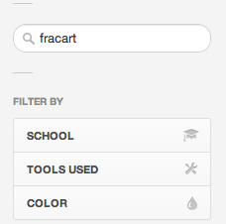
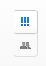
3- The 'discover' mode, where a user can meander through, and how does this work, based on associated/suggested/related work, random projects, etc. Mike suggested Netflix as a comparison, how they generate suggested movies to you...

Concrete example with other services:

Behance.net:

1- behance offers a specific search field. You can also precise a certain number of filters like: school, tools used, or color. You can also search a user or a specific project.
Once on the result page these criteria are displayed to the user

2- behance offers the possibility of browsing via a specific creative field. A preselection of field is displayed but the user can also select manually his interest.

Note that you can also sort the project by / Most appreciated / most viewed /most recent / most discussed

3- for suggesting you some interesting work Behance uses your personal tags.In general, they use filter more than suggestion.

Dribble.com:

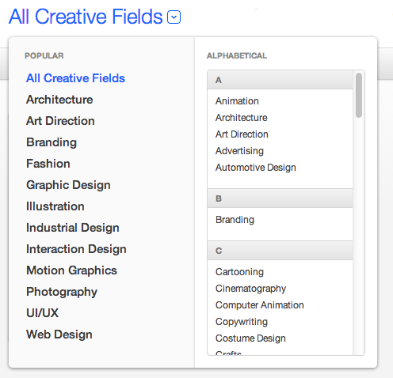
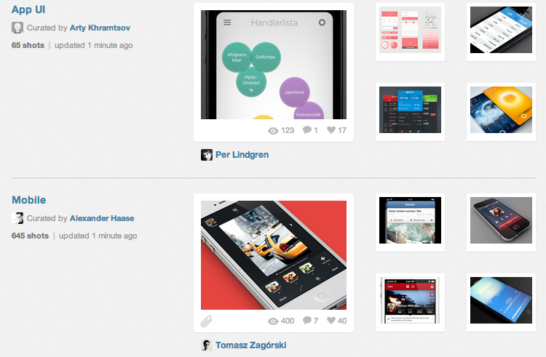
1- dribbble offers a specific research field but you can only precise the result of your research once the results are displayed.

The result are displayed in two columns “Member” and “Project” and you can sort the results by popularity and time.

2- you can explore work via a dedicated section. On the bucket panel the projects are displayed via categories.

On the highlights (the default page) you can found popular projects.

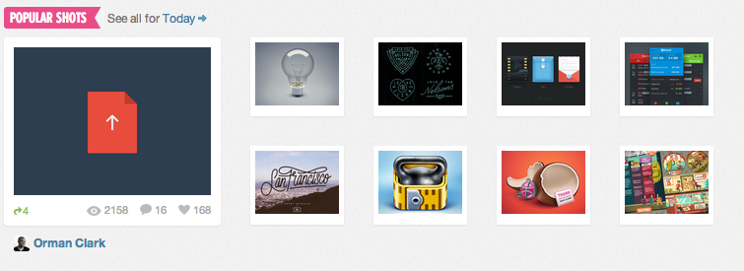
Note that you can also see the project via tags and colors (by default sorting is done on a time basis)

Designs

Site Map

User Flow Charts

Wireframes

Storyboards

Class Diagram

Database Schema

