**COMPSCI 589: MACHINE LEARNING**

**PROJECT 2 REPORT**

**Student:** Trung Dang – 33858723

1. Result from running python hw2.py

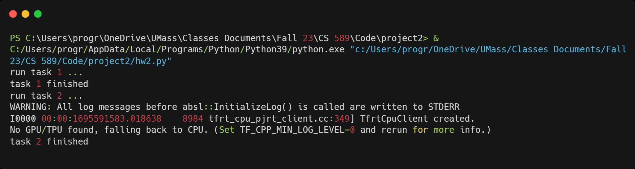

1. Task 1

* Value of the cost function at w_0 = 2:

**g(2) = 1/50 * (16 + 4 + 20) = 0.8**

* Value of the derivative of the function at w_0 = 2

**g’(2) = 1/50(4*8 + 2*2 + 10) = 46/50 = 23/25**

* Below is the plot for different step length

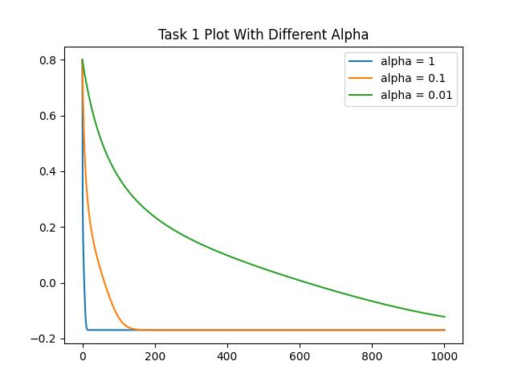

* The steplength that works best for this function is 1
* Initial point is w0 =2

1. Task 2

