Key Facts and Figures
UNGA81 | Available session records | Analysis date 2026-09-28. AI mentions: 5/6 (83.3%) reviewed Member State addresses; 6 obtained and 0 unresolved. Unobserved country-years are not counted as negatives.
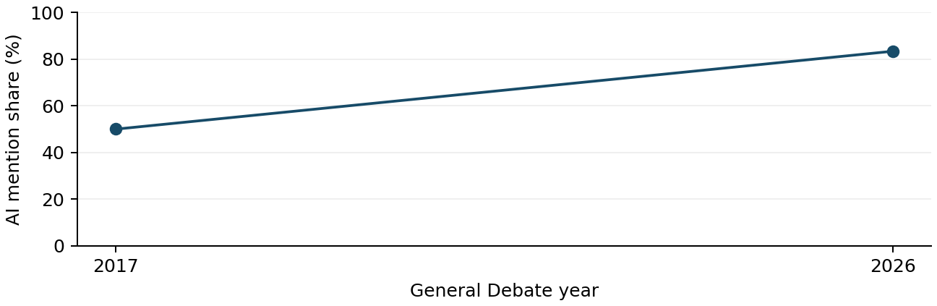
UN regional group | AI mentions n/N | Uncertain
African States | 20/30 (66.7%) | 2
Asia-Pacific States | 20/30 (66.7%) | 2
Eastern European States | 20/30 (66.7%) | 2
Latin American and Caribbean States | 20/30 (66.7%) | 2
Western European and other States | 20/30 (66.7%) | 2
United States (nonmember) | 20/30 (66.7%) | 2
Other | 20/30 (66.7%) | 2
Synthetic layout check only; no real country findings or policy claims are represented here. Synthetic layout check only; no real country findings or policy claims are represented here. Synthetic layout check only; no real country findings or policy claims are represented here. Synthetic layout check only; no real country findings or policy claims are represented here. Synthetic layout check only; no real country findings or policy claims are represented here. Synthetic layout check only; no real country findings or policy claims are represented here. Synthetic layout check only; no real [E00001; E00002; annual:1]
Synthetic layout check only; no real country findings or policy claims are represented here. Synthetic layout check only; no real country findings or policy claims are represented here. Synthetic layout check only; no real country findings or policy claims are represented here. Synthetic layout check only; no real country findings or policy claims are represented here. Synthetic layout check only; no real country findings or policy claims are represented here. Synthetic layout check only; no real country findings or policy claims are represented here. Synthetic layout check only; no real [E00001; E00002; annual:1]
Source changes: official English records (2017-2024); user-accepted automatic transcripts (2025-2026). Squares mark partial years. Regional mapping fixed at 25 September 2026.

Themes
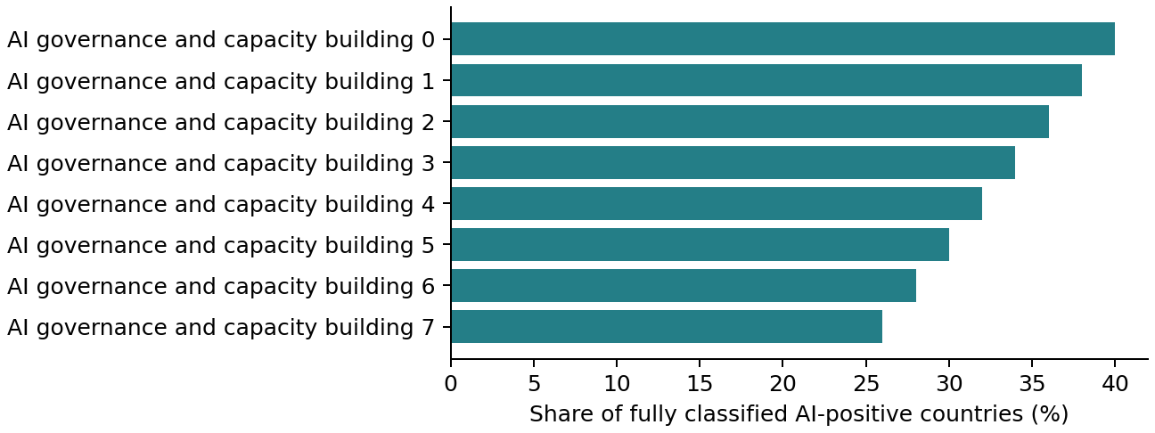
Synthetic layout check only; no real country findings or policy claims are represented here. Synthetic layout check only; no real country findings or policy claims are represented here. Synthetic layout check only; no real country findings or policy claims are represented here. Synthetic layout check only; no real country findings or policy claims are represented here. Synthetic layout check only; no real country findings or policy claims are represented here. Synthetic layout check only; no real country findings or policy claims are represented here. Synthetic layout check only; no real [E00001; E00002; annual:1]
Synthetic layout check only; no real country findings or policy claims are represented here. Synthetic layout check only; no real country findings or policy claims are represented here. Synthetic layout check only; no real country findings or policy claims are represented here. Synthetic layout check only; no real country findings or policy claims are represented here. Synthetic layout check only; no real country findings or policy claims are represented here. Synthetic layout check only; no real country findings or policy claims are represented here. Synthetic layout check only; no real [E00001; E00002; annual:1]
Theme pair | Joint n / N | P(B|A) / P(A|B)
CAPACITY_BUILDING + GOVERNANCE_COOPERATION | 20 / 50 | 0.50 / 0.60
CAPACITY_BUILDING + GOVERNANCE_COOPERATION | 20 / 50 | 0.50 / 0.60
Reviewed expression | Countries n/N | First observed
artificial intelligence capacity development | 5/50 | 2017
artificial intelligence capacity development | 5/50 | 2017
artificial intelligence capacity development | 5/50 | 2017
artificial intelligence capacity development | 5/50 | 2017
Theme denominator: AI-positive countries with completed thematic review. Multiple labels may sum above 100%. Co-mention is within the same country-year, not evidence of alignment or a sentence-level link. Full tables include baselines and matched-country comparisons.

Role of UN
Synthetic layout check only; no real country findings or policy claims are represented here. Synthetic layout check only; no real country findings or policy claims are represented here. Synthetic layout check only; no real country findings or policy claims are represented here. Synthetic layout check only; no real country findings or policy claims are represented here. Synthetic layout check only; no real country findings or policy claims are represented here. Synthetic layout check only; no real country findings or policy claims are represented here. Synthetic layout check only; no real [E00001; E00002; annual:1]
Synthetic layout check only; no real country findings or policy claims are represented here. Synthetic layout check only; no real country findings or policy claims are represented here. Synthetic layout check only; no real country findings or policy claims are represented here. Synthetic layout check only; no real country findings or policy claims are represented here. Synthetic layout check only; no real country findings or policy claims are represented here. Synthetic layout check only; no real country findings or policy claims are represented here. Synthetic layout check only; no real [E00001; E00002; annual:1]
Mechanism / stance | n | Countries
New body/verification regime / commitment | 20 | CAN, USA, FRA, GBR, KOR, BRA, GHA, IRL, ITA, KEN +10 (see CSV)
New body/verification regime / commitment | 20 | CAN, USA, FRA, GBR, KOR, BRA, GHA, IRL, ITA, KEN +10 (see CSV)
New body/verification regime / commitment | 20 | CAN, USA, FRA, GBR, KOR, BRA, GHA, IRL, ITA, KEN +10 (see CSV)
New body/verification regime / commitment | 20 | CAN, USA, FRA, GBR, KOR, BRA, GHA, IRL, ITA, KEN +10 (see CSV)
New body/verification regime / commitment | 20 | CAN, USA, FRA, GBR, KOR, BRA, GHA, IRL, ITA, KEN +10 (see CSV)
New body/verification regime / commitment | 20 | CAN, USA, FRA, GBR, KOR, BRA, GHA, IRL, ITA, KEN +10 (see CSV)
New body/verification regime / commitment | 20 | CAN, USA, FRA, GBR, KOR, BRA, GHA, IRL, ITA, KEN +10 (see CSV)
New body/verification regime / commitment | 20 | CAN, USA, FRA, GBR, KOR, BRA, GHA, IRL, ITA, KEN +10 (see CSV)
New body/verification regime / commitment | 20 | CAN, USA, FRA, GBR, KOR, BRA, GHA, IRL, ITA, KEN +10 (see CSV)
Model / proposer | Requested function | Evidence
New body/verification regime / CAN | scientific assessment, monitoring/oversight/verification | E00001: Synthetic layout check only; no real country findings or policy claims are represented here. Synthetic layout check only; no real country findings or policy claims
New body/verification regime / CAN | scientific assessment, monitoring/oversight/verification | E00001: Synthetic layout check only; no real country findings or policy claims are represented here. Synthetic layout check only; no real country findings or policy claims
New body/verification regime / CAN | scientific assessment, monitoring/oversight/verification | E00001: Synthetic layout check only; no real country findings or policy claims are represented here. Synthetic layout check only; no real country findings or policy claims
New body/verification regime / CAN | scientific assessment, monitoring/oversight/verification | E00001: Synthetic layout check only; no real country findings or policy claims are represented here. Synthetic layout check only; no real country findings or policy claims
Mention, welcome, support, request and commitment are separate. Only explicit UN requests enter UN-request counts. Country positions derive from speech evidence; background proposals and drafts do not enter those counts. Full stance and model tables accompany this report.

Implications
Synthetic layout check only; no real country findings or policy claims are represented here. Synthetic layout check only; no real country findings or policy claims are represented here. Synthetic layout check only; no real country findings or policy claims are represented here. Synthetic layout check only; no real country findings or policy claims are represented here. Synthetic layout check only; no real country findings or policy claims are represented here. Synthetic layout check only; no real country findings or policy claims are represented here. Synthetic layout check only; no real [E00001; E00002; annual:1]
Synthetic layout check only; no real country findings or policy claims are represented here. Synthetic layout check only; no real country findings or policy claims are represented here. Synthetic layout check only; no real country findings or policy claims are represented here. Synthetic layout check only; no real country findings or policy claims are represented here. Synthetic layout check only; no real country findings or policy claims are represented here. Synthetic layout check only; no real country findings or policy claims are represented here. Synthetic layout check only; no real [E00001; E00002; annual:1]
UN / SPMU: Synthetic layout check only; no real country findings or policy claims are represented here. Synthetic layout check only; no real country findings or policy claims are represented here. Synthetic layout Synthetic layout check only; no real country findings or policy claims are represented here. Synthetic layout check only; no real country findings or policy claims are represented here. Synthetic layout check only; no real country [E00001; annual:1]
UN / SPMU: Synthetic layout check only; no real country findings or policy claims are represented here. Synthetic layout check only; no real country findings or policy claims are represented here. Synthetic layout Synthetic layout check only; no real country findings or policy claims are represented here. Synthetic layout check only; no real country findings or policy claims are represented here. Synthetic layout check only; no real country [E00001; annual:1]
UN / SPMU: Synthetic layout check only; no real country findings or policy claims are represented here. Synthetic layout check only; no real country findings or policy claims are represented here. Synthetic layout Synthetic layout check only; no real country findings or policy claims are represented here. Synthetic layout check only; no real country findings or policy claims are represented here. Synthetic layout check only; no real country [E00001; annual:1]
UN / SPMU: Synthetic layout check only; no real country findings or policy claims are represented here. Synthetic layout check only; no real country findings or policy claims are represented here. Synthetic layout Synthetic layout check only; no real country findings or policy claims are represented here. Synthetic layout check only; no real country findings or policy claims are represented here. Synthetic layout check only; no real country [E00001; annual:1]
UN / SPMU: Synthetic layout check only; no real country findings or policy claims are represented here. Synthetic layout check only; no real country findings or policy claims are represented here. Synthetic layout Synthetic layout check only; no real country findings or policy claims are represented here. Synthetic layout check only; no real country findings or policy claims are represented here. Synthetic layout check only; no real country [E00001; annual:1]
Review limits: two automated text/classification passes with exact-quote checks; no full audio or human verification. Unresolved AI speeches: 0; incomplete thematic cases: 0. The 2025 VCT prepared-only paragraph remains unresolved if its source note persists. Participation rosters are not independently reconciled. Recommendations are analytical proposals.

