Key Facts and Figures
UNGA81 | Available session records | Analysis date 2026-09-28. AI mentions: 5/6 (83.3%) reviewed Member State addresses; 6 obtained and 0 unresolved. Unobserved country-years are not counted as negatives.
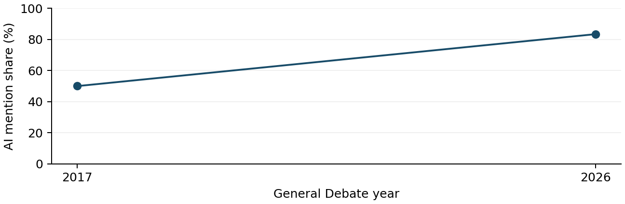
UN regional group | AI mentions n/N | Uncertain
Fixture region | 5/6 (83.3%) | 0
Synthetic workflow fixture. This is not a finding about any actual Member State. [annual:1]
Source changes: official English records (2017-2024); user-accepted automatic transcripts (2025-2026). Squares mark partial years. Regional mapping fixed at 25 September 2026.

Themes
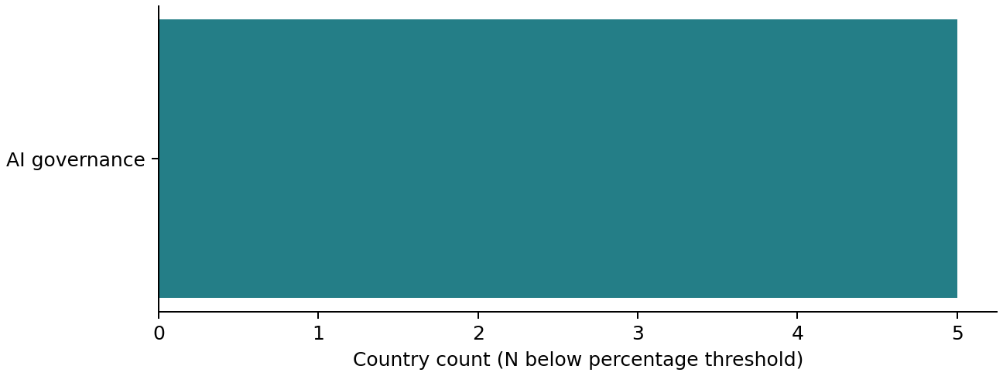
Synthetic workflow fixture. This is not a finding about any actual Member State. [annual:1]
Reviewed expression | Countries n/N | First observed
artificial intelligence | 5/5 | 2017
Theme denominator: AI-positive countries with completed thematic review. Multiple labels may sum above 100%. Co-mention is within the same country-year, not evidence of alignment or a sentence-level link. Full tables include baselines and matched-country comparisons.

Role of UN
Synthetic workflow fixture. This is not a finding about any actual Member State. [annual:1]
Mention, welcome, support, request and commitment are separate. Only explicit UN requests enter UN-request counts. Country positions derive from speech evidence; background proposals and drafts do not enter those counts. Full stance and model tables accompany this report.

Implications
Synthetic workflow fixture. This is not a finding about any actual Member State. [annual:1]
SPMU: Inspect the accompanying synthetic evidence ledger. This recommendation exists only to exercise the reporting layout. [annual:1]
SPMU: Inspect the accompanying synthetic evidence ledger. This recommendation exists only to exercise the reporting layout. [annual:1]
SPMU: Inspect the accompanying synthetic evidence ledger. This recommendation exists only to exercise the reporting layout. [annual:1]
Review limits: two automated text/classification passes with exact-quote checks; no full audio or human verification. Unresolved AI speeches: 0; incomplete thematic cases: 0. The 2025 VCT prepared-only paragraph remains unresolved if its source note persists. Participation rosters are not independently reconciled. Recommendations are analytical proposals.

