Key Facts and Figures
UNGA81 | Available session records | Analysis date 2026-09-29. Verified AI mentions: 5/6 (83.3%); 6 obtained and 0 unresolved. Denominator: AI-resolved addresses. Unobserved country-years are not counted as negatives.
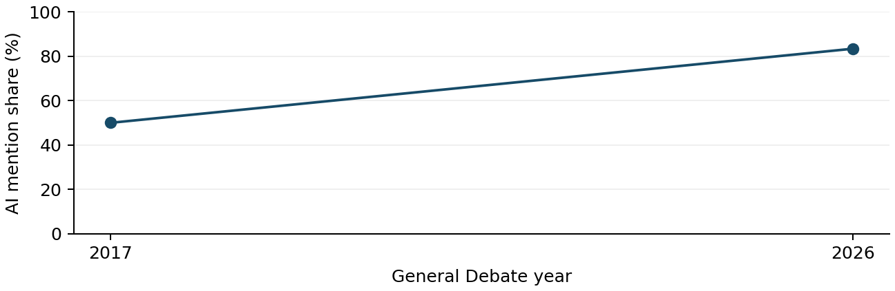
UN regional group | AI mentions n/N | Uncertain
Fixture region | 5/6 (83.3%) | 0
Synthetic layout fixture only; no actual country finding is represented. Synthetic layout fixture only; no actual country finding is represented. Synthetic layout fixture only; no actual country finding is represented. Synthetic layout fixture only; no actual country finding is represented. Synthetic layout fixture only; no actual country finding is represented. Synthetic layout fixture only; no actual country finding is represented. Synthetic layout fixture only; no actual country finding is represented. Synthetic layout fixture only; no actual country finding is represented. Synthetic layout fixture only; no actual country finding is represented. Synthetic layout fixture only; no actual country finding is represented. (2017 [1])
Synthetic layout fixture only; no actual country finding is represented. Synthetic layout fixture only; no actual country finding is represented. Synthetic layout fixture only; no actual country finding is represented. Synthetic layout fixture only; no actual country finding is represented. Synthetic layout fixture only; no actual country finding is represented. Synthetic layout fixture only; no actual country finding is represented. Synthetic layout fixture only; no actual country finding is represented. Synthetic layout fixture only; no actual country finding is represented. Synthetic layout fixture only; no actual country finding is represented. Synthetic layout fixture only; no actual country finding is represented. (2017 [1])
Source changes: official English records (2017-2024); user-accepted automatic transcripts (2025-2026). Squares mark partial years. Regional mapping fixed at 25 September 2026.

Themes
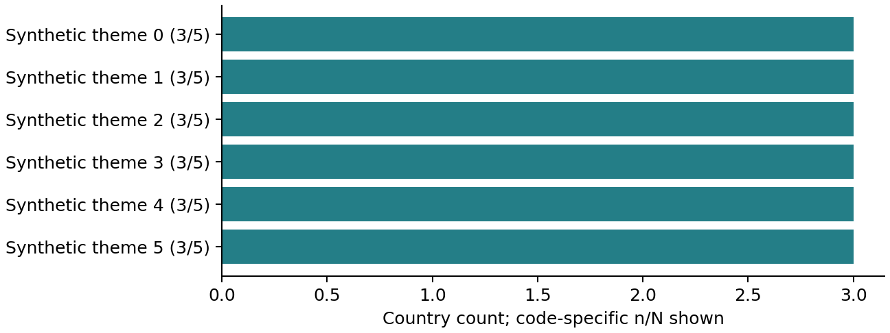
Synthetic layout fixture only; no actual country finding is represented. Synthetic layout fixture only; no actual country finding is represented. Synthetic layout fixture only; no actual country finding is represented. Synthetic layout fixture only; no actual country finding is represented. Synthetic layout fixture only; no actual country finding is represented. Synthetic layout fixture only; no actual country finding is represented. Synthetic layout fixture only; no actual country finding is represented. Synthetic layout fixture only; no actual country finding is represented. Synthetic layout fixture only; no actual country finding is represented. Synthetic layout fixture only; no actual country finding is represented. (2017 [1])
Synthetic layout fixture only; no actual country finding is represented. Synthetic layout fixture only; no actual country finding is represented. Synthetic layout fixture only; no actual country finding is represented. Synthetic layout fixture only; no actual country finding is represented. Synthetic layout fixture only; no actual country finding is represented. Synthetic layout fixture only; no actual country finding is represented. Synthetic layout fixture only; no actual country finding is represented. Synthetic layout fixture only; no actual country finding is represented. Synthetic layout fixture only; no actual country finding is represented. Synthetic layout fixture only; no actual country finding is represented. (2017 [1])
Synthetic layout fixture only; no actual country finding is represented. Synthetic layout fixture only; no actual country finding is represented. Synthetic layout fixture only; no actual country finding is represented. Synthetic layout fixture only; no actual country finding is represented. Synthetic layout fixture only; no actual country finding is represented. Synthetic layout fixture only; no actual country finding is represented. Synthetic layout fixture only; no actual country finding is represented. Synthetic layout fixture only; no actual country finding is represented. Synthetic layout fixture only; no actual country finding is represented. Synthetic layout fixture only; no actual country finding is represented. (2017 [1])
Synthetic layout fixture only; no actual country finding is represented. Synthetic layout fixture only; no actual country finding is represented. Synthetic layout fixture only; no actual country finding is represented. Synthetic layout fixture only; no actual country finding is represented. Synthetic layout fixture only; no actual country finding is represented. Synthetic layout fixture only; no actual country finding is represented. Synthetic layout fixture only; no actual country finding is represented. Synthetic layout fixture only; no actual country finding is represented. Synthetic layout fixture only; no actual country finding is represented. Synthetic layout fixture only; no actual country finding is represented. (2017 [1])
Synthetic layout fixture only; no actual country finding is represented. Synthetic layout fixture only; no actual country finding is represented. Synthetic layout fixture only; no actual country finding is represented. Synthetic layout fixture only; no actual country finding is represented. Synthetic layout fixture only; no actual country finding is represented. Synthetic layout fixture only; no actual country finding is represented. Synthetic layout fixture only; no actual country finding is represented. Synthetic layout fixture only; no actual country finding is represented. Synthetic layout fixture only; no actual country finding is represented. Synthetic layout fixture only; no actual country finding is represented. (2017 [1])
Synthetic layout fixture only; no actual country finding is represented. Synthetic layout fixture only; no actual country finding is represented. Synthetic layout fixture only; no actual country finding is represented. Synthetic layout fixture only; no actual country finding is represented. Synthetic layout fixture only; no actual country finding is represented. Synthetic layout fixture only; no actual country finding is represented. Synthetic layout fixture only; no actual country finding is represented. Synthetic layout fixture only; no actual country finding is represented. Synthetic layout fixture only; no actual country finding is represented. Synthetic layout fixture only; no actual country finding is represented. (2017 [1])
Reviewed expression | Countries n/N | First observed
artificial intelligence | 5/5 | 2017
Theme N: AI-positive country-years resolved for that code; denominators differ by code. Co-mention N requires both codes resolved. Matched-country panels are code-specific. Unknowns remain NA. Multiple labels may sum above 100%. Co-mention is not alignment or a sentence-level link. Full tables include denominators and baselines.

Role of UN
Synthetic layout fixture only; no actual country finding is represented. Synthetic layout fixture only; no actual country finding is represented. Synthetic layout fixture only; no actual country finding is represented. Synthetic layout fixture only; no actual country finding is represented. Synthetic layout fixture only; no actual country finding is represented. Synthetic layout fixture only; no actual country finding is represented. Synthetic layout fixture only; no actual country finding is represented. Synthetic layout fixture only; no actual country finding is represented. Synthetic layout fixture only; no actual country finding is represented. Synthetic layout fixture only; no actual country finding is represented. (2017 [1])
Synthetic layout fixture only; no actual country finding is represented. Synthetic layout fixture only; no actual country finding is represented. Synthetic layout fixture only; no actual country finding is represented. Synthetic layout fixture only; no actual country finding is represented. Synthetic layout fixture only; no actual country finding is represented. Synthetic layout fixture only; no actual country finding is represented. Synthetic layout fixture only; no actual country finding is represented. Synthetic layout fixture only; no actual country finding is represented. Synthetic layout fixture only; no actual country finding is represented. Synthetic layout fixture only; no actual country finding is represented. (2017 [1])
Synthetic layout fixture only; no actual country finding is represented. Synthetic layout fixture only; no actual country finding is represented. Synthetic layout fixture only; no actual country finding is represented. Synthetic layout fixture only; no actual country finding is represented. Synthetic layout fixture only; no actual country finding is represented. Synthetic layout fixture only; no actual country finding is represented. Synthetic layout fixture only; no actual country finding is represented. Synthetic layout fixture only; no actual country finding is represented. Synthetic layout fixture only; no actual country finding is represented. Synthetic layout fixture only; no actual country finding is represented. (2017 [1])
Synthetic layout fixture only; no actual country finding is represented. Synthetic layout fixture only; no actual country finding is represented. Synthetic layout fixture only; no actual country finding is represented. Synthetic layout fixture only; no actual country finding is represented. Synthetic layout fixture only; no actual country finding is represented. Synthetic layout fixture only; no actual country finding is represented. Synthetic layout fixture only; no actual country finding is represented. Synthetic layout fixture only; no actual country finding is represented. Synthetic layout fixture only; no actual country finding is represented. Synthetic layout fixture only; no actual country finding is represented. (2017 [1])
Mechanism / stance | n | Countries
Synthetic mechanism 0 / mention | 3 | SYNTHETIC, SYNTHETIC, SYNTHETIC
Synthetic mechanism 1 / mention | 3 | SYNTHETIC, SYNTHETIC, SYNTHETIC
Synthetic mechanism 2 / mention | 3 | SYNTHETIC, SYNTHETIC, SYNTHETIC
Synthetic mechanism 3 / mention | 3 | SYNTHETIC, SYNTHETIC, SYNTHETIC
Synthetic mechanism 4 / mention | 3 | SYNTHETIC, SYNTHETIC, SYNTHETIC
Synthetic mechanism 5 / mention | 3 | SYNTHETIC, SYNTHETIC, SYNTHETIC
Synthetic mechanism 6 / mention | 3 | SYNTHETIC, SYNTHETIC, SYNTHETIC
Synthetic mechanism 7 / mention | 3 | SYNTHETIC, SYNTHETIC, SYNTHETIC
Synthetic mechanism 8 / mention | 3 | SYNTHETIC, SYNTHETIC, SYNTHETIC
Model / proposer | Requested function | Evidence
New body / synthetic / FIXTURE | scientific assessment | 2026: Synthetic source quotation for layout testing only.
New body / synthetic / FIXTURE | scientific assessment | 2026: Synthetic source quotation for layout testing only.
New body / synthetic / FIXTURE | scientific assessment | 2026: Synthetic source quotation for layout testing only.
New body / synthetic / FIXTURE | scientific assessment | 2026: Synthetic source quotation for layout testing only.
Mention, welcome, support, request and commitment are separate. Only explicit UN requests enter UN-request counts. Country positions derive from speech evidence; background proposals and drafts do not enter those counts. Full stance and model tables accompany this report.

Implications
Synthetic layout fixture only; no actual country finding is represented. Synthetic layout fixture only; no actual country finding is represented. Synthetic layout fixture only; no actual country finding is represented. Synthetic layout fixture only; no actual country finding is represented. Synthetic layout fixture only; no actual country finding is represented. Synthetic layout fixture only; no actual country finding is represented. Synthetic layout fixture only; no actual country finding is represented. Synthetic layout fixture only; no actual country finding is represented. Synthetic layout fixture only; no actual country finding is represented. Synthetic layout fixture only; no actual country finding is represented. (2017 [1])
Synthetic layout fixture only; no actual country finding is represented. Synthetic layout fixture only; no actual country finding is represented. Synthetic layout fixture only; no actual country finding is represented. Synthetic layout fixture only; no actual country finding is represented. Synthetic layout fixture only; no actual country finding is represented. Synthetic layout fixture only; no actual country finding is represented. Synthetic layout fixture only; no actual country finding is represented. Synthetic layout fixture only; no actual country finding is represented. Synthetic layout fixture only; no actual country finding is represented. Synthetic layout fixture only; no actual country finding is represented. (2017 [1])
SPMU: Inspect synthetic evidence. This is a layout fixture, not a real policy recommendation. This is a layout fixture, not a real policy recommendation. This is a layout fixture, not a real policy recommendation. This is a layout fixture, not a real policy recommendation. This is a layout fixture, not a real policy recommendation. (2017 [1])
SPMU: Inspect synthetic evidence. This is a layout fixture, not a real policy recommendation. This is a layout fixture, not a real policy recommendation. This is a layout fixture, not a real policy recommendation. This is a layout fixture, not a real policy recommendation. This is a layout fixture, not a real policy recommendation. (2017 [1])
SPMU: Inspect synthetic evidence. This is a layout fixture, not a real policy recommendation. This is a layout fixture, not a real policy recommendation. This is a layout fixture, not a real policy recommendation. This is a layout fixture, not a real policy recommendation. This is a layout fixture, not a real policy recommendation. (2017 [1])
SPMU: Inspect synthetic evidence. This is a layout fixture, not a real policy recommendation. This is a layout fixture, not a real policy recommendation. This is a layout fixture, not a real policy recommendation. This is a layout fixture, not a real policy recommendation. This is a layout fixture, not a real policy recommendation. (2017 [1])
SPMU: Inspect synthetic evidence. This is a layout fixture, not a real policy recommendation. This is a layout fixture, not a real policy recommendation. This is a layout fixture, not a real policy recommendation. This is a layout fixture, not a real policy recommendation. This is a layout fixture, not a real policy recommendation. (2017 [1])
Review limits: automated speech review with sampled second checks and two classification passes; exact-quote checks; no full audio or human verification. Unresolved AI speeches: 0; incomplete thematic cases: 0. The 2025 VCT prepared-only paragraph remains unresolved if its source note persists. Participation rosters are not independently reconciled. Recommendations are analytical proposals.

