Eightieth session
Items 137 and 138 of the preliminary list*

Proposed programme budget for 2026

Programme planning

Proposed programme budget for 2026

Part IV

International cooperation for development

Section 14

Environment

Programme 11

Environment

Contents
 |  |  | Page
- Proposed programme plan for 2026 and programme performance in 2024** |  |  | 3
Overall orientation |  |  | 3
Programme of work |  |  | 12
Subprogramme 1. Climate action |  |  | 12
Subprogramme 2. Digital transformations in supporting environmental action |  |  | 16
Subprogramme 3. Nature action |  |  | 21
Subprogramme 4. Environmental governance |  |  | 25
Subprogramme 5. Chemicals and pollution action |  |  | 30
Subprogramme 6. Finance and economic transformations |  |  | 34
Subprogramme 7. Science policy |  |  | 39
* A/80/50.
** In keeping with paragraph 10 of General Assembly resolution 77/267, the part consisting of the programme plan and programme performance information (part II) is submitted through the Committee for Programme and Coordination for the consideration of the Assembly.
- Proposed post and non-post resource requirements for 2026*** | 44
Overview | 44
Policymaking organs | 50
Executive direction and management | 51
Programme of work | 56
Subprogramme 1. Climate action | 56
Subprogramme 2. Digital transformations in supporting environmental action | 57
Subprogramme 3. Nature action | 58
Subprogramme 4. Environmental governance | 59
Subprogramme 5. Chemicals and pollution action | 60
Subprogramme 6. Finance and economic transformations | 61
Subprogramme 7. Science policy | 62
Programme support | 63
Annexes
- Organizational structure and post distribution for 2026 | 66
- Summary of proposed post changes, by component and subprogramme | 67
*** In keeping with paragraph 10 of General Assembly resolution 77/267, the part consisting of the post and non-post resource requirements (part III) is submitted through the Advisory Committee on Administrative and Budgetary Questions for the consideration of the Assembly.

A. Proposed programme plan for 2026 and programme performance in 2024

Overall orientation

Mandates and background

14.1 The United Nations Environment Programme (UNEP) is responsible for leading and coordinating action on environmental matters within the United Nations system. The mandate derives from the priorities established in relevant General Assembly resolutions and decisions, including resolution 2997 (XXVII), and by the Governing Council of UNEP in its decision 19/1. That decision set out the Nairobi Declaration on the Role and Mandate of the United Nations Environment Programme, which the Assembly subsequently endorsed in 1997 in the annex to its resolution S-19/2 and further reaffirmed in its resolutions 53/242, in 1999, and 66/288 and 67/213, in 2012. In Assembly resolution 70/1, Member States recognized the importance of the environmental dimension to the successful implementation of the 2030 Agenda for Sustainable Development. Within its mandate, UNEP will support Member States by providing strategic direction towards the achievement of environmental sustainability, while contributing to a balanced integration of the economic, social and environmental dimensions of sustainable development. Acknowledging the integrated nature of the challenges that countries face, UNEP will play a critical role in catalysing the fulfilment of the commitments and actions that drive transformational change for sustainable development.

Strategy and external factors for 2026

14.2 The medium-term strategy for the period 2026–2029 will guide the strategic direction and operational activities of UNEP to support Member States in intensifying efforts towards the environmental dimension of sustainable development and addressing the crises of climate change, biodiversity and nature loss, and pollution and waste. The strategy, which is to be considered by Member States at the seventh session of the United Nations Environment Assembly, will be based on inclusive, regular consultations with Member States and relevant stakeholders, and will be informed by an assessment of progress, ongoing challenges and emerging issues, while incorporating lessons learned from the implementation of its medium-term strategy for the period 2022–2025. UNEP will continue to advocate for science to remain at the centre of all decision-making processes, including on emerging issues, and for improved global environmental governance, aligned closely with the multilateral environmental agreements for which it provides the secretariats, and the direction set by the 2030 Agenda and relevant actions and decisions contained in the Pact for the Future.
14.3 With regard to cooperation with other entities at the global, regional, subregional, national and local levels, UNEP will continue to raise ambitions and promote leadership through advocacy and a normative and standard-setting approach. It will support Member States through transformative strategic partnerships that deliver sustainable solutions, integrating health, education, poverty reduction, and economic and social well-being. Its partnerships with the secretariats of multilateral environmental agreements will remain pivotal to securing stronger synergies and enhancing the impact of the work of the relevant parties. UNEP will encourage non-governmental stakeholders, including the private sector and the finance community, to increase investment in new and renewable sources of energy and improve environmental sustainability. Within the context of those partnerships, action will be aimed at making a broader impact in support of sustainable development, while strengthening the ability of countries to rapidly respond to the environmental impacts of disasters and armed conflicts.
14.4 With regard to inter-agency coordination and liaison, UNEP has the overall responsibility for leading and coordinating the response on environmental issues within the United Nations system. Through the United Nations Environment Management Group, UNEP will catalyse international action to enhance the coherence of environmental sustainability strategies and provide more visibility on partnership initiatives. UNEP will leverage the United Nations development system reform to continue to address the crises of climate change, biodiversity and nature loss, and pollution and waste, and enhance its guiding role, raise ambitions and accelerate and scale up progress during the decade of action to deliver the Sustainable Development Goals. It will continue to focus on ensuring that its work is reflected and embedded in the new generation of United Nations country teams and the reinvigorated resident coordinator system through engagement with the Development Coordination Office and to leverage its work and expertise at the regional, subregional and country levels. UNEP will also integrate the priorities of the multilateral environmental agreements into global follow-up and review processes, in particular the 2030 Agenda.
14.5 With regard to the external factors, the overall plan for 2026 is based on the following planning assumptions:
(a) Member States and partners remain committed to the development and implementation of science-based environmental policies;
(b) The continued availability of extrabudgetary funding for the implementation of UNEP planned activities.
14.6 UNEP integrates a gender perspective into its operational activities, deliverables and results, as appropriate. It will work to fully implement United Nations Environment Assembly resolution 4/17 on promoting gender equality and the human rights and empowerment of women and girls in environmental governance and will continue to operationalize it in programme and project design and delivery. UNEP will support Member States in their achievement of Sustainable Development Goal 5 in the context of the environment, calling for women’s full and effective participation and equal opportunities for leadership at all levels of environmental decision-making.
14.7 In line with the United Nations Disability Inclusion Strategy, UNEP will be attentive and responsive to the inclusion of persons with disabilities, including by raising awareness of their needs and concerns in its programme and project design and implementation and tailoring its projects to fit the conditions and needs of local communities. For example, addressing the concerns and needs of persons with disabilities will be emphasized when supporting climate change-related early warning systems or in projects that deal with environmental disasters and armed conflicts. UNEP will continue to reinforce the promotion and protection of the rights of persons with disabilities through its safeguard risk screening and mitigation procedure.

Legislative mandates

14.8 The list below, which was reviewed in the preparation of the proposed programme budget, provides all mandates entrusted to the programme.

General Assembly resolutions

2997 (XXVII) | Institutional and financial arrangements for international environmental cooperation
47/190 | Report of the United Nations Conference on Environment and Development
S-19/2 | Programme for the Further Implementation of Agenda 21
53/242 | Report of the Secretary-General on environment and human settlements
65/2 | Outcome document of the High-level Review Meeting on the Implementation of the Mauritius Strategy for the Further Implementation of the Programme of Action for the Sustainable Development of Small Island Developing States
66/288 | The future we want
67/251 | Change of the designation of the Governing Council of the United Nations Environment Programme
68/99 | Strengthening of international cooperation and coordination of efforts to study, mitigate and minimize the consequences of the Chernobyl disaster
68/215 | Report of the Governing Council of the United Nations Environment Programme on its first universal session and the implementation of section IV.C, entitled “Environmental pillar in the context of sustainable development”, of the outcome document of the United Nations Conference on Sustainable Development
70/1 | Transforming our world: the 2030 Agenda for Sustainable Development
73/238 | The role of the international community in the prevention of the radiation threat in Central Asia
74/216 | Implementation of Agenda 21, the Programme for the Further Implementation of Agenda 21 and the outcomes of the World Summit on Sustainable Development and of the United Nations Conference on Sustainable Development
75/271 | Nature knows no borders: transboundary cooperation – a key factor for biodiversity conservation, restoration and sustainable use
76/201 | Sustainable tourism and sustainable development in Central America
76/298 | Implementation of the recommendations contained in the report of the Secretary-General on the causes of conflict and the promotion of durable peace and sustainable development in Africa
77/159 | Enhancing the role of parliaments in accelerating the achievement of the Sustainable Development Goals
77/161 | Promoting zero-waste initiatives to advance the 2030 Agenda for Sustainable Development
78/128 | 2025 United Nations Conference to Support the Implementation of Sustainable Development Goal 14: Conserve and sustainably use the oceans, seas and marine resources for sustainable development
78/146 | Cooperative measures to assess and increase awareness of environmental effects related to waste originating from chemical munitions dumped at sea
78/159 | Strengthening cooperation for integrated coastal zone management for achieving sustainable development
78/160 | Science, technology and innovation for sustainable development
78/161 | Culture and sustainable development
78/163 | Follow-up to the second United Nations Conference on Landlocked Developing Countries
78/179 | Policies and programmes involving youth
79/1 | The Pact for the Future
79/45 | Observance of environmental norms in the drafting and implementation of agreements on disarmament and arms control
79/85 | Effects of atomic radiation
79/139 | International cooperation on humanitarian assistance in the field of natural disasters, from relief to development
79/140 | Strengthening of the coordination of emergency humanitarian assistance of the United Nations
79/171 | The right to food
79/194 | Information and communications technologies for sustainable development
79/195 | International trade and development
79/196 | International financial system and development
79/197 | External debt sustainability and development
79/198 | Promoting investments for sustainable development
79/199 | Follow-up to and implementation of the outcomes of the International Conferences on Financing for Development
79/200 | Oil slick on Lebanese shores
79/201 | Entrepreneurship for sustainable development
79/202 | Promoting sustainable consumption and production patterns for the implementation of the 2030 Agenda for Sustainable Development, building on Agenda 21
79/203 | Follow-up to and implementation of the SIDS Accelerated Modalities of Action (SAMOA) Pathway and the Mauritius Strategy for the Further Implementation of the Programme of Action for the Sustainable Development of Small Island Developing States
79/205 | Disaster risk reduction
79/207 | Implementation of the United Nations Convention to Combat Desertification in Those Countries Experiencing Serious Drought and/or Desertification, Particularly in Africa
79/209 | Report of the United Nations Environment Assembly of the United Nations Environment Programme
79/212 | Combating sand and dust storms
79/226 | Quadrennial comprehensive policy review of operational activities for development of the United Nations system
79/228 | Towards global partnerships: a principle-based approach to enhanced cooperation between the United Nations and all relevant partners
79/234 | Promotion of international cooperation to combat illicit financial flows and strengthen good practices on assets return to foster sustainable development
79/263 | New Partnership for Africa’s Development: progress in implementation and international support

Governing Council of the United Nations Environment Programme decisions

SS.VIII/1, sect. II, 25/1, sect. II | Implementation of decision SS.VII/1 on international environmental governance: strengthening the scientific base of the United Nations Environment Programme
SS.XI/2 | United Nations Environment Programme support for Haiti: strengthening environmental response in Haiti
19/1 | Nairobi Declaration on the Role and Mandate of the United Nations Environment Programme
23/7 | Strengthening environmental emergency response and developing disaster prevention, preparedness, mitigation and early-warning systems in the aftermath of the Indian Ocean tsunami disaster
23/11 | Gender equality in the field of the environment
24/11 | Intensified environmental education for achieving sustainable development
26/15 | Strengthening international cooperation on the environmental aspects of emergency response and preparedness
27/2 | Implementation of paragraph 88 of the outcome document of the United Nations Conference on Sustainable Development
27/11 | State of the environment and contribution of the United Nations Environment Programme to meeting substantive environmental challenges

United Nations Environment Assembly resolutions and decisions

1/1 | Ministerial outcome document of the first session of the United Nations Environment Assembly of the United Nations Environment Programme
1/4 | Science-policy interface
1/8 | Ecosystems-based adaptation
1/10 | Different visions, approaches, models and tools to achieve environmental sustainability in the context of sustainable development and poverty eradication
1/11 | Coordination across the United Nations system in the field of the environment, including the Environment Management Group
1/12 | Relationship between the United Nations Environment Programme and multilateral environmental agreements
1/13 | Implementation of Principle 10 of the Rio Declaration on Environment and Development
1/16 | Management of trust funds and earmarked contributions
1/17 | Amendments to the Instrument for the Establishment of the Restructured Global Environment Facility
2/2 | Role and functions of the regional forums of ministers of the environment and environment authorities
2/3 | Investing in human capacity for sustainable development through environmental education and training
2/4 | Role, functions and modalities for United Nations Environment Programme implementation of the SAMOA Pathway as a means of facilitating achievement of the Sustainable Development Goals
2/5 | Delivering on the 2030 Agenda for Sustainable Development
2/6 | Supporting the Paris Agreement
2/13 | Sustainable management of natural capital for sustainable development and poverty eradication
2/15 | Protection of the environment in areas affected by armed conflict
2/16 | Mainstreaming of biodiversity for well-being
2/17 | Enhancing the work of the United Nations Environment Programme in facilitating cooperation, collaboration and synergies among biodiversity-related conventions
2/18 | Relationship between the United Nations Environment Programme and the multilateral environmental agreements for which it provides the secretariat
2/19 | Midterm review of the fourth Programme for the Development and Periodic Review of Environmental Law (Montevideo Programme IV)
2/20 | Proposed medium-term strategy for 2018–2021 and programme of work and budget for 2018–2019
2/24 | Combating desertification, land degradation and drought and promoting sustainable pastoralism and rangelands
2/25 | Application of Principle 10 of the Rio Declaration on Environment and Development in the Latin America and Caribbean Region
3/1 | Pollution mitigation and control in areas affected by armed conflict or terrorism
3/2 | Pollution mitigation by mainstreaming biodiversity into key sectors
3/3 | Contributions of the United Nations Environment Assembly to the high-level political forum on sustainable development
3/4 | Environment and health
3/5 | Investing in innovative environmental solutions for accelerating the implementation of the Sustainable Development Goals
3/6 | Managing soil pollution to achieve sustainable development
3/8 | Preventing and reducing air pollution to improve air quality globally
3/9 | Eliminating exposure to lead paint and promoting environmentally sound management of waste lead-acid batteries
3/10 | Addressing water pollution to protect and restore water-related ecosystems
3/11 | Implementation of paragraph 88 (a)–(h) of the outcome document of the United Nations Conference on Sustainable Development, entitled “The future we want”
4/3 | Sustainable mobility
4/17 | Promote gender equality, and the human rights and empowerment of women and girls in environmental governance
4/18 | Poverty-environment nexus
4/20 | Fifth Programme for the Development and Periodic Review of Environmental Law (Montevideo V): delivering for people and the planet
4/21 | Implementation plan “Towards a pollution-free planet”
4/22 | Implementation and follow up of United Nations Environment Assembly resolutions
4/23 | Keeping the world environment under review: enhancing the United Nations Environment Programme science-policy interface and endorsement of the Global Environment Outlook
5/1 | Animal welfare – environment – sustainable development nexus
5/2 | Sustainable nitrogen management
5/3 | Future of the Global Environment Outlook
5/4 | Sustainable lake management
5/5 | Nature-based solutions for supporting sustainable development
5/6 | Biodiversity and health
5/7 | Sound management of chemicals and waste
5/8 | Science-policy panel to contribute further to the sound management of chemicals and waste and to prevent pollution
5/9 | Sustainable and resilient infrastructure
5/10 | The environmental dimension of a sustainable, resilient and inclusive post-COVID-19 recovery
5/11 | Enhancing circular economy as a contribution to achieving sustainable consumption and production
5/12 | Environmental aspects of minerals and metals management
5/13 | Due regard to the principle of equitable geographical distribution, in accordance with paragraph 3 of Article 101 of the Charter of the United Nations
5/14 | End plastic pollution: towards an international legally binding instrument
6/1 | Circularity of a resilient and low-carbon sugar cane agro-industry
6/2 | Amendments to the Instrument for the Establishment of the Restructured Global Environment Facility
6/3 | Enhancing the role and viability of regional forums of environment ministers and United Nations Environment Programme regional offices in achieving multilateral cooperation in tackling environmental challenges
6/4 | Promoting synergies, cooperation or collaboration for national implementation of multilateral environmental agreements and other relevant environmental instruments
6/5 | Environmental aspects of minerals and metals
6/6 | Fostering national action to address global environmental challenges through increased cooperation between the United Nations Environment Assembly, the United Nations Environment Programme and multilateral environmental agreements
6/7 | Combating sand and dust storms
6/8 | Promoting sustainable lifestyles
6/9 | Sound management of chemicals and waste
6/10 | Promoting regional cooperation on air pollution to improve air quality globally
6/11 | Highly hazardous pesticides
6/12 | Environmental assistance and recovery in areas affected by armed conflict
6/13 | Effective and inclusive solutions for strengthening water policies to achieve sustainable development in the context of climate change, biodiversity loss and pollution
6/14 | Strengthening international efforts to combat desertification and land degradation, restore degraded land, promote land conservation and sustainable land management, contribute to land degradation neutrality and enhance drought resilience
6/15 | Strengthening ocean efforts to tackle climate change, marine biodiversity loss and pollution

Subprogramme 1

Climate action

General Assembly resolutions

69/225 | Promotion of new and renewable sources of energy
73/230 | Effective global response to address the impacts of the El Niño phenomenon
79/206 | Protection of global climate for present and future generations of humankind
79/211 | Ensuring access to affordable, reliable, sustainable and modern energy for all

Governing Council of the United Nations Environment Programme decision

27/10 | Climate Technology Centre and Network

Subprogramme 2

Digital transformation in supporting environmental action

Governing Council of the United Nations Environment Programme decision

23/1, sect. I | Implementation of decision SS.VII/1 on international environmental governance: Bali Strategic Plan for Technology Support and Capacity-building

Subprogramme 3

Nature action

General Assembly resolutions

65/161 | Convention on Biological Diversity
68/205 | World Wildlife Day
68/232 | World Soil Day and International Year of Soils
73/251 | World Pulses Day
77/172 | Sustainable mountain development
77/285 | Implementation of the United Nations Decade of Action on Nutrition (2016–2025)
77/325 | Tackling illicit trafficking in wildlife
78/144 | Agricultural technology for sustainable development
79/144 | Oceans and the law of the sea
79/145 | Sustainable fisheries, including through the 1995 Agreement for the Implementation of the Provisions of the United Nations Convention on the Law of the Sea of 10 December 1982 relating to the Conservation and Management of Straddling Fish Stocks and Highly Migratory Fish Stocks, and related instruments
79/204 | Towards the sustainable development of the Caribbean Sea for present and future generations
79/208 | Implementation of the Convention on Biological Diversity and its contribution to sustainable development
79/210 | Harmony with Nature
79/227 | Agriculture development, food security and nutrition

Governing Council of the United Nations Environment Programme decisions

26/14 | Global Environment Monitoring System/ Water Programme
26/16 | Promoting South-South cooperation on biodiversity for development
27/3 | International water quality guidelines for ecosystems
27/4 | Intergovernmental Science-Policy Platform on Biodiversity and Ecosystem Services
27/6 | Oceans

United Nations Environment Assembly resolutions

1/9 | Global Environment Monitoring System/ Water Programme (GEMS/Water)
2/10 | Oceans and seas
2/14 | Illegal trade in wildlife and wildlife products
4/10 | Innovation on biodiversity and land degradation
4/12 | Sustainable management for global health of mangroves
4/13 | Sustainable coral reefs management
4/15 | Innovations in sustainable rangelands and pastoralism
4/16 | Conservation and sustainable management of peatlands

Subprogramme 4

Environmental governance

Governing Council of the United Nations Environment Programme ministerial declarations and decisions

SS.VI/1 | Malmö Ministerial Declaration
SS.VII/4 | Compliance with and enforcement of multilateral environmental agreements
SS.XI/5 | Environmental law
SS.XII/3 | International environmental governance
25/11 | Environmental law
27/5 | Coordination across the United Nations system, including the Environment Management Group
27/9 | Advancing justice, governance and law for environmental sustainability

United Nations Environment Assembly resolution

1/3 | Illegal trade in wildlife

Subprogramme 5

Chemicals and pollution action

General Assembly resolutions

74/212 | International Day of Clean Air for blue skies
77/161 | Promoting zero-waste initiatives to advance the 2030 Agenda for Sustainable Development
79/2 | Political declaration of the high-level meeting on antimicrobial resistance

Governing Council of the United Nations Environment Programme decisions

SS.IX/1 | Strategic Approach to International Chemicals Management
SS.XII/4 | Consultative process on financing options for chemicals and wastes
SS.XII/5 | Enhancing cooperation and coordination within the chemicals and wastes cluster
24/4 | Prevention of illegal international trade
25/5 | Chemicals management, including mercury
27/12 | Chemicals and waste management

United Nations Environment Assembly resolutions

1/5 | Chemicals and waste
1/6 | Marine plastic debris and microplastics
1/7 | Strengthening the role of the United Nations Environment Programme in promoting air quality
3/7 | Marine litter and microplastics
2/11, 4/6 | Marine plastic litter and microplastics
4/7 | Environmentally sound management of waste
4/9 | Addressing single-use plastic products pollution

Subprogramme 6

Finance and economic transformations

General Assembly resolutions

74/209 | International Day of Awareness of Food Loss and Waste
74/214 | Sustainable tourism and sustainable development in Central Asia
79/220 | Promotion of sustainable and resilient tourism, including ecotourism, for poverty eradication and environment protection

Governing Council of the United Nations Environment Programme decisions

27/7 | Work by the United Nations Environment Programme on sustainable consumption and production
27/8 | Green economy in the context of sustainable development and poverty eradication

United Nations Environment Assembly resolutions

2/8 | Sustainable consumption and production
2/9 | Prevention, reduction and reuse of food waste
4/1 | Innovative pathways to achieve sustainable consumption and production
4/2 | Promoting sustainable practices and innovative solutions for curbing food loss and waste
4/4 | Addressing environmental challenges through sustainable business practices
4/5 | Sustainable infrastructure

Subprogramme 7

Science policy

General Assembly resolution

71/313 | Work of the Statistical Commission pertaining to the 2030 Agenda for Sustainable Development

Governing Council of the United Nations Environment Programme decisions

SS.X/5 | Global Environment Outlook: environment for development
SS.XII/6 | World environmental situation

United Nations Environment Assembly ministerial declarations and decisions

Decision 3/1 | Extension of the delivery date for the sixth Global Environment Outlook report
UNEP/EA.4/HLS.1 | Ministerial declaration of the United Nations Environment Assembly at its fourth session: innovative solutions for environmental challenges and sustainable consumption and production

Deliverables

14.9 Table 14.1 lists all cross-cutting deliverables of the programme.

Table 14.1

Cross-cutting deliverables for the period 2024–2026, by category and subcategory

Category and subcategory | 2024 planned | 2024 actual | 2025 planned | 2026 planned
A. Facilitation of the intergovernmental process and expert bodies
Conference and secretariat services for meetings (number of three-hour meetings) | 4 | 4 | 4 | 3
Meetings of:
1. United Nations Environment Assembly | 1 | 1 | 1 | –
2. Advisory Committee on Administrative and Budgetary Questions | 1 | 1 | 1 | 1
3. Committee for Programme and Coordination | 1 | 1 | 1 | 1
4. Fifth Committee | 1 | 1 | 1 | 1
B. Generation and transfer of knowledge
Field and technical cooperation projects (number of projects) | 2 | 2 | 2 | 2
5. To assess environmental risks from disasters and armed conflicts | 1 | 1 | 1 | 1
6. On institutional and legal frameworks to improve national and local preparedness to mitigate environmental risks from disasters and armed conflicts | 1 | 1 | 1 | 1
Publications (number of publications) | 2 | 2 | 3 | 3
7. On disaster risk reduction, preparedness assessments and road maps | 1 | 1 | 2 | 2
8. UNEP annual report | 1 | 1 | 1 | 1
C. Substantive deliverables
Consultation, advice and advocacy: advice to humanitarian and military actors on environmental footprint reduction; and advice to 31 Member States, upon request, on the monitoring and implementation of strategies to enhance environmental risk reduction, environmental emergency response and environmental recovery and to make progress towards the achievement of the Sustainable Development Goals.

Evaluation activities

14.10 The following evaluations conducted by UNEP and completed in 2024 have guided the proposed programme plan for 2026:
(a) Evaluation of subprogramme 1, Climate action (2014–2023);
(b) Formative evaluation of the UNEP delivery model and associated programmatic approach.
14.11 In response to the results of the evaluations referenced above, UNEP will align its climate action work more closely with the Paris Agreement, strengthen its role as a knowledge broker and enhance its visibility in global climate action arenas. UNEP will also improve project sustainability and develop strategies for scalable mitigation and adaptation solutions, while enhancing country-level engagement, including through greater coordination within United Nations country teams. Lastly, UNEP will develop robust theories of change and strengthen results-based management.
14.12 The following evaluations to be conducted by UNEP are planned for 2026:
(a) Evaluation of subprogramme 3, Nature action (2014–2024);
(b) Evaluation of subprogramme 7, Science policy (2020–2025).

Programme of work

Subprogramme 1

Climate action

Objective

14.13 The objective, to which this subprogramme contributes, is to advance the transition of countries to low-emission economic development and increase their adaptation and resilience to climate change.

Strategy

14.14 To contribute to the objective, the subprogramme will:
(a) Support Member States in the development of policies and standards to promote low-emission development plans and investment in clean energy and improve the global rate of energy efficiency;
(b) Support Member States in implementing gender-sensitive policies that achieve quantifiable social and environmental benefits, including through the reduction in greenhouse gas emissions from deforestation and forest degradation;
(c) Build the technical capacity of Member States to integrate ecosystem-based management into their national adaptation plans, put in place institutional arrangements to coordinate such plans and gain access to climate change adaptation finance for implementing such plans;
(d) Collaborate with the private sector in constructive and results-oriented partnerships that leverage climate finance and scale up the ambitions and impacts of climate action globally;
(e) Advocate and provide evidence and technical support for the use of climate strategies, such as a fiscal stimulus, in the context of sustainable recovery;
(f) Support Member States in making progress towards the achievement of Sustainable Development Goals 1, 5, 7, 11, 15 and 17.
14.15 The above-mentioned work is expected to result in:
(a) Member States lowering their emissions of greenhouse gases and other pollutants by reducing energy intensity and demand in sectors such as lighting, appliances, equipment, buildings and transport;
(b) Member States increasingly capitalizing on investment opportunities that reduce greenhouse emissions from deforestation and forest degradation with adequate social and environmental safeguards;
(c) Member States increasingly capable of better institutionalizing, implementing and monitoring their national adaptation plans alongside efforts to deliver sustainable development;
(d) Member States making use of innovative models to enhance financing for sustainable investment and the dissemination of low-emission technologies that help to significantly reduce greenhouse gas emissions, promote access to energy and enhance productive energy use;
(e) Increased low-emission investment as a result of countries using climate strategies to guide investments.

Programme performance in 2024

Strengthened commitment of Member States to increase the sustainability of the buildings and construction sector

14.16 The buildings and construction sector represents more than one fifth of global greenhouse gas emissions. In 2023, the subprogramme launched the “Buildings Breakthrough” initiative at the twenty-eighth session of the Conference of the Parties to the United Nations Framework Convention on Climate Change to strengthen international collaboration towards increasing the sustainability of the sector and enhancing the climate resilience of buildings. In 2024, the subprogramme, through the Global Alliance for Buildings and Construction, published the Global Status Report for Buildings and Construction: Beyond Foundations, which outlined that, in 2022, the buildings sector was responsible for 34 per cent of global energy demand and 37 per cent of energy and process-related carbon dioxide emissions. To maintain the momentum for the Buildings Breakthrough initiative, in 2024 the subprogramme co-organized, with the Government of France, the first Buildings and Climate Global Forum, which gathered national ministers and high-level representatives from across the buildings sector value chain to discuss pathways for mainstreaming sustainable solutions to reduce the sector’s emissions. The Forum concluded with 70 countries adopting the Chaillot Declaration, which set a foundation international cooperation on the issue.
14.17 Progress towards the objective is presented in the performance measure below (see table 14.2).

Table 14.2

Performance measure

2022 (actual) | 2023 (actual) | 2024 (actual)
– | 27 countries pledged their commitment to the Buildings Breakthrough initiative | 70 countries adopted the Chaillot Declaration at the first Buildings and Climate Global Forum  2 additional countries pledged their commitment to the Buildings Breakthrough initiative

Planned results for 2026

Result 1: enhanced national early warning systems

Programme performance in 2024 and target for 2026

14.18 The subprogramme’s work contributed to 25 countries establishing early warning systems, which exceeded the planned target of 22 countries.
14.19 Progress towards the objective and the target for 2026 are presented in the performance measure below (see figure 14.I).

Figure 14.I

Performance measure: number of countries that have established early warning systems (cumulative)

Result 2: Member States develop national methane road maps and action plans

Programme performance in 2024 and target for 2026

14.20 The subprogramme’s work contributed to an additional 27 countries developing national methane road maps and action plans, for a total of 95, which exceeded the planned target of 93.
14.21 Progress towards the objective and the target for 2026 are presented in the performance measure below (see figure 14.II).

Figure 14.II

Performance measure: number of countries that have developed national methane road maps and action plans (cumulative)

Result 3: Member states adopt environmentally sound technologies for climate change mitigation and adaptation

Proposed programme plan for 2026

14.22 UNEP promotes the accelerated transfer of environmentally sound technologies for climate change mitigation and adaptation at the request of developing countries through the Climate Technology Centre and Network. The Network provides technology solutions, capacity-building and advice on policy, legal and regulatory frameworks tailored to the needs of individual countries by harnessing the expertise of a global network of technology companies and institutions. The subprogramme supports these efforts by providing scientific evidence, leading advocacy, promoting knowledge-sharing and providing technical guidance to requesting Member States.

Lessons learned and planned change

14.23 The lesson for the subprogramme was the need to leverage the next cycle of nationally determined contributions, recognizing their potential as investment blueprints, to attract funding and support for climate initiatives, including technology support. In applying the lesson, the subprogramme will advocate for the development of ambitious nationally determined contributions and support the transfer and uptake of environmentally sound technologies for climate change mitigation and adaptation. In addition, it will work closely with its partners to mobilize resources, foster collaboration and scale solutions aimed at ensuring that Member States integrate capacity-building and technology transfer into their broader development strategies.
14.24 Expected progress towards the objective is presented in the performance measure below (see figure 14.III).

Figure 14.III

Performance measure: number of countries equipped to implement technology policies and solutions for climate mitigation and adaptation (cumulative)

Deliverables

14.25 Table 14.3 lists all deliverables of the subprogramme.

Table 14.3

Subprogramme 1: deliverables for the period 2024–2026, by category and subcategory

Category and subcategory | 2024 planned | 2024 actual | 2025 planned | 2026 planned
B. Generation and transfer of knowledge
Field and technical cooperation projects (number of projects) | 3 | 12 | 3 | 3
1. On mitigation and adaptation technologies through the Climate Technology Centre and Network | 3 | 12 | 3 | 3
Publications (number of publications) | 6 | 8 | 6 | 6
2. On renewable energy, energy efficiency and the energy sector | 3 | 4 | 3 | 3
3. On adaptation and resilience (assessments and tools) | 3 | 4 | 3 | 3
C. Substantive deliverables
Consultation, advice and advocacy: advice to 85 countries on climate matters, including South-South cooperation, ecosystem-based adaptation, climate financing, the United Nations Framework Convention on Climate Change, short-lived climate pollutants, low-emission development, sustainable energy and energy efficiency, and the Warsaw Framework for REDD-plus.
D. Communication deliverables
Outreach programmes, special events and information materials: 50 side events, media outreach, goodwill ambassador outreach, 5 Global Adaptation Network newsletters, 6 regional forums on nationally determined contributions and 16 events on climate action, reaching an audience in excess of 1 million.
Digital platforms and multimedia platforms: some 16 stories and 5 videos for social media platforms and web pages.

Subprogramme 2

Digital transformations in supporting environmental action

Objective

14.26 The objective, to which this subprogramme contributes, is to advance the use of data and analytics on environmental issues to allow more effective policies, decisions, actions and investments by Member States and the private sector towards the achievement of the targets of the Sustainable Development Goals related to climate, nature and pollution, and of relevant multilateral environmental agreements.

Strategy

14.27 To contribute to the objective, the subprogramme will support and scale up access to environmental information through an effectively governed and inclusive data architecture and digital ecosystem for the planet. Specifically, the subprogramme will:
(a) Through its enabling role, digitize scientific knowledge and democratize its availability across the thematic subprogrammes of UNEP, using digital tools to enable, accelerate and amplify impact, as well as to bring more transparency to knowledge about the state of the planet;
(b) Initiate partnerships with public and private sector actors to harness data, digital technologies and computational sustainability, in order to help Member States to amplify and accelerate deeper structural transformations, with a view to driving markets, value chains, consumer behaviours and decision-making towards the achievement of environmentally sustainability outcomes;
(c) Use integrated data sets and analysis, based on digital norms and governance frameworks, to produce actionable, real-time and predictive insights, enabling the automatic monitoring of global, national and local progress towards achieving key targets of the Sustainable Development Goals related to climate, biodiversity and pollution and relevant internationally agreed frameworks, including multilateral environmental agreements;
(d) Work with Member States, the private sector and civil society to improve digital literacy and use digital platforms to enable further public participation in decision-making, open innovation and citizen science, helping to make progress towards achievement of the targets under Sustainable Development Goals 9, 16 and 17;
(e) Provide normative support, upon request, on closing the digital divide through the use of information and communications technologies procured in accordance with sustainability standards.
14.28 The above-mentioned work is expected to result in:
(a) Increased capacity of Member States to monitor the world environmental situation through the adoption of a global data architecture, governance frameworks, safeguards and standards for environmental and climate data and related digital public goods;
(b) Improved ability of Member States to predict and address future environment-related risks through the development of big data platforms that can measure the increasing convergence of environmental and climate stress and disaster vulnerability over space and time and to provide predictive analytics and an early warning system;
(c) Accelerated adoption of low-carbon and low-emission behaviours, lifestyles and products by consumers and citizens, through increased greenhouse gas emissions transparency, digital eco-labelling and digital nudging, including through e-commerce platforms and digital games;
(d) Identification and scaled adoption of digital technologies by Member States to support the conservation, sustainable use and equitable benefit-sharing of biodiversity;
(e) Reduced environmental impacts, e-waste and greenhouse gas emissions arising from the procurement and installation of digital infrastructure used to bridge the digital divide.

Programme performance in 2024

Member States and companies took action to reduce methane emissions

14.29 The General Assembly, in its resolution 79/1 on the Pact for the Future, further recognized the need for accelerating and substantially reducing non-carbon dioxide emissions globally, including, in particular, methane emissions, by 2030. The International Methane Emissions Observatory provides transparent, reliable and actionable data to reduce and mitigate methane emissions. In 2024, the subprogramme enhanced the platform to assemble a public database of empirically verified methane emissions data, sourced from satellites and global scientific measurement campaigns. That comprehensive approach enabled countries and companies to take swift, targeted action to reduce emissions. In 2024, the Observatory’s system notified companies and Governments of approximately 1,900 releases. The alerts spanned five continents and helped emitters to plug major leaks. Overall, data from the observatory have prevented the release of greenhouse gases equivalent to the amount produced by more than 1 million cars over the course of a year.
14.30 Progress towards the objective is presented in the performance measure below (see table 14.4).

Table 14.4

Performance measure

2022 (actual) | 2023 (actual) | 2024 (actual)
– | – | National Governments and private sector companies received approximately 1,900 methane release notifications, enabling them to take swift mitigation action

Planned results for 2026

Result 1: increased effectiveness of data platforms

Programme performance in 2024 and target for 2026

14.31 The subprogramme’s work contributed to one additional digital platform (a citizen science platform containing regional and country-level data) integrated with the World Environment Situation Room, for a cumulative total of three digital platforms, which met the planned target.
14.32 Progress towards the objective and the target for 2026 are presented in the performance measure below (see figure 14.IV).

Figure 14.IV

Performance measure: number of digital regional platforms integrated with the World Environment Situation Room (cumulative)

Result 2: increased interoperability of global environmental data

Programme performance in 2024 and target for 2026

14.33 The subprogramme’s work contributed to 10 additional data partnerships that enhanced the interoperability of global environmental data, for a total of 11 partnerships, which met the planned target.
14.34 Progress towards the objective and the target for 2026 are presented in the performance measure below (see figure 14.V).

Figure 14.V

Performance measure: number of data partnerships that enhance the interoperability of global environmental data (cumulative)

Result 3: strengthened digital capacities to drive environmental sustainability

Proposed programme plan for 2026

14.35 In the ministerial declaration adopted at the sixth session of the United Nations Environment Assembly, the importance of leveraging emerging technologies and closely monitoring their development to ensure that they contribute to sustainability, while ensuring that digitalization remained inclusive, equitable and sustainable, was emphasized. Strengthening Member States’ digital capacities, while bridging the digital divide, is essential to leveraging data-driven technologies that foster informed decision-making and sustainable environmental action. The subprogramme has achieved significant progress in digital capacity-building through initiatives such as the Digital4Sustainability learning path, an e-learning course that explores the transformational role that digital solutions and innovations can play in advancing environmental sustainability, and the Digital Accelerator Lab, an innovation platform to scale digital technologies and data for sustainable development.

Lessons learned and planned change

14.36 The lesson for the subprogramme was that it needed to provide further capacity-building support to Member States in emerging areas, such as artificial intelligence, for environmental management. In applying the lesson, the subprogramme will develop targeted training programmes and resources for Member States to enable the uptake of digital solutions to address environmental challenges, while focusing on underserved regions to bridge the digital divide. The subprogramme will also work to strengthen digital capacities across other subprogrammes. These efforts will drive impactful action towards environmental sustainability.
14.37 Expected progress towards the objective is presented in the performance measure below (see figure 14.VI).

Figure 14.VI

Performance measure: number of stakeholders equipped to utilize digital solutions to address environmental challenges (annual)

Deliverables

14.38 Table 14.5 lists all deliverables of the subprogramme.

Table 14.5

Subprogramme 2: deliverables for the period 2024–2026, by category and subcategory

Category and subcategory | 2024 planned | 2024 actual | 2025 planned | 2026 planned
B. Generation and transfer of knowledge
Field and technical cooperation projects (number of projects) | 2 | 2 | 3 | 4
1. Using the World Environment Situation Room at the global, regional or national levels | 2 | 2 | 3 | 4
Seminars, workshops and training events (number of days) | 24 | 18 | 24 | 24
2. Training events on digital transformation for environmental sustainability – national training | 6 | 4 | 6 | 6
3. Seminars and workshops on the development of a global environmental data strategy and digital cooperation framework | 6 | 6 | 6 | 6
4. Seminars and workshops on development of the World Environment Situation Room and identification of transformative applications | 6 | 4 | 6 | 6
5. Seminars and workshops on development and implementation of the environmental action plan for the Secretary-General’s Road Map for Digital Cooperation | 6 | 4 | 6 | 6
Publications (number of publications) | 4 | 4 | 4 | 4
6. On digital technologies to achieve climate neutrality and pollution-reduction | 4 | 4 | 4 | 4
Technical materials (number of materials) | 2 | 2 | 2 | 2
7. On minimizing the environmental, climate and e-waste footprint of the information and communications technology sector | 2 | 2 | 2 | 2
C. Substantive deliverables
Consultation, advice and advocacy: consultation with at least 100 Member States and other entities on the global environmental data strategy and on integration methods for environmental data and analytics; advice to 15 Member States and stakeholders on strengthening the adoption of data and digital transformation to achieve national climate, nature and pollution targets; and advice to approximately 15 Member States and stakeholders on using digital platforms and tools to enhance public participation in decision-making, open innovation and citizen science.
Databases and substantive digital materials: World Environment Situation Room; and Digital Accelerator Lab

Subprogramme 3

Nature action

Objective

14.39 The objective, to which this subprogramme contributes, is to strengthen the capacity of countries to manage marine, freshwater and terrestrial ecosystems through an integrated approach for maintaining and restoring their biodiversity and long-term functioning and ensuring the supply of ecosystem goods and services.

Strategy

14.40 To contribute to the objective, the subprogramme will:
(a) Advance cooperation with Member States, regional entities and other partners, including the United Nations Educational, Scientific and Cultural Organization and the Food and Agriculture Organization of the United Nations, to support education on sustainability by engaging with formal and non-formal education activities that shift knowledge, attitudes, behaviours and norms;
(b) Promote knowledge-sharing among countries and other non-governmental sectoral partners within the scope of existing transboundary cooperation frameworks, including the uptake and use of knowledge products, such as scenarios, spatial plans, trade-off analyses and ecosystem-based sectoral monitoring systems, disseminating publications and conducting normative work;
(c) Raise awareness on how to take into consideration nature and the ecosystem approach in public and private economic decision-making and provide technical advice, policy support and capacity-building to Member States on sustainable approaches to natural resource management and on biodiversity and health links among various sectors. In doing so, the subprogramme will support Member States in making progress towards the achievement of Sustainable Development Goals 2, 3, 6, 12 to 15 and 17.
14.41 The above-mentioned work is expected to result in:
(a) More coherent and cross-sectoral participation and cooperation among countries worldwide, including at the transboundary level, for the management and effective monitoring of nature;
(b) Youth-led action that addresses the indirect drivers of biodiversity loss and the degradation of nature;
(c) An enabling environment for embedding nature considerations into the financial and economic decision-making of public and private sector entities at multiple levels (global, regional, subregional and national) using a well-coordinated, whole-of-government approach that balances the demands of various sectors;
(d) Development of updated national plans for natural capital accounting by Member States;
(e) Enhanced capacity of Member States to manage and reduce risks to both human and ecosystem health and to integrate nature into national and international public health decision-making through science-based approaches.

Programme performance in 2024

Policymakers and practitioners equipped to apply management and conservation approaches to strengthen resilience to disasters and the impacts of climate change

14.42 Nature offers many solutions to reduce the impacts of disasters and climate change, such as protecting forests on steep slopes and maintaining sand dunes along coastlines and wetlands to buffer excess rainwater. In 2021, the subprogramme, in partnership with the SDG Academy, launched an open online course to equip participants with in-depth knowledge on the application of nature-based solutions, ecosystem-based approaches and other management and conservation approaches to strengthen resilience to disasters and the impacts of climate change. As at the end of 2024, 109,808 participants from 168 countries had enrolled in the course. Aimed at policymakers and practitioners and designed for global accessibility, the course is offered in seven languages: Arabic, English, Spanish, French, Hindi, Bahasa Indonesia and Chinese. The course fosters critical knowledge that not only enhances global awareness, but also empowers participants to influence policy frameworks, drive governmental action and implement sustainable practices.
14.43 Progress towards the objective is presented in the performance measure below (see figure 14.VII).

Figure 14.VII

Performance measure: number of people equipped to apply management and conservation approaches to build resilience to disasters and the impacts of climate change (cumulative)

Planned results for 2026

Result 1: finance sector commits itself to biodiversity target-setting

Programme performance in 2024 and target for 2026

14.44 The subprogramme’s work contributed to 93 additional financial institutions making commitments to setting portfolio-wide biodiversity targets, for a total of 418 financial institutions, which exceeded the planned target of 384.
14.45 Progress towards the objective and the target for 2026 are presented in the performance measure below (see figure 14.VIII).

Figure 14.VIII

Performance measure: number of financial institutions that signed a commitment to set biodiversity targets to reduce their impacts on nature (cumulative)

Result 2: public sector institutions capture the economic contribution of biodiversity and ecosystem services in decision-making

Programme performance in 2024 and target for 2026

14.46 The subprogramme’s work contributed to 6 additional public sector institutions capturing the economic valuation of biodiversity and ecosystem services in their policies, for a total of 21 institutions, which exceeded the planned target of 20.
14.47 Progress towards the objective and the target for 2026 are presented in the performance measure below (see figure 14.IX).

Figure 14.IX

Performance measure: number of public sector institutions that capture the economic valuation of biodiversity and ecosystem services in their policies (cumulative)

Result 3: strengthened resilience of coastal reef ecosystems and local communities

Proposed programme plan for 2026

14.48 The Global Fund for Coral Reefs is the world’s leading financial vehicle to ensure a future for coral reefs and related ecosystems. As an implementation vehicle for the Kunming-Montreal Global Biodiversity Framework and Sustainable Development Goal 14, the subprogramme, in partnership with the Fund coalition, supports the strengthening of the resilience of coastal reef ecosystems, local communities and economies by mobilizing new public and private resources that advance sustainable businesses and innovative financial solutions. The Fund invests in solutions in more than 20 countries with coral reefs, including businesses and financial mechanisms that have a positive impact on coral reef resilience while providing sustainable benefits for ecosystems, economies and local communities.

Lessons learned and planned change

14.49 The lesson for the subprogramme was the need for an effective monitoring and evaluation framework to measure progress towards meeting the ambitious goals of the Global Fund for Coral Reefs, to support demonstration and learning across the portfolio of supported interventions and to inform the replication and scaling-up of successful investments. In applying the lesson, the subprogramme will strengthen its technical assistance and capacity-building support to the Fund’s beneficiaries and apply a structured and standardized approach to assess the progress and effectiveness of the Fund’s programmes, including in the global tracking of the impact indicators of the fund.
14.50 Expected progress towards the objective is presented in the performance measure below (see figure 14.X).

Figure 14.X

Performance measure: area of coral reefs under improved management (cumulative)
(Hectares)

Deliverables

14.51 Table 14.6 lists all deliverables of the subprogramme.

Table 14.6

Subprogramme 3: deliverables for the period 2024–2026, by category and subcategory

Category and subcategory | 2024 planned | 2024 actual | 2025 planned | 2026 planned
A. Facilitation of the intergovernmental process and expert bodies
Substantive services for meetings (number of three-hour meetings) | 5 | 5 | 4 | 4
1. Meetings of the governing bodies for multilateral environmental agreements | 5 | 5 | 4 | 4
B. Generation and transfer of knowledge
Field and technical cooperation projects (number of projects) | 3 | 3 | 3 | 3
2. On ecosystem services | 3 | 3 | 3 | 3
Seminars, workshops and training events (number of days) | 6 | 6 | 6 | 6
3. Seminars and training events on ecosystems management | 6 | 6 | 6 | 6
Publications (number of publications) | 7 | 7 | 7 | 8
4. On mainstreaming biodiversity in production sectors | 2 | 2 | 2 | 2
5. On the knowledge, networks and funding available to influence public and private financial flows for conservation, management and sustainable use approaches, such as ecosystem-based approaches and nature-based solutions, to be implemented in a manner consistent with the relevant mandate | 2 | 2 | 2 | 2
6. On marine and terrestrial ecosystems | 2 | 2 | 2 | 2
7. On biodiversity and wildlife | 1 | 1 | 1 | 2
Technical materials (number of materials) | 4 | 4 | 6 | 6
8. On integrated ecosystem management (tools and methodologies) | 2 | 2 | 3 | 3
9. On investing in nature (assessments, tools and methodologies) | 2 | 2 | 3 | 3
C. Substantive deliverables
Consultation, advice and advocacy: advice to Member States to implement the Kunming-Montreal Global Biodiversity Framework, supporting 138 countries participating in the early action support project for the Framework.
D. Communication deliverables
Outreach programmes, special events and information materials: outreach campaigns on sustainable management and use of natural resources and the United Nations Decade on Ecosystem Restoration.

Subprogramme 4

Environmental governance

Objective

14.52 The objective, to which this subprogramme contributes, is to ensure that countries achieve environmental policy coherence and abide by strong legal and institutional frameworks that increasingly implement environmental goals in the context of sustainable development at the global, regional and national levels.

Strategy

14.53 To contribute to the objective, the subprogramme will:
(a) Facilitate relevant meetings and intergovernmental processes at the global, regional and national levels involving Governments, other United Nations entities, inter-agency mechanisms and regional ministerial forums through information management products, technical support and advisory services on environmental law and policy;
(b) Support the coherent implementation of the multilateral environmental agreements operating in similar clusters by strengthening national efforts to achieve global environmental targets and supporting parties in national reporting to related conventions, including to ease the national reporting load by promoting effective knowledge management across ministries and administrative units;
(c) Develop and disseminate innovative knowledge management tools and initiatives such as the United Nations Information Portal on Multilateral Environmental Agreements and the Programme for the Development and Periodic Review of Environmental Law (Montevideo Programme), supported by training, technical assistance and communication activities, including mainstreaming a gender perspective;
(d) Promote the uptake of environmentally sound practices across the United Nations system through the provision of policy advice and cooperate with United Nations country teams to mainstream lessons learned through the implementation of programmes, including replicating and scaling up interventions;
(e) In doing so, support Member States in making progress towards the achievement of Sustainable Development Goals 1, 5, 16 and 17.
14.54 The above-mentioned work is expected to result in:
(a) Increased efficiency and effectiveness of environmental policymaking processes leading to coherent and science-based policies, including through Member States’ concerted action on international environmental issues;
(b) Improved governance and partnerships with major groups and stakeholders in the development of synergistic national programmes, as well as increased integration of the environment into national and subnational planning and budgeting processes on sustainable development.

Programme performance in 2024

Sustained integration of the environmental dimension into United Nations Sustainable Development Cooperation Frameworks

14.55 The subprogramme has continued to leverage the United Nations system to strengthen its support for Governments and national stakeholders in identifying and responding to national environmental challenges. In addition to providing environmental analysis through input to United Nations common country analyses and the development of environmental summaries, the subprogramme has enhanced the capacities of United Nations country teams and their national counterparts by providing guidance and integrated advisory services on the environmental dimension of the 2030 Agenda. These efforts have led to the integration of the environmental dimension into United Nations Sustainable Development Cooperation Frameworks, as well as various national policies and strategic plans.
14.56 Progress towards the objective is presented in the performance measure below (see figure 14.XI).

Figure 14.XI

Performance measure: number of countries with United Nations Sustainable Development Cooperation Frameworks that integrate the environmental dimension of sustainable development (cumulative)

Planned results for 2026

Result 1: strengthened development and implementation of environmental law at the international and national levels

Programme performance in 2024 and target for 2026

14.57 The subprogramme’s work contributed to an additional 9 countries drafting environmental legislation to address environmental goals, for a total of 63 countries, which met the planned target.
14.58 Progress towards the objective and the target for 2026 are presented in the performance measure below (see figure 14.XII).

Figure 14.XII

Performance measure: number of countries that drafted environmental legislation to address environmental goals (cumulative)

Result 2: reduced production and consumption of hydrofluorocarbons through the implementation of the Kigali Amendment to the Montreal Protocol on Substances that Deplete the Ozone Layer

Programme performance in 2024 and target for 2026

14.59 The subprogramme’s work contributed to 23 additional countries implementing the Kigali Amendment to the Montreal Protocol on Substances that Deplete the Ozone Layer, for a total of 83 countries, which met the planned target.
14.60 Progress towards the objective and the target for 2026 are presented in the performance measure below (see figure 14.XIII).

Figure 14.XIII

Performance measure: number of countries implementing the Kigali Amendment to the Montreal Protocol on Substances that Deplete the Ozone Layer (cumulative)

Result 3: legal stakeholders enhance the implementation and enforcement of environmental law

Proposed programme plan for 2026

14.61 Legal stakeholders, including judges, prosecutors, legal practitioners, parliamentarians and enforcement officials, play a crucial role in countries’ environmental law implementation and enforcement, including through safeguarding access to justice and remedies. Without the rule of law and the enforcement of legal rights and obligations, environmental governance may be discretionary, subjective and unpredictable. Enhancing the knowledge of legal stakeholders on how to implement and enforce environmental laws is vital to improving the effectiveness of legal and institutional frameworks.

Lessons learned and planned change

14.62 The lesson for the subprogramme was that there was a need for sustained and continuous capacity-building for legal stakeholders on various aspects of environmental law implementation and enforcement. This is essential owing to the frequent turnover of stakeholders, institutional changes and evolving legal and policy frameworks, which necessitate ongoing training to ensure consistency and effectiveness in implementation and enforcement. In applying the lesson, the subprogramme will build on its successes by enhancing the capacities of legal stakeholders, such as judges, prosecutors, legal practitioners, parliamentarians and enforcement officials, through regular training programmes, capacity-building events and dialogues on issues of environmental law. This work will also be complemented by the development of toolkits, legislative assessment reports and targeted guidance materials.
14.63 Expected progress towards the objective is presented in the performance measure below (see figure 14.XIV).

Figure 14.XIV

Performance measure: number of countries with strengthened capacities of legal stakeholders on the implementation and enforcement of environmental law (cumulative)

Deliverables

14.64 Table 14.7 lists all deliverables of the subprogramme.

Table 14.7

Subprogramme 4: deliverables for the period 2024–2026, by category and subcategory

Category and subcategory | 2024 planned | 2024 actual | 2025 planned | 2026 planned
A. Facilitation of the intergovernmental process and expert bodies
Conference and secretariat services for meetings (number of three-hour meetings) | 40 | 40 | 50 | 50
1. Meetings of the Committee of Permanent Representatives on environmental law and governance | 40 | 40 | 50 | 50
B. Generation and transfer of knowledge
Field and technical cooperation projects (number of projects) | 6 | 6 | 16 | 16
2. On environmental law development and support to mainstream environmental issues, the implementation of multilateral environmental agreements and the linkages between poverty and the environment | 6 | 6 | 16 | 16
Seminars, workshops and training events (number of days) | 15 | 15 | 15 | 15
3. Train-the-trainer events on environmental governance | 15 | 15 | 15 | 15
Publications (number of publications) | 8 | 3 | 3 | 3
4. On environmental law (global) | 8 | 3 | 3 | 3
C. Substantive deliverables
Consultation, advice and advocacy: advice to approximately 25 Member States, upon request, on the monitoring and implementation of multilateral environmental agreements, legislative strategies and frameworks to counter environmental degradation resulting from climate change and crimes that affect the environment.
Databases and substantive digital materials: 20 online courses introducing various multilateral environmental agreements.

Subprogramme 5

Chemicals and pollution action

Objective

14.65 The objective, to which this subprogramme contributes, is to advance the sound management of chemicals and waste and improve air quality at all levels in order to achieve a healthier environment and better health for all.

Strategy

14.66 To contribute to the objective, the subprogramme will:
(a) Provide technical advice, policy support and capacity-building to Member States, the private sector and civil society, within the framework of relevant multilateral environmental agreements and the broader international chemicals and waste agenda, for enabling the development and implementation of policies, strategies, legislation and action plans on sound chemicals and waste management, including, but not limited to, mercury, persistent organic pollutants and lead, as well as on waste prevention and the sound management of electronic and other forms of waste;
(b) Provide technical and advisory support to Member States regarding the development and implementation of policies, strategies and mechanisms on the prevention of and reduction in waste, and environmentally sound waste treatment and disposal of the waste, including in the context of disaster or conflict-related environmental emergencies;
(c) Support the reduction in pollution release, building institutional capacity for the development and use of air quality assessments with publicly accessible monitoring data and for the development of policies and legal, regulatory, financial and technical measures to reduce air, water, soil and ocean pollutants;
(d) In doing so, will help Member States to make progress towards the achievement of targets 6.3, 12.3, 12.4 and 14.1 of the Sustainable Development Goals.
14.67 The above-mentioned work is expected to result in:
(a) An increased number of Member States developing or implementing policies, strategies, legislation or action plans that promote sound chemical and waste management and/or the implementation of multilateral environmental agreements and the existing framework on chemicals and waste;
(b) An increased number of Member States developing or implementing policies, strategies and mechanisms to prevent or reduce waste and ensure environmentally sound waste treatment or disposal, including in the context of disaster or conflict-related environmental emergencies;
(c) An increased number of policy, regulatory, financial and technical measures developed to reduce pollution in air, water, soil and the ocean;
(d) A reduction in the release of pollutants to the environment;
(e) Enhanced action by the private sector and civil society on pollution prevention and control.

Programme performance in 2024

Strengthened waste and wastewater management systems

14.68 Improving waste and wastewater management can reduce pollution affecting the most vulnerable significantly. The subprogramme delivers interventions at the subnational, national, regional and global levels by supporting the development and implementation of policies, strategies and mechanisms and promoting cooperation, capacity-building and knowledge generation and knowledge-sharing. At the subnational level, the subprogramme provided policy recommendations and facilitated multi-stakeholder collaboration on wastewater and sanitation in Sabah, Malaysia. In Iraq, in partnership with the International Office on Migration, the subprogramme established a pilot wetland system in Islah, Dhi Qar Governorate, to recycle wastewater, which is expected to benefit 30,000 people by 2025. In Comoros, the subprogramme supported integrating extended producer responsibility principles into national waste legislation. In the Gambia, the subprogramme funded and guided the development of a national solid waste management strategy based on circular economy principles. Regionally, the UNEP zero waster in the Caribbean initiative supported the eighth high-level forum on waste management, held in Port of Spain in October 2024, at which ministers adopted a declaration on regional action towards zero waste. Circular economy approaches, improved waste management policies, financial mobilization, digital transformation and enhanced data systems to support sustainable waste management are emphasized in the declaration. Globally, UNEP convened the Climate and Clean Air Coalition and co-launched the declaration on reducing methane from organic waste at the twenty-ninth session of the Conference of the Parties to the United Nations Framework Convention on Climate Change, in November 2024. More than 30 countries, responsible for nearly 50 per cent of global methane emissions from organic waste, endorsed the declaration and committed themselves to integrating targets for reducing methane emissions into future nationally determined contributions.
14.69 Progress towards the objective is presented in the performance measure below (see figure 14.XV).

Figure 14.XV

Performance measure: number of countries that strengthened their waste and wastewater management systems (cumulative)

Planned results for 2026

Result 1: policies and regulatory, financial and technical measures developed to reduce pollution

Programme performance in 2024 and target for 2026

14.70 The subprogramme’s work contributed to the development of an additional 55 policies and measures to reduce pollution, for a total of 169 policies and measures, which exceeded the planned target of 154.
14.71 Progress towards the objective and the target for 2026 are presented in the performance measure below (see figure 14.XVI).

Figure 14.XVI

Performance measure: number of policies and regulatory, financial and technical measures developed to reduce pollution in air, water, soil and the ocean (cumulative)

Result 2: adoption of circular economy policies and practices in high-impact sectors to reduce pollution

Programme performance in 2024 and target for 2026

14.72 The subprogramme’s work contributed to three governments (Argentina, Malaysia and Nigeria) taking policy action to advance extended producer responsibility and similar scheme development to prevent and reduce pollution, which exceeded the planned target of two governments, including subnational governments, and producer responsibility organizations.
14.73 Progress towards the objective and the target for 2026 are presented in the performance measure below (see figure 14.XVII).

Figure 14.XVII

Performance measure: number of governments, including subnational governments, and producer responsibility organizations taking policy action to advance extended producer responsibility and similar scheme development to prevent and reduce pollution (cumulative)

Result 3: adoption of policies and strategies to address the environmental dimensions of antimicrobial resistance

Proposed programme plan for 2026

14.74 Antimicrobial resistance is a pressing global health issue that demands urgent action to safeguard the ability to treat diseases, enhance food safety, food security and nutrition, foster economic development, equity, and a healthy environment, and advance the Sustainable Development Goals. In 2022, the subprogramme partnered with the Food and Agriculture Organization of the United Nations, the World Health Organization and the World Organization for Animal Health to form a quadripartite alliance to raise awareness, coordinate a global, multisectoral response and support countries in developing and implementing national action plans on antimicrobial resistance.

Lessons learned and planned change

14.75 The lesson for the subprogramme was the need to foster greater private sector engagement to ensure a coordinated multisectoral response to address antimicrobial resistance. In applying the lesson, the subprogramme will increase its efforts to facilitate engagement and commitment from industry actors in the three economic sectors and their value chains that are key drivers of antimicrobial resistance development and spread in the environment (i.e., pharmaceuticals and other chemicals, agriculture and food, and healthcare). The subprogramme will also continue to work within the quadripartite framework to update the global action plan on antimicrobial resistance and to provide technical support and advisory services to Member States in integrating the environmental considerations into national action plans on antimicrobial resistance and into national chemical pollution and waste management programmes.
14.76 Expected progress towards the objective is presented in the performance measure below (see figure 14.XVIII).

Figure 14.XVIII

Performance measure: number of initiatives, policies, strategies or action plans undertaken by public or private actors from key economic sectors to address the environmental factors driving antimicrobial resistance (cumulative)

Deliverables

14.77 Table 14.8 lists all deliverables of the subprogramme.

Table 14.8

Subprogramme 5: deliverables for the period 2024–2026, by category and subcategory

Category and subcategory | 2024 planned | 2024 actual | 2025 planned | 2026 planned
B. Generation and transfer of knowledge
Field and technical cooperation projects (number of projects) | 8 | 8 | 8 | 8
1. On the development of policies and legal, institutional or fiscal strategies and mechanisms for sound chemicals management | 8 | 8 | 8 | 8
Seminars, workshops and training events (number of days) | 8 | 9 | 10 | 10
2. Seminars and training events on the sound management of chemicals and waste | 8 | 9 | 10 | 10
Publications (number of publications) | 1 | 2 | 1 | 1
3. Global assessment of the state of and trends in laws, regulations and fiscal policies for sound chemicals and waste management | 1 | 2 | 1 | 1
Technical materials (number of materials) | 4 | 4 | 6 | 6
4. On status, trends and related risks and improvements in chemicals and waste management at various scales | 2 | 2 | 3 | 3
5. On action plans related to air quality at various scales, in particular at the subnational, national and regional levels | 2 | 2 | 3 | 3
Fact-finding, monitoring and investigation missions (number of missions) | 4 | 6 | 4 | 4
6. Monitoring missions on the status and trends relating to chemicals management, waste management and air quality, including on marine litter and other forms of pollution | 4 | 6 | 4 | 4
C. Substantive deliverables
Consultation, advice and advocacy: advice to 3 countries and 5 entities of the private sector and civil society on pollution prevention and control.
D. Communication deliverables
Outreach programmes, special events and information materials: outreach programmes, campaigns and information materials for Member States and stakeholders to increase awareness of pollution prevention and reduction in achieving the Sustainable Development Goals.

Subprogramme 6

Finance and economic transformations

Objective

14.78 The objective, to which this subprogramme contributes, is to advance the transition by countries and businesses to sustainable development through multiple pathways, including the uptake of green economy in the context of sustainable development and poverty eradication, the adoption of sustainable consumption and production patterns and the decoupling of economic activity from unsustainable resource use and environmental impact, while improving human well-being.

Strategy

14.79 To contribute to the objective, the subprogramme will:
(a) Deliver country assessments, promote the uptake of policy planning and implementation tools and convene knowledge platforms that will enable policymakers and businesses to actively pursue sustainable pathways;
(b) Generate and disseminate knowledge through its extensive network of partners in the public and private sectors, including the financial sector, as well as civil society and academia;
(c) Promote sustainable patterns of consumption and production through policy recommendations on the green economy in the context of sustainable development and poverty eradication, on sustainable finance and on business practices and tools and knowledge that allow consumers to make informed choices, while considering issues related to generational and gender equality;
(d) Catalyse the alignment of finance and investment with sustainability objectives and policy priorities by developing or contributing to the norms for sustainable finance, providing the basis for standard-setting and promoting the role of private sustainable finance in complementing public finance;
(e) Support Governments and subnational governments in strengthening institutional capacities and implementing national development plans, policies and/or action plans; and support businesses adopting and implementing sustainable management and cleaner production practices across value chains, helping Member States to make progress towards the achievement of targets under Sustainable Development Goals 1, 4, 5, 7 to 9, 11 to 13 and 17;
(f) Strengthen the capacities of Member States and other stakeholders to integrate environmental sustainability and sustainable patterns of consumption and production into their decision-making approaches, including on sustainable finance, trade and infrastructure.
14.80 The above-mentioned work is expected to result in:
(a) Integrated sustainable development pathways, including policies and frameworks on the green economy in the context of sustainable development and poverty eradication or on sustainable consumption and production, for improved resource efficiency and human well-being and reduced ecological and material footprints;
(b) Improved environmental sustainability of private sector actors, including in the financial sector, in their core business practices and across their value chains, such as through sustainable investment and resource extraction, transformation and use, to create sustainable and more inclusive markets and economies;
(c) Public, private and individual consumers having access to and increasingly demanding and consuming sustainable goods and services.

Programme performance in 2024

Member States adopted enabling policies to advance environmental sustainability

14.81 In order to meet the 2030 Agenda objectives, it is necessary to manage resources more responsibly while also addressing sustainability, poverty, equity, employment, economic growth, security and health objectives. Building on the long-standing work on sustainable finance, life cycle thinking and green economy in the context of sustainable development and poverty eradication, the subprogramme responded to heightened demand from Member States for support in policy formulation and implementation by enhancing capacity-building, fostering sectoral partnerships and promoting access to technologies. In 2024, the subprogramme worked to foster sustainability through targeted capacity-building, multi-stakeholder partnerships and integrating circular economy approaches into national and regional frameworks. For example, the subprogramme facilitated the adoption of 14 policies to advance sustainable transitions globally, including in Brazil, Chile, Indonesia, Kazakhstan and Uruguay. The subprogramme’s work also contributed to the development of the Latin America and the Caribbean regional strategy on sustainable consumption and production (2024–2030) and to the adoption of United Nations Environment Assembly resolutions 6/1, on the circularity of a resilient and low-carbon sugar cane agro-industry, and 6/8, on promoting sustainable lifestyles.
14.82 Progress towards the objective is presented in the performance measure below (see figure 14.XIX).

Figure 14.XIX

Performance measure: number of economic, finance, industry and trade policies adopted by Member States to enable sustainable transitions (cumulative)

Planned results for 2026

Result 1: increased availability of sustainable insurance

Programme performance in 2024 and target for 2026

14.83 The subprogramme’s work contributed to an additional 9 insurance companies adopting the UNEP Finance Initiative Principles for Sustainable Insurance, for a total of 168 companies, which exceeded the planned target of 160. These principles represent an industry standard for responsible insurance.
14.84 Progress towards the objective and the target for 2026 are presented in the performance measure below (see figure 14.XX).

Figure 14.XX

Performance measure: number of insurance companies that adopted the Principles for Sustainable Insurance (cumulative)

Result 2: increased availability of tools and measures to transform choices and behaviour by governments, businesses and individual consumers for environmental sustainability

Programme performance in 2024 and target for 2026

14.85 The subprogramme’s work contributed to an additional 21 consumer information and education tools and products that inform decision-making, choices and changes in behaviour towards sustainability, for a total of 349 tools and products, which exceeded the planned target of 331.
14.86 Progress towards the objective and the target for 2026 are presented in the performance measure below (see figure 14.XXI).

Figure 14.XXI

Performance measure: number of consumer information and education tools and products that inform decision-making, choices and changes in behaviour towards sustainability (cumulative)

Result 3: accelerating progress towards sustainable consumption and production patterns

Proposed programme plan for 2026

14.87 Unsustainable patterns of consumption and production are key drivers of natural resource depletion, climate change, biodiversity loss, pollution, malnutrition and land degradation. Fundamental changes in the way in which societies produce and consume goods and services are required, by making the transition to more sustainable economic and business models that promote sustainable consumption and production patterns and sustainable lifestyles. The subprogramme has provided policy advice, developed global knowledge products and facilitated global and regional policy initiatives in high-impact sectors to support countries in providing the enabling conditions for sustainable consumption and production (market signals, policy frameworks, incentives, innovation, infrastructure and education), accelerating the transition to sustainable development and the achievement of the Sustainable Development Goals.

Lessons learned and planned change

14.88 The lesson for the subprogramme was the importance of capacity-building tailored to the unique socioeconomic contexts of countries, given that past experience demonstrated that a tailored approach was critical for ensuring local ownership and institutional readiness to implement reforms. In applying the lesson, the subprogramme will enhance its focus on capacity-building initiatives, while fostering stronger partnerships with local institutions and stakeholders. It will also implement adaptive monitoring mechanisms to track progress and refine strategies dynamically. This adaptive approach will ensure that transitions towards sustainable consumption and production are context-sensitive, inclusive and resilient, ultimately driving greater impact and sustainable outcomes.
14.89 Expected progress towards the objective is presented in the performance measure below (see figure14.XXII).

Figure 14.XXII

Performance measure: number of initiatives undertaken by Member States to integrate sustainable consumption and production and economic and financial incentives into national planning and/or sectoral strategies (cumulative)

Deliverables

14.90 Table 14.9 lists all deliverables of the subprogramme.

Table 14.9

Subprogramme 6: deliverables for the period 2024–2026, by category and subcategory

Category and subcategory | 2024 planned | 2024 actual | 2025 planned | 2026 planned
B. Generation and transfer of knowledge
Field and technical cooperation projects (number of projects) | 15 | 18 | 20 | 16
1. On finance and economic transformations | 15 | 18 | 20 | 16
Seminars, workshops and training events (number of days) | 15 | 19 | 20 | 15
2. Seminars and training events on finance and economic transformation approaches | 15 | 19 | 20 | 15
Publications (number of publications) | 4 | 4 | 2 | 2
3. On finance and economic transformation approaches | 4 | 4 | 2 | 2
Technical materials (number of materials) | 8 | 9 | 8 | 5
4. On finance and economic transformations approaches | 8 | 9 | 8 | 5
C. Substantive deliverables
Consultation, advice and advocacy: advice on sustainable lifestyles, resource efficiency, the green economy in the context of sustainable development and poverty eradication, sustainable consumption and production, and finance and economic transformations to 8 Member States; 3 national assessments in high-impact sectors on sustainable livelihoods for young people; consultations on circular economy approaches to 5 governments; and 1 meeting of the 10-Year Framework of Programmes on Sustainable Consumption and Production Patterns and the One Planet network.
Databases and substantive digital materials: global platform on circular economy approaches; and skills hub on green economy in the context of sustainable development and poverty eradication.
D. Communication deliverables
Outreach programmes, special events and information materials: 1 side event of the 10-Year Framework of Programmes and the One Planet network at the 2026 high-level political forum on sustainable development; and 1 technical workshop and 2 online training courses for policymakers on youth employment in high-impact sectors in 3 countries.

Subprogramme 7

Science policy

Objective

14.91 The objective, to which this subprogramme contributes, is to strengthen the capacity of governments and non-government actors to access, generate and use quality environmental data and analysis and to sustain a strengthened science-policy interface that generates evidence-based environmental assessments, identifies emerging environmental issues and fosters relevant policy action at the global, regional and national levels, including for the achievement of the environment-related Sustainable Development Goals.

Strategy

14.92 To contribute to the objective, the subprogramme will:
(a) Review the world environmental situation and strengthen the interface between science and policymaking across the sustainable development agenda, including through collaboration with the Statistical Commission and the five regional commissions;
(b) Develop scientifically credible and unbiased data, information and knowledge and provide policy-relevant analysis and policy recommendations to catalyse and accelerate solutions and action for the environment, based on a continuous review of the global status of the environment and trends;
(c) Catalyse systematic and transformative shifts that can drive progress towards the aspirations of achieving the environmental dimension of the 2030 Agenda, through gender-sensitive partnerships across all geographical areas, involving Governments and non-governmental organizations, the business and scientific communities, and citizens;
(d) Pursue broad stakeholder engagement as a critical step in enhancing societal understanding, acceptance and uptake of its scientific analysis and serve as a knowledge broker that builds consensus on existing and emerging environmental issues through platforms and networks, such as the Science-Policy-Business Forum on the Environment, the International Resource Panel, the World Adaptation Science Programme and the One Planet network;
(e) Provide analytical research, increase awareness of the environmental dimension of sustainable development and build capacity to measure, monitor and report on progress, helping Member States to integrate common methods for tracking and measuring the environment-related Sustainable Development Goals, including in their national processes, in particular Goals 6, 12 to 15 and 17.
14.93 The above-mentioned work is expected to result in:
(a) Increased production and use of scientific environmental data by Member States and other stakeholders;
(b) A more coherent approach to harmonizing country data, tracking progress and science-based environmental policymaking within and among countries;
(c) Increased capacity of Member States to measure progress towards achieving the Sustainable Development Goals and to increase policy coherence for the integration of national sustainable development plans and other internationally agreed environmental goals.

Programme performance in 2024

Strengthened evidence base for environmental policymaking in Africa

14.94 Strengthening the availability of science-based evidence is critical for policymakers to improve their understanding of the environmental priority action required to achieve sustainable development. The subprogramme has been working towards enhancing the use of environmental data and statistics to inform government policy and decision-making. Since 2023, the subprogramme has spearheaded the development of national environment summary reports, which provide critical information on climate, nature and pollution to support member States in increasing the policy coherence of national sustainable development plans with other internationally agreed environmental goals. These summary reports also contribute to the strengthening of the evidence base for United Nations country programming by harmonizing country data, while facilitating enhanced policy coherence for sustained development planning and supplementing the development of United Nations Sustainable Development Cooperation Frameworks.
14.95 Progress towards the objective is presented in the performance measure below (see figure 14.XXIII).

Figure 14.XXIII

Performance measure: number of national environmental summaries available to Member States (cumulative)

Planned results for 2026

Result 1: improved country-level monitoring of water quality

Programme performance in 2024 and target for 2026

14.96 The subprogramme’s work contributed to 1 additional country submitting quality-assured data on surface and groundwater quality to the Global Freshwater Quality Database, for a total of 15 countries, which met the planned target.
14.97 Progress towards the objective and the target for 2026 are presented in the performance measure below (see figure 14.XXIV).

Figure 14.XXIV

Performance measure: number of countries that submit quality-assured data on surface and groundwater quality to the Global Freshwater Quality Database (cumulative)

Result 2: improved electronic waste (e-waste) monitoring and collection

Programme performance in 2024 and target for 2026

14.98 The subprogramme’s work contributed to three additional countries establishing e-waste monitoring frameworks, for a total of eight countries, which met the planned target.
14.99 Progress towards the objective and the target for 2026 are presented in the performance measure below (see figure 14.XXV).

Figure 14.XXV

Performance measure: number of countries that have established an e-waste monitoring framework (cumulative)

Result 3: strengthened science-policy interface in Latin America and the Caribbean

Proposed programme plan for 2026

14.100 Following decision 5/2021 of the Forum of Ministers of Environment of Latin America and the Caribbean, UNEP has been working towards bridging the gap between science and policy in the region. The decision emphasized the need for a stronger science-policy interface, highlighting the importance of improving data capacities and continuously monitoring the region’s environmental status.

Lessons learned and planned change

14.101 The lesson for the subprogramme was that expanding knowledge management and collaboration among experts and professionals was essential in providing tailored and targeted training for stakeholders. In applying the lesson, the subprogramme fostered collaboration among governments, scientific institutions and international organizations through thematic working groups to address priority areas such as environmental data management and integrating scientific evidence into policymaking. Recognizing the unique challenges of the Caribbean, dedicated working groups will focus on the subregion’s specific issues. These initiatives will be assessed for their relevance, impact and effectiveness in guiding decision makers with robust scientific analyses, ensuring that they contribute to evidence-based policies that address the region’s pressing environmental challenges.
14.102 Expected progress towards the objective is presented in the performance measure below (see figure 14.XXVI).

Figure 14.XXVI

Performance measure: number of ministerial decisions and related initiatives adopted in Latin America and the Caribbean informed by scientific evidence (cumulative)

Deliverables

14.103 Table 14.10 lists all deliverables of the subprogramme.

Table 14.10

Subprogramme 7: deliverables for the period 2024–2026, by category and subcategory

Category and subcategory | 2024 planned | 2024 actual | 2025 planned | 2026 planned
B. Generation and transfer of knowledge
Field and technical cooperation projects (number of projects) | 8 | 8 | 9 | 9
1. On keeping the environment under review | 5 | 5 | 6 | 6
2. On supporting the implementation of the Sustainable Development Goals | 3 | 3 | 3 | 3
Seminars, workshops and training events (number of days) | 4 | 4 | 4 | 4
3. Seminar on keeping the environment under review | 4 | 4 | 4 | 4
Publications (number of publications) | 2 | 2 | 3 | 3
4. On keeping the environment under review (global) | 2 | 2 | 3 | 3
Technical materials (number of materials) | 2 | 2 | 3 | 3
5. On early warning and scientific assessments | 2 | 2 | 3 | 3
C. Substantive deliverables
Consultation, advice and advocacy: consultation with some 25 Member States and stakeholders on methodology development and capacity development in data-collection methodologies relating to the Sustainable Development Goals; advice to at least 20 Member States and stakeholders on strengthening the science-policy interface; and advice to at least 25 Member States and stakeholders on implementing national environmental information systems.
D. Communication deliverables
Digital platforms and multimedia content: web pages, multimedia material and audio, video and social media content on the scientific work of UNEP to be utilized by Member States, stakeholders and the public.

B. Proposed post and non-post resource requirements for 2026

Overview

14.104 The proposed regular budget resources for 2026, including the breakdown of resource changes, as applicable, are reflected in tables 14.11 to 14.13.

Table 14.11

Overall: evolution of financial resources by object of expenditure
(Thousands of United States dollars)

Object of expenditure | 2024 expenditureª | 2025 approved | Changes |  |  |  |  | 2026 estimate
Object of expenditure | 2024 expenditureª | 2025 approved | Technical adjustments | New/expanded mandates | Other | Total | Percentage | 2026 estimate
Posts | 19 730.6 | 22 258.6 | – | 110.8 | – | 110.8 | 0.5 | 22 369.4
Other staff costs | 193.1 | 240.2 | (208.0) | – | – | (208.0) | (86.6) | 32.2
Hospitality | 10.0 | 20.5 | (20.1) | – | – | (20.1) | (98.0) | 0.4
Consultants | 65.2 | 390.2 | – | 95.1 | – | 95.1 | 24.4 | 485.3
Travel of representatives | 34.4 | 84.2 | – | – | – | – | – | 84.2
Travel of staff | 4.6 | 173.1 | – | 10.0 | – | 10.0 | 5.8 | 183.1
Contractual services | 108.8 | 268.1 | (45.1) | 20.0 | 0.4 | (24.7) | (9.2) | 243.4
General operating expenses | 173.7 | 623.2 | (195.8) | 5.0 | – | (190.8) | (30.6) | 432.4
Supplies and materials | 0.3 | 20.3 | – | – | – | – | – | 20.3
Furniture and equipment | 4.1 | 24.3 | – | – | – | – | – | 24.3
Grants and contributions | 141.5 | 398.4 | – | – | – | – | – | 398.4
Total | 20 466.3 | 24 501.1 | (469.0) | 240.9 | 0.4 | (227.7) | (0.9) | 24 273.4

ª At the time of reporting, the expenditure presented in this table and subsequent tables is not final and may be subject to adjustments that could result in minor differences between the information contained in the present report and the financial statements to be issued by 31 March 2025.

Table 14.12

Note: The following abbreviations are used in tables and figures: USG, Under-Secretary-General, ASG, Assistant Secretary-General; GS (OL), General Service (Other level); GS (PL), General Service (Principal level); LL, Local level.

Overall: proposed posts and post changes for 2026
(Number of posts)

 | Number | Details
Approved for 2025 | 115 | 1 USG, 1 ASG, 4 D-2, 11 D-1, 26 P-5, 40 P-4, 14 P-3, 1 P-2/1, 1 GS (PL), 6 GS (OL), 10 LL
Establishment | 1 | P-3 in subprogramme 5, Chemicals and pollution action
Proposed for 2026 | 116 | 1 USG, 1 ASG, 4 D-2, 11 D-1, 26 P-5, 40 P-4, 15 P-3, 1 P-2/1, 1 GS (PL), 6 GS (OL), 10 LL

Table 14.13

Overall: proposed posts by category and grade
(Number of posts)

 |  | Changes
Category and grade | 2025 approved | Technical adjustments | New/expanded mandates | Other | Total | 2026 proposedª
Professional and higher
USG | 1 | – | – | – | – | 1
ASG | 1 | – | – | – | – | 1
D-2 | 4 | – | – | – | – | 4
D-1 | 11 | – | – | – | – | 11
P-5 | 26 | – | – | – | – | 26
P-4 | 40 | – | – | – | – | 40
P-3 | 14 | – | 1 | – | – | 15
P-2/1 | 1 | – | – | – | – | 1
Subtotal | 98 | – | 1 | – | – | 99
General Service and related |  |  | – | – | –
GS (PL) | 1 | – | – | – | – | 1
GS (OL) | 6 | – | – | – | – | 6
LL | 10 | – | – | – | – | 10
Subtotal | 17 | – | – | – | – | 17
Total | 115 | – | 1 | – | – | 116

ª Includes one temporary post (P-3) pursuant to General Assembly resolution 79/2.

14.105 Additional details on the distribution of the proposed resources for 2026 are reflected in tables 14.14 to 14.16 and figure 14.XXVII.
14.106 As shown in tables 14.14 (1) and 14.15 (1), the overall resources proposed for 2026 amount to $24,273,400, reflecting a net decrease of $227,700 (or 0.9 per cent) compared with the approved budget for 2025. Resource changes result from technical adjustments, new and expanded mandates, and other changes. The proposed level of resources provides for the full, efficient and effective implementation of mandates.

Table 14.14

Overall: evolution of financial resources by source of funding, component and subprogramme
(Thousands of United States dollars)

(1) Regular budget

Component/subprogramme |  |  | Changes |  |  |  |  | 2026 estimate
Component/subprogramme | 2024 expenditure | 2025 approved | Technical adjustments | New/ expanded mandates | Other | Total | Percentage | 2026 estimate
A. Policymaking organs | 463.3 | 477.3 | (469.0) | – | – | (469.0) | 98.3 | 8.3
B. Executive direction and management
1. Office of the Executive Director | 3 257.6 | 3 406.8 | – | – | – | – | – | 3 406.8
2. United Nations Scientific Committee on the Effects of Atomic Radiation | 674.8 | 1 193.8 | – | – | – | – | – | 1 193.8
Subtotal, B | 3 932.4 | 4 600.6 | – | – | – | – | – | 4 600.6
C. Programme of work
1. Climate action | 2 242.4 | 2 211.0 | – | – | – | – | – | 2 211.0
2. Digital transformations in supporting environmental action | 829.0 | 1 597.6 | – | – | – | – | – | 1 597.6
3. Nature action | 2 003.1 | 2 674.0 | – | – | – | – | – | 2 674.0
4. Environmental governance | 4 486.5 | 4 696.7 | – | – | 0.4 | 0.4 | 0.0 | 4 697.1
5. Chemicals and pollution action | 1 715.3 | 1 818.0 |  | 240.9 |  | 240.9 | 13.3 | 2 058.9
6. Finance and economic transformations | 1 475.1 | 2 002.3 | – | – | – | – | – | 2 002.3
7. Science policy | 2 559.2 | 3 208.2 | – | – | – | – | – | 3 208.2
Subtotal, C | 15 310.6 | 18 207.8 | – | 240.9 | 0.4 | 241.3 | 1.3 | 18 449.1
D. Programme support | 760.0 | 1 215.4 | – | – | – | – | – | 1 215.4
Subtotal, 1 | 20 466.3 | 24 501.1 | (469.0) | 240.9 | 0.4 | (227.7) | (0.9) | 24 273.4

(2) Extrabudgetary

Component/subprogramme | 2024 expenditure | 2025 estimate | Change | Percentage | 2026  estimate
A. Policymaking organs | 2 554.3 | 2 298.9 | – | – | 2 298.9
B. Executive direction and management
1. Office of the Executive Director | 6 328.6 | 5 695.8 | – | – | 5 695.8
2. United Nations Scientific Committee on the Effects of Atomic Radiation | 295.0 | 295.4 | – | – | 295.4
Subtotal, B | 6 623.6 | 5 991.2 | – | – | 5 991.2
C. Programme of work
1. Climate action | 230 737.8 | 207 664.0 | – | – | 207 664.0
2. Digital transformations in supporting environmental action | 9 337.9 | 8 404.1 | – | – | 8 404.1
3. Nature action | 117 079.3 | 105 371.4 | – | – | 105 371.4
4. Environmental governance | 59 378.8 | 53 440.9 | – | – | 53 440.9
5. Chemicals and pollution action | 105 075.7 | 94 568.2 | – | – | 94 568.2
6. Finance and economic transformations | 50 864.4 | 45 777.9 | – | – | 45 777.9
7. Science policy | 21 187.9 | 19 069.1 | – | – | 19 069.1
Subtotal, C | 593 661.8 | 534 295.6 | – | – | 534 295.6
D. Programme support | 39 888.7 | 35 899.8 | – | – | 35 899.8
Subtotal, 2 | 642 728.4 | 578 485.5 | – | – | 578 485.5
Total (1+2) | 663 194.7 | 602 986.6 | (227.7) | (0.4) | 602 758.9

Table 14.15

Overall: proposed posts for 2026 by source of funding, component and subprogramme
(Number of posts)

(1) Regular budget

 |  | Changes
Component/subprogramme | 2025  approved | Technical adjustments | New/expanded mandates | Other | Total | 2026 proposed
A. Policymaking organs | – | – | – | – | – | –
B. Executive direction and management
1. Office of the Executive Director | 18 | – | – | – | – | 18
2. United Nations Scientific Committee on the Effects of Atomic Radiation | 6 | – | – | – | – | 6
Subtotal, B | 24 | – | – | – | – | 24
C. Programme of work
1. Climate action | 10 | – | – | – | – | 10
2. Digital transformations in supporting environmental action | 8 | – | – | – | – | 8
3. Nature action | 13 | – | – | – | – | 13
4. Environmental governance | 23 | – | – | – | – | 23
5. Chemicals and pollution action | 9 | – | 1 | – | – | 10
6. Finance and economic transformations | 11 | – | – | – | – | 11
7. Science policy | 12 | – | – | – | – | 12
Subtotal, C | 86 | – | 1 | – | – | 87
D. Programme support | 5 | – | – | – | – | 5
Subtotal, 1 | 115 | – | 1 | – | – | 116

(2) Extrabudgetary

Component/subprogramme | 2025  estimate | Change | 2026  estimate
A. Policymaking organs | 12 | – | 12
B. Executive direction and management
1. Office of the Executive Director | 35 | – | 35
2. United Nations Scientific Committee on the Effects of Atomic Radiation | 1 | – | 1
Subtotal, B | 36 | – | 36
C. Programme of work
1. Climate action | 174 | – | 174
2. Digital transformations in supporting environmental action | 39 | – | 39
3. Nature action | 149 | – | 149
4. Environmental governance | 146 | – | 146
5. Chemicals and pollution action | 143 | – | 143
6. Finance and economic transformations | 121 | – | 121
7. Science policy | 67 | – | 67
Subtotal, C | 839 | – | 839
D. Programme support | 126 | – | 126
Subtotal, 2 | 1 013 | – | 1 013
Total (1+2) | 1 128 | 1 | 1 129

Table 14.16

Overall: evolution of financial and post resources
(Thousands of United States dollars/number of posts)

 |  |  | Changes |  |  |  |  | 2026  estimate
 | 2024 expenditure | 2025 approved | Technical adjustments | New/ expanded mandates | Other | Total | Percentage | 2026  estimate
Financial resources by main category of expenditure
Posts | 19 730.6 | 22 258.6 | – | 110.8 | – | 110.8 | 0.5 | 22 369.4
Non-post | 735.7 | 2 242.5 | (469.0) | 130.1 | 0.4 | (338.5) | (15.1) | 1 904.0
Total | 20 466.3 | 24 501.1 | (469.0) | 240.9 | 0.4 | (227.7) | (0.9) | 24 273.4
Post resources by category
Professional and higher |  | 98 | – | 1 | – | – | – | 99
General Service and related |  | 17 | – | – | – | – | – | 17
Total |  | 115 | – | 1 | – | – | – | 116

Figure 14.XXVII

Distribution of proposed resources for 2026
(Number of posts/thousands of United States dollars)

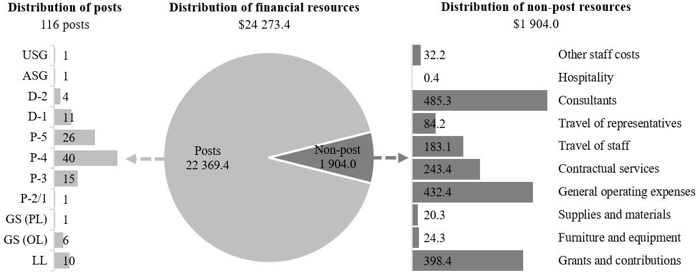

Explanation of variances by factor, component and subprogramme

Overall resource changes

Technical adjustments

14.107 As shown in table 14.14 (1), resource changes reflect a decrease of $469,000 under policymaking organs, which is related to the removal of the non-recurrent provisions associated with the seventh session of the United Nations Environment Assembly that were approved for 2025 and are not required in 2026. These consist of other staff costs ($208,000), hospitality ($20,100), contractual services ($45,100) and general operating expenses ($195,800).

New and expanded mandates

14.108 As reflected in table 14.14 (1), resource changes reflect an increase of $240,900 under subprogramme 5, Chemicals and pollution action, which is related to the request to update the global action plan on antimicrobial resistance pursuant to General Assembly resolution 79/2 titled “Political declaration of the high-level meeting on antimicrobial resistance”. The requirements consist of one temporary Programme Management Officer (P-3) ($110,800) costed at a 50 per cent vacancy rate in accordance with established practice for newly established posts, consultants ($95,100), travel ($10,000), contractual services ($20,000) and general operating expenses ($5,000).

Other changes

14.109 As shown in table 14.14 (1), resource changes reflect a net increase of $400 under subprogramme 4, Environmental governance, and relate to a higher standard price of the core software package for non-field personnel outside of United Nations Headquarters under contractual services.

Extrabudgetary resources

14.110 As reflected in table 14.14 (2), extrabudgetary resources amount to $578,485,500. The resources would complement regular budget resources and would be used mainly to provide for 1,013 posts (1 Assistant Secretary-General, 3 D-2, 36 D-1, 94 P-5, 200 P-4, 190 P-3, 83 P-2/1, 12 National Professional Officer and 394 Local level), as well as non-post requirements. In addition, the non-post resources would be used in line with the priorities and deliverables approved by the United Nations Environment Assembly for the 2026–2027 programme of work. The programme of work will be presented for approval to the Environment Assembly in December 2025. Accordingly, the post numbers in the present document to be funded from extrabudgetary resources for 2026 are preliminary.
14.111 The extrabudgetary resources under the present section are subject to the oversight of the United Nations Environment Assembly.

Policymaking organs

14.112 The resources proposed under this component would provide for the policymaking organs as shown in table 14.17.

Table 14.17

Policymaking organs
(Thousands of United States dollars)

Policymaking organ | Additional information | 2025 approved | 2026 estimate
United Nations Environment Assembly | Mandate: General Assembly resolutions 67/213 and 67/251 and Governing Council decision 27/2 | 360.9 | –
United Nations Environment Assembly | Membership: 193 Member States | 360.9 | –
United Nations Environment Assembly | Number of sessions in 2026: 0 | 360.9 | –
Committee of Permanent Representatives | Mandate: Governing Council decision 27/2 | 108.1 | –
Committee of Permanent Representatives | Membership: 150 accredited Member States | 108.1 | –
Committee of Permanent Representatives | Number of sessions in 2026: 4 | 108.1 | –
Subcommittee of the Committee of Permanent Representatives | Mandate: Governing Council decision 27/2 | 8.3 | 8.3
Subcommittee of the Committee of Permanent Representatives | Membership: 50 accredited Member States | 8.3 | 8.3
Subcommittee of the Committee of Permanent Representatives | Number of sessions in 2026: 1 | 8.3 | 8.3
Total |  | 477.3 | 8.3

14.113 The proposed regular budget resources for 2026 amount to $8,300 and reflect a decrease of $469,000 compared with the approved budget for 2025. The proposed change is explained in paragraph 14.106. Additional details on the distribution of the proposed resources for 2026 are reflected in table 14.18 and figure 14.XXVIII.

Table 14.18

Policymaking organs: evolution of financial resources
(Thousands of United States dollars)

 |  |  | Changes |  |  |  |  | 2026  estimate
 | 2024 expenditure | 2025 approved | Technical adjustments | New/ expanded mandates | Other | Total | Percentage | 2026  estimate
Financial resources by main category of expenditure
Non-post | 463.3 | 477.3 | (469.0) | – | – | (469.0) | (98.3) | 8.3
Total | 463.3 | 477.3 | (469.0) | – | – | (469.0) | (98.3) | 8.3

Figure 14.XXVIII

Policymaking organs: distribution of proposed resources for 2026
(Thousands of United States dollars)

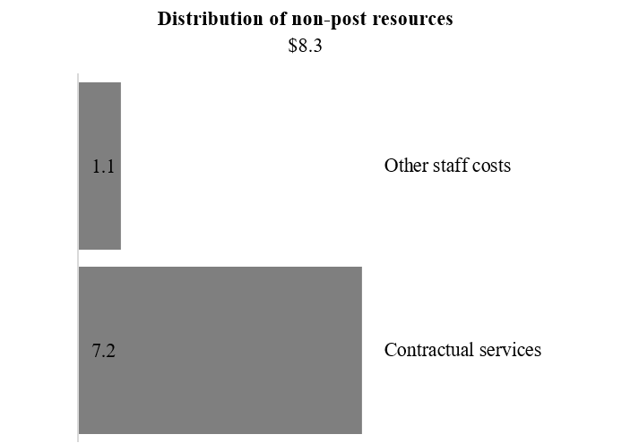

Executive direction and management

14.114 The executive direction and management component comprises the Office of the Executive Director and the United Nations Scientific Committee on the Effects of Atomic Radiation. The proposed regular budget resources for 2026 amount to $4,600,600 and reflect no change compared with the approved budget for 2025. Additional details on the distribution of the proposed resources for 2026 are reflected in table 14.19 and figure 14.XXIX below.

Table 14.19

Executive direction and management: evolution of financial and post resources
(Thousands of United States dollars/number of posts)

 |  |  | Changes |  |  |  |  | 2026  estimate
 | 2024 expenditure | 2025 approved | Technical adjustments | New/ expanded mandates | Other | Total | Percentage | 2026  estimate
Financial resources by main category of expenditure
Posts | 3 781.3 | 4 305.1 | – | – | – | – | – | 4 305.1
Non-post | 151.1 | 295.5 | – | – | – | – | – | 295.5
Total | 3 932.4 | 4 600.6 | – | – | – | – | – | 4 600.6
Post resources by category
Professional and higher |  | 17 | – | – | – | – | – | 17
General Service and related |  | 7 | – | – | – | – | – | 7
Total |  | 24 | – | – | – | – | – | 24

Figure 14.XXIX

Executive direction and management: distribution of proposed resources for 2026
(Number of posts/thousands of United States dollars)

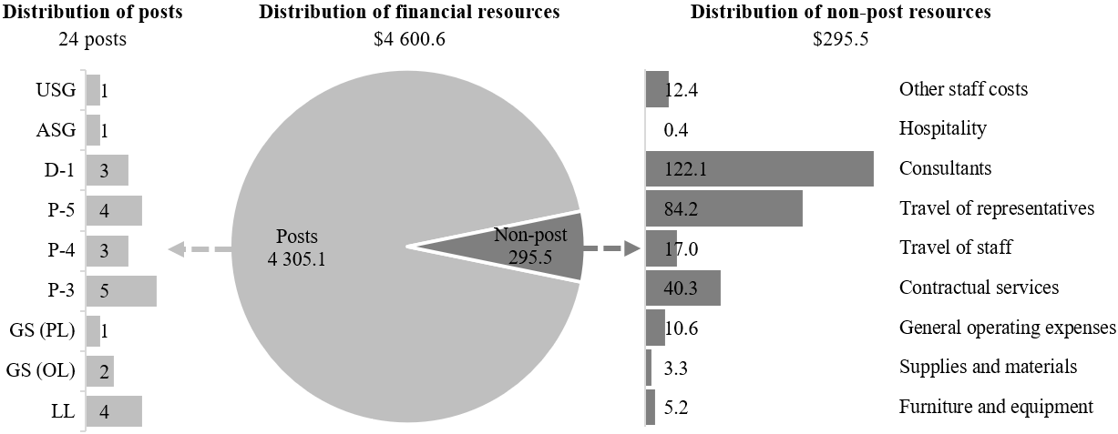

Office of the Executive Director

14.115 The executive direction and management component comprises the Executive Office, the Governance Affairs Office and an independent Evaluation Office that reports directly to the Executive Director. The Executive Office provides executive and support services to the Executive Director, the Deputy Executive Director and other members of the UNEP senior management team. It provides guidance and policy clearance on all programmatic and administrative matters with the support of the Corporate Services and Policy and Programme Divisions. The Executive Director, with the support of the Deputy Executive Director, provides the vision and direction for the work of UNEP in accordance with its legislative mandates and has overall responsibility for the management of UNEP resources.
14.116 The main responsibilities of the executive direction and management component also include leading UNEP in order to provide general policy guidance for the coordination of coherent environmental action within the United Nations system and keeping its implementation under review (see General Assembly resolution 2997 (XXVII)) and to provide leadership on the environmental dimension of sustainable development, informing global processes. This will be informed by assessments of the causes and effects of environmental challenges, as well as emerging issues of global, regional and national significance. UNEP will work through inter-agency mechanisms such as the United Nations Environment Management Group and the United Nations System Chief Executives Board for Coordination and its subsidiary bodies, to support and enhance coordination, cooperation and collaboration across the United Nations system through system-wide strategies and common approaches on the environment, such as the common approach on biodiversity and the common approach on pollution. In addition, UNEP will work to integrate the priorities of multilateral environmental agreements into United Nations country programming, ensuring a more coordinated and effective response to specific country needs. The year 2026 will mark the first year of the implementation of the UNEP medium-term strategy and programme of work for the period 2026–2027. UNEP has a new set of targets for 2026 and 2027, focusing on indicators that are aligned with organizational objectives, the Sustainable Development Goals and internationally agreed environmental commitments. UNEP strives to monitor change over a term longer than the four years of its strategy by employing impact metrics with project performance dashboards and cross-project leader boards to gauge effectiveness and assess the level of uptake of its products and services.
14.117 UNEP will continue to provide leadership on the environmental dimension of sustainable development, informing and influencing global environmental policymaking through global intergovernmental processes within the United Nations such as the General Assembly, the Economic and Social Council, the Human Rights Council and the Security Council.
14.118 The UNEP Sustainable United Nations facility will continue to coordinate the implementation of phase I (environmental sustainability in the area of management) of the Strategy for Sustainability Management in the United Nations System 2020–2030, including by measuring the progress of the United Nations system environmental footprint and efforts to reduce that footprint annually at the system-wide and entity levels. Work of the facility responds also to paragraph 35 of General Assembly resolution 79/226 on the quadrennial comprehensive policy review of operational activities for development of the United Nations system, in which the Assembly called upon the entities of the United Nations development system to advance a system-wide approach, implement measures and report regularly on their efforts to reduce their environmental footprint.
14.119 In accordance with target 12.6 of the Sustainable Development Goals, in which organizations are encouraged to integrate sustainability information into their reporting cycles and in compliance with the cross-cutting mandate set out in paragraph 19 of General Assembly resolution 72/219, UNEP is integrating environmental management practices into its operations, including the sound management of waste.
14.120 Information on the timely submission of documentation and advance booking for air travel is reflected in table 14.20. The lower rates of compliance for 2024 were due mainly to late nomination of travellers. UNEP continues to streamline its processes and, accordingly, has issued internal guidelines to all staff. In addition, numerous outreach sessions were held to bring more awareness to the requirement of timely submission. UNEP will continue to minimize travel and monitor compliance through the enhanced travel dashboard.

Table 14.20

Compliance rate
(Percentage)

 | Actual 2022 | Actual 2023 | Actual 2024 | Planned 2025 | Planned 2026
Timely submission of documentation | 43 | 76 | 70 | 100 | 100
Air tickets purchased at least 2 weeks before the commencement of travel | 37 | 82 | 78 | 100 | 100

14.121 The proposed regular budget resources for 2026 amount to $3,406,800 and reflect no change compared with the approved budget for 2025. Additional details on the distribution of the proposed resources for 2026 are reflected in table 14.21 and figure 14.XXX.

Table 14.21

Office of the Executive Director: evolution of financial and post resources
(Thousands of United States dollars/number of posts)

 |  |  | Changes |  |  |  |  | 2026  estimate
 | 2024 expenditure | 2025 approved | Technical adjustments | New/ expanded mandates | Other | Total | Percentage | 2026  estimate
Financial resources by main category of expenditure
Posts | 3 257.6 | 3 371.3 | – | – | – | – | – | 3 371.3
Non-post | – | 35.5 | – | – | – | – | – | 35.5
Total | 3 257.6 | 3 406.8 | – | – | – | – | – | 3 406.8
Post resources by category
Professional and higher |  | 14 | – | – | – | – | – | 14
General Service and related |  | 4 | – | – | – | – | – | 4
Total |  | 18 | – | – | – | – | – | 18

Figure 14.XXX

Office of the Executive Director: distribution of proposed resources for 2026
(Number of posts/thousands of United States dollars)

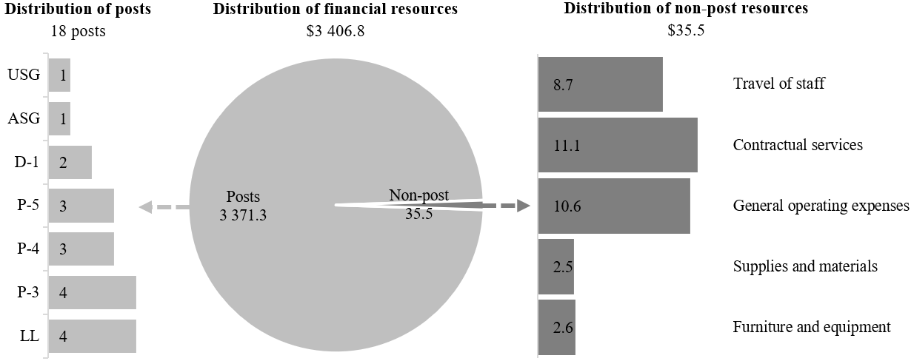

United Nations Scientific Committee on the Effects of Atomic Radiation

14.122 The General Assembly, by its resolution 913 (X), established the United Nations Scientific Committee on the Effects of Atomic Radiation to undertake broad scientific evaluations of developing knowledge on sources of ionizing radiation and its effects on human health and the environment. Since 1955, the Committee has played an important role in improving international scientific understanding of levels of exposure to ionizing radiation and its health and environmental effects. The Assembly, in its resolution 79/85, reaffirmed the functions of the Committee
14.123 The Committee conducts evaluations on behalf of all States Members of the United Nations, which are used to assess the levels, trends and effects of exposure to radiation in areas such as medicine, research, agriculture and industry. The Committee’s scientific synthesis of the most up-to-date radiobiological and epidemiological knowledge provides a recognized authoritative benchmark for scientists around the world. Moreover, the Committee’s publications play a fundamental role in the international radiation safety regime, critically underpinning international standards for protecting the public, workers, patients and the environment against ionizing radiation. In turn, these standards serve as a basis for national and international programmes and legislative instruments.
14.124 During the annual session of the Committee, more than 170 scientific advisors representing the 31 States members of the Committee, as well as observers from relevant international organizations, scrutinize the scientific content of several complex documents. Organizational responsibility for serving the Committee lies with UNEP. The secretariat of the Committee convenes the annual sessions and coordinates the development of such documents, which are compiled using scientific and technical information obtained from Member States and scientific literature in accordance with the Committee’s requests. Once approved by the Committee, these documents are published periodically as scientific annexes to the report of the Committee to the General Assembly, after a formulation period that lasts, in general, four to five years, in a rolling publication scheme. The secretariat arranges for the dissemination of the Committee’s findings to the Assembly, the scientific community and the public.
14.125 In relation to the Sustainable Development Goals, the work of the Committee contributes to the achievement of Goals 3, 10, 14, 15 and 17. At its seventy-first session, held from 20 to 24 May 2024, the Committee approved its related report (A/79/46) containing two scientific reports. The first report, on second primary cancer after radiotherapy, establishes the basis for long-term medical care and preventive intervention that will benefit the growing population of cancer survivors globally, while the second, on an evaluation of public exposure to ionizing radiation, provides the scientific basis for radiation protection of the public from natural and anthropogenic sources of radiation, which contributes to achieving several Goals, especially Goal 3.
14.126 Also at its seventy-first session, the Committee approved its future programme of work for 2025–2029 and its public information and outreach strategy for the period 2025–2029. It reviewed the progress made in its scientific evaluations, namely, epidemiological studies of ionizing radiation and cancer, the effects of ionizing radiation on the circulatory system and the effects of ionizing radiation on the nervous system, and endorsed its strategy to improve the collection, analysis and dissemination of data on radiation exposure, including consideration of the Committee’s ad hoc working group on sources and exposure.
14.127 The Committee has identified its thematic priorities for 2026 with the continuation of the evaluations on the effects of ionizing radiation on the nervous system and the effects of ionizing radiation on the eye, as well as the commencement of the evaluations on the effects of ionizing radiation on the immune system and the update of the evaluation of medical exposure to ionizing radiation. The new evaluations will support Sustainable Development Goals 3 and 10. The evaluations on the effects of ionizing radiation on the eye and on the effects of radiation on the immune system have been postponed to 2025 and 2026, respectively, owing to liquidity constraints.
14.128 In line with General Assembly resolution 79/85, the secretariat continues to maintain the online platform for the collection of data from Member States on public, medical and occupational exposure, to facilitate the Committee’s regular evaluation and monitoring of trends in such exposures. The current network consists of 200 national contact persons and alternates from 112 Member States who are actively involved in the exchange of information and the formulation of data.
14.129 The proposed regular budget resources for 2026 amount to $1,193,800 and reflect no change compared with the approved budget for 2025. Additional details on the distribution of proposed resources for 2026 are reflected in table 14.22 and figure 14.XXXI.

Table 14.22

United Nations Scientific Committee on the Effects of Atomic Radiation: evolution of financial and post resources
(Thousands of United States dollars/number of posts)

 |  |  | Changes |  |  |  |  | 2026  estimate
 | 2024 expenditure | 2025 approved | Technical adjustments | New/ expanded mandates | Other | Total | Percentage | 2026  estimate
Financial resources by main category of expenditure
Posts | 523.7 | 933.8 | – | – | – | – | – | 933.8
Non-post | 151.1 | 260.0 | – | – | – | – | – | 260.0
Total | 674.8 | 1 193.8 | – | – | – | – | – | 1 193.8
Post resources by category
Professional and higher |  | 3 | – | – | – | – | – | 3
General Service and related |  | 3 | – | – | – | – | – | 3
Total |  | 6 | – | – | – | – | – | 6

Figure 14.XXXI

United Nations Scientific Committee on the Effects of Atomic Radiation: distribution of proposed resources for 2026
(Number of posts/thousands of United States dollars)

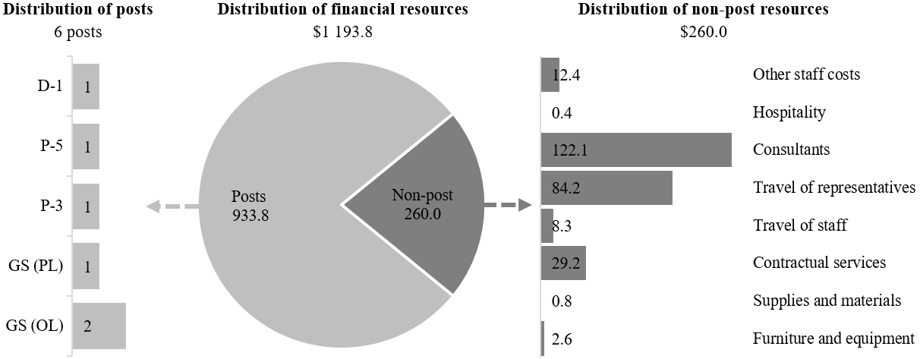

Programme of work

Subprogramme 1

Climate action

14.130 The proposed regular budget resources for 2026 amount to $2,211,000 and reflect no change compared with the approved budget for 2025. Additional details on the distribution of the proposed resources for 2026 are reflected in table 14.23 and figure 14.XXXII.

Table 14.23

Subprogramme 1: evolution of financial and post resources
(Thousands of United States dollars/number of posts)

 |  |  | Changes |  |  |  |  | 2026  estimate
 | 2024 expenditure | 2025 approved | Technical adjustments | New/ expanded mandates | Other | Total | Percentage | 2026  estimate
Financial resources by main category of expenditure
Posts | 2 242.4 | 2 091.0 | – | – | – | – | – | 2 091.0
Non-post | – | 120.0 | – | – | – | – | – | 120.0
Total | 2 242.4 | 2 211.0 | – | – | – | – | – | 2 211.0
Post resources by category
Professional and higher |  | 10 | – | – | – | – | – | 10
Total |  | 10 | – | – | – | – | – | 10

Figure 14.XXXII

Subprogramme 1: distribution of proposed resources for 2026
(Number of posts/thousands of United States dollars)

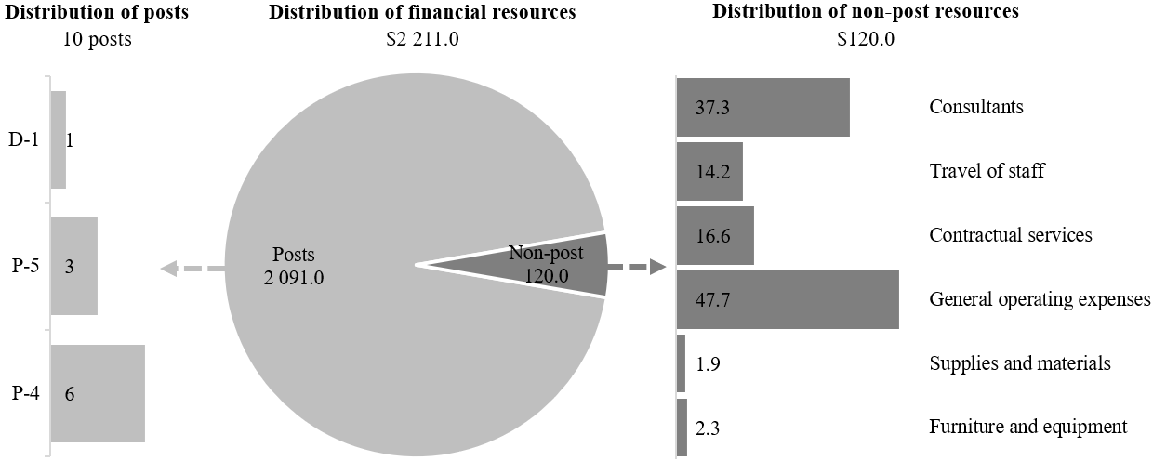

Subprogramme 2

Digital transformations in supporting environmental action

14.131 The proposed regular budget resources for 2026 amount to $1,597,600 and reflect no change compared with the approved budget for 2025. Additional details on the distribution of the proposed resources for 2026 are reflected in table 14.24 and figure 14.XXXIII.

Table 14.24

Subprogramme 2: evolution of financial and post resources
(Thousands of United States dollars/number of posts)

 |  |  | Changes |  |  |  |  | 2026  estimate
 | 2024 expenditure | 2025 approved | Technical adjustments | New/ expanded mandates | Other | Total | Percentage | 2026  estimate
Financial resources by main category of expenditure
Posts | 829.0 | 1 520.0 | – | – | – | – | – | 1 520.0
Non-post | – | 77.6 | – | – | – | – | – | 77.6
Total | 829.0 | 1 597.6 | – | – | – | – | – | 1 597.6
Post resources by category
Professional and higher |  | 7 | – | – | – | – | – | 7
General Service and related |  | 1 | – | – | – | – | – | 1
Total |  | 8 | – | – | – | – | – | 8

Figure 14.XXXIII

Subprogramme 2: distribution of proposed resources for 2026
(Number of posts/thousands of United States dollars)

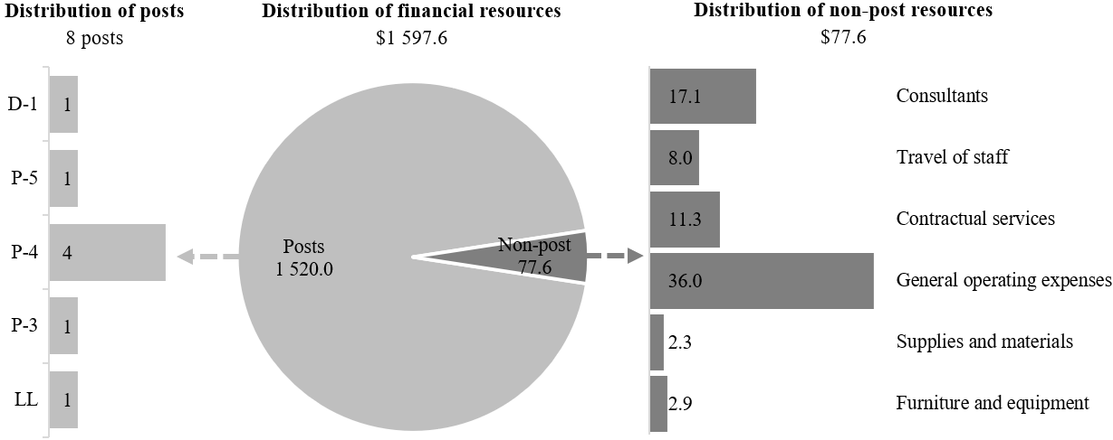

Subprogramme 3

Nature action

14.132 The proposed regular budget resources for 2026 amount to $2,674,000 and reflect no change compared with the approved budget for 2025. Additional details on the distribution of the proposed resources for 2026 are reflected in table 14.25 and figure 14.XXXIV.

Table 14.25

Subprogramme 3: evolution of financial and post resources
(Thousands of United States dollars/number of posts)

 |  |  | Changes |  |  |  |  | 2026  estimate
 | 2024 expenditure | 2025 approved | Technical adjustments | New/ expanded mandates | Other | Total | Percentage | 2026  estimate
Financial resources by main category of expenditure
Posts | 2 003.1 | 2 544.9 | – | – | – | – | – | 2 544.9
Non-post | – | 129.1 | – | – | – | – | – | 129.1
Total | 2 003.1 | 2 674.0 | – | – | – | – | – | 2 674.0
Post resources by category
Professional and higher |  | 11 | – | – | – | – | – | 11
General Service and related |  | 2 | – | – | – | – | – | 2
Total |  | 13 | – | – | – | – | – | 13

Figure 14.XXXIV

Subprogramme 3: distribution of proposed resources for 2026
(Number of posts/thousands of United States dollars)

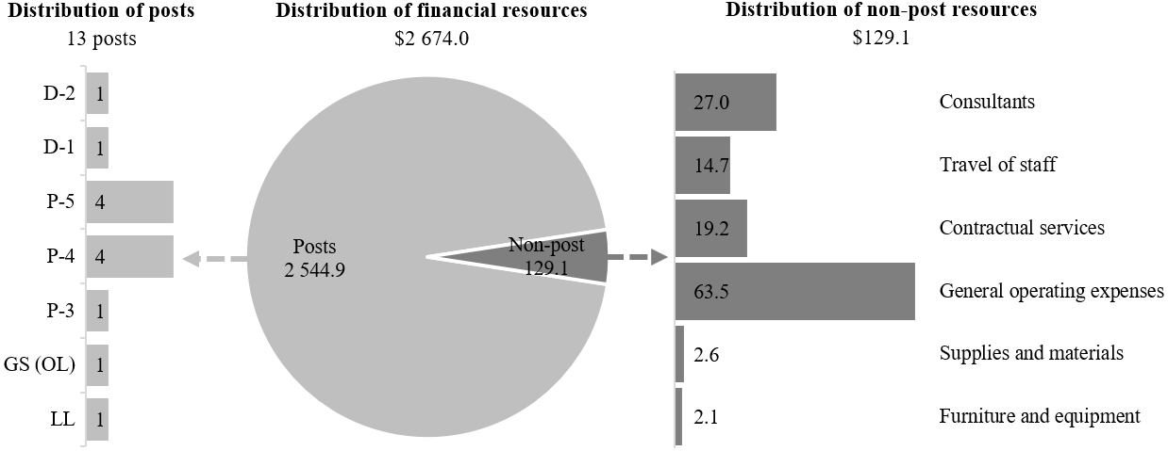

Subprogramme 4

Environmental governance

14.133 The proposed regular budget resources for 2026 amount to $4,697,100 and reflect an increase of $400 compared with the approved budget for 2025. The proposed change is explained in paragraph 14.108 above. Additional details on the distribution of the proposed resources for 2026 are reflected in table 14.26 and figure 14.XXXV.

Table 14.26

Subprogramme 4: evolution of financial and post resources
(Thousands of United States dollars/number of posts)

 |  |  | Changes |  |  |  |  | 2026  estimate
 | 2024 expenditure | 2025 approved | Technical adjustments | New/ expanded mandates | Other | Total | Percentage | 2026  estimate
Financial resources by main category of expenditure
Posts | 4 486.5 | 4 546.3 | – | – | – | – | – | 4 546.3
Non-post | – | 150.4 | – | – | 0.4 | 0.4 | 0.3 | 150.8
Total | 4 486.5 | 4 696.7 | – | – | 0.4 | 0.4 | 0.0 | 4 697.1
Post resources by category
Professional and higher |  | 19 | – | – | – | – | – | 19
General Service and related |  | 4 | – | – | – | – | – | 4
Total |  | 23 | – | – | – | – | – | 23

Figure 14.XXXV

Subprogramme 4: distribution of proposed resources for 2026
(Number of posts/thousands of United States dollars)

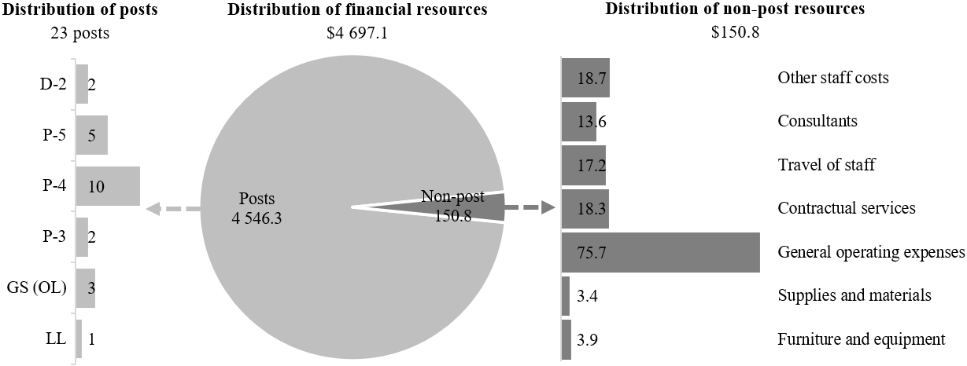

Subprogramme 5

Chemicals and pollution action

14.134 The proposed regular budget resources for 2026 amount to $2,058,900 and reflect an increase of $240,900 compared with the approved budget for 2025. The proposed change is explained in paragraph 14.107 above. Additional details on the distribution of the proposed resources for 2026 are reflected in table 14.27 and figure 14.XXXVI.

Table 14.27

Subprogramme 5: evolution of financial and post resources
(Thousands of United States dollars/number of posts)

 |  |  | Changes |  |  |  |  | 2026  estimate
 | 2024 expenditure | 2025 approved | Technical adjustments | New/ expanded mandates | Other | Total | Percentage | 2026  estimate
Financial resources by main category of expenditure
Posts | 1 715.3 | 1 700.1 | – | 110.8 | – | 110.8 | 6.5 | 1 810.9
Non-post | – | 117.9 | – | 130.1 | – | 130.1 | 110.3 | 248.0
Total | 1 715.3 | 1 818.0 | – | 240.9 | – | 240.9 | 13.3 | 2 058.9
Post resources by category
Professional and higher |  | 8 | – | 1 | – | – | – | 9
General Service and related |  | 1 | – | – | – | – | – | 1
Total |  | 9 | – | 1 | – | – | – | 10

Figure 14.XXXVI

Subprogramme 5: distribution of proposed resources for 2026
(Number of posts/thousands of United States dollars)

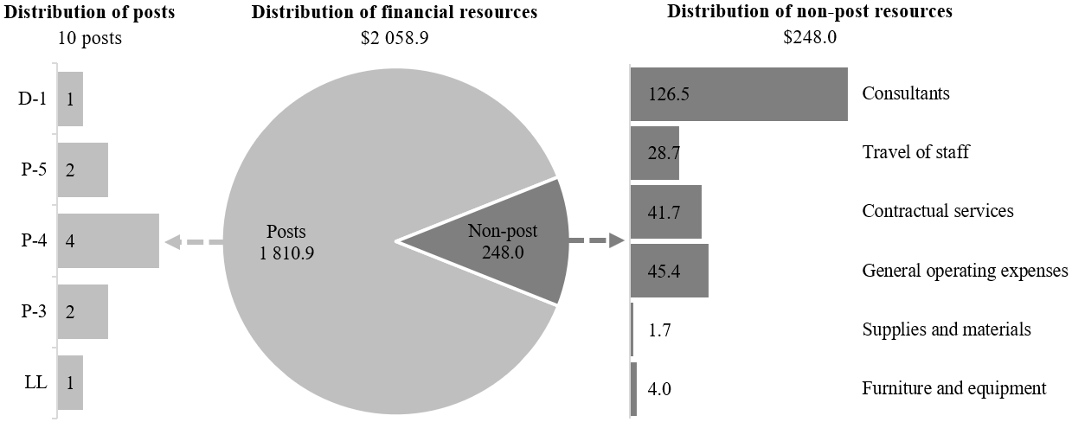

Subprogramme 6

Finance and economic transformations

14.135 The proposed regular budget resources for 2026 amount to $2,002,300 and reflect no change compared with the approved budget for 2025. Additional details on the distribution of the proposed resources for 2026 are reflected in table 14.28 and figure 14.XXXVII.

Table 14.28

Subprogramme 6: evolution of financial and post resources
(Thousands of United States dollars/number of posts)

 |  |  | Changes |  |  |  |  | 2026  estimate
 | 2024 expenditure | 2025 approved | Technical adjustments | New/ expanded mandates | Other | Total | Percentage | 2026  estimate
Financial resources by main category of expenditure
Posts | 1 475.1 | 1 870.3 | – | – | – | – | – | 1 870.3
Non-post | – | 132.0 | – | – | – | – | – | 132.0
Total | 1 475.1 | 2 002.3 | – | – | – | – | – | 2 002.3
Post resources by category
Professional and higher |  | 9 | – | – | – | – | – | 9
General Service and related |  | 2 | – | – | – | – | – | 2
Total |  | 11 | – | – | – | – | – | 11

Figure 14.XXXVII

Subprogramme 6: distribution of proposed resources for 2026
(Number of posts/thousands of United States dollars)

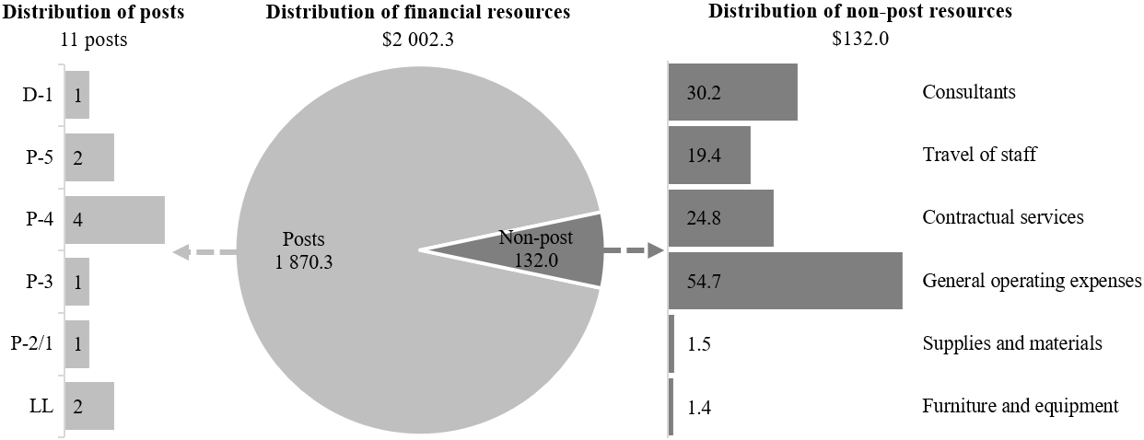

Subprogramme 7

Science policy

14.136 The proposed regular budget resources for 2026 amount to $3,208,200 and reflect no change compared with the approved budget for 2025. Additional details on the distribution of the proposed resources for 2026 are reflected in table 14.29 and figure 14.XXXVIII.

Table 14.29

Subprogramme 7: evolution of financial and post resources
(Thousands of United States dollars/number of posts)

 |  |  | Changes |  |  |  |  | 2026  estimate
 | 2024 expenditure | 2025 approved | Technical adjustments | New/ expanded mandates | Other | Total | Percentage | 2026  estimate
Financial resources by main category of expenditure
Posts | 2 417.7 | 2 484.7 | – | – | – | – | – | 2 484.7
Non-post | 141.5 | 723.5 | – | – | – | – | – | 723.5
Total | 2 559.2 | 3 208.2 | – | – | – | – | – | 3 208.2
Post resources by category
Professional and higher |  | 12 | – | – | – | – | – | 12
Total |  | 12 | – | – | – | – | – | 12

Figure 14.XXXVIII

Subprogramme 7: distribution of proposed resources for 2026
(Number of posts/thousands of United States dollars)

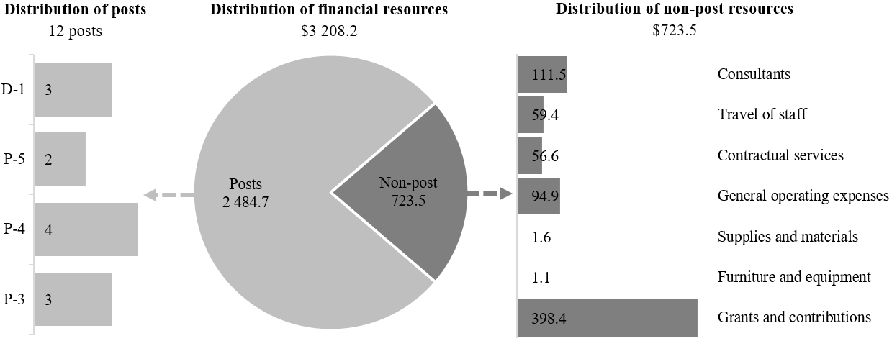

Programme support

14.137 The programme support component comprises the Corporate Services and the Policy and Programme Divisions. The component aims to ensure efficient and effective development and delivery of the programmatic priorities of the medium-term strategy, underpinned by sound resource management, risk management and leadership practices. Programme management and support provide guidance on programme and project design, delivery and closure; governance of resources; corporate policy development and oversight; programme monitoring and reporting; building of staff knowledge and capacity; and the development of programme and resource management tools that support decision-making.
14.138 The main responsibilities of the programme support component include the strategic management of UNEP financial, human and information technology resources, ensuring alignment of the resources with programmatic needs and strategic objectives, such as gender balance in the workplace. The component works in close collaboration and coordination with the United Nations Office at Nairobi and its other United Nations service providers, including the United Nations Office at Geneva, in respect of accounting, payroll and payments, recruitment and staff services, staff development, network and other systems administration, information and communications technology, procurement and inventory management. The component also interacts with the United Nations Office at Nairobi in the areas of host country relations, buildings management, conference management, medical services, and security and safety.
14.139 In 2026, the component will continue with its strong engagement in keeping with its role in promoting the coherent implementation of the environmental dimension of sustainable development within the United Nations system.
14.140 The proposed regular budget resources for 2026 amount to $1,215,400 and reflect no change compared with the approved budget for 2025. Additional details on the distribution of the proposed resources for 2026 are reflected in table 14.30 and figure 14.XXXIX.

Table 14.30

Programme support: evolution of financial and post resources
(Thousands of United States dollars)

 |  |  | Changes |  |  |  |  | 2026  estimate
 | 2024 expenditure | 2025 approved | Technical adjustments | New/ expanded mandates | Other | Total | Percentage | 2026  estimate
Financial resources by main category of expenditure
Posts | 760.0 | 1 196.2 | – | – | – | – | – | 1 196.2
Non-post | – | 19.2 | – | – | – | – | – | 19.2
Total | 760.0 | 1 215.4 | – | – | – | – | – | 1 215.4
Post resources by category
Professional and higher |  | 5 | – | – | – | – | – | 5
Total |  | 5 | – | – | – | – | – | 5

Figure 14.XXXIX

Programme support: distribution of proposed resources for 2026
(Number of posts/thousands of United States dollars)

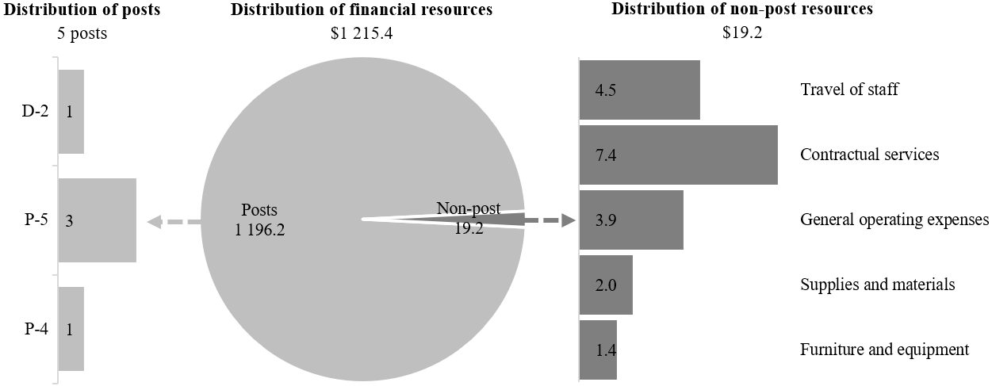

Annex I

Organizational structure and post distribution for 2026
Corporate Services Division
(programme support)
RB: XB:
1 D-2 3 D-1
1 P-5 7 P-5
1 P-4 13 P-4
1 P-3 14 P-3
3 P-2
52 LL
4 92
Total: 96
United Nations Scientific Committee on the Effects of Atomic Radiation
RB: XB:
1 D-1 1 P-3
1 P-5
1 P-3
1 GS (PL)
2 GS (OL)
6 1
Total: 7
Evaluation Office
(executive direction and management)
RB: XB:
1 D-1 2 P-4
1 P-5 5 P-3
3 LL
2 10
Total: 12
Governance Affairs
(policymaking organs and executive direction and management)
RB: XB:
1 D-1
1 P-5 1 P-5
1 P-4 3 P-4
1 P-3 1 P-3
1 LL 2 P-2
6 LL
4 14
Total: 18
Climate Change Division
(subprogramme 1)
XB:
1 D-2
5 D-1
7 P-5
23 P-4
30 P-3
8 P-2
2 NPO
32 LL

Total: 108
Regional offices
(all subprogrammes)
RB: XB:
6 D-1 20 P-5
7 P-5 30 P-4
30 P-4 13 P-3
7 P-3 5 P-2
2 GS (OL) 6 NPO
1 LL 75 LL
53 149
Total: 202
Law Division
(subprogramme 4)
RB: XB:
1 D-2 5 D-1
2 P-5 5 P-5
1 P-4 19 P-4
2 LL 22 P-3
6 P-2
38 LL
6 95

Total: 101
Early Warning and Assessment Division (former Science Division)
(subprogramme 7)
RB : XB:
1 D-2 4 D-1
1 D-1 6 P-5
3 P-5 12 P-4
1 P-4 11 P-3
2 LL 10 P-2
24 LL
8 67
Total: 75
Communication Division
(all subprogrammes)
RB: XB:
1 D-1 3 P-5
1 P-3 11 P-4
1 P-2 8 P-3
1 P-2
2 GS (OL) 14 LL
5 37

Total: 42
Policy and Programme
Division
(all subprogrammes and programme support)
RB: XB:
4 P-5 1 D-2
1 P-4 1 D-1
2 P-3 3 P-5
1 LL 6 P-4
7 P-3
3 P-2
15 LL
8 36
Total: 44
Ecosystems Division
(subprogrammes 1 and 3)
RB: XB:
1 D-2 8 D-1
2 P-5 24 P-5
2 P-4 36 P-4
22 P-3
11 P-2
3 NPO
61 LL
5 165
Total: 170
Industry and Economy Division (former Economy Division)
(subprogrammes 5 and 6)
RB: XB:
2 P-5 1 D-2
1 P-3 7 D-1
12 P-5
36 P-4
46 P-3
26 P-2
1 NPO
52 LL
3 181
Total: 184
Executive Office
(all subprogrammes)
RB: XB:
1 USG 1 ASG
1 P-4 2 D-1
2 LL 4 P-5
7 P-4
7 P-3
8 P-2
18 LL

New York Office

RB: XB:
1 ASG 2 P-5
1 D-1 2 P-4
2 P-5 3 P-3
2 P-4 4 LL
1 P-3
1 LL
12 58

Total: 70

Abbreviations: ASG, Assistant Secretary-General; GS (OL), General Service (Other level); GS (PL), General Service (Principal level); LL, Local level; NPO, National Professional Officer; RB, regular budget; USG, Under-Secretary-General; XB, extrabudgetary.

Annex II

Summary of proposed post changes, by component and subprogramme

Component/subprogramme | Posts | Grade | Description | Reason for change
Subprogramme 5, Chemicals and pollution action | 1 | P-3 | Establishment of Programme Management Officer | The proposed establishment is related to the need to strengthen the capacity required to enhance the environmental dimension of antimicrobial resistance pursuant to General Assembly resolution 79/2. The incumbent would: (a) update the global action plan by 2026; (b) support input to the report on antimicrobial resistance for the eighty-first session of the General Assembly; and (c) support the substantive arrangements for the high-level meeting on antimicrobial resistance in 2029. The post would be established as a temporary post for the period 2026–2029.

