Eightieth session
Items 137 and 138 of the preliminary list*

Proposed programme budget for 2026

Programme planning

Proposed programme budget for 2026

Part IV

International cooperation for development

Section 15

Human settlements

Programme 12

Human settlements

Contents
 |  |  | Page
- Proposed programme plan for 2026 and programme performance in 2024** |  |  | 3
Overall orientation |  |  | 3
Programme of work |  |  | 11
Subprogramme 1. Reduced spatial inequality and poverty in communities across the urban-rural continuum |  |  | 11
Subprogramme 2. Enhanced shared prosperity of cities and regions |  |  | 16
Subprogramme 3. Strengthened climate action and improved urban environment |  |  | 21
Subprogramme 4. Effective urban crisis prevention and response |  |  | 26
- Proposed post and non-post resource requirements for 2026*** |  |  | 31
* A/80/50.
** In keeping with paragraph 10 of General Assembly resolution 77/267, the part consisting of the programme plan and programme performance information (part II) is submitted through the Committee for Programme and Coordination for the consideration of the Assembly.
*** In keeping with paragraph 10 of General Assembly resolution 77/267, the part consisting of the post and non-post resource requirements (part III) is submitted through the Advisory Committee on Administrative and Budgetary Questions for the consideration of the Assembly.
Overview | 31
Policymaking organs | 36
Executive direction and management | 38
Programme of work | 40
Subprogramme 1. Reduced spatial inequality and poverty in communities across the urban-rural continuum | 40
Subprogramme 2. Enhanced shared prosperity of cities and regions | 41
Subprogramme 3. Strengthened climate action and improved urban environment | 42
Subprogramme 4. Effective urban crisis prevention and response | 43
Programme support | 44
Annex
Organizational structure and post distribution for 2026 | 46

A. Proposed programme plan for 2026 and programme performance in 2024

Overall orientation

Mandates and background

15.1 The United Nations Human Settlements Programme (UN-Habitat) is the focal point for sustainable urbanization and human settlements in the United Nations system. It supports Member States in the development of sustainable cities and human settlements through its normative and operational work at the global, regional, national and local levels. UN-Habitat leads and coordinates the monitoring of and reporting on global progress in the implementation of the New Urban Agenda and the achievement of Sustainable Development Goal 11. The mandate derives from the priorities established in relevant General Assembly resolutions and decisions, including resolution 3327 (XXIX), by which the Assembly established the United Nations Habitat and Human Settlements Foundation, and resolution 32/162, by which the Assembly established the United Nations Centre for Human Settlements (Habitat). The Assembly, through its resolution 56/206, transformed the Centre into the United Nations Human Settlements Programme (UN-Habitat), effective 1 January 2002. The Assembly, through its resolution 73/239, established a new governance structure for the Programme, consisting of the universal UN-Habitat Assembly, the 36-member Executive Board and the Committee of Permanent Representatives. The UN-Habitat Assembly adopted resolutions providing further guidance on the work of UN-Habitat at its first and second sessions, held in May 2019 and June 2023, respectively.
15.2 The Programme’s support is aimed at developing the capacity at all levels of government and other key stakeholders to formulate and implement policies, plans and concrete activities for sustainable urban development. Such support is also provided through the implementation of projects under the regular programme of technical cooperation and the United Nations Development Account.

Strategy and external factors for 2026

15.3 UN-Habitat operates in a world that will continue to urbanize over the coming three decades. Approximately 90 per cent of urban growth is taking place in less developed regions, where unplanned growth is driving the rise of informal settlements, slums and homelessness, exacerbating urban poverty, inequality and a lack of adequate and affordable housing. By contrast, many cities in other parts of the world are facing negative growth and shrinking populations. The global housing challenge is intensifying, with the demand for affordable and adequate housing outpacing supply, further deepening inequality and vulnerability, in particular in urban areas. Globally, more than 1.6 billion people live in inadequate housing and more than 1.12 billion reside in slums and informal settlements. In addition, there are 304 million international migrants, most of whom live in urban areas, and 75.9 million internally displaced persons.
15.4 Growing inequalities, housing challenges, climate change and biodiversity loss, conflicts and other natural and human-made disasters often converge in cities, with the urban poor suffering the worst consequences. Being prepared for and overcoming these challenges is critical for a better urban future. The UN-Habitat strategy for 2026 will be guided by the UN-Habitat strategic plan for 2026–2029, to be considered by the UN-Habitat Assembly in May 2025. In the strategic plan, greater focus will be placed on access to adequate housing, land and basic services, with a view to strengthening its impact. UN-Habitat will also focus on pathways to transformative change and showcase examples of cities that reached a tipping point and turned the corner by instituting innovative policies and planning regimes.
15.5 Cities are hotspots for environmental challenges, accounting for approximately 75 per cent of global energy consumption, 70 per cent of global greenhouse gas emissions and more than 70 per cent of resource use. In the Pact for the Future (General Assembly resolution 79/1), Member States reiterated their commitment to ensuring access for all to adequate, safe and affordable housing and supporting developing countries in planning and implementing just, safe, healthy, accessible, resilient and sustainable cities. In that context UN-Habitat will support cities in integrating urban and territorial planning, management, and investment and finance aspects and will support national and local governments in developing sustainable construction value chains and policies, supported by innovations and technology, that help to overcome inequalities and build resilience.
15.6 The deterioration in progress towards achieving the Sustainable Development Goals and implementing the Paris Agreement in the context of interrelated global crises calls for more transformative multilevel action. UN-Habitat will continue to fast-track integration between its normative and operational work, scaling up and accelerating the impact of the organization. UN-Habitat recognizes that rapid urban growth requires bold, forward-looking and collective action to shape cities in ways that address the most pressing urban challenges. As a global advocate for urban development, UN-Habitat will support countries in navigating complex housing issues, including by supporting the open-ended intergovernmental expert working group on adequate housing for all, by providing evidence-based policy advice and technical support and by driving urban programmes to address complex housing issues.
15.7 In line with its capacity-building strategy for the implementation of the 2030 Agenda for Sustainable Development and the New Urban Agenda, UN-Habitat will continue to localize the Sustainable Development Goals and to respond to local challenges by identifying and targeting specific capacity gaps while raising awareness and building skills in the area of transformative solutions. UN-Habitat will strengthen capacity development as a cross-cutting function across its operations, through the continued digitalization and dissemination of knowledge and tools, supported by strategic partnerships for innovation, knowledge and learning across practices.
15.8 In its catalytic role as a knowledge hub and partner convenor, UN-Habitat will carry out advocacy, communication and outreach activities and mobilize broad-based support for the implementation of the New Urban Agenda. It will operationalize stronger stakeholder engagement and collaboration with universities and centres of knowledge and research in order to continue to leverage advocacy and knowledge platforms, including the thirteenth session of the World Urban Forum, the Urban Agenda Platform, coalitions, global corporate events, regional ministerial conferences, the ministerial meeting on urbanization and climate change and the intersessional activities of the open-ended intergovernmental expert working group on adequate housing for all.
15.9 Furthermore, UN-Habitat will continue to monitor and report on global trends and provide evidence for policymaking, including through the enhanced use of technologies for data collection and analysis, data visualization and management of information. It will continue to expand the roll-out of the Global Urban Monitoring Framework and its support for Member States and other stakeholders in monitoring and reporting on the progress on the implementation of the New Urban Agenda and other global agendas and the achievement of the Sustainable Development Goals.
15.10 With regard to cooperation with other entities at the global, regional, national and local levels, UN-Habitat will continue its close cooperation with international and regional organizations, such as the Organisation for Economic Co-operation and Development, the World Bank, the European Union and regional development banks. UN-Habitat will also explore and deepen partnerships with relevant institutions from the global South. UN-Habitat will maintain its focus on partnerships with local authorities and their associations and city networks, grass-roots organizations, foundations, international financial institutions, the private sector and academia to promote participatory and multilevel governance and support municipal efforts in the localization of the Sustainable Development Goals and will continue to serve as the secretariat and co-Chair of the Local2030 coalition.
15.11 With regard to inter-agency coordination and liaison, UN-Habitat will continue to collaborate with the Department of Economic and Social Affairs and the United Nations regional economic and social commissions and strengthen its strategic inter-agency partnerships, building on the United Nations system-wide strategy on sustainable urban development and agency-specific collaborative frameworks. UN-Habitat will also continue to advance the goals of the United Nations reform aimed at increasing sustainable development impacts at the country level. A focus on regional collaboration will be achieved through the regional development cooperation platforms and issue-based coalitions. UN-Habitat will also deepen its collaboration with the Development Coordination Office to strengthen the United Nations system-wide impact on sustainable development by providing technical guidance, contributing to the revision of system-wide guidance, helping to build capacity for the use of innovative diagnostic and planning methodologies, and working with the resident coordinator system and United Nations country teams on the common country analyses and United Nations Sustainable Development Cooperation Frameworks.
15.12 To pursue stronger integration of environmental, social and economic sustainability and the protection of biodiversity into urban development, UN-Habitat will continue to strengthen its collaboration with the United Nations Environment Programme in serving as the secretariat for the Secretary-General’s Advisory Board of Eminent Persons on Zero Waste and as a partner in the Global Alliance for Buildings and Construction, which is led by the United Nations Environment Programme. It will also continue to collaborate with the Office of the United Nations High Commissioner for Refugees, the United Nations Development Programme, the International Organization for Migration, the United Nations Office for Disaster Risk Reduction, the World Food Programme and all relevant United Nations entities and international actors to integrate sustainable urban development into resilience, humanitarian response, solutions to forced displacement and urban recovery.
15.13 With regard to the external factors, the overall plan for 2026 is based on the following planning assumptions:
(a) Adequate unearmarked extrabudgetary resources are available to implement the planned work and produce the deliverables;
(b) Countries remain committed to the New Urban Agenda and the 2030 Agenda;
(c) National and local governments continue to request policy advice and technical assistance from UN-Habitat in the development and implementation of their urban legislation, policies, plans and strategies;
(d) Urban indicators, data and information are used to formulate policies, with adequate mechanisms available for impact monitoring and performance assessments;
(e) Countries in which UN-Habitat delivers large programmes maintain political, economic and social conditions that allow for the implementation of programmes and projects.
15.14 UN-Habitat will continue to mainstream social inclusion to address cross-cutting issues relating to women and girls, older persons, persons with disabilities, children and young people. It will also continue to implement platforms and mechanisms to engage young people, such as the UN-Habitat Youth Advisory Board and the one-stop youth resource centres, and develop critical programmes in the areas of livelihoods, public space and climate change, such as the Youth 2030 Cities programme and the Young Gamechangers initiative.
15.15 UN-Habitat integrates a gender perspective into its operational activities, deliverables and results, as appropriate, through its gender policy and action plan. Furthermore, the Advisory Group on Gender Issues advises the Executive Director on how to promote gender equality and women’s empowerment in sustainable urban development. UN-Habitat, in collaboration with the United Nations Entity for Gender Equality and the Empowerment of Women (UN-Women), will continue to support Member States with policy, legislation, planning and financing instruments to achieve integrated, inclusive and participatory results. For example, UN-Habitat will continue to promote land and housing policies that incorporate a gender perspective and improve tenure security for all, especially women.
15.16 In line with the United Nations Disability Inclusion Strategy, UN-Habitat will continue to work with its partners, including the World Blind Union and World Enabled, to integrate disability inclusion into its programmatic work. It will implement an action plan that ensures that disability inclusion is mainstreamed throughout the organization’s work, highlight good practices and identify key areas that require capacity development, technical resources and assistance. The action plan will strengthen the established environmental and social safeguards framework that is applied to all projects.

Legislative mandates

15.17 The list below, which was reviewed in the preparation of the proposed programme budget, provides all mandates entrusted to the programme.

General Assembly resolutions

3327 (XXIX) | Establishment of the United Nations Habitat and Human Settlements Foundation
34/114 | Global report on human settlements and periodic reports on international cooperation and assistance on human settlements
42/146 | Realization of the right to adequate housing
53/242 | Report of the Secretary-General on environment and human settlements
S-25/2 | Declaration on Cities and Other Human Settlements in the New Millennium
56/206 | Strengthening the mandate and status of the Commission on Human Settlements and the status, role and functions of the United Nations Centre for Human Settlements (Habitat)
70/1 | Transforming our world: the 2030 Agenda for Sustainable Development
71/256 | New Urban Agenda
71/327 | The United Nations in global economic governance
76/183 | Integrating sport into youth crime prevention and criminal justice strategies
77/161 | Promoting zero-waste initiatives to advance the 2030 Agenda for Sustainable Development
77/286 | World Sustainable Transport Day
78/122 | World Cleanup Day
78/149 | The pivotal role of reliable and stable energy connectivity in driving sustainable development
78/150 | Achieving gender equality and empowering all women and girls for realizing all Sustainable Development Goals
78/172 | Inclusive policies and programmes to address homelessness, including in the aftermath of the coronavirus disease (COVID-19)
78/178 | Promoting social integration through social inclusion
78/179 | Policies and programmes involving youth
78/180 | Violence against women migrant workers
78/181 | Improvement of the situation of women and girls in rural areas
79/1 | The Pact for the Future
79/170 | The right to development
79/211 | Ensuring access to affordable, reliable, sustainable and modern energy for all
79/214 | Implementation of the outcomes of the United Nations Conferences on Human Settlements and on Housing and Sustainable Urban Development and strengthening of the United Nations Human Settlements Programme (UN-Habitat)
79/223 | Women in development
79/225 | Eradicating rural poverty to implement the 2030 Agenda for Sustainable Development
79/226 | Quadrennial comprehensive policy review of operational activities for development of the United Nations system

UN-Habitat Assembly resolutions and decisions

1/2 | United Nations System-Wide Guidelines on Safer Cities and Human Settlements
1/3 | Enhancing capacity-building for the implementation of the New Urban Agenda and the urban dimension of the 2030 Agenda for Sustainable Development
1/4 | Achieving gender equality through the work of the United Nations Human Settlements Programme to support inclusive, safe, resilient and sustainable cities and human settlements
2/1 | International guidelines on people-centred smart cities
2/2 | Accelerating the transformation of informal settlements and slums by 2030
2/3 | World Cleanup Day
2/4 | Biodiverse and resilient cities: mainstreaming biodiversity and ecosystem services into urban and territorial planning
2/5 | Enhancing the interlinkage between urbanization and climate change resilience
2/6 | Localization of the Sustainable Development Goals
2/7 | Adequate housing for all
2/8 | Urban planning and sustainable infrastructure
2/9 | Creation of a human settlements resilience framework for early warning, foresight, risk reduction, crisis response and post-crisis recovery and reconstruction
2/10 | Equitable financing and effective monitoring of the implementation of resolutions adopted by the United Nations Habitat Assembly
Decision 1/3 | Arrangements for the transition towards the new governance structure of the United Nations Human Settlements Programme
Decision 2/1 | Extension of the strategic plan for the period 2020–2023 until the year 2025
Decision 2/2 | Dates of the resumed second session of the United Nations Habitat Assembly
Decision 2/3 | Term of office of the members of the Executive Board and the Bureau of the United Nations Habitat Assembly
Decision 2/4 | Stakeholder engagement policy of the United Nations Human Settlements Programme

Executive Board decisions

2023/5 | Implementation of the normative and operational activities of UN-Habitat; reporting on the programmatic activities of the Programme in 2022; implementation of subprogrammes, flagship programmes and technical cooperation activities
2023/6 | Implementation of the outcomes of the second session of the UN-Habitat Assembly including preparation of the strategic plan for the period 2026–2029
2024/3 | Update on the implementation of resolutions adopted by the UN-Habitat Assembly
2024/5 | Financial, budgetary and administrative matters of UN-Habitat; the work programme of UN-Habitat and the budget for 2025 and 2026; implementation of the strategic plan for the period 2020–2025 and preparation of the strategic plan for the period 2026–2029; implementation of the recommendations of the Joint Inspection Unit based on its review of the management and administration of UN-Habitat
2024/6 | Implementation of the normative and operational activities of the UN-Habitat; reporting on the programmatic activities of the Programme in 2024, implementation of subprogrammes, flagship programmes and technical cooperation activities
2024/7 | Update on the implementation of resolutions adopted by the United Nations Habitat Assembly and preparations for its resumed second session

Committee of Permanent Representatives recommendations

1/1 | Implementation of the resolutions adopted by the United Nations Habitat Assembly at its first session, in May 2019
1/2 | Implementation of resolution 1/1 on the United Nations Human Settlements strategic plan for the period 2020–2023
1/3 | Quadrennial report of the Secretary-General on the implementation of the New Urban Agenda, the high-level meeting of the General Assembly to assess progress in the implementation of the New Urban Agenda, and the eleventh session of the World Urban Forum

Governing Council resolutions

19/4 | Cooperation between the United Nations Human Settlements Programme and the United Nations Environment Programme
19/11 | Strengthening the United Nations Habitat and Human Settlements Foundation
20/6 | Best practices, good policies and enabling legislation in support of sustainable urbanization and the attainment of internationally agreed development goals
20/16 | Enhancing the involvement of civil society in local governance
21/3 | Guidelines on decentralization and strengthening of local authorities
21/7 | Sustainable public-private partnership incentives for attracting large-scale private-sector investment in low-income housing
21/8 | Africa fund/financing mechanism on slum prevention and upgrading
21/9 | Women’s land and property rights and access to finance
21/10 | Strengthening the Habitat and Human Settlements Foundation: experimental financial mechanisms for pro-poor housing and infrastructure
22/9 | South-South cooperation in human settlements
23/3 | Support for pro-poor housing
23/4 | Sustainable urban development through access to quality urban public spaces
23/8 | Third United Nations conference on housing and sustainable urban development
23/10 | Future activities by the United Nations Human Settlements Programme in urban economy and financial mechanisms for urban upgrading, housing and basic services for the urban poor
23/17 | Sustainable urban development through expanding equitable access to land, housing, basic services and infrastructure
24/2 | Strengthening the work of the United Nations Human Settlements Programme on urban basic services
24/5 | Pursuing sustainable development through national urban policies
24/7 | Making slums history: a worldwide challenge
24/9 | Inclusive national and local housing strategies to achieve the Global Housing Strategy paradigm shift
24/11 | Promoting sustainable urban development by creating improved economic opportunities for all, with special reference to youth and gender
24/13 | Country activities by the United Nations Human Settlements Programme
25/1 | Contribution of the United Nations Human Settlements Programme to the post-2015 development agenda in order to promote sustainable urban development and human settlements
25/2 | Strengthening national ownership and operational capacity
25/6 | International guidelines on urban and territorial planning
25/7 | United Nations Human Settlements Programme governance reform
26/4 | Promoting safety in cities and human settlements
26/5 | Regional technical support on sustainable housing and urban development by regional consultative structures
26/6 | World Urban Forum
26/9 | Human settlements development in the Occupied Palestinian Territory

Economic and Social Council resolutions

2003/62 | Coordinated implementation of the Habitat Agenda
2017/24 | Human settlements
2020/7 | Affordable housing and social protection systems for all to address homelessness
2022/7 | Inclusive and resilient recovery from COVID-19 for sustainable livelihoods, well-being and dignity for all: eradicating poverty and hunger in all its forms and dimensions to achieve the 2030 Agenda
2024/3 | Mainstreaming a gender perspective into all policies and programmes in the United Nations system
2024/19 | Progress in the implementation of General Assembly resolution 75/233 on the quadrennial comprehensive policy review of operational activities for development of the United Nations system

Subprogramme 1

Reduced spatial inequality and poverty in communities across the urban-rural continuum

General Assembly resolutions

69/213 | Role of transport and transit corridors in ensuring international cooperation for sustainable development
76/255 | Integration of mainstream bicycling into public transportation systems for sustainable development
77/334 | Follow-up to the United Nations Conference on the Midterm Comprehensive Review of the Implementation of the Objectives of the International Decade for Action, “Water for Sustainable Development”, 2018–2028
78/148 | Strengthening the links between all modes of transport to achieve the Sustainable Development Goals
78/172 | Inclusive policies and programmes to address homelessness, including in the aftermath of the coronavirus disease (COVID-19)
78/206 | The human rights to safe drinking water and sanitation
78/290 | Improving global road safety
78/327 | Modalities of the 2026 United Nations Water Conference to Accelerate the Implementation of Sustainable Development Goal 6: Ensure availability and sustainable management of water and sanitation for all

Subprogramme 2

Enhanced shared prosperity of cities and regions

General Assembly resolutions

78/160 | Science, technology and innovation for sustainable development
79/175 | The right to privacy in the digital age
79/194 | Information and communications technologies for sustainable development

Governing Council resolution

24/3 | Inclusive and sustainable urban planning and elaboration of international guidelines on urban and territorial planning

UN-Habitat Assembly resolution

1/5 | Enhancing urban-rural linkages for sustainable urbanization and human settlements

Economic and Social Council resolutions

2021/30 | Open-source technologies for sustainable development
2024/14 | Science, technology and innovation for development

Subprogramme 3

Strengthened climate action and improved urban environment

General Assembly resolutions

63/217 | Natural disasters and vulnerability
67/263 | Reliable and stable transit of energy and its role in ensuring sustainable development and international cooperation
79/202 | Promoting sustainable consumption and production patterns for the implementation of the 2030 Agenda for Sustainable Development, building on Agenda 21
79/203 | Follow-up to and implementation of the SIDS Accelerated Modalities of Action (SAMOA) Pathway and the Mauritius Strategy for the Further Implementation of the Programme of Action for the Sustainable Development of Small Island Developing States
79/205 | Disaster risk reduction
79/206 | Protection of global climate for present and future generations of humankind
79/207 | Implementation of the United Nations Convention to Combat Desertification in Those Countries Experiencing Serious Drought and/or Desertification, particularly in Africa
79/208 | Implementation of the Convention on Biological Diversity and its contribution to sustainable development

Governing Council resolution

22/3 | Cities and climate change

United Nations Environment Assembly of the United Nations Environment Programme resolutions

5/5 | Nature-based solutions for supporting sustainable development

Subprogramme 4

Effective urban crisis prevention and response

General Assembly resolutions

69/280 | Strengthening emergency relief, rehabilitation and reconstruction in response to the devastating effects of the earthquake in Nepal
69/283 | Sendai Framework for Disaster Risk Reduction 2015–2030
73/230 | Effective global response to address the impacts of the El Niño phenomenon
78/161 | Culture and sustainable development
78/185 | Assistance to refugees, returnees and displaced persons in Africa
78/205 | Protection of and assistance to internally displaced persons
79/139 | International cooperation on humanitarian assistance in the field of natural disasters, from relief to development
79/140 | Strengthening of the coordination of emergency humanitarian assistance of the United Nations
79/217 | International migration and development

Governing Council resolutions

20/17 | Post-conflict, natural and human-made disaster assessment and reconstruction
23/18 | Natural disaster risk reduction, preparedness, prevention and mitigation as a contribution to sustainable urban development
26/2 | Enhancing the role of UN-Habitat in urban crisis response

Economic and Social Council resolution

2024/8 | Strengthening of the coordination of emergency humanitarian assistance of the United Nations

Deliverables

15.18 Table 15.1 lists all cross-cutting deliverables of the programme.

Table 15.1

Cross-cutting deliverables for the period 2024–2026, by category and subcategory

Category and subcategory | 2024 planned | 2024 actual | 2025 planned | 2026 planned
A. Facilitation of the intergovernmental process and expert bodies
Parliamentary documentation (number of documents) | 1 | 1 | – | 2
1. Implementation of the outcome of the United Nations Conference on Housing and Sustainable Urban Development (Habitat III) and strengthening of the United Nations Human Settlements Programme (UN-Habitat): report of the Secretary-General | 1 | 1 | – | 1
2. Report of the Secretary-General on progress in the implementation of the New Urban Agenda | – | – | – | 1
Substantive services for meetings (number of three-hour meetings) | 15 | 21 | 30 | 22
Meetings of:
3. The governing bodies (UN-Habitat Assembly, Executive Board and Committee of Permanent Representatives) | 12 | 18 | 26 | 18
4. The Committee for Programme and Coordination | 1 | 1 | 1 | 1
5. The Advisory Committee on Administrative and Budgetary Questions | 1 | 1 | 1 | 1
6. The Fifth Committee | 1 | 1 | 1 | 1
7. The General Assembly on the review of the implementation of the New Urban Agenda | – | – | 1 | 1
B. Generation and transfer of knowledge
Publications (number of publications) | 2 | 2 | 1 | 2
8. World Cities Report | 1 | 1 | – | 1
9. UN-Habitat annual report | 1 | 1 | 1 | 1
C. Substantive deliverables
Consultation, advice and advocacy: consultations with all Member States on resolutions of the General Assembly and of the Economic and Social Council; and briefings to all Member States on sustainable development issues and processes.
Databases and substantive digital materials: Global Urban Indicators database with more than 3,000 users updated with new data for 114 urban-related indicators; and the Global Urban Monitoring Framework, an indicator framework to monitor the implementation of the quadrennial comprehensive policy review and progress towards achieving the Sustainable Development Goals, and which currently contains 114 indicators, with substantive improvements to the Framework to include the addition of 20 new housing-focused indicators and an integrated partner information management system containing information on networks and alliances for housing and urban development.
D. Communication deliverables
Outreach programmes, special events and information materials: digital and print materials about UN-Habitat and ministerial meetings at the Conference of the Parties to the United Nations Framework Convention on Climate Change; materials and reports for the commemoration of international days and events, including the thirteenth session of the World Urban Forum and Urban October; and the UN-Habitat annual report; the World Cities Report.
External and media relations: interviews and commentaries about UN-Habitat focus themes: housing, urban climate action, urban crisis response and shared prosperity; and articles and blogs about Sustainable Development Goal 11 and local action to achieve sustainable cities and communities.
Digital platforms and multimedia content: Urban Agenda Platform; materials on adequate housing, land and basic services, urban climate action, urban crisis response and shared prosperity; and social media materials for the UN-Habitat annual report, and online and social media materials for sustainable urban development topics at the General Assembly.

Evaluation activities

15.19 The following evaluations completed in 2024 have guided the proposed programme plan for 2026:
(a) Midterm evaluation conducted by the Office of Internal Oversight Services of the UN-Habitat strategic plan for the period 2020–2025;
(b) Evaluations conducted by UN-Habitat of 10 projects and programmes, including on the Global Future Cities Programme, climate change, the water sector, urban policies, land-sea planning and management, the response to the coronavirus disease (COVID-19) pandemic and accountability systems.
15.20 In response to the results of the evaluations referenced above, UN-Habitat has incorporated the findings and recommendations from the midterm evaluation of its strategic plan for 2020–2025 into the development of its strategic plan for 2026–2029. For example, the strategic plan for 2026–2029 will contain a single strategic focus on access to adequate housing, land and basic services for all, including the urgent transformation of informal settlements and slums. In addition, in response to the results and recommendations from the midterm evaluation of a project on land-sea planning and management, UN-Habitat will strengthen capacity-building for regional and county governments, establish a coastal region data management system and draft land-sea planning guidelines.
15.21 The following evaluations are planned for 2026:
(a) Final evaluation of the UN-Habitat strategic plan for the period 2020–2025;
(b) Evaluation of thirteenth session of the World Urban Forum;
(c) One country programme evaluation;
(d) One thematic evaluation;
(e) Sixteen project and programme evaluations.

Programme of work

Subprogramme 1

Reduced spatial inequality and poverty in communities across the urban-rural continuum

Objective

15.22 The objective, to which this subprogramme contributes, is to reduce inequality between and within communities and to reduce poverty in communities across the urban-rural continuum through increased and equal access to basic services, sustainable mobility, accessible and safe public space, increased and secure access to land, adequate and affordable housing and effective human settlements growth and regeneration.

Strategy

15.23 To contribute to the objective, the subprogramme will:
(a) Develop standards, tools and guidelines for local and national governments, and engage them in policy dialogues, learning and best practices, in addition to capacity-building with regard to adequate housing, infrastructure, planning, water, sanitation, mobility, waste management and energy, localizing the Sustainable Development Goals and designing low-emission and climate-resilient actions;
(b) Provide technical support to Member States with policy, legislation, strategic planning and financing instruments to implement integrated, inclusive, low-emission, climate-resilient and gender-sensitive land and housing policies, strategies and action plans, and provide technical support to an intergovernmental expert working group on accelerating progress towards the universal achievement of adequate housing;
(c) Advocate for adequate, safe and affordable housing, a more integrated, comprehensive and inclusive approach thereto, including the prevention of unlawful forced evictions, and the implementation of sustainable building codes, regulations and certification tools;
(d) Provide technical assistance to national and local governments seeking to implement sustainable and inclusive urban transformation, expansion and regeneration, and support partner cities in institutionalizing urban regeneration and adequate housing through planning, policies and equitable solutions, in line with the International Guidelines on Urban and Territorial Planning and the principles of sustainable urbanization;
(e) Support national and local governments in addressing structural inequalities, developing technical guidelines, scaling up access to basic and social services and infrastructure, sustainable mobility and safe public spaces, taking transformative actions targeting homelessness, slums and informal settlements, and putting the most vulnerable first, by co-producing programmes with a multilevel governance and partnership approach and initiating learning, innovations and long-term commitments towards inclusive and sustainable urbanization.
15.24 In doing so, the subprogramme will assist Member States in making progress towards achieving Sustainable Development Goals 1, 2, 5, 6, 7, 10, 11, 12, 14, 15 and 17.
15.25 The above-mentioned work is expected to result in:
(a) Safer, more accessible and inclusive public spaces integrated into national and local urban policies and sectoral plans, with diverse stakeholders supporting the localization of transformative actions, in particular for the most vulnerable;
(b) Increased accessibility to low-emission, adequate and affordable housing, and strengthened capacities of policymakers, in particular local and regional governments, to implement sustainable transformative actions, including land governance systems, while leaving no one behind;
(c) Sustainable, integrated transformation and regeneration of urban areas into socially and economically inclusive and climate resilient neighbourhoods that offer improved quality of life to all, including improved access to basic services.

Programme performance in 2024

Enhanced water, sanitation and hygiene services in the Lao People’s Democratic Republic

15.26 More than 70 per cent of the population of the Lao People’s Democratic Republic depends on small-scale water sources for daily needs, which are increasingly vulnerable to the impacts of climate change, such as droughts, erratic rainfall and floods. In partnership with the Ministry of Public Works and Transport and the Ministry of Natural Resources and Environment, the subprogramme implemented projects to enhance water, sanitation and hygiene services and build the climate resilience of local communities. In Sekong, Attapeu and Saravan Provinces, a comprehensive climate risk and vulnerability assessment informed urban planning, resulting in the development of water, sanitation and hygiene resilience plans. Between 2022 and 2024, this initiative benefited some 123,000 people directly, who had access to enhanced water, sanitation and hygiene services. The subprogramme also supported the Government in developing a national climate risk and vulnerability assessment. In addition, capacity-building workshops have benefited more than 200 local stakeholders by enhancing their knowledge on climate-resilient practices and infrastructure management. The projects have not only improved water, sanitation and hygiene services, but also fostered healthier communities that are more resilient to the impacts of climate change.
15.27 Progress towards the objective is presented in the performance measure below (see figure 15.I).

Figure 15.I

Performance measure: number of people with access to enhanced water, sanitation and hygiene services in the Lao People’s Democratic Republic (annual)

Planned results for 2026

Result 1: inclusive cities and communities through urban regeneration

Programme performance in 2024 and target for 2026

15.28 The subprogramme’s work contributed to an additional 19 cities implementing urban and territorial regeneration initiatives, for a total of 51 cities across eight countries in the Middle East and North Africa and the Latin America and the Caribbean regions, which exceeded the planned target of 50 cities.
15.29 Progress towards the objective and the target for 2026 are presented in the performance measure below (see figure 15.II).

Figure 15.II

Performance measure: number of partner cities that have implemented urban and territorial regeneration initiatives (cumulative)

Result 2: cities and countries commit to providing adequate housing for all and addressing homelessness and housing exclusion

Programme performance in 2024 and target for 2026

15.30 The subprogramme’s work contributed to two additional countries and 14 cities adopting strategies towards ending homelessness, which met the planned target and exceeded the planned target of 3 cities, respectively.
15.31 Progress towards the objective and the target for 2026 are presented in the performance measure below (see figure 15.III).

Figure 15.III

Performance measure: number of partner cities and countries that have adopted strategies towards ending homelessness and ensuring sustainable access to adequate housing for all (cumulative)

Result 3: increased security of tenure rights to land

Proposed programme plan for 2026

15.32 Access to land and other natural resources and the associated security of tenure have significant implications for human development. However, land tenure insecurity remains a significant challenge for many countries and cities, especially for the poor and vulnerable. Conventional ways to manage and administer land and housing have failed in large part to deliver secure tenure at an affordable cost for all. Furthermore, the complex interplay between land tenure security and housing availability can severely limit individuals’ ability to gain and maintain access to stable housing. The subprogramme supported 40 cities in implementing innovative land tools and approaches to improve tenure security, such as the Social Tenure Domain Model and participatory and inclusive land readjustment approaches.

Lessons learned and planned change

15.33 The lesson for the subprogramme was that capacity-building for land actors on innovative land tools and approaches, as well as on the institutionalization of those tools, had contributed significantly to land reforms at the local and national levels. In applying the lesson, the subprogramme will support a sustained focus on secure land and housing tenure by strengthening partnerships with cities, building the capacity of local and national authorities to promote scaled implementation, and institutionalizing land tools within countries’ policy and implementation frameworks.
15.34 Expected progress towards the objective is presented in the performance measure below (see figure 15.IV).

Figure 15.IV

Performance measure: number of partner cities implementing innovative strategies, tools or approaches in order to increase the security of tenure rights to land (cumulative)

Deliverables

15.35 Table 15.2 lists all deliverables for the subprogramme.

Table 15.2

Subprogramme 1: deliverables for the period 2024–2026, by category and subcategory

Category and subcategory | 2024 planned | 2024 actual | 2025 planned | 2026 planned
B. Generation and transfer of knowledge
Field and technical cooperation projects (number of projects) | 38 | 38 | 38 | 38
1. Projects on urban basic services: mobility, water and sanitation, energy and solid waste management and safe, inclusive and accessible public space | 14 | 14 | 15 | 15
2. Projects on development of national and local policies on urban heritage, historical landscape and culture | 1 | 1 | 1 | 1
3. Projects on housing, slum upgrading, innovative financing for housing and land readjustment and on integrated urban and territorial renewal and regeneration | 9 | 9 | 9 | 9
4. Projects on land tenure security, land-based financing and implementation of the Secretary-General’s guidance note on land and conflict | 7 | 7 | 6 | 6
5. Projects on integrated urban and territorial planning and effective planning laws | 5 | 5 | 6 | 6
6. Projects on urban monitoring, evidence-based policies for crime prevention and community safety and social cohesion in cities and human settlements | 2 | 2 | 2 | 2
Seminars, workshops and training events (number of days) | 57 | 57 | 59 | 60
7. Training sessions on urban basic services: mobility, water and sanitation, energy and solid waste management | 23 | 23 | 25 | 25
8. Training sessions on slum upgrading, housing, heritage in urban development, regeneration and urban growth, urban design governance, public space, urban planning, design labs, crime prevention and urban safety | 13 | 13 | 14 | 15
9. Global and regional training workshops on land, housing, slum upgrading, housing studios and practitioner labs | 6 | 6 | 6 | 6
10. Technical workshops on monitoring the Sustainable Development Goals and the New Urban Agenda | 5 | 5 | 5 | 5
11. Training sessions on policy, planning and design, governance, legislation and finance and data collection | 7 | 7 | 7 | 7
12. Training sessions on land and conflict and on land tenure, governance and financing; and expert group meetings on urban land governance | 3 | 3 | 2 | 2
Publications (number of publications) | 3 | 3 | 6 | 5
13. Publication on land tenure and land degradation | 1 | 1 | 1 | 1
14. Publication on land governance, finance and territorial planning | 1 | 1 | 2 | 2
15. Publication on affordable and sustainable housing, including homelessness and slum transformation | 1 | 1 | 2 | 2
16. Global report on localizing the Sustainable Development Goals and the state of water and sanitation service providers | – | 1 | 1 | –
Technical materials (number of materials) | 13 | 13 | 15 | 14
17. Compendium of policies, plans and good practices on urban planning, regeneration, heritage conservation and extension | 1 | 1 | 1 | 1
18. Best practices, guides and case studies on increased and equal access to basic services, sustainable mobility and public space | 3 | 3 | 4 | 4
19. Guide for land management and spatial plans for poverty reduction and spatial equality | 1 | 1 | 1 | 1
20. Guidelines on the right to adequate housing and prevention of homelessness among those in vulnerable situations, including migrants | 1 | 1 | 1 | 1
21. Guide series for innovative land, legal and financial mechanisms in relation to conservation and regeneration | 1 | 1 | 1 | 1
22. Toolkits, housing profiles and technical guides for city leaders on planning, on managing and implementing affordable and sustainable housing and on slum upgrading programmes | 2 | 2 | 3 | 3
23. Guides and tools to improve land management and tenure security | 1 | 1 | 1 | 1
24. Guidelines and handbooks on slum upgrading solutions | 2 | 2 | 2 | 1
25. Neighbourhood planning guidelines on participation and inclusive regeneration | 1 | 1 | 1 | 1
C. Substantive deliverables
Consultation, advice and advocacy: technical advice to requesting Member States on monitoring and implementation of the New Urban Agenda, the Sustainable Development Goals and UN-Habitat Assembly resolutions; urban basic services and integrated inclusive slum upgrading; inclusive and integrated urban planning; and the right to housing and tenure security for all, urban law reform and effective urban regeneration and growth management and urban land administration and management.
Databases and substantive digital materials: UrbanLex database; global knowledge platforms on adequate housing; digital materials on global commitments related to land, housing, urban basic services, mobility, energy, water and sanitation, solid waste management, air quality, climate change mitigation and adaptation and cultural heritage; and African Clean Cities Platform and the Waste Wise Cities platform.
D. Communication deliverables
Outreach programmes, special events and information materials: Global Network of Public Space; dedicated housing campaign under the World Urban Campaign umbrella; Best Practices Awards; global initiative on transforming informal settlements and slums by 2030; and brochures, leaflets and spotlights on slum upgrading, urban regeneration, public space and housing, urban land governance and management, and urban basic services.
External and media relations: media kits, press releases, web stories and social media content on inclusive cities.
Digital platforms and multimedia content: video documentaries, infographics, webinars and open digital platforms on urban safety, heritage, regeneration and urban growth.

Subprogramme 2

Enhanced shared prosperity of cities and regions

Objective

15.36 The objective, to which this subprogramme contributes, is to enhance the shared prosperity of cities and regions through improved spatial connectivity and productivity, increased and equitably distributed locally generated revenue and expanded deployment of frontier technologies and innovation.

Strategy

15.37 To contribute to the objective, the subprogramme will:
(a) Support Member States and other partners through the formulation of national urban policies and related legal, financial and implementation frameworks integrated into whole-of-government planning, policy and financing frameworks; knowledge transfer; capacity-building; and the development of tools on urban and rural territorial planning and design;
(b) Provide technical assistance, capacity-building and advisory services to cities on:
(i) Developing participatory and accountable budgeting approaches, optimizing local revenue systems through data collection and the development of municipal databases, and leveraging private sources of capital for sustainable urban development;
(ii) Effectively procuring, testing and implementing people-centred frontier technologies and innovations such as sensor networks, machine-to-machine communication, artificial intelligence, virtual and augmented reality, geographic information systems, remote sensing and big data processing and visualization;
(c) Build on the lessons learned from challenges to local revenue generation exposed by global risks to develop tailored policies and technical assistance, with a focus on effective local public financial management.
15.38 In doing so, the subprogramme will assist Member States in making progress towards Sustainable Development Goals 1, 8, 9, 10 and 11.
15.39 The above-mentioned work is expected to result in:
(a) Balanced territorial development and better-connected human settlements;
(b) Enactment by local authorities of institutional and legal reforms conducive to the generation of additional financial resources, including through public-private partnerships, land-based revenue and financing tools;
(c) Strengthened urban-level action to address inequalities and bridge social, spatial and digital divides.

Programme performance in 2024

Multilevel policies for sustainable urban development

15.40 Home to approximately half of the world’s population, cities are hubs of economic, social and cultural activity, acting as engines of growth, innovation and global connectivity, and accounting for more than 80 per cent of the world’s gross domestic product. However, challenges such as climate change and inequalities in cities are jeopardizing sustainable development. The targets related to the urban resilience of many cities are below the 2015 baselines. While several factors can explain poor progress, a critical factor is often limited coordination across levels of government and policy areas. Given that cities influence economic, social and environmental outcomes beyond their boundaries, it is essential that sustainable urban development policy interventions be designed and implemented across wider territorial scales. In that respect, national urban policies can provide a clear strategic framework and an effective coordination mechanism to articulate policies across the urban-rural continuum, including at metropolitan and regional scales. The subprogramme has, to date, supported 64 countries in developing national urban policies, with a view to enhancing spatial connectivity and productivity and advancing sustainable urban development. In Paraguay, for example, the urban planning, housing and habitat policy was adopted by presidential decree in 2024 and will support the country’s transformative housing programme, through which the Government has already provided more than 17,000 housing units. In addition, the subprogramme, in collaboration with Organisation for Economic Co-operation and Development, published the report Global State of National Urban Policy 2024: Building Resilience and Promoting Adequate, Inclusive and Sustainable Housing, which highlights how national urban policies have become critical instruments in localizing the Sustainable Development Goals, especially Goal 11.
15.41 Progress towards the objective is presented in the performance measure below (see figure 15.V).

Figure 15.V

Performance measure: number of countries that have developed national urban policies with the support of UN-Habitat (cumulative)

Planned results for 2026

Result 1: voluntary local reviews to enhance the shared prosperity of cities and regions globally through Sustainable Development Goal localization

Programme performance in 2024 and target for 2026

15.42 The subprogramme’s work contributed to the development of 15 voluntary local reviews by local and regional governments with the subprogramme’s direct support, which met the planned target, and to the monitoring of the development of 46 voluntary local reviews globally, which did not meet the planned target of 65. The target was not met owing to the competing priorities of local and regional governments.
15.43 Progress towards the objective and the target for 2026 are presented in the performance measure below (see figure 15.VI).

Figure 15.VI

Performance measure: number of voluntary local reviews prepared by local and regional governments (annual)

Result 2: digital transformation for sustainable urban development

Programme performance in 2024 and target for 2026

15.44 The subprogramme’s work contributed to 20 cities piloting strategies, plans and projects to inform the development of the international guidelines on people-centred smart cities, which did not meet the planned target of 25 cities. The target was not met owing to lower-than-expected voluntary contributions and the focus of the subprogramme on the development of the international guidelines, which delayed the operationalization of projects.
15.45 Progress towards the objective and the target for 2026 are presented in the performance measure below (see table 15.3).

Table 15.3

Performance measure

2022 (actual) | 2023 (actual) | 2024 (actual) | 2025 (planned) | 2026 (planned)
Thirty cities adopted people-centred smart city strategies | UN-Habitat Assembly adopted resolution 2/1  Fifteen cities developed people-centred smart city strategies and plans | Twenty cities piloted strategies, plans and projects to inform the development of the international guidelines on people-centred smart cities | The international guidelines on people-centred smart cities are endorsed by the UN-Habitat Assembly | Ten cities pilot the international guidelines on people-centred smart cities

Result 3: upgraded own-source revenue systems to improve the performance of local governments

Proposed programme plan for 2026

15.46 Effective devolution of authority and service delivery require robust own-source revenue systems for local governments. Own-source revenue enhances flexibility, creditworthiness and accountability, driving improved service delivery and representation in exchange for tax contributions. To support own-source revenue reforms, the subprogramme has provided technical assistance to more than 30 local governments, developed an e-learning course on own-source revenue and upgraded the rapid own-source revenue analysis tool for self-assessment. Efforts also include fostering participatory budgeting and engaging civil society while reforming national fiscal decentralization and intergovernmental transfer mechanisms.

Lessons learned and planned change

15.47 The lesson for the subprogramme was that own-source revenue reforms required multilevel interventions to guarantee their sustainability. In applying the lesson, the subprogramme will expand its online tools to empower more local governments to strengthen their own-source revenue frameworks. It will also engage more closely with national authorities and civil society to ensure broader and more sustainable implementation of the own-source revenue reforms.
15.48 Expected progress towards the objective is presented in the performance measure below (see figure 15.VII).

Figure 15.VII

Performance measure: number of local governments that have developed strategies and reform initiatives to enhance own-source revenue (annual)

Deliverables

15.49 Table 15.4 lists all deliverables for the subprogramme.

Table 15.4

Subprogramme 2: deliverables for the period 2024–2026, by category and subcategory

Category and subcategory | 2024 planned | 2024 actual | 2025 planned | 2026 planned
B. Generation and transfer of knowledge
Field and technical cooperation projects (number of projects) | 27 | 27 | 27 | 27
1. Projects on spatial connectivity, urban policies and spatial frameworks, urban planning and design, urban-rural links and integrated territorial development | 13 | 13 | 13 | 13
2. Projects on spatial productivity, local economic development, urban and municipal finance, financing urban basic services and infrastructure | 6 | 6 | 6 | 6
3. Projects on best practices, centres of excellence, university partnerships, prosperity indices, frontier technologies and legal and governance frameworks for sustainable, inclusive and innovative development of cities and regions | 8 | 8 | 8 | 8
Seminars, workshops and training events (number of days) | 41 | 41 | 40 | 40
4. Training events and dialogues on spatial connectivity, urban planning and design, metropolitan planning, urban and rural linkages, action planning, urban and territorial planning and national urban policies | 26 | 26 | 26 | 26
5. Training events and workshops on frontier technologies and innovation, best practices, legal and governance frameworks and prosperity indices for sustainable urban development and implementation of the New Urban Agenda and the achievement of the Sustainable Development Goals | 6 | 6 | 6 | 6
6. Training events and workshops on urban productivity, local economic development, urban and municipal finance, public financial management and local governance | 9 | 9 | 8 | 8
Publications (number of publications) | 2 | 2 | 2 | 2
7. National cities reports | 2 | 2 | 2 | 2
Technical materials (number of materials) | 12 | 12 | 12 | 12
8. Technical materials on spatial connectivity, urban planning and design, metropolitan planning, urban and rural links, action planning, urban and territorial planning, national urban policies and people-centred smart cities | 6 | 6 | 6 | 6
9. Technical materials on spatial productivity, local economic development, urban and municipal finance, financing urban basic services and infrastructure | 3 | 3 | 3 | 3
10. Technical materials on frontier technologies and innovation, best practices, legal and governance frameworks and prosperity indices for sustainable urban development and implementation of the New Urban Agenda and the achievement of the Sustainable Development Goals | 3 | 3 | 3 | 3
C. Substantive deliverables
Consultation, advice and advocacy: advisory services to 20 Member States on national urban policy, urban-rural linkages, metropolitan development, territorial development, urban monitoring, financing sustainable urban development, smart cities and private sector-focused engagement frameworks.
Databases and substantive digital materials: national urban policy database comprising approximately 160 countries; compendium of urban-rural links case studies; e-learning courses on urban policy and urban-rural linkages; and global municipal database, comprising 50 countries and approximately 110 cities.
D. Communication deliverables
Outreach programmes, special events and information materials: brochures, leaflets, profiles and events on national urban policy, urban-rural links, metropolitan development, territorial development, urban monitoring, financing sustainable urban development, smart cities and private sector-focused engagement frameworks.
Digital platforms and multimedia content: content for social media.

Subprogramme 3

Strengthened climate action and improved urban environment

Objective

15.50 The objective, to which this subprogramme contributes, is strengthened climate action and improved urban environments through reducing greenhouse gas emissions and improving air quality, improving resource efficiency and protecting ecological assets, and the effective adaptation of communities and infrastructure to climate change.

Strategy

15.51 To contribute to the objective, the subprogramme will:
(a) Provide technical support for the development of low-emission and climate-resilient cities and the integration of climate action into domains of sustainable urban development;
(b) Provide assistance on sustainable approaches to urban climate action to requesting Member States through innovative technologies, knowledge transfer, capacity-building, data and the development of an evidence base, policy advice and peer-to-peer engagement in global and regional networks;
(c) Provide assistance to Member States on the integration of the urban dimension into nationally determined contributions, national adaptation plans and other national climate change policies, strategies and plans and support their implementation across all levels of government;
(d) Promote solutions to environmental protection, renovation and restoration through the development of tools, guidelines and field projects;
(e) Promote innovative solutions to address climate change adaptation, mitigation, loss and damage and mobilize climate finance through the facilitation of global, regional and national joint networks of practitioner and researchers networks and the development of tools and guidelines;
(f) Provide assistance in the formulation of policy and legislation, urban planning and design, multilevel governance and financing instruments, including through its flagship programme titled “RISE-UP: resilient settlements for the urban poor”, which focuses on mobilizing investment to address climate resilience issues affecting urban communities in vulnerable situations;
(g) Support the implementation of global adaptation initiatives, such as the National Adaptation Plan Global Support Programme and the Nationally Determined Contributions Partnership.
15.52 In doing so, the subprogramme will assist Member States in making progress towards achieving Sustainable Development Goals 1, 5, 6, 7, 8, 9, 10, 11, 12, 13, 14 and 15.
15.53 The above-mentioned work is expected to result in:
(a) Multidimensional climate action and urban environment planning by Member States and partner cities that reduces greenhouse gas emissions, builds the climate resilience of urban systems and communities, preserves, regenerates and restores urban biodiversity, and reduces air and water pollution;
(b) Mobilization of additional financial resources for adaptation to climate change at the national and subnational levels;
(c) Member States’ nationally determined contributions and national climate adaptation plans incorporating urban dimensions;
(d) More climate- and pandemic-resilient cities, human settlements and communities.

Programme performance in 2024

Policymakers, experts and other stakeholders identify knowledge gaps and action priorities for climate action in cities

15.54 The accelerated dissemination and application of innovations are necessary to stimulate climate action at the urban level. The subprogramme, in response to UN-Habitat Assembly resolution 2/5, advanced the dissemination of information on innovations relating to climate action, with an emphasis on closing research and knowledge gaps. In 2024, the subprogramme, in collaboration with the Global Covenant of Mayors for Climate and Energy, organized the Innovate4Cities conference, convening nearly 2,000 experts, leaders and advocates across research, government, business and civil society. Directly informed by the 2024 conference, the subprogramme also co-developed an updated “Global research and action agenda on cities and climate change science”, in which 160 knowledge gaps and 259 action priorities were identified that, if addressed, could accelerate climate action implementation at the speed and scale needed to meet Paris Agreement goals and the Sustainable Development Goals. The action agenda is also intended to infuse cutting-edge practice, research and innovation into climate action in cities. The UN-Habitat World Cities Report 2024 drew from the cutting-edge knowledge presented at Innovate4Cities, expert knowledge and good practice. The subprogramme also ensured that the outcomes of the Innovate4Cities conference and recommendations contained in World Cities Report 2024 informed the upcoming Intergovernmental Panel on Climate Change special report on climate change and cities.
15.55 Progress towards the objective is presented in the performance measure below (see table 15.5).

Table 15.5

Performance measure

2022 (actual) | 2023 (actual) | 2024 (actual)
– | – | Policymakers, experts and other stakeholders exchanged views and identified 160 knowledge gaps and 259 action priorities for climate action in cities

Planned results for 2026

Result 1: conservation, management and sustainable use approaches, such as nature-based solutions and ecosystem-based approaches, to improve the livelihoods and resilience of urban poor communities

Programme performance in 2024 and target for 2026

15.56 The subprogramme’s work contributed to an additional 5 cities with resources mobilized and implementing conservation, management and sustainable use approaches, such as nature-based solutions and ecosystem-based approaches, for a total of 37 towns and cities, which did not meet the planned target of 40 towns and cities. The target was not met owing to lower-than-expected voluntary contributions.
15.57 Progress towards the objective and the target for 2026 are presented in the performance measure below (see figure 15.VIII).

Figure 15.VIII

Performance measure: number of towns and cities implementing conservation, management and sustainable use approaches, such as nature-based solutions and ecosystem-based approaches (cumulative)

Result 2: nationally determined contributions increasingly contain urban content

Programme performance in 2024 and target for 2026

15.58 The subprogramme’s work contributed to 68 per cent of nationally determined contributions with urban content, which met the planned target.
15.59 Progress towards the objective and the target for 2026 are presented in the performance measure below (see figure 15.IX).

Figure 15.IX

Performance measure: percentage of nationally determined contributions with urban content (cumulative)

Result 3: urban climate action plans to build the resilience of the most vulnerable

Proposed programme plan for 2026

15.60 Approximately one in four urban dwellers, or more than 1.1 billion people, live in slums or informal settlements globally, the majority of whom are extremely vulnerable to the impacts of climate change. At the same time, climate change is exacerbating pre-existing vulnerabilities within slums, trapping the urban poor in an unrelenting cycle of enduring hardship. The subprogramme has worked to strengthen the climate resilience of these communities, with a focus on those residing in informal settlements. Building on UN-Habitat’s long-standing experience in participatory slum upgrading, Member States have been supported through direct interventions at the community level and through capacity-building and governance support at the city level.

Lessons learned and planned change

15.61 The lesson for the subprogramme was that integrated approaches to climate resilience that take into account economic development, poverty eradication, social integration, disaster risk reduction, nature-based solutions, ecosystem-based approaches and other management and conservation approaches are effective in improving resilience and development outcomes. In applying the lesson, the subprogramme will foster such integrated approaches through support for local and national authorities in developing urban climate action plans that are coordinated at the subnational level and aligned with national adaptation plans, nationally determined contributions and/or national climate change policies and strategies. Such action plans would help cities to attract further climate and development finance and increase the resilience of the most vulnerable.
15.62 Expected progress towards the objective is presented in the performance measure below (see figure 15.X).

Figure 15.X

Performance measure: number of integrated urban climate action plans developed by local and national authorities focusing on the most vulnerable (cumulative)

Deliverables

15.63 Table 15.6 lists all deliverables of the subprogramme.

Table 15.6

Subprogramme 3: deliverables for the period 2024–2026, by category and subcategory

Category and subcategory | 2024 planned | 2024 actual | 2025 planned | 2026 planned
B. Generation and transfer of knowledge
Field and technical cooperation projects (number of projects) | 30 | 30 | 37 | 45
1. Projects on improving urban air quality, the urban environment, climate change mitigation, and increased access to low-emission basic services, more sustainable infrastructure and buildings | 4 | 4 | 5 | 5
2. Projects on policies, legal instruments, plans and strategies for better urban air quality, the urban environment, climate change mitigation, low-emission basic services and sustainable infrastructure and buildings | 2 | 2 | 3 | 6
3. Projects on effective adaptation of communities and infrastructure to climate change, informed by participatory processes, assessments of local vulnerabilities and innovative data collection (e.g., remote sensing) and processing | 16 | 16 | 18 | 20
4. Projects on policies, legal instruments, plans and strategies for strengthened resilience and effective adaptation of communities and infrastructure to climate change | 4 | 4 | 5 | 6
5. Projects on urban environmental management and restoration, biodiversity protection, circular economy and ecosystem services | 2 | 2 | 4 | 4
6. Projects on urban resource management and efficiency, including circular economy, efficient use of urban land, service provision and sustainable water and waste management, and promotion of cleaner energy and energy efficiency | 2 | 2 | 2 | 4
Seminars, workshops and training events (number of days) | 47 | 47 | 61 | 61
7. Training events for partners and those in vulnerable situations (e.g., in informal settlements) on climate change mitigation, air quality and low-emission basic services | 12 | 12 | 15 | 15
8. Training events on effective adaptation of communities and infrastructure to climate change | 30 | 30 | 35 | 35
9. Training events on sustainable city models and their application, sustainable infrastructure and urban planning | – | - | 6 | 6
10. Training events for national and local government partners and other urban stakeholders on urban environmental management, restoration and renovation, biodiversity protection, circular economy and ecosystem services | 5 | 5 | 5 | 5
Publications (number of publications) | 4 | 4 | 6 | 6
11. Publications on climate change mitigation and air quality | 2 | 2 | 2 | 2
12. Publications on effective adaptation of communities of slums and other urban communities in vulnerable situations in urban neighbourhoods, and infrastructure, to climate change | 1 | 1 | 2 | 2
13. Publications on improved low-emission urban services and resource efficiency (e.g. focusing on technological innovation) | 1 | 1 | 2 | 2
Technical materials (number of materials) | 8 | 8 | 10 | 12
14. Technical materials on improved resource efficiency and protection of ecological assets, including sectoral materials | 2 | 2 | 2 | 3
15. Technical materials on climate change mitigation and air quality | 2 | 2 | 2 | 2
16. Technical materials on climate action, basic services or environment in human settlements | 2 | 2 | 2 | 3
17. Technical materials on national, regional and local guidelines, plans, coordination mechanisms and strategies on climate action, the urban environment, ecosystems and biodiversity, ecological assets and ecosystem services | 1 | 1 | 2 | 2
18. Technical materials on improved low-emission urban services, resource efficiency and (electric) mobility solutions and infrastructure (including monitoring) | 1 | 1 | 2 | 2
C. Substantive deliverables
Consultation, advice and advocacy: advisory services to 20 Member States on reducing urban greenhouse gas emissions to achieve climate change mitigation and adaptation, improving air quality and low-emission urban services, improving resource efficiency and protecting ecological assets.
Databases and substantive digital materials: databases on urban climate- or environment-relevant subjects, and simulations, including a global database on the urban dimension of nationally determined contributions; urban climate resilience frameworks in Southern Africa, ecosystems-based adaptation solutions in South-East Asia, the Arab region and Latin America and the Caribbean and a toolbox for urban biodiversity solutions; and e-mobility toolbox supporting the shift to electric mobility.
D. Communication deliverables
Outreach programmes, special events and information materials: brochures, campaigns and events on greenhouse gas emissions and air quality, resource efficiency, protection of ecological assets and effective adaptation of communities and infrastructure to climate change.
External and media relations: press articles on climate action and the urban environment.
Digital platforms and multimedia content: websites and content for social media accounts; and multimedia content on urban climate- or environment-relevant subjects.

Subprogramme 4

Effective urban crisis prevention and response

Objective

15.64 The objective, to which this subprogramme contributes, is to enhance urban crisis prevention and response and advance social integration and inclusive communities, as well as improved living standards and the inclusion of migrants, refugees, internally displaced persons and returnees.

Strategy

15.65 To contribute to the objective, the subprogramme will:
(a) Engage in-country comprehensive, participatory and inclusive operational programmes that respond to crises, establishing fit-for-purpose land administration aimed at the achievement of tenure security for all in crisis-affected areas, while supporting measures for national urban frameworks;
(b) Support Member States in adopting evidence-based recovery approaches, settlement-based approaches and community participatory processes while ensuring equitable representation;
(c) Build the capacity of national, regional and local actors to increase social cohesion, reduce discrimination in urban crisis situations and prevent disaster risk, including through foresight and early warning;
(d) Prioritize improved living standards and the inclusion of migrants, refugees, internally displaced persons and returnees, focusing on housing, land and basic services and by supporting integrated urban development strategies for host communities and the displaced;
(e) Develop evidence-based local disaster risk reduction and resilience strategies and support their implementation in target cities and territories;
(f) Facilitate early collaboration between humanitarian and development actors in displacement situations.
15.66 In doing so, the subprogramme will assist Member States in making progress towards achieving Sustainable Development Goals 1, 5, 8, 9, 10, 11, 13 and 16.
15.67 The above-mentioned work is expected to result in:
(a) Increased community participation in crisis-affected areas in local decision-making related to recovery, thereby ensuring social inclusion;
(b) Increased number of cities offering secure tenure, sustainable basic services and adequate housing, safety and security for the displaced and host communities;
(c) Reduced multidimensional risks and increased protection for those in vulnerable situations in cities;
(d) Strengthened city-level infrastructure analysis and decision-making, with a focus on resilience, in particular in crisis settings;
(e) Increased adoption of an integrated settlements approach to manage the presence of the displaced across a territory and in cities.

Programme performance in 2024

Sustainable integration of displacement-affected communities for improved access to housing, land and property

15.68 Ethiopia hosts one of the world’s largest populations of internally displaced persons, with 4.51 million identified as of February 2022, according to the International Organization for Migration Displacement Tracking Matrix. In response, the Government of Ethiopia launched a durable solutions initiative in 2019, providing a framework for multisectoral programme support for the return, relocation and local integration of internally displaced persons. In 2024, the subprogramme completed a report on the legal, policy and institutional frameworks for housing, land and property rights in the Oromia and Somali regions, providing a foundational analysis for advancing durable solutions. More than 116 regional, zonal and district officials have been trained on durable solutions, housing, land and property rights, mainstreaming internally displaced persons into planning and budgeting, solid waste management, and geographical information systems and remote sensing-based early warning and monitoring systems. As a result of this support, two settlement plans have been finalized, with six others undergoing consultation. The subprogramme also co-delivered, with displacement-affected communities and civil society organizations, solutions for wind and flood protection through tree-planting initiatives and distributed solid waste management equipment and awareness-raising materials in local languages across six sites. The subprogramme contributed to increasing the capacities of seven local and two regional administrations to enhance displacement-affected communities’ access to housing, land and property rights.
15.69 Progress towards the objective is presented in the performance measure below (see figure 15.XI).

Figure 15.XI

Performance measure: number of regional and local administrations that supported access to housing, land and property rights in Ethiopia

Planned results for 2026

Result 1: enhanced sustainable solutions to migration

Programme performance in 2024 and target for 2026

15.70 The subprogramme’s work contributed to the adoption of context-specific responses to urban migration and forced displacement in two additional countries (Burkina Faso and Ukraine), for a total of seven countries, which met the planned target.
15.71 Progress towards the objective and the target for 2026 are presented in the performance measure below (see figure 15.XII).

Figure 15.XII

Performance measure: number of countries adopting a context-specific response to urban migration and displacement (cumulative)

Result 2: sustainable integration of displaced communities in urban areas in Somalia

Programme performance in 2024 and target for 2026

15.72 The subprogramme’s work contributed to the integration of displaced communities in Somalia through the issuance of 1,554 land title and tenure security documents, which exceeded the planned target of 1,500.
15.73 Progress towards the objective and the target for 2026 are presented in the performance measure below (see figure 15.XIII).

Figure 15.XIII

Performance measure: number of land title deeds and tenure security documents issued in Somalia in support of integrating displaced communities (cumulative)

Result 3: integrated and participatory urban planning and inclusive development

Proposed programme plan for 2026

15.74 Displaced populations are increasingly settling in urban areas, which may strain urban infrastructure and services. Addressing these challenges requires sustainable and inclusive approaches that target the needs of both displaced and host communities. To this end, the subprogramme has focused on housing, land and basic services for displaced populations, supporting a comprehensive whole-of-system response, including greater cooperation, coherence, coordination and complementarity in terms of development, disaster risk reduction, humanitarian action and sustaining peace. Efforts include urban planning initiatives, community-based approaches and enhancing partnerships with local governments to ensure durable solutions in displacement contexts.

Lessons learned and planned change

15.75 The lesson for the subprogramme was the need to prioritize collaboration with local actors and to better align humanitarian and development activities, given that this can help to support a comprehensive whole-of-system response and enable the scalability of interventions. In applying the lesson, the subprogramme will strengthen engagement with local governments and adopt cross-sectoral, area-based approaches that integrate displaced and host communities. These efforts will focus on spatial urban planning, enhancing land tenure security and housing and building on urban systems for sustainable infrastructure development, while embedding resilience-building into crisis responses to support inclusive urban development.
15.76 Expected progress towards the objective is presented in the performance measure below (see figure 15.XIV).

Figure 15.XIV

Performance measure: number of settlements with displaced populations adopting integrated, participatory urban planning and inclusive development approaches (cumulative)

Deliverables

15.77 Table 15.7 lists all deliverables of the subprogramme.

Table 15.7

Subprogramme 4: deliverables for the period 2024–2026, by category and subcategory

Category and subcategory | 2024 planned | 2024 actual | 2025 planned | 2026 planned
B. Generation and transfer of knowledge
Field and technical cooperation projects (number of projects) | 22 | 22 | 22 | 22
1. Projects on enhanced social integration and cohesive communities | 8 | 8 | 8 | 8
2. Projects on improved living standards and inclusion of migrants, refugees and internally displaced persons | 8 | 8 | 8 | 8
3. Projects on enhanced resilience of the built environment and infrastructure | 6 | 6 | 6 | 6
Seminars, workshops and training events (number of days) | 31 | 31 | 31 | 31
4. Seminars, workshops and training events on enhanced social integration and cohesive communities | 10 | 10 | 10 | 10
5. Seminars, workshops and training events on improved living standards and inclusion of migrants, refugees and internally displaced persons | 9 | 9 | 9 | 9
6. Seminars, workshops and training events on enhanced resilience of the built environment and infrastructure | 12 | 12 | 12 | 12
Publications (number of publications) | – | – | 1 | 1
7. Publication on improved living standards and inclusion of migrants, refugees and internally displaced persons | – | – | 1 | 1
Technical materials (number of materials) | 7 | 7 | 7 | 7
8. Technical materials on enhanced social integration and cohesive communities | 2 | 2 | 2 | 2
9. Technical materials on improved living standards and inclusion of migrants, refugees and internally displaced persons | 3 | 3 | 3 | 3
10. Technical materials on enhanced resilience of the built environment and infrastructure | 2 | 2 | 2 | 2
C. Substantive deliverables
Consultation, advice and advocacy: advisory services provided to five Member States on urban crisis mitigation and response and on enhancing urban resilience to multi-hazard threats, including impacts from ongoing conflicts, climate change and crises related to migration and displacement.
Databases and substantive digital materials: urban migration indicators in the UN-Habitat Global Urban Monitoring Framework.
D. Communication deliverables
Outreach programmes, special events and information materials: brochures, leaflets and online awareness-raising and digital learning materials on social inclusion and the response to migration and displacement, urban recovery and reconstruction, risk reduction, and early warning systems and foresight.
Digital platforms and multimedia content: content for social media accounts, blogs and websites related to the social and economic inclusion of migrants, refugees, internally displaced persons and returnees in urban crisis contexts; and risk reduction and recovery in urban areas.

B. Proposed post and non-post resource requirements for 2026

Overview

15.78 The proposed regular budget resources for 2026, including the breakdown of resource changes, as applicable, are reflected in tables 15.8 to 15.10.

Table 15.8

Overall: evolution of financial resources by object of expenditure
(Thousands of United States dollars)

 |  |  | Changes
Object of expenditure | 2024 expenditure | 2025 approved | Technical adjustments | New/ expanded mandates | Other | Total | Percentage | 2026 estimate
Posts | 11 640.2 | 13 469.8 | – | – | – | – | – | 13 469.8
Other staff costs | 86.0 | 407.8 | – | – | – | – | – | 407.8
Hospitality | – | 3.4 | – | – | – | – | – | 3.4
Consultants | – | 184.6 | (41.3) | – | – | (41.3) | (22.4) | 143.3
Experts | – | 101.8 | (23.5) | – | – | (23.5) | (23.1) | 78.3
Travel of representatives | – | 12.0 | – | – | – | – | – | 12.0
Travel of staff | – | 125.6 | – | – | – | – | – | 125.6
Contractual services | 7.2 | 408.4 | – | – | (0.3) | (0.3) | (0.1) | 408.1
General operating expenses | 122.3 | 246.3 | – | – | – | – | – | 246.3
Supplies and materials | 1.2 | 19.5 | – | – | – | – | – | 19.5
Furniture and equipment | 1.1 | 75.8 | – | – | – | – | – | 75.8
Total | 11 858.0 | 15 055.0 | (64.8) | – | (0.3) | (65.1) | (0.4) | 14 989.9

Table 15.9

Note: The following abbreviations are used in the tables and figures: GS (OL), General Service (Other level); LL, Local level; USG, Under-Secretary-General.

Overall: proposed posts and post changes for 2026
(Number of posts)

 | Number | Details
Approved for 2025 | 82 | 1 USG, 1 D-2, 5 D-1, 9 P-5, 21 P-4, 15 P-3, 5 P-2/1, 2 GS (OL), 23 LL
Proposed for 2026 | 82 | 1 USG, 1 D-2, 5 D-1, 9 P-5, 21 P-4, 15 P-3, 5 P-2/1, 2 GS (OL), 23 LL

Table 15.10

Overall: proposed posts by category and grade
(Number of posts)

Category and grade | 2025 approved | Changes |  |  |  | 2026 proposed
Category and grade | 2025 approved | Technical adjustments | New/expanded mandates | Other | Total | 2026 proposed
Professional and higher
USG | 1 | – | – | – | – | 1
D-2 | 1 | – | – | – | – | 1
D-1 | 5 | – | – | – | – | 5
P-5 | 9 | – | – | – | – | 9
P-4 | 21 | – | – | – | – | 21
P-3 | 15 | – | – | – | – | 15
P-2/1 | 5 | – | – | – | – | 5
Subtotal | 57 | – | – | – | – | 57
General Service and related
GS (OL) | 2 | – | – | – | – | 2
LL | 23 | – | – | – | – | 23
Subtotal | 25 | – | – | – | – | 25
Total | 82 | – | – | – | – | 82

15.79 Additional details on the distribution of the proposed resources for 2026 are reflected in tables 15.11 to 15.13 and figure 15.XV.
15.80 As shown in tables 15.11 (1) and 15.12 (1), the overall resources proposed for 2026 amount to $14,989,900 and reflect a decrease of $65,100 (or 0.4 per cent) compared with the approved budget for 2025. Resource changes result from technical adjustments and other changes. The proposed level of resources provides for the full, efficient and effective implementation of mandates.

Table 15.11

Overall: evolution of financial resources by source of funding, component and subprogramme
(Thousands of United States dollars)

(1) Regular budget

Component/subprogramme | 2024 expenditure | 2025  approved | Changes |  |  |  |  | 2026 estimate
Component/subprogramme | 2024 expenditure | 2025  approved | Technical adjustments | New/expanded mandates | Other | Total | Percentage | 2026 estimate
A. Policymaking organs | 733.2 | 823.1 | – | – | – | – | – | 823.1
B. Executive direction and management | 1 668.6 | 2 002.3 | – | – | – | – | – | 2 002.3
C. Programme of work
1. Reduced spatial inequality and poverty in communities across the urban-rural continuum | 2 018.8 | 2 549.6 | (64.8) | – | – | (64.8) | (2.5) | 2 484.8
2. Enhanced shared prosperity of cities and regions | 2 022.4 | 2 769.3 | – | – | – | – | – | 2 769.3
3. Strengthened climate action and improved urban environment | 2 054.7 | 2 679.6 | – | – | – | – | – | 2.679.6
4. Effective urban crisis prevention and response | 2 053.3 | 2 704.3 | – | – | – | – | – | 2 704.3
Subtotal, C | 8 149.2 | 10 702.8 | (64.8) | – | – | (64.8) | (0.6) | 10 638.0
D. Programme support | 1 307.0 | 1 526.8 | – | – | (0.3) | (0.3) | (0.1) | 1 526.5
Subtotal, 1 | 11 858.0 | 15 055.0 | (64.8) | – | (0.3) | (65.1) | (0.4) | 14 989.9

(2) Extrabudgetary

Component/subprogramme | 2024 expenditure | 2025 estimate |  | Change | Percentage | 2026  estimate
A. Policymaking organs | 476.1 | 557.2 |  | (134.6) | (24.1) | 422.6
B. Executive direction and management | 3 825.9 | 2 367.4 |  | 629.6 | 26.6 | 2 997.0
C. Programme of work
1. Reduced spatial inequality and poverty in communities across the urban-rural continuum | 54 736.8 | 53 548.2 |  | 1 004.6 | 1.9 | 54 552.8
2. Enhanced shared prosperity of cities and regions | 22 631.1 | 18 605.7 |  | 4 443.6 | 23.9 | 23 049.3
3. Strengthened climate action and improved urban environment | 28 020.4 | 21 983.2 |  | 8 554.6 | 38.9 | 30 537.8
4. Effective urban crisis prevention and response | 52 006.5 | 59 673.3 |  | (6 258.8) | (10.5) | 53 414.5
Subtotal, C | 157 394.8 | 153 810.4 |  | 7 744.0 | 5.0 | 161 554.4
D. Programme support | 8 226.1 | 5 417.9 |  | 4 934.7 | 91.1 | 10 352.6
Subtotal, 2 | 169 922.9 | 162 152.9 |  | 13 173.7 | 8.1 | 175 326.6
Total (1+2) | 181 780.9 | 177 208.1 |  | 13 088.6 | 7.4 | 190 316.5

Table 15.12

Overall: proposed posts for 2026 by source of funding, component and subprogramme
(Number of posts)

(1) Regular budget

Component/subprogramme | 2025 approved | Changes |  |  |  | 2026 proposed
Component/subprogramme | 2025 approved | Technical adjustments | New/expanded mandates | Other | Total | 2026 proposed
A. Policymaking organs | 6 | – | – | – | – | 6
B. Executive direction and management | 9 | – | – | – | – | 9
C. Programme of work
1. Reduced spatial inequality and poverty in communities across the urban-rural continuum | 13 | – | – | – | – | 13
2. Enhanced shared prosperity of cities and regions | 16 | – | – | – | – | 16
3. Strengthened climate action and improved urban environment | 14 | – | – | – | – | 14
4. Effective urban crisis prevention and response | 15 | – | – | – | – | 15
Subtotal, C | 58 | – | – | – | – | 58
D. Programme support | 9 | – | – | – | – | 9
Subtotal, 1 | 82 | – | – | – | – | 82

(2) Extrabudgetary

Component/subprogramme | 2025 estimate |  | Change | 2026 estimate
A. Policymaking organs | – |  | – | –
B. Executive direction and management | 11 |  | 3 | 14
C. Programme of work
1. Reduced spatial inequality and poverty in communities across the urban-rural continuum | 13 |  | (9) | 4
2. Enhanced shared prosperity of cities and regions | 10 |  | (2) | 8
3. Strengthened climate action and improved urban environment | 9 |  | (5) | 4
4. Effective urban crisis prevention and response | 8 |  | (4) | 4
Subtotal, C | 40 |  | (20) | 20
D. Programme support | 23 |  | 9 | 32
Subtotal, 2 | 74 |  | (8) | 66
Total (1+2) | 156 |  | (8) | 148

Table 15.13

Overall: evolution of financial and post resources
(Thousands of United States dollars/number of posts)

 | 2024 expenditure | 2025 approved | Changes |  |  |  |  | 2026  estimate
 | 2024 expenditure | 2025 approved | Technical adjustments | New/expanded mandates | Other | Total | Percentage | 2026  estimate
Financial resources by main category of expenditure
Posts | 11 640.2 | 13 469.8 | – | – | – | – | – | 13 469.8
Non-post | 217.8 | 1 585.2 | (64.8) | – | (0.3) | (65.1) | (0.4) | 1 520.1
Total | 11 858.0 | 15 055.0 | (64.8) | – | (0.3) | (65.1) | (0.4) | 14 989.9
Post resources by category
Professional and higher |  | 57 | – | – | – | – | – | 57
General Service and related |  | 25 | – | – | – | – | – | 25
Total |  | 82 | – | – | – | – | – | 82

Figure 15.XV

Distribution of proposed resources for 2026
(Number of posts/thousands of United States dollars)

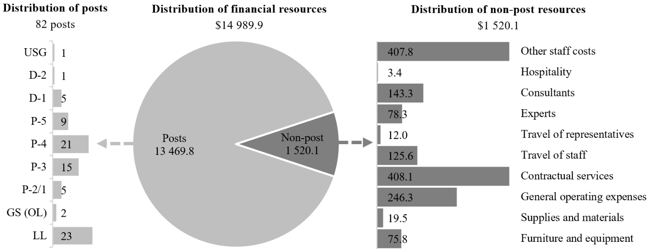

Explanation of variances by factor, component and subprogramme

Overall resource changes

Technical adjustments

15.81 As shown in tables 15.8 and 15.11 (1), resource changes reflect a decrease of $64,800, which relates to subprogramme 1. The decrease of $64,800 relates to the removal of non-recurrent provisions associated with the resource requirements related to the report to the General Assembly on the progress achieved and remaining challenges in addressing homelessness requested by the Assembly in its resolution 78/172, entitled “Inclusive policies and programmes to address homelessness, including in the aftermath of the coronavirus disease (COVID-19)”, that were approved for 2025 and are no longer required in 2026.

Other changes

15.82 As shown in table 15.11 (1), resource changes reflect a decrease of $300, which relates to a decrease under programme support. The decrease relates to changes to the standard price of the core software package.

Extrabudgetary resources

15.83 As reflected in tables 15.11 (2) and 15.12 (2), extrabudgetary resources amount to $175,326,600. The resources would complement regular budget resources and would be used mainly to provide for 66 posts (1 Assistant Secretary-General, 5 D-1, 9 P-5, 9 P-4, 13 P-3, 3 P-2, 2 National Professional Officer, level B, and 24 Local Level), to perform mainly the functions of programme support and some normative roles. In addition, non-post resources would be used for payments directly associated with the posts under service-level agreements with internal service providers, procurement of office automation equipment and payments to some external service providers, and in relation to projects implemented in country offices.
15.84 The extrabudgetary resources under the present section are subject to the oversight of the Executive Board, which has delegated authority from the UN-Habitat Assembly.

Policymaking organs

15.85 The resources proposed under this component would provide for the policymaking organs as shown in table 15.14.

Table 15.14

Policymaking organs
(Thousands of United States dollars)

Policymaking organ | Additional information | 2025 approved | 2026 estimate
UN-Habitat Assembly | Provides policy guidance on human settlements and sustainable urbanization and strategic oversight of UN-Habitat. The UN-Habitat Assembly approves the UN-Habitat four-year strategic plan. It reports every four years on its work to the General Assembly through the Economic and Social Council at its substantive session. The UN-Habitat Assembly meets every four years for five days. Its first session was held in May 2019. The second session was held in June 2023, while the resumed second session is scheduled to be held on 29 and 30 May 2025.  Mandate: General Assembly resolution 73/239 and note by the Secretary-General (A/73/726)  UN-Habitat Assembly rules of procedure  Membership: 193 government officials  Number of sessions in 2026: 0 | – | –
Committee of Permanent Representatives | Permanent intersessional subsidiary body of the UN-Habitat Assembly. The Committee is responsible for a high-level midterm review of the implementation of Assembly decisions and resolutions and of the UN-Habitat strategic plan, and for preparing for the next session of the Assembly. It meets twice every four years: once prior to the Assembly session, in preparation for that session, and a second time for a high-level midterm review. The open-ended meeting of the Committee of Permanent Representatives on preparations for the resumed second session of the UN-Habitat Assembly and midterm review is scheduled to be held from 26 to 28 May 2025.  Mandate: General Assembly resolutions 73/239 and 56/206 and note by the Secretary-General (A/73/726)  UN-Habitat Assembly rules of procedure  Membership: 193 government officials  Number of sessions in 2026: 0 | – | –
Executive Board | Permanent intersessional subsidiary body of the UN-Habitat Assembly. The Executive Board is responsible for strengthening the oversight of UN-Habitat operations and enhancing the accountability, transparency, efficiency and effectiveness of UN-Habitat. It oversees the preparation of the draft strategic plan before its approval by the Assembly and is responsible for the review and approval of the annual programme of work and budget and the resource mobilization strategy, in accordance with the strategic plan and guidance provided by the Assembly. The Board meets two to three times per year as provided in the rules of procedure. Its sessions in 2026 are scheduled to be held in March and November.  Mandate: General Assembly resolution 73/239 and note by the Secretary-General (A/73/726)  UN-Habitat Assembly resolution 1/1, adopted by the Assembly at its first session in May 2019  UN-Habitat Assembly rules of procedure  Rules of procedure of the Executive Board of UN-Habitat  Membership: 36  Number of sessions in 2026: 2 | 823.1 | 823.1
Total |  | 823.1 | 823.1

15.86 The proposed regular budget resources for 2026 amount to $823,100 and reflect no change compared with the approved budget for 2025. Additional details on the distribution of the proposed resources for 2026 are reflected in table 15.15 and figure 15.XVI.

Table 15.15

Policymaking organs: evolution of financial resources
(Thousands of United States dollars/number of posts)

 | 2024 expenditure | 2025 approved | Changes |  |  |  |  | 2026  estimate
 | 2024 expenditure | 2025 approved | Technical adjustments | New/expanded mandates | Other | Total | Percentage | 2026  estimate
Financial resources by main category of expenditure
Posts | 694.5 | 773.9 | – | – | – | – | – | 773.9
Non-post | 38.7 | 49.2 | – | – | – | – | – | 49.2
Total | 733.2 | 823.1 | – | – | – | – | – | 823.1
Post resources by category
Professional and higher |  | 3 | – | – | – | – | – | 3
General Service and related |  | 3 | – | – | – | – | – | 3
Total |  | 6 | – | – | – | – | – | 6

Figure 15.XVI

Policymaking organs: distribution of proposed resources for 2026
(Number of posts/thousands of United States dollars)

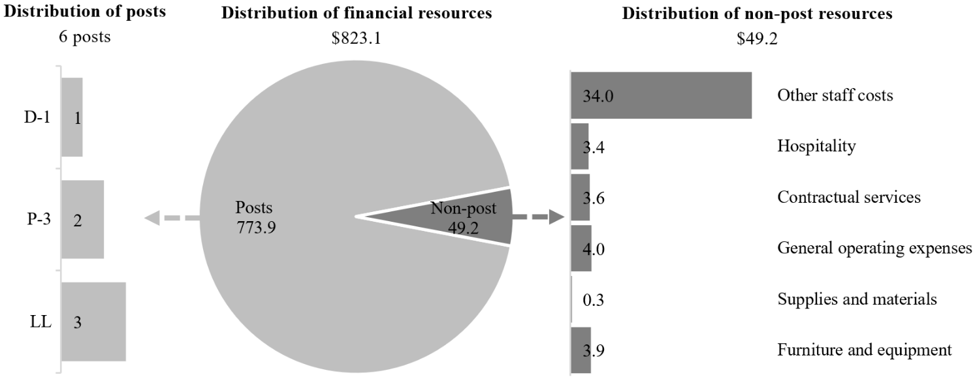

Executive direction and management

15.87 The executive direction and management component comprises the Office of the Executive Director, the Office of the Deputy Executive Director, the Office of the Chief of Staff, the liaison offices in New York, Brussels and Geneva, the Governing Bodies Secretariat, the Legal Unit and the Independent Evaluation Unit. The Executive Director is also supported by the Office of the Principal Adviser, which undertakes special assignments.
15.88 The overall responsibilities of the executive direction and management component include the following functions:
(a) To provide overall direction, translating the vision of the Executive Director and the guidance from the Executive Board into the Programme’s work priorities;
(b) To foster relationships with Member States and keep abreast of the needs of the Executive Board, the Committee of Permanent Representatives, the UN-Habitat Assembly and stakeholders affiliated with the Economic and Social Council;
(c) To coordinate the planning and ensure the implementation of the UN-Habitat strategic plan by ensuring the overall effectiveness of the Programme’s organizational structure. It provides direction and alignment through the Executive Committee, which is chaired by the Executive Director, whom it assists in providing policy direction in order to ensure the effectiveness of the Programme;
(d) To contribute, in close cooperation with other United Nations agencies, to discussions on, and the implementation of, United Nations reforms, in particular in relation to improving system-wide coherence in United Nations development work, with a special focus on sustainable urbanization;
(e) To foster the mainstreaming of gender and disability inclusion into the four subprogrammes of UN-Habitat.
15.89 In accordance with the 2030 Agenda for Sustainable Development, in particular target 12.6 of the Sustainable Development Goals, in which organizations are encouraged to integrate sustainability information into their reporting cycles, and in compliance with the cross-cutting mandate set out in paragraph 19 of General Assembly resolution 72/219, UN-Habitat continues to integrate environmental management practices into its operations. UN-Habitat will continue to incrementally improve the environmental management performance of its operations and facilities management in a number of ways. In 2024, in partnership with the Secretariat and in accordance with the United Nations Framework Convention on Climate Change, UN-Habitat offset its greenhouse gas emissions for the year 2024.
15.90 Information on the timely submission of parliamentary documentation and advance booking for air travel is reflected in table 15.16. In 2025, UN-Habitat is maintaining centralized monitoring and oversight of the timely purchase of air tickets, with exceptions requiring approval from the Office of the Executive Director. The rate of compliance for timely submission of documentation to the Department for General Assembly and Conference Management improved in 2024. However, the rate of travel compliance fell from 58 per cent to 52 per cent, due largely to the late nomination of meeting participants, including for the session of the World Urban Forum held in 2024. In response, the Executive Director has issued additional guidance and reminders to support improvement in this statistic.

Table 15.16

Compliance rate
(Percentage)

 | 2022 actual | 2023 actual | 2024 actual | 2025 planned | 2026 planned
Timely submission of documentation | 97 | 73 | 77 | 100 | 100
Air tickets purchased at least two weeks before the commencement of travel | 34 | 58 | 52 | 100 | 100

15.91 The proposed regular budget resources for 2026 amount to $2,002,300 and reflect no change compared with the approved budget for 2025. Additional details on the distribution of the proposed resources for 2026 are reflected in table 15.17 and figure 15.XVII.

Table 15.17

Executive direction and management: evolution of financial and post resources
(Thousands of United States dollars/number of posts)

 | 2024 expenditure | 2025 approved | Changes |  |  |  |  | 2026 estimate
 | 2024 expenditure | 2025 approved | Technical adjustments | New/expanded mandates | Other | Total | Percentage | 2026 estimate
Financial resources by main category of expenditure
Posts | 1 630.8 | 1 785.9 | – | – | – | – | – | 1 785.9
Non-post | 37.8 | 216.4 | – | – | – | – | – | 216.4
Total | 1 668.6 | 2 002.3 | – | – | – | – | – | 2 002.3
Post resources by category
Professional and higher |  | 6 | – | – | – | – | – | 6
General Service and related |  | 3 | – | – | – | – | – | 3
Total |  | 9 | – | – | – | – | – | 9

Figure 15.XVII

Executive direction and management: distribution of proposed resources for 2026
(Number of posts/thousands of United States dollars)

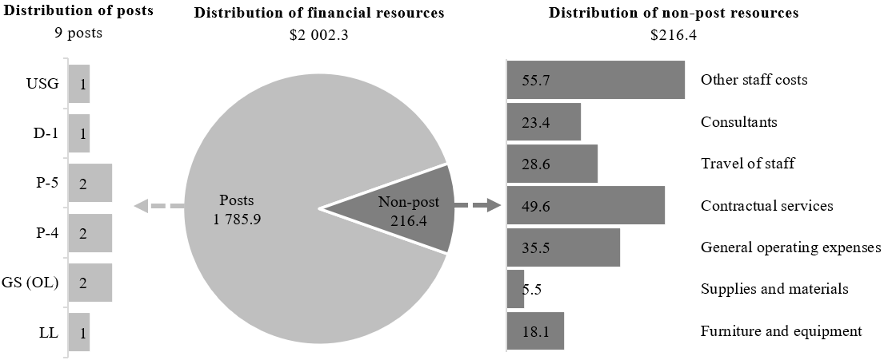

Programme of work

Subprogramme 1

Reduced spatial inequality and poverty in communities across the urban-rural continuum

15.92 The proposed regular budget resources for 2026 amount to $2,484,800 and reflect a decrease of $64,800 compared with the approved budget for 2025. The proposed change is explained in paragraph 15.81. Additional details on the distribution of the proposed resources for 2026 are reflected in table 15.18 and figure 15.XVIII.

Table 15.18

Subprogramme 1: evolution of financial and post resources
(Thousands of United States dollars/number of posts)

 | 2024 expenditure | 2025  approved | Changes |  |  |  |  | 2026 estimate
 | 2024 expenditure | 2025  approved | Technical adjustments | New/expanded mandates | Other | Total | Percentage | 2026 estimate
Financial resources by main category of expenditure
Posts | 1 999.3 | 2 156.4 | – | – | – | – | – | 2 156.4
Non-post | 19.5 | 393.2 | (64.8) | – | – | (64.8) | (16.5) | 328.4
Total | 2 018.8 | 2 549.6 | (64.8) | – | – | (64.8) | (2.5) | 2 484.8
Post resources by category
Professional and higher |  | 9 | – | – | – | – | – | 9
General Service and related |  | 4 | – | – | – | – | – | 4
Total |  | 13 | – | – | – | – | – | 13

Figure 15.XVIII

Subprogramme 1: distribution of proposed resources for 2026
(Number of posts/thousands of United States dollars)

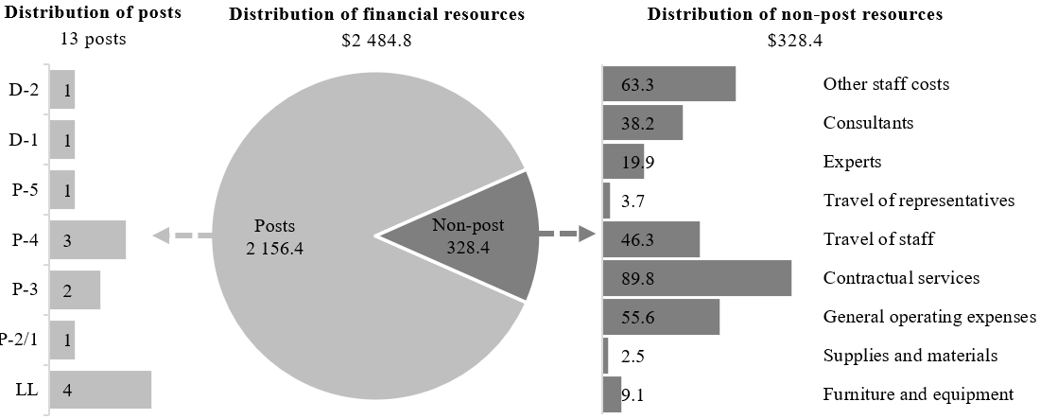

Subprogramme 2

Enhanced shared prosperity of cities and regions

15.93 The proposed regular budget resources for 2026 amount to $2,769,300 and reflect no change compared with the approved budget for 2025. Additional details on the distribution of the proposed resources for 2026 are reflected in table 15.19 and figure 15.XIX.

Table 15.19

Subprogramme 2: evolution of financial and post resources
(Thousands of United States dollars/number of posts)

 | 2024 expenditure | 2025  approved | Changes |  |  |  |  | 2026 estimate
 | 2024 expenditure | 2025  approved | Technical adjustments | New/expanded mandates | Other | Total | Percentage | 2026 estimate
Financial resources by main category of expenditure
Posts | 1 996.7 | 2 505.0 | – | – | – | – | – | 2 505.0
Non-post | 25.7 | 264.3 | – | – | – | – | – | 264.3
Total | 2 022.4 | 2 769.3 | – | – | – | – | – | 2 769.3
Post resources by category
Professional and higher |  | 11 | – | – | – | – | – | 11
General Service and related |  | 5 | – | – | – | – | – | 5
Total |  | 16 | – | – | – | – | – | 16

Figure 15.XIX

Subprogramme 2: distribution of proposed resources for 2026
(Number of posts/thousands of United States dollars)

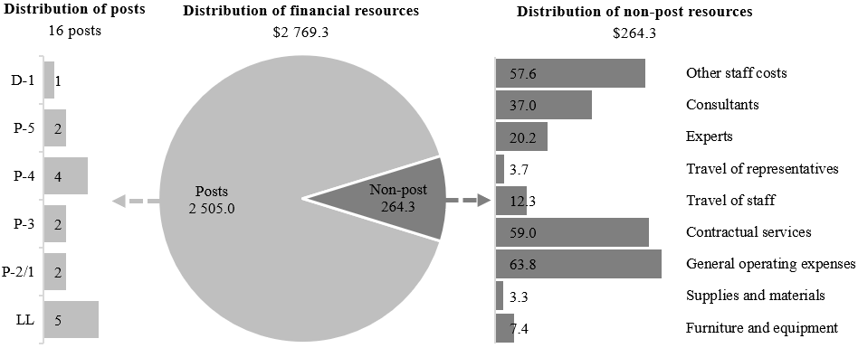

Subprogramme 3

Strengthened climate action and improved urban environment

15.94 The proposed regular budget resources for 2026 amount to $2,679,600 and reflect no change compared with the approved budget for 2025. Additional details on the distribution of the proposed resources for 2026 are reflected in table 15.20 and figure 15.XX.

Table 15.20

Subprogramme 3: evolution of financial and post resources
(Thousands of United States dollars/number of posts)

 | 2024 expenditure | 2025  approved | Changes |  |  |  |  | 2026 estimate
 | 2024 expenditure | 2025  approved | Technical adjustments | New/expanded mandates | Other | Total | Percentage | 2026 estimate
Financial resources by main category of expenditure
Posts | 2 028.6 | 2 419.4 | – | – | – | – | – | 2 419.4
Non-post | 26.1 | 260.2 | – | – | – | – | – | 260.2
Total | 2 054.7 | 2 679.6 | – | – | – | – | – | 2 679.6
Post resources by category
Professional and higher |  | 11 | – | – | – | – | – | 11
General Service and related |  | 3 | – | – | – | – | – | 3
Total |  | 14 | – | – | – | – | – | 14

Figure 15.XX

Subprogramme 3: distribution of proposed resources for 2026
(Number of posts/thousands of United States dollars)

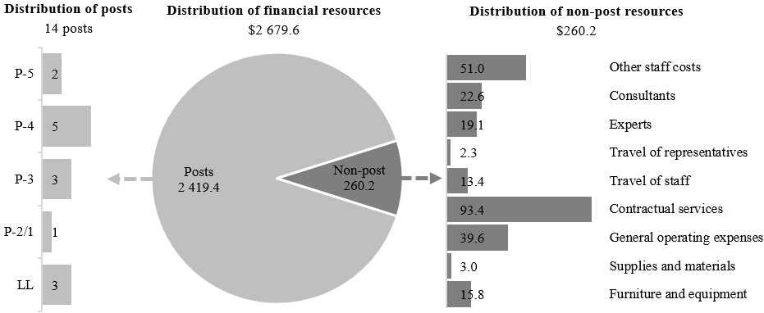

Subprogramme 4

Effective urban crisis prevention and response

15.95 The proposed regular budget resources for 2026 amount to $2,704,300 and reflect no change compared with the approved budget for 2025. Additional details on the distribution of the proposed resources for 2026 are reflected in table 15.21 and figure 15.XXI.

Table 15.21

Subprogramme 4: evolution of financial and post resources
(Thousands of United States dollars/number of posts)

 | 2024 expenditure | 2025  approved | Changes |  |  |  |  | 2026 estimate
 | 2024 expenditure | 2025  approved | Technical adjustments | New/expanded mandates | Other | Total | Percentage | 2026 estimate
Financial resources by main category of expenditure
Posts | 1 991.8 | 2 347.7 | – | – | – | – | – | 2 347.7
Non-post | 61.5 | 356.6 | – | – | – | – | – | 356.6
Total | 2 053.3 | 2 704.3 | – | – | – | – | – | 2 704.3
Post resources by category
Professional and higher |  | 11 | – | – | – | – | – | 11
General Service and related |  | 4 | – | – | – | – | – | 4
Total |  | 15 | – | – | – | – | – | 15

Figure 15.XXI

Subprogramme 4: distribution of proposed resources for 2026
(Number of posts/thousands of United States dollars)

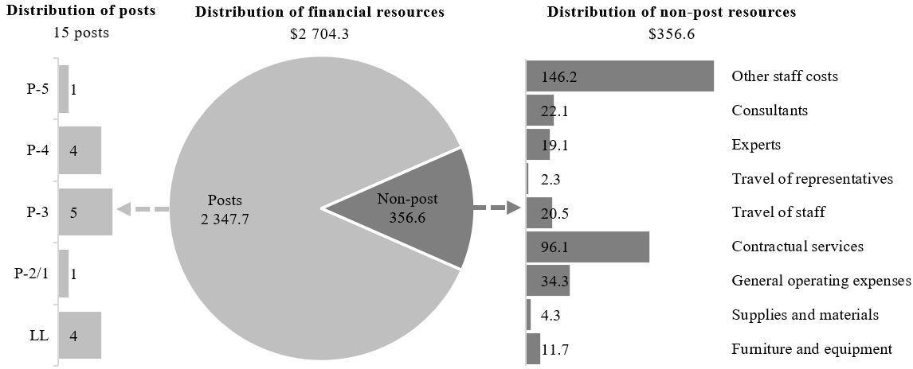

Programme support

15.96 The programme support component comprises the Management Advisory and Compliance Service of UN-Habitat.
15.97 The main responsibilities of the programme support component include the following functions: human resources management; budget and finance; information and communications technology; oversight and internal controls; and operations support.
15.98 The proposed regular budget resources for 2026 amount to $1,526,500 and reflect a decrease of $300 compared with the approved budget for 2025. The proposed decrease is explained in paragraph 15.82. Additional details on the distribution of the proposed resources for 2026 are reflected in table 15.22 and figure 15.XXII.

Table 15.22

Programme support: evolution of financial and post resources
(Thousands of United States dollars/number of posts)

 | 2024 expenditure | 2025  approved | Changes |  |  |  |  | 2026 estimate
 | 2024 expenditure | 2025  approved | Technical adjustments | New/expanded mandates | Other | Total | Percentage | 2026 estimate
Financial resources by main category of expenditure
Posts | 1 298.4 | 1 481.5 | – | – | – | – | – | 1 481.5
Non-post | 8.6 | 45.3 | – | – | (0.3) | (0.3) | (0.1) | 45.0
Total | 1 307.0 | 1 526.8 | – | – | (0.3) | (0.3) | (0.1) | 1 526.5
Post resources by category
Professional and higher |  | 6 | – | – | – | – | – | 6
General Service and related |  | 3 | – | – | – | – | – | 3
Total |  | 9 | – | – | – | – | – | 9

Figure 15.XXII

Programme support: distribution of proposed resources for 2026
(Number of posts/thousands of United States dollars)

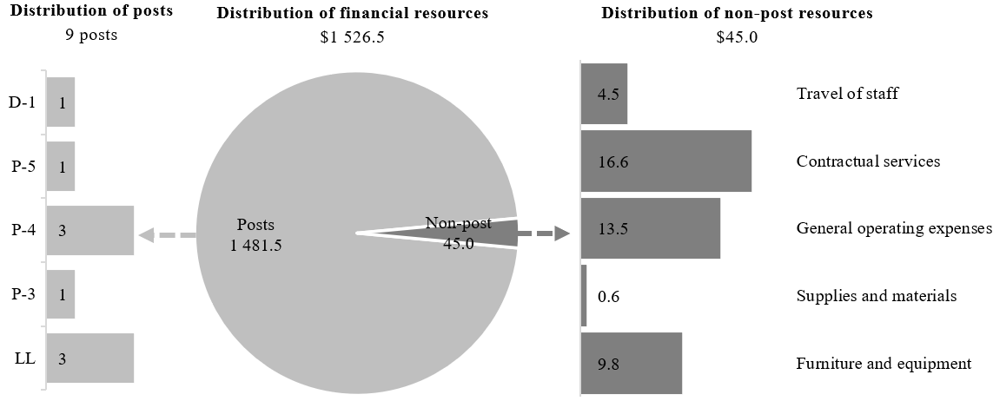

Annex

Organizational structure and post distribution for 2026

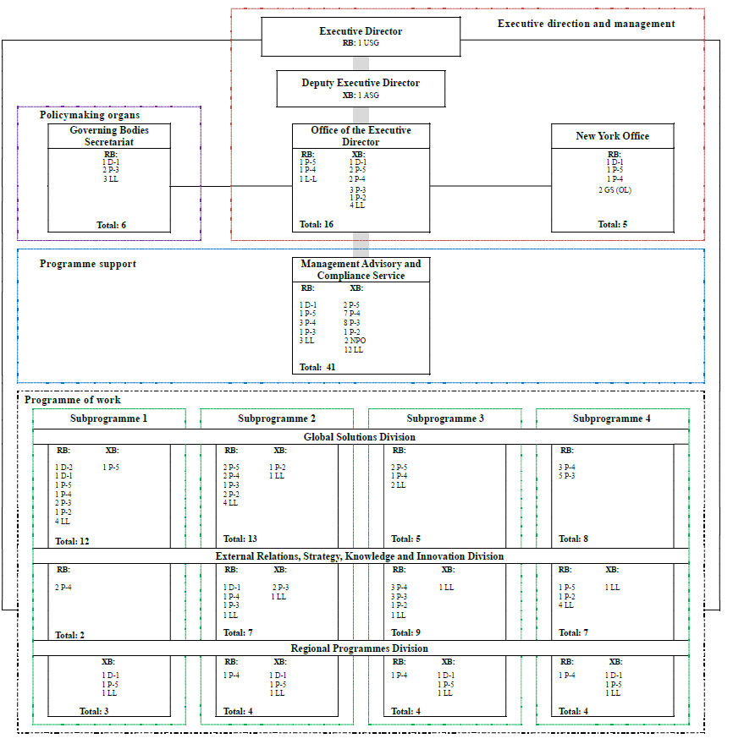

Abbreviations: ASG, Assistant Secretary-General; GS (OL), General Service (Other level); LL, Local level; NPO, National Professional Officer; RB, regular budget; USG, Under-Secretary-General; XB, extrabudgetary.

United Nations Human Settlements Programme (UN-Habitat), Global Urban Indicators database (2025).
United Nations, Department of Economic and Social Affairs, “International migrant stock 2024: key facts and figures”, advance unedited version (January 2025); International Displacement Monitoring Centre, Global Report on Internal Displacement 2024 (Geneva, 2024).
International Energy Agency, Empowering Urban Energy Transitions: Smart Cities and Smart Grids (2024).

