Eightieth session
Items 137 and 138 of the preliminary list*

Proposed programme budget for 2026

Programme planning

Proposed programme budget for 2026

Part I

Overall policymaking, direction and coordination

Section 2

General Assembly and Economic and Social Council affairs and conference management

Programme 1

General Assembly and Economic and Social Council affairs and conference management

Contents
 |  |  | Page
- Proposed programme plan for 2026 and programme performance in 2024** |  |  | 4
Overall orientation |  |  | 4
Programme of work |  |  | 9
Subprogramme 1. General Assembly and Economic and Social Council affairs |  |  | 9
Conference management, New York |  |  | 13
Subprogramme 2. Planning and coordination of conference services |  |  | 13
Subprogramme 3. Documentation services |  |  | 17
Subprogramme 4. Meetings and publishing services |  |  | 22
* A/80/50.
** In keeping with paragraph 10 of General Assembly resolution 77/267, the part consisting of the programme plan and programme performance information (part II) is submitted through the Committee for Programme and Coordination for the consideration of the Assembly.
Conference management, Geneva | 26
Subprogramme 2. Planning and coordination of conference services | 26
Subprogramme 3. Documentation services | 29
Subprogramme 4. Meetings and publishing services | 33
Conference management, Vienna | 36
Subprogramme 2. Planning and coordination of conference services | 36
Subprogramme 3. Documentation services | 40
Subprogramme 4. Meetings and publishing services | 43
Conference management, Nairobi | 47
Subprogramme 2. Planning and coordination of conference services | 47
Subprogramme 3. Documentation services | 50
Subprogramme 4. Meetings and publishing services | 54

*** In keeping with paragraph 10 of General Assembly resolution 77/267, the part consisting of the post and non-post resource requirements (part III) is submitted through the Advisory Committee on Administrative and Budgetary Questions for the consideration of the Assembly.
- Proposed post and non-post resource requirements for 2026*** | 58
Overview | 58
Policymaking organs | 69
Executive direction and management | 70
Programme of work | 72
Subprogramme 1. General Assembly and Economic and Social Council affairs | 72
Conference management, New York | 73
Subprogramme 2. Planning and coordination of conference services | 73
Subprogramme 3. Documentation services | 74
Subprogramme 4. Meetings and publishing services | 75
Conference management, Geneva | 76
Subprogramme 2. Planning and coordination of conference services | 76
Subprogramme 3. Documentation services | 77
Subprogramme 4. Meetings and publishing services | 78
Conference management, Vienna | 79
Subprogramme 2. Planning and coordination of conference services | 81
Subprogramme 3. Documentation services | 82
Subprogramme 4. Meetings and publishing services | 83
Conference management, Nairobi | 84
Subprogramme 2. Planning and coordination of conference services | 84
Subprogramme 3. Documentation services | 85
Subprogramme 4. Meetings and publishing services | 86
Programme support | 87
Annexes
- Organizational structure and post distribution for 2026 | 91
- Summary of proposed post changes, by component and subprogramme | 95

A. Proposed programme plan for 2026 and programme performance in 2024

Overall orientation

Mandates and background

2.1 The mandates of the Department for General Assembly and Conference Management derive from the relevant rules of procedure and resolutions of the principal organs of the United Nations, including General Assembly resolutions 43/222 A–E, 50/11, 73/346, 74/303 and 79/248. The Department is responsible for:
(a) The facilitation, through the provision of procedural and technical secretariat support and authoritative advice, of the orderly and effective conduct of the deliberations and follow-up actions of the General Assembly, its General, First, Special Political and Decolonization (Fourth), Second and Third Committees and various subsidiary organs, the Economic and Social Council and most of its subsidiary bodies, and special United Nations conferences;
(b) Assistance in the revitalization efforts of the Assembly and other United Nations bodies, including through the substantive servicing of meetings of the Ad Hoc Working Group on the Revitalization of the Work of the General Assembly and the intergovernmental negotiations on the question of equitable representation on and increase in the membership of the Security Council and other matters relating to the Council;
(c) Substantive and technical secretariat support to the Committee on Conferences and high-quality conference-servicing support, including multilingual meeting and documentation services, to all intergovernmental and expert bodies meeting at Headquarters and at the United Nations Offices at Geneva, Vienna and Nairobi, and other conferences and meetings held under the auspices of the United Nations at other locations, under shared responsibility with the Directors-General of the United Nations Offices at Geneva, Vienna and Nairobi, taking into account the principle of equal treatment to be applied to all official languages in each organ of the Organization;
(d) Protocol services for the Secretary-General, the Deputy Secretary-General and visiting high-level dignitaries, as well as host country liaison services for Member States and Permanent Observers and the provision, upon request, of protocol services to the President of the General Assembly.
2.2 In accordance with General Assembly resolution 57/283 B, the Under-Secretary-General for General Assembly and Conference Management sets the policies, formulates standards and guidelines, manages resources under section 2 of the programme budget and oversees operations at Headquarters, while the Directors-General of the United Nations Offices at Geneva, Vienna and Nairobi are responsible for ensuring the implementation of those policies, standards and guidelines and for managing day-to-day operations at their duty stations. Furthermore, the Secretary-General has promulgated the establishment of a framework for delegation of authority (see ST/SGB/2019/2). The Secretary-General’s bulletin on the organization of the Department (ST/SGB/2021/3) reflects the intergovernmental mandates confirming the division of responsibilities among the Under-Secretary-General and the Directors-General at Geneva, Vienna and Nairobi for delivering conference services in a standardized and integrated manner.
2.3 In addition, pursuant to General Assembly resolution 69/250, the Under-Secretary-General for General Assembly and Conference Management is responsible for the Secretariat-wide coordination of multilingualism, a core value of the United Nations, and serves as system-wide lead entity on this matter in collaboration with the secretariat of the United Nations System Chief Executives Board for Coordination. With reference to Assembly resolution 78/330, the Office of the Coordinator for Multilingualism will continue to facilitate, from within existing capacity, a coordinated, consistent and coherent approach to multilingualism across the Secretariat.

Strategy and external factors for 2026

2.4 The 2026 programme plan is guided by the Department’s long-standing strategy of continuous modernization and improvement in all areas. In line with paragraph 73 (a) of the Pact for the Future, under action 45 (see General Assembly resolution 79/1), the Department will continue to cultivate an organizational culture that advances agility, creativity, learning and adaptability and further develop a quintet of cutting-edge skills in the areas of innovation, data analytics, digital transformation, strategic foresight and behavioural science that will enable it to harness new technological capabilities even as the landscape of how services are delivered evolves.
2.5 New technologies, including artificial intelligence, offer potential efficiencies and improvements to services in multiple aspects of multilingual conference-servicing, from improved automation of workflows to increased accessibility of products and services for persons with disabilities. The Department will continue to invest, utilizing available resources and to the extent possible, in systems that enhance integrated global management and the efficiency, effectiveness, continuity, sustainability and accessibility of the services it provides, in line with the priorities outlined in the Secretary-General’s information and communications technology strategy.
2.6 Specifically, the functionality and user-friendliness of e-deleGATE will be further improved with the incorporation of new features, and artificial intelligence-based tools will be used to increase the accessibility of publishing products. Job profiles will be revised in the light of evolving working methods and staff recruited with the new skill sets required. Cross-functional training, in addition to technical and subject-matter training, will be introduced to increase the versatility of staff and the agility of the Department as a whole.
2.7 The effective and efficient utilization of available resources and programme delivery will be ensured through clearly defined results-based performance indicators and benchmarks outlined under the respective subprogrammes in the present document. To manage surges in demand for multilingual meetings and documentation services, the Department will leverage temporary assistance to complement its in-house teams of interpreters, editors, translators, précis-writers, verbatim reporters and production editors. Competitive recruitment examinations for both core and temporary staff will be conducted as required.
2.8 The proactive analysis of client needs and client feedback, including through a revised single global survey, will continue to guide the Department’s activities in developing its services in support of the work of the intergovernmental and expert bodies.
2.9 The Department will coordinate measures to enhance multilingualism in the Organization in accordance with the terms of reference of the Coordinator for Multilingualism (A/71/757, annex II).
2.10 With regard to inter-agency coordination and liaison, the Department will continue to provide substantive and technical secretariat support and serve as the permanent Chair of the International Annual Meeting on Language Arrangements, Documentation and Publications.
2.11 With regard to the external factors, the overall plan for 2026 is based on the following planning assumptions:
(a) Information on changes to the calendar of conferences and meetings, as well as to the programmes of work of intergovernmental and expert bodies, is made available in a timely manner and in conformity with the applicable rules of procedure;
(b) The number of non-calendar meetings does not exceed that of 2024;
(c) Extraordinary meetings, including special and emergency special sessions, will be scheduled with sufficient notice;
(d) Unforeseen high-priority documentation will be manageable;
(e) Stakeholders will fulfil their responsibilities and obligations in accordance with established rules for the submission of documentation and meeting requests in a predictable manner;
(f) Global supply chains enable the timely sourcing of high-quality goods, capacity and services.
2.12 The programme integrates a gender perspective into its operational activities, deliverables and results, as appropriate.
2.13 In line with the United Nations Disability Inclusion Strategy, the Department will continue to adjust and refine its systems, platforms, workflows and requirements for conference services, including seating arrangements, with a view to ensuring equal participation by delegates and participants with disabilities in the work of the United Nations.

Legislative mandates

2.14 The list below, which was reviewed in the preparation of the proposed programme budget, provides the mandates entrusted to the programme.

General Assembly resolutions

43/222 A–E; 69/250; 79/248 | Pattern of conferences
50/11; 76/268; 78/330 | Multilingualism
74/303 | Revitalization of the work of the General Assembly
79/257 | Questions relating to the proposed programme budget for 2025

Conference management, New York

General Assembly mandate

A/520/Rev.20 | Rules of procedure of the General Assembly (rule 56)

Economic and Social Council mandate

E/5715/Rev.2 | Rules of procedure of the Economic and Social Council (rule 32)

Security Council mandate

S/96/Rev.7 | Provisional rules of procedure of the Security Council (rule 41)

Conference management, Geneva

General Assembly resolutions

174 (II) | Establishment of an International Law Commission
1166 (XII) | International assistance to refugees within the mandate of the United Nations High Commissioner for Refugees
48/189 | United Nations Framework Convention on Climate Change
60/184 | International trade and development
60/251 | Human Rights Council
62/193; 66/201 | Implementation of the United Nations Convention to Combat Desertification in Those Countries Experiencing Serious Drought and/or Desertification, Particularly in Africa
63/160 | Report of the Human Rights Council
68/268 | Strengthening and enhancing the effective functioning of the human rights treaty body system
79/258, sect. IX | Special subjects relating to the proposed programme budget for 2025: revised estimates resulting from resolutions and decisions adopted by the Human Rights Council at its fifty-fifth, fifty-sixth and fifty-seventh regular sessions

Conference on Disarmament mandate

CD/8/Rev.10 | Rules of procedure of the Conference on Disarmament (sect. X)

Economic and Social Council resolution

36 (IV) | Economic Commission for Europe

Conference management, Vienna

General Assembly resolutions

913 (X) | Effects of atomic radiation
1145 (XII) | Agreement governing the relationship between the United Nations and the International Atomic Energy Agency
1472 (XIV) A; 69/85 | International cooperation in the peaceful uses of outer space
2152 (XXI) | United Nations Industrial Development Organization
2205 (XXI) | Establishment of the United Nations Commission on International Trade Law
50/245 | Comprehensive Nuclear-Test-Ban Treaty
55/25 | United Nations Convention against Transnational Organized Crime
55/255 | Protocol against the Illicit Manufacturing of and Trafficking in Firearms, Their Parts and Components and Ammunition, supplementing the United Nations Convention against Transnational Organized Crime
58/4 | United Nations Convention against Corruption
68/1 | Review of the implementation of General Assembly resolution 61/16 on the strengthening of the Economic and Social Council
78/223 | Follow-up to the Fourteenth United Nations Congress on Crime Prevention and Criminal Justice and preparations for the Fifteenth United Nations Congress on Crime Prevention and Criminal Justice
79/117 | Report of the United Nations Commission on International Trade Law on the work of its fifty-seventh session
79/243 | United Nations Convention against Cybercrime;  Strengthening International Cooperation for Combating Certain Crimes Committed by Means of Information and Communications Technology Systems and for the Sharing of Evidence in Electronic Form of Serious Crimes

Economic and Social Council resolutions

9 (I) | Commission on Narcotic Drugs
1992/1 | Establishment of the Commission on Crime Prevention and Criminal Justice

International Narcotics Control Board

Single Convention on Narcotic Drugs of 1961, article 11
Convention on Psychotropic Substances of 1971
United Nations Convention against Illicit Traffic in Narcotic Drugs and Psychotropic Substances of 1988
Rules of Procedure of the Board

Conference management, Nairobi

General Assembly resolutions

71/231; 74/222; 76/208; 77/168; 79/209 | Report of the United Nations Environment Assembly of the United Nations Environment Programme
73/239; 77/173; 79/214 | Implementation of the outcomes of the United Nations Conferences on Human Settlements and on Housing and Sustainable Urban Development and strengthening of the United Nations Human Settlements Programme (UN-Habitat)

Deliverables

2.15 Table 2.1 lists all cross-cutting deliverables of the programme.

Table 2.1

Cross-cutting deliverables for the period 2024–2026, by category and subcategory

Category and subcategory | 2024 planned | 2024 actual | 2025 planned | 2026 planned
A. Facilitation of the intergovernmental process and expert bodies
Parliamentary documentation (number of documents) | 2 | 2 | 1 | 2
1. Report of the Secretary-General on the pattern of conferences | 1 | 1 | 1 | 1
2. Report of the Secretary-General on multilingualism | 1 | 1 | – | 1
Substantive services for meetings (number of three-hour meetings) | 23 | 10 | 22 | 23
Meetings of:
3. The General Assembly related to multilingualism | 1 | 1 | – | 1
4. The Committee on Conferences, the Advisory Committee on Administrative and Budgetary Questions and the Fifth Committee on the item on the pattern of conferences | 16 | 5 | 16 | 16
5. The Committee for Programme and Coordination, the Advisory Committee on Administrative and Budgetary Questions and the Fifth Committee related to programme planning and the budgetary process | 6 | 4 | 6 | 6
C. Substantive deliverables
Consultation, advice and advocacy: International Annual Meeting on Language Arrangements, Documentation and Publications, with an estimated 60 entities.
D. Communication deliverables
Outreach programmes, special events and information materials: 6 language days, 2 internationally recognized language celebrations and other related observances on multilingualism in accordance with General Assembly guidance.
External and media relations: meetings with language groupings or other relevant international organizations, upon request and in line with the role of the Coordinator for Multilingualism.
Digital platforms and multimedia content: multilingual content for websites and social media accounts of the Department for General Assembly and Conference Management, including on outreach to universities and on multilingualism.
E. Enabling deliverables
Correspondence and documentation services: documentation services (110 non-parliamentary documents); and correspondence services, including notes verbales and official correspondence of the Secretary-General and departments with Member States.

Evaluation activities

2.16 A global evaluation on publishing and distribution in the digital age, conducted by the Department and completed in 2024, has guided the proposed programme plan for 2026.
2.17 In response to the results of the evaluation referenced above, the Department will continue using the digital platforms that have enabled the more efficient and timely distribution of parliamentary documentation at all duty stations and will explore options to enhance the quality and accessibility of digital products and services, as described in subprogramme 4.
2.18 A global evaluation of translation workload forecasting to be conducted by the Department is planned for 2026.

Programme of work

Subprogramme 1

General Assembly and Economic and Social Council affairs

Objective

2.19 The objective, to which this subprogramme contributes, is to ensure efficient and effective deliberation and decision-making processes of intergovernmental and relevant expert bodies and United Nations conferences.

Strategy

2.20 To contribute to the objective, the subprogramme will:
(a) Provide technical secretariat services to, and coordinate substantive support for, intergovernmental bodies, including the General Assembly, its General, First, Special Political and Decolonization (Fourth), Second and Third Committees and its various subsidiary and ad hoc bodies; the Economic and Social Council and its forums and subsidiary and ad hoc bodies; the Trusteeship Council; and conferences and other ad hoc and extraordinary meetings held under the auspices of the United Nations;
(b) Provide procedural advice and substantive, analytical and historical information;
(c) In response to requests from Member States, strengthen its core software tools, including e-deleGATE, which is available in the official languages of the United Nations and is able to capture interaction among various intergovernmental bodies, and which, along with existing e-deleGATE modules, the General Assembly, in its resolution 77/335, called upon its subsidiary organs to use, as much as possible.
2.21 The above-mentioned work is expected to result in:
(a) The smooth conduct of meetings of the intergovernmental bodies serviced;
(b) Expanded availability and accessibility of secretariat support to the delegations;
(c) Improved user experience for delegations on the e-deleGATE portal.

Programme performance in 2024

Delegates and the public have direct access to intergovernmental data through the new iGov portal

2.22 In its resolution 77/335, the General Assembly called upon its subsidiary organs to use, as much as possible, existing e-deleGATE modules and requested the Secretariat to consolidate e-services provided to delegates under the e-deleGATE platform. The subprogramme launched the iGov portal in February 2024 to delegates and the public. The iGov portal provides a window to intergovernmental data and allows users to cross-reference meetings, documents and agenda items and to obtain comprehensive information across different search criteria. It provides a “snapshot” overview of future and past meetings, with links to the list of speakers, voting results and other relevant material, such as informal documents and letters, as well as access to the latest information on the schedule of meetings, lists of proposals, lists of adopted resolutions and decisions, and documentation. The portal is part of the e-deleGATE environment and links the enhancements in digital service delivery and technical integration with a consolidated knowledge hub.
2.23 Progress towards the objective is presented in table 2.2.

Table 2.2

Performance measure

2022 (actual) | 2023 (actual) | 2024 (actual)
Unstructured data on meeting proceedings available on diverse sites | Unstructured data on meeting proceedings available on diverse sites | Delegates and the public have direct access to structured intergovernmental data on the iGov portal

Planned results for 2026

Result 1: delegates and the public have access to new services that are unlocked by the intergovernmental data model for meeting proceedings

Programme performance in 2024 and target for 2026

2.24 The subprogramme’s work contributed to the schedule and programme of work of the Main Committees of the General Assembly being available to delegates in multiple places and in different formats, which met the planned target.
2.25 Progress towards the objective and the target for 2026 are presented in table 2.3.

Table 2.3

Performance measure

2022 (actual) | 2023 (actual) | 2024 (actual) | 2025 (planned) | 2026 (planned)
Delegates and the public have access to data-driven reports for all bodies that the subprogramme services | Delegates and the public have access to 2 versions of the schedule of the General Assembly, unlocked by the intergovernmental data model | Delegates and the public have access to the schedule and programme of work of the Main Committees in multiple places and in different formats | Delegates and the public have access to additional reporting services that are unlocked by the intergovernmental data model | Delegates and the public have access to additional services that are unlocked by the intergovernmental data model

Result 2: standardized information on the proceedings of various intergovernmental bodies available to delegates

Programme performance in 2024 and target for 2026

2.26 The subprogramme’s work contributed to a new module providing live information on proposals, amendments, and resolutions and decisions being available to delegates and the public, which exceeded the planned target of a new module being under development but not yet available in 2024.
2.27 Progress towards the objective and the target for 2026 are presented in table 2.4.

Table 2.4

Performance measure

2022 (actual) | 2023 (actual) | 2024 (actual) | 2025 (planned) | 2026 (planned)
– | Member States have access to information on intergovernmental decision-making, but this varies in content and form from one body to another | New module providing information on proposals, amendments, and resolutions and decisions available in e-deleGATE | Member States have access to new module in e-deleGATE providing information on proposals, amendments, and resolutions and decisions | Member States have access to new module in e-deleGATE providing information on proposals, amendments, and resolutions and decisions, with automated quality assurance of key elements (logical progression, naming conventions, etc.)

Result 3: simpler, more intuitive interaction between delegations and the Secretariat using the e-deleGATE platform

Proposed programme plan for 2026

2.28 The working methods of intergovernmental bodies supported by the subprogramme leverage information technology at different stages of their deliberation and decision-making processes. The subprogramme has a role in supporting these working methods using tools such as the e-deleGATE platform.

Lessons learned and planned change

2.29 The lesson for the subprogramme was that, while many of the new e-deleGATE modules were well received by delegates, more could be done to simplify the interaction between delegates and the Secretariat using the e-deleGATE platform. In applying this lesson, the subprogramme will centralize functions of the e-deleGATE platform, so that requesting specific services, whether for a reasonable accommodation request (in line with resolution 77/335), an inscription on a list of speakers, a request for a vote or voting intention, or a nameplate, becomes simpler and more intuitive.
2.30 Expected progress towards the objective is presented in table 2.5.

Table 2.5

Performance measure

2022 (actual) | 2023 (actual) | 2024 (actual) | 2025 (planned) | 2026 (planned)
Member States make requests through specific modules on the e-deleGATE platform or by email | Member States make requests through specific modules on the e-deleGATE platform or by email | Member States make requests through specific modules on the e-deleGATE platform or by email | Member States make requests through specific modules on the e-deleGATE platform or by email while a centralized module is developed | Member States make requests and receive responses from the Secretariat through a centralized module

Deliverables

2.31 Table 2.6 lists all deliverables of the subprogramme.

Table 2.6

Subprogramme 1: deliverables for the period 2024–2026, by category and subcategory

Category and subcategory | 2024 planned | 2024 actual | 2025 planned | 2026 planned
A. Facilitation of the intergovernmental process and expert bodies
Parliamentary documentation (number of documents) | 217 | 160 | 181 | 207
Documents of:
1. The General Assembly and its subsidiary bodies | 102 | 79 | 110 | 160
2. The Economic and Social Council and its subsidiary bodies | 90 | 59 | 66 | 47
3. United Nations conferences | 24 | 22 | 5 | –
4. The Trusteeship Council | 1 | – | – | –
Conference and secretariat services for meetings (number of three-hour meetings) | 929 | 971 | 757 | 920
5. Meetings of the plenary of the General Assembly, the General Committee and the Ad Hoc Working Group on the Revitalization of the Work of the General Assembly | 363 | 420 | 333 | 340
6. United Nations conferences | 70 | 117 | 10 | 10
7. Meetings of the First Committee | 33 | 31 | 33 | 33
8. Meetings of the Special Political and Decolonization Committee (Fourth Committee) | 30 | 30 | 30 | 30
9. Meetings of the Second Committee | 28 | 30 | 28 | 28
10. Meetings of the Third Committee | 56 | 62 | 59 | 60
11. Meetings of the other subsidiary bodies of the General Assembly | 120 | 71 | 60 | 202
12. Meetings of the Economic and Social Council | 55 | 81 | 55 | 55
13. Meetings of the high-level political forum on sustainable development convened under the auspices of the Economic and Social Council | 24 | 10 | 24 | 20
14. Economic and Social Council forum on financing for development follow-up | 10 | 11 | 10 | 10
15. Multi-stakeholder forum on science, technology and innovation for the Sustainable Development Goals | 4 | 4 | 5 | 4
16. Meetings of the subsidiary bodies of the Economic and Social Council | 135 | 104 | 110 | 128
17. Meetings of the plenary of the Trusteeship Council | 1 | – | – | –
B. Generation and transfer of knowledge
Publications (number of publications) | 1 | 1 | 1 | 1
18. Delegates’ Handbook | 1 | 1 | 1 | 1
C. Substantive deliverables
Databases and substantive digital materials: online portals, including e-deleGATE, for approximately 35 intergovernmental bodies.

Conference management, New York

Subprogramme 2

Planning and coordination of conference services

Objective

2.32 The objective, to which this subprogramme contributes, is to ensure efficient, effective and multilingual deliberation and decision-making processes of intergovernmental and expert bodies and conferences serviced by the United Nations in New York.

Strategy

2.33 To contribute to the objective, the subprogramme will, in coordination with the other duty stations:
(a) Plan and manage meetings and documentation services in a globally coordinated manner by leveraging technologies, including gMeets, gDoc and gData, and optimizing workflows;
(b) Lead global innovation projects in areas related to planning and coordination, including gMeets and the Journal of the United Nations;
(c) Centrally coordinate evaluation activities and risk management, including business continuity within existing mandates, and provide high-quality and reliable data to facilitate informed managerial decision-making and performance monitoring;
(d) Engage in regular consultations with Member States and substantive and technical secretariats to address conference-servicing needs;
(e) Provide technical and substantive support to the Committee on Conferences through expanded use of the e-deleGATE portal.
2.34 The above-mentioned work is expected to result in:
(a) The addressing of Member States’ needs with more responsive, timely, efficient and user-friendly conference services;
(b) Smooth deliberations in the intergovernmental process;
(c) Well-established and mature standard operating procedures complemented by information technology systems applied to all services for Member States;
(d) The timely and simultaneous issuance of parliamentary documents in all six official languages.

Programme performance in 2024

Efficient delivery of meetings and documents

2.35 In 2024, the subprogramme continued to support the intergovernmental process and ensure that Member States could hold meetings as planned, despite liquidity constraints, through effective service planning that involved a combination of the continuous reprioritization of requests and the implementation of various measures, such as holding meetings on weekdays only and during the official meeting hours of 10 a.m. to 6 p.m. and strictly enforcing agreed word counts in document processing. The proactive decision by the Department to implement these measures meant that Member States continued to receive high-quality conference services, despite the limited resources.
2.36 Progress towards the objective is presented in figure 2.I.

Figure 2.I

Performance measure: meetings programmed and held in New York

Planned results for 2026

Result 1: timely and reliable reporting of key performance indicators across duty stations made available to Member States

Programme performance in 2024 and target for 2026

2.37 The subprogramme’s work contributed to all indicators subject to mandated reporting to Member States being calculated using globally harmonized methodologies, which met the planned target.
2.38 Progress towards the objective and the target for 2026 are presented in table 2.7.

Table 2.7

Performance measure

2022 (actual) | 2023 (actual) | 2024 (actual) | 2025 (planned) | 2026 (planned)
Availability of some indicators and reports for mandated reporting to Member States | All indicators available in new gData dashboards, with globally harmonized methodologies for some indicators | All indicators subject to mandated reporting are calculated using globally harmonized methodologies | Mandated reporting of all indicators to Member States based on gData reports | More report types are readily available through the integration of gData with other enterprise applications

Result 2: global gateway for servicing conferences and meetings

Programme performance in 2024 and target for 2026

2.39 The subprogramme’s work contributed to all clients being able to request meeting services in Vienna through One-Stop Shop, which met the planned target. The subprogramme’s work also contributed to the preparations for the deployment of One-Stop Shop in Geneva, which did not meet the planned target of “a subset of clients can request meeting services in Geneva”. The target was not met because deployment in Geneva had to be postponed due to the liquidity situation.
2.40 Progress towards the objective and the target for 2026 are presented in table 2.8.

Table 2.8

Performance measure

2022 (actual) | 2023 (actual) | 2024 (actual) | 2025 (planned) | 2026 (planned)
A subset of clients can request meeting services in Nairobi through One-Stop Shop | All clients can request meeting services in Nairobi through One-Stop Shop  A subset of clients can request meeting services in Vienna through One-Stop Shop | All clients can request meeting services in Vienna through One-Stop Shop | All clients at all duty stations can request meeting services, obtain cost estimates and receive a single bill through One-Stop Shop | All clients at all duty stations use One-Stop Shop to request meeting services and receive a single bill

Result 3: increased feedback from Member States through the global survey

Proposed programme plan for 2026

2.41 As reiterated by the General Assembly in its resolution 79/248, the satisfaction of Member States is a key performance indicator in conference management and conference services, and the Department is mandated to continue to explore best practices and techniques in client satisfaction evaluations, to seek a larger rate of response to surveys on quality of service and to report regularly to the Assembly on the results achieved. Currently both a global survey and several local surveys are used to gather feedback from conference participants.

Lessons learned and planned change

2.42 The lesson for the subprogramme was that the growing harmonization of tools, systems and processes has rendered the questions in the local surveys almost indistinguishable from those in the global survey. A single integrated survey would produce more results and hence more valuable and actionable feedback. In applying the lesson, the subprogramme will lead the incorporation of local survey questions into the global survey in such a way as to obtain globally relevant results while paying due attention to local matters. The subprogramme will also take measures to increase the response rate by discontinuing local surveys; publishing links to the global survey on the conference management platforms available to delegates; and promoting the survey through methods that have already proved to yield high response rates at some duty stations, such as making the survey available by means of Quick Response (QR) codes and on tablets in conference rooms.
2.43 Expected progress towards the objective is presented in figure 2.II.

Figure 2.II

Performance measure: number of responses to the global survey (annual)

Deliverables

2.44 Table 2.9 lists all deliverables of the subprogramme.

Table 2.9

New York, subprogramme 2: deliverables for the period 2024–2026, by category and subcategory

Category and subcategory | 2024 planned | 2024 actual | 2025 planned | 2026 planned
A. Facilitation of the intergovernmental process and expert bodies
Parliamentary documentation (number of documents) | 11 | 11 | 12 | 11
1. Report of the Committee on Conferences | 1 | 1 | 1 | 1
2. Report of the Secretary-General on the pattern of conferences | 1 | 1 | 1 | 1
3. Note by the Secretariat on the calendar of conferences and meetings | 2 | 2 | 2 | 2
4. Documents for the Committee on Conferences | 6 | 6 | 7 | 6
5. Revitalization of the work of the General Assembly: status of documentation for the General Assembly | 1 | 1 | 1 | 1
Substantive services for meetings (number of three-hour meetings) | 11 | 3 | 11 | 11
6. Meetings of the Committee on Conferences | 11 | 3 | 11 | 11
Conference and secretariat services for meetings (number of three-hour meetings) | 12 700 | 7 644 | 12 700 | 11 000
7. Meetings of the Security Council and its sanctions committees and subsidiary working groups | 750 | 694 | 750 | 750
8. Meetings of the General Assembly and its Main Committees and subsidiary bodies | 3 200 | 3 553 | 3 200 | 4 000
9. Meetings of the Economic and Social Council and its subsidiary bodies and functional commissions | 750 | 505 | 750 | 750
10. Meetings of the permanent and observer missions to the United Nations | 3 130 | 858 | 3 130 | 2 250
11. Other meetings | 4 870 | 2 034 | 4 870 | 3 250
B. Generation and transfer of knowledge
Technical materials (number of materials) | 252 | 252 | 251 | 251
12. Journal of the United Nations | 252 | 252 | 251 | 251
C. Substantive deliverables
Consultation, advice and advocacy: consultations with five Bureau members on issues relating to the Committee on Conferences; Bureau meetings and briefing for the 18 members of the Committee on Conferences; and consultations and coordination with Committees and expert bodies and other Secretariat entities to ensure the timely submission of 1,700 parliamentary documents and thereby facilitate timely issuance.
Databases and substantive digital materials: One-Stop Shop platform for meetings and conference service requests.
D. Communication deliverables
Digital platforms and multimedia content: website of the Journal of the United Nations (daily Journal provided for 251 working days) and calendar of conferences and meetings website, available in all six official languages and accessible from mobile devices.

Subprogramme 3

Documentation services

Objective

2.45 The objective, to which this subprogramme contributes, is to ensure efficient and effective multilingual deliberation and decision-making processes of intergovernmental and expert bodies and conferences serviced by the United Nations in New York.

Strategy

2.46 To contribute to the objective, the subprogramme will, in coordination with the other duty stations:
(a) Deliver multilingual documentation services, including translation, editing, précis-writing, desktop publishing and correspondence services, while improving quality and timeliness by leveraging technologies, optimizing workflows, matching capacity with workload and developing staff skills through training;
(b) Promote the versatility of language professionals with regard to processing highly complex legal and technical documents by providing continuous subject-matter training, including by leading projects on knowledge management and training tools and by organizing briefings with substantive secretariats;
(c) Implement new technological solutions and maintain existing systems to manage its workload and workforce;
(d) Strengthen performance management and quality assurance mechanisms and manage the quality of internally and externally processed documents by applying rigorous quality-control standards;
(e) Enhance outreach to universities;
(f) Improve recruitment methods, including through remote competitive examinations and testing of skills in post-editing of machine translation;
(g) Lead global innovation projects and programmes in areas relating to documentation, including gText and gDoc, to improve the ability of the subprogramme to plan and process multilingual documentation within established time frames and to support the skills of linguists to satisfy the mandate on quality;
(h) Maintain and enhance the UNTERM portal, which contains official terminology and is publicly accessible online;
(i) Convert categories of documents into machine-readable format to develop further information services that will leverage the wealth of the Organization’s knowledge.
2.47 The above-mentioned work is expected to result in:
(a) The timely availability of high-quality documents, issued simultaneously in the official languages, in compliance with existing mandates;
(b) The consistent use of official terminology in the official languages;
(c) Improved access to knowledge resources through the provision of machine-readable documents.

Programme performance in 2024

Simultaneous and timely delivery of high-quality documentation to Member States ensured through new working methods

2.48 The work done by the desktop publishing teams (formerly known as text-processing units) is the final step in the processing chain and essential to the simultaneous and timely delivery of high-quality documentation. A self-evaluation on text-processing conducted in 2022 found that practices varied by language and duty station and that desktop publishing and translation workflow management practices should be more aligned, with the goal of ensuring delivery on the Department’s timeliness and simultaneous-issuance mandates, especially with new technologies available to desktop publishing. This goal was made possible with the implementation of the Department’s new global management system, gDoc 2.0, which concluded in December 2023. In 2024, the subprogramme began to consolidate the separate front desks of the translation and desktop publishing teams so as to create a single team per language and thereby increase the ability to ensure timeliness and simultaneous issuance. Also in line with the recommendations of the self-evaluation, the subprogramme began to explore, with the other three duty stations, ways to enhance workload-sharing and improve the consistency and comparability of the statistical data related to desktop publishing.
2.49 Progress towards the objective is presented in figure 2.III.

Figure 2.III

Performance measure: simultaneous issuance of parliamentary documentation (annual)
(Percentage)

Note: Although subprogramme 3 issued all documentation simultaneously in 2024, the different language versions of 56 documents were issued on the Official Document System in a non-simultaneous manner as a result of a technological glitch.

Planned results for 2026

Result 1: innovation in action: leveraging machine-readable documents

Programme performance in 2024 and target for 2026

2.50 The subprogramme’s work contributed to the availability of a collection of Security Council draft resolutions in publicly accessible portals, as well as the automated generation of General Assembly resolution files in the six official languages, which met the planned target.
2.51 Progress towards the objective and the target for 2026 are presented in table 2.10.

Table 2.10

Performance measure

2022 (actual) | 2023 (actual) | 2024 (actual) | 2025 (planned) | 2026 (planned)
Decisions of the General Assembly available in machine-readable format and displayed in multilingual reports with visualizations  Automated compilation of volume II of the resolutions and decisions of the General Assembly, containing the decisions adopted by the Assembly, and of the resolutions and decisions adopted by the Economic and Social Council, available in machine-readable format | Availability of additional resolutions in enriched machine-readable format with visualizations and data extracts | Availability of a collection of Security Council draft resolutions in publicly accessible portals and automated generation of General Assembly resolution files | Availability of further refinements, including through master data, to facilitate information retrieval by Member States | Information retrieval by Member States is further facilitated by leveraging metadata contained in gDoc to further automate the generation of machine-readable documentation

Result 2: high-quality multilingual documentation through translation quality management framework

Programme performance in 2024 and target for 2026

2.52 The subprogramme’s work contributed to Member States providing feedback in the global survey by responding to questions aligned with the new translation quality framework, whereby they indicated that translation quality met their needs and expectations, which met the planned target.
2.53 Progress towards the objective and the target for 2026 are presented in table 2.11.

Table 2.11

Performance measure

2022 (actual) | 2023 (actual) | 2024 (actual) | 2025 (planned) | 2026 (planned)
– | Member States provide feedback on their satisfaction with the linguistic quality of translated documents through the annual survey on conference services  Responses received in 2023 indicate satisfaction with translation quality | Member States provide feedback through the global survey by responding to questions aligned with the new translation quality framework  Responses received in 2024 indicate satisfaction with translation quality | Member States indicate that translation quality meets their needs and expectations to the same extent as in 2024 | Member States indicate that translation quality meets their needs and expectations to the same extent as in 2025

Result 3: timely availability of documentation for meetings

Proposed programme plan for 2026

2.54 In its resolution 79/248, the General Assembly requested the Secretary-General to continue to take action on providing the timely and simultaneous issuance of documents in all six official languages. In an environment of rapid technological change stemming from the progress of artificial intelligence, including neural networks and large language models, linguists with subject matter expertise are key to providing high-quality documentation in a timely manner. In the same resolution, the Assembly also requested the Secretary-General to continue to improve and strengthen his initiatives related to training and replenishing the language capacity of the Organization. To meet the training expectations of Member States, the subprogramme established a learning and knowledge management programme aimed at facilitating access to learning and training opportunities for documentation staff. This effort is consistent with the approach of the subprogramme for constant optimization of the services provided to Member States in the six official languages.

Lessons learned and planned change

2.55 The lesson for the subprogramme was the need to continue to develop the capacity of documentation staff in the context of increased workload standards and technological advances. In applying the lesson, the subprogramme will target learning and training in key areas of work in New York, such as budgeting and auditing, which account for a significant proportion of the documentation processed by the subprogramme, as well as maintaining a dedicated SharePoint site that serves as a repository of training information. These efforts will enhance the expertise and hence efficiency of staff, contributing to the timely availability of documentation.
2.56 Expected progress towards the objective is presented in figure 2.IV.

Figure 2.IV

Performance measure: global timely issuance of parliamentary documentation (annual)
(Percentage)

Deliverables

2.57 Table 2.12 lists all deliverables of the subprogramme.

Table 2.12

New York, subprogramme 3: deliverables for the period 2024–2026, by category and subcategory

Category and subcategory | 2024 planned | 2024 actual | 2025 planned | 2026 planned
A. Facilitation of the intergovernmental process and expert bodies
Parliamentary documentation (number of documents) | 223 | 308 | 223 | 223
Summary records of:
1. Meetings of Security Council subsidiary bodies | 18 | 18 | 18 | 18
2. Meetings of the General Assembly | 150 | 243 | 150 | 150
3. Meetings of the Economic and Social Council | 35 | 38 | 35 | 35
4. Other meetings | 20 | 9 | 20 | 20
Documentation services for meetings (thousands of words) | 116 000ª | 108 012ª | 116 000ª | 116 000ª
Editing, translation and desktop publishing of:
5. Documents for the Security Council | 19 200 | 15 445 | 19 200 | 19 200
6. Documents for the General Assembly | 79 300 | 75 833 | 79 300 | 79 300
7. Documents for the Economic and Social Council | 16 400 | 14 062 | 16 400 | 16 400
8. Other documents | 1 100 | 2 672 | 1 100 | 1 100
C. Substantive deliverables
Databases and substantive digital materials: UNTERM, comprising some 680,000 records.
E. Enabling deliverables
Correspondence and documentation services: documentation services for some 36 clients (processing more than 5 million words); and correspondence services, including notes verbales and official correspondence of the Secretary-General and departments with all Member States.

ª Excludes editorial corrections generated by parallel processing, which is necessary to ensure timeliness.

Subprogramme 4

Meetings and publishing services

Objective

2.58 The objective, to which this subprogramme contributes, is to ensure efficient and effective multilingual deliberation and decision-making processes of intergovernmental and expert bodies and conferences serviced by the United Nations in New York.

Strategy

2.59 To contribute to the objective, the subprogramme will, in coordination with the other duty stations:
(a) Provide multilingual verbatim reporting, interpretation, meeting support and publishing services at Headquarters and for conferences and meetings held away from Headquarters;
(b) Utilize data-driven methodologies to project, plan and obtain the staff and temporary workforce capacity necessary to sustain peak periods of demand at Headquarters and for meetings held away from Headquarters, including by leading global innovation projects in areas related to interpretation, such as the interpreters assignment programme (eAPG);
(c) Develop and implement good practices relating to conference support and the sustainability and accessibility of meetings and publishing services.
2.60 The above-mentioned work is expected to result in:
(a) Better matching of servicing capacity with expected increases in meeting demand during peak periods;
(b) Continued sustainability of conference support and publishing services.

Programme performance in 2024

Reduced environmental impact through digital solutions

2.61 Significant reductions in page impressions have been achieved through the development of digital solutions, such as the eSubscription portal, investments in on-demand printing systems and the promotion of online distribution tools since the General Assembly, in its resolution 67/297, encouraged Member States to make full use of the e-services provided by the Secretariat, taking into account the cost savings and the reduced environmental impact that might accrue from that exercise, in order to improve the quality and distribution of documents. In 2024, 7.6 million pages were printed – the lowest figure since the implementation of these new working methods. With the shift to an on-demand system, by which Member States can request hard copies of documents, the subprogramme is aligned with the Secretary-General’s bulletin on the environmental policy for the United Nations Secretariat (ST/SGB/2019/7) with regard to the environmental sustainability of operations.
2.62 Progress towards the objective is presented in figure 2.V.

Figure 2.V

Performance measure: number of pages printed (annual)
(Millions of pages)

Planned results for 2026

Result 1: timely processing of verbatim records of the General Assembly through the use of fit-for-purpose technologies

Programme performance in 2024 and target for 2026

2.63 The subprogramme’s work contributed to the processing of verbatim records, with 74 unprocessed verbatim records remaining from previous sessions of the General Assembly as of the first day of the new session, which did not meet the planned target of zero unprocessed verbatim records. The target was not met due to liquidity constraints that prevented the hiring of the same number of freelance staff normally hired to process verbatim records.
2.64 Progress towards the objective and the target for 2026 are presented in figure 2.VI.

Figure 2.VI

Performance measure: number of unprocessed verbatim records remaining from previous sessions of the General Assembly as of the first day of the new session

Result 2: increased interpretation services available to meet the growing demand of Member States for meetings with interpretation

Programme performance in 2024 and target for 2026

2.65 The subprogramme’s work contributed to the use of interpretation resources being optimized through close coordination and loans between duty stations. While refinements in the forecasting function of the eAPG application contributed to efficient capacity planning, only 6,306 meetings were held with interpretation globally, which did not meet the planned target of 7,102 meetings being serviced. The target was not met due to the liquidity constraints in 2024.
2.66 Progress towards the objective and the target for 2026 are presented in figure 2.VII.

Figure 2.VII

Performance measure: global number of meetings held with interpretation (annual)

Result 3: enhanced publishing products for Member States and the public

Proposed programme plan for 2026

2.67 The subprogramme has a long-standing commitment to utilize the electronic distribution of documents and publications, as called for in successive General Assembly resolutions. Through the subprogramme’s investments in technology and the expanded use of digital tools, such as the eSubscription platform, the availability of digital documents and publications has steadily grown. To continue expanding the production of digital documents and publications, the subprogramme has implemented workflows and production systems that can make documentation available in digital and accessible formats. These initiatives are consistent with the overall approach in the subprogramme’s publishing operations to shift to a fully digital environment.

Lessons learned and planned change

2.68 The lesson for the subprogramme was the need to equip staff with the technical skills to take full advantage of existing and new tools to produce digital and accessible content. In applying the lesson, the subprogramme designed a tailored training programme to bring colleagues to the required level of proficiency to leverage technology and produce digital publications. The subprogramme will roll out this training and also continue to invest in production technology that allows for the flexible output of documents and publications.
2.69 Expected progress towards the objective is presented in table 2.13.

Table 2.13

Performance measure

2022 (actual) | 2023 (actual) | 2024 (actual) | 2025 (planned) | 2026 (planned)
Postcards are distributed to delegates with Quick Response (QR) codes for direct access to the website and PDF versions of publications in the six official languages | Improved timeliness in the issuance of publications through the fine-tuning of the gDoc 2.0 workload management system | Accessibility enhanced by embedding alternative text into publications, such as the Secretary-General’s annual report on the work of the Organization, in the six official languages | Availability of metadata-enriched digital and accessible content, including in Extensible Markup Language (XML) format, which enhances searchability and facilitates research | Timeliness, accessibility and quality of publications improved through the use of artificial intelligence tools

Deliverables

2.70 Table 2.14 lists all deliverables of the subprogramme.

Table 2.14

New York, subprogramme 4: deliverables for the period 2024–2026, by category and subcategory

Category and subcategory | 2024 planned | 2024 actual | 2025 planned | 2026 planned
A. Facilitation of the intergovernmental process and expert bodies
Parliamentary documentation (number of documents) | 2 580 | 2 863 | 2 880 | 2 880
1. Verbatim records of the General Assembly | 700 | 445 | 700 | 700
2. Verbatim records of the Security Council | 1 600 | 2 083 | 1 900 | 1 900
3. Verbatim records of the First Committee | 200 | 186 | 200 | 200
4. Verbatim records of the Disarmament Commission | 36 | 12 | 36 | 36
5. Verbatim records of the Committee on the Exercise of the Inalienable Rights of the Palestinian People | 6 | 12 | 6 | 6
6. Verbatim records of the Military Staff Committee | 26 | 16 | 26 | 26
7. Verbatim records of the special sessions of the General Assembly | 6 | 109 | 6 | 6
8. Verbatim records of the Trusteeship Council | 6 | – | 6 | 6
Conference and secretariat services for meetings (number of three-hour meetings) | 12 700 | 7 643 | 12 700 | 11 000
Meetings with interpretation for: | 2 850 | 2 569 | 2 850 | 2 650
9. The Security Council and its sanctions committees and subsidiary working groups | 650 | 648 | 650 | 700
10. The General Assembly and its Main Committees and subsidiary bodies | 1 400 | 1 348 | 1 400 | 1 350
11. The Economic and Social Council and its subsidiary bodies and functional commissions | 300 | 223 | 300 | 250
12. Permanent and observer missions to the United Nations | 30 | 41 | 30 | 50
13. Other requesters | 470 | 309 | 470 | 300
Meetings without interpretation for: | 9 850 | 5 074 | 9 850 | 8 350
14. The Security Council and its sanctions committees and subsidiary working groups | 100 | 46 | 100 | 50
15. The General Assembly and its Main Committees and subsidiary bodies | 1 800 | 2 204 | 1 800 | 2 650
16. The Economic and Social Council and its subsidiary bodies and functional commissions | 450 | 282 | 450 | 500
17. Permanent and observer missions to the United Nations | 3 100 | 817 | 3 100 | 2 200
18. Other requesters | 4 400 | 1 725 | 4 400 | 2 950
E. Enabling deliverables
Publishing services: publications, official records (approximately 2,800 verbatim records annually) and other materials in all official languages for hard copy and digital distribution; 21,000 parliamentary documents printed, bound and distributed; 211 publications and other materials in hard copy; and materials available in digital format.

Conference management, Geneva

Subprogramme 2

Planning and coordination of conference services

Objective

2.71 The objective, to which this subprogramme contributes, is to ensure efficient, effective and multilingual deliberation and decision-making processes of intergovernmental and expert bodies and conferences serviced by the United Nations in Geneva.

Strategy

2.72 To contribute to the objective, the subprogramme will, in coordination with the other duty stations and in addition to the activities indicated in paragraph 2.33 above:
(a) Participate in the global innovation projects of the Department;
(b) Provide digital documentation to delegates in a structured and integrated way.
2.73 The above-mentioned work is expected to result in:
(a) More effective utilization and expanded provision of the Organization’s meetings and publishing services;
(b) Greater access for meeting participants and end users of publishing services to United Nations products to maximize their engagement with the intergovernmental process.

Programme performance in 2024

Increased satisfaction of conference participants with accessibility services at conferences amid constraints

2.74 The subprogramme faced a series of operational and financial challenges in 2024, including liquidity constraints and disruptions due to ongoing conference room renovations and closures. Despite these obstacles, the subprogramme successfully managed to plan the provision of all requests for sign language interpretation and captioning services, demonstrating resilience and adaptability. Meetings management staff maintained proactive communication with conference organizers regarding scheduling and space limitations. Positive feedback received from conference participants through a survey on accessibility reinforced the importance of maintaining high standards of service even during periods of uncertainty and heightened operational complexity.
2.75 Progress towards the objective is presented in figure 2.VIII.

Figure 2.VIII

Performance measure: conference participants’ satisfaction with International Sign interpretation and captioning services, as reported in the satisfaction survey (annual)
(Percentage of survey respondents)

Planned results for 2026

Result 1: timely and reliable reporting of key performance indicators across duty stations made available to Member States

Programme performance in 2024 and target for 2026

2.76 The subprogramme’s work contributed to all indicators subject to mandated reporting to Member States being calculated using globally harmonized methodologies, which met the planned target.
2.77 Progress towards the objective and the target for 2026 are presented in table 2.15.

Table 2.15

Performance measure

2022 (actual) | 2023 (actual) | 2024 (actual) | 2025 (planned) | 2026 (planned)
Availability of some indicators and reports for mandated reporting to Member States | All indicators available in new gData dashboards, with globally harmonized methodologies for some indicators | All indicators subject to mandated reporting are calculated using globally harmonized methodologies | Mandated reporting of all indicators to Member States based on gData reports | More report types are readily available through the integration of gData with other enterprise applications

Result 2: global gateway for servicing conferences and meetings

Programme performance in 2024 and target for 2026

2.78 The subprogramme’s work contributed to the preparations for the deployment of One-Stop Shop in Geneva, which did not meet the planned target of a subset of Geneva-based clients being able to request meeting services in Geneva through One-Stop Shop. The target was not met because the deployment in Geneva had to be postponed due to the lack of financial resources.
2.79 Progress towards the objective and the target for 2026 are presented in table 2.16.

Table 2.16

Performance measure

2022 (actual) | 2023 (actual) | 2024 (actual) | 2025 (planned) | 2026 (planned)
– | – | – | All clients at all duty stations can request meeting services, obtain cost estimates and receive a single bill through One-Stop Shop | All clients at all duty stations use One-Stop Shop to request meeting services and receive a single bill

Result 3: increased feedback from Member States through the global survey

Proposed programme plan for 2026

2.80 The subprogramme, in cooperation with the other duty stations, will revamp and implement the global survey, as described in paragraph 2.41 above.

Lessons learned and planned change

2.81 In line with the lesson learned, the subprogramme will implement measures to enhance the response rate for the global survey, as described in paragraph 2.42 above. To streamline efforts and avoid duplication, local surveys will be discontinued.
2.82 Expected progress towards the objective is presented in figure 2.IX.

Figure 2.IX

Performance measure: number of responses to the global survey (annual)

Deliverables

2.83 Table 2.17 lists all deliverables of the subprogramme.

Table 2.17

Geneva, subprogramme 2: deliverables for the period 2024–2026, by category and subcategory

Category and subcategory | 2024 planned | 2024 actual | 2025 planned | 2026 planned
A. Facilitation of the intergovernmental process and expert bodies
Conference and secretariat services for meetings (number of three-hour meetings) | 12 000 | 8 505 | 9 000 | 8 800
1. Meetings of intergovernmental and expert bodies on human rights, including the Human Rights Council and the treaty bodies | 3 750 | 3 083 | 3 750 | 3 550
2. Meetings of intergovernmental and expert bodies on the environment, including the Conference of the Parties to the United Nations Framework Convention on Climate Change | 2 000 | 1 838 | 1 600 | 1 600
3. Meetings of intergovernmental and expert bodies on cooperation for development, including the United Nations Conference on Trade and Development and the Economic Commission for Europe | 1 950 | 1 154 | 1 250 | 1 250
4. Meetings of intergovernmental and expert bodies on disarmament, including the Conference on Disarmament | 700 | 579 | 500 | 500
5. Other | 3 600 | 1 851 | 1 900 | 1 900
B. Generation and transfer of knowledge
Technical materials (number of materials) | 1 | 1 | 1 | 1
6. Annual calendar of conferences and meetings in Geneva | 1 | 1 | 1 | 1
C. Substantive deliverables
Consultation, advice and advocacy: informational session for permanent missions.
D. Communication deliverables
Outreach programmes, special events and information materials: notes verbales for permanent missions.
Digital platforms and multimedia content: multilingual content for websites of the Department for General Assembly and Conference Management and the United Nations Office at Geneva, including on outreach to universities and on multilingualism.

Subprogramme 3

Documentation services

Objective

2.84 The objective, to which this subprogramme contributes, is to ensure efficient and effective multilingual deliberation and decision-making processes of intergovernmental and expert bodies and conferences serviced by the United Nations in Geneva.

Strategy

2.85 To contribute to the objective, the subprogramme will continue, in coordination with the other main conference-servicing duty stations and in addition to the activities indicated in paragraph 2.46 above, to:
(a) Participate in the global innovation projects of the Department, including gDoc and gText, leverage information technology tools, including eLUNa, provide input to UNTERM and maintain its repository of Geneva-specific reference material for in-house and external language professionals;
(b) Reinforce communication to ensure that terminology creation standards remain aligned in UNTERM, in collaboration with New York;
(c) Continuously improve recruitment methods for temporary language staff and individual language contractors.
2.86 The above-mentioned work is expected to result in:
(a) The timely availability of high-quality documents, issued simultaneously in the official languages, in compliance with existing mandates;
(b) The consistent use of official terminology in the official languages;
(c) Improved access to knowledge resources through the provision of machine-readable documents.

Programme performance in 2024

Yearbooks of the International Law Commission are available sooner with the highest editorial standards maintained

2.87 In its resolution 79/248, the General Assembly emphasized that one of the Department’s major goals was to provide high-quality documents in a timely manner in all official languages as efficiently and cost-effectively as possible. Within the subprogramme, it has been a challenge to process the Yearbooks of the International Law Commission in the six official languages given the length and complexity of these technical legal publications, which are used by Member States’ national authorities and legal experts.
2.88 In 2024, the subprogramme streamlined the workflow for the Yearbooks by leveraging information technology tools, avoiding duplication and reducing the number of days required for proofreading, so as to deliver the Yearbooks faster. This new, rigorous process relied on close cooperation among editors, proofreaders and desktop publishing units in Geneva and succeeded in ensuring the highest editorial standards of publication.
2.89 Progress towards the objective is presented in table 2.18.

Table 2.18

Performance measure

2022 (actual) | 2023 (actual) | 2024 (actual)
– | – | Yearbooks of the International Law Commission available sooner due in part to the number of days required for proofreading being on average 14 per cent lower

Planned results for 2026

Result 1: innovation in action: leveraging machine-readable documents

Programme performance in 2024 and target for 2026

2.90 The subprogramme’s work contributed to the availability of resolutions adopted by the Human Rights Council in machine-readable format in line with the Akoma Ntoso standard, with visualizations, which met the planned target.
2.91 Progress towards the objective and the target for 2026 are presented in table 2.19.

Table 2.19

Performance measure

2022 (actual) | 2023 (actual) | 2024 (actual) | 2025 (planned) | 2026 (planned)
User requirements validated and standardized markup available for Human Rights Council resolutions in machine-readable format in line with the Akoma Ntoso standard | Human Rights Council resolutions and decisions automatically generated in machine-readable format on a pilot basis in line with the Akoma Ntoso standard | Availability of resolutions adopted by the Human Rights Council in machine-readable format in line with the Akoma Ntoso standard, with visualizations | Availability of further refinements, including through master data, to facilitate information retrieval by Member States | Information retrieval by Member States is further facilitated by leveraging metadata contained in gDoc to further automate the generation of machine-readable documentation

Result 2: high-quality multilingual documentation through a translation quality management framework

Programme performance in 2024 and target for 2026

2.92 The subprogramme’s work contributed to Member States providing feedback in the global survey by responding to questions aligned with the new translation quality framework, whereby they indicated that translation quality met their needs and expectations, which met the planned target.
2.93 Progress towards the objective and the target for 2026 are presented in table 2.20.

Table 2.20

Performance measure

2022 (actual) | 2023 (actual) | 2024 (actual) | 2025 (planned) | 2026 (planned)
– | Member States provide feedback on their satisfaction with the linguistic quality of translated documents through the annual survey on conference services  Responses received in 2023 indicate satisfaction with translation quality | Member States provide feedback through the global survey by responding to questions aligned with the new translation quality framework  Responses received in 2024 indicate satisfaction with translation quality | Member States indicate that translation quality meets their needs and expectations to the same extent as in 2024 | Member States indicate that translation quality meets their needs and expectations to the same extent as in 2025

Result 3: timely availability of documentation for meetings

Proposed programme plan for 2026

2.94 The subprogramme, in coordination with the other duty stations, will implement a learning and knowledge management programme, as described in paragraph 2.54 above.

Lessons learned and planned change

2.95 In line with the lesson described in paragraph 2.55 above, the subprogramme will target learning and training in key areas of work in Geneva, such as the International Law Commission, the Office for Disarmament Affairs and the United Nations Framework Convention on Climate Change, as well as maintaining a dedicated SharePoint site that serves as a repository of training information.
2.96 Expected progress towards the objective is presented in figure 2.X.

Figure 2.X

Performance measure: global timely issuance of parliamentary documentation (annual)
(Percentage)

Deliverables

2.97 Table 2.21 lists all deliverables of the subprogramme.

Table 2.21

Geneva, subprogramme 3: deliverables for the period 2024–2026, by category and subcategory

Category and subcategory | 2024 planned | 2024 actual | 2025 planned | 2026 planned
A. Facilitation of the intergovernmental process and expert bodies
Parliamentary documentation (number of documents) | 550 | 458 | 580 | 500
Summary records of:
1. Meetings of intergovernmental and expert bodies on human rights | 490 | 401 | 520 | 430
2. Meetings of intergovernmental and expert bodies on legal affairs | 35 | 44 | 50 | 50
3. Other meetings | 25 | 13 | 10 | 20
Documentation services for meetings (thousands of words) | 73 000 | 84 134 | 83 000 | 84 000
4. Editing, translation and desktop publishing of documents for intergovernmental and expert bodies on human rights, including the Human Rights Council and the treaty bodies | 42 250 | 48 614 | 51 500 | 51 500
5. Translation and desktop publishing of documents for intergovernmental and expert bodies on cooperation for development, including the United Nations Conference on Trade and Development and the Economic Commission for Europe | 16 000 | 17 590 | 18 500 | 18 500
6. Editing, translation and desktop publishing of documents for intergovernmental and expert bodies on legal affairs, including the International Law Commission | 4 850 | 2 526 | 2 500 | 3 000
7. Translation and desktop publishing of documents for intergovernmental and expert bodies on disarmament, including the Conference on Disarmament | 3 500 | 6 510 | 3 500 | 4 000
8. Translation and desktop publishing of documents for intergovernmental and expert bodies on the environment, including the Conference of the Parties to the United Nations Framework Convention on Climate Change and the Conference of the Parties to the United Nations Convention to Combat Desertification | 2 400 | 4 049 | 3 200 | 3 200
9. Editing, translation and desktop publishing of documents for other intergovernmental and expert bodies | 4 000 | 4 845 | 3 800 | 3 800
C. Substantive deliverables
Databases and substantive digital materials: UNTERM, comprising some 680,000 records.
E. Enabling deliverables
Correspondence and documentation services: documentation services; approximately 300 non-parliamentary documents provided to 30 clients; and mandated publications for the International Law Commission in the six official languages.

Subprogramme 4

Meetings and publishing services

Objective

2.98 The objective, to which this subprogramme contributes, is to ensure efficient and effective multilingual deliberation and decision-making processes of intergovernmental and expert bodies and conferences serviced by the United Nations in Geneva.

Strategy

2.99 To contribute to the objective, the subprogramme will, in coordination with the other duty stations and in addition to the activities, except for verbatim reporting, indicated in paragraph 2.59 above:
(a) Lead innovation projects, including Indico.UN and fully automated speech-to-text (FAST) technology, and participate in full in the global innovation projects of the Department, including eAPG;
(b) Provide digital documentation to delegates in a structured and integrated way.
2.100 The above-mentioned work is expected to result in:
(a) More effective utilization and expanded provision of the Organization’s meetings and publishing services;
(b) Greater access for meeting participants and end users of publishing services to United Nations products to maximize their engagement with the intergovernmental process.

Programme performance in 2024

The Journal of the United Nations for Geneva: a new official digital platform for the provision of conference-related information

2.101 Before 2024, there was no official centralized platform for meeting and conference participants to access meeting-related content. To support integrated global management and building on successful launches in Vienna and Nairobi, the subprogramme leveraged existing technical expertise to expand the Journal of the United Nations to Geneva. In April 2024, the platform was officially launched in Geneva, providing users with easy access to essential meeting-related information, including documentation through a link to the “Documents and Services” web page supported by Indico.UN, webcasting and meeting room details. Since its launch, the Journal of the United Nations in Geneva has announced over 2,000 meetings and supported more than 75 intergovernmental bodies, offering webcasting capabilities where available.
2.102 Progress towards the objective is presented in figure 2.XI.

Figure 2.XI

Performance measure: number of users of the Journal of the United Nations in Geneva

Result 1: automatic transcription in all languages through the use of fit-for-purpose technologies

Programme performance in 2024 and target for 2026

2.103 The subprogramme’s work contributed to 19,950 hours of meeting recordings transcribed in 2024, which exceeded the planned target of 15,000 hours.
2.104 Progress towards the objective and the target for 2026 are presented in figure 2.XII.

Figure 2.XII

Performance measure: number of hours of meeting recordings transcribed (annual)

Result 2: increased interpretation services available to meet the growing demand of Member States for meetings with interpretation

Programme performance in 2024 and target for 2026

2.105 As described in paragraph 2.65 above, the subprogramme’s work contributed to 6,306 meetings held with interpretation globally, which did not meet the planned target of 7,102 meetings. The target was not met due to liquidity constraints in 2024.
2.106 Progress towards the objective and the target for 2026 are presented in figure 2.XIII.

Figure 2.XIII

Performance measure: global number of meetings held with interpretation (annual)

Result 3: enhanced publishing products for Member States and the public

Proposed programme plan for 2026

2.107 The subprogramme has a long-standing commitment to enhancing the production and distribution of documents and publications, as mandated by successive General Assembly resolutions, and is pursuing a shift to a fully digital environment, as described in paragraph 2.67 above.

Lessons learned and planned change

2.108 Building on the lesson outlined in paragraph 2.68 above, the subprogramme will focus on enhancing staff skills through peer-to-peer training, resulting in the improved quality of digital products and services.
2.109 Expected progress towards the objective is presented in table 2.22.

Table 2.22

Performance measure

2022 (actual) | 2023 (actual) | 2024 (actual) | 2025 (planned) | 2026 (planned)
Increased availability of documents in electronic format through the Indico.UN platform | Increased availability of publications in digital format to enable the author department to disseminate effectively | Provision of the Journal of the United Nations for Geneva. Availability of Quick Response (QR) codes for broader reach to official documents and publications | Availability of metadata-enriched digital and accessible content, including in Extensible Markup Language (XML) format, which enhances searchability and facilitates research | Timeliness, accessibility and quality of publications improved through the use of artificial intelligence tools

Deliverables

2.110 Table 2.23 lists all deliverables of the subprogramme.

Table 2.23

Geneva, subprogramme 4: deliverables for the period 2024–2026, by category and subcategory

Category and subcategory | 2024 planned | 2024 actual | 2025 planned | 2026 planned
A. Facilitation of the intergovernmental process and expert bodies
Conference and secretariat services for meetings (number of three-hour meetings) | 3 200 | 2 756 | 3 200 | 3 000
Meetings with interpretation for:
1. Intergovernmental and expert bodies on human rights, including the Human Rights Council and the treaty bodies | 1 530 | 1 477 | 1 850 | 1 550
2. Intergovernmental and expert bodies on the environment, including the Conference of the Parties to the United Nations Framework Convention on Climate Change | 50 | 81 | 50 | 80
3. Intergovernmental and expert bodies on cooperation for development, including the United Nations Conference on Trade and Development and the Economic Commission for Europe | 860 | 767 | 800 | 770
4. Intergovernmental and expert bodies on disarmament | 240 | 214 | 250 | 250
5. Other meetings | 520 | 217 | 250 | 350
E. Enabling deliverables
Publishing services: design and layout of publications, multimedia products, web pages, outreach materials and other products, formatted for hard-copy and digital distribution to clients based in Geneva and at the request of entities outside Geneva.

Conference management, Vienna

Subprogramme 2

Planning and coordination of conference services

Objective

2.111 The objective, to which this subprogramme contributes, is to ensure efficient and effective multilingual deliberation and decision-making processes of intergovernmental and expert bodies and conferences serviced by the United Nations in Vienna.

Strategy

2.112 To contribute to the objective, the subprogramme will, in coordination with the other duty stations, and in addition to the activities indicated in paragraph 2.33 above:
(a) Optimize capacity for meetings and documentation services in a globally coordinated manner;
(b) Engage in continuous dialogue and regular consultations with Member States and substantive and technical secretariats to respond early to any changing conference-servicing and documentation needs of all Vienna-based international organizations;
(c) Continue to develop innovative processes and best practices to meet the evolving needs of global conference servicing and leverage new technologies, including for business continuity within existing mandates.
2.113 The above-mentioned work is expected to result in:
(a) The cost-effective use of conference-servicing resources in the context of the mandated meetings of the client bodies;
(b) Responsive conference services that provide a broader range of client service modalities;
(c) The timely and simultaneous issuance of parliamentary documents in all six official languages.

Programme performance in 2024

Self-serviced meetings address increased demand for non-calendar meetings

2.114 In 2024, to support the increased demand for non-calendar meetings, the subprogramme promoted self-serviced meetings and provided clients with guidance for operating the meeting room equipment and with troubleshooting support to hold non-calendar meetings autonomously. In this way, meeting organizers, including secretariats and Member States, benefited from more flexibility and were able to increase the number of non-calendar meetings despite imposed limits on resources.
2.115 Progress towards the objective is presented in figure 2.XIV.

Figure 2.XIV

Performance measure: number of non-calendar meetings held in Vienna

Planned results for 2026

Result 1: timely and reliable reporting of key performance indicators across duty stations made available to Member States

Programme performance in 2024 and target for 2026

2.116 The subprogramme’s work contributed to all indicators subject to mandated reporting to Member States being calculated using globally harmonized methodologies, which met the planned target.
2.117 Progress towards the objective and the target for 2026 are presented in table 2.24.

Table 2.24

Performance measure

2022 (actual) | 2023 (actual) | 2024 (actual) | 2025 (planned) | 2026 (planned)
Availability of some indicators and reports for mandated reporting to Member States | All indicators available in new gData dashboards, with globally harmonized methodologies for some indicators | All indicators subject to mandated reporting are calculated using globally harmonized methodologies | Mandated reporting of all indicators to Member States based on gData reports | More report types are readily available through the integration of gData with other enterprise applications

Result 2: global gateway for servicing conferences and meetings

Programme performance in 2024 and target for 2026

2.118 The subprogramme’s work contributed to all clients being able to request meeting services in Vienna through One-Stop Shop, which met the planned target.
2.119 Progress towards the objective and the target for 2026 are presented in table 2.25.

Table 2.25

Performance measure

2022 (actual) | 2023 (actual) | 2024 (actual) | 2025 (planned) | 2026 (planned)
– | A subset of clients can request meeting services in Vienna through One-Stop Shop | All clients can request meeting services in Vienna through One-Stop Shop | All clients at all duty stations can request meeting services, obtain cost estimates and receive a single bill through One-Stop Shop | All clients at all duty stations use One-Stop Shop to request meeting services and receive a single bill

Result 3: increased feedback from Member States through the global survey

Proposed programme plan for 2026

2.120 The subprogramme, in cooperation with the other duty stations, will revamp and implement the global survey, as described in paragraph 2.41 above.

Lessons learned and planned change

2.121 In line with the lesson learned, the subprogramme will take measures to increase the response rate, as described in paragraph 2.42 above. To streamline efforts and avoid duplication, local surveys will be discontinued.
2.122 Expected progress towards the objective is presented in figure 2.XV.

Figure 2.XV

Performance measure: number of responses to global survey (annual)

Deliverables

2.123 Table 2.26 lists all deliverables of the subprogramme.

Table 2.26

Vienna, subprogramme 2: deliverables for the period 2024–2026, by category and subcategory

Category and subcategory | 2024 planned | 2024 actual | 2025 planned | 2026 planned
A. Facilitation of the intergovernmental process and expert bodies
Conference and secretariat services for meetings (number of three-hour meetings) | 5 890 | 6 034 | 4 900 | 5 151
1. Meetings of the Commission on Narcotic Drugs, the Commission on Crime Prevention and Criminal Justice, the Conference of the States Parties to the United Nations Convention against Corruption and the Conference of the Parties to the United Nations Convention against Transnational Organized Crime, as well as meetings related to the United Nations Convention against Cybercrime and other subsidiary bodies (United Nations Office on Drugs and Crime) | 3 060 | 2 855 | 2 250 | 2 546
2. Meetings of the International Narcotics Control Board | 110 | 155 | 160 | 160
3. Meetings of the Committee on the Peaceful Uses of Outer Space and its subcommittees | 560 | 554 | 560 | 615
4. Meetings of the United Nations Commission on International Trade Law (UNCITRAL) and its working groups | 130 | 127 | 160 | 140
5. Meetings of the United Nations Scientific Committee on the Effects of Atomic Radiation | 90 | 40 | 110 | 90
6. Meetings of the United Nations Industrial Development Organization | 380 | 349 | 390 | 330
7. Meetings of the Preparatory Commission for the Comprehensive Nuclear-Test-Ban Treaty Organization, Working Groups A and B | 1 060 | 779 | 770 | 770
8. Other meetings | 500 | 1 175 | 500 | 500
B. Generation and transfer of knowledge
Technical materials (number of materials) | 252 | 245 | 252 | 252
9. Annual calendar of conferences and meetings in Vienna | 1 | 1 | 1 | 1
10. Daily “master final” programme of meetings of intergovernmental bodies | 251 | 244 | 251 | 251
C. Substantive deliverables
Consultation, advice and advocacy: informational session for 152 permanent missions in Vienna.
D. Communication deliverables
Outreach programmes, special events and information materials: language day celebrations of the six official languages.

Subprogramme 3

Documentation services

Objective

2.124 The objective, to which this subprogramme contributes, is to ensure efficient and effective multilingual deliberation and decision-making processes of intergovernmental and expert bodies and conferences serviced by the United Nations in Vienna.

Strategy

2.125 To contribute to the objective, the subprogramme will, in coordination with the other duty stations and in addition to the activities indicated in paragraph 2.46 above:
(a) Participate in the Department’s global innovation projects, including gDoc and gText, leverage information technology tools, including eLUNa, provide input to UNTERM and maintain its repository of Vienna-specific reference material for in-house and external language professionals;
(b) Provide guidance to producers and users of terminology to ensure that terminology creation standards remain aligned in UNTERM;
(c) Pursue dialogue with substantive secretariats and Member States to respond to their needs, requirements and priorities, and rigorously plan and coordinate documentation workflows and capacity.
2.126 The above-mentioned work is expected to result in:
(a) The timely availability of high-quality documents, issued simultaneously in the official languages, in compliance with existing mandates;
(b) The consistent use of official terminology in the official languages;
(c) Improved access to knowledge resources through the provision of machine-readable documents.

Programme performance in 2024

Linguistic consistency ensured for the United Nations Convention against Cybercrime in the six official languages

2.127 After four years of intergovernmental negotiations, the Ad Hoc Committee to Elaborate a Comprehensive International Convention on Countering the Use of Information and Communications Technologies for Criminal Purposes held its concluding session in 2024 to finalize the text of the Convention. At that final stage, it was important that the sensitive legal and technical concepts contained in the text be understood in the same way in all six official languages to facilitate adoption. To that end, a language consistency group composed of Member State delegates representing the six official languages was convened by the Ad Hoc Committee.
2.128 In 2024, the subprogramme provided its linguistic expertise to the consistency group, working closely with delegates to answer queries and clarify critical issues regarding editorial standards, terminology and phraseology. As a result, the text of the instrument was further improved, as acknowledged and appreciated by the consistency group, and was aligned in the six official languages.
2.129 Progress towards the objective is presented in table 2.27.

Table 2.27

Performance measure

2022 (actual) | 2023 (actual) | 2024 (actual)
Timely provision of documents, including draft resolutions, which facilitated the negotiation process | Convention drafting proceeded with the support of dedicated linguistic expertise, translation guidelines and harmonized terminology in the six official languages | Adoption of the Convention was facilitated through the sharing of expertise with the language consistency group

Planned results for 2026

Result 1: innovation in action: leveraging machine-readable documents

Programme performance in 2024 and target for 2026

2.130 The subprogramme’s work contributed to the United Nations Convention on Contracts for the International Sale of Goods being automatically generated in a machine-readable format in line with the Akoma Ntoso standard, which met the planned target.
2.131 Progress towards the objective and the target for 2026 are presented in table 2.28.

Table 2.28

Performance measure

2022 (actual) | 2023 (actual) | 2024 (actual) | 2025 (planned) | 2026 (planned)
User requirements validated through an assessment of the feasibility of converting certain UNCITRAL document types into machine-readable format | UNCITRAL summary records automatically generated in machine-readable format on a pilot basis in line with the Akoma Ntoso standard | Availability of UNCITRAL model laws and conventions in machine-readable format in line with the Akoma Ntoso standard, with visualizations | Availability of further refinements, including through master data, to facilitate information retrieval by Member States | Information retrieval by Member States is further facilitated by leveraging metadata contained in gDoc to further automate the generation of machine-readable documentation

Result 2: high-quality multilingual documentation through a translation quality management framework

Programme performance in 2024 and target for 2026

2.132 The subprogramme’s work contributed to Member States providing feedback in the global survey by responding to questions aligned with the new translation quality framework, whereby they indicated that translation quality met their needs and expectations, which met the planned target.
2.133 Progress towards the objective and the target for 2026 are presented in table 2.29.

Table 2.29

Performance measure

2022 (actual) | 2023 (actual) | 2024 (actual) | 2025 (planned) | 2026 (planned)
– | Member States provide feedback on their satisfaction with the linguistic quality of translated documents through the annual survey on conference services  Responses received in 2023 indicate satisfaction with translation quality | Member States provide feedback through the global survey by responding to questions aligned with the new translation quality framework  Responses received in 2024 indicate satisfaction with translation quality | Member States indicate that translation quality meets their needs and expectations to the same extent as in 2024 | Member States indicate that translation quality meets their needs and expectations to the same extent as in 2025

Result 3: timely availability of documentation for meetings

Proposed programme plan for 2026

2.134 The subprogramme, in coordination with the other duty stations, will implement a learning and knowledge management programme, as described in paragraph 2.54 above.

Lessons learned and planned change

2.135 In line with the lesson described in paragraph 2.55 above, the subprogramme will engage with the substantive secretariats of client entities in Vienna to organize presentations for language staff about emerging and specialized concepts and developments in key areas of work, such as international trade law, outer space, and drugs and crime. It will also maintain a dedicated SharePoint site that serves as a repository of training information.
2.136 Expected progress towards the objective is presented in figure 2.XVI.

Figure 2.XVI

Performance measure: global timely issuance of parliamentary documentation (annual)
(Percentage)

Deliverables

2.137 Table 2.30 lists all deliverables of the subprogramme.

Table 2.30

Vienna, subprogramme 3: deliverables for the period 2024–2026, by category and subcategory

Category and subcategory | 2024 planned | 2024 actual | 2025 planned | 2026 planned
A. Facilitation of the intergovernmental process and expert bodies
Documentation services for meetings (thousands of words) | 26 400 | 23 053 | 25 180 | 26 870
1. Editing, translation and desktop publishing of documents for the Commission on Narcotic Drugs, the Commission on Crime Prevention and Criminal Justice, the Conference of the States Parties to the United Nations Convention against Corruption and the Conference of the Parties to the United Nations Convention against Transnational Organized Crime, as well as meetings related to the United Nations Convention against Cybercrime and other subsidiary bodies (United Nations Office on Drugs and Crime) | 11 300 | 9 050 | 10 300 | 12 000
2. Editing, translation and desktop publishing of documents for the International Narcotics Control Board | 4 200 | 3 296 | 3 150 | 3 000
3. Editing, translation and desktop publishing of documents for the Committee on the Peaceful Uses of Outer Space and its subcommittees | 2 800 | 2 312 | 2 550 | 2 500
4. Editing, translation and desktop publishing of documents for UNCITRAL and its working groups | 6 030 | 5 611 | 6 575 | 6 500
5. Editing, translation and desktop publishing of documents for the United Nations Scientific Committee on the Effects of Atomic Radiation | 70 | 48 | 105 | 70
6. Translation and desktop publishing of documents for the Preparatory Commission for the Comprehensive Nuclear-Test-Ban Treaty Organization, Working Groups A and B | 1 000 | 893 | 1 000 | 1 000
7. Translation and desktop publishing of documents for the United Nations Industrial Development Organization | 1 000 | 1 032 | 1 500 | 1 000
8. Editing, translation and desktop publishing of documents for other United Nations entities | – | 811 | – | 800
C. Substantive deliverables
Databases and substantive digital materials: UNTERM, comprising some 680,000 records.
E. Enabling deliverables
Correspondence and documentation services: documentation services of more than 5 million words of non-parliamentary documents and publications in all official languages.

Subprogramme 4

Meetings and publishing services

Objective

2.138 The objective, to which this subprogramme contributes, is to ensure efficient and effective multilingual deliberation and decision-making processes of intergovernmental and expert bodies and conferences serviced by the United Nations in Vienna.

Strategy

2.139 To contribute to the objective, the subprogramme will, in coordination with the other duty stations and in addition to the activities, except for verbatim reporting, indicated in paragraph 2.59 above:
(a) Provide interpretation and publishing services in the official languages for United Nations entities and governing bodies operating from Vienna, as well as for other Vienna-based organizations;
(b) Utilize data-driven methodologies to ensure maximum responsiveness to client needs, including by increasing the pool of freelance interpreters;
(c) Ensure the sustainability and accessibility of publishing services, including by expanding the array of e-publishing products.
2.140 The above-mentioned work is expected to result in:
(a) Optimized interpretation services that are responsive to new and emerging conference services needs;
(b) Member States receiving visually informative content that is processed and distributed with minimal environmental impact.

Programme performance in 2024

Strengthened multilingualism through updated website in seven languages

2.141 The subprogramme continued to take concrete measures to implement multilingualism in publishing services. This was achieved through the modernization, redesign and innovation of the United Nations Office at Vienna public website in the six official languages, as well as the host country language, German. The design was brought into line with both the latest United Nations guidelines on website design and website creation/management tools, which allow for the creation of a modern “mobile-responsive” website and support interactive features (e.g. a sortable meetings calendar).
2.142 Progress towards the objective is presented in table 2.31.

Table 2.31

Performance measure

2022 (actual) | 2023 (actual) | 2024 (actual)
– | Public website content is outdated and non-compliant with United Nations design guidelines | Public website is compliant with United Nations design guidelines and provides up-to-date content, including in mobile-responsive formats, with interactive features such as a sortable meetings calendar

Planned results for 2026

Result 1: improved discoverability and accessibility of publications through the use of fit-for-purpose technologies

Programme performance in 2024 and target for 2026

2.143 The subprogramme’s work contributed to improving the accessibility and discoverability of publications through the inclusion of improved accessibility elements, such as alternative text descriptions for tables and figures for key publications, such as the annual reports of the United Nations Industrial Development Organization and of the Office for Outer Space Affairs, which met the planned target.
2.144 Progress towards the objective and the target for 2026 are presented in table 2.32.

Table 2.32

Performance measure

2022 (actual) | 2023 (actual) | 2024 (actual) | 2025 (planned) | 2026 (planned)
Vienna-based organizations have metadata included in their publications to improve discoverability, along with a social media product to support the online promotion of their publications | Alternative text descriptions for tables and figures for some publications available to support accessibility and updated metadata guidelines to improve discoverability | Improved accessibility and discoverability of publications, including through the incorporation of accessibility elements, such as alternative text, in all six official languages | Improved digital publications and metadata with higher levels of accessibility and discoverability | Improved digital publications and metadata with higher levels of accessibility and discoverability

Result 2: increased interpretation services available to meet the growing demand of Member States for meetings with interpretation

Programme performance in 2024 and target for 2026

2.145 As described in paragraph 2.65 above, the subprogramme’s work contributed to 6,306 meetings held with interpretation globally, which did not meet the planned target of 7,102 meetings. The target was not met due to liquidity constraints in 2024.
2.146 Progress towards the objective and the target for 2026 are presented in figure 2.XVII.

Figure 2.XVII

Performance measure: global number of meetings held with interpretation (annual)

Result 3: enhanced publishing products for Member States and the public

Proposed programme plan for 2026

2.147 The subprogramme has a long-standing commitment to take advantage of the electronic distribution of documents and publications and is pursuing a shift to a fully digital environment, as described in paragraph 2.67 above.

Lessons learned and planned change

2.148 Building on the lesson outlined in paragraph 2.68 above, the subprogramme will focus on enhancing staff skills through peer-to-peer training, resulting in the improved quality of digital products and services.
2.149 Expected progress towards the objective is presented in table 2.33.

Table 2.33

Performance measure

2022 (actual) | 2023 (actual) | 2024 (actual) | 2025 (planned) | 2026 (planned)
– | Improved timeliness in the issuance of publications through the fine-tuning of the gDoc 2.0 workload management system | Availability of publications enhanced with accessibility features, such as image descriptions and the setting of the correct reading order for headings, text and images in read-aloud mode | Availability of metadata-enriched digital and accessible content, including in Extensible Markup Language (XML) format, which enhances searchability and facilitates research | Timeliness, accessibility and quality of publications improved through the use of artificial intelligence tools

Deliverables

2.150 Table 2.34 lists all deliverables of the subprogramme.

Table 2.34

Vienna, subprogramme 4: deliverables for the period 2024–2026, by category and subcategory

Category and subcategory | 2024 planned | 2024 actual | 2025 planned | 2026 planned
A. Facilitation of the intergovernmental process and expert bodies
Conference and secretariat services for meetings (number of three-hour meetings) | 702 | 603 | 786 | 761
Meetings with interpretation for:
1. The Commission on Narcotic Drugs, the Commission on Crime Prevention and Criminal Justice, the Conference of the States Parties to the United Nations Convention against Corruption and the Conference of the Parties to the United Nations Convention against Transnational Organized Crime, as well as meetings with interpretation related to the United Nations Convention against Cybercrime and other subsidiary bodies (United Nations Office on Drugs and Crime) | 322 | 204 | 276 | 286
2. The International Narcotics Control Board | 60 | 59 | 60 | 60
3. The Committee on the Peaceful Uses of Outer Space and its subcommittees | 60 | 58 | 60 | 65
4. UNCITRAL and its working groups | 70 | 64 | 100 | 70
5. The United Nations Scientific Committee on the Effects of Atomic Radiation | 10 | 8 | 10 | 10
6. The Preparatory Commission for the Comprehensive Nuclear-Test-Ban Treaty Organization, Working Groups A and B | 60 | 61 | 70 | 70
7. The International Atomic Energy Agency | 90 | 114 | 180 | 170
8. The United Nations Industrial Development Organization | 30 | 25 | 30 | 30
9. Other | – | 10 | – | –
E. Enabling deliverables
Publishing services: correspondence for 7 United Nations entities; and layout and design of publications, multimedia products, web pages, outreach materials and other products in the 6 official languages for hard-copy and digital distribution to the Vienna client group, and at the request of entities outside Vienna.

Conference management, Nairobi

Subprogramme 2

Planning and coordination of conference services

Objective

2.151 The objective, to which this subprogramme contributes, is to ensure efficient and effective multilingual deliberation and decision-making processes of intergovernmental and expert bodies and conferences serviced by the United Nations in Nairobi.

Strategy

2.152 To contribute to the objective, the subprogramme will, in coordination with the other duty stations and in addition to the activities indicated in paragraph 2.33 above:
(a) Provide substantive and organizational support to the main intergovernmental bodies headquartered in Nairobi and to other non-calendar intergovernmental bodies, such as those under the substantive coordination of the United Nations Environment Programme (UNEP) and the United Nations Human Settlements Programme (UN-Habitat);
(b) Optimize capacity for meetings and documentation services in a globally coordinated manner;
(c) Engage in regular consultations with Member States and substantive and technical secretariats to respond immediately to any changing conference-servicing and documentation needs of the Nairobi-based clients;
(d) Contribute to innovative processes and best practices to meet the evolving needs of global conference servicing and leverage new technologies, including for business continuity within existing mandates;
(e) Streamline workflows relating to conference service requests.
2.153 The above-mentioned work is expected to result in:
(a) An increased number of meetings of intergovernmental bodies provided with adequate conference services;
(b) An enhanced user experience, in particular with regard to the advance planning of events, including better budgeting, resulting in improved deliberations and decision-making processes of the bodies and organs serviced;
(c) The timely and simultaneous availability of parliamentary documents in all six official languages.

Programme performance in 2024

Meeting service requests for newly established open-ended intergovernmental expert working group fulfilled

2.154 In 2024, the subprogramme provided organizational and conference-servicing support for the newly established open-ended intergovernmental expert working group on adequate housing for all, an intergovernmental process mandated by the UN-Habitat Assembly at its second session. Since the meetings of the working group were an unexpected addition to the calendar of meetings in Nairobi, the Department engaged and coordinated closely with UN-Habitat on scheduling and the programme of work, which ensured the efficient fulfilment of the associated conference-servicing needs.
2.155 Progress towards the objective is presented in figure 2.XVIII.

Figure 2.XVIII

Performance measure: number of meetings serviced for the open-ended intergovernmental expert working group on adequate housing for all

Planned results for 2026

Result 1: timely and reliable reporting of key performance indicators across duty stations made available to Member States

Programme performance in 2024 and target for 2026

2.156 The subprogramme’s work contributed to all indicators subject to mandated reporting to Member States being calculated using globally harmonized methodologies, which met the planned target.
2.157 Progress towards the objective and the target for 2026 are presented in table 2.35.

Table 2.35

Performance measure

2022 (actual) | 2023 (actual) | 2024 (actual) | 2025 (planned) | 2026 (planned)
Availability of some indicators and reports for mandated reporting to Member States | All indicators available in new gData dashboards, with globally harmonized methodologies for some indicators | All indicators subject to mandated reporting are calculated using globally harmonized methodologies | Mandated reporting of all indicators to Member States based on gData reports | More report types are readily available through the integration of gData with other enterprise applications

Result 2: global gateway for servicing conferences and meetings

Programme performance in 2024 and target for 2026

2.158 The subprogramme’s work contributed to all clients being able to obtain cost estimates for meeting services in Nairobi through local applications, which met the planned target.
2.159 Progress towards the objective and the target for 2026 are presented in table 2.36.

Table 2.36

Performance measure

2022 (actual) | 2023 (actual) | 2024 (actual) | 2025 (planned) | 2026 (planned)
A subset of clients can request meeting services in Nairobi through One-Stop Shop | All clients can request meeting services in Nairobi through One-Stop Shop | All clients can obtain cost estimates for meeting services in Nairobi through local applications | All clients at all duty stations can request meeting services, obtain cost estimates and receive a single bill through One-Stop Shop | All clients at all duty stations use One-Stop Shop to request meeting services and receive a single bill

Result 3: increased feedback from Member States through the global survey

Proposed programme plan for 2026

2.160 The subprogramme, in cooperation with the other duty stations, will revamp and implement the global survey, as described in paragraph 2.41 above.

Lessons learned and planned change

2.161 The lesson for the subprogramme was as described in paragraph 2.42 above, and the subprogramme will take measures to increase the response rate, as described in paragraph 2.42 above. To streamline efforts and avoid duplication, local surveys will be discontinued.
2.162 Expected progress towards the objective is presented in figure 2.XIX.

Figure 2.XIX

Performance measure: number of responses to the global survey (annual)

Deliverables

2.163 Table 2.37 lists all deliverables of the subprogramme.

Table 2.37

Nairobi, subprogramme 2: deliverables for the period 2024–2026, by category and subcategory

Category and subcategory | 2024 planned | 2024 actual | 2025 planned | 2026 planned
A. Facilitation of the intergovernmental process and expert bodies
Conference and secretariat services for meetings (number of three-hour meetings) | 5 000 | 4 415 | 5 500 | 4 400
1. Meetings of the United Nations Environment Assembly and subsidiary bodies | 250 | 482 | 200 | 480
2. Meetings of the UN-Habitat Assembly and its subsidiary bodies | 150 | 70 | 235 | 70
3. Meetings of the Intergovernmental Science-Policy Platform on Biodiversity and Ecosystem Services | 50 | 64 | 70 | 60
4. Meetings of the Parties to the Montreal Protocol on Substances that Deplete the Ozone Layer/Vienna Convention for the Protection of the Ozone Layer | 100 | 78 | 80 | 80
5. Meetings on the Basel Convention on the Control of Transboundary Movements of Hazardous Wastes and Their Disposal, the Rotterdam Convention on the Prior Informed Consent Procedure for Certain Hazardous Chemicals and Pesticides in International Trade and the Stockholm Convention on Persistent Organic Pollutants | 120 | 58 | 130 | 60
6. African Ministerial Conference on the Environment | – | 34 | 10 | 30
7. Conference of the Parties to the Minamata Convention on Mercury | – | – | 50 | –
8. Conference of the Parties to the Convention on Biological Diversity | 50 | 473 | 50 | 470
9. Meetings of regional and other groupings of Member States | 450 | 642 | 600 | 640
10. Meetings of other intergovernmental or expert bodies and on programme delivery facilitation | 3 830 | 2 514 | 4 075 | 2 510
C. Substantive deliverables
Consultation, advice and advocacy: informational services and advice to the Bureau of the UN-Habitat Executive Board, the Committee of Permanent Representatives to UNEP and the United Nations Environment Assembly; and orientation sessions for new members of the Committee of Permanent Representatives to UNEP and of the Committee of Permanent Representatives to UN-Habitat.

Subprogramme 3

Documentation services

Objective

2.164 The objective, to which this subprogramme contributes, is to ensure efficient and effective multilingual deliberation and decision-making processes of intergovernmental and expert bodies and conferences serviced by the United Nations in Nairobi.

Strategy

2.165 To contribute to the objective, the subprogramme will, in coordination with the other duty stations and in addition to the activities indicated in paragraph 2.46 above:
(a) Participate in the global innovation projects of the Department, including gDoc and gText, leverage information technology tools, including eLUNa, provide input to UNTERM and maintain its repository of Nairobi-specific reference material for in-house and external language professionals;
(b) Pursue dialogue with substantive secretariats and Member States to respond to their needs, requirements and priorities, and rigorously plan and coordinate documentation workflows and capacity;
(c) Provide report-writing services for substantive secretariats of various multilateral environmental agreements.
2.166 The above-mentioned work is expected to result in:
(a) The timely availability of high-quality documents, issued simultaneously in the official languages, in compliance with existing mandates;
(b) The consistent use of official terminology in the official languages;
(c) Improved access to knowledge resources through the provision of machine-readable documents for the United Nations.

Programme performance in 2024

New intergovernmental body receives high-quality documentation services

2.167 In 2024, the subprogramme began to service the newly established open-ended intergovernmental expert working group on adequate housing for all, as noted in paragraph 2.154 above. The subprogramme successfully readjusted its priorities, despite the liquidity constraints, and provided high-quality multilingual documentation services, ensuring an efficient and effective multilingual deliberation and decision-making process.
2.168 Progress towards the objective is presented in figure 2.XX.

Figure 2.XX

Performance measure: words processed for the open-ended intergovernmental expert working group on adequate housing for all

Planned results for 2026

Result 1: innovation in action: leveraging machine-readable documents

Programme performance in 2024 and target for 2026

2.169 The subprogramme’s work contributed to the availability of United Nations Environment Assembly resolutions generated in machine-readable format in line with the Akoma Ntoso standard, with visualizations, which met the planned target.
2.170 Progress towards the objective and the target for 2026 are presented in table 2.38.

Table 2.38

Performance measure

2022 (actual) | 2023 (actual) | 2024 (actual) | 2025 (planned) | 2026 (planned)
User requirements validated through a feasibility assessment consisting of converting United Nations Environment Assembly resolutions into a machine-readable format | United Nations Environment Assembly resolutions automatically generated in machine-readable format on a pilot basis in line with the Akoma Ntoso standard | Availability of United Nations Environment Assembly resolutions generated in machine-readable format in line with the Akoma Ntoso standard, with visualizations | Availability of further refinements, including through master data, to facilitate information retrieval by Member States | Information retrieval by Member States is further facilitated by leveraging metadata contained in gDoc to further automate machine-readable documentation

Result 2: high-quality multilingual documentation through a translation quality management framework

Programme performance in 2024 and target for 2026

2.171 The subprogramme’s work contributed to Member States providing feedback in the global survey by responding to questions aligned with the new translation quality framework, whereby they indicated that translation quality met their needs and expectations, which met the planned target.
2.172 Progress towards the objective and the target for 2026 are presented in table 2.39.

Table 2.39

Performance measure

2022 (actual) | 2023 (actual) | 2024 (actual) | 2025 (planned) | 2026 (planned)
– | Member States provide feedback on their satisfaction with the linguistic quality of translated documents through the annual survey on conference services  Responses received in 2023 responses indicate satisfaction with translation quality | Member States provide feedback through the global survey by responding to questions aligned with the new translation quality framework  Responses received in 2024 indicate satisfaction with translation quality | Member States indicate that translation quality meets their needs and expectations to the same extent as in 2024 | Member States indicate that translation quality meets their needs and expectations to the same extent as in 2025

Result 3: timely availability of documentation for meetings

Proposed programme plan for 2026

2.173 The subprogramme, in coordination with the other duty stations, will implement a learning and knowledge management programme, as described in paragraph 2.54 above.

Lesson learned and planned change

2.174 In line with the lesson described in paragraph 2.55 above, the subprogramme will target learning and training activities in the key areas of work in Nairobi, such as the Minamata Convention on Mercury, the Stockholm Convention on Persistent Organic Pollutants, the Basel Convention on the Control of Transboundary Movements of Hazardous Wastes and Their Disposal and other areas that require highly technical knowledge. The subprogramme will also maintain a dedicated SharePoint site that serves as a repository of training material.
2.175 Expected progress towards the objective is presented in figure 2.XXI.

Figure 2.XXI

Performance measure: global timely issuance of parliamentary documentation (annual)
(Percentage)

Deliverables

2.176 Table 2.40 lists all deliverables of the subprogramme.

Table 2.40

Nairobi, subprogramme 3: deliverables for the period 2024–2026, by category and subcategory

Category and subcategory | 2024 planned | 2024 actual | 2025 planned | 2026 planned
A. Facilitation of the intergovernmental process and expert bodies
Documentation services for meetings (thousands of words) | 9 000 | 8 105 | 9 250 | 8 000
Editing, translation and desktop publishing of documents for:
1. The United Nations Environment Assembly and subsidiary bodies | 600 | 982 | 100 | 900
2. The UN-Habitat Assembly and its subsidiary bodies | 800 | 542 | 1 250 | 550
3. The Intergovernmental Science-Policy Platform on Biodiversity and Ecosystem Services | 800 | 365 | 800 | 350
4. The Meetings of the Parties to the Montreal Protocol on Substances that Deplete the Ozone Layer/Vienna Convention for the Protection of the Ozone Layer | 900 | 1 325 | 900 | 1 300
5. The Conference of the Parties to the Basel, Rotterdam and Stockholm Conventions on the Control of Transboundary Movements of Hazardous Wastes and Their Disposal, on the Prior Informed Consent Procedure for Certain Hazardous Chemicals and Pesticides in International Trade, and on Persistent Organic Pollutants | 1 800 | 1 484 | 1 800 | 1 500
6. The African Ministerial Conference on the Environment | 50 | 35 | 100 | 50
7. The Conference of the Parties to the Minamata Convention on Mercury | – | 313 | 1 000 | 300
8. The intergovernmental negotiating committee on plastic pollution to develop an international legally binding instrument on plastic pollution, including in the marine environment | 600 | 950 | – | 950
9. The ad hoc open-ended working group on a science-policy panel to contribute further to the sound management of chemicals and waste and to prevent pollution | 600 | 620 | – | 600
10. Other intergovernmental bodies | 2 850 | 1 489 | 3 300 | 1 500
C. Substantive deliverables
Databases and substantive digital materials: UNTERM, comprising some 680,000 records.

Subprogramme 4

Meetings and publishing services

Objective

2.177 The objective, to which this subprogramme contributes, is to ensure efficient and effective multilingual deliberation and decision-making processes of intergovernmental and expert bodies and conferences serviced by the United Nations in Nairobi.

Strategy

2.178 To contribute to the objective, the subprogramme will, in coordination with the other duty stations and in addition to the activities, except for verbatim reporting, indicated in paragraph 2.59 above, provide meetings and publishing services to the main intergovernmental bodies headquartered in Nairobi and to other non-calendar intergovernmental bodies or secretariats requesting interpretation and publishing services.
2.179 The above-mentioned work is expected to result in:
(a) Servicing capacity aligned with expected increases in meeting demand;
(b) Enhanced accessibility and continued sustainability of publishing services and of conference support services for meetings participants.

Programme performance in 2024

A new intergovernmental body receives high-quality interpretation services

2.180 In 2024, the subprogramme began to service the newly established open-ended intergovernmental expert working group on adequate housing for all, as noted in paragraph 2.154 above. The subprogramme successfully readjusted its priorities despite the liquidity constraints and provided high-quality interpretation services in the six official languages, ensuring efficient and effective multilingual deliberation and decision-making processes.
2.181 Progress towards the objective is presented in figure 2.XXII.

Figure 2.XXII

Performance measure: number of additional sessions serviced for the new open-ended intergovernmental expert working group on adequate housing for all

Planned results for 2026

Result 1: enhanced accessibility and usability of publications through the use of defined best practices and fit-for-purpose digital technologies

Programme performance in 2024 and target for 2026

2.182 The subprogramme’s work contributed, through the application of accessibility guidelines, to enhancing the discoverability and accessibility of a subset of 120 publications for UN-Habitat, which met the planned target.
2.183 Progress towards the objective and the target for 2026 are presented in table 2.41.

Table 2.41

Performance measure

2022 (actual) | 2023 (actual) | 2024 (actual) | 2025 (planned) | 2026 (planned)
– | A small subset of publications updated that apply the guidelines to enhance their discoverability and usability | Improved discoverability and usability of 120 publications for UN-Habitat in all official languages | Improved digital publications and metadata with higher levels of accessibility and discoverability | 200 additional UN-Habitat publications with enhanced level of accessibility and discoverability

Result 2: increased interpretation services available to meet the growing demand of Member States for meetings with interpretation

Programme performance in 2024 and target for 2026

2.184 As described in paragraph 2.65 above, the subprogramme’s work contributed to 6,306 meetings held with interpretation globally, which did not meet the planned target of 7,102 meetings. The target was not met due to liquidity constraints in 2024.
2.185 Progress towards the objective and the target for 2026 are presented in figure 2.XXIII.

Figure 2.XXIII

Performance measure: global number of meetings held with interpretation (annual)

Result 3: enhanced publishing products for Member States and the public

Proposed programme plan for 2026

2.186 The subprogramme has a long-standing commitment to take advantage of the electronic distribution of documents and publications and is pursuing a shift to a fully digital environment, as described in paragraph 2.67 above.

Lessons learned and planned change

2.187 Building on the lesson outlined in paragraph 2.68 above, the subprogramme will focus on enhancing staff skills through peer-to-peer training, resulting in the improved quality of digital products and services.
2.188 Expected progress towards the objective is presented in table 2.42.

Table 2.42

Performance measure

2022 (actual) | 2023 (actual) | 2024 (actual) | 2025 (planned) | 2026 (planned)
– | Improved timeliness in the issuance of publications through the fine-tuning of the gDoc 2.0 workload management system | Extension of the Journal of the United Nations to include more events, such as non-calendar UNEP meetings held outside the established headquarters | Availability of metadata-enriched digital and accessible content, including in Extensible Markup Language (XML) format, which enhances searchability and facilitates research | Timeliness, accessibility and quality of publications improved through the use of artificial intelligence tools

Deliverables

2.189 Table 2.43 lists all deliverables of the subprogramme.

Table 2.43

Nairobi, subprogramme 4: deliverables for the period 2024–2026, by category and subcategory

Category and subcategory | 2024 planned | 2024 actual | 2025 planned | 2026 planned
A. Facilitation of the intergovernmental process and expert bodies
Conference and secretariat services for meetings (number of three-hour meetings) | 350 | 378 | 400 | 380
Meetings with interpretation for:
1. The United Nations Environment Assembly and subsidiary bodies | 27 | 27 | 4 | 30
2. The UN-Habitat Assembly and its subsidiary bodies | 12 | 18 | 20 | 20
3. The Intergovernmental Science-Policy Platform on Biodiversity and Ecosystem Services | 20 | 20 | 20 | 20
4. The Parties to the Montreal Protocol on Substances that Deplete the Ozone Layer/Vienna Convention for the Protection of the Ozone Layer | 20 | 23 | 20 | 20
5. The Conference of the Parties to the Basel Convention on the Control of Transboundary Movements of Hazardous Wastes and Their Disposal, the Rotterdam Convention on the Prior Informed Consent Procedure for Certain Hazardous Chemicals and Pesticides in International Trade and the Stockholm Convention on Persistent Organic Pollutants | 29 | 5 | 37 | 10
6. The African Ministerial Conference on the Environment | – | 11 | 20 | 10
7. The Conference of the Parties to the Minamata Convention on Mercury | – | – | 10 | –
8. The Conference of the Parties to the Convention on Biological Diversity | 20 | 77 | 10 | 80
9. Other intergovernmental or expert bodies and on programme delivery facilitation | 222 | 197 | 259 | 190
E. Enabling deliverables
Publishing services: design and layout of publications, multimedia projects such as motion-graphic videos, and outreach and visibility materials, formatted for both hard-copy and digital distribution to more than 40 client entities in Nairobi.

B. Proposed post and non-post resource requirements for 2026

Overview

2.190 The proposed regular budget resources for 2026, including the breakdown of resource changes, as applicable, are reflected in tables 2.44 to 2.46.

Table 2.44

Overall: evolution of financial resources by object of expenditure
(Thousands of United States dollars)

Object of expenditure | 2024 expenditureª | 2025 approved | Changes |  |  |  |  | 2026 estimate
Object of expenditure | 2024 expenditureª | 2025 approved | Technical adjustments | New/expanded mandates | Other | Total | Percentage | 2026 estimate
Posts | 267 028.8 | 298 411.8 | – | – | (808.0) | (808.0) | (0.3) | 297 603.8
Other staff costs | 17 134.9 | 52 728.2 | (6 044.4) | 2 475.9 | (6 340.4) | (9 908.9) | (18.8) | 42 819.3
Hospitality | – | 0.8 | – | – | (0.6) | (0.6) | (75.0) | 0.2
Consultants | 15.6 | – | – | – | – | – | – | –
Travel of staff | 49.6 | 95.2 | – | – | 10.0 | 10.0 | 10.5 | 105.2
Contractual services | 12 958.6 | 16 188.1 | – | – | 6 367.3 | 6 367.3 | 39.3 | 22 555.4
General operating expenses | 1 548.5 | 1 914.9 | – | – | (274.7) | (274.7) | (14.3) | 1 640.2
Supplies and materials | 111.5 | 196.3 | – | – | (27.2) | (27.2) | (13.9) | 169.1
Furniture and equipment | 1 463.1 | 1 290.5 | – | – | 547.7 | 547.7 | 42.4 | 1 838.2
Improvement of premises | 19.5 | 1.7 | – | – | 9.8 | 9.8 | 576.5 | 11.5
Grants and contributions | 25 257.6 | 30 194.0 | (1 338.3) | 1 687.5 | (69.9) | 279.3 | 0.9 | 30 473.3
Total | 325 587.7 | 401 021.5 | (7 382.7) | 4 163.4 | (586.0) | (3 805.3) | (0.9) | 397 216.2

ª 2024 expenditure reflects and is indicative of the cost-saving measures and modified scope of conference services implemented by the Department for General Assembly and Conference Management in the course of 2024.

Table 2.45

Note: The following abbreviations are used in tables and figures: ASG, Assistant Secretary-General; GS (OL), General Service (Other level); GS (PL), General Service (Principal level); LL, Local level; USG, Under-Secretary-General.

Overall: proposed posts and post changes for 2026
(Number of posts)

 | Number | Details
Approved for 2025 | 1 586 | 1 USG, 1 ASG, 6 D-2, 18 D-1, 211 P-5, 426 P-4, 333 P-3, 11 P-2/1, 74 GS (PL), 493 GS (OL), 12 LL
Redeployment | – | 1 D-1 from programme support to executive direction and management, 1 P-3 from subprogramme 4 to subprogramme 3 in Nairobi
Reassignment/ redeployment | – | 1 GS (PL) from subprogramme 3 in New York to programme support in New York
Reassignment | – | 1 GS (OL) in subprogramme 2 in Geneva, 1 GS (OL) in subprogramme 3 in Geneva
Abolishment | (7) | 1 GS (PL) in subprogramme 3 in New York, 4 GS (OL) in subprogramme 4 in New York, 1 GS (OL) in subprogramme 3 in Geneva, 1 GS (OL) in subprogramme 4 in Geneva
Proposed for 2026 | 1 579 | 1 USG, 1 ASG, 6 D-2, 18 D-1, 211 P-5, 426 P-4, 333 P-3, 11 P-2/1, 73 GS (PL), 487 GS (OL), 12 LL

Table 2.46

Overall: proposed posts by category and grade
(Number of posts)

Category and grade | 2025 approved | Changes |  |  |  | 2026 proposed
Category and grade | 2025 approved | Technical adjustments | New/expanded mandates | Other | Total | 2026 proposed
Professional and higher
USG | 1 | – | – | – | – | 1
ASG | 1 | – | – | – | – | 1
D-2 | 6 | – | – | – | – | 6
D-1 | 18 | – | – | – | – | 18
P-5 | 211 | – | – | – | – | 211
P-4 | 426 | – | – | – | – | 426
P-3 | 333 | – | – | – | – | 333
P-2/1 | 11 | – | – | – | – | 11
Subtotal | 1 007 | – | – | – | – | 1 007
General Service and related
GS (PL) | 74 | – | – | (1) | (1) | 73
GS (OL) | 493 | – | – | (6) | (6) | 487
LL | 12 | – | – | – | – | 12
Subtotal | 579 | – | – | (7) | (7) | 572
Total | 1 586 | – | – | (7) | (7) | 1 579

2.191 Additional details on the distribution of the proposed resources for 2026 are reflected in tables 2.47 to 2.49 and figure 2.XXIV.
2.192 As shown in tables 2.47 (1) and 2.48 (1), the overall resources proposed for 2026 amount to $397,216,200, reflecting a decrease of $3,805,300 (or 0.9 per cent) compared with the approved budget for 2025. Resource changes result from technical adjustments, new and expanded mandates, and other changes. The proposed level of resources provides for the full, efficient and effective implementation of mandates.

Table 2.47

Overall: evolution of financial resources by source of funding, component and subprogramme
(Thousands of United States dollars)

(1) Regular budget

Component/subprogramme | 2024 expenditure | 2025 approved | Changes |  |  |  |  | 2026 estimate
Component/subprogramme | 2024 expenditure | 2025 approved | Technical adjustments | New/expanded mandates | Other | Total | Percentage | 2026 estimate
A. Policymaking organs | 180.4 | 175.4 | – | – | 47.3 | 47.3 | 27.0 | 222.7
B. Executive direction and management | 4 735.1 | 4 318.5 | – | – | 240.3 | 240.3 | 5.6 | 4 558.8
C. Programme of work
Conference management, New York
1. General Assembly and Economic and Social Council affairs | 7 183.9 | 7 353.4 | (256.5) | – | (45.9) | (302.4) | (4.1) | 7 051.0
2. Planning and coordination of conference services | 6 342.7 | 7 012.8 | – | – | (170.8) | (170.8) | (2.4) | 6 842.0
3. Documentation services | 85 006.1 | 105 905.2 | (2 235.8) | 975.8 | (2 495.6) | (3 755.6) | (3.5) | 102 149.6
4. Meetings and publishing services | 57 840.7 | 65 431.5 | (1 438.1) | 433.2 | (366.2) | (1 371.1) | (2.1) | 64 060.4
Conference management, Geneva
2. Planning and coordination of conference services | 12 060.4 | 47 012.0 | (1 379.4) | 1 066.9 | (22 285.4) | (22 597.9) | (48.1) | 24 414.1
3. Documentation services | 62 635.8 | 64 922.3 | – | – | 15 174.2 | 15 174.2 | 23.4 | 80 096.5
4. Meetings and publishing services | 36 952.9 | 35 283.4 | – | – | 7 111.2 | 7 111.2 | 20.2 | 42 394.6
Conference management, Viennaª | 24 281.3 | 28 914.9 | (1 338.3) | 1 687.5 | (10.0) | 339.2 | 1.2 | 29 254.1
Conference management, Nairobi
2. Planning and coordination of conference services | 1 792.0 | 3 742.2 | (734.6) | – | (976.3) | (1 710.9) | (45.7) | 2 031.3
3. Documentation services | 4 544.5 | 5 343.4 | – | – | 765.8 | 765.8 | 14.3 | 6 109.2
4. Meetings and publishing services | 3 903.8 | 4 961.2 | – | – | 213.5 | 213.5 | 4.3 | 5 174.7
Subtotal, C | 302 544.1 | 375 882.3 | (7 382.7) | 4 163.4 | (3 085.5) | (6 304.8) | (1.7) | 369 577.5
D. Programme support | 18 128.1 | 20 645.3 | – | – | 2 211.9 | 2 211.9 | 10.7 | 22 857.2
Subtotal, 1 | 325 587.7 | 401 021.5 | (7 382.7) | 4 163.4 | (586.0) | (3 805.3) | (0.9) | 397 216.2

ª Net budget representing the United Nations share of jointly financed activities for conference management, Vienna.

(2) Extrabudgetary

Component/subprogramme | 2024 expenditure | 2025 estimate | Change | Percentage | 2026 estimate
A. Policymaking organs | – | – | – | – | –
B. Executive direction and management | 83.1 | – | – | – | –
C. Programme of work
Conference management, New York
1. General Assembly and Economic and Social Council affairs | 0.9 | – | – | – | –
2. Planning and coordination of conference services | 387.7 | 43.7 | – | – | 43.7
3. Documentation services | 2 378.4 | 2 992.7 | – | – | 2 992.7
4. Meetings and publishing services | 548.8 | 3 342.1 | – | – | 3 342.1
Conference management, Geneva
2. Planning and coordination of conference services | 469.4 | 477.3 | – | – | 477.3
3. Documentation services | 595.1 | 800.0 | – | – | 800.0
4. Meetings and publishing services | 1 514.6 | 2 707.8 | – | – | 2 707.8
Conference management, Vienna
2. Planning and coordination of conference services | 82.9 | 400.0 | – | – | 400.0
3. Documentation services | 553.6 | 800.0 | – | – | 800.0
4. Meetings and publishing services | 526.0 | 700.0 | – | – | 700.0
Conference management, Nairobi
2. Planning and coordination of conference services | 2 078.1 | 2 374.2 | (9.4) | (0.4) | 2 364.8
3. Documentation services | 1 980.4 | 2 537.0 | (173.4) | (6.8) | 2 363.6
4. Meetings and publishing services | 4 092.4 | 4 411.4 | (424.0) | (9.6) | 3 987.4
Subtotal, C | 15 208.3 | 21 586.2 | (606.8) | (2.8) | 20 979.4
D. Programme support | 4 478.3 | 4 559.7 | 11.8 | 0.3 | 4 571.5
Subtotal, 2 | 19 769.7 | 26 145.9 | (595.0) | (2.3) | 25 550.9
Total (1+2) | 345 357.4 | 427 167.4 | (4 400.3) | (1.0) | 422 767.1

Table 2.48

Overall: proposed posts for 2026 by source of funding, component and subprogramme
(Number of posts)

(1) Regular budget

Component/subprogramme |  | Changes
Component/subprogramme | 2025  approved | Technical adjustments | New/expanded mandates | Other | Total | 2026 proposed
A. Policymaking organs | – | – | – | – | – | –
B. Executive direction and management | 22 | – | – | 1 | 1 | 23
C. Programme of work
Conference management, New York
1. General Assembly and Economic and Social Council affairs | 41 | – | – | – | – | 41
2. Planning and coordination of conference services | 46 | – | – | – | – | 46
3. Documentation services | 504 | – | – | (2) | (2) | 502
4. Meetings and publishing services | 287 | – | – | (4) | (4) | 283
Conference management, Geneva
2. Planning and coordination of conference services | 68 | – | – | – | – | 68
3. Documentation services | 323 | – | – | (1) | (1) | 322
4. Meetings and publishing services | 167 | – | – | (1) | (1) | 166
Conference management, Viennaª | – | – | – | – | – | –
Conference management, Nairobi
2. Planning and coordination of conference services | 9 | – | – | – | – | 9
3. Documentation services | 28 | – | – | 1 | 1 | 29
4. Meetings and publishing services | 24 | – | – | (1) | (1) | 23
Subtotal, C | 1 497 | – | – | (8) | (8) | 1 489
D. Programme support | 67 | – | – | – | – | 67
Subtotal, 1 | 1 586 | – | – | (7) | (7) | 1 579

ª Under conference management, Vienna, in addition to the programme budget, 186 posts in 2025 and in 2026 are financed on a cost-shared basis. The post composition is detailed in figures 2.XXXIV to 2.XXXVI and table 2.71.

(2) Extrabudgetary

Component/subprogramme | 2025 estimate |  | Change | 2026 estimate
A. Policymaking organs | – |  | – | –
B. Executive direction and management | – |  | – | –
C. Programme of work
Conference management, New York
1. General Assembly and Economic and Social Council affairs | – |  | – | –
2. Planning and coordination of conference services | – |  | – | –
3. Documentation services | 10 |  | – | 10
4. Meetings and publishing services | – |  | – | –
Conference management, Geneva
2. Planning and coordination of conference services | – |  | – | –
3. Documentation services | – |  | – | –
4. Meetings and publishing services | – |  | – | –
Conference management, Vienna | – |  | – | –
Conference management, Nairobi
2. Planning and coordination of conference services | 25 |  | – | 25
3. Documentation services | 22 |  | – | 22
4. Meetings and publishing services | 17 |  | – | 17
Subtotal, C | 74 |  | – | 74
D. Programme support | 4 |  | – | 4
Subtotal, 2 | 78 |  | – | 78
Total (1+2) | 1 664 |  | – | 1 657

Table 2.49

Overall: evolution of financial and post resources
(Thousands of United States dollars/number of posts)

 | 2024 expenditure | 2025 approved | Changes |  |  |  |  | 2026  estimate
 | 2024 expenditure | 2025 approved | Technical adjustments | New/expanded mandates | Other | Total | Percentage | 2026  estimate
Financial resources by main category of expenditure
Posts | 267 028.8 | 298 411.8 | – | – | (808.0) | (808.0) | (0.3) | 297 603.8
Non-post | 58 558.9 | 102 609.7 | (7 382.7) | 4 163.4 | 222.0 | (2 997.3) | (2.9) | 99 612.4
Total | 325 587.7 | 401 021.5 | (7 382.7) | 4 163.4 | (586.0) | (3 805.3) | (0.9) | 397 216.2
Post resources by category
Professional and higher |  | 1 007 | – | – | – | – | – | 1 007
General Service and related |  | 579 | – | – | (7) | (7) | (1.2) | 572
Total |  | 1 586 | – | – | (7) | (7) | (0.4) | 1 579

Figure 2.XXIV

Distribution of proposed resources for 2026
(Number of posts/thousands of United States dollars)

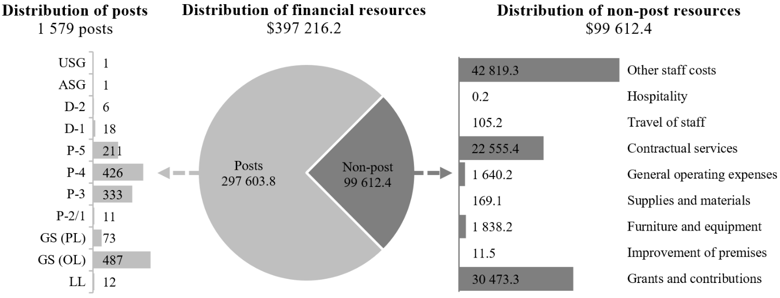

Explanation of variances by factor, component and subprogramme

Overall resource changes

Technical adjustments

2.193 As shown in table 2.47 (1), resource changes reflect a decrease of $7,382,700 under other staff costs ($6,044,400) and grants and contributions ($1,338,300), comprising the following: $256,500 under subprogramme 1, New York; $2,235,800 under subprogramme 3, New York; $1,438,100 under subprogramme 4, New York; $1,379,400 under subprogramme 2, Geneva; $1,338,300 under conference management, Vienna; and $734,600 under subprogramme 2, Nairobi, relating to the removal of non-recurrent provisions in support of new and expanded mandates from the General Assembly, including resolutions and decisions adopted by the Human Rights Council.

New and expanded mandates

2.194 As shown in table 2.47 (1), resource changes reflect an increase of $4,163,400, as follows:
(a) New York, subprogramme 3, Documentation services. The increase of $975,800 under other staff costs relates to additional documentation requirements in support of mandates from the General Assembly on:
(i) Multidimensional vulnerability index ($31,800; resolution 78/322);
(ii) Nuclear war effects and scientific research ($44,600; resolution 79/238);
(iii) Comprehensive study of the question of nuclear-weapon-free zones in all its aspects ($89,000; resolution 79/241);
(iv) Promotion of international cooperation to combat illicit financial flows and strengthen good practices on assets return to foster sustainable development ($25,300; resolution 79/234);
(v) A global call for concrete action for the elimination of racism, racial discrimination, xenophobia and related intolerance and the comprehensive implementation of and follow-up to the Durban Declaration and Programme of Action ($25,300; resolution 78/234);
(vi) Addressing the legacy of nuclear weapons: providing victim assistance and environmental remediation to Member States affected by the use or testing of nuclear weapons ($89,100; resolution 79/60);
(vii) Sustainable fisheries, including through the 1995 Agreement for the Implementation of the Provisions of the United Nations Convention on the Law of the Sea of 10 December 1982 relating to the Conservation and Management of Straddling Fish Stocks and Highly Migratory Fish Stocks, and related instruments” ($50,500; resolution 79/145);
(viii) Follow-up to the Fifth United Nations Conference on the Least Developed Countries ($25,300; resolution 79/218);
(ix) Investigation into the conditions and circumstances resulting in the tragic death of Dag Hammarskjöld and of the members of the party accompanying him ($103,900; resolution 79/244);
(x) Promotion of inclusive and effective international tax cooperation at the United Nations ($245,200; resolution 79/235);
(xi) Protection of persons in the event of disasters ($102,000; resolution 79/128);
(xii) The illicit trade in small arms and light weapons in all its aspects ($108,800; resolution 79/40);
(xiii) United Nations Conference of Plenipotentiaries on Prevention and Punishment of Crimes against Humanity ($35,000; resolution 79/122).
(b) New York, subprogramme 4, Meetings and publishing services. The increase of $433,200 under other staff costs relates to additional meeting service requirements in support of mandates from the General Assembly on:
(i) Comprehensive study of the question of nuclear-weapon-free zones in all its aspects ($82,000; resolution 79/241);
(ii) Sustainable fisheries, including through the 1995 Agreement for the Implementation of the Provisions of the United Nations Convention on the Law of the Sea of 10 December 1982 relating to the Conservation and Management of Straddling Fish Stocks and Highly Migratory Fish Stocks, and related instruments” ($23,100; resolution 79/145);
(iii) Protection of persons in the event of disasters ($82,000; resolution 79/128);
(iv) The illicit trade in small arms and light weapons in all its aspects ($82,000; resolution 79/40);
(v) United Nations Conference of Plenipotentiaries on Prevention and Punishment of Crimes against Humanity ($164,100; resolution 79/122).
(c) Geneva, subprogramme 2, Planning and coordination of conference services. The increase of $1,066,900) under other staff costs relates to additional conference service requirements of $7,100 in support of the Permanent Forum of People of African Descent (General Assembly resolution 75/314), and requirements of $1,059,800 pursuant to resolutions adopted by the Human Rights Council as follows:

Human Rights Council resolutions before 2024 ($133,400)

(i) Human rights, democracy and the rule of law ($69,200; resolutions 28/14 and 34/41);
(ii) The right to development ($40,100; resolution 42/23);
(iii) Business and human rights ($24,100; resolution 53/3);

Human Rights Council resolutions and decisions from the fifty-fifth to fifty-seventh regular sessions and eighteenth organizational session ($926,400)

(i) Support systems to ensure community inclusion of persons with disabilities ($12,900; resolution 55/8);
(ii) Role of States in countering the negative impact of disinformation on the enjoyment and realization of human rights ($24,100; resolution 55/10);
(iii) Prevention of genocide ($24,100; resolution 55/13);
(iv) Human rights and a culture of peace ($37,000; resolution 55/17);
(v) Postponement of the implementation of certain activities mandated by the Human Rights Council ($56,000; decision 55/115);
(vi) Enhancing the support capabilities of the open-ended intergovernmental working group on transnational corporations and other business enterprises with respect to human rights, established by Human Rights Council resolution 26/9 ($138,600; decision 56/116);
(vii) Open-ended intergovernmental working group on an optional protocol to the Convention on the Rights of the Child on the rights to early childhood education, free pre-primary education and free secondary education ($60,800; resolution 56/5);
(viii) Safety of the child in the digital environment ($110,900; resolution 56/6);
(ix) Freedom of opinion and expression ($24,100; resolution 56/7);
(x) Human rights and climate change ($24,100; resolution 56/8);
(xi) Menstrual hygiene management, human rights and gender equality ($24,100; resolution 56/11);
(xii) Accelerating progress towards preventing adolescent girls’ pregnancy ($48,200; resolution 56/21);
(xiii) Elimination of all forms of discrimination against women ($24,100; resolution 56/22);
(xiv) Countering cyberbullying ($24,100; resolution 57/6);
(xv) World Programme for Human Rights Education: the plan of action for the fifth phase ($12,900; resolution 57/10);
(xvi) Local government and human rights ($24,100; resolution 57/12);
(xvii) The human rights to safe drinking water and sanitation ($24,100; resolution 57/13);
(xviii) Human rights of migrants ($51,200; resolution 57/14);
(xix) Human rights and Indigenous Peoples ($24,100; resolution 57/15);
(xx) Equal participation in political and public affairs ($24,100; resolution 57/17);
(xxi) Elimination of domestic violence ($24,100; resolution 57/18);
(xxii) Education as a tool to prevent racism, racial discrimination, xenophobia and related intolerance ($24,100; resolution 57/24);
(xxiii) Biodiversity and human rights ($24,100; resolution 57/28);
(xxiv) Promotion, protection and enjoyment of human rights on the Internet ($24,100; resolution 57/29);
(xxv) Youth and human rights ($36,400; resolution 57/30).
(d) Vienna, conference management. The increase of $1,687,500 under grants and contributions relates to additional conference services requirements in support of mandates from the General Assembly on:
(i) Strengthening international cooperation for combating certain crimes committed by means of information and communications technology systems and for the sharing of evidence in electronic form of serious crimes ($835,200; resolution 79/243);
(ii) Follow-up to the Fourteenth United Nations Congress on Crime Prevention and Criminal Justice and preparations for the Fifteenth United Nations Congress on Crime Prevention and Criminal Justice ($827,700; resolution 79/186);
(iii) Strengthening and promoting effective measures and international cooperation on organ donation and transplantation to prevent and combat trafficking in persons for the purpose of organ removal and trafficking in human organs ($24,600; resolution 77/236).

Other changes

2.195 As shown in table 2.47 (1), resource changes reflect a net decrease of $586,000, as follows:
(a) Policymaking organs. A net increase of $47,300 comprises mainly an increase of $46,200 under other staff costs, reflecting requirements to provide administrative, technical, logistical and protocol-related support for the General Assembly;
(b) Executive direction and management. A net increase of $240,300 comprises mainly an increase of $285,700 under posts reflecting the proposed inward redeployment of the D-1 post of Chief of Conference Services from programme support, as explained in annex II, as well as an increase of $27,600 under general operating expenses to ensure further enhancement of the integrated global management of conference services, offset in part by a decrease of $63,800 under grants and contributions related to the discontinuation of the Umoja business support resources;
(c) New York, subprogramme 1, General Assembly and Economic and Social Council affairs. A net decrease of $45,900 comprises mainly a decrease of $105,600 under other staff costs, on the basis of expenditure patterns, offset in part by an increase of $48,600 under contractual services resulting from the redistribution of information and communication technology user costs across subprogrammes;
(d) New York, subprogramme 2, Planning and coordination of conference services. A net decrease of $170,800 comprises mainly decrease of $266,500 under other staff cost based on expenditure patterns, offset in part by increase of $95,400 under contractual services mainly resulting from the redistribution of information and communication technology user costs across subprogrammes;
(e) New York, subprogramme 3, Documentation Services. A net decrease of $2,495,600 comprises mainly decreases of, on the one hand, $228,000 under posts, reflecting the proposed abolishment of one post of Senior Language Reference Assistant (General Service (Principal level)) and the outward redeployment of one post of Senior Language Reference Assistant (General Service (Principal level)) to programme support and its reassignment as Senior Human Resources Assistant, as explained in annex II, and on the other hand $4,052,500 under other staff costs, offset in part by increases of $1,714,000 under contractual services and $55,800 under general operating expenses. The decrease under other staff costs reflects the reallocation of resources from temporary assistance for meeting to contractual capacities in the subprogramme to utilize commercial translation services and deliver documentation processing services in the most effective and cost-efficient manner, as well as to programme support to prioritize funding for technological and other innovations in support of the integrated global management of conference services in line with General Assembly resolution 79/248;
(f) New York, subprogramme 4, Meetings and publishing services. A net decrease of $366,200 comprises mainly decreases of $396,400 under posts, reflecting the proposed abolishment of four General Service (Other level) posts of two Publishing Assistants, one Language Service Assistant and one Administrative Assistant, as explained in annex II; of $2,179,300 under other staff costs; and of $156,500 under general operating expenses, on the basis of expenditure patterns, offset in part by an increase of $2,364,500 under contractual services. The internal realignment of resources for language capacities under posts, other staff costs and contractual services is made on the basis of expenditure patterns and reflects the optimal distribution of resources for interpretation services by temporary assistance for meetings and verbatim reporting by contractual services to complement the subprogramme’s core staff capacity;
(g) Geneva, subprogramme 2, Planning and coordination of conference services. A decrease of $22,285,400 comprises decreases of $17,688,000 under other staff costs and $4,597,400 under contractual services. The decrease under other staff costs reflects the cost-neutral redeployment of funds to subprogrammes 3 and 4 in Geneva ($10,428,000 and $7,260,000, respectively) to align with the planned programme of work and outputs for documentation and interpretation services on the basis of past implementation patterns. Similarly, the decrease under contractual services reflects the cost-neutral redeployment of funds to subprogramme 3 for documentation services;
(h) Geneva, subprogramme 3, Documentation services. A net increase of $15,174,200 comprises increases of $10,428,000 under other staff costs and $4,895,000 under contractual services, offset in part by a decrease of $148,800 under posts, reflecting the proposed abolishment of one post of Editorial and Desktop Publishing Assistant (General Service (Other level)), as explained in annex II. As explained in paragraph 2.195 (g) above, the increase under other staff costs reflects the cost-neutral redeployment of funds from subprogramme 2. The increase under contractual services reflects, on a cost-neutral basis, the redeployment of funds from subprogramme 2 and resources made available through the abolishment of the posts under subprogrammes 3 and 4;
(i) Geneva, subprogramme 4, Meetings and publishing services. A net increase of $7,111,200 comprises an increase of $7,260,000 under other staff costs, offset in part by a decrease of $148,800 under posts, reflecting the proposed abolishment of one Administrative Assistant post (General Service (Other level)), as explained in annex II. As explained in paragraph 2.195 (g) above, the increase under other staff costs reflects the cost-neutral redeployment of funds from subprogramme 2;
(j) Vienna, conference management. A decrease of $10,000 under grants and contributions, reflecting the United Nations share of jointly financed activities for conference services in Vienna, reflects the redistribution of resources within the Department on the basis of the prioritization of travel requirements between the duty stations;
(k) Nairobi, subprogramme 2, Planning and coordination of conference services. A net decrease of $976,300 comprises mainly decreases of $749,000 under other staff costs and $230,300 under contractual services. Those decreases reflect the cost-neutral redeployment of funds to subprogrammes 3 and 4 in Nairobi under the respective budget class to align with the planned programme of work and with outputs for documentation and interpretation services, on the basis of past implementation patterns. Similar to the redistribution of resources in other duty stations, this approach harmonizes and streamlines the planning and utilization of resources for language capacities to achieve efficient and cost-effective delivery of conference service. Core staff capacity will continue to be complemented with temporary assistance for meetings and contractual personnel during high workload periods;
(l) Nairobi, subprogramme 3, Documentation services. An increase of $765,800 comprises increases of $364,000 under other staff costs and $201,000 under contractual services, as explained in paragraph 2.195 (k) above, as well as an increase of $200,800 under posts, to reflect the proposed redeployment of one P-3 post of Editor from subprogramme 4, as explained in annex II;
(m) Nairobi, subprogramme 4, Meetings and publishing services. A net increase of $213,500 comprises increases of $385,000 under other staff costs and $29,300 under contractual services, offset in part by a decrease of $200,800 under posts, to reflect the proposed redeployment of one P-3 post of Publishing Officer to subprogramme 3, as explained in annex II;
(n) Programme support. A net increase of $2,211,900 comprises mainly increases of $1,839,100 under contractual services, $214,200 under other staff costs, and $545,600 under furniture and equipment, offset in part by decreases of $171,700 under posts and $219,200 under general operating expenses. The Department aims to prioritize resources for innovation, the advancement of technology and the further advancement of user experience, through the cost-neutral redeployment of funds from subprogrammes in New York to the Global Innovation and Data Analytics Service under programme support. The increase under contractual services reflects higher requirements for technology services for functions not available in the Organization but critical for the continuity and sustainability of conference management systems ($1,817,900), as well as increased provisions for personal computing services in Geneva ($19,300) and Nairobi ($1,900). Similar increase in provisions for Vienna is reflected under grants and contributions. The increases under other staff costs, as well as furniture and equipment, would also facilitate the continuous effort by the Service to design, develop, deploy and maintain innovative information technology solutions for delegates and clients in New York, Geneva, Vienna and Nairobi and to ensure timely responses to the needs of Member States by maintaining broadly used technology platforms. The decrease under posts reflects the proposed outward redeployment of one D-1 post to executive direction and management ($285,700), offset in part by the proposed inward reassignment of a General Service (Principal level) post from subprogramme 3 in New York ($114,000), as explained in annex II.

Extrabudgetary resources

2.196 As reflected in tables 2.47 (2) and 2.48 (2), extrabudgetary resources amount to $25,550,900, including provisions for 78 posts, inclusive of 10 posts funded from the trust fund for German language translation. The expected decrease of $595,000 compared with the estimated requirements for 2025 is attributable to the lower number of intergovernmental meetings expected in 2026 in Nairobi.
2.197 The Department receives voluntary contributions to the trust fund for German language translation, established in 1974 to provide resources to issue in German the resolutions and decisions of the General Assembly, as well as the other supplements to its official records, and the resolutions and decisions of the Security Council and the Economic and Social Council; and to the trust fund in support of General Assembly and conference management activities established by the Secretary General in 2013. Other extrabudgetary resources include: (a) a share of programme support costs allocated to the Department; and (b) a fund to backstop operations funded from cost recoveries. The extrabudgetary resources under the present section are subject to the oversight of the Department for General Assembly and Conference Management, in accordance with the delegation of authority by the Secretary-General.
2.198 The extrabudgetary resources in the four duty stations supplement training funds to ensure service delivery of the highest quality and to support the implementation of the United Nations Secretariat Learning Strategy by the Department in all four duty stations.

Policymaking organs

2.199 The resources proposed under this component would provide for the policymaking organs as shown in table 2.50. With regard to the Economic and Social Council, resources for technical secretariat support and conference services for meetings are provided for under conference management, New York.

Table 2.50

Policymaking organs
(Thousands of United States dollars)

Policymaking organ | Additional information | 2025 approved | 2026 estimate
General Assembly | Mandate: Articles 10 to 17 of the Charter of the United Nations | 175.4 | 222.7
Trusteeship Council | Mandate: Article 7 of the Charter of the United Nations | – | –
Economic and Social Council | Mandate: Articles 62 to 66 of the Charter of the United Nations | – | –
Total |  | 175.4 | 222.7

2.200 The proposed regular budget resources for 2026 amount to $222,700 and reflect an increase of $47,300 compared with the approved budget for 2025. The proposed change is explained in paragraph 2.195 (a) above. Additional details on the distribution of the proposed resources for 2026 are reflected in table 2.51 and figure 2.XXV.

Table 2.51

Policymaking organs: evolution of financial resources
(Thousands of United States dollars)

 | 2024 expenditure | 2025 approved | Changes |  |  |  |  | 2026  estimate
 | 2024 expenditure | 2025 approved | Technical adjustments | New/expanded mandates | Other | Total | Percentage | 2026  estimate
Financial resources by main category of expenditure
Non-post | 180.4 | 175.4 | – | – | 47.3 | 47.3 | 27.0 | 222.7
Total | 180.4 | 175.4 | – | – | 47.3 | 47.3 | 27.0 | 222.7

Figure 2.XXV

Policymaking organs: distribution of proposed resources for 2026
(Thousands of United States dollars)

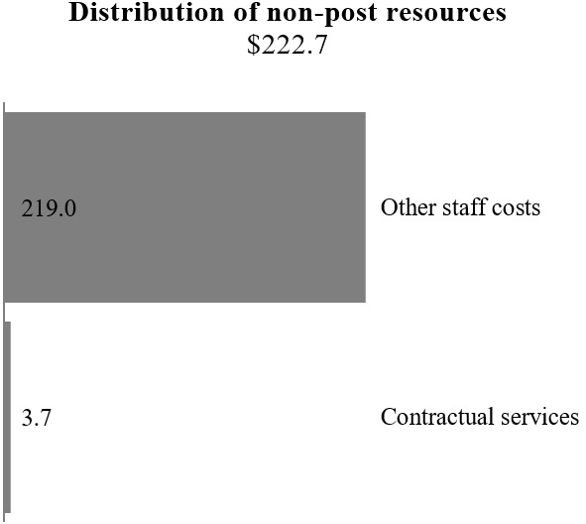

Executive direction and management

2.201 The executive direction and management component comprises the Office of the Under-Secretary-General and the Protocol and Liaison Service. The Under-Secretary-General for General Assembly and Conference Management is responsible for all the activities of the Department, as well as its administration, and represents the Secretary-General in meetings relating to the functions of the Department and in intergovernmental organs and expert bodies, as required. The Under-Secretary-General is also responsible for guiding integrated global conference management involving Headquarters and the United Nations Offices at Geneva, Vienna and Nairobi, which includes managing the conference-servicing resources at Headquarters and providing policy guidance with regard to the utilization of the conference-servicing resources, the authority for which has been subdelegated to the Directors-General of the United Nations Offices at Geneva, Vienna and Nairobi, with a view to achieving the highest possible level of cohesion, synergy and efficiency. The Under-Secretary-General also chairs the International Annual Meeting on Language Arrangements, Documentation and Publications.
2.202 The Protocol and Liaison Service provides protocol support to the Secretary-General, the Deputy Secretary-General and, upon request, the President of the General Assembly. It also supports the protocol requirements of high-level dignitaries participating in United Nations meetings and conferences, whether at United Nations Headquarters or at conferences away from Headquarters. The Service ensures the timely registration of both mission personnel and conference participants, liaises with the host country and permanent missions and observer offices and provides protocol guidance on the United Nations system.
2.203 In accordance with the 2030 Agenda for Sustainable Development, in particular target 12.6 of the Sustainable Development Goals, in which organizations are encouraged to integrate sustainability information into their reporting cycles, and in compliance with the cross-cutting mandate set out in paragraph 19 of General Assembly resolution 72/219, the Department is integrating environmental management practices into its operations. In 2019, the Department maintained International Organization for Standardization (ISO) 14001 certification for its publishing operations in Geneva, Nairobi and Vienna. The Department continued the ISO certification process at Headquarters in 2023 and finalized the first part of the procurement process. Owing to the liquidity constraints beginning in the second half of 2023, the Department has paused the process.
2.204 Information on the timely submission of documentation and advance booking for air travel is reflected in table 2.52. The Department will continue to implement measures to improve the compliance rate through the advance purchasing of air tickets, the advance planning and nomination of travellers, advance planning for the onboarding of staff with contingencies in place and communicating with staff and managers to raise awareness of the policy framework and requirements.

Table 2.52

Compliance rate
(Percentage)

 | 2022 actual | 2023 actual | 2024 actual | 2025 planned | 2026 planned
Timely submission of documentation | 100 | 100 | 100 | 100 | 100
Air tickets purchased at least two weeks before the commencement of travel | 58 | 73 | 87 | 100 | 100

2.205 The proposed regular budget resources for 2026 amount to $4,558,800 and reflect a net increase of $240,300 compared with the approved budget for 2025. The proposed change is explained in paragraph 2.195 (b) above. Additional details on the distribution of the proposed resources for 2026 are reflected in table 2.53 and figure 2.XXVI.

Table 2.53

Executive direction and management: evolution of financial and post resources
(Thousands of United States dollars/number of posts)

 | 2024 expenditure | 2025 approved | Changes |  |  |  |  | 2026 estimate
 | 2024 expenditure | 2025 approved | Technical adjustments | New/expanded mandates | Other | Total | Percentage | 2026 estimate
Financial resources by main category of expenditure
Posts | 4 362.5 | 4 081.7 | – | – | 285.7 | 285.7 | 7.0 | 4 367.4
Non-post | 372.6 | 236.8 | – | – | (45.4) | (45.4) | (19.2) | 191.4
Total | 4 735.1 | 4 318.5 | – | – | 240.3 | 240.3 | 5.6 | 4 558.8
Post resources by category
Professional and higher |  | 12 | – | – | 1 | 1 | 8.3 | 13
General Service and related |  | 10 | – | – | – | – | – | 10
Total |  | 22 | – | – | 1 | 1 | 4.5 | 23

Figure 2.XXVI

Executive direction and management: distribution of proposed resources for 2026
(Number of posts/thousands of United States dollars)

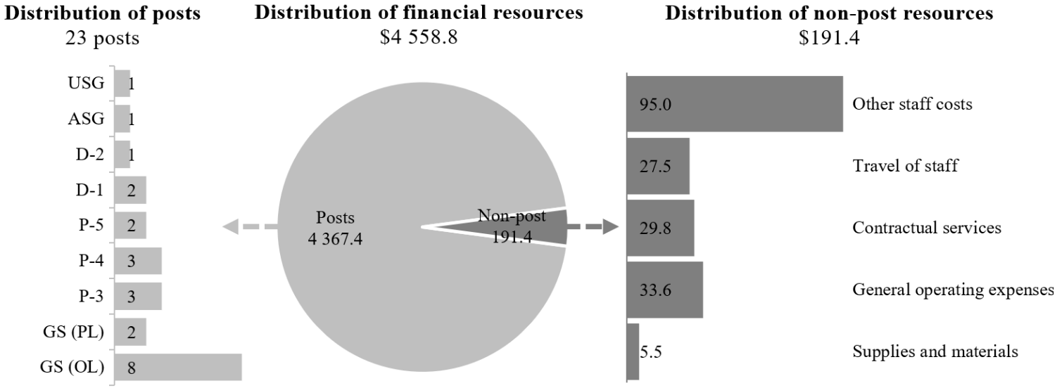

Programme of work

Subprogramme 1

General Assembly and Economic and Social Council affairs

2.206 The proposed regular budget resources for 2026 amount to $7,051,000 and reflect a decrease of $302,400 compared with the approved budget for 2025. The proposed changes are explained in paragraphs 2.193 and 2.195 (c). Additional details on the distribution of the proposed resources for 2026 are reflected in table 2.54 and figure 2.XXVII.

Table 2.54

Subprogramme 1: evolution of financial and post resources
(Thousands of United States dollars/number of posts)

 | 2024 expenditure | 2025  approved | Changes |  |  |  |  | 2026 estimate
 | 2024 expenditure | 2025  approved | Technical adjustments | New/expanded mandates | Other | Total | Percentage | 2026 estimate
Financial resources by main category of expenditure
Posts | 7 085.4 | 6 928.9 | – | – | – | – | – | 6 928.9
Non-post | 98.5 | 424.5 | (256.5) | – | (45.9) | (302.4) | (71.2) | 122.1
Total | 7 183.9 | 7 353.4 | (256.5) | – | (45.9) | (302.4) | (4.1) | 7 051.0
Post resources by category
Professional and higher |  | 20 | – | – | – | – | – | 20
General Service and related |  | 21 | – | – | – | – | – | 21
Total |  | 41 | – | – | – | – | – | 41

Figure 2.XXVII

Subprogramme 1: distribution of proposed resources for 2026
(Number of posts/thousands of United States dollars)

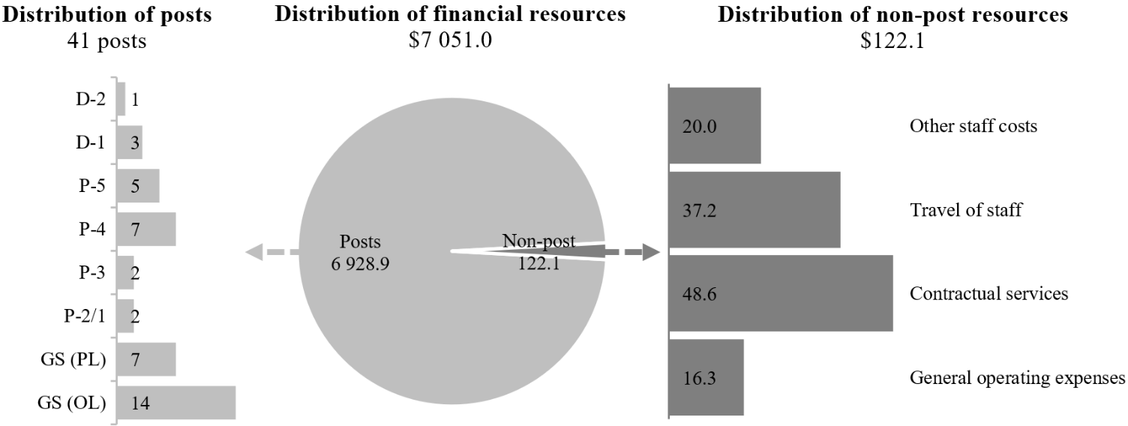

Conference management, New York

Subprogramme 2

Planning and coordination of conference services

2.207 The proposed regular budget resources for 2026 amount to $6,842,000 and reflect a decrease of $170,800 compared with the approved budget for 2025. The proposed change is explained in paragraph 2.195 (d). Additional details on the distribution of the proposed resources for 2026 are reflected in table 2.55 and figure 2.XXVIII.

Table 2.55

Subprogramme 2: evolution of financial and post resources
(Thousands of United States dollars/number of posts)

 | 2024 expenditure | 2025  approved | Changes |  |  |  |  | 2026 estimate
 | 2024 expenditure | 2025  approved | Technical adjustments | New/expanded mandates | Other | Total | Percentage | 2026 estimate
Financial resources by main category of expenditure
Posts | 6 003.3 | 6 502.0 | – | – | – | – | – | 6 502.0
Non-post | 339.4 | 510.8 | – | – | (170.8) | (170.8) | (33.4) | 340.0
Total | 6 342.7 | 7 012.8 | – | – | (170.8) | (170.8) | (2.4) | 6 842.0
Post resources by category
Professional and higher |  | 14 | – | – | – | – | – | 14
General Service and related |  | 32 | – | – | – | – | – | 32
Total |  | 46 | – | – | – | – | – | 46

Figure 2.XXVIII

Subprogramme 2: distribution of proposed resources for 2026
(Number of posts/thousands of United States dollars)

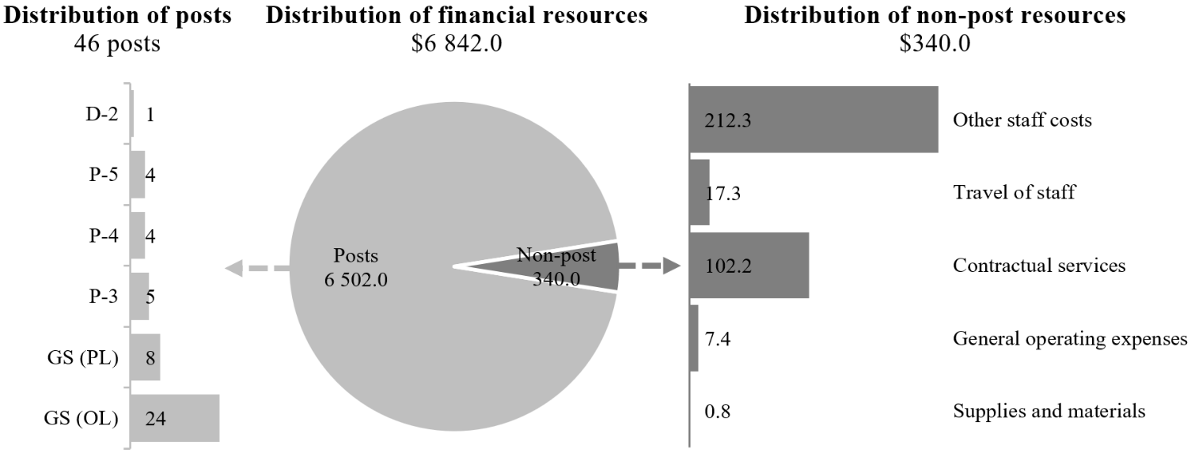

Subprogramme 3

Documentation services

2.208 The proposed regular budget resources for 2026 amount to $102,149,600 and reflect a decrease of $3,755,600 compared with the approved budget for 2025. The proposed changes are explained in paragraphs 2.193, 2.194 (a) and 2.195 (e). Additional details on the distribution of the proposed resources for 2026 are reflected in table 2.56 and figure 2.XXIX.

Table 2.56

Subprogramme 3: evolution of financial and post resources
(Thousands of United States dollars/number of posts)

 | 2024 expenditure | 2025  approved | Changes |  |  |  |  | 2026 estimate
 | 2024 expenditure | 2025  approved | Technical adjustments | New/expanded mandates | Other | Total | Percentage | 2026 estimate
Financial resources by main category of expenditure
Posts | 81 259.2 | 94 385.2 | – | – | (228.0) | (228.0) | (0.2) | 94 157.2
Non-post | 3 746.9 | 11 520.0 | (2 235.8) | 975.8 | (2 267.6) | (3 527.6) | (30.6) | 7 992.4
Total | 85 006.1 | 105 905.2 | (2 235.8) | 975.8 | (2 495.6) | (3 755.6) | (3.5) | 102 149.6
Post resources by category
Professional and higher |  | 355 | – | – | – | – | – | 355
General Service and related |  | 149 | – | – | (2) | (2) | (1.3) | 147
Total |  | 504 | – | – | (2) | (2) | (0.4) | 502

Figure 2.XXIX

Subprogramme 3: distribution of proposed resources for 2026
(Number of posts/thousands of United States dollars)

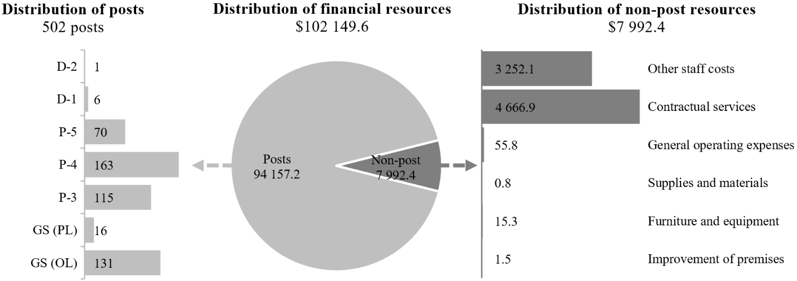

Subprogramme 4

Meetings and publishing services

2.209 The proposed regular budget resources for 2026 amount to $64,060,400 and reflect a decrease of $1,371,100 compared with the approved budget for 2025. The proposed changes are explained in paragraphs 2.193, 2.194 (b) and 2.195 (f). Additional details on the distribution of the proposed resources for 2026 are reflected in table 2.57 and figure 2.XXX.

Table 2.57

Subprogramme 4: evolution of financial and post resources
(Thousands of United States dollars/number of posts)

 | 2024 expenditure | 2025  approved | Changes |  |  |  |  | 2026 estimate
 | 2024 expenditure | 2025  approved | Technical adjustments | New/expanded mandates | Other | Total | Percentage | 2026 estimate
Financial resources by main category of expenditure
Posts | 50 836.0 | 53 436.2 | – | – | (396.4) | (396.4) | (0.7) | 53 039.8
Non-post | 7 004.7 | 11 995.3 | (1 438.1) | 433.2 | 30.2 | (974.7) | (8.1) | 11 020.6
Total | 57 840.7 | 65 431.5 | (1 438.1) | 433.2 | (366.2) | (1 371.1) | (2.1) | 64 060.4
Post resources by category
Professional and higher |  | 200 | – | – | – | – | – | 200
General Service and related |  | 87 | – | – | (4) | (4) | (4.6) | 83
Total |  | 287 | – | – | (4) | (4) | (1.4) | 283

Figure 2.XXX

Subprogramme 4: distribution of proposed resources for 2026
(Number of posts/thousands of United States dollars)

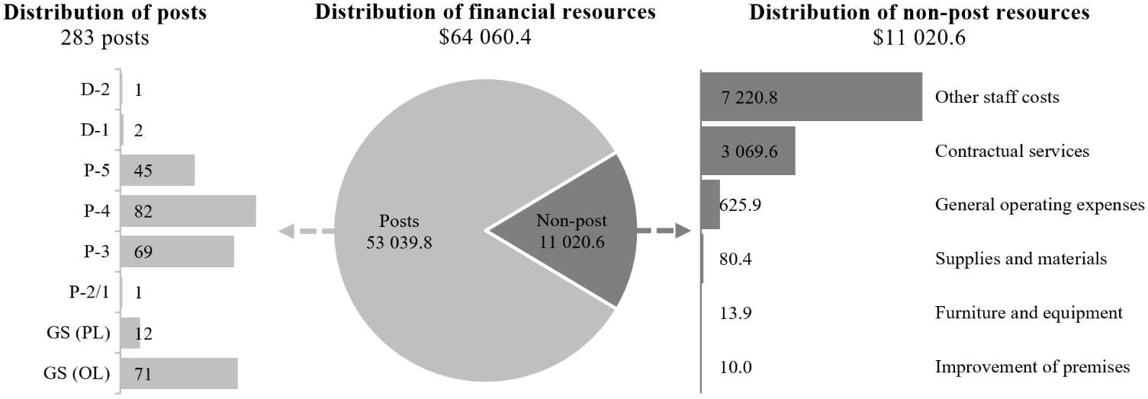

Conference management, Geneva

Subprogramme 2

Planning and coordination of conference services

2.210 The proposed regular budget resources for 2026 amount to $24,414,100 and reflect a decrease of $22,597,900 compared with the approved budget for 2025. The proposed changes are explained in paragraphs 2.193, 2.194 (c) and 2.195 (g). Additional details on the distribution of the proposed resources for 2026 are reflected in table 2.58 and figure 2.XXXI.

Table 2.58

Subprogramme 2: evolution of financial and post resources
(Thousands of United States dollars/number of posts)

 | 2024 expenditure | 2025  approved | Changes |  |  |  |  | 2026 estimate
 | 2024 expenditure | 2025  approved | Technical adjustments | New/ expanded mandates | Other | Total | Percentage | 2026 estimate
Financial resources by main category of expenditure
Posts | 10 634.5 | 11 878.3 | – | – | – | – | – | 11 878.3
Non-post | 1 425.9 | 35 133.7 | (1 379.4) | 1 066.9 | (22 285.4) | (22 597.9) | (64.3) | 12 535.8
Total | 12 060.4 | 47 012.0 | (1 379.4) | 1 066.9 | (22 285.4) | (22 597.9) | (48.1) | 24 414.1
Post resources by category
Professional and higher |  | 18 | – | – | – | – | – | 18
General Service and related |  | 50 | – | – | – | – | – | 50
Total |  | 68 | – | – | – | – | – | 68

Figure 2.XXXI

Subprogramme 2: distribution of proposed resources for 2026
(Number of posts/thousands of United States dollars)

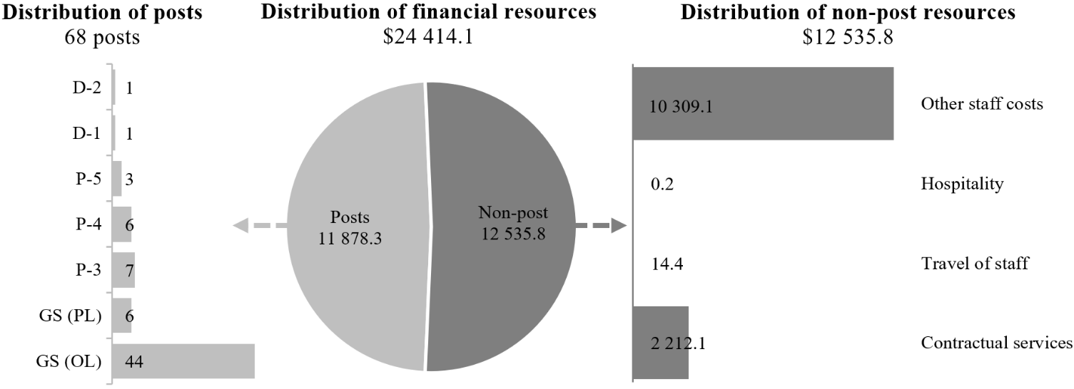

Subprogramme 3

Documentation services

2.211 The proposed regular budget resources for 2026 amount to $80,096,500 and reflect a net increase of 15,174,200 compared with the approved budget for 2025. The proposed change is explained in paragraph 2.195 (h). Additional details on the distribution of the proposed resources for 2026 are reflected in table 2.59 and figure 2.XXXII.

Table 2.59

Subprogramme 3: evolution of financial and post resources
(Thousands of United States dollars/number of posts)

 | 2024 expenditure | 2025  approved | Changes |  |  |  |  | 2026 estimate
 | 2024 expenditure | 2025  approved | Technical adjustments | New/ expanded mandates | Other | Total | Percentage | 2026 estimate
Financial resources by main category of expenditure
Posts | 56 384.0 | 64 922.3 | – | – | (148.8) | (148.8) | (0.2) | 64 773.5
Non-post | 6 251.8 | – | – | – | 15 323.0 | 15 323.0 | – | 15 323.0
Total | 62 635.8 | 64 922.3 | – | – | 15 174.2 | 15 174.2 | 23.4 | 80 096.5
Post resources by category
Professional and higher |  | 205 | – | – | – | – | – | 205
General Service and related |  | 118 | – | – | (1) | (1) | (0.8) | 117
Total |  | 323 | – | – | (1) | (1) | (0.3) | 322

Figure 2.XXXII

Subprogramme 3: distribution of proposed resources for 2026
(Number of posts/thousands of United States dollars)

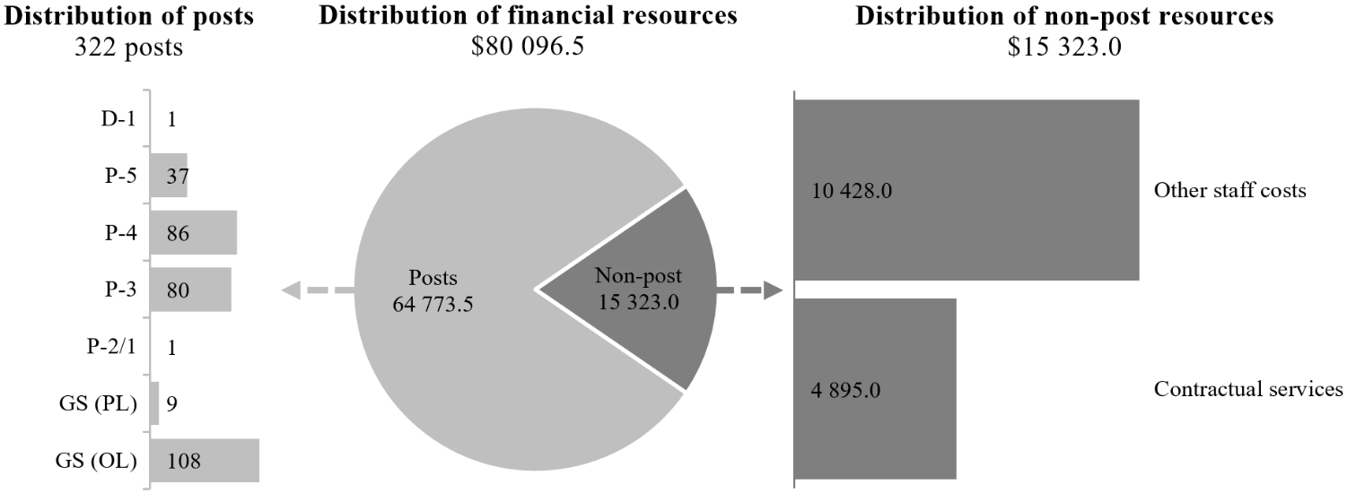

Subprogramme 4

Meetings and publishing services

2.212 The proposed regular budget resources for 2026 amount to $42,394,600 and reflect a net increase of $7,111,200 compared with the approved budget for 2025. The proposed change is explained in paragraph 2.195 (i). Additional details on the distribution of the proposed resources for 2026 are reflected in table 2.60 and figure 2.XXXIII.

Table 2.60

Subprogramme 4: evolution of financial and post resources
(Thousands of United States dollars/number of posts)

 | 2024 expenditure | 2025  approved | Changes |  |  |  |  | 2026 estimate
 | 2024 expenditure | 2025  approved | Technical adjustments | New/ expanded mandates | Other | Total | Percentage | 2026 estimate
Financial resources by main category of expenditure
Posts | 32 911.9 | 34 610.6 | – | – | (148.8) | (148.8) | (0.4) | 34 461.8
Non-post | 4 041.0 | 672.8 | – | – | 7 260.0 | 7 260.0 | 1 079.1 | 7 932.8
Total | 36 952.9 | 35 283.4 | – | – | 7 111.2 | 7 111.2 | 20.2 | 42 394.6
Post resources by category
Professional and higher |  | 109 | – | – | – | – | – | 109
General Service and related |  | 58 | – | – | (1) | (1) | (1.7) | 57
Total |  | 167 | – | – | (1) | (1) | (0.6) | 166

Figure 2.XXXIII

Subprogramme 4: distribution of proposed resources for 2026
(Number of posts/thousands of United States dollars)

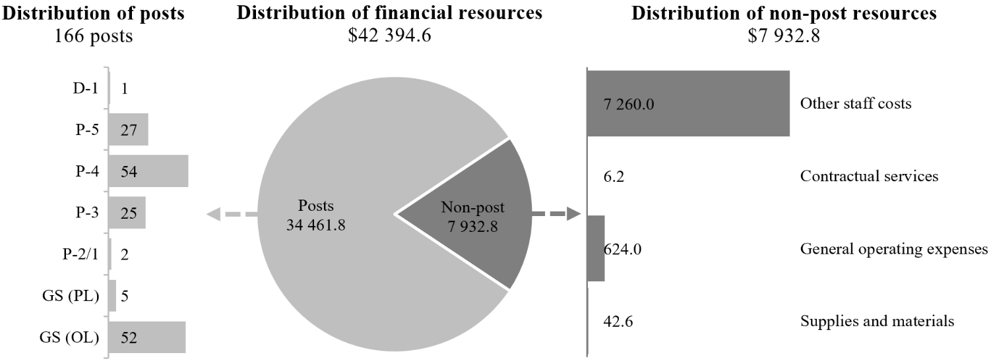

Conference management, Vienna

2.213 The General Assembly, in its resolution 49/237, requested the Secretary-General to establish a unified conference-servicing facility at the Vienna International Centre under the management of the United Nations. Accordingly, the Conference Management Service in Vienna provides services not only to the United Nations Office at Vienna and the United Nations Office on Drugs and Crime, but also to the International Atomic Energy Agency, the United Nations Industrial Development Organization and the Preparatory Commission for the Comprehensive Nuclear-Test-Ban Treaty Organization.
2.214 In 2026, the servicing of the above-mentioned non-Secretariat client organizations is estimated to account for approximately 36 per cent of the interpretation workload, 21 per cent of the meeting-servicing workload and 7 per cent of the documentation-servicing workload, including translation, editing and desktop publishing.

United Nations share (net budget)

2.215 The requirements of the conference services at Vienna are budgeted on a net basis, whereby the appropriation under the United Nations programme budget is made for the United Nations share of relevant activities. The gross budget, for which the United Nations has responsibility under the arrangements for unified conference services, is also presented for consideration and approval by the General Assembly. Thus, the estimates that follow are presented on both a gross basis, which includes reimbursements by non-Secretariat organizations, and a net basis, as summarized in table 2.61.

Table 2.61

Vienna, programme of work: evolution of requirements on a gross and net basis
(Thousands of United States dollars)

 | 2024 | 2025 | 2026 estimate (before recosting)
Conference services, Vienna (gross budget) | 33 287.5 | 34 765.9 | 35 105.1
Reimbursement by IAEA, UNIDO and the Preparatory Commission for the Comprehensive Nuclear-Test-Ban Treaty Organization | 5 659.0 | 5 851.0 | 5 851.0
United Nations (net budget) | 27 628.5 | 28 914.9 | 29 254.1

Abbreviations: IAEA, International Atomic Energy Agency; UNIDO, United Nations Industrial Development Organization.

2.16 As shown in table 2.61, the regular budget resource requirements for 2026 are estimated at $29,254,100 which represents 83.3 per cent of the gross requirements.

Conference services, Vienna (gross budget)

Table 2.62

Evolution of financial resources by subprogramme
(Thousands of United States dollars/number of posts)

 | 2024 expenditure | 2025  approved | Changes |  |  |  |  | 2026 estimate
 | 2024 expenditure | 2025  approved | Technical adjustments | New/ expanded mandates | Other | Total | Percentage | 2026 estimate
Programme of work
2. Planning and coordination of conference services | 5 211.8 | 6 510.5 | (84.6) | – | (10.0) | (94.6) | (1.5) | 6 415.9
3. Documentation services | 13 890.0 | 16 977.2 | (921.5) | 1 255.5 | – | 334.0 | 2.0 | 17 311.2
4. Meetings and publishing services | 9 863.2 | 11 278.2 | (332.2) | 432.0 | – | 99.8 | 0.9 | 11 378.0
Total | 28 965.0 | 34 765.9 | (1 338.3) | 1 687.5 | (10.0) | 339.2 | 1.0 | 35 105.1

Overall resource changes, Vienna (gross budget)

Technical adjustments

2.217 As shown in table 2.62, resource changes reflect a decrease of $1,338,300 under other staff costs, comprising the following: $84,600 under subprogramme 2, Vienna; $921,500 under subprogramme 3, Vienna; and $332,200 under subprogramme 4, Vienna, relating to the removal of non-recurrent provisions in support of new and expanded mandates from the General Assembly.

New and expanded mandates

2.218 As shown in table 2.62, resource changes reflect an increase of $1,687,500, as follows:
(a) Vienna, subprogramme 3, Documentation services. The increase of $1,255,500 under other staff costs relates to additional documentation requirements in support of mandates from the General Assembly on:
(i) Strengthening international cooperation for combating certain crimes committed by means of information and communications technology systems and for the sharing of evidence in electronic form of serious crimes ($752,100; resolution 79/243);
(ii) Follow-up to the Fourteenth United Nations Congress on Crime Prevention and Criminal Justice and preparations for the Fifteenth United Nations Congress on Crime Prevention and Criminal Justice ($478,800; resolution 79/186);
(iii) Strengthening and promoting effective measures and international cooperation on organ donation and transplantation to prevent and combat trafficking in persons for the purpose of organ removal and trafficking in human organs ($24,600; resolution 77/236);
(b) Vienna, subprogramme 4, Meetings and publishing services. The increase of $432,000 under other staff costs relates to additional meeting service requirements in support of mandates from the General Assembly on:
(i) Strengthening international cooperation for combating certain crimes committed by means of information and communications technology systems and for the sharing of evidence in electronic form of serious crimes ($83,100; resolution 79/243);
(ii) Follow-up to the Fourteenth United Nations Congress on Crime Prevention and Criminal Justice and preparations for the Fifteenth United Nations Congress on Crime Prevention and Criminal Justice ($348,900; resolution 79/186).

Other changes

2.219 As shown in table 2.62, resource changes reflect a decrease of $10,000, under Vienna, subprogramme 2, Planning and coordination of conference services. The decrease of $10,000 under travel of staff reflects the redistribution of resources within the Department on the basis of the prioritization of travel requirements between the duty stations.

Subprogramme 2

Planning and coordination of conference services

2.220 The proposed regular budget resources for 2026 amount to $6,415,900 and reflect a decrease of $94,600 compared with the approved budget for 2025. The proposed changes are explained in paragraphs 2.217 and 2.219. Additional details on the distribution of the proposed resources for 2026 are reflected in table 2.63 and figure 2.XXXIV.

Table 2.63

Subprogramme 2: evolution of financial and post resources
(Thousands of United States dollars/number of posts)

 | 2024 expenditure | 2025  approved | Changes |  |  |  |  | 2026 estimate
 | 2024 expenditure | 2025  approved | Technical adjustments | New/expanded mandates | Other | Total | Percentage | 2026 estimate
Financial resources by main category of expenditure
Posts | 4 007.5 | 4 291.0 | – | – | – | – | – | 4 291.0
Non-post | 1 204.3 | 2 219.5 | (84.6) | – | (10.0) | (94.6) | (4.3) | 2 124.9
Total | 5 211.8 | 6 510.5 | (84.6) | – | (10.0) | (94.6) | (1.5) | 6 415.9
Post resources by category
Professional and higher |  | 8 | – | – | – | – | – | 8
General Service and related |  | 26 | – | – | – | – | – | 26
Total |  | 34 | – | – | – | – | – | 34

Figure 2.XXXIV

Subprogramme 2: distribution of proposed resources for 2026
(Number of posts/thousands of United States dollars)

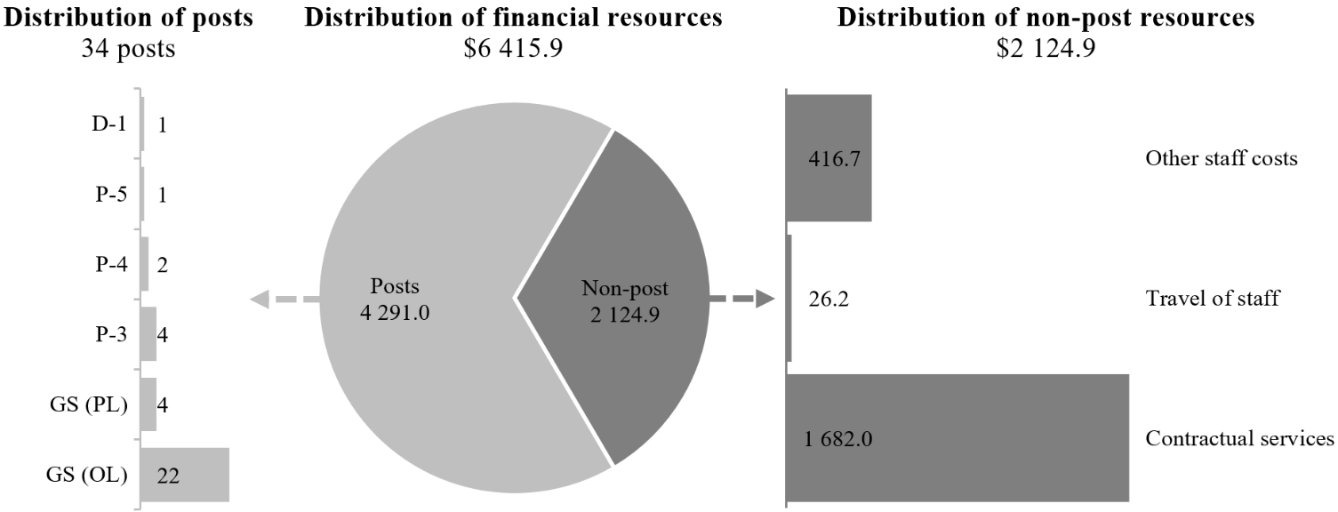

Subprogramme 3

Documentation services

2.221 The proposed regular budget resources for 2026 amount to $17,311,200 and reflect an increase of $334,000 compared with the approved budget for 2025. The proposed changes are explained in paragraphs 2.217 and 2.218 (a). Additional details on the distribution of the proposed resources for 2026 are reflected in table 2.64 and figure 2.XXXV.

Table 2.64

Subprogramme 3: evolution of financial and post resources
(Thousands of United States dollars/number of posts)

 | 2024 expenditure | 2025  approved | Changes |  |  |  |  | 2026 estimate
 | 2024 expenditure | 2025  approved | Technical adjustments | New/expanded mandates | Other | Total | Percentage | 2026 estimate
Financial resources by main category of expenditure
Posts | 13 358.2 | 14 436.5 | – | – | – | – | – | 14 436.5
Non-post
Other staff costs | 531.8 | 2 540.7 | (921.5) | 1 255.5 | – | 334.0 | 13.1 | 2 874.7
Total | 13 890.0 | 16 977.2 | (921.5) | 1 255.5 | – | 334.0 | 2.0 | 17 311.2
Post resources by category
Professional and higher |  | 49 | – | – | – | – | – | 49
General Service and related |  | 44 | – | – | – | – | – | 44
Total |  | 93 | – | – | – | – | – | 93

Figure 2.XXXV

Subprogramme 3: distribution of proposed resources for 2026
(Number of posts/thousands of United States dollars)

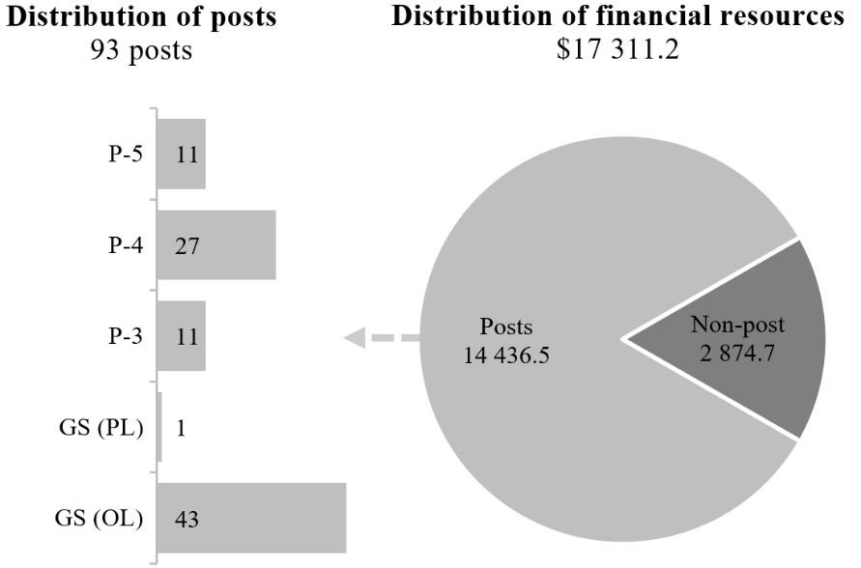

Subprogramme 4

Meetings and publishing services

2.222 The proposed regular budget resources for 2026 amount to $11,378,000 and reflect an increase of $99,800 compared with the approved budget for 2025. The proposed changes are explained in paragraphs 2.217 and 2.218 (b). Additional details on the distribution of the proposed resources for 2026 are reflected in table 2.65 and figure 2.XXXVI.

Table 2.65

Subprogramme 4: evolution of financial and post resources
(Thousands of United States dollars/number of posts)

 | 2024 expenditure | 2025  approved | Changes |  |  |  |  | 2026 estimate
 | 2024 expenditure | 2025  approved | Technical adjustments | New/expanded mandates | Other | Total | Percentage | 2026 estimate
Financial resources by main category of expenditure
Posts | 8 652.0 | 8 982.4 | – | – | – | – | – | 8 982.4
Non-post | 1 211.2 | 2 295.8 | (332.2) | 432.0 | – | 99.8 | 4.3 | 2 395.6
Total | 9 863.2 | 11 278.2 | (332.2) | 432.0 | – | 99.8 | 0.9 | 11 378.0
Post resources by category
Professional and higher |  | 31 | – | – | – | – | – | 31
General Service and related |  | 25 | – | – | – | – | – | 25
Total |  | 56 | – | – | – | – | – | 56

Figure 2.XXXVI

Subprogramme 4: distribution of proposed resources for 2026
(Number of posts/thousands of United States dollars)

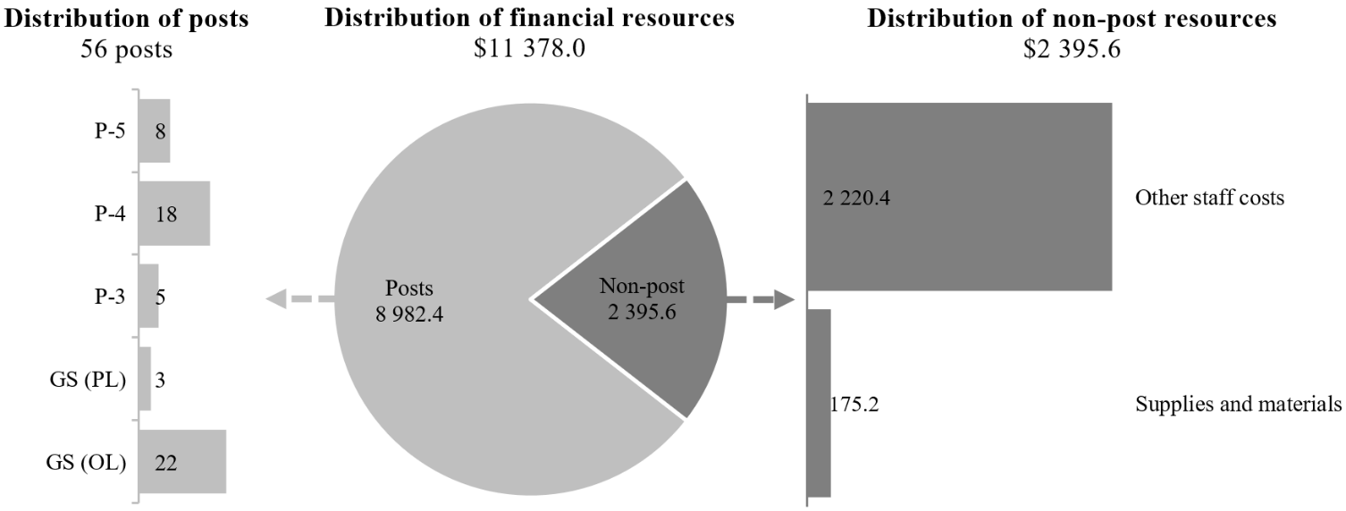

Conference management, Nairobi

Subprogramme 2

Planning and coordination of conference services

2.223 The proposed regular budget resources for 2026 amount to $2,031,300 and reflect a decrease of $1,710,900 compared with the approved budget for 2025. The proposed changes are explained in paragraphs 2.193 and 2.195 (k). Additional details on the distribution of the proposed resources for 2026 are reflected in table 2.66 and figure 2.XXXVII.

Table 2.66

Subprogramme 2: evolution of financial and post resources
(Thousands of United States dollars/number of posts)

 | 2024 expenditure | 2025  approved | Changes |  |  |  |  | 2026 estimate
 | 2024 expenditure | 2025  approved | Technical adjustments | New/expanded mandates | Other | Total | Percentage | 2026 estimate
Financial resources by main category of expenditure
Posts | 1 501.0 | 1 474.8 | – | – | – | – | – | 1 474.8
Non-post | 291.0 | 2 267.4 | (734.6) | – | (976.3) | (1 710.9) | (75.5) | 556.5
Total | 1 792.0 | 3 742.2 | (734.6) | – | (976.3) | (1 710.9) | (45.7) | 2 031.3
Post resources by category
Professional and higher |  | 6 | – | – | – | – | – | 6
General Service and related |  | 3 | – | – | – | – | – | 3
Total |  | 9 | – | – | – | – | – | 9

Figure 2.XXXVII

Subprogramme 2: distribution of proposed resources for 2026
(Number of posts/thousands of United States dollars)

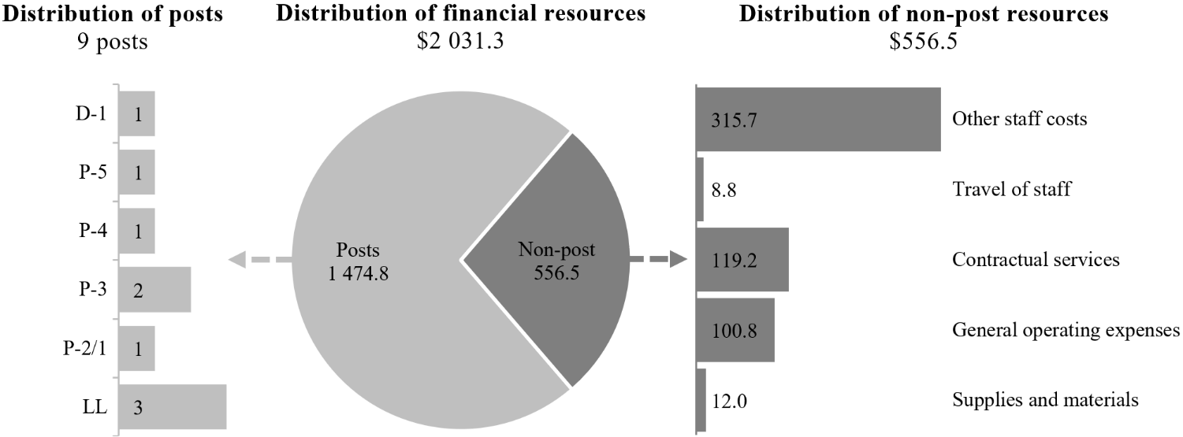

Subprogramme 3

Documentation services

2.224 The proposed regular budget resources for 2026 amount to $6,109,200 and reflect an increase of $765,800 compared with the approved budget for 2025. The proposed change is explained in paragraph 2.195 (l). Additional details on the distribution of the proposed resources for 2026 are reflected in table 2.67 and figure 2.XXXVIII.

Table 2.67

Subprogramme 3: evolution of financial and post resources
(Thousands of United States dollars/number of posts)

 | 2024 expenditure | 2025  approved | Changes |  |  |  |  | 2026 estimate
 | 2024 expenditure | 2025  approved | Technical adjustments | New/expanded mandates | Other | Total | Percentage | 2026 estimate
Financial resources by main category of expenditure
Posts | 4 115.1 | 5 343.4 | – | – | 200.8 | 200.8 | 3.8 | 5 544.2
Non-post | 429.4 | – | – | – | 565.0 | 565.0 | – | 565.0
Total | 4 544.5 | 5 343.4 | – | – | 765.8 | 765.8 | 14.3 | 6 109.2
Post resources by category
Professional and higher |  | 22 | – | – | 1 | 1 | 4.5 | 23
General Service and related |  | 6 | – | – | – | – | – | 6
Total |  | 28 | – | – | 1 | 1 | 3.6 | 29

Figure 2.XXXVIII

Subprogramme 3: distribution of proposed resources for 2026
(Number of posts/thousands of United States dollars)

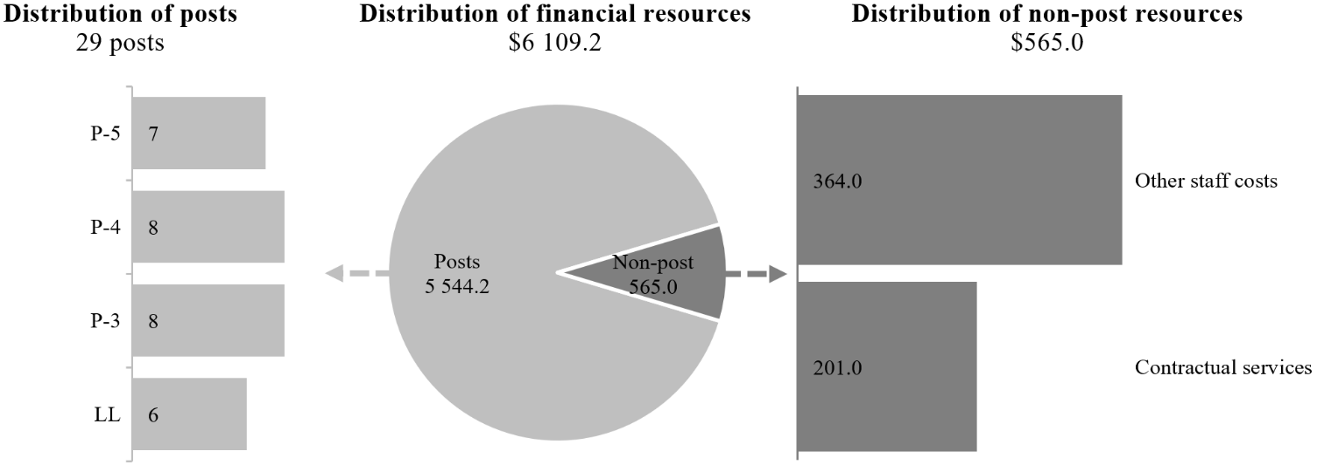

Subprogramme 4

Meetings and publishing services

2.225 The proposed regular budget resources for 2026 amount to $5,174,700 and reflect a net increase of $213,500 compared with the approved budget for 2025. The proposed change is explained in paragraph 2.195 (m). Additional details on the distribution of the proposed resources for 2026 are reflected in table 2.68 and figure 2.XXXIX.

Table 2.68

Subprogramme 4: evolution of financial and post resources
(Thousands of United States dollars/number of posts)

 | 2024 expenditure | 2025  approved | Changes |  |  |  |  | 2026 estimate
 | 2024 expenditure | 2025  approved | Technical adjustments | New/expanded mandates | Other | Total | Percentage | 2026 estimate
Financial resources by main category of expenditure
Posts | 3 526.5 | 4 961.2 | – | – | (200.8) | (200.8) | (4.0) | 4 760.4
Non-post | 377.3 | – | – | – | 414.3 | 414.3 | – | 414.3
Total | 3 903.8 | 4 961.2 | – | – | 213.5 | 213.5 | 4.3 | 5 174.7
Post resources by category
Professional and higher |  | 21 | – | – | (1) | (1) | (4.8) | 20
General Service and related |  | 3 | – | – | – | – | – | 3
Total |  | 24 | – | – | (1) | (1) | (4.2) | 23

Figure 2.XXXIX

Subprogramme 4: distribution of proposed resources for 2026
(Number of posts/thousands of United States dollars)

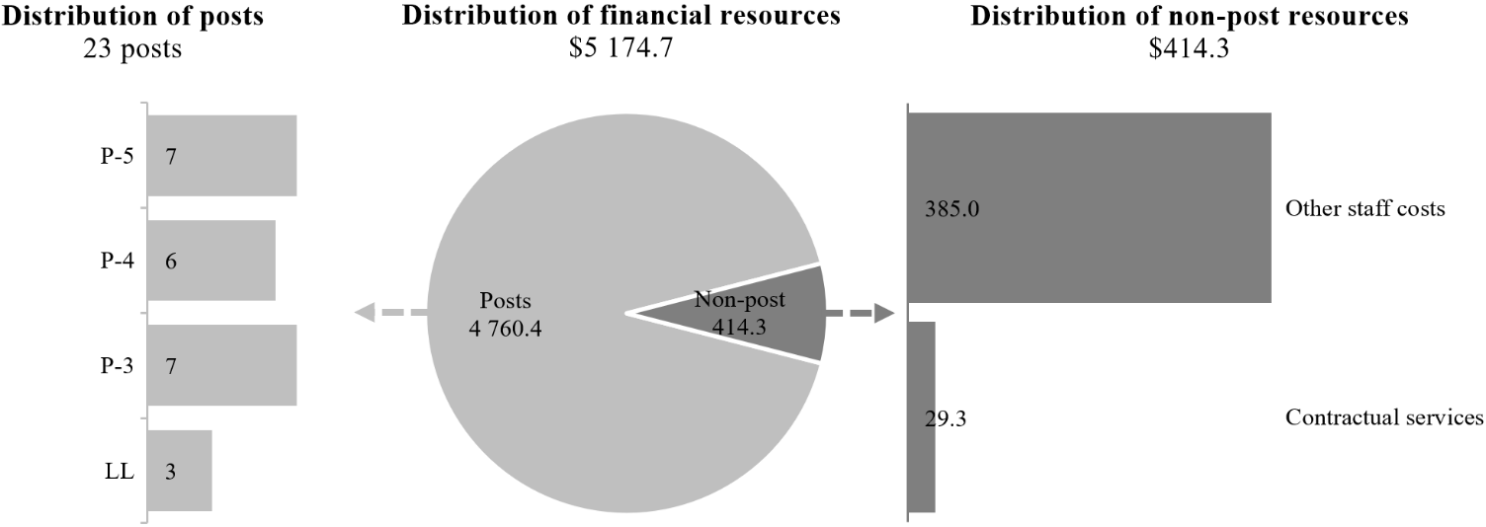

Programme support

2.226 The programme support component comprises the Executive Office in New York, as well as the Global Innovation and Data Analytics Service. In 2026, the Global Innovation and Data Analytics Service will continue to provide enterprise conference management solutions to all conference management operations in the four duty stations and United Nations common system entities. The systems and applications developed and maintained in-house by the Service enable planning and delivery of the integrated global conference services. The functionalities of eAPG, gMeets, consolidated gText and gDoc systems, e-deleGATE and eJournal would be further enhanced and maintained by the Service on the basis of requirements formulated by business users – substantive offices of the Department. Together, the products comprise the conference and events management suite of applications implemented in alignment with the enterprise priorities of the United Nations. The above applications facilitate efficient conference planning, document processing, language capacity management and meeting services.
2.227 The Service will continue to focus on rationalizing and streamlining operational support activities and coordinate the work of the Service with the Office of Information and Communications Technology and the Enterprise Resource Planning Solution Division to ensure integration of the conference and events management suite of applications developed in-house by the Department with the United Nations enterprise systems such as Umoja and Inspira. To enhance technology service delivery efficiency within the Department, in 2025, the Global Innovation and Data Analytics Service completed the consolidation of the Business Analysis Section in New York and the Global Technical Team in Vienna.
2.228 The Information Technology and Business Analysis Unit and the Evaluation, Analysis and Monitoring Section, based in Geneva, and the Information Technology Unit, based in Nairobi, also receive guidance through the Global Innovation and Data Analytics Service. Both Units are responsible for maintaining, enhancing, supporting and advancing enterprise technology solutions and local information technology support that are critical to the delivery of effective and cost-efficient conference services to clients.
2.229 The Executive Office provides central administrative services and policy advice to the Department in the areas of resource planning, human resources management, financial management, contracts, trust fund management and general administration. As the functional experts in these areas, the Executive Office develops user requirements for modules in relation to administrative services and ensures that solutions developed and rolled out by the Global Innovation and Data Analytics Service comply with the policy framework of the Organization and are developed in the context of the enterprise environment. In the context of the integrated global management of conference services, the Executive Office is responsible for standardizing and harmonizing the administrative, budgetary and cost-recovery methodologies of the conference-servicing components at all four conference servicing duty stations and for coordinating workforce and succession planning, staff development and performance management, harmonization and standardization of a notional cost, and the implementation of audit recommendations. The Executive Office also advises senior managers on implementation of the delegation of authority framework and ensures that effective controls are in place for the areas identified in the annual statement of internal controls.
2.230 The Executive Office works closely with the Department of Management Strategy, Policy and Compliance and the Department of Operational Support to ensure that the human resources policies and guidelines take into account specifics of the language services and language staff, and ensures their equal treatment in line with relevant General Assembly resolutions. The Executive Office also provides administrative support and policy guidance to the Office of the President of the General Assembly and ensures that staff and other personnel of the Office are recruited annually before a new Assembly session begins it work.
2.231 The proposed regular budget resources for 2026 amount to $22,857,200 and reflect a net increase of $2,211,900 compared with the approved budget for 2025. The proposed change is explained in paragraph 2.195 (n). Additional details on the distribution of the proposed resources for 2026 are reflected in table 2.69 and figure 2.XL.

Table 2.69

Programme support: evolution of financial and post resources
(Thousands of United States dollars/number of posts)

 | 2024 expenditure | 2025  approved | Changes |  |  |  |  | 2026 estimate
 | 2024 expenditure | 2025  approved | Technical adjustments | New/expanded mandates | Other | Total | Percentage | 2026 estimate
Financial resources by main category of expenditure
Posts | 8 409.4 | 9 887.2 | – | – | (171.7) | (171.7) | (1.7) | 9 715.5
Non-post | 9 718.7 | 10 758.1 | – | – | 2 383.6 | 2 383.6 | 22.2 | 13 141.7
Total | 18 128.1 | 20 645.3 | – | – | 2 211.9 | 2 211.9 | 10.7 | 22 857.2
Post resources by category
Professional and higher |  | 25 | – | – | (1) | (1) | (4.0) | 24
General Service and related |  | 42 | – | – | 1 | 1 | 2.4 | 43
Total |  | 67 | – | – | – | – | – | 67

Figure 2.XL

Programme support: distribution of proposed resources for 2026
(Number of posts/thousands of United States dollars)

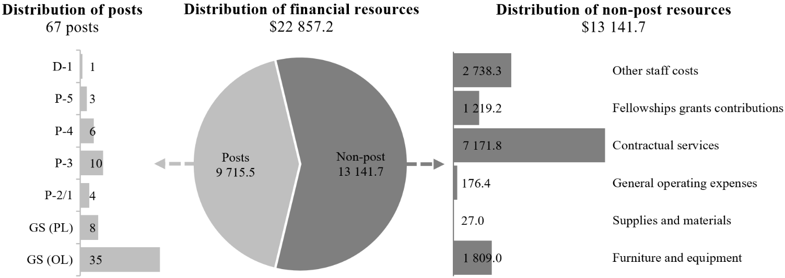

United Nations share (net budget): information technology support, Vienna

2.232 The requirements relating to information technology support for conference services in Vienna are budgeted on a net basis, whereby the appropriation under the programme budget is made for the United Nations share of those activities. The gross budget, for which the United Nations has responsibility under the arrangements for unified conference services, is also presented for the consideration and approval of the General Assembly. Thus, the estimates for information technology that follow are presented on both a gross basis, which includes reimbursements by non-Secretariat organizations, and a net basis, as summarized in table 2.70.

Table 2.70

Information technology support, Vienna: evolution of requirements by gross and net budget
(Thousands of United States dollars)

 | 2024 | 2025 | 2026 estimate (before recosting)
Conference services, Vienna (gross budget) | 1 460.5 | 1 491.4 | 1 495.3
Reimbursement by IAEA, UNIDO and the Preparatory Commission for the Comprehensive Nuclear-Test-Ban Treaty Organization | 289.4 | 276.1 | 276.1
United Nations (net budget) | 1 171.1 | 1 215.3 | 1 219.2

Abbreviations: IAEA, International Atomic Energy Agency; UNIDO, United Nations Industrial Development Organization.

2.233 As shown in table 2.70, the regular budget resource requirements for 2026 are estimated at $1,219,200 which represents 81.5 per cent of the gross requirements.

Resource requirements (gross budget): information technology support, Vienna

2.234 The proposed regular budget resources for 2026 amount to $1,495,300 and reflect an increase of $3,900 compared with the approved budget for 2025. Additional details on the distribution of the proposed resources for 2026 are reflected in table 2.71 and figure 2.XLI.

Table 2.71

Information technology support, Vienna: evolution of financial and post resources (gross budget)
(Thousands of United States dollars/number of posts)

 | 2024 expenditure | 2025  approved | Changes |  |  |  |  | 2026 estimate
 | 2024 expenditure | 2025  approved | Technical adjustments | New/expanded mandates | Other | Total | Percentage | 2026 estimate
Financial resources by main category of expenditure
Posts | 124.2 | 301.5 | – | – | – | – | – | 301.5
Non-post | 559.7 | 1 189.9 | – | – | 3.9 | 3.9 | 0.3 | 1 193.8
Total | 683.9 | 1 491.4 | – | – | 3.9 | 3.9 | 0.3 | 1 495.3
Post resources by category
General Service and related
General Service (Other level) |  | 3 | – | – | – | – | – | 3
Total |  | 3 | – | – | – | – | – | 3

Figure 2.XLI

Programme support: distribution of proposed resources for 2026
(Thousands of United States dollars)

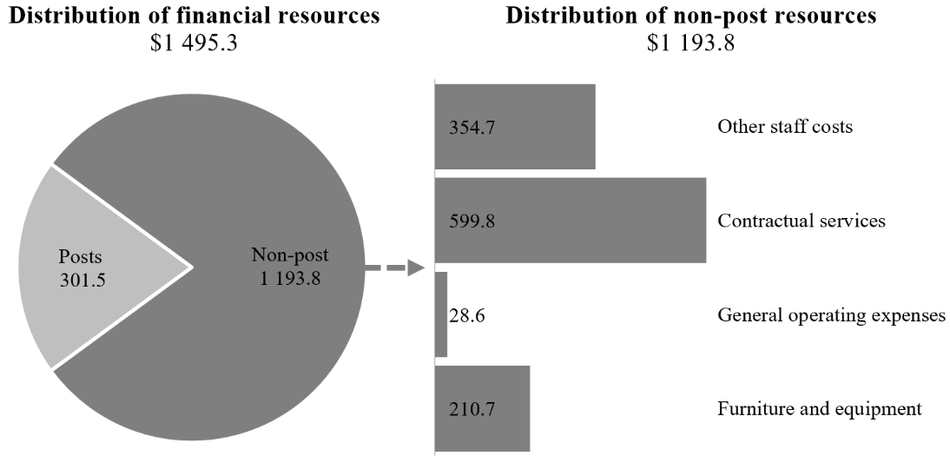

Annex I

Organizational structure and post distribution for 2026

A. Department for General Assembly and Conference Management, New York

Protocol and Liaison Service
(executive direction and management)
RB:
1 D-2
1 P-5
1 P-4
2 P-3
2 GS (PL)
4 GS (OL)
Total: 11
Executive Office
(programme support)
RB:
1 D-1
1 P-5
2 P-4
2 P-3
2 P-2/1
4 GS PL
1 GS (PL)ª
14 GS (OL)
Total: 27
Meetings and
Publishing Division
(subprogramme 4)
RB:
1 D-2
2 D-1
45 P-5
82 P-4
69 P-3
1 P-2/1
12 GS (PL)
71 GS (OL)
Total: 283
Documentation Division
(subprogramme 3)
RB: XB:
1 D-2 1 D-1
6 D-1 1 P-5
70 P-5 3 P-4
163 P-4 2 P-3
115 P-3 1 GS (PL)
16 GS (PL) 2 GS (OL)
131 GS (OL)
502 10
Total: 512
Central Planning and Coordination Division
(subprogramme 2)
RB:
1 D-2
4 P-5
4 P-4
5 P-3
8 GS (PL)
24 GS (OL)
Total: 46
General Assembly and Economic and Social Council Affairs Division
(subprogramme 1)
RB:
1 D-2
3 D-1
5 P-5
7 P-4
2 P-3
2 P-2/1
7 GS (PL)
14 GS (OL)
Total: 41
Office of the Under-Secretary-General (executive direction and management)
RB:
1 USG
1 ASG
1 D-1
1 D-1ª
1 P-5
2 P-4
1 P-3
4 GS (OL)
Total: 12
Global Innovation and Data Analytics Service
(programme support)

in New York in Vienna
1 P-5 1 P-5
3 P-4 4 P-3
1 P-2/1 1 GS (PL)
2 GS (PL)
13 GS (OL)
20 6
Total: 26

ª Redeployment.

B. Division of Conference Management, Geneva

Interpretation Service
(subprogramme 4)

RB:
1 D-1
26 P-5
53 P-4
21 P-3
1 GS (PL)
4 GS (OL)
Total: 106
Languages Service
(subprogramme 3)

RB:
1 D-1
37 P-5
86 P-4
80 P-3
1 P-2
9 GS (PL)
108 GS (OL)
1 GS (OL)ª
Total: 322
Central Planning and Coordination Service
(subprogramme 2)

RB:
1 D-1
2 P-5
4 P-4
5 P-3
3 GS (PL)
40 GS (OL)
Total: 55
Production and Support Service
(subprogramme 4)

RB:
1 P-5
1 P-4
4 P-3
2 P-2
4 GS (PL)
48 GS (OL)
Total: 60
Information Technology and Business Analysis Unit
(programme support)

RB:
1 P-4
3 P-3
1 P-2
8 GS (OL)
Total: 13
Office of the Director
(subprogramme 2)

RB:
1 D-2
1 P-5
2 P-4
2 P-3
3 GS (PL)
3 GS (OL)
1 GS (OL)ª
Total: 13

ª Reassignment.

C. Conference Management Service, Vienna

Meetings and publishing services
(subprogramme 4)

RB:
8 P-5
18 P-4
5 P-3
3 GS (PL)
22 GS (OL)
Total: 56
Documentation services
(subprogramme 3)

RB:
11 P-5
27 P-4
11 P-3
1 GS (PL)
43 GS (OL)
Total: 93
Planning and coordination of conference services (subprogramme 2)

RB:
1 P-5
2 P-4
2 P-3
3 GS (PL)
18 GS (OL)
Total: 26
Information
Technology Unit
(programme support)

RB:
3 GS (OL)
Total: 3
Office of the Chief
(subprogramme 2)

RB:
1 D-1
2 P-3
1 GS (PL)
4 GS (OL)
Total: 8

D. Division of Conference Services, Nairobi

Office of the Chief
(subprogramme 2)

RB: XB:
1 D-1 1 LL
1 LL
2 1
Total: 3

Conference Support Section
(subprogramme 2)

RB: XB:
1 P-5 2 P-4
1 P-3 1 P-3
12 LL
2 15
Total: 17
Interpretation Section and Publishing Services Section
(subprogramme 4)

RB: XB:
7 P-5 17 LL
6 P-4
7 P-3
3 LL
23 17
Total: 40
Planning and Coordination Section
(subprogramme 2)

RB: XB:
1 P-4 1 P-5
1 P-3 8 LL
1 P-2/1
2 LL

5 9
Total: 14
Translation and Editorial Section
(subprogramme 3)

RB: XB:
7 P-5 1 P-3
8 P-4 21 LL
7 P-3
1 P-3ª
6 LL
29 22
Total: 51
Information Technology Unit
(programme support)

RB: XB:
1 P-3 4 LL
1 4
Total: 5

Abbreviations: ASG, Assistant Secretary-General; GS (OL), General Service (Other level); GS (PL), General Service (Principal level); LL, Local level; RB, regular budget; USG, Under-Secretary-General; XB, extrabudgetary.
ª Redeployment.

Annex II

Summary of proposed post changes, by component and subprogramme

Component/subprogramme | Posts | Grade | Description | Reason for change
Executive direction and management | 1 | D-1 | Redeployment of Chief, Conference Services | The proposed redeployment reflects the strategic and cross-cutting nature of the function, which has evolved since its establishment in 2023. The Chief of the Global Innovation and Data Analytics Service assumed the global resource planning role and oversees the development and maintenance of the global conference management systems facilitating the delivery of conference services by all four duty stations in line with paragraphs 40, 42, 44 and 45 of General Assembly resolution 79/248 on the pattern of conferences. The Chief leads the efforts of the Department to consolidate the information technology and business analysis functions previously maintained locally, to harmonize and streamline analytical and data management initiatives. The Chief supports the Under-Secretary-General and Assistant Secretary-General in ensuring good governance over innovative solutions proposed for implementation by the Department.
Programme support | (1) | D-1
New York: Subprogramme 3, Documentation services | (1) | GS (PL) | Abolishment of Senior Language Reference Assistant | Owing to the continuous modernization of the working methods in the Translation Service, one post is proposed for abolishment, and one post for reassignment as Senior Human Resources Assistant under programme support to support the Department’s workforce and succession planning efforts, as well as capacity management and related activities.
Programme support | (1) | GS (PL) | Reassignment/ redeployment of Senior Language Reference Assistant as Senior Human Resources Assistant
 | 1 | GS (PL)
New York: subprogramme 4, Meetings and publishing services | (1) | GS (OL) | Abolishment of Administrative Assistant | The proposed abolishment in the Office of the Director results from synergies and the distribution of tasks across the front offices in the services and sections, as well as increased use of technology.
New York: subprogramme 4, Meetings and publishing services | (2) | GS (OL) | Abolishment of two Publishing Assistants | The proposed abolishment in the Meeting Services Unit is the result of a significant decrease in requests by delegates and meeting participants for hard copies of official documents and publications, as well as increased reliance on digital formats.
New York: subprogramme 4, Meetings and publishing services | (1) | GS (OL) | Abolishment of Language Service Assistant | The proposed abolishment is due to the consolidation of the copy preparation and proofreading functions with the desktop publishing functions, resulting in synergies across the six language subdivisions.
Geneva: subprogramme 2, Planning and coordination of conference services | – | GS (OL) | Reassignment of Staff Assistant as Programme Management Assistant | The proposed reassignment reflects a transition of responsibilities from general administrative support to tasks focused on innovation and the use of data-driven insights to support conference-related activities.
Geneva: subprogramme 3, Documentation services | – | GS (OL) | Reassignment of Staff Assistant as Language Service Assistant | The proposed reassignment reflects a shift from general administrative duties to supporting language services, integrating innovative approaches and data-driven solutions to enhance service effectiveness.
Geneva: subprogramme 3, Documentation services | (1) | GS (OL) | Abolishment of Editorial and Desktop Publishing Assistant | The proposed abolishment is in line with the continued enhancements of language technologies and improvements in working methods. The related resources would be reallocated to contractual services to allow for flexibility and to supplement the core staff capacity during peaks in the meetings and conferences calendar.
Geneva: subprogramme 4, Meetings and publishing services | (1) | GS (OL) | Abolishment of Administrative Assistant | The proposed abolishment is a result of improved operational efficiencies and the consolidation of responsibilities. The related resources would be reallocated to contractual services to allow for flexibility and to supplement the core staff capacity during peaks in the meetings and conferences calendar.
Nairobi: subprogramme 3, Documentation services | 1 | P-3 | Redeployment of Publishing Officer as Editor | The proposed redeployment to subprogramme 3, enabled through the streamlining of capacities under subprogramme 4, would enhance the editing and report-writing capacity by ensuring documents are properly edited before translation, while also reflecting evolving publishing requirements.
Nairobi: subprogramme 4, Meetings and publishing services | (1) | P-3

Abbreviation: GS (OL), General Service (Other level); GS (PL), General Service (Principal level).

See https://igov.un.org/.

