Eightieth session
Items 137 and 138 of the preliminary list*

Proposed programme budget for 2026

Programme planning

Proposed programme budget for 2026

Part VII

Global communications

Section 28

Global communications

Programme 24

Global communications

Contents
 |  |  | Page
- Proposed programme plan for 2026 and programme performance in 2024** |  |  | 3
Overall orientation |  |  | 3
Programme of work |  |  | 6
Subprogramme 1. Campaigns and country operations services |  |  | 6
Subprogramme 2. News services |  |  | 10
Subprogramme 3. Outreach and knowledge services |  |  | 13
- Proposed post and non-post resource requirements for 2026*** |  |  | 19
Overview |  |  | 19
Executive direction and management |  |  | 26
* A/80/50.
** In keeping with paragraph 10 of General Assembly resolution 77/267, the part consisting of the programme plan and programme performance information (part II) is submitted through the Committee for Programme and Coordination for the consideration of the Assembly.
*** In keeping with paragraph 10 of General Assembly resolution 77/267, the part consisting of the post and non-post resource requirements (part III) is submitted through the Advisory Committee on Administrative and Budgetary Questions for the consideration of the Assembly.
Programme of work | 28
Subprogramme 1. Campaigns and country operations services | 28
Subprogramme 2. News services | 29
Subprogramme 3. Outreach and knowledge services | 30
Programme support | 31
Annexes
- Organizational structure and post distribution for 2026 | 33
- Summary of proposed post changes, by component and subprogramme | 34

A. Proposed programme plan for 2026 and programme performance in 2024

Overall orientation

Mandates and background

28.1 The Department of Global Communications is responsible for communicating to the world the ideals and work of the United Nations; interacting and partnering with diverse audiences; and building support for the purposes and principles enshrined in the Charter of the United Nations. The mandate derives from the priorities established in relevant General Assembly resolutions and decisions, including resolutions 13 (I), 78/330 on multilingualism and 79/93 A and B on questions relating to information. The Department will leverage the power of communications to tell the United Nations story to global audiences in multiple languages and platforms in order to mobilize action in support of the United Nations agenda.

Strategy and external factors for 2026

28.2 The overall programme plan for 2026 reflects the Department’s strategy to strengthen support for the work and purposes of the United Nations by engaging with audiences and encouraging them to act, through impactful storytelling and a focus on solutions. The Department takes the following core approaches in its work: strategic planning by identifying communications goals and target audiences; maintaining close working relationships with stakeholders, offices of the Secretariat, entities of the United Nations system and other key partners; enhancing audience reach through multilingualism and the parity of all six official languages in the preparation of news and communications products, including content on United Nations websites and social media accounts; targeted use of social and digital media to deliver information directly and instantaneously to key audiences; and measuring the impact of campaigns in order to improve the Department’s work.
28.3 The Department, through its subprogrammes, delivers strategic communications campaigns to engage and inspire target audiences. It works through a global network of United Nations information centres, integrated with United Nations resident coordinator offices, to reach local audiences and provide content for global platforms. It produces accurate, objective and balanced multilingual news and communications products that convey authoritative information and solutions-based stories. It advocates on priority issues with Member States, civil society, academia, the media, young people and other partners. The Department contributes to the observance of international days and celebrations established by the General Assembly.
28.4 The Department also provides services to delegates and staff, including through the Dag Hammarskjöld Library, and promotes knowledge-sharing and internal communication by way of iSeek, the United Nations intranet.
28.5 The Department continues to place information integrity at the centre of its work and is committed to increasing access to relevant, reliable and accurate information and knowledge. In an age when misinformation, disinformation, hate speech and content inciting harm are disseminated, the Department works towards advancing the United Nations Global Principles for Information Integrity and relevant commitments in the Pact for the Future and the Global Digital Compact throughout its work.
28.6 The Department will lead and coordinate crisis communications by strengthening the United Nations response through aligned messaging and mitigating risk by developing guidance on crisis communications.
28.7 With regard to cooperation with other entities at the global, regional, national and local levels, the Department will leverage partnerships with an array of partners, including from civil society, academia, the media and the private sector, to enhance its ability to target and deliver information to an even wider community, with a focus on young people around the world.
28.8 With regard to inter-agency coordination and liaison, the Department will strengthen the coordination of communications across the United Nations system, including through United Nations communications groups at the country and regional levels. Coordination will also be strengthened through the integration of United Nations information centres with resident coordinator offices and by streamlining processes and communication. The Department will continue its work with the Development Coordination Office to provide strategic communications support to resident coordinators in countries without an information centre presence to ensure that information is widely disseminated.
28.9 With regard to the external factors, the overall plan for 2026 is based on the following planning assumptions:
(a) All stakeholders and partners fulfil their responsibilities and obligations under service agreements and partnerships;
(b) Access by target audiences to programmes, products and services is not limited by communications technology, security or infrastructure conditions.
28.10 The Department integrates a gender perspective in its operational activities, deliverables and results, as appropriate. For example, the Department will promote the balanced presence of women and men in all its products, campaigns, events and activities.
28.11 In line with the United Nations Disability Inclusion Strategy, the Department will use its network of focal points to help to develop a common and coordinated approach to making United Nations services and activities accessible for persons with disabilities. The focal points will provide communications support to the Strategy, including by setting accessibility standards for United Nations websites.

Legislative mandates

28.12 The list below, which was reviewed in the preparation of the proposed programme budget, provides all mandates entrusted to the programme.

General Assembly resolutions

13 (I) | Organization of the Secretariat
168 (II) | United Nations Day
423 (V) | Human Rights Day
32/40 B | Question of Palestine
35/201 | Annual Reham Al-Farra Memorial Journalists’ Fellowship Programme
36/67 | International Year of Peace and International Day of Peace
54/134 | International Day for the Elimination of Violence against Women
57/129 | International Day of United Nations Peacekeepers
60/7 | Holocaust remembrance
60/225 | Assistance to survivors of the 1994 genocide in Rwanda, particularly orphans, widows and victims of sexual violence
62/122 | Permanent memorial to and remembrance of the victims of slavery and the transatlantic slave trade
64/13 | Nelson Mandela International Day
77/24 | Special information programme on the question of Palestine of the Department of Global Communications of the Secretariat
78/182 | Follow-up to the Fourth World Conference on Women and full implementation of the Beijing Declaration and Platform for Action and the outcome of the twenty-third special session of the General Assembly
78/234 | A global call for concrete action for the elimination of racism, racial discrimination, xenophobia and related intolerance and the comprehensive implementation of and follow-up to the Durban Declaration and Programme of Action
78/277 | Follow-up to the Declaration and Programme of Action on a Culture of Peace
78/282 | International Day of Reflection and Commemoration of the 1995 Genocide in Srebrenica
78/330 | Multilingualism
79/1 | The Pact for the Future
79/69 | United Nations Disarmament Information Programme
79/93 A–B | Questions relating to information
79/113 | Dissemination of information on decolonization
79/115 | Implementation of the Declaration on the Granting of Independence to Colonial Countries and Peoples: eradicating colonialism in all its forms and manifestations
79/218 | Follow-up to the Fifth United Nations Conference on the Least Developed Countries
79/219 | Follow-up to the Third United Nations Conference on Landlocked Developing Countries

Deliverables

28.13 Table 28.1 lists all cross-cutting deliverables of the programme.

Table 28.1

Cross-cutting deliverables for the period 2024–2026, by category and subcategory

Category and subcategory | 2024 planned | 2024 actual | 2025 planned | 2026 planned
A. Facilitation of the intergovernmental process and expert bodies
Substantive services for meetings (number of three-hour meetings) | 3 | 3 | 3 | 3
Meetings of:
1. The Advisory Committee on Administrative and Budgetary Questions | 1 | 1 | 1 | 1
2. The Committee for Programme and Coordination | 1 | 1 | 1 | 1
3. The Fifth Committee | 1 | 1 | 1 | 1

Evaluation activities

28.14 An Office of Internal Oversight Services evaluation of the contribution of strategic communications to fostering public trust in peacekeeping operations was completed in 2024 and has guided the proposed programme plan for 2026.
28.15 In response to the results of the evaluation referenced above, the Department will strengthen ongoing efforts to support United Nations peacekeeping operations and to foster public trust through strategic communications, including through enhanced guidance and templates for communication strategies for peacekeeping.
28.16 An independent review of the Department’s work, as called for in General Assembly resolutions 79/257 and 78/330, will begin in 2025 and continue in 2026.

Programme of work

Subprogramme 1

Campaigns and country operations services

Objective

28.17 The objective, to which this subprogramme contributes, is to mobilize audiences and strengthen support for the work, principles and purposes of the United Nations.

Strategy

28.18 To contribute to the objective, the subprogramme will:
(a) Deliver communications campaigns related to United Nations priorities, including sustainable development, climate change, peace and security and human rights, directed by the global communications strategy for the United Nations and facilitated through a variety of communications tools, including audience-targeted messaging, issue-focused content and inspiring stories;
(b) Promote these priorities through the United Nations information centres by developing multimedia content that supports targeted and localized messages and communications campaigns;
(c) Provide strategic and crisis communications guidance to resident coordinator offices and United Nations country teams in their relevant regions;
(d) Devise strategic guidance on countering misinformation, disinformation and information manipulation and develop and promote content to counter false narratives and build confidence among global audiences.
28.19 The above-mentioned work is expected to result in:
(a) Increased knowledge and engagement of target audiences around the globe, and further action in support of United Nations priorities;
(b) Global reach of communications campaigns available in the languages and on the platforms used by audiences, thus ensuring greater impact.

Programme performance in 2024

Strengthened public engagement on issues related to climate change

28.20 In its resolution 79/93 B, the General Assembly reaffirmed the crucial role of the Department in addressing the spread of misinformation, disinformation and information manipulation. In 2024, the subprogramme continued to use its Verified initiative – originally launched during the coronavirus disease (COVID-19) pandemic – to build information literacy on issues related to climate change. The Verified communications model employed a three-pillar approach to reach audiences: trusted messengers engaged audiences at the grass-roots level; global creative campaigns reached target audiences en masse; and convenings encouraged people to focus on expert insights and solutions for global cooperation. For the first pillar, the subprogramme enlisted climate experts, scientists and Indigenous leaders in Brazil, Spain and the United Arab Emirates as trusted messengers. Combined, these 43 messengers created over 220 videos to combat misinformation, disinformation and information manipulation on social media, reaching 600 million people. For the second pillar, a campaign entitled “The Future Thanks You”, launched in April 2024, appealed for a transition to renewable sources of energy. Through a dedicated microsite, over 30,000 people around the world submitted responses to questions about the future they envisioned. For the third pillar, a round table on the theme “Winning the climate story” brought together scientists, media practitioners and campaigners to discuss communications for driving climate action. Through this multifaceted approach, the subprogramme enabled engagement of the global public on factual and evidence-based information related to climate change.
28.21 Progress towards the objective is presented in the performance measure below (see table 28.2).

Table 28.2

Performance measure

2022 (actual) | 2023 (actual) | 2024 (actual)
– | – | 600 million people accessed reliable content on climate change from trusted messengers

Planned results for 2026

Result 1: increased public engagement with the global peace and security agenda

Programme performance in 2024 and target for 2026

28.22 The subprogramme’s work contributed to 35,000 views on the new United Nations website on peace and security issues, which did not meet the planned target of 80,000 views The target was not met due to delays in the web migration process and subsequent launch of the website in August 2024.
28.23 Progress towards the objective and the target for 2026 are presented in the performance measure below (see figure 28.I).

Figure 28.I

Performance measure: views of United Nations website on peace and security issues
(Thousands)

Result 2: increased action on the 2030 Agenda for Sustainable Development

Programme performance in 2024 and target for 2026

28.24 The subprogramme’s work contributed to an additional 8.5 million individual actions logged towards achieving the Sustainable Development Goals for a cumulative total of 24.5 million actions logged, which exceeded the planned target of 21 million actions.
28.25 Progress towards the objective and the target for 2026 are presented in the performance measure below (see figure 28.II).

Figure 28.II

Performance measure: number of individual actions logged through the ActNow campaign (cumulative)
(Millions)

Result 3: greater public understanding of and engagement on critical issues related to the Sustainable Development Goals

Proposed programme plan for 2026

28.26 In the lead-up to the Summit of the Future, the subprogramme developed new and engaging content to explain the issues debated for inclusion in the Pact for the Future, the Global Digital Compact and the Declaration on Future Generations. All assets were made available to United Nations information centres and country offices in adaptable formats to offer content in additional languages. Pro bono advertising on billboards, bus stops, trains and other public spaces ran in 14 countries. As a result, global online engagement increased (6 million engagements and 8.6 million video views), peaking at the Summit itself.

Lessons learned and planned change

28.27 The lesson for the subprogramme was that clear, accessible content that explains key issues and offers actionable steps effectively captures audience interest and drives increasing engagement. In applying the lesson, the subprogramme will leverage the Sustainable Development Goals and Climate Action websites to expand explanatory content that is action-oriented in all six official languages. This approach will help to contribute to increasing public understanding and global participation in actions to advance the Goals.
28.28 Expected progress towards the objective is presented in the performance measure below (see figure 28.III).

Figure 28.III

Performance measure: number of views of the United Nations Sustainable Development Goals and Climate Action websites (annual)
(Millions)

Deliverables

28.29 Table 28.3 lists all deliverables of the subprogramme.

Table 28.3

Subprogramme 1: deliverables for the period 2024–2026, by category and subcategory

Category and subcategory | 2024 planned | 2024 actual | 2025 planned | 2026 planned
A. Facilitation of the intergovernmental process and expert bodies
Parliamentary documentation (number of documents) | 1 | 1 | 1 | 1
1. Report for the General Assembly on the dissemination of information on decolonization | 1 | 1 | 1 | 1
B. Generation and transfer of knowledge
Seminars, workshops and training events (number of days) | 26 | 25 | 26 | 26
2. Training programme for Palestinian broadcasters and journalists | 24 | 24 | 24 | 24
3. International Media Seminar on Peace in the Middle East | 2 | 1 | 2 | 2
D. Communication deliverables
Outreach programmes, special events and information materials: communications campaigns and strategic outreach events and programmes through the Department’s field offices reaching local audiences, including lectures, exhibits and the organization of more than 100 Model United Nations conferences on priority issues or special observances of the United Nations, with specific target audiences (e.g. civil society, young people, academia, Governments and the private sector) and working in some 124 languages.
External and media relations: press conferences, briefings and panel discussions on United Nations priorities, activities, events, publications, reports and outcomes of negotiations or other United Nations activities; media outreach, including media interviews and/or placement of opinion articles; strategic partnerships with education institutions, the media, civil society, the private sector, the creative community and other partners; and radio and television programmes.
Digital platforms and multimedia content: flagship and other social media accounts, campaigns and multilingual websites managed by United Nations information centres.

Subprogramme 2

News services

Objective

28.30 The objective, to which this subprogramme contributes, is to mobilize audiences and strengthen support for the work, principles and purposes of the United Nations.

Strategy

28.31 To contribute to the objective, the subprogramme will:
(a) Provide the timely delivery of accurate, impartial, comprehensive, balanced, coherent and objective news and information;
(b) Produce customized news and information materials (textual, audiovisual and photographic);
(c) Provide services to the media and other consumers, including through the use of the newest web-based and mobile distribution platforms, with an overall emphasis on multilingualism from the planning stage.
28.32 The above-mentioned work is expected to result in increased public awareness of and engagement with the United Nations through access to more user-friendly and diversified content and a broader range of options available to audiences, from traditional to social media.

Programme performance in 2024

Enhanced real-time coverage of United Nations events for global audiences

28.33 The subprogramme, through United Nations Television and Video, broadcasts live events at United Nations Headquarters in New York to more than 70 international television networks, as well as to broadcast unions with regional client networks and international news agencies. Whenever viewers anywhere in the world see news about the Security Council or the General Assembly with multi-camera coverage, the footage comes from United Nations Television and Video. During the high-level segment of the seventy-ninth session of the General Assembly, United Nations Television and Video directed and transmitted coverage and managed access for broadcasters at the Sustainable Development Goals media zone. It also introduced, for the first time, live camera media points for broadcasters and Member States in two different locations at United Nations Headquarters. By providing access to live broadcast points, the subprogramme offered broadcasters the chance to set up live two-way interviews from United Nations Headquarters in real time, providing audiences of participating broadcasters with a unique bespoke live interview experience capturing the essence of proceedings as events unfolded. These live points enabled Heads of State and Government to address national broadcasters and allowed dignitaries and senior officials to engage with the press and broadcasters globally in live interviews. As the week progressed, broadcasters were eager to make use of the live point service offered by the subprogramme: bookings for the service increased, and positive feedback was received from all broadcasters who used the service. This growing demand allowed the subprogramme to extend its reach to global audiences that it would not otherwise have been able to engage.
28.34 Progress towards the objective is presented in the performance measure below (see figure 28.IV).

Figure 28.IV

Performance measure: number of live interviews by broadcasters during the high-level segment of the seventy-ninth session of the General Assembly

Planned results for 2026

Result 1: increased global audience for the United Nations Web TV platform in the six official languages

Programme performance in 2024 and target for 2026

28.35 The subprogramme’s work contributed to 101.5 million minutes of watch time on the United Nations Web TV platform, which exceeded the planned target of 83 million minutes.
28.36 Progress towards the objective and the target for 2026 are presented in the performance measure below (see figure 28.V).

Figure 28.V

Performance measure: watch time on United Nations Web TV platform (annual)
(Millions of minutes)

Result 2: deeper engagement of audiences through live-blogging tools and formats

Programme performance in 2024 and target for 2026

28.37 The subprogramme’s work contributed to 1,665 hours and 43 minutes of audience engagement time on live blogs, which exceeded the planned target of 300 hours.
28.38 Progress towards the objective and the target for 2026 are presented in the performance measure below (see figure 28.VI).

Figure 28.VI

Performance measure: audience engagement time on live blogs (annual)
(Total time spent on page: hours.minutes)

Result 3: increased audience engagement and support for United Nations international observances

Proposed programme plan for 2026

28.39 The United Nations observes designated days, weeks and years, each with a theme, or topic that is linked to the main fields of action of the United Nations. By creating special observances, the United Nations promotes international awareness and action on various issues. The subprogramme produces and maintains a dedicated website for each General Assembly-mandated international observance in the six official languages of the United Nations.

Lessons learned and planned change

28.40 The lesson for the subprogramme was that the United Nations international observances serve as powerful advocacy tools, as demonstrated by the growing interest from audiences in the subprogramme’s dedicated websites for each international observance. In applying the lesson, the subprogramme will strengthen and enrich the content within each website to increase measurable engagement and support for the various themes and topics covered under United Nations international observances.
28.41 Expected progress towards the objective is presented in the performance measure below (see figure 28.VII).

Figure 28.VII

Performance measure: views of websites for international observances
(Millions)

Note: Data for 2023 are from 1 May to 31 December 2023. Data prior to 1 May 2023 existed in an old version of the web analytics service used and are no longer retrievable.

Deliverables

28.42 Table 28.4 lists all deliverables of the subprogramme.

Table 28.4

Subprogramme 2: deliverables for 2026, by category and subcategory

Category and subcategory
D. Communication deliverables
External and media relations: accreditation of and services to 4,800 members of the media (including 1,000 long-term grounds passes, 2,000 temporary passes and 1,800 requests for media passes from Member States); covering United Nations meetings and issuing press releases in the six official languages; coverage of intergovernmental meetings; online publication and distribution of speeches and statements of the Secretary-General and the Deputy Secretary-General and transcripts of press encounters of the Secretary-General; and photo coverage of meetings of key intergovernmental bodies and activities of the Secretary-General, the Deputy Secretary-General and the President of the General Assembly.
Digital platforms and multimedia content: daily multimedia content – audio, video and text – in the six official languages and four non-official languages (Hindi, Kiswahili, Portuguese and Urdu) disseminated through multiple platforms and channels, including online and on social media, and through partnerships with external media organizations; the core United Nations website (including the home page), 217 United Nations observances and major global campaigns in the six official languages; assistance to United Nations entities in the multilingual aspects of their websites (55 websites); live television coverage, including live streams, and the posting of on-demand webcasts of intergovernmental meetings and other newsworthy events taking place at Headquarters, including the Sustainable Development Goals Studio; and provision of audiovisual and photo library services to delegates, media outlets and others.

Subprogramme 3

Outreach and knowledge services

Objective

28.43 The objective, to which this subprogramme contributes, is to mobilize audiences and strengthen support for the work, principles and purposes of the United Nations.

Strategy

28.44 To contribute to the objective, the subprogramme will:
(a) Engage in advocacy with a broad and international range of academic institutions, students and educators, the creative community and civil society;
(b) Organize briefing programmes, special events, guided tours and interactive workshops, and engage with organizers of Model United Nations conferences;
(c) Organize outreach and education programmes on the Holocaust and the transatlantic slave trade and create publications, research guides and exhibits on the same priorities, with a special focus on young people;
(d) Develop communications materials, visual identities and branding in support of United Nations priorities;
(e) Develop and maintain strategic partnerships with the entertainment, advertising and publishing industries, major sports and international events and institutions of higher education and research, targeting young people in particular;
(f) Work with partners to develop multilingual and effective educational resources and programmes, campaigns, projects and events to inspire and encourage action for the Sustainable Development Goals;
(g) Facilitate knowledge-sharing and the preservation of United Nations information resources for internal and external audiences.
28.45 The above-mentioned work is expected to result in:
(a) A better understanding of the principles and purposes of the United Nations and the mobilization of young people and student participation in local, regional or national political, non-governmental and intergovernmental processes;
(b) Increased mobilization of youth and student activity to advance the achievement of the Goals and foster a new generation of leaders committed to the principles and values of the United Nations;
(c) Increased access to United Nations documentation and information by Member States, United Nations staff around the world, research institutions, young people, schools and the general public for improved engagement, awareness and decision-making.

Programme performance in 2024

Increased civil society engagement in support of the Summit of the Future and beyond

28.46 The subprogramme organized the 2024 United Nations Civil Society Conference, which was held on 9 and 10 May in Nairobi, in support of the Summit of the Future. The Conference was a milestone event on the road to the high-level Summit, which took place in New York on 22 and 23 September 2024. The Conference was an inclusive platform for dialogue that enabled meaningful engagement for civil society and other stakeholders with United Nations leadership, Governments, the co-facilitators of the Pact for the Future, the Global Digital Compact and the Declaration on Future Generations. With the participation of more than 1,400 organizations and 2,600 individuals representing 115 nationalities, the Conference showcased civil society’s contributions towards multilateral processes. Moreover, the subprogramme’s outreach with civil society contributed to the formation of 20 ImPACT Coalitions. These are civil society-generated coalitions, with varied stakeholders from across academia, the private sector, Member States and the United Nations collaborating to support the implementation of the Pact for the Future.
28.47 Progress towards the objective is presented in the performance measure below (see table 28.5).

Table 28.5

Performance measure

2022 (actual) | 2023 (actual) | 2024 (actual)
– | – | 20 ImPACT Coalitions established by civil society organizations to support implementation of the Pact for the Future, including in the areas of artificial intelligence, children’s rights, youth and intergenerational engagement, financing for development and reducing the digital divide, among others

Planned results for 2026

Result 1: increased communication and advocacy regarding the Sustainable Development Goals

Programme performance in 2024 and target for 2026

28.48 The subprogramme’s work contributed to the participation of 80 macro influencers with a combined reach of 280 million followers in communications and advocacy efforts on the Sustainable Development Goals, which exceeded the planned target of 60 macro influencers but did not meet the planned target of 450 million followers. The target was not met due to a number of factors, including shifts in influencer selection, with a greater focus on engagement quality rather than sheer follower count, as well as reduced posting of content by some influencers with higher numbers of followers.
28.49 Progress towards the objective and the target for 2026 are presented in the performance measure below (see figure 28.VIII).

Figure 28.VIII

Performance measure: number of macro influencers engaged and combined number of followers (annual)

Result 2: young journalists gain access and insight into the work of the United Nations

Programme performance in 2024 and target for 2026

28.50 The subprogramme’s work contributed to seven young journalists participating in the Reham Al-‍Farra Memorial Journalists’ Fellowship Programme, which did not meet the planned target of 12 fellows. The target was not met due to liquidity constraints, which required the Programme to be conducted in a hybrid format. The fellows produced a total of 289 materials, including 60 stories published in their media outlets and 229 posts, photos and video stories on social media platforms, which exceeded the planned target of 185 news stories.
28.51 Progress towards the objective and the target for 2026 are presented in the performance measure below (see figure 28.IX).

Figure 28.IX

Performance measure: number of young journalists participating in the Programme and number of news stories produced by fellows (annual)

Result 3: advancing implementation of the Sustainable Development Goals through higher education institutions

Proposed programme plan for 2026

28.52 Current progress towards achieving the 2030 Agenda falls far short of what is required to meet the Sustainable Development Goals. Higher education institutions can play a unique role in research, teaching and learning to engage scholars and leaders in focusing their work and studies on addressing the pressing global challenges. The subprogramme’s United Nations Academic Impact initiative aims to drive meaningful engagement in education, research and partnerships in advancing implementation of the Goals.

Lessons learned and planned change

28.53 The lesson for the subprogramme was the need to strengthen engagement with a broader range of universities and higher education institutions to foster greater leadership and more strategic approaches to advancing the Goals. In applying the lesson, the subprogramme will expand its outreach and will revitalize the Sustainable Development Goals Hub network. Each hub is chaired by a university and is designated to focus on one specific Goal, promoting greater research, education and global collaboration to advance that Goal. The 17 hubs will lead the work of engaging and training additional universities to focus research on critical issues, expand their curricula and courses, and build partnerships with communities, Governments and practitioners to implement evidence-based solutions to achieve the 2030 Agenda.
28.54 Expected progress towards the objective is presented in the performance measure below (see figure 28.X).

Figure 28.X

Performance measure: number of universities that are members of the United Nations Academic Impact network (cumulative)

Deliverables

28.55 Table 28.6 lists all deliverables of the subprogramme.

Table 28.6

Subprogramme 3: deliverables for the period 2024–2026, by category and subcategory

Category and subcategory | 2024 planned | 2024 actual | 2025 planned | 2026 planned
A. Facilitation of the intergovernmental process and expert bodies
Parliamentary documentation (number of documents) | 4 | 4 | 4 | 4
1. Reports for the General Assembly on questions of information and on the activities of the Department: campaigns and country operations services, news services and outreach and knowledge services | 4 | 4 | 4 | 4
Substantive services for meetings (number of three-hour meetings) | 20 | 20 | 20 | 20
2. Meetings of the Committee on Information | 20 | 20 | 20 | 20
B. Generation and transfer of knowledge
Seminars, workshops and training events (number of days) | 370 | 429 | 370 | 390
3. Workshops on intergovernmental engagements for non-governmental organizations and orientation programme for newly associated non-governmental organizations | 40 | 50 | 40 | 40
4. Training event on Dag Hammarskjöld Library services and training courses for iSeek content creators, editors and focal points | 300 | 339 | 300 | 320
5. Training event on journalism as part of Reham Al-Farra Memorial Journalists’ Fellowship Programme | 30 | 40 | 30 | 30
C. Substantive deliverables
Consultation, advice and advocacy: guidance and expert advice to the Model United Nations; and conferences on subjects such as slavery and the transatlantic slave trade and Holocaust remembrance.
D. Communication deliverables
Outreach programmes, special events and information materials: partnerships with civil society, academic institutions and other entities; educational and promotional materials, such as UN Chronicle; responses to public enquiries; exhibits at United Nations Headquarters and online; multilingual guided tours; outreach programme with prominent personalities, including Messengers of Peace and other celebrities; special events and observances of selected commemorative days and years; promotion of the United Nations or a United Nations issue in a film, television or theatre product; promotion of the Sustainable Development Goals through sports; and graphic design products in support of United Nations branding, and communication campaigns.
External and media relations: press conferences and press releases to announce new outreach partnerships and special events; and exhibit openings.
Digital platforms and multimedia content: iSeek; the United Nations delegate website (www.un.org/en/delegate); and shop.un.org.
Library services: a secure digital United Nations central repository (United Nations Digital Library) in the six official languages; online library products, loan and related services and the provision of research to representatives of Member States; management of the United Nations System Electronic Information Acquisition Consortium; and curation of diverse library content.

B. Proposed post and non-post resource requirements for 2026

Overview

28.56 The proposed regular budget resources for 2026, including the breakdown of resource changes, as applicable, are reflected in tables 28.7 to 28.9.

Table 28.7

Note: The following abbreviations are used in tables and figures: GS (OL), General Service (Other level); GS (PL), General Service (Principal level); LL, Local level; NPO, National Professional Officer; USG, Under-Secretary-General.

Overall: evolution of financial resources by object of expenditure
(Thousands of United States dollars)

Object of expenditure | 2024 expenditure | 2025 approved | Changes |  |  |  |  | 2026 estimate
Object of expenditure | 2024 expenditure | 2025 approved | Technical adjustments | New/  expanded mandates | Other | Total | Percentage | 2026 estimate
Posts | 88 466.6 | 96 481.9 | 300.3 | 124.8 | – | 425.1 | 0.4 | 96 907.0
Other staff costs | 4 500.1 | 10 329.4 | (31.6) | 44.9 | – | 13.3 | 0.1 | 10 342.7
Hospitality | – | 28.8 | – | – | – | – | – | 28.8
Experts | 0.4 | – | – | – | – | – | – | –
Consultants | 90.1 | – | – | – | – | – | – | –
Travel of representatives | 12.1 | – | – | – | – | – | – | –
Travel of staff | 293.6 | 304.2 | – | 6.9 | – | 6.9 | 2.3 | 311.1
Contractual services | 4 720.3 | 8 406.9 | (120.6) | 100.1 | (122.8) | (143.3) | (1.7) | 8 263.6
General operating expenses | 3 612.2 | 5 878.6 | – | – | (0.9) | (0.9) | – | 5 877.7
Supplies and materials | 82.5 | 559.1 | (88.1) | 21.0 | (149.0) | (216.1) | (38.7) | 343.0
Furniture and equipment | 191.9 | 727.7 | (7.9) | 2.4 | (19.4) | (24.9) | (3.4) | 702.8
Improvement of premises | 13.8 | – | – | – | – | – | – | –
Grants and contributions | 172.2 | 762.9 | – | 20.6 | – | 20.6 | 2.7 | 783.5
Total | 102 155.7 | 123 479.5 | 52.1 | 320.7 | (292.1) | 80.7 | 0.1 | 123 560.2

Table 28.8

Overall: proposed posts and post changes for 2026
(Number of posts)

 | Number | Details
Approved for 2025 | 690 | 1 USG, 3 D-2, 18 D-1, 34 P-5, 71 P-4, 105 P-3, 58 P-2/1, 7 GS (PL), 200 GS (OL), 143 LL, 50 NPO
Establishment | 1 | P-4 under subprogramme 3
Proposed for 2026 | 691 | 1 USG, 3 D-2, 18 D-1, 34 P-5, 72 P-4, 105 P-3, 58 P-2/1, 7 GS (PL), 200 GS (OL), 143 LL, 50 NPO

Table 28.9

Overall: proposed posts by category and grade
(Number of posts)

Category and grade | 2025 approved | Changes |  |  |  | 2026 proposed
Category and grade | 2025 approved | Technical adjustments | New/expanded mandates | Other | Total | 2026 proposed
Professional and higher
USG | 1 | – | – | – | – | 1
D-2 | 3 | – | – | – | – | 3
D-1 | 18 | – | – | – | – | 18
P-5 | 34 | – | – | – | – | 34
P-4 | 71 | – | 1 | – | 1 | 72
P-3 | 105 | – | – | – | – | 105
P-2/1 | 58 | – | – | – | – | 58
Subtotal | 290 | – | 1 | – | 1 | 291
General Service and related
GS (PL) | 7 | – | – | – | – | 7
GS (OL) | 200 | – | – | – | – | 200
LL | 143 | – | – | – | – | 143
NPO | 50 | – | – | – | – | 50
Subtotal | 400 | – | – | – | – | 400
Total | 690 | – | 1 | – | 1 | 691

28.57 Additional details on the distribution of the proposed resources for 2026 are reflected in tables 28.10 to 28.12 and figure 28.XI.
28.58 As shown in tables 28.10 (1) and 28.11 (1), the overall resources proposed for 2026 amount to $123,560,200, reflecting a net increase of $80,700 (or 0.1 per cent) compared with the approved budget for 2025. Resource changes result from technical adjustments, new and expanded mandates, and other changes. The proposed level of resources provides for the full, efficient and effective implementation of mandates.

Table 28.10

Overall: evolution of financial resources by source of funding, component and subprogramme
(Thousands of United States dollars)

(1) Regular budget

 |  |  | Changes |  |  |  |  | 2026 estimate
Component/subprogramme | 2024 expenditure | 2025 approved | Technical adjustments | New/expanded mandates | Other | Total | Percentage | 2026 estimate
A. Executive direction and management | 3 336.7 | 2 894.1 | – | – | – | – | – | 2 894.1
B. Programme of work
1. Campaigns and country operations services | 39 366.6 | 48 920.7 | 118.8 | 11.4 | – | 130.2 | 0.3 | 49 050.9
2. News services | 34 291.2 | 43 620.2 | (40.9) | 51.3 | – | 10.4 | 0.0 | 43 630.6
3. Outreach and knowledge services | 21 033.0 | 23 604.0 | (25.8) | 256.8 | – | 231.0 | 1.0 | 23 835.0
Subtotal, B | 98 027.5 | 116 144.9 | 52.1 | 319.5 | – | 371.6 | 0.3 | 116 516.5
C. Programme support | 4 128.2 | 4 440.5 | – | 1.2 | (292.1) | (290.9) | (6.6) | 4 149.6
Subtotal, 1 | 102 155.7 | 123 479.5 | 52.1 | 320.7 | (292.1) | 80.7 | 0.1 | 123 560.2

(2) Other assessed

Component/subprogramme | 2024 expenditure | 2025  estimate | Change | Percentage | 2026 estimate
A. Executive direction and management | – | – | – | – | –
B. Programme of work
1. Campaigns and country operations services | 468.3 | 540.6 | 59.7 | 11.0 | 600.3
2. News services | 281.8 | 325.3 | 36.6 | 11.3 | 361.9
3. Outreach and knowledge services | – | – | – | – | –
Subtotal, B | 750.1 | 865.9 | 96.3 | 11.1 | 962.2
C. Programme support | – | – | – | – | –
Subtotal, 2 | 750.1 | 865.9 | 96.3 | 11.1 | 962.2

(3) Extrabudgetary

Component/subprogramme | 2024 expenditure | 2025 estimate | Change | Percentage | 2026 estimate
A. Executive direction and management | – | – | – | – | –
B. Programme of work
1. Campaigns and country operations services | 1 464.4 | 1 534.8 | (150.4) | (9.8) | 1 384.4
2. News services | 2 534.1 | 2 988.1 | – | – | 2 988.1
3. Outreach and knowledge services | 6 417.4 | 11 138.2 | (8 320.8) | (74.7) | 2 817.4
Subtotal, B | 10 415.9 | 15 661.1 | (8 471.2) | (54.1) | 7 189.9
C. Programme support | 549.6 | 320.0 | – | – | 320.0
Subtotal, 3 | 10 965.5 | 15 981.1 | (8 471.2) | (53.0) | 7 509.9
Total (1+2+3) | 113 871.3 | 140 326.5 | (8 294.2) | (6.0) | 132 032.3

Table 28.11

Overall: proposed posts for 2026 by source of funding, component and subprogramme
(Number of posts)

(1) Regular budget

 |  | Changes
Component/subprogramme | 2025  approved | Technical adjustments | New/expanded mandates | Other | Total | 2026 proposed
A. Executive direction and management | 16 | – | – | – | – | 16
B. Programme of work
1. Campaigns and country operations services | 337 | – | – | – | – | 337
2. News services | 181 | – | – | – | – | 181
3. Outreach and knowledge services | 134 | – | 1 | – | 1 | 135
Subtotal, B | 652 | – | 1 | – | 1 | 653
C. Programme support | 22 | – | – | – | – | 22
Subtotal, 1 | 690 | – | 1 | – | 1 | 691

(2) Other assessed

Component/subprogramme | 2025  estimate | Change | 2026 estimate
A. Executive direction and management | – | – | –
B. Programme of work
1. Campaigns and country operations services | 2 | – | 2
2. News services | 2 | – | 2
3. Outreach and knowledge services | – | – | –
Subtotal, B | 4 | – | 4
C. Programme support | – | – | –
Subtotal, 2 | 4 | – | 4

(3) Extrabudgetary

Component/subprogramme | 2025 estimate |  |  | Change | 2026 estimate
A. Executive direction and management | – |  |  | – | –
B. Programme of work
1. Campaigns and country operations services | – |  |  | – | –
2. News services | – |  |  | – | –
3. Outreach and knowledge services | 3 |  |  | (3) | –
Subtotal, B | 3 |  |  | (3) | –
C. Programme support | – |  |  | – | –
Subtotal, 3 | 3 |  |  | (3) | –
Total (1+2+3) | 697 |  |  | (2) | 695

Table 28.12

Overall: evolution of financial and post resources
(Thousands of United States dollars/number of posts)

 | 2024 expenditure | 2025 approved | Changes |  |  |  |  | 2026  estimate
 | 2024 expenditure | 2025 approved | Technical adjustments | New/  expanded mandates | Other | Total | Percentage | 2026  estimate
Financial resources by main category of expenditure
Posts | 88 466.6 | 96 481.9 | 300.3 | 124.8 | – | 425.1 | 0.4 | 96 907.0
Non-post | 13 689.1 | 26 997.6 | (248.2) | 195.9 | (292.1) | (344.4) | (1.3) | 26 653.2
Total | 102 155.7 | 123 479.5 | 52.1 | 320.7 | (292.1) | 80.7 | 0.1 | 123 560.2
Post resources by category
Professional and higher |  | 290 | – | 1 | – | 1 | 0.3 | 291
General Service and related |  | 400 | – | – | – | – | – | 400
Total |  | 690 | – | 1 | – | 1 | 0.1 | 691

Figure 28.XI

Distribution of proposed resources for 2026
(Number of posts/thousands of United States dollars)

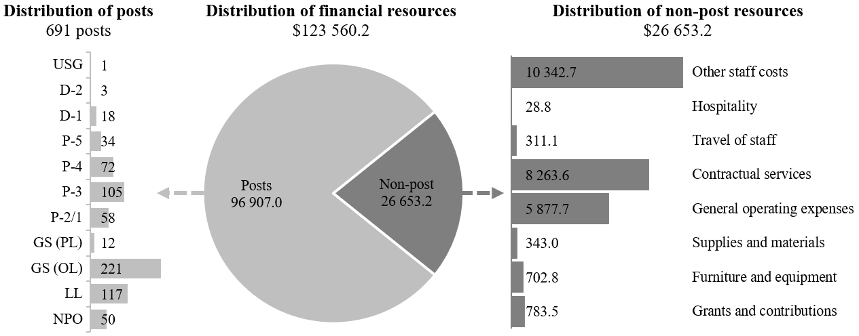

Explanation of variances by factor, component and subprogramme

Overall resource changes

Technical adjustments

28.59 As shown in table 28.10 (1), resource changes reflect a net increase of $52,100, as follows:
(a) Subprogramme 1, Campaigns and country operations services. The net increase of $118,800 comprises:
(i) An increase of $300,300 under posts relating to the higher provision at continuing vacancy rates for the posts established in 2025 pursuant to General Assembly resolution 79/258 (1 P-2 and 3 General Service (Other level)), which were subject to a 50 per cent vacancy rate in accordance with the established practice for newly established posts;
(ii) A decrease of $181,500 relating to the removal of non-recurrent provisions under contractual services ($85,500), supplies and materials ($88,100) and furniture and equipment ($7,900) for webcasting and public information services and equipment that were approved for 2025 pursuant to General Assembly resolutions 79/258, 79/199, 79/259, 79/22, 78/318 and 78/223, and are no longer required in 2026;
(b) Subprogramme 2, News services. The decrease of $40,900 relates to the removal of non-recurrent provisions under other staff costs ($31,600) and contractual services ($9,300) associated with meetings coverage and webcasting activities that were approved for 2025 pursuant to General Assembly resolutions 78/272 and 79/259, respectively, and are no longer required in 2026;
(c) Subprogramme 3, Outreach and knowledge services. The decrease of $25,800 relates to the removal of non-recurrent provisions under contractual services associated with the development of a website for the International Day of Reflection and Commemoration of the 1995 Genocide in Srebrenica that were approved for 2025 pursuant to General Assembly resolution 79/258 and are no longer required in 2026.

New and expanded mandates

28.60 As shown in table 28.10 (1), resource changes reflect an increase of $320,700, as follows:
(a) Subprogramme 1, Campaigns and country operations services. The increase of $11,400 under contractual services would provide for webcasting services for two substantive sessions of the working group on the prevention of an arms race in outer space in all its aspects, pursuant to General Assembly resolution 79/22. In addition, the resources reflect cost-neutral redeployments from supplies and materials ($10,200) to travel on official business ($6,900) and contractual services ($3,300);
(b) Subprogramme 2, News services. The increase of $51,300 under other staff costs ($44,900) and contractual services ($6,400) would provide for meetings coverage and webcasting services for various meetings and conferences, pursuant to General Assembly resolutions 79/40 on the illicit trade in small arms and light weapons in all its aspects; 79/122 on the United Nations Conference of Plenipotentiaries on Prevention and Punishment of Crimes against Humanity; 79/128 on protection of persons in the event of disasters; and 79/145 on sustainable fisheries, including through the 1995 Agreement for the Implementation of the Provisions of the United Nations Convention on the Law of the Sea of 10 December 1982 relating to the Conservation and Management of Straddling Fish Stocks and Highly Migratory Fish Stocks, and related instruments;
(c) Subprogramme 3, Outreach and knowledge services. The increase of $256,800 comprises the following, pursuant to General Assembly resolution 79/115:
(i) An increase of $124,800 under posts, which would cover the proposed establishment of one Programme Management Officer post (P-4) (see annex II);
(ii) An increase of $129,100 under contractual services ($77,500), supplies and materials ($31,000) and grants and contributions ($20,600), which would provide for the development and implementation of an outreach programme to mobilize educational institutions and civil society to expand their activities in the field of remembering colonialism, its root causes and consequences, in close consultation with relevant international, regional and subregional organizations, as well as with concerned former colonies among the States Members of the United Nations;
(iii) An increase of $2,900 under contractual services ($300), supplies and materials ($200) and furniture and equipment ($2,400) relating to the non-post provisions associated with the proposed establishment of the P-4 post;
(d) Programme support. The increase of $1,200 under contractual services relates to the requirements of the service level agreement with the Office of Information and Communications Technology associated with the proposed establishment of the P-4 post.

Other changes

28.61 As shown in table 28.10 (1), resource changes under the programme support component reflect a net decrease of $292,100 under contractual services owing mainly to the reduction of $303,600 due to the lower standard rate for information and communications technology services for personnel at United Nations Headquarters, offset in part by an increase of $11,500 relating to the higher standard rate for the core software package for non-field personnel outside of Headquarters. In addition, the resources reflect cost-neutral redeployments from general operating expenses ($900), supplies and materials ($149,000) and furniture and equipment ($19,400) to contractual services ($169,300).

Other assessed resources

28.62 As reflected in tables 28.10 (2) and 28.11 (2), other assessed resources amount to $962,200. The resources would complement regular budget resources and provide for the requirements indicated in the report of the Secretary-General on the budget for the support account for peacekeeping operations for the period from 1 July 2025 to 30 June 2026 (A/79/783).

Extrabudgetary resources

28.63 As reflected in tables 28.10 (3) and 28.11 (3), extrabudgetary resources amount to $7,509,900. The resources would complement regular budget resources and would be used mainly to provide for non-post resources that would be used to support the Department’s capacity development work; support specific communications campaigns at Headquarters and in the field; support multimedia and operational activities in Hindi; provide webcast and website support activities; conduct activities in support of United Nations Academic Impact and the United Nations System Electronic Information Acquisition Consortium programmes; and provide administrative support for those programmes. The decrease of approximately $8.5 million in the estimate for 2026 compared with the estimate for 2025 is due mainly to the conclusion of Expo 2025 and the closure of the United Nations Development Business programme.
28.64 The extrabudgetary resources under the present section are subject to the oversight of the Department, which has delegated authority from the Secretary-General.

Executive direction and management

28.65 The executive direction and management component comprises the Office of the Under-Secretary-General.
28.66 The main responsibilities of the executive direction and management component include:
(a) The overall direction and strategic management of United Nations communications in the implementation of the Department’s mandates and its approved programme of work, both at Headquarters and in the field;
(b) The establishment of departmental strategy, policies and guidelines, while dealing with specific policy and management issues and problems;
(c) The administrative, financial and personnel management of the Department;
(d) The direction of liaison functions performed by the Department with regard to intergovernmental bodies, such as the Committee on Information, and with the United Nations Communications Group;
(e) Oversight of crisis communications and reputation management, convening relevant United Nations entities and partners within crisis cells to align approaches and messaging, and providing crisis communications policy, guidance and training;
(f) The establishment of United Nations communications priorities, identifying opportunities to communicate about these within a congested media landscape, and providing coordination across the United Nations system by strengthening the United Nations Communications Group, including at the country level through United Nations information centres and the resident coordinator system;
(g) The strengthening of the information ecosystem through the implementation of the United Nations Global Principles for Information Integrity, and the development and implementation of strategies to effectively research, analyse and mitigate risks in the information environment affecting the United Nations and its work.
28.67 In accordance with the 2030 Agenda for Sustainable Development, in particular target 12.6 of the Sustainable Development Goals, in which organizations are encouraged to integrate sustainability information into their reporting cycles, and in compliance with the cross-cutting mandate set out in paragraph 19 of General Assembly resolution 72/219, the Department is integrating environmental management practices into its operations. The Department will, where feasible and effective, continue to make all official documentation, publications, brochures, and communications and advocacy materials available online, rather than in print, in order to reduce its carbon footprint and save energy. It will also continue to adopt a range of sustainability practices, including reducing the photocopying and printing of internal documents, and will promote videoconferencing, in order to reduce the travel undertaken, where possible. The Department will also continue to support internal and external communications on United Nations system sustainability efforts and will encourage staff to join the ActNow campaign and other Secretariat initiatives focused on individual action related to climate change and sustainability.
28.68 Information on the timely submission of documentation and advance booking for air travel is reflected in table 28.13. With regard to the advance booking for air travel, the Department has implemented the requirement for travellers to request approval from the Under-Secretary-General for cases that are non-compliant with the policy and to provide a reason for the delayed request and justification for travel. In addition, the Department closely reviews the exceptions sought and regularly sends communications to directors, managers and staff to raise awareness of the policy requirement and the importance of minimizing the instances of exceptions.

Table 28.13

Compliance rate
(Percentage)

 | 2022 actual | 2023 actual | 2024 actual | 2025 planned | 2026 planned
Timely submission of documentation | 100 | 89 | 100 | 100 | 100
Air tickets purchased at least two weeks before the commencement of travel | 55 | 67 | 53 | 100 | 100

28.69 The proposed regular budget resources for 2026 amount to $2,894,100 and reflect no change compared with the approved budget for 2025. Additional details on the distribution of the proposed resources for 2026 are reflected in table 28.14 and figure 28.XII.

Table 28.14

Executive direction and management: evolution of financial and post resources
(Thousands of United States dollars/number of posts)

 | 2024 expenditure | 2025 approved | Changes |  |  |  |  | 2026  estimate
 | 2024 expenditure | 2025 approved | Technical adjustments | New/  expanded mandates | Other | Total | Percentage | 2026  estimate
Financial resources by main category of expenditure
Posts | 2 697.6 | 2 782.2 | – | – | – | – | – | 2 782.2
Non-post | 639.1 | 111.9 | – | – | – | – | – | 111.9
Total | 3 336.7 | 2 894.1 | – | – | – | – | – | 2 894.1
Post resources by category
Professional and higher |  | 9 | – | – | – | – | – | 9
General Service and related |  | 7 | – | – | – | – | – | 7
Total |  | 16 | – | – | – | – | – | 16

Figure 28.XII

Executive direction and management: distribution of proposed resources for 2026
(Number of posts/thousands of United States dollars)
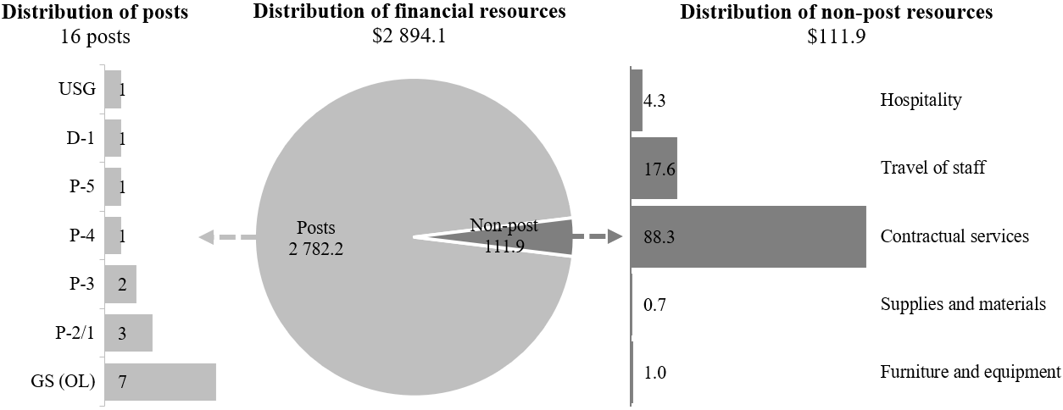

Programme of work

Subprogramme 1

Campaigns and country operations services

28.70 The proposed regular budget resources for 2026 amount to $49,050,900 and reflect a net increase of $130,200 compared with the approved budget for 2025. The proposed changes are explained in paragraphs 28.59 (a) and 28.60 (a). Additional details on the distribution of the proposed resources for 2026 are reflected in table 28.15 and figure 28.XIII.

Table 28.15

Subprogramme 1: evolution of financial and post resources
(Thousands of United States dollars/number of posts)

 | 2024 expenditure | 2025  approved | Changes |  |  |  |  | 2026 estimate
 | 2024 expenditure | 2025  approved | Technical adjustments | New/  expanded mandates | Other | Total | Percentage | 2026 estimate
Financial resources by main category of expenditure
Posts | 34 728.1 | 39 264.1 | 300.3 | – | – | 300.3 | 0.8 | 39 564.4
Non-post | 4 638.5 | 9 656.6 | (181.5) | 11.4 | – | (170.1) | (1.8) | 9 486.5
Total | 39 366.6 | 48 920.7 | 118.8 | 11.4 | – | 130.2 | 0.3 | 49 050.9
Post resources by category
Professional and higher |  | 95 | – | – | – | – | – | 95
General Service and related |  | 242 | – | – | – | – | – | 242
Total |  | 337 | – | – | – | – | – | 337

Figure 28.XIII

Subprogramme 1: distribution of proposed resources for 2026
(Number of posts/thousands of United States dollars)

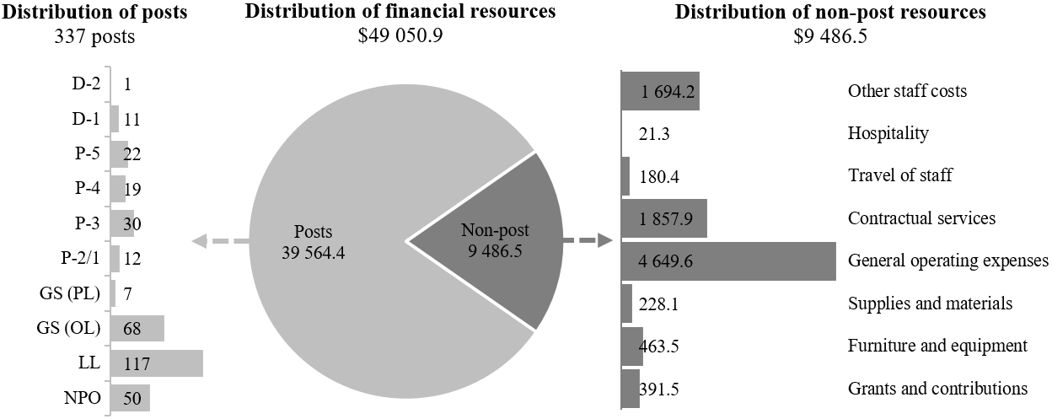

Subprogramme 2

News services

28.71 The proposed regular budget resources for 2026 amount to $43,630,600 and reflect a net increase of $10,400 compared with the approved budget for 2025. The proposed changes are explained in paragraphs 28.59 (b) and 28.60 (b). Additional details on the distribution of the proposed resources for 2026 are reflected in table 28.16 and figure 28.XIV.

Table 28.16

Subprogramme 2: evolution of financial and post resources
(Thousands of United States dollars/number of posts)

 | 2024 expenditure | 2025  approved | Changes |  |  |  |  | 2026 estimate
 | 2024 expenditure | 2025  approved | Technical adjustments | New/  expanded mandates | Other | Total | Percentage | 2026 estimate
Financial resources by main category of expenditure
Posts | 28 529.7 | 30 320.1 | – | – | – | – | – | 30 320.1
Non-post | 5 761.5 | 13 300.1 | (40.9) | 51.3 | – | 10.4 | 0.1 | 13 310.5
Total | 34 291.2 | 43 620.2 | (40.9) | 51.3 | – | 10.4 | 0.0 | 43 630.6
Post resources by category
Professional and higher |  | 111 | – | – | – | – | – | 111
General Service and related |  | 70 | – | – | – | – | – | 70
Total |  | 181 | – | – | – | – | – | 181

Figure 28.XIV

Subprogramme 2: distribution of proposed resources for 2026
(Number of posts/thousands of United States dollars)

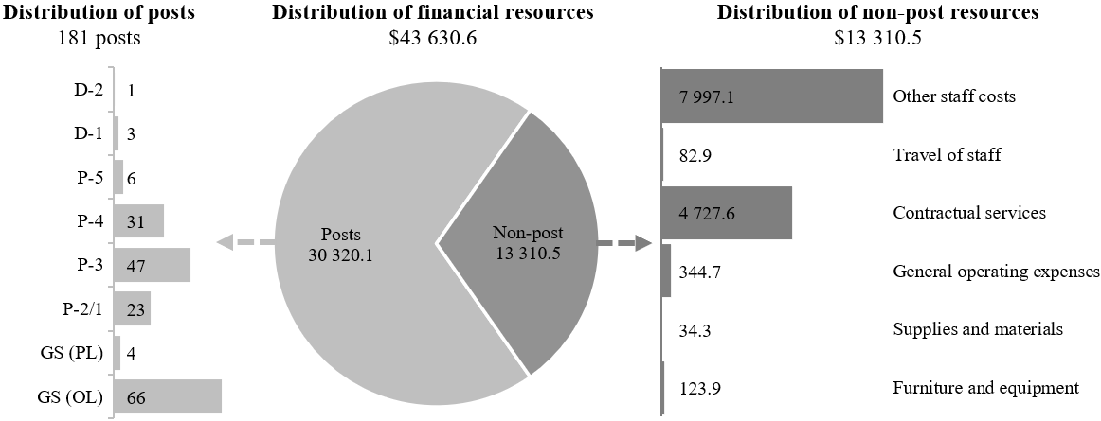

Subprogramme 3

Outreach and knowledge services

28.72 The proposed regular budget resources for 2026 amount to $23,835,000 and reflect a net increase of $231,000 compared with the approved budget for 2025. The proposed changes are explained in paragraphs 28.59 (c) and 28.60 (c). Additional details on the distribution of the proposed resources for 2026 are reflected in table 28.17 and figure 28.XV.

Table 28.17

Subprogramme 3: evolution of financial and post resources
(Thousands of United States dollars/number of posts)

 | 2024 expenditure | 2025 approved | Changes |  |  |  |  | 2026  estimate
 | 2024 expenditure | 2025 approved | Technical adjustments | New/  expanded mandates | Other | Total | Percentage | 2026  estimate
Financial resources by main category of expenditure
Posts | 19 580.2 | 20 953.3 | – | 124.8 | – | 124.8 | 0.6 | 21 078.1
Non-post | 1 452.8 | 2 650.7 | (25.8) | 132.0 | – | 106.2 | 4.0 | 2 756.9
Total | 21 033.0 | 23 604.0 | (25.8) | 256.8 | – | 231.0 | 1.0 | 23 835.0
Post resources by category
Professional and higher |  | 68 | – | 1 | – | 1 | 1.5 | 69
General Service and related |  | 66 | – | – | – | – | – | 66
Total |  | 134 | – | 1 | – | 1 | 0.7 | 135

Figure 28.XV

Subprogramme 3: distribution of proposed resources for 2026
(Number of posts/thousands of United States dollars)

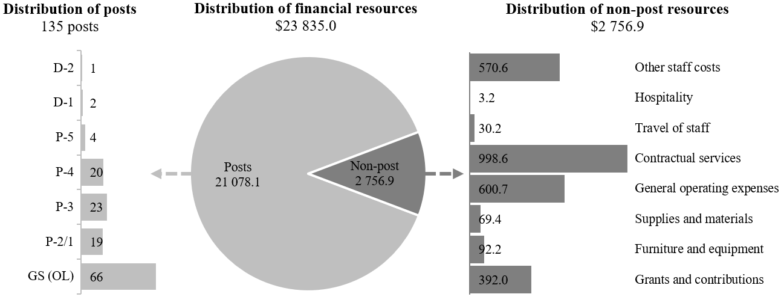

Programme support

28.73 The proposed regular budget resources for 2026 amount to $4,149,600 and reflect a decrease of $290,900 compared with the approved budget for 2025. The proposed changes are explained in paragraphs 28.60 (d) and 28.61. Additional details on the distribution of the proposed resources for 2026 are reflected in table 28.18 and figure 28.XVI.

Table 28.18

Programme support: evolution of financial and post resources
(Thousands of United States dollars/number of posts)

 | 2024 expenditure | 2025 approved | Changes |  |  |  |  | 2026  estimate
 | 2024 expenditure | 2025 approved | Technical adjustments | New/  expanded mandates | Other | Total | Percentage | 2026  estimate
Financial resources by main category of expenditure
Posts | 2 931.0 | 3 162.2 | – | – | – | – | – | 3 162.2
Non-post | 1 197.2 | 1 278.3 | – | 1.2 | (292.1) | (290.9) | (22.8) | 987.4
Total | 4 128.2 | 4 440.5 | – | 1.2 | (292.1) | (290.9) | (6.6) | 4 149.6
Post resources by category
Professional and higher |  | 7 | – | – | – | – | – | 7
General Service and related |  | 15 | – | – | – | – | – | 15
Total |  | 22 | – | – | – | – | – | 22

Figure 28.XVI

Programme support: distribution of proposed resources for 2026
(Number of posts/thousands of United States dollars)

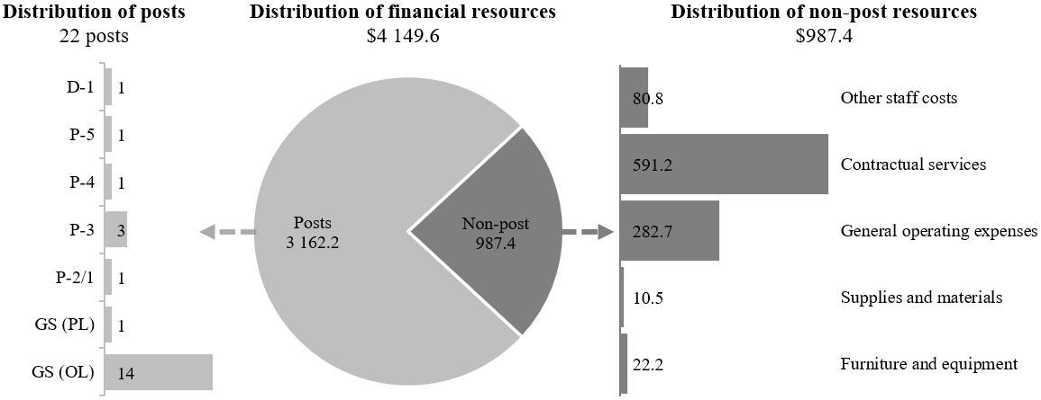

Annex I

Organizational structure and post distribution for 2026

United Nations Information Service in Nairobi

RB:
1 D-1
1 P-4
1 P-3
3 LL

Total: 6
United Nations Information Service in Vienna

RB:
1 D-1
1 P-4
2 P-3
1 P-2
1 GS (PL)
4 GS (OL)

Total: 10
Outreach Division
(subprogramme 3)

RB:
1 D-2
2 D-1
4 P-5
19 P-4
1 P-4ª
23 P-3
19 P-2
66 GS (OL)

135

Total: 135
News and Media Division
(subprogramme 2)

RB: OA:
1 D-2 1 P-2
3 D-1 1 GS (OL)
6 P-5
31 P-4
47 P-3
23 P-2
4 GS (PL)
66 GS (OL)

181 2

Total: 183
Campaigns and Country Operations Division
(subprogramme 1)

RB: OA:
1 D-2 2 P-4
2 D-1
6 P-5
7 P-4
16 P-3
7 P-2
28 GS (OL)

67 2

Total: 69
Executive Office
(programme support)

RB:
1 D-1
1 P-5
1 P-4
3 P-3
1 P-2
1 GS (PL)
14 GS (OL)

Total: 22
Office of the Under-Secretary-General
(executive direction and management)
RB:
1 USG
1 D-1
1 P-5
1-P-4
2 P-3
3 P-2
7 GS (OL)

Total: 16
United Nations Information Service in Geneva

RB:
1 D-1
2 P-5
3 P-4
4 P-3
4 P-2
1 GS (PL)
15 GS (OL)

Total: 30
United Nations information centres and offices

RB:
6 D-1
14 P-5
7 P-4
7 P-3
50 NPO
140 LL

Total: 224
Abbreviations: GS (OL), General Service (Other level); GS (PL), General Service (Principal level); LL, Local level; NPO, National Professional Officer; OA, other assessed; RB, regular budget; USG, Under-Secretary-General; XB, extrabudgetary.
ª Establishment.

Annex II

Summary of proposed post changes, by component and subprogramme

Component/subprogramme | Posts | Grade | Description | Reason for change
Subprogramme 3  Outreach and knowledge services | 1 | P-4 | Establishment of 1 Programme Management Officer | The proposed establishment of the Programme Management Officer post is related to General Assembly resolution 79/115, wherein the Assembly requested the Secretary-General, in close consultation with relevant international, regional and subregional organizations, as well as with concerned former colonies among the States Members of the United Nations, to develop an outreach programme to mobilize educational institutions and civil society to expand their activities in the field of remembering colonialism, its root causes and consequences. The Department of Global Communications currently has four outreach programmes: the Holocaust and the United Nations Outreach Programme, which is covered by three staff (1 P-4, 1 P-2 and 1 GS (OL)); the Outreach Programme on the Transatlantic Slave Trade and Slavery, which is covered by three staff (1 P-4, 1 P-3 (GTA) and 1 GS (OL)); the outreach programme on the 1994 genocide against the Tutsi in Rwanda and the United Nations, which is covered by two staff (1 P-4 and 1 GS (OL) (GTA)); and the outreach programme entitled “The Srebrenica Genocide and the United Nations”, established pursuant to Assembly resolution 78/282, which has no dedicated posts.  The incumbent would be responsible for working with relevant international, regional and subregional organizations, as well as with concerned former colonies among the States Members of the United Nations, to develop an outreach programme to mobilize educational institutions and civil society to expand their activities in the field of remembering colonialism, its root causes and consequences. The incumbent would also work with the Department of Political and Peacebuilding Affairs and would be responsible for developing and managing the outreach programme; providing strategic direction on issues, methods and approaches for mobilizing educational institutions and civil society to expand their activities in the field of colonialism, including by providing overall coordination for the preparation of substantive content related to the outreach programme; and leading the development of the outreach programme, including the associated strategy and planning. The P-4 post would be supported by programme management officers (P-3, P-2) and administrative assistants (GS (OL)) from the other outreach programmes, as required.

Abbreviations: GS (OL), General Service (Other level); GTA, general temporary assistance.

