Eightieth session
Items 137 and 138 of the preliminary list*

Proposed programme budget for 2026

Programme planning

Proposed programme budget for 2026

Part VIII

Common support services

Section 29B

* A/80/50.
** In keeping with paragraph 10 of General Assembly resolution 77/267, the part consisting of the programme plan and programme performance information (part II) is submitted through the Committee for Programme and Coordination for the consideration of the Assembly.

Department of Operational Support

Programme 25

Management and support services

Contents
 |  |  | Page
- Proposed programme plan for 2026 and programme performance in 2024** |  |  | 3
Overall orientation |  |  | 3
Programme of work |  |  | 5
Subprogramme 1. Support operations |  |  | 5
Component 1. Human resources support |  |  | 5
Component 2. Capacity development and operational training |  |  | 9
Component 3. Healthcare management and occupational safety and health |  |  | 13
Subprogramme 2. Supply chain management |  |  | 17
Component 1. Integrated supply chain management |  |  | 17
Component 2. Uniformed capabilities support |  |  | 21
Subprogramme 3. Special activities |  |  | 26
Subprogramme 4. Administration, New York |  |  | 30
- Proposed post and non-post resource requirements for 2026*** |  |  | 35
Overview |  |  | 35
Executive direction and management |  |  | 44
Programme of work |  |  | 47
Subprogramme 1. Support operations |  |  | 47
Component 1. Human resources support |  |  | 47
Component 2. Capacity development and operational training |  |  | 48
Component 3. Healthcare management and occupational safety and health |  |  | 49
Subprogramme 2. Supply chain management |  |  | 50
Component 1. Integrated supply chain management |  |  | 50
Component 2. Uniformed capabilities support |  |  | 51
Subprogramme 3. Special activities |  |  | 52
Subprogramme 4. Administration, New York |  |  | 53
Programme support |  |  | 54
Annexes
- Organizational structure and post distribution for 2026 |  |  | 55
- Summary of proposed post changes, by component and subprogramme |  |  | 57

*** In keeping with paragraph 10 of General Assembly resolution 77/267, the part consisting of the post and non-post resource requirements (part III) is submitted through the Advisory Committee on Administrative and Budgetary Questions for the consideration of the Assembly.

A. Proposed programme plan for 2026 and programme performance in 2024

Overall orientation

Mandates and background

29B.1 The Department of Operational Support is the operational arm of the Secretariat and the client-facing interface for operational support matters in the Secretariat’s management structure, which exists to support the objective of effective mandate delivery, in partnership with Secretariat entities and other clients. The mandate derives from the priorities established in relevant General Assembly resolutions and decisions, including resolutions 72/266 B and 73/281. The Department delivers rapid, effective, efficient, responsible and, where required, customized enabling solutions that help partners to meet their mandates, including in the most challenging operating environments.

Strategy and external factors for 2026

29B.2 For 2026, the Department will enable effective mandate delivery through the provision of operational support. To implement its programme, the Department will work with client entities to define requirements and co-create solutions in the areas of end-to-end supply chain management, uniformed personnel support, human resources, diverse training services, business process improvement and medical and occupational health and safety, as well as information and communications technology solutions through the Office of Information and Communications Technology. It will, in exceptional cases, exercise delegated authority on behalf of clients across the Secretariat.
29B.3 The Department will work to provide a balance of direct and advisory support, adapting to diverse client needs and ensuring a positive client experience. It will employ foresight methodologies in its planning to anticipate and respond to changes in the operating environment, fostering a culture that is agile, responsive and forward-looking. In addition, the Department will embrace technology, automation and innovation, as well as high-quality data, in order to streamline processes. It will also support relevant Secretariat actors to integrate positive legacy considerations into the design and management of their operations (including facilities, infrastructure and services) in order to maximize opportunities to provide a secondary benefit for host communities.
29B.4 With regard to cooperation with other entities at the global, regional, national and local levels, the Department will reinforce its collaboration with Member States and regional organizations, including through capacity-building activities, knowledge exchange and functional arrangements in diverse areas of operational support, in order to achieve the scale and effectiveness needed to address complex challenges.
29B.5 With regard to inter-agency coordination and liaison, the Department will progress its modus operandi for the delivery of a full range of services within and beyond the United Nations Secretariat on the basis of comparative advantage, leading a network of service providers, where the Department focuses its efforts on enhancing delivery.
29B.6 With regard to the external factors, the Department considered applicable risks identified in its risk register and, accordingly, the overall plan for 2026 is based on the following planning assumptions:
(a) There is adequate support from all stakeholders to enable effective operational support solutions in challenging operating environments;
(b) Requirements for crisis response and other special situations will not exceed the Department’s capacity to respond.
29B.7 The Department will continue to integrate a gender perspective into its operational activities, deliverables and results, as appropriate. For example, activities will include camp design methodologies, improvements in the area of women’s health, staffing initiatives such as the senior women talent pipeline, and advice to field entities, upon request, to enable them to meet targets related to gender parity. In order to encourage a more equitable approach to the Organization’s supply chain, the Department will continue to strengthen outreach and training for vendors, including for women-owned businesses.
29B.8 In line with the United Nations Disability Inclusion Strategy, the Department will support efforts to improve accessibility for persons with disabilities to the United Nations premises, to allow their full, meaningful and effective participation in the work of the United Nations.

Legislative mandates

29B.9 The list below, which was reviewed in the preparation of the proposed programme budget, provides all mandates entrusted to the programme.

General Assembly resolutions

72/266 A; 72/266 B; 73/281; 77/267 | Shifting the management paradigm in the United Nations
76/274 | Cross-cutting issues
79/1 | The Pact for the Future
79/257 | Questions relating to the proposed programme budget for 2025
79/258 | Special subjects relating to the proposed programme budget for 2025
79/259 A–C | Programme budget for 2025

Subprogramme 2

Supply chain management

Component 1

Integrated supply chain management

General Assembly resolutions

69/273 | Procurement
78/250 B | Financing of the United Nations Multidimensional Integrated Stabilization Mission in Mali
78/297 | Financing of the United Nations Interim Security Force for Abyei
78/298 | Financing of the United Nations Multidimensional Integrated Stabilization Mission in the Central African Republic
78/300 | Financing of the United Nations Peacekeeping Force in Cyprus
78/301 | Financing of the United Nations Organization Stabilization Mission in the Democratic Republic of the Congo
78/302 | Financing of the United Nations Interim Administration Mission in Kosovo
78/304 | Financing of the United Nations Disengagement Observer Force
78/305 | Financing of the United Nations Interim Force in Lebanon
78/306 | Financing of the United Nations Mission in South Sudan
78/307 | Financing of the United Nations Mission for the Referendum in Western Sahara
78/309 | Financing of the activities arising from Security Council resolution 1863 (2009)

Component 2

Uniformed capabilities support

General Assembly resolutions

50/222 | Reform of the procedures for determining reimbursement to Member States for contingent-owned equipment
67/261 | Report of the Senior Advisory Group established pursuant to General Assembly resolution 65/289 to consider rates of reimbursement to troop-contributing countries and other related issues
76/275 | Post-traumatic stress disorder framework
76/276 | Rates of reimbursement to troop- and police-contributing countries
77/303 | Triennial review of the rates and standards for reimbursement to Member States for contingent-owned equipment
78/293 | Support account for peacekeeping operations

Subprogramme 3

Special activities

Security Council resolution

2719 (2023)

Deliverables

29B.10 Table 29B.1 lists all cross-cutting deliverables of the programme.

Table 29B.1

Cross-cutting deliverables for the period 2024–2026, by category and subcategory

Category and subcategory | 2024 planned | 2024 actual | 2025 planned | 2026 planned
A. Facilitation of the intergovernmental process and expert bodies
Substantive services for meetings (number of three-hour meetings) | 4 | 4 | 4 | 4
Meetings of the:
1. Fifth Committee | 1 | 1 | 1 | 1
2. Advisory Committee on Administrative and Budgetary Questions | 1 | 1 | 1 | 1
3. Committee for Programme and Coordination | 1 | 1 | 1 | 1
4. Special Committee on Peacekeeping Operations | 1 | 1 | 1 | 1
E. Enabling deliverables
Administration: six meetings of the Management Client Board.

Evaluation activities

29B.11 The following evaluations to be conducted by the Department are planned for 2026:
(a) Evaluation of the Knowledge Gateway;
(b) Evaluation of client orientation in the implementation of integrated supply chain management;
(c) A joint evaluation by the Department of Management Strategy, Policy and Compliance, the Department of Operational Support and the Office of Information and Communications Technology on information and communications technology security will be completed in 2026.

Programme of work

Subprogramme 1

Support operations

Component 1

Human resources support

Objective

29B.12 The objective, to which this component contributes, is to strengthen the human resources capacity of all Secretariat entities, enable improved, simplified human resources processes and offer the Organization talented and diverse staffing pools.

Strategy

29B.13 To contribute to the objective, the component will:
(a) Support Secretariat entities in the exercise of delegated authority in the area of human resources, including through:
(i) Specialized advisory support and guidance to human resources business partners across the Secretariat, including on dispute prevention and resolution, affiliated-personnel capacities and other entity-specific operational human resources needs;
(ii) Active engagement and regular analysis of support requests, with a view to communicating required policy changes to the Department of Management Strategy, Policy and Compliance on the basis of client needs;
(iii) Simplification and digitalization of human resources processes, tools and procedures, such as recruitment, rostering, testing and examination services, affiliated-personnel capacities and workforce planning, in cooperation with the Office of Human Resources and the Office of Information and Communications Technology;
(b) Offer high-quality and diverse pools of candidates by managing global Secretariat rosters across all job families;
(c) Administer the young professionals programme.
29B.14 The above-mentioned work is expected to result in:
(a) Secretariat entities accountably, effectively and efficiently exercising their delegated human resources authority in support of their mandates;
(b) Increased efficiencies and measurable reductions in delays and redundancies in human resources processes;
(c) Strengthened capacity for the timely identification and recruitment of candidates and talent that are the best fit.

Programme performance in 2024

Effective transition of United Nations Office for Project Services partner personnel

29B.15 The component provided extensive support to client entities to implement a new memorandum of understanding established in 2024 between the United Nations Office for Project Services (UNOPS) and the United Nations Secretariat, supporting the transition of entities using UNOPS for project implementation and, where exceptionally approved, as provider of partner personnel outlined in the 2014 memorandum of understanding. The new memorandum of understanding transforms the use of UNOPS to be either an implementing partner or a service provider. At the beginning of 2024, more than 2,500 partner personnel were engaged through UNOPS on an exceptional basis and had to be either transitioned to other modalities or phased out in 2025. The subprogramme supported entities in transitioning their financial agreements and phasing out the use of partner personnel through a multilayer approach. It provided guidance and capacity-building to human resources practitioners and assisted 16 client entities with the review of their existing arrangements to advise on suitable modalities for the necessary transition.
29B.16 Progress towards the objective is presented in the performance measure below (see table 29B.2).

Table 29B.2

Performance measure

2022 (actual) | 2023 (actual) | 2024 (actual)
– | – | 16 entities received support, including briefings and guidance, to effectively implement the new memorandum of understanding and transition their partner personnel, leading to a reduction of approximately 700 partner personnel by the end of 2024

Planned results for 2026

Result 1: Secretariat entities engage in workforce planning and organizational design

Programme performance in 2024 and target for 2026

29B.17 The component’s work contributed to clients gaining access to an organizational design guide and participating in dedicated briefing sessions on new workforce capabilities to enable decision-making on how the entity should be structured to achieve its goals, which met the planned target. In addition, a priority workforce capabilities toolkit was launched in August 2024 for entities to progressively incorporate the priority workforce capabilities.
29B.18 Progress towards the objective and the target for 2026 are presented in the performance measure below (see table 29B.3).

Table 29B.3

Performance measure

2022 (actual) | 2023 (actual) | 2024 (actual) | 2025 (planned) | 2026 (planned)
Clients have access to overview of entry-level positions to guide utilization of P-1 and P-2 and guidance on rejuvenation of the workforce  Clients have increased opportunities to share best practices in the workforce planning and organizational design network, with 59 client entities represented | Clients have access to the workforce capabilities briefing sessions to be able to progressively incorporate the priority workforce capabilities (e.g., data analytics and management, digital transformation and innovation)  Clients have access to an organizational design guide to decide how the entity should be structured and function in order to achieve its goals | Clients have access to dedicated workshops on the workforce capabilities in order to address their specific workforce needs  Clients have access to the priority workforce capabilities toolkit to operationalize the workforce capabilities at the entity level | Clients have access to, and utilize, data-driven roster health analysis to forecast their upcoming requirements | Clients have access to, and utilize, enhanced data-driven roster health analysis to plan, prioritize and holistically forecast their upcoming requirements over a four-year horizon

Result 2: improved performance management across the Secretariat

Programme performance in 2024 and target for 2026

29B.19 The component’s work contributed to increased capacity of 47 local human resources practitioners from 30 client entities to advise and guide managers on performance management through the “train-the-trainers” programme, which met the planned target.
29B.20 Progress towards the objective and the target for 2026 are presented in the performance measure below (see table 29B.4).

Table 29B.4

Performance measure

2022 (actual) | 2023 (actual) | 2024 (actual) | 2025 (planned) | 2026 (planned)
– | Managers and human resources practitioners in 48 client entities gain capacity and understanding on the different stages of the performance cycle and their responsibilities at each stage | Increased capacity of 47 human resources practitioners from 30 client entities to advise on complex performance management cases | Managers are empowered to better manage performance and respond to issues related to performance management through guidance, briefings and training | Human resources practitioners and managers increase their awareness and capacity in the area of performance management through lessons learned initiatives

Result 3: enhanced roster building and management for the global Secretariat

Proposed programme plan for 2026

29B.21 The subprogramme is planning and implementing a new roster building and management approach to ensure that all Secretariat entities have access to refreshed and time-bound rosters to enhance the quality, efficiency and fairness of the rostering process. In 2024, the subprogramme designed, in coordination with the Office of Information and Communications Technology, the necessary enhancements to Inspira. The subprogramme refined a roster health analysis tool to make informed recommendations for rosters in need of replenishment and developed a quality assurance framework. In addition, roster-building workshops were conducted with human resources stakeholders in November and December 2024.

Lessons learned and planned change

29B.22 The lesson for the component was a need for enhanced change and knowledge management, a consistent approach to roster replenishment prioritization, and operational readiness in planning, systems and training to implement the new roster building and management approach. In applying the lesson, the subprogramme will develop a communications strategy and standardize assessment services by providing guidance, implementing a planning tool for efficient rostering, and ensuring alignment with the quality assurance framework. The component will also continue to prioritize rostering exercises on the basis of workforce requirements to achieve healthy rosters.
29B.23 Expected progress towards the objective is presented in the performance measure below (see table 29B.5).

Table 29B.5

Performance measure

2022 (actual) | 2023 (actual) | 2024 (actual) | 2025 (planned) | 2026 (planned)
– | Increased collaboration and communication with stakeholders to ensure alignment and coherence | Increased comprehension by human resources stakeholders of the new global roster management approach to effectively manage the change | Clients have access to enhanced Inspira tools to streamline roster building and management  United Nations entities have access to refreshed, time-bound rosters for efficient and high-quality recruitment selections | Increased accuracy and efficiency of roster management

Deliverables

29B.24 Table 29B.6 lists all deliverables of the component.

Table 29B.6

Subprogramme 1, component 1: deliverables for 2026, by category and subcategory

Category and subcategory
E. Enabling deliverables
Administration: advice and guidance to Secretariat entities on all human resources issues, including escalation to the Department of Management Strategy, Policy and Compliance regarding authoritative policy interpretation, when necessary; affiliated-personnel administration, recruitment and rostering improvements; advice on attaining targets related to gender equality; talent programmes focused on field mission recruitment (e.g. senior women talent pipeline); examinations and tests, including the competitive examination for language positions for approximately 5,000 candidates, the young professionals programme for approximately 2,000 candidates and the language proficiency examination for approximately 6,000 participants; placement of approximately 60 young professionals programme roster candidates and reassignment of young professional staff members after their initial two years of service; roster assessment and schedule determination for refreshing rosters across 23 job families; updated procedures, assessments and tools for rostering and recruitment; guidance packages, advice and capacity-building on human resources delegation of authority, performance management, affiliated personnel administration, workforce planning, organizational design and roster management to facilitate the human resources planning process for all Secretariat entities; tools and enhancements in the Inspira talent management platform for recruitment and rostering; official status files in largely digital format for the efficient administration of peacekeeping personnel and towards a Secretariat-wide personnel records management system; and enhanced Umoja functionalities in support of human resources processes globally.

Component 2

Capacity development and operational training

Objective

29B.25 The objective, to which this component contributes, is to ensure that all Secretariat entities have the operational capacities necessary to effectively deliver on the mandates entrusted to them.

Strategy

29B.26 To contribute to the objective, the component will:
(a) Collaborate with Secretariat entities to design, develop and deliver a diverse portfolio of training and capacity-building services tailored to operational needs; create and execute comprehensive training programmes across key operational areas, such as resources stewardship, data-related capacities and other support functions, including Umoja; and emphasize the integration of e-learning platforms and apply change management strategies to facilitate effective learning outcomes and seamless adaptation;
(b) Strengthen knowledge management and innovative information-sharing to boost operational effectiveness through standardized, accessible guidance and process improvement initiatives;
(c) Expand the range and content of training programmes and learning resources to improve multilingualism.
29B.27 The above-mentioned work is expected to result in:
(a) Stronger organizational governance by senior leadership teams, as well as better trained and empowered staff to support operational decision-making, resource management and improved operational processes;
(b) Knowledge management and learning management platforms that reach a broad spectrum of practitioners across the Secretariat, resulting in strengthened awareness and competence with regard to resource stewardship and other operational responsibilities;
(c) Greater linguistic capability and diversity and improved communication capacities across the Secretariat in support of multilingualism.

Programme performance in 2024

Improved administration of rest and recuperation entitlements across the Secretariat

29B.28 In early 2024, the process improvement advisory group, to which the component acts as the secretariat, finalized the selection of 10 process improvement projects with a view to enhancing efficiency, streamlining workflows and optimizing service delivery across key Secretariat support functions. One of these projects focused on the enhancement of the administration of rest and recuperation entitlements for staff working in hardship duty stations. During 2024, the component conducted interviews, focus group discussions and surveys with representatives from 29 Secretariat entities to identify challenges and inefficiencies in the administration of such entitlements. Subsequently, business process improvement workshops were held to redesign the process to address inefficiencies in workflows and enhance decision-making. These workshops utilized behavioural science principles to uncover “pain points” in the process and identify evidence-based approaches to address them. They also offered the opportunity for different improvements to be tested to determine their utility and effectiveness. As a result, an agreement on a streamlined, simplified workflow was achieved and will be implemented in 2025.
29B.29 Progress towards the objective is presented in the performance measure below (see table 29B.7).

Table 29B.7

Performance measure

2022 (actual) | 2023 (actual) | 2024 (actual)
– | – | A streamlined, simplified workflow for the administration of rest and recuperation entitlements was developed and agreed by Secretariat entities, which will reduce processing time for around 20,000 requests, benefiting over 5,000 staff entitled to rest and recuperation as well as managers and human resources partners involved in the approval process

Planned results for 2026

Result 1: effective resource stewardship in the Secretariat

Programme performance in 2024 and target for 2026

29B.30 The component’s work contributed to the availability of 14 learning solutions on effective resource management, which exceeded the planned target of 12 learning solutions.
29B.31 Progress towards the objective and the target for 2026 are presented in the performance measure below (see figure 29B.I).

Figure 29B.I

Performance measure: number of learning solutions on effective resource management available to client entities (cumulative)

Result 2: UNTold: collective learning and innovation across the United Nations system

Programme performance in 2024 and target for 2026

29B.32 The component’s work contributed to the engagement of 841 United Nations personnel in UNTold interactive learning sessions, which exceeded the planned target of 835 personnel.
29B.33 Progress towards the objective and the target for 2026 are presented in the performance measure below (see figure 29B.II).

Figure 29B.II

Performance measure: number of United Nations personnel engaged in UNTold interactive learning sessions (annual)

Result 3: strengthened organizational capabilities in innovation, data analytics, digital transformation, strategic foresight and behavioural science

Proposed programme plan for 2026

29B.34 The subprogramme works with Secretariat entities to design, develop and deliver a diverse portfolio of training and capacity-building services tailored to operational needs. In paragraph 73 (a) of its resolution 79/1, entitled “The Pact for the Future”, under action 45, the General Assembly decided to achieve a more agile, responsive and resilient United Nations, in particular by enhancing the Organization’s capabilities in innovation, data analytics, digital transformation, strategic foresight and behavioural science to better support Member States and deliver on its mandates.

Lessons learned and planned change

29B.35 The lesson for the component was the need to further align its learning initiatives with the five areas identified in paragraph 73 (a) of the Pact for the Future. In applying the lesson, the subprogramme will ensure that ongoing and future operational learning projects are appropriately scoped, clearly integrate learning objectives in line with paragraph 73 (a) of the Pact for the Future and are intentionally designed for maximum impact towards strengthening the Organization’s capabilities in those five areas.
29B.36 Expected progress towards the objective is presented in the performance measure below (see figure 29B.III).

Figure 29B.III

Performance measure: number of operational learning initiatives to strengthen organizational capabilities in innovation, data analytics, digital transformation, strategic foresight and behavioural science (cumulative)

Deliverables

29B.37 Table 29B.8 lists all deliverables of the component.

Table 29B.8

Subprogramme 1, component 2: deliverables for 2026, by category and subcategory

Category and subcategory
E. Enabling deliverables
Administration: in-person, online and blended courses, workshops, guides, reference material, capacity development programmes and initiatives; in-person and virtual governance improvement programme for approximately 16 senior leadership staff from 2 United Nations Secretariat entities; at least 6 learning products on communication in all 6 United Nations official languages, including instructor-led training and self-paced content for 500 beneficiaries, and illustrative samples (text, video and audio) to demonstrate language production at the various United Nations levels; instructor-led and self-paced language and communication training in all 6 official United Nations languages, including direct provision at United Nations Headquarters and other duty stations, with approximately 350 initiatives and promotion of comparable online language learning licences in 14 Secretariat entities; training on the use of updated and simplified enterprise system workflows and business process improvement; guidance and best practices in more than 135 thematic areas to simplify and harmonize operational processes; and embedded accessibility tools for persons with disabilities in the Knowledge Gateway.

Component 3

Healthcare management and occupational safety and health

Objective

29B.38 The objective, to which this component contributes, is to ensure the health and well-being of the United Nations workforce.

Strategy

29B.39 To contribute to the objective, the component will:
(a) Ensure standardized credentialing for United Nations healthcare personnel and ensure that healthcare personnel with appropriate qualifications and skills are deployed to all field duty stations;
(b) Implement healthcare quality and patient safety standards at all United Nations healthcare facilities at level 1+ and above by assessing facilities, training medical personnel in healthcare quality and patient safety standards and assessment methodologies and reviewing data from the hospital evaluation tool;
(c) Promote a culture of safety at all level 1+ and above healthcare facilities by implementing a clinical adverse event reporting system to support data collection for surveillance and the reporting of patient safety risks and adverse events and by administering a culture of safety survey;
(d) Develop evidence-based chronic disease prevention and health promotion programmes and policies, based on a disease surveillance system, for implementation by United Nations medical services globally;
(e) Implement the components of an occupational safety and health management system for Secretariat entities, including an incident reporting system and a monitoring and evaluation system, through support for an oversight body, the development of policy and standards and training;
(f) Modernize business processes, including for the collection of medical entitlements through the electronic medical record system, the improved capture of the cause of sickness absences and the integration of systems covering incidents, sickness, work-related medical evacuations and service-incurred compensation;
(g) Undertake workplace and meeting risk assessments at United Nations Headquarters and implement mitigation strategies to prevent workplace illness and injury;
(h) Implement support measures for women’s health, including training for the United Nations healthcare workforce on the provision of gender-sensitive medical services;
(i) Improve the access of personnel of peace operations to health facilities, including mental health services, in line with paragraph 42 (d) of the Pact for the Future, under action 21.
29B.40 The above-mentioned work is expected to result in:
(a) A reduction in adverse events and preventable harm by enhancing the health and well-being of personnel;
(b) Continued mitigation of occupational health and safety risks;
(c) Improved compliance of field and referral hospitals with United Nations healthcare quality and patient safety standards that meet the needs of United Nations healthcare professionals and staff.

Programme performance in 2024

Enhanced literacy on mental health issues for uniformed personnel

29B.41 Serving in diverse and often challenging environments, uniformed and civilian personnel in peace operations put their physical and mental well-being at risk. Recognizing the importance of building resilience and safeguarding the well-being of personnel in peace operations, the subprogramme launched, in 2023, the Mental Health Strategy for United Nations Uniformed Personnel. The Strategy underscores the critical importance of improving mental health literacy, with a view to reducing barriers to seeking support. It also outlines comprehensive roles and responsibilities in providing mental health support to uniformed personnel. In 2024, the subprogramme developed a web and mobile phone application, “UN’s MindCompanion”, to increase awareness and understanding of mental health issues, facilitate coping skills, enhance accessibility to mental health literacy resources, foster a positive and supportive work environment and reduce barriers to seeking support. Available in 17 languages and functioning seamlessly both online and offline, the application ensures privacy and confidentiality for the user and also includes a self-assessment feature to help users to gauge their mental well-being and track it over time.
29B.42 Progress towards the objective is presented in the performance measure below (see table 29B.9).

Table 29B.9

Performance measure

2022 (actual) | 2023 (actual) | 2024 (actual)
– | Mental Health Strategy for United Nations Uniformed Personnel launched in December 2023 | “UN’s MindCompanion”, a digital platform (web and mobile application), available in 17 languages as of October 2024, with 4,800 downloads between October and December

Planned results for 2026

Result 1: a safe and healthy environment for female civilian and uniformed personnel in peace operations

Programme performance in 2024 and target for 2026

29B.43 The component’s work contributed to 495 field medical personnel having access to training on women’s health and reporting improved knowledge and capabilities for gender-sensitive services, which exceeded the planned target of 150.
29B.44 Progress towards the objective and the target for 2026 are presented in the performance measure below (see figure 29B.IV).

Figure 29B.IV

Performance measure: number of field medical personnel who have access to training on women’s health and who report improved knowledge and capabilities for gender-sensitive services (annual)

Result 2: United Nations personnel use preventive health services to improve their health and well-being

Programme performance in 2024 and target for 2026

29B.45 The component’s work contributed to 82 per cent of United Nations personnel accessing preventive health services and 64 per cent reporting an active lifestyle, which met the planned target.
29B.46 Progress towards the objective and the target for 2026 are presented in the performance measure below (see figure 29B.V).

Figure 29B.V

Performance measure: improved health and well-being of United Nations personnelª

ª The survey is conducted biennially. Data for 2024 (actual) reflect the latest available data from the survey conducted in 2023.

Result 3: improved quality of patient care

Proposed programme plan for 2026

29B.47 Clinical standards and pathways contribute to improving patient care by identifying and standardizing best practices, reducing variations in treatment and promoting evidence-based approaches. The component, in collaboration with the World Health Organization, has worked to establish clinical standards and pathways for United Nations operations, and has provided extensive guidance and training to medical personnel on their implementation.

Lessons learned and planned change

29B.48 The lesson for the component was that in addition to guidance and training on the standards and pathways, it was important to continuously monitor the quality of patient care. In applying the lesson, the component will conduct continuous reviews of professional practice, including daily and monthly reviews, to assess compliance with established clinical standards or pathways. The component will also identify specific areas for improvement and corrective actions, and will engage with United Nations medical personnel to provide training and guidance to ensure the implementation of recommendations arising from reviews of professional practice. These efforts will be further enhanced through an electronic monitoring system which provides all United Nations medical personnel with immediate access to recommendations and enables them to monitor their performance, and ultimately contributes to continuous improvement in the quality of care.
29B.49 Expected progress towards the objective is presented in the performance measure below (see figure 29B.VI).

Figure 29B.VI

Performance measure: compliance rates with clinical standards or pathways (annual)
(Percentage)

29B.50 Table 29B.10 lists all deliverables of the component.

Table 29B.10

Subprogramme 1, component 3: deliverables for 2026, by category and subcategory

Category and subcategory
E. Enabling deliverables
Healthcare management and occupational safety and health: credentialing process for healthcare personnel in compliance with the guidelines for technical clearances and the technical skills framework; psychosocial services, including mental health services; medical clearance of 4,000 personnel for recruitment and travel and immunizations of 1,500 personnel; guidance on global occupational health and safety services; advice on workplace accommodation and occupational ergonomics; field health support plans for field duty stations and field missions, upon request; assessment of field hospitals for compliance with healthcare quality and patient safety standards, and training medical personnel on those standards; clinical audits of field healthcare facilities; patient experience surveys; weekly webinars for medical personnel and online courses on women’s health and emergency hemotherapy; training on occupational health and safety issues and on medical entitlement for field health case managers; guidance for public health emergencies; assessments on emergency preparedness, including for mass casualty events; and emergency preparedness and response.

Subprogramme 2

Supply chain management

Component 1

Integrated supply chain management

Objective

29B.51 The objective, to which this component contributes, is to ensure the availability of the right goods and services at the right place, the right time and the right costs for effective and efficient mandate implementation by United Nations Secretariat client entities.

Strategy

29B.52 To contribute to the objective, the component will:
(a) Improve alignment of the Secretariat’s end-to-end supply chain with the 2030 Agenda for Sustainable Development and operationalize 24-month rolling supply chain planning, for continuous monitoring and update of supply chain plans to meet operational requirements and priorities;
(b) Identify and ensure the availability of appropriate sourcing options and solutions, such as global and regional systems contracts, local procurement, letters of assist and memorandums of understanding, or the leveraging of existing stock, integrating practices that are client-centric, effective, efficient and gender-sensitive;
(c) Continue outreach efforts to facilitate diversity and proportionate participation in business opportunities with the United Nations, including through targeted outreach to Member States and the enhanced use of business seminars, in particular for women-owned and disability-inclusive businesses and vendors from developing countries and countries with economies in transition;
(d) Maintain the list of strategic goods and services sourced through Headquarters to improve risk management in procurement, economies of scale and standardization;
(e) Support all entities with the timely and effective sourcing and delivery of goods and services, including the fulfilment of unforeseen requirements.
29B.53 The above-mentioned work is expected to result in:
(a) The availability of the right goods and services at the right time, while taking into consideration their whole-life cost;
(b) Client entities gaining access to appropriate, effective and efficient sourcing and delivery solutions to implement their mandates;
(c) A more diversified vendor roster for more inclusive and effective international competition.

Programme performance in 2024

Safe deployment and relocation of United Nations personnel to and from Haiti

29B.54 The component supports client entities with timely and effective sourcing and delivery of goods and services, including the fulfilment of unforeseen requirements. In response to the security situation in Haiti, the component facilitated the deployment or relocation of United Nations staff and personnel to or from Haiti. In March 2024, the component supported the urgent deployment and redeployment of 64 United Nations personnel to and from Haiti. In November 2024, the component facilitated the safe relocation of 24 staff and multinational police advisers from Haiti, utilizing a United Nations contracted aircraft which was temporarily shared by the United Nations Verification Mission in Colombia. The component also established from June 2024 air ambulance services and level 3 hospital services in the Dominican Republic to provide medical support to personnel of the Multinational Security Support Mission in Haiti established by the Security Council in its resolution 2699 (2023).
29B.55 Progress towards the objective is presented in the performance measure below (see table 29B.11).

Table 29B.11

Performance measure

2022 (actual) | 2023 (actual) | 2024 (actual)
– | – | Safe deployment and relocation of 88 United Nations staff members and multinational police advisers to and from Haiti

Planned results for 2026

Result 1: reduced environmental footprint through effective supply chain management

Programme performance in 2024 and target for 2026

29B.56 The component’s work contributed to client entities having access to seven system contracts, including one for hybrid vehicles and six for turnkey renewable energy solutions for the improvement of camp infrastructure, which met the planned target.
29B.57 Progress towards the objective and the target for 2026 are presented in the performance measure below (see table 29B.12).

Table 29B.12

Performance measure

2022 (actual) | 2023 (actual) | 2024 (actual) | 2025 (planned) | 2026 (planned)
Peacekeeping missions have access to guidance on improved fuel utilization | Selection of vendor for turnkey renewable energy solutions | Client entities have access to 7 system contracts, including for hybrid vehicles and turnkey renewable energy solutions for the improvement of camp infrastructure | Peacekeeping missions increase the proportion of energy consumed through renewable sources to 6 per cent | Existing system contracts contribute to a further reduction of the environmental footprint of United Nations operations

Result 2: diversified participation in United Nations business opportunities

Programme performance in 2024 and target for 2026

29B.58 The component’s work contributed to 9,757 women-owned businesses and 18,649 disability-inclusive businesses registered in the United Nations Global Marketplace, which exceeded the planned target of 8,083 and 17,995, respectively.
29B.59 Progress towards the objective and the target for 2026 are presented in the performance measure below (see figure 29B.VII).

Figure 29B.VII

Performance measure: number of women-owned and disability-inclusive businesses registered in the United Nations Global Marketplace (cumulative)

Result 3: increased availability of on-call logistics solutions

Proposed programme plan for 2026

29B.60 The component provides cost-effective, client-oriented and efficient supply chain solutions to client entities. In its efforts to improve client experiences with fit-for-purpose supply chain solutions, the component engages with Member States to establish on-call and standby logistics solutions that further enable the United Nations to rapidly address emergency and surge requirements where speed and agility are critical, and to supplement commercial arrangements.

Lessons learned and planned change

29B.61 The lesson for the component was that the partnership with Member States can enhance the capacity of the United Nations to address critical logistics gaps in areas where commercial services are not easily available when needed and improve the Organization’s responsiveness to unforeseen circumstances. In applying the lesson, the component will enhance and strengthen its partnership with Member States in various areas of on-call logistics solutions, where such solutions are available.
29B.62 Expected progress towards the objective is presented in the performance measure below (see table 29B.13).

Table 29B.13

Performance measure

2022 (actual) | 2023 (actual) | 2024 (actual) | 2025 (planned) | 2026 (planned)
– | – | – | United Nations Secretariat entities have access to logistical solutions through new or existing partnerships with Member States | Agencies, funds and programmes have access to logistical solutions through new or existing partnerships with Member States

Deliverables

29B.63 Table 29B.14 lists all deliverables of the component.

Table 29B.14

Subprogramme 2, component 1: deliverables for the period 2024–2026, by category and subcategory

Category and subcategory | 2024 planned | 2024 actual | 2025 planned | 2026 planned
A. Facilitation of the intergovernmental process and expert bodies
Parliamentary documentation (number of documents) | – | – | 1 | –
1. Report of the Secretary-General on supply chain activities to the General Assembly (biennial report) | – | – | 1 | –
B. Generation and transfer of knowledge
Seminars, workshops and training events (number of days) | 54 | 60 | 54 | 54
2. Seminars on how to do business with the United Nations for suppliers from developing countries and countries with economies in transition | 54 | 60 | 54 | 54
C. Substantive deliverables
Consultation, advice and advocacy: advice on 100 local procurement authority requests from client entities.
D. Communication deliverables
Outreach programmes, special events and information materials: briefings for 6 international partners, including Member States, on functional arrangements within areas of logistical cooperation in all field missions, system-wide cooperation on business operation projects and procurement cases with the United Nations entities procurement network; and outreach to vendors.
Digital platforms and multimedia content: e-catalogue for goods and services; Ariba eTendering platform; supply chain performance management framework; business intelligence reports for all functions in the Secretariat-wide supply chain, including on supply chain performance; dedicated virtual space to encourage innovation and excellence in supply chain management; and annual update of Secretariat procurement statistics.
E. Enabling deliverables
Administration: advisory services on procurement matters for 44 client entities, including on optimal acquisition plans, sourcing solutions, system contracts, procurement modalities and other supply chain matters; annual supply chain plan and strategic sourcing; operationalized mutual recognition, in line with the promulgated supply chain operational guidance on cooperation with United Nations organizations; global systems contracts and turnkey contracts, air transportation service contracts and other contracts; vendor registration documents in the 6 official United Nations languages; strategic-level support within the logistics specialist areas; system-wide aviation regulatory framework; guidance on aviation safety, including that related to air service vendors; operational guidance, manuals, contract performance evaluation tools and best practices on supply chain management; and Umoja master data management and data quality assurance.

Component 2

Uniformed capabilities support

Objective

29B.64 The objective, to which this component contributes, is to ensure the efficient and effective functioning of the peace and security pillar of the United Nations.

Strategy

29B.65 To contribute to the objective, the component will:
(a) Serve as the single point of contact for troop- and police-contributing countries on all administrative and logistical issues related to force generation, memorandums of understanding, contingent-owned equipment and reimbursement;
(b) Support the periodic review by the General Assembly of the reimbursement framework associated with uniformed capabilities deployed in formed units, support the negotiation and finalization of memorandums of understanding with troop- and police-contributing countries, expeditiously process applicable reimbursements in line with the decisions of the Assembly and facilitate the strategic integration of relevant performance data related to deployed contingent-owned equipment;
(c) Provide a streamlined reimbursement process involving an enhanced memorandum of understanding and payment processes;
(d) Provide strategic and operational support and foster enhanced partnerships with troop- and police-contributing countries.
29B.66 The above-mentioned work is expected to result in:
(a) Servicing of the General Assembly during the periodic review of the reimbursement framework for formed units and the implementation of all derivative guidance;
(b) Streamlined and timely payments to troop- and police-contributing countries for uniformed personnel and contingent-owned equipment deployed in formed units, letter-of-assist reimbursements, death and disability claims and ad hoc claims;
(c) Increased transparency and accountability of the reimbursement process and the real-time availability of data to Member States, Headquarters and field missions.

Programme performance in 2024

Safe disposal of unserviceable ammunition for the United Nations Multidimensional Integrated Stabilization Mission in Mali

29B.67 In accordance with Security Council resolution 2690 (2023), the component provided extensive support to the United Nations Multidimensional Integrated Stabilization Mission in Mali (MINUSMA) during its drawdown, withdrawal and liquidation. The disposal of the Mission’s ammunition emerged as a critical priority since MINUSMA was unable to dispose of ammunition within the mission area. Given the time constraints and complex operational needs, the component was requested to assist, and in response led the drafting and negotiation of a letter of assist and managed the disposal process with an outside service entity, with technical support from the Mine Action Service of the United Nations and logistical support from the Mission’s liquidation entity. The component successfully led and managed the safe disposal process that was carried out in another country in November 2024.
29B.68 Progress towards the objective is presented in the performance measure below (see table 29B.15).

Table 29B.15

Performance measure

2022 (actual) | 2023 (actual) | 2024 (actual)
– | – | Safe disposal of unserviceable ammunition by the required time frame of November 2024

Planned results for 2026

Result 1: single point of contact in the areas of administrative, logistical and financial support for troop- and police-contributing countries for faster reimbursement

Programme performance in 2024 and target for 2026

29B.69 The component’s work contributed to the certification of 5,487 reimbursement claims, with 100 per cent of claims certified within the mandated three-month timeline, which exceeded the planned target of 5,000 claims.
29B.70 Progress towards the objective and the target for 2026 are presented in the performance measure below (see figure 29B.VIII).

Figure 29B.VIII

Performance measure: number of reimbursement claims (uniformed personnel and contingent-owned equipment) certified within the mandated three months following the end of the preceding quarter (annual)

Result 2: a secure one-stop-gateway for Member States to submit claims and access information on their deployments to peace operations

Programme performance in 2024 and target for 2026

29B.71 The component’s work contributed to the development and testing of new functionalities which were further enhanced to provide more detailed information on the status of death and disability claims, which met the planned target.
29B.72 Progress towards the objective and the target for 2026 are presented in the performance measure below (see table 29B.16).

Table 29B.16

Performance measure

2022 (actual) | 2023 (actual) | 2024 (actual) | 2025 (planned) | 2026 (planned)
– | The Member States Portal for Uniformed Capabilities Support provides basic information and visualizations | Functionalities were further enhanced to provide more detailed information on the status of death and disability claims | Troop- and police-contributing countries use the Member States Portal for Uniformed Capabilities Support to submit claims and securely access memorandums of understanding and reimbursement information | Troop- and police-contributing countries use the Member States Portal for Uniformed Capabilities Support to directly access payment letters, quarterly reimbursement letters and final quarterly contingent-owned equipment verification reports

Result 3: updated policies, procedures, standards and definitions for uniformed personnel and contingent-owned equipment

Proposed programme plan for 2026

29B.73 The General Assembly periodically reviews the standards and rates of reimbursement to uniformed personnel and for contingent-owned equipment. In 2024, the component initiated preparations for the quadrennial survey and the 2026 meeting of the triennial Working Group on Contingent-Owned Equipment, including providing guidance and briefings to Member States and Secretariat focal points.

Lessons learned and planned change

29B.74 The lesson for the component was to ensure prior engagement with the stakeholders and wider dissemination of information, resulting in more effective substantive deliberations during the formal meeting. In applying the lesson, the subprogramme will conduct pre-meeting briefings, as well as informal consultations, with all stakeholders, with the aim of achieving improved results from the quadrennial survey and the 2026 Working Group on Contingent-Owned Equipment.
29B.75 Expected progress towards the objective is presented in the performance measure below (see table 29B.17).

Table 29B.17

Performance measure

2022 (actual) | 2023 (actual) | 2024 (actual) | 2025 (planned) | 2026 (planned)
Pre-sessional bureau of the 2023 Working Group on Contingent-Owned Equipment was convened | Standards and rates of reimbursement for contingent-owned equipment were updated on the basis of the 57 recommendations of the 2023 Working Group on Contingent-Owned Equipment | Member States received guidance on preparing issue papers and national cost data for the 2026 Working Group on Contingent-Owned Equipment | Sample group for the quadrennial survey nominated  Completion of the mandated studies from the 2023 Working Group on Contingent-Owned Equipment  Pre-sessional bureau of the 2026 Working Group on Contingent-Owned Equipment convened | General Assembly receives the survey on the standard rate of reimbursement for uniformed personnel deployed in formed units  Standards and rates of reimbursement for the Working Group on Contingent-Owned Equipment updated on the basis of the recommendations of the 2026 Working Group on Contingent-Owned Equipment

Deliverables

29B.76 Table 29B.18 lists all deliverables of the component.

Table 29B.18

Subprogramme 2, component 2: deliverables for the period 2024–2026, by category and subcategory

Category and subcategory | 2024 planned | 2024 actual | 2025 planned | 2026 planned
A. Facilitation of the intergovernmental process and expert bodies
Parliamentary documentation (number of documents) | – | – | – | 3
Reports of the:
1. 2026 Working Group on Contingent-Owned Equipment | – | – | – | 1
2. Secretary-General on the 2026 Working Group on Contingent-Owned Equipment | – | – | – | 1
3. Quadrennial survey | – | – | – | 1
Substantive services for meetings (number of three-hour meetings) | 5 | 5 | 5 | 5
4. Meeting of intergovernmental bodies, including the Fifth Committee and the Working Group on Contingent-Owned Equipment | 5 | 5 | 5 | 5
B. Generation and transfer of knowledge
Seminars, workshops and training events (number of days) | 10 | 10 | 20 | 20
5. Training events on the various aspects of memorandums of understanding and contingent-owned equipment policies and procedures, as well as death and disability compensation claims (for Member States) | 10 | 10 | 20 | 20
E. Enabling deliverables
Administration: reimbursement framework for formed units, including: the quadrennial survey on standard uniformed personnel reimbursements; administration of the Member States Portal for Uniformed Capabilities Support; training for Secretariat entities and all field missions with formed units on the reimbursement framework; new and amended statements of unit requirements, memorandums of understanding, letters of assist and agreements for military and police contingents deployed to field missions or pledged to the rapid deployment level of the Peacekeeping Capability Readiness System and participation in advisory, predeployment, rapid deployment-level, contingent-owned equipment verification and other visits to troop- and police-contributing countries; reimbursements to military and police personnel and for contingent-owned equipment deployed to field missions on memorandums of understanding or letters of assist, including through the calculation of premiums, deductions and death and disability and post-traumatic stress disorder compensation; servicing of the Contingent-Owned Equipment/Memorandum of Understanding Management Review Board; and comparative performance analysis and management decision reports.

Subprogramme 3

Special activities

Objective

29B.77 The objective, to which this subprogramme contributes, is to ensure effective and efficient operational support responses by the Secretariat, including for unique and escalated requirements.

Strategy

29B.78 To contribute to the objective, the subprogramme will:
(a) Lead and coordinate the Secretariat’s operational support response to emerging situations and other unique and surge-level requirements, including through planning support and monitoring, shared situational awareness, the provision of surge and specialized capacities and the facilitation of coordinated efforts;
(b) Work with client entities, major service providers in the global operational support architecture and United Nations system entities to improve service delivery, including through facilitation, coordination and the provision of specialist advice and direct support;
(c) Facilitate a robust value-for-money and resource stewardship agenda to inform efficient, effective and responsive operational support functions across the Secretariat;
(d) Coordinate and maintain bilateral and other multiparty relationships with key non-Secretariat partners in operational support, including on the implementation of Security Council resolution 2719 (2023).
29B.79 The above-mentioned work is expected to result in:
(a) Sustainable and multidimensional operational response to escalated situations and unique requirements;
(b) Fit-for-purpose support solutions that leverage existing capacities and expertise across the Secretariat and with United Nations agencies, funds and programmes to enhance efficiency, responsiveness, interoperability and operational continuity;
(c) Mutually beneficial collaboration between Secretariat and non-Secretariat entities, including Member States and regional organizations, that addresses priority needs across Secretariat entities;
(d) Measurable gains in efficiency and responsiveness across the Secretariat operational support architecture, including deepened cooperation in support operations with United Nations agencies, funds and programmes;
(e) Secretariat entities having access to guidance on operational support resourcing priorities and standards that is responsive to evolving requirements.

Programme performance in 2024

Successful drawdown and closure of the United Nations Multidimensional Integrated Stabilization Mission in Mali

29B.80 The subprogramme coordinated the engagement of the Department of Operational Support with the drawdown, withdrawal and liquidation of MINUSMA, which was one of the largest mission closures in recent history. The complexity and challenges inherent in repatriating 12,000 uniformed personnel and their equipment, separating or reassigning more than 4,000 civilian personnel, returning 15 camps to government ownership following environmental remediation and asset disposal and completing the myriad of administrative and logistical issues arising throughout the process required close coordination of the Department’s work. The short time frame available to complete the work and the prevailing security environment exacerbated these challenges. The subprogramme was instrumental in this coordination, engaging the whole Department, the Mission’s liquidation entity and strategic partners to ensure alignment of efforts.
29B.81 The closure of MINUSMA offered many lessons for the Department. The importance of contingency planning, the ongoing need for flexible, innovative support solutions and the unique challenges that arise from completing a closure in a non-permissive security environment all influenced the work of the Department. The principal lesson derived from this closure, however, was the need for field entities to ensure their preparation for transition. The limited time available to prepare underscored the need for field entities to address issues throughout the mission life rather than waiting until closure. Despite all these challenges, the drawdown of MINUSMA was successfully achieved. The lessons will be incorporated into forthcoming guidance for field entities facing transition.
29B.82 Progress towards the objective is presented in the performance measure below (see table 29B.19).

Table 29B.19

Performance measure

2022 (actual) | 2023 (actual) | 2024 (actual)
– | – | The drawdown, withdrawal and liquidation of MINUSMA was successfully achieved in the time frame with lessons learned incorporated into guidance materials for entities facing transition

Planned results for 2026

Result 1: mutually beneficial collaboration in support operations through a support partnerships framework

Programme performance in 2024 and target for 2026

29B.83 The subprogramme’s work contributed to: (a) the development of the joint African Union-United Nations road map for the operationalization of resolution 2719 (2023), with particular focus on core area (b), on mission support; (b) the development of overall mission design for a proposed successor mission to the African Union Transition Mission in Somalia, in accordance with Security Council resolution 2748 (2024); and (c) strengthened engagement of the African Union, the European Union and other regional organizations, enabling mutual understanding and interoperability on operational support matters, including through the expansion of the knowledge and expertise exchange programme with the African Union and improved coordination to operationalize the Framework Agreement between the European Union and the United Nations for the Provision of Mutual Support in the context of their respective missions and operations in the field, which met the planned target.
29B.84 Progress towards the objective and the target for 2026 are presented in the performance measure below (see table 29B.20).

Table 29B.20

Performance measure

2022 (actual) |  | 2023 (actual) | 2024 (actual) | 2025 (planned) | 2026 (planned)
Active engagement of the African Union in the development of a joint United Nations-African Union road map to renew the knowledge and expertise exchange programme  Support implications for the proposed reconfiguration of African Union operations in Somalia reviewed by the African Union, the United Nations and other key partners to inform the Security Council’s consideration of a future direction |  | Two operational support framework agreements established with the African Union that provide an overarching framework to promote responsive solutions to operational challenges faced by key partners in security  Secretariat entities have access to a central repository of information on operational support framework agreements | Joint African Union-United Nations road map for the operationalization of resolution 2719 (2023) developed and endorsed  Overall mission design for a proposed successor mission to the African Union Transition Mission in Somalia developed, in accordance with resolution 2748 (2024)  Strengthened engagement of the African Union, the European Union and other regional organizations, enabling mutual understanding and interoperability on operational support matters | Mechanisms in place to enhance collaboration in operational support between the African Union and the United Nations in accordance with resolution 2719 (2023) | Enhanced operational support skills for African Union Commission and United Nations Secretariat staff involved in joint engagements

Result 2: enhanced through-life management of operational support functions by entities undergoing transitions

Programme performance in 2024 and target for 2026

29B.85 The subprogramme’s work contributed to MINUSMA utilizing the beta version of the operational support monitoring tool in its work managing the liquidation process, which met the planned target.
29B.86 Progress towards the objective and the target for 2026 are presented in the performance measure below (see table 29B.21).

Table 29B.21

Performance measure

2022 (actual) | 2023 (actual) | 2024 (actual) | 2025 (planned) | 2026 (planned)
– | – | MINUSMA utilized the beta version of the operational support monitoring tool in its work managing the liquidation process | Operational support monitoring tool and related training available to field entities | Refined operational support monitoring tool and related training is available for field entities

Result 3: efficient and improved service delivery through enhanced support and advisory services

Proposed programme plan for 2026

29B.87 The subprogramme provides direct support to entities in implementing the Secretary-General’s vision for improving service delivery and has undertaken efforts to strengthen integration and harmonization across the Secretariat’s major service providers, review and optimize entity-specific operational support models, address structural barriers to collaboration with other United Nations system entities and support a client-centric environment and culture.

Lessons learned and planned change

29B.88 The lesson for the subprogramme was that the complexity around the diversity of mandates and entities across the Secretariat requires the strengthening of operational structures and the provision of both cross-cutting advisory support and tailored guidance. In applying the lesson, the subprogramme will develop tools and standards that will allow entities to receive high-quality guidance tailored to their operational needs, while leveraging Secretariat and system-wide partnerships to improve service delivery and deliver effective and efficient operational support solutions. The subprogramme will also develop and roll out a new service provider common performance framework to support entities to identify and leverage shared services from existing Secretariat service providers.
29B.89 Expected progress towards the objective is presented in the performance measure below (see table 29B.22).

Table 29B.22

Performance measure

2022 (actual) | 2023 (actual) | 2024 (actual) | 2025 (planned) | 2026 (planned)
– | – | – | Full realization of the United Nations common back office initiative in three countries for all Secretariat entities  Two Secretariat shared services available in an expanded solution across the United Nations system | Full realization of the United Nations common back office initiative in five additional countries for all Secretariat entities  Two additional Secretariat shared services available in an expanded solution across the United Nations system

Deliverables

29B.90 Table 29B.23 lists all deliverables of the subprogramme.

Table 29B.23

Subprogramme 3: deliverables for 2026, by category and subcategory

Category and subcategory
E. Enabling deliverables
Administration: 52 regular situational response and awareness reports; standardized procedures for escalated situations and an emerging situation data management platform; deployments of surge and specialized support capacities within 10 days; administration of residual entity liquidation issues; support partnerships, including arrangements that address client priority needs; workshop to review and address barriers to collaborate with agencies, funds and programmes; key performance indicator dashboard module and common client satisfaction survey for common operational performance framework; revised assessment framework for the assignment of service providers to Secretariat entities; assignment of shared service providers to two Secretariat entities; support programme and package to five Secretariat entities entering into United Nations system common back office arrangements; training programme and package on the use of the operational monitoring tool deployed to entities undergoing transitions.

Subprogramme 4

Administration, New York

Objective

29B.91 The objective, to which this subprogramme contributes, is to ensure a safe and fit-for-purpose physical environment at Headquarters and responsive facilities, as well as administrative, logistical, information and other services in support of the efficient functioning of the Organization and a public informed of the work of the United Nations.

Strategy

29B.92 To contribute to the objective, the subprogramme will:
(a) Proactively maintain and operate the Headquarters buildings to achieve efficiencies, promote a modern workplace and preserve the property value of the campus, with an emphasis on reviewing building components completed more than 10 years ago and improving accessibility for persons with disabilities and environmental sustainability;
(b) Regularly adjust the long-term planning of office accommodation to support the needs of entities in New York, centred on implementing the recommendations from the mandated assessment of the real estate portfolio (see General Assembly resolution 75/253 C);
(c) Provide efficient, timely and cost-effective services to clients in New York in the areas of building management, office space, asset and official gift management, inventory and warehouse management, travel and transportation, mail and pouch services, event management, postal administration and catering and other commercial operations;
(d) Provide effective archives and records management services to Secretariat entities globally and strengthen the subprogramme’s capacity to manage the accelerated shift from paper to digital archives;
(e) Provide specialized human resources support in the areas of onboarding, separations and the processing of complex entitlements (including education grants, dependency allowances and rental subsidies) for the staff of all Headquarters-based United Nations entities and relevant field locations;
(f) Coordinate and manage commercial insurance policies to mitigate and transfer risk pertaining to property, terrorism and liability programmes, as well as the malicious acts insurance policy, for the Organization, including offices away from Headquarters and peacekeeping and special political missions; adjudicate claims emanated from these insurance programmes and obtain settlements from the insurers; and provide insurance advice for vendor, memorandum of understanding and pro bono contracts and agreements;
(g) Ensure accurate and timely disbursement of salaries and related allowances for all staff based at United Nations Headquarters and international staff in field missions and all field staff from various entities administered by Headquarters;
(h) Process other disbursements in respect of the financial obligations of the Organization and process the tax reimbursement claims of United States taxpayers.
29B.93 The above-mentioned work is expected to result in:
(a) A highly functional, more inclusive and sustainable campus that symbolizes the ideals of the United Nations;
(b) High client satisfaction and cost-efficiency in the provision of services;
(c) Increased public awareness of the past and current work of the Organization.

Programme performance in 2024

Automation of retiring staff members’ pension payments process

29B.94 The United Nations Joint Staff Pension Fund requires the submission of the separation notification form (PF4), which provides all the information that the Fund requires in order for pension payments to be released to separated staff members. The subprogramme has automated the PF4 form, in collaboration with the Umoja team and the Pension Fund. This automation replaces a previously manual, five-step process with a single-click solution in Umoja, significantly reducing processing time and human error. The primary beneficiaries of this initiative are separating and retiring staff members, who will now receive pension payments in a timely and efficient manner. The automation underwent extensive testing for over two years and was initially deployed in New York in September 2024, with full implementation across all payroll offices globally completed by November 2024. This advancement strengthens the integration between the United Nations and the Pension Fund, delivering improved tracking, transparency and reporting and reduced risk of errors.
29B.95 Progress towards the objective is presented in the performance measure below (see table 29B.24).

Table 29B.24

Performance measure

2022 (actual) | 2023 (actual) | 2024 (actual)
– | – | Retiring and separating staff members received pension payments in a timely and efficient manner through the automation of the separation notification form (PF4)

Planned results for 2026

Result 1: shorter wait time, improved accuracy of estimates and other improvements enabled by simpler and harmonized payroll and accounts payable processes

Programme performance in 2024 and target for 2026

29B.96 The subprogramme’s work contributed to an average lead time of 1 working day for off-cycle payments to be processed for personnel at Headquarters and all payroll offices globally; and to improved accuracy of estimates of resource requirements by client entities based on full adherence to payroll processes, which met the planned target.
29B.97 Progress towards the objective and the target for 2026 are presented in the performance measure below (see table 29B.25).

Table 29B.25

Performance measure

2022 (actual) | 2023 (actual) | 2024 (actual) | 2025 (planned) | 2026 (planned)
Average lead time of 1 working day for off-cycle payments to be processed for personnel at Headquarters | Average lead time of 1 working day for off-cycle payments to be processed for personnel at Headquarters and 3 other payroll offices | Average lead time of 1 working day for off-cycle payments to be processed for personnel at Headquarters and all payroll offices globally  Improved accuracy of estimates of resource requirements by client entities based on full adherence to payroll processes | Offices globally receive automated monthly payroll batch and invoice processing | Continued improvement in payroll and accounts payable processes, including automation of expense reports processing

Result 2: historical records digitally preserved

Programme performance in 2024 and target for 2026

29B.98 The subprogramme’s work contributed to the establishment of processes to dispose digital records, in accordance with approved retention schedules, that no longer need to be kept by the United Nations, which met the planned target.
29B.99 Progress towards the objective and the target for 2026 are presented in the performance measure below (see table 29B.26).

Table 29B.26

Performance measure

2022 (actual) | 2023 (actual) | 2024 (actual) | 2025 (planned) | 2026 (planned)
– | – | Processes established to dispose digital records, in accordance with approved retention schedules, that no longer need to be kept by the United Nations | A comprehensive inventory of the digital records available to Secretariat entities | Digital records of enduring and permanent value preserved

Result 3: office space aligned with the needs of the Organization

Proposed programme plan for 2026

29B.100 The flexible workplace project has transformed the office environment in the Secretariat Building by introducing new work modalities and facilitating flexible working arrangements while increasing the capacity of the office space. The increased capacity has allowed the Organization to vacate several leases, including the DC-1 Building in March 2023 and the Falchi Building in October 2024, and to realize significant savings. The subprogramme will continue to further optimize the alignment of office space with the evolving needs of the Organization through the implementation of flexible workplace environments, as part of the planned renovation of the DC-2 Building.

Lessons learned and planned change

29B.101 The lesson for the subprogramme was that adjustments to the flexible workplace environment are required to effectively support operational needs, including recommendations from the Office of Internal Oversight Services to implement optimal occupancy levels and address issues of noise and lack of privacy. In applying the lesson, the subprogramme will further monitor office space requirements in order to ensure that the workplace is aligned with the evolving needs of the Organization and its personnel.
29B.102 Expected progress towards the objective is presented in the performance measure below (see table 29B.27).

Table 29B.27

Performance measure

2022 (actual) | 2023 (actual) | 2024 (actual) | 2025 (planned) | 2026 (planned)
Office space aligned with the current needs of the Organization by reassigning personnel from the DC-1 Building into remaining buildings, mainly into flexible workplace floors in the Secretariat Building, in preparation for vacating the lease in March 2023 | The General Assembly took note of the report of the Secretary-General on the assessment of the workplace at United Nations Headquarters (A/78/325)  DC-1 lease vacated | Real estate portfolio further reduced with the lease of the Falchi Building vacated in October 2024 | Lease renewal for the DC-2 Building  Preparations commence for the renovation of the DC-2 Building, including consultation with occupants to identify workspace requirements | Increased availability of flexible workspaces in the DC-2 Building, as part of phase 1 of the DC-2 renovation project

Deliverables

29B.103 Table 29B.28 lists all deliverables of the subprogramme.

Table 29B.28

Subprogramme 4: deliverables for 2026, by category and subcategory

Category and subcategory
D. Communication deliverables
External and media relations: information and reception services to visitors, delegates and the general public, including responses to approximately 20,000 enquiries on the current and past work of the United Nations.
Library services: archives, records and information management services to all entities at United Nations Headquarters and field missions; guidance on record-keeping for Secretariat entities; security-screened, catalogued, stored and preserved paper and digital records; and digitized legacy paper archives.
E. Enabling deliverables
Logistics: management and maintenance of the United Nations Headquarters complex and leased premises, related facilities and assets, including gifts; office accommodations provided for Secretariat personnel; completion of approximately 7,000 service requests for facilities and commercial services; conferences and special events logistics; warehousing and transportation services; approximately 27,500 travel requests and travel documents, lump-sum calculations and host country registrations processed; airline agreements; mail services; and processing of approximately 650,000 postal, courier and diplomatic pouch shipment and messenger services.
Administration: administrative support services, including specialized human resources support in the areas of onboarding and the processing of complex entitlements, dependency benefits and rental subsidies for approximately 8,250 staff of all Headquarters-based United Nations entities and relevant field locations; transactions and claims for 6,600 staff members in the area of tax reimbursement; management of 18 commercial insurance programmes covering $2.95 billion in assets under the global property and terrorism insurance policies, 206,000 personnel under the malicious acts policy and 24,800 vehicles of diverse types under the worldwide auto policy, including the adjudication of related claims; insurance advice and review of certificates of insurance for 150 contracts and agreements; payroll for 26,000 staff and retirees, including assignment and separation payments; pension schedules for all entities at United Nations Headquarters and offices away from Headquarters; troop- and contingent-owned equipment reimbursements; payments to vendors, consultants and individual contractors; annual declaration exercise; and annual rental subsidy monitoring exercise.

B. Proposed post and non-post resource requirements for 2026

Overview

29B.104 The proposed regular budget resources for 2026, including the breakdown of resource changes, as applicable, are reflected in tables 29B.29 to 29B.31.

Table 29B.29

Overall: evolution of financial resources by object of expenditure

(Thousands of United States dollars)

 |  |  | Changes |  |  |  |  | 2026 estimate
Object of expenditure | 2024 expenditure | 2025 approved | Technical adjustments | New/expanded mandates | Other | Total | Percentage | 2026 estimate
Posts | 40 348.5 | 45 100.4 | – | – | 808.4 | 808.4 | 1.8 | 45 908.8
Other staff costs | 4 189.0 | 4 051.6 | (7.7) | – | (808.4) | (816.1) | (20.1) | 3 235.5
Hospitality | – | 2.6 | – | – | – | – | – | 2.6
Consultants | 482.6 | 399.3 | – | – | – | – | – | 399.3
Travel of staff | 237.4 | 369.7 | – | – | 16.3 | 16.3 | 4.4 | 386.0
Contractual services | 6 735.2 | 6 388.9 | (61.9) | – | (219.6) | (281.5) | (4.4) | 6 107.4
General operating expenses | 34 034.6 | 42 499.8 | (470.6) | 99.4 | 661.3 | 290.1 | 0.7 | 42 789.9
Supplies and materials | 377.2 | 542.9 | – | – | (28.8) | (28.8) | (5.3) | 514.1
Furniture and equipment | 808.6 | 1 057.0 | – | – | (14.7) | (14.7) | (1.4) | 1 042.3
Improvement of premises | 43.3 | – | – | – | – | – | – | –
Grants and contributions | 395.6 | 631.7 | – | – | – | – | – | 631.7
Total | 87 652.1 | 101 043.9 | (540.2) | 99.4 | 414.5 | (26.3) | (0.0) | 101 017.6

Table 29B.30

Overall: proposed posts and post changes for 2026

(Number of posts)

 | Number | Details
Approved for 2025 | 366 | 1 USG, 2 ASG, 5 D-2, 6 D-1, 12 P-5, 16 P-4, 16 P-3, 13 P-2/1, 16 GS (PL), 186 GS (OL), 93 TC
Conversion | 4 | 2 P-5 under subprogramme 1, component 3; and 1 P-4 and 1 P-2/1 under subprogramme 3
Proposed for 2026 | 370 | 1 USG, 2 ASG, 5 D-2, 6 D-1, 14 P-5, 17 P-4, 16 P-3, 14 P-2/1, 16 GS (PL), 186 GS (OL), 93 TC

Note: The following abbreviations are used in the tables and figures: ASG, Assistant Secretary-General; GS (OL), General Service (Other level); GS (PL), General Service (Principal level); TC, Trades and Crafts; USG, Under-Secretary-General.

Table 29B.31

Overall: proposed posts by category and grade

(Number of posts)

Category and grade | 2025 approved | Changes |  |  |  | 2026 proposed
Category and grade | 2025 approved | Technical adjustments | New/expanded mandates | Other | Total | 2026 proposed
Professional and higher
USG | 1 | – | – | – | – | 1
ASG | 2 | – | – | – | – | 2
D-2 | 5 | – | – | – | – | 5
D-1 | 6 | – | – | – | – | 6
P-5 | 12 | – | – | 2 | 2 | 14
P-4 | 16 | – | – | 1 | 1 | 17
P-3 | 16 | – | – | – | – | 16
P-2/1 | 13 | – | – | 1 | 1 | 14
Subtotal | 71 | – | – | 4 | 4 | 75
General Service and related
GS (PL) | 16 | – | – | – | – | 16
GS (OL) | 186 | – | – | – | – | 186
TC | 93 | – | – | – | – | 93
Subtotal | 295 | – | – | – | – | 295
Total | 366 | – | – | 4 | 4 | 370

29B.105 Additional details on the distribution of the proposed resources for 2026 are reflected in tables 29B.32 to 29B.34 and figure 29B.IX.
29B.106 As shown in tables 29B.32 (1) and 29B.33 (1), the overall resources proposed for 2026 amount to $101,017,600, reflecting a net decrease of $26,300 compared with the approved budget for 2025. Resource changes result from technical adjustments, new and expanded mandates, and other changes. The proposed level of resources provides for the full, efficient and effective implementation of mandates.

Table 29B.32

Overall: evolution of financial resources by source of funding, component and subprogramme

(Thousands of United States dollars)

(1) Regular budget

 |  |  | Changes |  |  |  |  | 2026 estimate
Component/subprogramme | 2024 expenditure | 2025 approved | Technical adjustments | New/ expanded mandates | Other | Total | Percentage | 2026 estimate
A. Executive direction and management | 2 156.7 | 2 039.7 | – | – | 10.9 | 10.9 | 0.5 | 2 050.6
B. Programme of work
1. Support operations
Component 1. Human resources support | 3 799.7 | 3 725.8 | – | – | (15.3) | (15.3) | (0.4) | 3 710.5
Component 2. Capacity development and operational training | 6 079.8 | 6 970.4 | – | – | (8.3) | (8.3) | (0.1) | 6 962.1
Component 3. Healthcare management and occupational safety and health | 3 327.0 | 3 606.1 | – | – | 104.2 | 104.2 | 2.9 | 3 710.3
2. Supply chain management
Component 1. Integrated supply chain management | 3 838.0 | 5 149.5 | (61.9) | – | (20.9) | (82.8) | (1.6) | 5 066.7
Component 2. Uniformed capabilities support | 322.7 | 360.2 | – | – | (1.8) | (1.8) | (0.5) | 358.4
3. Special activities | 687.5 | 1 460.9 | – | – | (4.7) | (4.7) | (0.3) | 1 456.2
4. Administration, New York | 64 401.4 | 75 558.6 | (478.3) | 99.4 | 359.9 | (19.0) | (0.0) | 75 539.6
Subtotal, B | 83 859.5 | 96 831.5 | (540.2) | 99.4 | 413.1 | (27.7) | (0.0) | 96 803.8
C. Programme support | 1 635.9 | 2 172.7 | – | – | (9.5) | (9.5) | (0.4) | 2 163.2
Subtotal, 1 | 87 652.1 | 101 043.9 | (540.2) | 99.4 | 414.5 | (26.3) | (0.0) | 101 017.6

(2) Other assessed

Component/subprogramme | 2024 expenditure | 2025 estimate |  |  | Change | Percentage | 2026 estimate
A. Executive direction and management | 7 543.1 | 7 535.9 |  |  | 981.9 | 13.0 | 8 517.8
B Programme of work
1. Support operations
Component 1. Human resources support | 17 057.0 | 16 180.4 |  |  | 1 727.5 | 10.7 | 17 907.9
Component 2. Capacity development and operational training | 6 072.2 | 6 119.4 |  |  | 190.5 | 3.1 | 6 309.9
Component 3. Healthcare management and occupational safety and health | 3 908.0 | 3 544.8 |  |  | 276.1 | 7.8 | 3 820.9
2. Supply chain management
Component 1. Integrated supply chain management | 36 975.8 | 36 135.2 |  |  | 8 493.7 | 23.5 | 44 628.9
Component 2. Uniformed capabilities support | 10 970.3 | 10 850.6 |  |  | 2 109.8 | 19.4 | 12 960.4
3. Special activities | 7 881.2 | 9 947.8 |  |  | 1 638.2 | 16.5 | 11 586.0
4. Administration, New York | 26 258.3 | 24 550.9 |  |  | (839.2) | (3.4) | 23 711.7
Subtotal, B | 109 122.8 | 107 329.1 |  |  | 13 596.6 | 12.7 | 120 925.7
C. Programme support | 2 275.5 | 2 310.2 |  |  | 105.8 | 4.6 | 2 416.0
Subtotal, 2 | 118 941.4 | 117 175.2 |  |  | 14 684.3 | 12.5 | 131 859.5

(3) Extrabudgetary

Component/subprogramme | 2024 expenditure | 2025 estimate |  |  | Change | Percentage | 2026 estimate
A. Executive direction and management | 416.0 | 7 532.8 |  |  | (4 732.2) | (62.8) | 2 800.6
B. Programme of work
1. Support operations
Component 1. Human resources support | 1 858.3 | 2 454.7 |  |  | (89.0) | (3.6) | 2 365.7
Component 2. Capacity development and operational training | 793.1 | 985.4 |  |  | 6.0 | 0.6 | 991.4
Component 3. Healthcare management and occupational safety and health | 5 876.9 | 6 747.1 |  |  | (1 031.8) | (15.3) | 5 715.3
2. Supply chain management
Component 1. Integrated supply chain management | 2 017.9 | 2 303.7 |  |  | 964.9 | 41.9 | 3 268.6
Component 2. Uniformed capabilities support | 331.7 | 442.0 |  |  | (265.6) | (60.1) | 176.4
3. Special activities | 5 567.6 | 5 889.8 |  |  | – | – | 5 889.8
4. Administration, New York | 50 234.9 | 47 344.8 |  |  | (91.0) | (0.2) | 47 253.8
Subtotal, B | 66 680.4 | 66 167.5 |  |  | (506.5) | (0.8) | 65 661.0
C. Programme support | 2 183.6 | 2 656.8 |  |  | (4.8) | (0.2) | 2 652.0
Subtotal, 3 | 69 280.1 | 76 357.1 |  |  | (5 243.5) | (6.9) | 71 113.6
Total (1+2+3) | 275 873.6 | 294 576.2 |  |  | 9 414.5 | 3.2 | 303 990.7

Table 29B.33

Overall: proposed posts for 2026 by source of funding, component and subprogramme

(Number of posts)

(1) Regular budget

 |  | Changes
Component/subprogramme | 2025 approved | Technical adjustments | New/expanded mandates | Other | Total | 2026 proposed
A. Executive direction and management | 9 | – | – | – | – | 9
B. Programme of work
1. Support operations
Component 1 Human resources support | 20 | – | – | – | – | 20
Component 2. Capacity development and operational training | 5 | – | – | – | – | 5
Component 3. Healthcare management and occupational safety and health | 16 | – | – | 2 | 2 | 18
2. Supply chain management
Component 1. Integrated supply chain management | 36 | – | – | – | – | 36
Component 2. Uniformed capabilities support | 3 | – | – | – | – | 3
3. Special activities | 3 | – | – | 2 | 2 | 5
4. Administration, New York | 260 | – | – | – | – | 260
Subtotal, B | 343 | – | – | 4 | 4 | 347
C. Programme support | 14 | – | – | – | – | 14
Subtotal, 1 | 366 | – | – | 4 | 4 | 370

(2) Other assessed

Component/subprogramme | 2025 estimate |  | Change | 2026 estimate
A. Executive direction and management | 36 |  | 2 | 38
B. Programme of work
1. Support operations
Component 1. Human resources support | 72 |  | 11 | 83
Component 2. Capacity development and operational training | 29 |  | – | 29
Component 3. Healthcare management and occupational safety and health | 17 |  | – | 17
2. Supply chain management
Component 1. Integrated supply chain management | 165 |  | 49 | 214
Component 2. Uniformed capabilities support | 37 |  | – | 37
3. Special activities | 46 |  | – | 46
4. Administration, New York | 21 |  | – | 21
Subtotal, B | 387 |  | 60 | 447
C. Programme support | 13 |  | – | 13
Subtotal, 2 | 436 |  | 62 | 498

(3) Extrabudgetary

Component/subprogramme | 2025 estimate |  | Change | 2026 estimate
A. Executive direction and management | 2 |  | (1) | 1
B. Programme of work
1. Support operations
Component 1. Human resources support | 2 |  | – | 2
Component 2. Capacity development and operational training | 1 |  | – | 1
Component 3. Healthcare management and occupational safety and health | 16 |  | – | 16
2. Supply chain management
Component 1. Integrated supply chain management | 3 |  | – | 3
Component 2. Uniformed capabilities support | 1 |  | – | 1
3. Special activities | 11 |  | – | 11
4. Administration, New York | 49 |  | – | 49
Subtotal, B | 83 |  | – | 83
C. Programme support | 12 |  | – | 12
Subtotal, 3 | 97 |  | (1) | 96
Total (1+2+3) | 899 |  | 65 | 964

Table 29B.34

Overall: evolution of financial and post resources

(Thousands of United States dollars/number of posts)

 |  |  | Changes |  |  |  |  | 2026 estimate
 | 2024 expenditure | 2025 approved | Technical adjustments | New/expanded mandates | Other | Total | Percentage | 2026 estimate
Financial resources by main category of expenditure
Posts | 40 348.5 | 45 100.4 | – | – | 808.4 | 808.4 | 1.8 | 45 908.8
Non-post | 47 303.5 | 55 943.5 | (540.2) | 99.4 | (393.9) | (834.7) | (1.5) | 55 108.8
Total | 87 632.1 | 101 043.9 | (540.2) | 99.4 | 414.5 | (26.3) | (0.0) | 101 017.6
Post resources by category
Professional and higher |  | 71 | – | – | 4 | 4 | 5.6 | 75
General Service and related |  | 295 | – | – | – | – | – | 295
Total |  | 366 | – | – | 4 | 4 | 1.1 | 370

Figure 29B.IX

Distribution of proposed resources for 2026

(Number of posts/thousands of United States dollars)

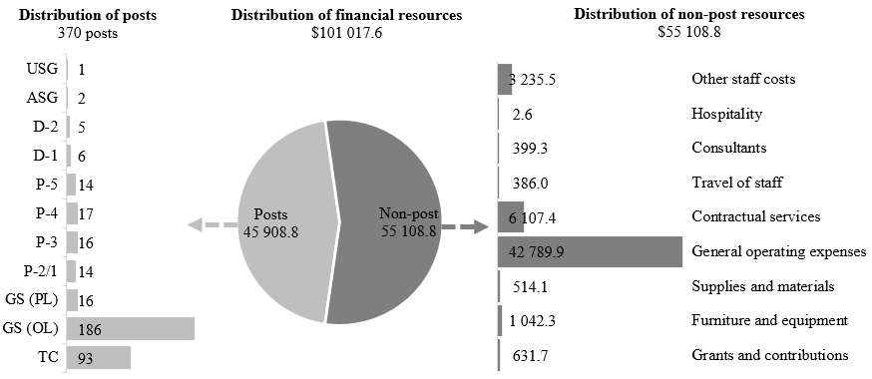

Explanation of variances by factor, component and subprogramme

Overall resource changes

Technical adjustments

29B.107 As shown in table 29B.32 (1), resource changes reflect a decrease of $540,200, as follows:
(a) Subprogramme 2, component 1, Integrated supply chain management. A decrease of $61,900 under contractual services, relating to the removal of non-recurrent provisions for updating the Procurement Manual in all six official languages in 2025, pursuant to section VI of General Assembly resolution 79/258;
(b) Subprogramme 4, Administration, New York. A decrease of $478,300, consisting of: (i) a decrease of $11,000 under other staff costs ($7,700) and general operating expenses ($3,300) relating to the removal of the non-recurrent provision for overtime and maintenance of premises, respectively, in support of the 2025 sessions of the Preparatory Commission for the Entry into Force of the Agreement under the United Nations Convention on the Law of the Sea on the Conservation and Sustainable Use of Marine Biological Diversity of Areas beyond National Jurisdiction and the Convening of the First Meeting of the Conference of the Parties to the Agreement, and the first meeting of the Conference of the Parties to the Agreement, pursuant to General Assembly decision 78/560 and resolution 79/258; and (ii) a decrease of $467,300 under general operating expenses relating to the removal of non-recurrent provisions for office space alterations for 31 posts and temporary positions established in 2025 under section 3, Political affairs, section 9, Economic and social affairs, section 10, Least developed countries, landlocked developing countries and small island developing States, and section 30, Internal oversight, pursuant to General Assembly resolutions 79/257 and 79/258.

New and expanded mandates

29B.108 As shown in table 29B.32 (1), resource changes reflect an increase of $99,400 under subprogramme 4, Administration, New York, for a non-recurrent provision under general operating expenses for office space alterations for seven posts proposed for establishment in New York under section 3, Political affairs, pursuant to General Assembly resolution 79/1, entitled “The Pact for the Future”.

Other changes

29B.109 As shown in table 29B.32 (1), resource changes reflect a net increase of $414,500, as follows:
(a) Executive direction and management. An increase of $10,900, reflecting the net effect of: (i) an increase of $16,300 under travel of staff, relating to the official travel of the Assistant Secretary-General for Support Operations to participate in meetings of the High-level Committee on Management that address common administrative management issues and promote reforms to enhance services and efficiency across the United Nations system, and (ii) a decrease of $5,400 under contractual services, resulting from reduced rates for information and communications technology (ICT) services;
(b) Subprogramme 1, component 1, Human resources support. A decrease of $15,300 under contractual services ($14,200) and general operating expenses ($1,100), reflecting lower rates for ICT services;
(c) Subprogramme 1, component 2, Capacity development and operational training. A net decrease of $8,300, consisting of: (i) a decrease of $17,700 under contractual services ($16,300) and general operating expenses ($1,400), reflecting lower rates for ICT services; and (ii) an increase of $9,400 under furniture and equipment, attributable to increased requirements for specialized e-learning tools and licences in support of the design, development and delivery of training and capacity development programmes. The types of tools required depend on the nature and design of the learning activity and consequently vary from year to year and enable the incorporation of new features, such as artificial intelligence capability, into e-learning licences in support of the design, development and/or delivery of various programmes;
(d) Subprogramme 1, component 3, Healthcare management and occupational safety and health. The net increase of $104,200 consists of the following:
(i) An increase under posts ($451,200), offset by a decrease under other staff costs ($451,200) relating to the proposed cost-neutral conversion of two P-5 temporary positions to established posts, as explained in annex II;
(ii) A decrease of $14,700 under contractual services, reflecting lower rates for ICT services;
(iii) An increase of $171,800 under general operating expenses, reflecting additional requirements for the maintenance and support of the EarthMed medical records system due to an enhancement of a safety module incorporated into the system to capture additional information ($26,200); and for the Secretariat share of the cost of administering the United Nations occupational health and safety mechanism by the World Health Organization (WHO) ($145,600). The purpose of the mechanism is to streamline and enhance the management of occupational health and safety across the United Nations system. Such a centralized mechanism would improve the coordination of occupational health and safety and well-being initiatives, reduce fragmentation and strengthen the response capabilities of the United Nations to occupational health and safety risks. The mechanism will support United Nations system entities in fulfilling their responsibilities and obligations of providing and continually improving the occupational health and safety and the well-being of United Nations personnel. Furthermore, the mechanism will be at the forefront of efforts to assist United Nations entities in the establishment and communication of risk-based guidance in addressing emerging global occupational health and safety hazards, providing a mechanism that would enable United Nations personnel to effectively deliver the Organization’s mandates while ensuring alignment with human rights standards, international labour standards and WHO recommendations;
(iv) A decrease of $28,800 under supplies and materials, attributable to lower requirements for operational supplies, due to reduced demand for influenza vaccines, the digitization of medical reports, and reduced materials and supplies for training, as the majority of courses are offered online;
(v) A decrease of $24,100 under furniture and equipment, attributable to reduced demand for the basic course licences for medical emergency preparedness training, as the component is organizing more advanced in-person courses for safety and healthcare personnel;
(e) Subprogramme 2, component 1, Integrated supply chain management. A decrease of $20,900 under contractual services ($19,200) and general operating expenses ($1,700), reflecting reduced rates for ICT services, including personal computing and telephone services;
(f) Subprogramme 2, component 2, Uniformed capabilities support. A decrease of $1,800 under general operating expenses, reflecting reduced rates for ICT services;
(g) Subprogramme 3, Special activities. A decrease of $4,700, consisting of the following:
(i) An increase under posts ($357,200), offset by a decrease under other staff costs ($357,200) relating to the proposed cost-neutral conversion of two temporary positions (1 P-4 and 1 P-2/1) to established posts, as explained in annex II;
(ii) A decrease of $4,700 under contractual services, relating to reduced rates for ICT services, including personal computing services;
(h) Subprogramme 4, Administration, New York. An increase of $359,900 reflects the net effect of:
(i) A decrease of $135,400 under contractual services, relating to reduced rates for ICT services, including personal computing services;
(ii) An increase of $495,300 under general operating expenses, relating to a non-recurrent provision for office space alterations for the post of Special Envoy of the Secretary-General for Future Generations (Under-Secretary-General), proposed under section 1, Overall policymaking, direction and coordination (A/80/6 (Sect. 1)) ($77,800), and an increase in the costs of cleaning and custodial services, based on a contractual clause for an annual escalation rate of 4.2 per cent ($433,000), offset in part by a decrease relating to lower rates for ICT services, including telephone services ($15,500);
(i) Programme support. A decrease of $9,500 under contractual services ($7,900) and general operating expenses ($1,600), relating to lower rates for ICT services, including personal computing and telephone services.

Other assessed resources

29B.110 As reflected in tables 29B.32 (2) and 29B.33 (2), other assessed resources under the support account for peacekeeping operations amount to $131,859,500. The resources would complement regular budget resources and provide for the requirements indicated in the report of the Secretary-General on the budget for the support account for peacekeeping operations for the period from 1 July 2025 to 30 June 2026 (A/79/783).

Extrabudgetary resources

29B.111 As reflected in tables 29B.32 (3) and 29B.33 (3), extrabudgetary resources amount to $70,951,700. The resources would complement regular budget resources and would be used mainly to provide for 96 posts (5 P-5, 16 P-4, 14 P-3, 7 P-2, 14 General Service (Principal level), 37 General Service (Other level) and 3 Trades and Crafts) and non-post resources. The resources would be used to:
(a) Strengthen capacities for renewable energy in peacekeeping operations;
(b) Provide support and services to agencies, funds and programmes in human resources, capacity development and healthcare management in the following areas: language proficiency examinations, language and communications programmes and the administration of special exams; and the facilitation of rostering and medical consultations, travel health advisories, immunizations and other medical administrative matters, such as medical clearances, sick leave certification and recommendations for medical evacuations/repatriations. Extrabudgetary resources support the client offices funded from extrabudgetary sources in the areas of facilities management and office space, travel and transportation and pouch and mail services, human resources services for processing separations, onboarding and complex entitlements, operational and transactional functions consisting of payroll, accounts payable and commercial insurance, and the processing of tax advances and settlements of federal and state taxes for United States citizens and residents employed by the United Nations and its agencies, funds and programmes;
(c) Support procurement actions in the areas of corporate support services for field and Headquarters operations and continuation of the project to implement gender-sensitive designs for infrastructure;
(d) Support the triangular partnership programme, a capacity-building model aimed at training uniformed personnel in the peacekeeping-enabling capacity through collaboration among Member States with expertise and resources, troop-contributing countries and the Secretariat.
29B.112 In addition, following the decision of the General Assembly to transfer the improved service delivery team from the Department of Management Strategy, Policy and Compliance to the Department of Operational Support (see resolution 79/257, para. 63), financial resources from central support costs would fund the extrabudgetary share of the improved service delivery team in the Resource Planning, Analysis and Improved Delivery Service (renamed from the Resource Planning and Analysis Section, in order to better reflect the work undertaken by this entity) in the Division for Special Activities, where the team will be integrated. Financial resources from central support costs would also fund the extrabudgetary resources share of Umoja business support resources.
29B.113 The extrabudgetary resources under the present section are subject to the oversight of the Department, which has delegated authority from the Secretary-General.

Executive direction and management

29B.114 The executive direction and management component comprises the Offices of the Under-Secretary-General, the Assistant Secretary-General for Support Operations and the Assistant Secretary-General for Supply Chain Management.
29B.115 The main responsibilities of the executive direction and management component include:
(a) The overall direction, supervision and management of the Department in the implementation of its mandates and its approved programme of work, including co-chairing of the Management Client Board by the Under-Secretary-General, jointly with the Under-Secretary-General for Management Strategy, Policy and Compliance;
(b) Provision of leadership management, including on strategic planning, and data analytics. The component coordinates, develops and prepares responses to oversight body reports and follows up on the recommendations of boards of inquiry;
(c) Provision of leadership and direction to support clients across the Secretariat, through guidance and advisory services in their exercise of authorities for the successful implementation of mandates relating to human resources, healthcare management and occupational health and safety, as well as capacity development and operational training;
(d) Provision of leadership and direction, as well as the overall administration and management, of all activities relating to the organizational entities, which together form the integrated supply chain and uniformed capabilities support.
29B.116 In accordance with the 2030 Agenda for Sustainable Development, in particular target 12.6 of the Sustainable Development Goals, in which organizations are encouraged to integrate sustainability information into their reporting cycles, and in compliance with the cross-cutting mandate set out in paragraph 19 of General Assembly resolution 72/219, the Department is integrating environmental management practices into its operations. The Department will provide technical guidance and advisory support to peacekeeping operations and field-based special political missions to facilitate and implement The Way Forward: Environment Strategy for Peace Operations 2023–2030, the environmental management of the United Nations campus and facilities, and environmental initiatives in the area of supply chain management.
29B.117 Information on the timely submission of documentation and advance booking for air travel is reflected in table 29B.35.
29B.118 The Department has improved its compliance rate by conducting presentations for senior leadership and staff on the implementation of the administrative instruction on official travel (ST/AI/2013/3/Rev.1) and providing clear directives on the exercise of discretionary authority for travel requests submitted less than 21 days in advance. The Department continues to monitor its compliance rate, ensures the timely scheduling of meetings and emphasizes travel policy requirements to all meeting participants. In addition, the Department has established service-level agreements with the Regional Service Centre in Entebbe, Uganda, and the Economic and Social Commission for Asia and the Pacific, leveraging local support to facilitate travel for external participants attending training in Asia and Africa.

Table 29B.35

Compliance rate

(Percentage)

 | 2022 actual | 2023 actual | 2024 actual | 2025 planned | 2026 planned
Timely submission of documentation | 100 | 100 | 100 | 100 | 100
Air tickets purchased at least two weeks before the commencement of travel | 46 | 80 | 90 | 100 | 100

29B.119 The proposed regular budget resources for 2026 amount to $2,050,600 and reflect a net decrease of $10,900 compared with the approved budget for 2025. The proposed change is explained in paragraph 29B.109 (a) above. Additional details on the distribution of the proposed resources for 2026 are reflected in table 29B.36 and figure 29B.X.

Table 29B.36

Executive direction and management: evolution of financial and post resources

(Thousands of United States dollars/number of posts)

 | 2024 expenditure | 2025 approved | Changes |  |  |  |  | 2026 estimate
 | 2024 expenditure | 2025 approved | Technical adjustments | New/ expanded mandates | Other | Total | Percentage | 2026 estimate
Financial resources by main category of expenditure
Posts | 2 115.1 | 2 007.0 | – | – | – | – | – | 2 007.0
Non-post | 41.6 | 32.7 | – | – | 10.9 | 10.9 | 33.3 | 43.6
Total | 2 156.7 | 2 039.7 | – | – | 10.9 | 10.9 | 0.5 | 2 050.6
Post resources by category
Professional and higher |  | 6 | – | – | – | – | – | 6
General Service and related |  | 3 | – | – | – | – | – | 3
Total |  | 9 | – | – | – | – | – | 9

Figure 29B.X

Executive direction and management: distribution of proposed resources for 2026

(Number of posts/thousands of United States dollars)

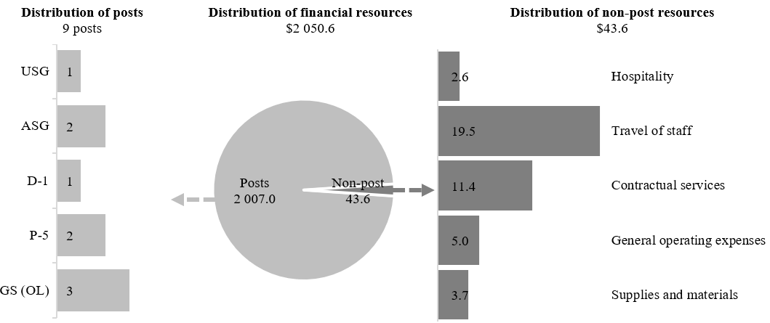

Programme of work

Subprogramme 1

Support operations

Component 1

Human resources support

29B.120 The proposed regular budget resources for 2026 amount to $3,710,500 and reflect a decrease of $15,300 compared with the approved budget for 2025. The proposed change is explained in paragraph 29B.109 (b) above. Additional details on the distribution of the proposed resources for 2026 are reflected in table 29B.37 and figure 29B.XI.

Table 29B.37

Subprogramme 1, component 1: evolution of financial and post resources

(Thousands of United States dollars/number of posts)

 | 2024 expenditure | 2025  approved | Changes |  |  |  |  | 2026 estimate
 | 2024 expenditure | 2025  approved | Technical adjustments | New/ expanded mandates | Other | Total | Percentage | 2026 estimate
Financial resources by main category of expenditure
Posts | 3 293.6 | 3 118.9 | – | – | – | – | – | 3 118.9
Non-post | 506.1 | 606.9 | – | – | (15.3) | (15.3) | 2.5 | 591.6
Total | 3 799.7 | 3 725.8 | – | – | (15.3) | (15.3) | (0.4) | 3 710.5
Post resources by category
Professional and higher |  | 11 | – | – | – | – | – | 11
General Service and related |  | 9 | – | – | – | – | – | 9
Total |  | 20 | – | – | – | – | – | 20

Figure 29B.XI

Subprogramme 1, component 1: distribution of proposed resources for 2026

(Number of posts/thousands of United States dollars)

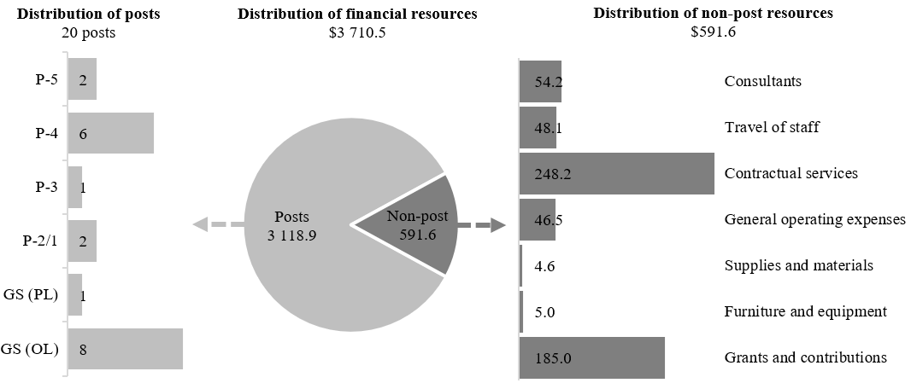

Component 2

Capacity development and operational training

29B.121 The proposed regular budget resources for 2026 amount to $6,962,100 and reflect a net decrease of $8,300 compared with the approved budget for 2025. The proposed change is explained in paragraph 29B.109 (c) above. Additional details on the distribution of the proposed resources for 2026 are reflected in table 29B.38 and figure 29B.XII.

Table 29B.38

Subprogramme 1, component 2: evolution of financial and post resources

(Thousands of United States dollars/number of posts)

 | 2024 expenditure | 2025  approved | Changes |  |  |  |  | 2026 estimate
 | 2024 expenditure | 2025  approved | Technical adjustments | New/  expanded mandates | Other | Total | Percentage | 2026 estimate
Financial resources by main category of expenditure
Posts | 677.5 | 873.8 | – | – | – | – | – | 873.8
Non-post | 5 402.3 | 6 096.6 | – | – | (8.3) | (8.3) | (0.1) | 6 088.3
Total | 6 079.8 | 6 970.4 | – | – | (8.3) | (8.3) | (0.1) | 6 962.1
Post resources by category
Professional and higher |  | 4 | – | – | – | – | – | 4
General Service and related |  | 1 | – | – | – | – | – | 1
Total |  | 5 | – | – | – | – | – | 5

Figure 29B.XII

Subprogramme 1, component 2: distribution of proposed resources for 2026

(Number of posts/thousands of United States dollars)

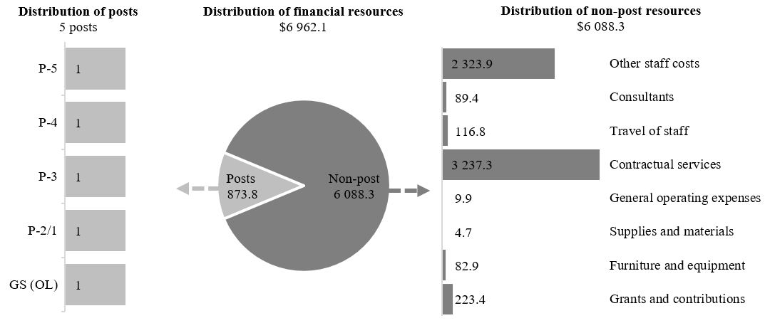

Component 3

Healthcare management and occupational safety and health

29B.122 The proposed regular budget resources for 2026 amount to $3,710,300 and reflect a net increase of $104,200 compared with the approved budget for 2025. The proposed change is explained in paragraph 29B.109 (d) above. Additional details on the distribution of the proposed resources for 2026 are reflected in table 29B.39 and figure 29B.XIII.

Table 29B.39

Subprogramme 1, component 3: evolution of financial and post resources

(Thousands of United States dollars/number of posts)

 | 2024 expenditure | 2025  approved | Changes |  |  |  |  | 2026 estimate
 | 2024 expenditure | 2025  approved | Technical adjustments | New/ expanded mandates | Other | Total | Percentage | 2026 estimate
Financial resources by main category of expenditure
Posts | 2 321.6 | 2 460.5 | – | – | 451.2 | 451.2 | 18.3 | 2 911.7
Non-post | 1 005.5 | 1 145.6 | – | – | (347.0) | (347.0) | (30.3) | 798.6
Total | 3 327.0 | 3 606.1 | – | – | 104.2 | 104.2 | 2.9 | 3 710.3
Post resources by category
Professional and higher |  | 7 | – | – | 2 | 2 | 28.6 | 9
General Service and related |  | 9 | – | – | – | – | – | 9
Total |  | 16 | – | – | 2 | 2 | 12.5 | 18

Figure 29B.XIII

Subprogramme 1, component 3: distribution of proposed resources for 2026

(Number of posts/thousands of United States dollars)

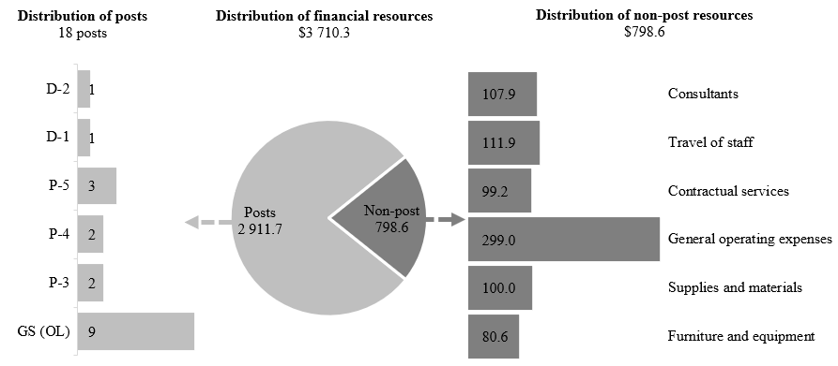

Subprogramme 2

Supply chain management

Component 1

Integrated supply chain management

29B.123 The proposed regular budget resources for 2026 amount to $5,066,700 and reflect a decrease of $82,800 compared with the approved budget for 2025. The proposed change is explained in paragraphs 29B.107 (a) and 29B.109 (e) above. Additional details on the distribution of the proposed resources for 2026 are reflected in table 29B.40 and figure 29B.XIV.

Table 29B.40

Subprogramme 2, component 1: evolution of financial and post resources

(Thousands of United States dollars/number of posts)

 | 2024 expenditure | 2025  approved | Changes |  |  |  |  | 2026 estimate
 | 2024 expenditure | 2025  approved | Technical adjustments | New/ expanded mandates | Other | Total | Percentage | 2026 estimate
Financial resources by main category of expenditure
Posts | 3 668.8 | 4 898.7 | – | – | – | – | – | 4 898.7
Non-post | 169.1 | 250.8 | (61.9) | – | (20.9) | (82.8) | (33.0) | 168.0
Total | 3 838.0 | 5 149.5 | (61.9) | – | (20.9) | (82.8) | (1.6) | 5 066.7
Post resources by category
Professional and higher |  | 12 | – | – | – | – | – | 12
General Service and related |  | 24 | – | – | – | – | – | 24
Total |  | 36 | – | – | – | – | – | 36

Figure 29B.XIV

Subprogramme 2, component 1: distribution of proposed resources for 2026

(Number of posts/thousands of United States dollars)

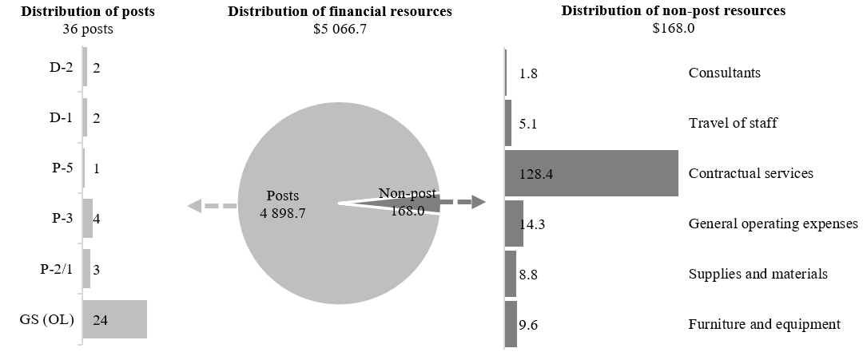

Component 2

Uniformed capabilities support

29B.124 The proposed regular budget resources for 2026 amount to $358,400 and reflect a decrease of $1,800 compared with the approved budget for 2025. The proposed change is explained in paragraph 29B.109 (f) above. Additional details on the distribution of the proposed resources for 2026 are reflected in table 29B.41 and figure 29B.XV.

Table 29B.41

Subprogramme 2, component 2: evolution of financial and post resources

(Thousands of United States dollars/number of posts)

 | 2024 expenditure | 2025  approved | Changes |  |  |  |  | 2026 estimate
 | 2024 expenditure | 2025  approved | Technical adjustments | New/ expanded mandates | Other | Total | Percentage | 2026 estimate
Financial resources by main category of expenditure
Posts | 314.8 | 349.3 | – | – | – | – | – | 349.3
Non-post | 7.9 | 10.9 | – | – | (1.8) | (1.8) | (16.5) | 9.1
Total | 322.7 | 360.2 | – | – | (1.8) | (1.8) | (0.5) | 358.4
Post resources by category
Professional and higher |  | 1 | – | – | – | – | – | 1
General Service and related |  | 2 | – | – | – | – | – | 2
Total |  | 3 | – | – | – | – | – | 3

Figure 29B.XV

Subprogramme 2, component 2: distribution of proposed resources for 2026

(Number of posts/thousands of United States dollars)

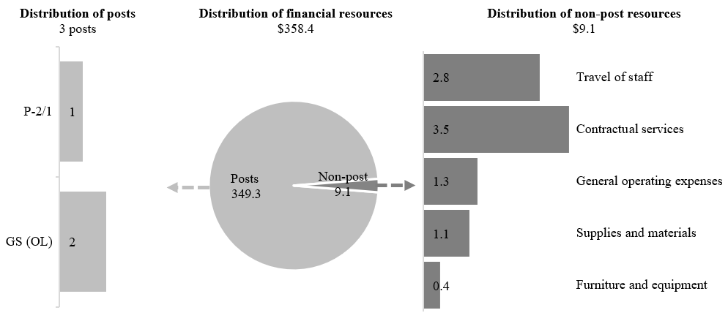

Subprogramme 3

Special activities

29B.125 The proposed regular budget resources for 2026 amount to $1,456,200 and reflect a decrease of $4,700 compared with the approved budget for 2025. The proposed change is explained in paragraph 29B.109 (g) above. Additional details on the distribution of the proposed resources for 2026 are reflected in table 29B.42 and figure 29B.XVI.

Table 29B.42

Subprogramme 3: evolution of financial and post resources

(Thousands of United States dollars/number of posts)

 | 2024 expenditure | 2025  approved | Changes |  |  |  |  | 2026 estimate
 | 2024 expenditure | 2025  approved | Technical adjustments | New/ expanded mandates | Other | Total | Percentage | 2026 estimate
Financial resources by main category of expenditure
Posts | 411.7 | 729.3 | – | – | 357.2 | 357.2 | 49.0 | 1 086.5
Non-post | 275.8 | 731.6 | – | – | (361.9) | (361.9) | 49.5 | 369.7
Total | 687.5 | 1 460.9 | – | – | (4.7) | (4.7) | (0.3) | 1 456.2
Post resources by category
Professional and higher |  | 3 | – | – | 2 | 2 | 66.7 | 5
General Service and related |  | – | – | – | – | – | – | –
Total |  | 3 | – | – | 2 | 2 | 66.7 | 5

Figure 29B.XVI

Subprogramme 3: distribution of proposed resources for 2026

(Number of posts/thousands of United States dollars)

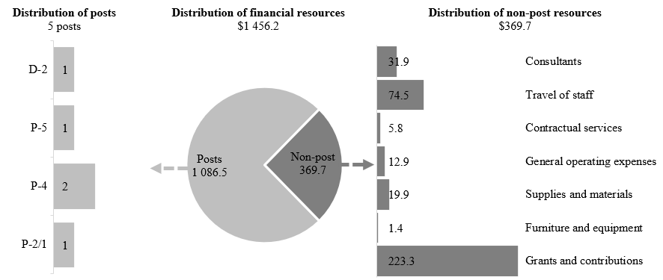

Subprogramme 4

Administration, New York

29B.126 The proposed regular budget resources for 2026 amount to $75,539,600 and reflect a net decrease of $19,000 compared with the approved budget for 2025. The proposed change is explained in paragraphs 29B.107 (b), 29B.108 and 29B.109 (h) above. Additional details on the distribution of the proposed resources for 2026 are reflected in table 29B.43 and figure 29B.XVII.

Table 29B.43

Subprogramme 4: evolution of financial and post resources

(Thousands of United States dollars/number of posts)

 | 2024 expenditure | 2025  approved | Changes |  |  |  |  | 2026 estimate
 | 2024 expenditure | 2025  approved | Technical adjustments | New/ expanded mandates | Other | Total | Percentage | 2026 estimate
Financial resources by main category of expenditure
Posts | 25 942.3 | 28 708.1 | – | – | – | – | – | 28 708.1
Non-post | 39 862.4 | 46 850.5 | (478.3) | 99.4 | 359.9 | (19.0) | (0.0) | 46 831.5
Total | 65 804.7 | 75 558.6 | (478.3) | 99.4 | 359.9 | (19.0) | (0.0) | 75 539.6
Post resources by category
Professional and higher |  | 22 | – | – | – | – | – | 22
General Service and related |  | 238 | – | – | – | – | – | 238
Total |  | 260 | – | – | – | – | – | 260

Figure 29B.XVII

Subprogramme 4: distribution of proposed resources for 2026

(Number of posts/thousands of United States dollars)

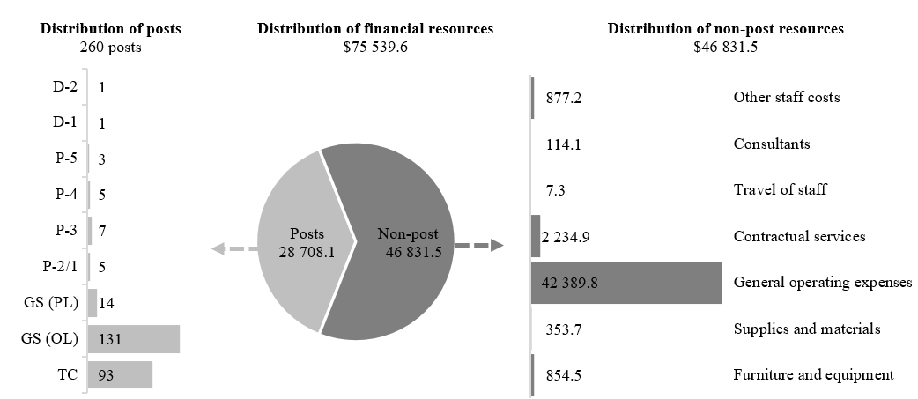

Programme support

29B.127 The proposed regular budget resources for 2026 amount to $2,163,200 and reflect a decrease of $9,500 compared with the approved budget for 2025. The proposed change is explained in paragraph 29B.109 (i) above. Additional details on the distribution of the proposed resources for 2026 are reflected in table 29B.44 and figure 29B.XVIII.

Table 29B.44

Programme support: evolution of financial and post resources

(Thousands of United States dollars/number of posts)

 | 2024 expenditure | 2025  approved | Changes |  |  |  |  | 2026 estimate
 | 2024 expenditure | 2025  approved | Technical adjustments | New/  expanded mandates | Other | Total | Percentage | 2026 estimate
Financial resources by main category of expenditure
Posts | 1 603.1 | 1 954.8 | – | – | – | – | – | 1 954.8
Non-post | 32.8 | 217.9 | – | – | (9.5) | (9.5) | (4.4) | 208.4
Total | 1 635.9 | 2 172.7 | – | – | (9.5) | (9.5) | (0.4) | 2 163.2
Post resources by category
Professional and higher |  | 5 | – | – | – | – | – | 5
General Service and related |  | 9 | – | – | – | – | – | 9
Total |  | 14 | – | – | – | – | – | 14

Figure 29B.XVIII

Programme support: distribution of proposed resources for 2026

(Number of posts/thousands of United States dollars)

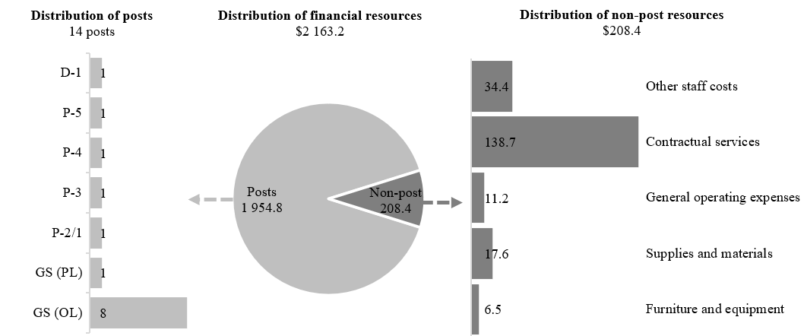

Annex I

Organizational structure and post distribution for 2026

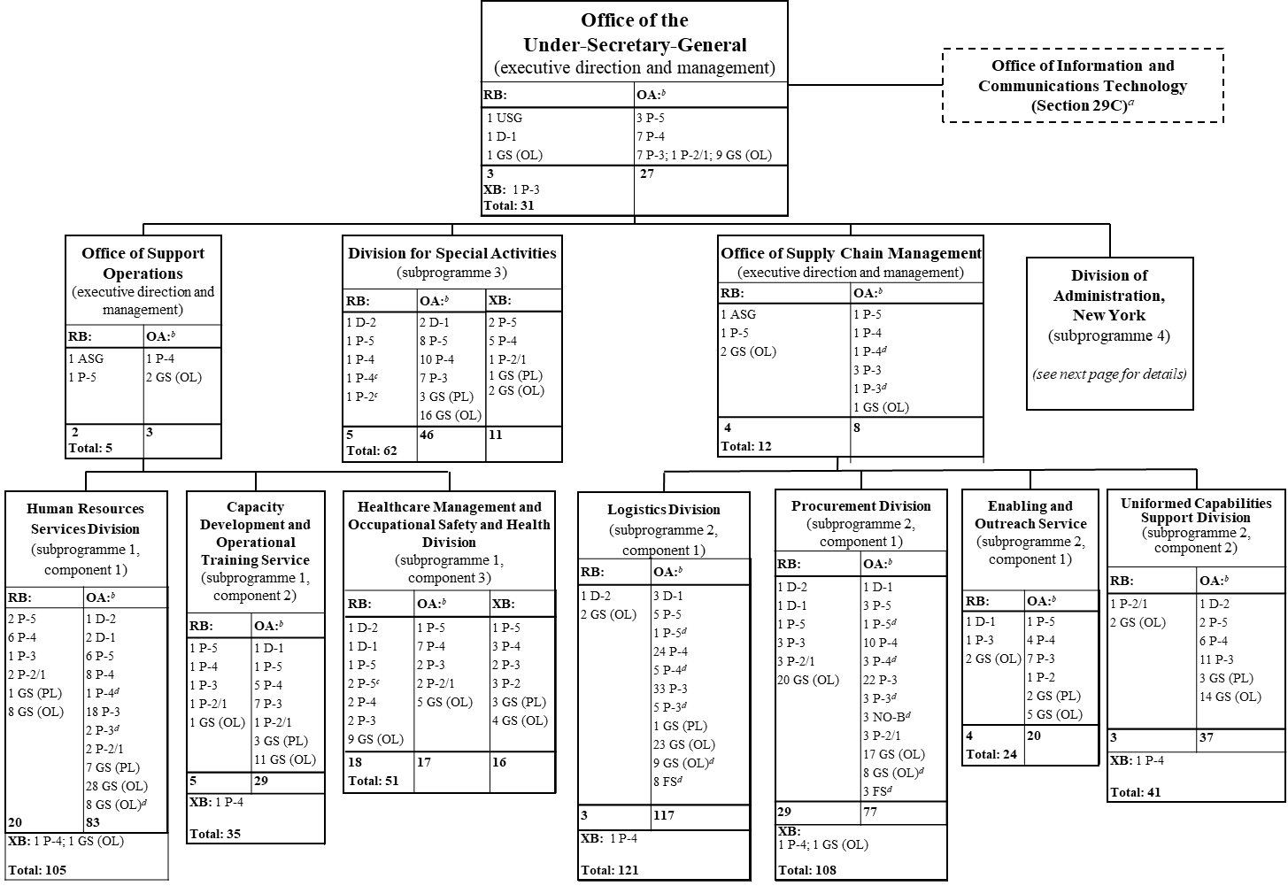

Organizational structure and post distribution for 2026 (continued)
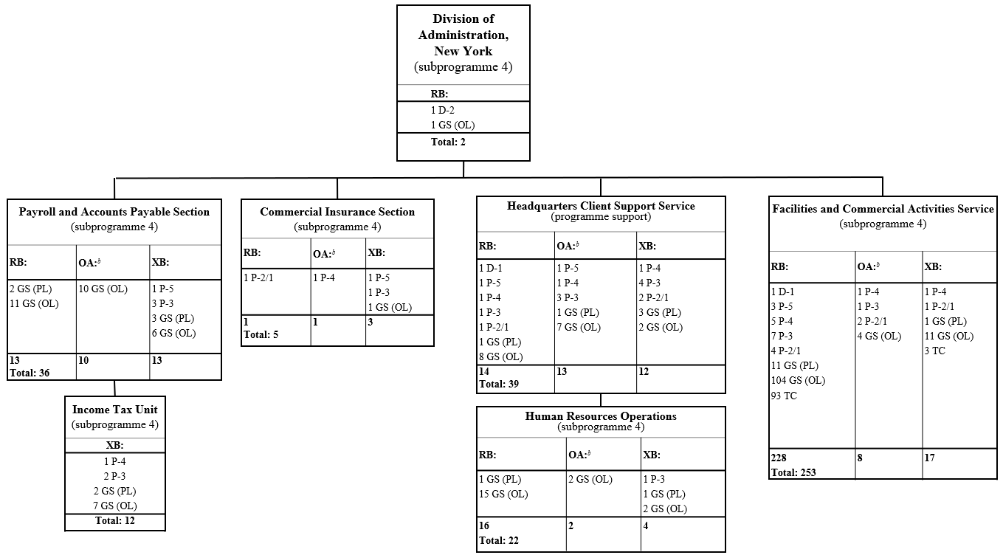

Abbreviations: ASG, Assistant Secretary-General; FS, Field Service; GS (OL), General Service (Other level); GS (PL), General Service (Principal level); LL, Local level; NO-B, National Professional Officer, level B; OA, other assessed; RB, regular budget; TC, Trades and Crafts; USG, Under-Secretary-General; XB, extrabudgetary.
ª Dual reporting to both the Under-Secretary-General for Management Strategy, Policy and Compliance and the Under-Secretary-General for Operational Support.
^{b} Other assessed resources are based on those proposed for the period 2025/26 (see A/79/783).
^{c} Conversion.
^{d} Redeployment.

Annex II

Summary of proposed post changes, by component and subprogramme

Component/subprogramme | Posts | Grade | Description | Reason for change
Subprogramme 1, component 3, Healthcare management and occupational safety and health | 2 | P-5 | Conversion of two temporary positions (one Senior Medical Officer – Public health crises, and one Senior Medical Officer – Emergency preparedness and response to mass casualty events) to established posts | The proposed cost-neutral conversion of four general temporary assistance positions (2 P-5, 1 P-4 and 1 P-2/1) to established posts would provide long-term stability in the execution of essential functions in support of the work of the Healthcare Management and Occupational Safety and Health Division and the Division for Special Activities. These positions were created in 2009 and 2010, more than 10 years ago, and their conversion is proposed given the long-term and core nature of the functions performed by the incumbents of these positions, including, as indicated below:
 |  |  |  | Senior Medical Officer – Public health crises (P-5): the incumbent advises the Administration on all matters and standards related to public health relevant to staff of the United Nations, including peacekeeping missions worldwide, the New York-based United Nations agencies and programmes and military contingent personnel under the Department of Peace Operations; oversees and provides health education and health promotion programmes through the development, coordination and implementation of preventive and response activities to public emergencies at duty stations with a United Nations presence; develops, reviews and revises various medical standards and guidelines on preventive measures to mitigate public health risks; provides leadership in the continuous assessment of needs, planning, development, implementation, monitoring, evaluation and/or updating policies, procedures, standards, protocols, guidelines and emergency plans in response to outbreaks of communicable diseases; monitors and analyses worldwide outbreak patterns of communicable diseases and provides strategic leadership in the development and implementation of the United Nations response to outbreaks; recommends a course of action to the Medical Director, including a communication strategy and preventive measures, in response to actual or imminent outbreak scenarios affecting the United Nations community; supervises nurses; and ensures availability of drugs and medical supplies during public health emergencies and outbreaks. The above-mentioned functions and work are critical and continuing in nature for public health crises and infectious disease outbreaks and for the coordination of health promotion and preventive health programmes for United Nations personnel globally.
Senior Medical Officer – Emergency preparedness and response to mass casualty events (P-5): over the last decade, medical crisis management has moved from a general capacity to a specific domain of expertise. As the volatility of the geopolitical sphere increases and in view of the impacts of climate change, converting the Senior Medical Officer role to an established post would promote stability, effectiveness and accountability in the emergency medical response efforts of the United Nations, aligning with broader goals of humanitarian aid and medical crisis management.
The scope of the position encompasses all aspects related to emergency care and medical crisis management, from single casualty and CASEVAC to mass casualty incident management, and the development of a casualty tracking system. The post would cover all United Nations entities with overarching advisory, monitoring and support and training functions to improve global medical resilience, fostering coordination, engagement and pursuance of mandates.
Subprogramme 3  Special activities | 1 | P-4 | Conversion of one temporary position of Programme Management Officer to an established post | The Programme Management Officer (P-4) functions reflect a continuous requirement of a dedicated capacity to support the provision of essential services and the organization of duty of care to United Nations personnel affected by critical emergency events (including malicious acts and natural disasters). The Programme Management Officer (P-4) carries out functions in the Client Support and Special Situations Section, which serves as a dedicated capacity to support the delivery of a full range of human resources expertise in mission start-ups, surges and transitions, including crisis preparedness and response. The Programme Management Officer leads the preparedness and coordination of a rapid, comprehensive and coordinated response to critical incidents, as well as the provision of continuous support to personnel and families, before, during and after a crisis.
 | 1 | P-2 | Conversion of one temporary position of Associate Administrative Officer to an established post
 |  |  |  | The Associate Administrative Officer (P-2/1) functions are a continuous requirement to enable the Secretariat to have a dedicated capacity to support the provision of essential services and the organization of duty of care to United Nations personnel affected by critical emergency events (including malicious acts and natural disasters). The Associate Administrative Officer supports the work of the Programme Management Officer (P-4) in the Client Support and Special Situations Section in the coordination of preparedness and rapid response to critical incidents and in the development of training programmes to build capacity closest to where critical incidents may arise.

