Eightieth session

* A/80/50.
** In keeping with paragraph 10 of General Assembly resolution 77/267, the part consisting of the programme plan and programme performance information (part II) is submitted through the Committee for Programme and Coordination for the consideration of the Assembly.
*** In keeping with paragraph 10 of General Assembly resolution 77/267, the part consisting of the post and non-post resource requirements (part III) is submitted through the Advisory Committee on Administrative and Budgetary Questions for the consideration of the Assembly.
Items 137 and 138 of the preliminary list*

Proposed programme budget for 2026

Programme planning

Proposed programme budget for 2026

Part VIII

Common support services

Section 29C

Office of Information and Communications Technology

Programme 25

Management and support services

Contents
 |  |  | Page
- Proposed programme plan for 2026 and programme performance in 2024** |  |  | 3
Overall orientation |  |  | 3
Programme of work |  |  | 5
Subprogramme 1. Strategy and technology innovation |  |  | 5
Subprogramme 2. Operations support |  |  | 9
Subprogramme 3. Enterprise solutions |  |  | 13
- Proposed post and non-post resource requirements for 2026*** |  |  | 18
Overview |  |  | 18
Executive direction and management |  |  | 23
Programme of work |  |  | 25
Subprogramme 1. Strategy and technology innovation |  |  | 25
Subprogramme 2. Operations support |  |  | 26
Subprogramme 3. Enterprise solutions |  |  | 27
Annexes
I. Organizational structure and post distribution for 2026 |  |  | 29
II. Summary of proposed post changes, by component and subprogramme |  |  | 30

A. Proposed programme plan for 2026 and programme performance in 2024

Overall orientation

Mandates and background

29C.1 The Office of Information and Communications Technology is responsible for the direction, strategy and delivery of information and communications technology (ICT) in the United Nations. The mandate derives from the priorities established in relevant General Assembly resolutions and decisions, including resolutions 63/262 and 72/266 B.

Strategy and external factors for 2026

29C.2 In 2026, the Office will continue to implement programmes that support the ICT strategic outcomes of ensuring an environment in which ICT allows the Organization to deliver efficiencies, facilitating coherent and integrated mandate implementation, ICT is leveraged as a critical operational and strategic enabler for the work of the United Nations and the Organization is protected from rapidly escalating threats to ICT security.
29C.3 The Office remains committed to providing resilient and secure global network and ICT systems, platforms and applications that enable collaboration and communication across the Secretariat and throughout the wider United Nations common system. Service availability and the reliability of centrally provided enterprise services and solutions necessitates upgrades and modernization efforts, where feasible and cost-effective. Operational efficiency will be enhanced through key performance indicators and reengineering processes on the basis of data insights, ensuring that ICT operational capabilities are preserved, secured, resilient and fit-for-purpose to support mandate delivery by Secretariat entities.
29C.4 The transformative potential of technology, including cloud-based platforms, enables United Nations personnel to collaborate and connect seamlessly. The Office will continue its strategic shift of leveraging hybrid cloud-based services and strengthen ICT security while maintaining enterprise on-premise solutions for legitimate business cases, such as compliance with specific resolutions and mandates. This hybrid multi-cloud strategy ensures flexibility in meeting diverse organizational needs and the agility to leverage strengths of multiple cloud providers, and further enhances operational resiliency while mitigating vendor lock-in.
29C.5 In the context of ICT security, challenges continue to grow in scale, pervasiveness and complexity. In response, the Office will centralize ICT security capacity, enhance the use of shared services of proactive threat-hunting capabilities and replace the reactive intrusion detection systems. The centralization of ICT security services will strengthen internal capacity, while a clear focus is kept on United Nations operations. Other key initiatives are also under way, including continuous improvements in networks, which is instrumental in containing threats and limiting the impact of successful attacks, the upgrade of various security solutions to detect issues of security concern and to protect end-user devices, digital identities and cloud-based services, and increased interactive awareness campaigns.
29C.6 The Office continues to support efforts to digitally transform the Organization into one that more effectively uses data and information to support decision-making and inform strategic direction. This work will be aligned with the ICT strategy (see A/77/489 and A/79/339) and the Data Strategy of the Secretary-General for Action by Everyone, Everywhere. The effective use of data across the Secretariat requires cross-cutting efforts, with the Office leading any such efforts relating to technology and the establishment of services and capacities that support the management and use of data. The Office continues to leverage technology enablers that support the exchange, reconciliation, storage and governance of data. Analytics and data solutions will also continue to be implemented, and associated standards and architecture will be formulated to achieve a consistent approach to data. Efforts will be made to address the growing demand for frontier technologies such as artificial intelligence. The Office will also support areas such as policy formulation and the governance of information management, including the use and adoption of artificial intelligence.
29C.7 In support of innovation, the Office will continue to provide access to technologies that can support a wide range of needs across the United Nations. Frontier technologies, in particular artificial intelligence, will support the work of the Organization and mandate delivery globally. Conversational artificial intelligence continues to be deployed to ensure more intuitive and efficient access to information. These solutions are designed to be foundational to ensure that they can be integrated into the various systems in use across the Organization.
29C.8 The Office will further advance its work in digital transformation, strengthening business relationships between the Office’s service providers and United Nations Secretariat entities by facilitating clear communication, managing demands effectively and ensuring effective problem resolution. The Office will also continue to serve as a centralized function for global enterprise ICT project governance through the project management team, ensuring that projects comply with the project management methodology, achieving desired outcomes and aligning with strategic objectives. It will also ensure that overall Secretariat ICT budget proposals are technically reviewed by the business relationship management team.
29C.9 With regard to inter-agency coordination and liaison, the Office will continue to collaborate with agencies, funds and programmes to agree on minimum standards of ICT security and communities of practice to discuss opportunities and challenges at the inter-agency level. This will be done through the United Nations System Chief Executives Board for Coordination Digital and Technology Network, which is co-chaired by the Assistant Secretary-General/Chief Information Technology Officer and serves as a mechanism to collaborate on, harmonize and explore possibilities for better use of shared ICT services. The Office will also continue to ensure access to Secretariat platforms for personnel from United Nations agencies, funds and programmes in order to facilitate collaboration and will strategize on the mitigation of cost increases and minimizing duplication across the United Nations common system to support coherence in mandate delivery.
29C.10 With regard to the external factors, the Office considered applicable risks identified in its risk register, and, accordingly, the overall plan for 2026 is based on the planning assumption that there will be adequate voluntary contributions through effective partnering to complement regular budget resources to carry out the activities of the Office.
29C.11 The Office integrates a gender perspective into its operational activities, deliverables and results, as appropriate. The Office will continue to coordinate and host events, both virtual and in-person, to promote women in technology within the Secretariat and to highlight the contributions of women to mandate delivery across all programmes.
29C.12 In line with the United Nations Disability Inclusion Strategy, the Office will continue to improve the accessibility of enterprise applications and public information websites for persons with disabilities, including by adding functionality to, remediating or configuring existing websites and applications in accordance with the established accessibility guidelines for United Nations websites.

Legislative mandates

29C.13 The list below, which was reviewed in the preparation of the proposed programme budget, provides all mandates entrusted to the programme.

General Assembly resolutions

63/262 | Information and communications technology, enterprise resource planning, and security, disaster recovery and business continuity
69/262, sect. II | Questions relating to the programme budget for the biennium 2014–2015: information and communications technology in the United Nations
70/248 A, sect. V | Special subjects relating to the proposed programme budget for the biennium 2016–2017: information and communications technology in the United Nations
71/272 B, sect. III | Special subjects relating to the programme budget for the biennium 2016–2017: status of implementation of the information and communications technology strategy for the United Nations
72/262 C, sect. I | Special subjects relating to the programme budget for the biennium 2018–2019: status of implementation of the information and communications technology strategy for the United Nations
78/243 | Information and communications technology strategy

Deliverables

29C.14 Table 29C.1 lists all cross-cutting deliverables of the programme.

Table 29C.1

Cross-cutting deliverables for the period 2024–2026, by category and subcategory

Category and subcategory | 2024 planned | 2024 actual | 2025 planned | 2026 planned
2026 planned
A. Facilitation of the intergovernmental process and expert bodies
Parliamentary documentation (number of documents) | 1 | 1 | – | 1
1. Report of the Secretary-General on the refined elements of the information and communications technology strategy for the United Nations | 1 | 1 | – | 1
Substantive services for meetings (number of three-hour meetings) | 5 | 5 | 3 | 5
Meetings of:
2. The Fifth Committee | 2 | 2 | 1 | 2
3. The Committee for Programme and Coordination | 1 | 1 | 1 | 1
4. The Advisory Committee on Administrative and Budgetary Questions | 2 | 2 | 1 | 2

Evaluation activities

29C.15 The joint evaluation by the Department of Management Strategy, Policy and Compliance, the Department of Operational Support and the Office on ICT security, which began in 2024, will continue and be completed in 2026. The evaluation entails the analysis of completed mandatory ICT security training, performance of fake phishing exercises and ICT security incidents affecting end users.

Programme of work

Subprogramme 1

Strategy and technology innovation

Objective

29C.16 The objective, to which this subprogramme contributes, is to enhance an innovative, secure, unified digital space for the United Nations.

Strategy

29C.17 To contribute to the objective, the subprogramme will continue to focus on the establishment of strategies, policies and governance, including support for the efficiency agenda, the development of technology strategies aligned with the Organization’s priorities, the establishment of technical procedures and guidelines, and a review of standards and architecture. Specifically, the subprogramme will:
(a) Provide advice covering data, analytics, artificial intelligence, innovation and information management;
(b) Develop technology standards and road maps to envisage and define how United Nations technologies should be implemented in support of the core mandates of the United Nations (see General Assembly resolution 69/262, sect. II, third preambular paragraph), taking into account organizational needs, as well as strategic direction and innovation;
(c) Work closely with United Nations clients to identify their key data, information and technology requirements or challenges and, in close collaboration with internal and external partners, design innovative, integrated and security resilient technology solutions, leveraging artificial intelligence, and facilitate an enabling environment to meet clients’ needs;
(d) Support United Nations entities in assessing and reducing the level of risk to the image, resources, data, operations and safety of the personnel and ICT assets of the United Nations and ensure that ICT security risks do not hamper efforts to implement United Nations mandates or adversely affect support to Member States, through the provision of specific ICT security guidance, the performance of system security reviews and the conduct of ICT security awareness training;
(e) Reinforce the centralized capacity for ICT security in the Enterprise Data Centre in Valencia, Spain, to more effectively address the continuous growth of the global threats affecting the Secretariat and the evolution of technology and ICT security operations, enabling efficient adaptation to rapidly changing and expanded ICT security risks and strengthening core capacity for proactive vulnerability and threat and incident management Secretariat-wide, as presented in the report of the Secretary-General on capital investment planning (A/77/519);
(f) Promote ICT security campaigns, the use of advanced security features, implementation and support of security measures, strengthening vulnerability management, operational resilience and proactive threat management capabilities;
(g) Promote the effective use of data, facilitate access to data across the Organization by leveraging modern technology, strengthen data literacy by co-leading the implementation of the Data Strategy of the Secretary-General and govern information and data management.
29C.18 The above-mentioned work is expected to result in:
(a) Better awareness of and access to innovation techniques and new technologies, and increased capacity for Secretariat entities to deliver on mandates;
(b) Strengthened operational resilience of the Organization, better end user awareness of ICT security threats and reduced exposure of the digital data and infrastructure of the United Nations to various security threats;
(c) Reinforced and centralized ICT security with core capacity for proactive vulnerability management and threat and incident management, while ensuring global Secretariat coordination on ICT security matters, including compliance;
(d) Integrated, secure and innovative use of information and data by United Nations entities;
(e) A coherent ICT landscape in the Secretariat through compliance with policies, procedures and guidelines, as well as common standards, strategies and architecture.

Programme performance in 2024

Unite Academy: strengthened data literacy for informed decisions

29C.19 As the United Nations becomes ever more data-driven, data literacy is critically important for improving both individual performance and achieving the mandates of the United Nations. Data literacy skills equip United Nations personnel with the acumen to navigate data landscapes, seek meaningful insights and confidently share those findings. Over time, this foundation fuels evidence-driven decisions, enhancing the quality and impact of the Organization’s initiatives. The subprogramme promotes data literacy through the Unite Academy training platform. Since its launch in 2021, biannual sessions have been run offering foundational courses and more advanced and specialized courses covering a wide range of topics, from data analysis and engineering to data governance, as well as ethics and responsibility surrounding the use of new and emerging technologies, such as artificial intelligence. In 2024, the programme offered 11 new courses. The training programme is intended to enable every United Nations staff member, from any position or technical background, with the insight and skill sets necessary to leverage data for improved decision-making.
29C.20 Progress towards the objective is presented in the performance measure below (see figure 29C.I).

Figure 29C.I

Performance measure: number of United Nations personnel with improved data literacy (cumulative)

Planned results for 2026

Result 1: advance mandate implementation through partnerships on innovative technology

Programme performance in 2024 and target for 2026

29C.21 The subprogramme’s work contributed to strengthened response and reduction in technological gaps for the just transitions in vulnerable places project, through an artificial intelligence-based tool that assists cities in improving data accessibility and automating land-mapping processes, which met the planned target.
29C.22 Progress towards the objective and the target for 2026 are presented in the performance measure below (see table 29C.2).

Table 29C.2

Performance measure

2022 (actual) | 2023 (actual) | 2024 (actual) | 2025 (planned) | 2026 (planned)
Member States have access to financial intelligence through the strengthening by United Nations entities of their ability to collect, analyse and share intelligence  Innovators from the general public submitted concepts on open-source software solutions for Sustainable Development Goals 4 and 11 through open innovation competitions in partnership with the European Commission | The Joint United Nations Programme on HIV/AIDS makes use of two new technology solutions developed by young innovators to raise awareness of HIV/AIDS  Strengthened engagement across the United Nations system through a joint declaration with the International Telecommunications Union on digital transformation and innovation issues | Strengthened response and reduction in technological gaps for the just transitions in vulnerable places project through an artificial intelligence-based tool that assists cities in improving data accessibility and automating land-mapping processes | Member States, the Secretariat, innovators and open-source leaders share knowledge and best practices on the use of open-source technologies for sustainable development | Innovators in the United Nations Secretariat and Member States contribute to solving global challenges by developing open-source technology solutions

Result 2: enhanced effectiveness in mandate delivery by leveraging generative artificial intelligence

Programme performance in 2024 and target for 2026

29C.23 The subprogramme’s work contributed to three entities processing documents more efficiently through the use of generative artificial intelligence: the Office of Human Resources for analysing new generic job profiles and administrative law matters; the Department of Economic and Social Affairs for processing public information related to the Sustainable Development Goals and publications; and the United Nations Operations and Crisis Centre for the analysis of crisis and situation reports, which met the planned target.
29C.24 Progress towards the objective and the target for 2026 are presented in the performance measure below (see table 29C.3).

Table 29C.3

Performance measure

2022 (actual) | 2023 (actual) | 2024 (actual) | 2025 (planned) | 2026 (planned)
– | Staff have access to initial guidance on and training on generative artificial intelligence | Office of Human Resources, the Department of Economic and Social Affairs and the United Nations Operations and Crisis Centre have prototype solutions that process information more efficiently through the use of generative artificial intelligence for strengthened mandate delivery | Five additional entities process documents more efficiently through the use of generative artificial intelligence for strengthened mandate delivery | Five additional entities process documents more efficiently through the use of generative artificial intelligence for strengthened mandate delivery

Result 3: ethical and responsible use of artificial intelligence

Proposed programme plan for 2026

29C.25 In its resolution 78/132, the General Assembly stressed the need to better realize the benefits and address the challenges of artificial intelligence. The subprogramme has been at the forefront of artificial intelligence governance initiatives and the provision of technologies in support of entities in their implementation of artificial intelligence, including generative artificial intelligence solutions.

Lessons learned and planned change

29C.26 The lesson for the subprogramme was the need for a comprehensive and effective artificial intelligence management mechanism that could be applied across the Organization. Clear, comprehensive guidance to regulate the development and deployment of artificial intelligence can help to minimize ethical risks. In addition, high-quality, secure data are a prerequisite for the effective and reliable use of artificial intelligence. In applying the lesson, the subprogramme will develop a robust and comprehensive artificial intelligence management framework that can be applied across the Organization. It will include clear policies, procedures and standards for the responsible and ethical implementation of artificial intelligence. This approach will promote consistency, accountability and transparency in artificial intelligence practices and foster trust in data and artificial intelligence processes across the Organization.
29C.27 Expected progress towards the objective is presented in the performance measure below (see table 29C.4).

Table 29C.4

Performance measure

2022 (actual) | 2023 (actual) | 2024 (actual) | 2025 (planned) | 2026 (planned)
– | Staff have access to guidelines on the responsible use of publicly available generative artificial intelligence tools | Availability of a framework for a system-wide model policy on artificial intelligence | Selected Secretariat entities pilot a standardized model for the systematic use and adoption of artificial intelligence | Reference model for artificial intelligence management mechanisms and related instruments are accessible to all Secretariat entities

Deliverables

29C.28 Table 29C.5 lists all deliverables of the subprogramme.

Table 29C.5

Subprogramme 1: deliverables for 2026, by category and subcategory

Category and subcategory
E. Enabling deliverables
Information and communications technology: ICT and information management policies and standards; enterprise architecture, ICT risks and compliance oversight mechanism; analytics and innovation guidelines for oversight and accountability; analytics and frontier technology solutions accessible to Secretariat entities; repeatable technology solutions and conversational artificial intelligence solutions; expert advice to Secretariat entities on information management; technical guidance on controls and tools to support policies and procedures for data privacy; disaster recovery plan for critical systems; and information security framework across Secretariat entities, comprising a framework document on information security and security assessment of systems and entities.

Subprogramme 2

Operations support

Objective

29C.29 The objective, to which this subprogramme contributes, is to achieve an optimized ICT infrastructure and technology environment for all United Nations entities, within which the Organization’s global technology solutions, systems and applications are used securely and in an intuitive manner.

Strategy

29C.30 To contribute to the objective, the subprogramme will continue to implement and upgrade enterprise systems and infrastructure to enable the Secretariat and Member States to effectively deliver on the Organization’s work. Specifically, the subprogramme will:
(a) Implement global enterprise solutions that provide users with a single place to meet, communicate, share files and collaborate within the larger United Nations common system;
(b) Enable enterprise systems and infrastructure to support the Secretariat in operationalizing data, innovation and digital transformation through artificial intelligence-driven systems and self-service analytics;
(c) Implement key initiatives, such as the Unite Aware technology platform, which will continue to be rolled out globally and will support data-informed decision-making by senior management in peace operations and enable situational awareness;
(d) Promote and extend the utilization of geographic information systems services;
(e) Implement a hybrid multi-cloud strategy to leverage the best-in-breed solutions available in the market and the United Nations-managed systems and enterprise data centre to mitigate single vendor risks and ensure reliability, cost-effectiveness and environmental sustainability;
(f) Enhance the enterprise service desk to deliver comprehensive support for global ICT services and enterprise applications such as Umoja, Inspira and Unite Mail;
(g) Provide broadcast, audiovisual and conferencing technologies to support intergovernmental meetings and the work of Secretariat entities.
29C.31 The above-mentioned work is expected to result in:
(a) The facilitation of mandate delivery by Secretariat entities by means of modern, resilient and secure global ICT infrastructure and services;
(b) Greater collaboration across the United Nations common system that supports the Secretariat in the execution of its mandates with greater agility;
(c) A modern and secure technology environment that provides simplified access to the Organization’s data and serves as the foundation for the Data Strategy of the Secretary-General;
(d) A highly capable workforce that is familiar with the systems and processes and derives insights and information that support data-driven decision-making;
(e) Timely resolution of incidents and service requests, with users expressing increased satisfaction with ICT enterprise services;
(f) Improved access to intergovernmental meetings, including in respect of remote participation, the access of Secretariat services to verbatim report-writing and translation, and the access of other audiences to interpretation, broadcasting and webcasting capabilities.

Programme performance in 2024

Enhanced collaboration and resilience through a hybrid multi-cloud strategy

29C.32 The Secretariat’s adoption of a hybrid multi-cloud strategy enables seamless collaboration and real-time coordination while preventing vendor lock-in. This diversified approach enhances organizational resilience through distributed hosting and provides access to specialized services across platforms.
29C.33 To strengthen these capabilities, the subprogramme implemented a comprehensive cloud governance framework that optimizes workloads, standardizes security protocols and enhances cost management across platforms. Through active participation in the Digital and Technology Network and close coordination with United Nations entities, the Organization leveraged shared technical expertise and implemented proven best practices. This systematic collaboration enables the Secretariat to readily adopt emerging technologies to respond to evolving organizational needs.
29C.34 Progress towards the objective is presented in the performance measure below (see table 29C.6).

Table 29C.6

Performance measure

2022 (actual) | 2023 (actual) | 2024 (actual)
Majority of enterprise users actively use cloud productivity tools  Improved cloud service compliance rating | Increased use of cloud services and reduced cloud storage through optimization | Increased multi-cloud resource utilization across the Organization

Planned results for 2026

Result 1: improved wireless infrastructure coverage for delegates and staff at United Nations Headquarters

Programme performance in 2024 and target for 2026

29C.35 The subprogramme’s work contributed to a reduction in Wi-Fi incidents to eight, which met the planned target, and the installation of 347 Wi-Fi access points, for a cumulative total of 1,387, which did not meet the planned target of 1,625. The target was not met owing to the measures imposed by the Secretariat to manage the liquidity situation.
29C.36 Progress towards the objective and the target for 2026 are presented in the performance measure below (see figure 29C.II).

Figure 29C.II

Performance measure: increased number of Wi-Fi access points results in a decrease in the number of Wi-Fi incidents

Result 2: strengthened governance of technologies that support intergovernmental meetings

Programme performance in 2024 and target for 2026

29C.37 The subprogramme’s work contributed to the working group completing the broadcast and conferencing interoperability guidelines, which establish the global architecture and standards for technology investment in the domain of broadcast and conferencing, which met the planned target.
29C.38 Progress towards the objective and the target for 2026 are presented in the performance measure below (see table 29C.7).

Table 29C.7

Performance measure

2022 (actual) | 2023 (actual) | 2024 (actual) | 2025 (planned) | 2026 (planned)
Each entity seeks technical clearance from the Office for non-standard local technology purchases | Secretariat entities nominate members for the working group on broadcasting and conferencing interoperability | The working group completed the broadcast and conferencing interoperability guidelines, which established the global architecture and standards on broadcasting and conferencing to guide future technology investment | Broadcast and conferencing technologies are standardized, interoperable and resilient as Secretariat entities adhere to the global architecture and framework for all technology investment in broadcasting and conferencing | Working group recommendations and lessons learned inform updates to the guidelines

Result 3: reduced risks through cloud-based authentication for secure access

Proposed programme plan for 2026

29C.39 Migrating user workstations to a cloud-based active directory to streamline workstation management, enforce policies, ensure proper configuration and maintain compliance is critical for the Secretariat to enhance its information security and operational resilience. The subprogramme has already begun to migrate workstations to the cloud through a structured project designed to minimize disruption while enhancing security, compliance and operational efficiency.

Lessons learned and planned change

29C.40 The lesson for the subprogramme was that, without ongoing modernization, the Organization remained exposed to significant risks, owing in particular to the reliance on outdated on-premise infrastructure to manage workstations. In applying the lesson, the subprogramme will take a more proactive approach to adopting cloud-based solutions, ensuring that user workstations are properly managed through security policies. By modernizing workstation management and making the transition to a cloud-based solution, the subprogramme reduces risks associated with outdated on-premise infrastructure and increases the resilience of the Organization’s ICT systems.
29C.41 Expected progress towards the objective is presented in the performance measure below (see figure 29C.III).

Figure 29C.III

Performance measure: number of user workstations in United Nations Headquarters that have been migrated to cloud-based authentication (cumulative)

Deliverables

29C.42 Table 29C.8 lists all deliverables of the subprogramme.

Table 29C.8

Subprogramme 2: deliverables for the period 2024–2026, by category and subcategory

Category and subcategory | 2024 planned | 2024 actual | 2025 planned | 2026 planned
A. Facilitation of the intergovernmental process and expert bodies
Conference and secretariat services for meetings (number of three-hour meetings)ª | 12 700 | 13 930 | 12 700 | 16 651
Meetings of intergovernmental and expert bodies | 12 700 | 13 930 | 12 700 | 16 651
E. Enabling deliverables
Information and communications technology: hardware and infrastructure, and software and applications.

ª The Broadcast and Conference Support Section of the Office of Information and Communications Technology facilitates meeting services for intergovernmental meetings in New York only.

Subprogramme 3

Enterprise solutions

Objective

29C.43 The objective, to which this subprogramme contributes, is to ensure the effective and efficient implementation of programmatic mandates by Secretariat entities.

Strategy

29C.44 To contribute to the objective, the subprogramme will:
(a) Continue to develop bespoke software solutions that support mandate delivery and the Sustainable Development Goals by partnering with Secretariat entities and leveraging emerging technologies to meet evolving challenges and mandates;
(b) Actively support the digital transformation of the Secretariat by designing process automation and knowledge management solutions for departments and offices;
(c) Implement the Data Strategy of the Secretary-General by delivering technical solutions for data exchange between systems through an enterprise platform;
(d) Enhance digital transformation by integrating artificial intelligence into ICT solutions;
(e) Enhance identity management by leveraging cloud technology, upgrade service management solutions, enhance talent management, manage the United Nations safety and security information systems, and design and operate the enterprise web content management platform.
29C.45 The above-mentioned work is expected to result in:
(a) Contribution to the Sustainable Development Goals through technology solutions, as articulated in programmatic mandates;
(b) Introduction of artificial intelligence to complement human expertise;
(c) Increased automation of administrative support processes;
(d) Expanded data-sharing between and among the Organization’s stakeholders, coordination and cooperation within and across the Secretariat and the broader United Nations system;
(e) Improved recruitment processes for the Secretariat through implementation of the new staff selection programme;
(f) Increased availability of information for professional security officers to perform their duties of protecting United Nations personnel across the United Nations system;
(g) Public information websites compliant with the Secretariat’s standards.

Programme performance in 2024

Data-driven decision-making across the Organization

29C.46 The subprogramme designed and built a platform for application programme interface management to enhance system interoperability and support low-code application development. Application programme interface management enables departments and offices to gain access to real-time, up-to-date data from a single source rather than duplicating it across multiple applications. This improved data efficiency streamlines information-sharing and accelerates the development of digital solutions with low programming efforts. By facilitating more seamless data exchange, application programme interface management enables departments and offices to more easily engage in data-driven decision-making, advancing the Organization’s digital transformation efforts.
29C.47 Progress towards the objective is presented in the performance measure below (see table 29C.9).

Table 29C.9

Performance measure

2022 (actual) | 2023 (actual) | 2024 (actual)
– | – | Departments and offices are enabled in order to gain access to real-time, up-to-date data from a single source, share information more easily and engage in more data-driven decision-making

Planned results for 2026

Result 1: process automation and knowledge management solutions to support the digital transformation of the Secretariat

Programme performance in 2024 and target for 2026

29C.48 The subprogramme’s work contributed to three automated business processes of the Secretariat, namely, the case management hub for the Office of Internal Oversight Services, the tracker of requests for support to the Department of Operational Support and upgraded technology of the Official Document System to a modern and sustainable standard, which met the planned target.
29C.49 Progress towards the objective and the target for 2026 are presented in the performance measure below (see table 29C.10).

Table 29C.10

Performance measure

2022 (actual) | 2023 (actual) | 2024 (actual) | 2025 (planned) | 2026 (planned)
 | Centralized official status file in use by the Department of Operational Support and the United Nations Office at Nairobi  Bot to analyse and send notifications of job openings to target candidates in use by hiring managers  Accurate computation of commercial vendor telecommunication bills in use by field missions and at Headquarters | Case management hub in use by the Office of Internal Oversight Services  Tracker of request for support in use by the Department of Operational Support  Official Document System technology upgrade in use by internal users of the United Nations and external users | Three additional process automation or knowledge management solutions in place, in which departments make use of process automation tools to reduce processing time and paperwork and simplify workflows | Three additional process automation or knowledge management solutions in place, in which departments make use of process automation tools to reduce processing time and paperwork and simplify workflows

Result 2: timely custom information technology solutions for mandate delivery

Programme performance in 2024 and target for 2026

29C.50 The subprogramme’s work contributed to three custom solutions, namely, a civil society platform for the Department of Global Communications, a global points of contact directory on ICT security for the Office of Disarmament Affairs and an ageing policies database for the Economic Commission for Europe, which met the planned target.
29C.51 Progress towards the objective and the target for 2026 are presented in the performance measure below (see table 29C.11).

Table 29C.11

Performance measure

2022 (actual) | 2023 (actual) | 2024 (actual) | 2025 (planned) | 2026 (planned)
Disaster risk resilience scorecard in use by the United Nations Office for Disaster Risk Reduction  Security Council resolution 2589 (2021) knowledge base in use by the Department of Peace Operations  Plastic pollution CounterMEASURE II in use by the United Nations Environment Programme | Online solution for information and networking among uniformed women in use by the Department of Peace Operations and the Department of Political and Peacebuilding Affairs  Assessment tool to evaluate performance of private-public partnership projects in use by the Economic Commission for Europe, and an application to accelerate customs procedures across borders  Information management centre to report, validate and analyse programmatic activities in use by the Department of Global Communications | Civil society platform in use by the civil society organizations, managed by the Department of Global Communications  Global points of contact directory on ICT security in use by the Member States, managed by the Office of Disarmament Affairs  Ageing policies database in use by the Member States, managed by the Economic Commission for Europe | Three additional custom information technology solutions available to support mandate delivery by Secretariat entities | Three additional custom information technology solutions available to support mandate delivery by Secretariat entities

Result 3: information and communications technology solutions integrate artificial intelligence to assist in decision-making

Proposed programme plan for 2026

29C.52 Advancements in artificial intelligence and machine learning, including generative and multimodal artificial intelligence, have unlocked unprecedented capabilities and opportunities. These innovations have transformative potential for the daily work of United Nations personnel and the way in which the Organization serves its constituencies.

Lessons learned and planned change

29C.53 The lesson for the subprogramme was the critical relationship and interdependence between data access, quality and preparation for successful artificial intelligence integration and solution development. Effective artificial intelligence models rely on high-quality, well-prepared data for rapid and efficient machine learning. In applying the lesson, the subprogramme will facilitate data access by operating the enterprise application programme interface management platform, which enables the secure and efficient sharing of data with artificial intelligence-featured applications. In addition, data quality will be improved through enforced data governance practices and clear data ownership.
29C.54 Expected progress towards the objective is presented in the performance measure below (see table 29C.12).

Table 29C.12

Performance measure

2022 (actual) | 2023 (actual) | 2024 (actual) | 2025 (planned) | 2026 (planned)
Artificial intelligence solution to analyse resumes in use by the Economic and Social Commission for Asia and the Pacific | Generative artificial intelligence to build course content for training available for all departments and offices using iLearn | Generative artificial intelligence to process Indigenous languages in use by the Regional Service Centre in Entebbe, Uganda | Two additional ICT solutions integrating artificial intelligence | Two additional ICT solutions integrating artificial intelligence

Deliverables

29C.55 Table 29C.13 lists all deliverables of the subprogramme.

Table 29C.13

Subprogramme 3: deliverables for2026, by category and subcategory

Category and subcategory
E. Enabling deliverables
Information and communications technology: content management solutions for the Secretariat; ongoing enhancement and support for the enterprise website content management platform, including security, standards, accessibility and multilingualism compliance, used by Secretariat entities, field missions and permanent missions; enterprise talent management solutions; Umoja support, including the uniformed capabilities management solution with the enhanced conduct and discipline cases module, new force abandonment calculations and standardized reporting; improvement in the memorandum of understanding module and support for the Member State portal interface with the uniformed capabilities management solution; support for service management solutions for approximately 45,000 users; safety and security solutions for 122,700 users; significant functional enhancements, in accordance with Security Council resolution 2605 (2021), to strengthen the national police recruitment system; upgrade of the misconduct and sexual exploitation and abuse system; application programme interface management platform to foster process automation and system interoperability; data reporting and analytics tools to support strategic planning; and custom solutions to support mandate delivery of programmatic entities.

B. Proposed post and non-post resource requirements for 2026

Overview

29C.56 The proposed regular budget resources for 2026, including the breakdown of resource changes, as applicable, are reflected in tables 29C.14 to 29C.16.

Table 29C.14

Overall: evolution of financial resources by object of expenditure
(Thousands of United States dollars)

 |  |  | Changes
Object of expenditure | 2024 expenditure | 2025 approved | Technical adjustments | New/expanded mandates | Other | Total | Percentage | 2026 estimate
Posts | 25 440.8 | 26 804.8 | – | – | (13.9) | (13.9) | (0.1) | 26 790.9
Other staff costs | 1 374.0 | 1 874.7 | – | – | (33.0) | (33.0) | (1.8) | 1 841.7
Consultants | 113.2 | 111.3 | – | – | – | – | – | 111.3
Travel of staff | 109.2 | 154.1 | – | – | – | – | – | 154.1
Contractual services | 15 832.8 | 14 551.7 | (144.3) | 249.3 | 1 035.1 | 1 140.1 | 7.8 | 15 691.8
General operating expenses | 6 176.4 | 10 296.5 | – | – | (1 205.5) | (1 205.5) | (11.7) | 9 091.0
Supplies and materials | 145.9 | 63.6 | – | – | 1.4 | 1.4 | 2.2 | 65.0
Furniture and equipment | 3 669.0 | 1 532.9 | – | – | 103.6 | 103.6 | 6.8 | 1 636.5
Improvement of premises | 0.3 | – | – | – | – | – | – | –
Grants and contributions | 7.2 | – | – | – | – | – | – | –
Total | 52 868.8 | 55 389.6 | (144.3) | 249.3 | (112.3) | (7.3) | – | 55 382.3

Table 29C.15

Note: The following abbreviations are used in the tables and figures: ASG, Assistant Secretary-General; GS (OL), General Service (Other level); GS (PL), General Service (Principal level); LL, Local level; USG, Under-Secretary-General.

Overall: proposed posts and post changes for 2026
(Number of posts)

 | Number | Details
Approved for 2025 | 178 | 1 ASG, 1 D-2, 6 D-1, 16 P-5, 23 P-4, 35 P-3, 9 P-2/1, 16 GS (PL), 69 GS (OL), 2 LL
Redeployment (geographical) | 2 | 2 P-4 under subprogramme 1
Proposed for 2026 | 178 | 1 ASG, 1 D-2, 6 D-1, 16 P-5, 23 P-4, 35 P-3, 9 P-2/1, 16 GS (PL), 69 GS (OL), 2 LL

Table 29C.16

Overall: proposed posts by category and grade
(Number of posts)

 |  | Changes
Category and grade | 2025 approved | Technical adjustments | New/expanded mandates | Other | Total | 2026 proposed
Professional and higher
ASG | 1 | – | – | – | – | 1
D-2 | 1 | – | – | – | – | 1
D-1 | 6 | – | – | – | – | 6
P-5 | 16 | – | – | – | – | 16
P-4 | 23 | – | – | – | – | 23
P-3 | 35 | – | – | – | – | 35
P-2/1 | 9 | – | – | – | – | 9
Subtotal | 91 | – | – | – | – | 91
General Service and related
GS (PL) | 16 | – | – | – | – | 16
GS (OL) | 69 | – | – | – | – | 69
LL | 2 | – | – | – | – | 2
Subtotal | 87 | – | – | – | – | 87
Total | 178 | – | – | – | – | 178

29C.57 Additional details on the distribution of the proposed resources for 2026 are reflected in tables 29C.17 to 29C.19 and figure 29C.IV.
29C.58 As shown in tables 29C.17 (1) and 29C.18 (1), the overall resources proposed for 2026 amount to $55,382,300, reflecting a net decrease of $7,300 (or 0.01 per cent) compared with the approved budget for 2025. Resource changes result from technical adjustments, new and expanded mandates, and other changes. The proposed level of resources provides for the full, efficient and effective implementation of mandates.

Table 29C.17

Overall: evolution of financial resources by source of funding, component and subprogramme
(Thousands of United States dollars)

(1) Regular budget

 |  |  | Changes
Component/subprogramme | 2024 expenditure | 2025 approved | Technical adjustments | New/expanded mandates | Other | Total | Percentage | 2026 estimate
A. Executive direction and management | 3 078.7 | 3 434.3 | – | – | (98.4) | (98.4) | (2.9) | 3 335.9
B. Programme of work
1. Strategy and technology innovation | 10 446.0 | 10 938.2 | – | – | (69.5) | (69.5) | (0.6) | 10 868.7
2. Operations support | 24 449.9 | 25 022.5 | (144.3) | 249.3 | – | 105.0 | 0.4 | 25 127.5
3. Enterprise solutions | 14 894.1 | 15 994.6 | – | – | 55.6 | 55.6 | 0.3 | 16 050.2
Subtotal, 1 | 52 868.7 | 55 389.6 | (144.3) | 249.3 | (112.3) | (7.3) | – | 55 382.3

(2) Other assessed

Component/subprogramme | 2024 expenditure | 2025 estimate |  | Change | Percentage | 2026 estimate
A. Executive direction and management | 37.5 | 46.4 |  | – | – | 46.4
B. Programme of work
1. Strategy and technology innovation | 2 253.1 | 1 710.6 |  | 70.6 | 4.1 | 1 781.2
2. Operations support | 17 873.3 | 18 481.2 |  | 428.8 | 2.3 | 18 910.0
3. Enterprise solutions | 14 688.8 | 14 030.5 |  | 280.4 | 2.0 | 14 310.9
Subtotal, 2 | 34 852.7 | 34 268.8 |  | 779.7 | 2.3 | 35 048.5

(3) Extrabudgetary

Component/subprogramme | 2024 expenditure | 2025 estimate |  | Change | Percentage | 2026 estimate
A. Executive direction and management | 3 339.6 | 2 732.5 |  | (159.4) | (5.8) | 2 573.1
B. Programme of work
1. Strategy and technology innovation | 2 553.0 | 2 790.0 |  | (924.6) | (33.1) | 1 865.4
2. Operations support | 50 846.1 | 48 616.2 |  | (3 619.5) | (7.4) | 44 996.7
3. Enterprise solutions | 20 643.4 | 15 582.6 |  | (1 406.2) | (9.0) | 14 176.4
Subtotal, 3 | 77 382.3 | 69 721.3 |  | (6 109.6) | (8.8) | 63 611.7
Total (1+2+3) | 165 001.5 | 159 379.6 |  | (5 337.1) | (3.3) | 154 042.5

Table 29C.18

Overall: proposed posts for 2026 by source of funding, component and subprogramme
(Number of posts)

(1) Regular budget

 |  | Changes
Component/subprogramme | 2025 approved | Technical adjustments | New/expanded mandates | Other | Total | 2026 proposed
A. Executive direction and management | 19 | – | – | – | – | 19
B. Programme of work
1. Strategy and technology innovation | 35 | – | – | – | – | 35
2. Operations support | 71 | – | – | – | – | 71
3. Enterprise solutions | 53 | – | – | – | – | 53
Subtotal, 1 | 178 | – | – | – | – | 178

(2) Other assessed

Component/subprogramme | 2025 estimate |  | Change | 2026 estimate
A. Executive direction and management | – |  | – | –
B. Programme of work
1. Strategy and technology innovation | 4 |  | – | 4
2. Operations support | 27 |  | – | 27
3. Enterprise solutions | 21 |  | – | 21
Subtotal, 2 | 52 |  | – | 52

(3) Extrabudgetary

Component/subprogramme | 2025 estimate |  | Change | 2026 estimate
A. Executive direction and management | – |  | – | –
B. Programme of work
1. Strategy and technology innovation | – |  | – | –
2. Operations support | 13 |  | – | 13
3. Enterprise solutions | – |  | – | –
Subtotal, 3 | 13 |  | – | 13
Total (1+2+3) | 243 |  | – | 243

Table 29C.19

Overall: evolution of financial and post resources
(Thousands of United States dollars/number of posts)

 |  |  | Changes
 | 2024 expenditure | 2025 approved | Technical adjustments | New/expanded mandates | Other | Total | Percentage | 2026 estimate
Financial resources by main category of expenditure
Posts | 25 440.8 | 26 804.8 | – | – | (13.9) | (13.9) | (0.1) | 26 790.9
Non-post | 27 428.0 | 28 584.8 | (144.3) | 249.3 | (98.4) | 6.6 | – | 28 591.4
Total | 52 868.8 | 55 389.6 | (144.3) | 249.3 | (112.3) | (7.3) | – | 55 382.3
Post resources by category
Professional and higher |  | 91 | – | – | – | – | – | 91
General Service and related |  | 87 | – | – | – | – | – | 87
Total |  | 178 | – | – | – | – | – | 178

Figure 29C.IV

Distribution of proposed resources for 2026
(Number of posts/thousands of United States dollars)

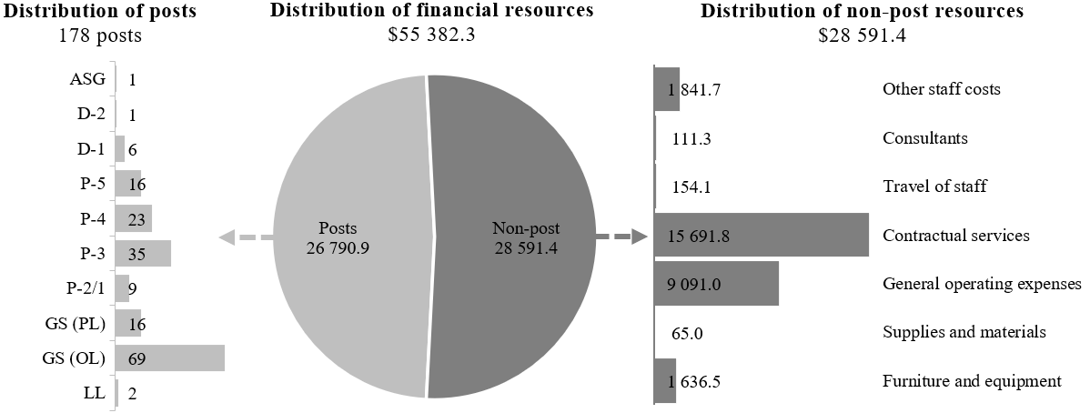

Explanation of variances by factor, component and subprogramme

Overall resource changes

Technical adjustments

29C.59 As shown in table 29C.17 (1), resource changes reflect a decrease of $144,300 under subprogramme 2, Operations support. The decrease, under contractual services, relates to the removal of non-recurrent provisions for conference services for 2025 in support of: (a) the Agreement under the United Nations Convention on the Law of the Sea on the Conservation and Sustainable Use of Marine Biological Diversity of Areas beyond National Jurisdiction, pursuant to Assembly resolution 78/272 ($50,800); (b) transparency in armaments, pursuant to Assembly resolution 77/69 ($15,400); (c) further modalities of the Fourth International Conference on Financing for Development, pursuant to Assembly resolution 78/271 ($25,700); (d) through-life conventional ammunition management, pursuant to Assembly resolution 78/47 ($8,400); (e) follow-up to and implementation of the outcomes of the International Conferences on Financing for Development, pursuant to Assembly resolution 79/199 ($35,900); and (f) Assembly resolution 79/237 on the open-ended working group on security of and in the use of information and communications technologies 2021–2025 established pursuant to General Assembly resolution 75/240 ($8,100).

New and expanded mandates

29C.60 As shown in table 29C.17 (1), resource changes reflect an increase of $249,300 under subprogramme 2, Operations support. The increase relates to additional requirements under contractual services for conference services in support of: (a) promotion of inclusive and effective international tax cooperation at the United Nations, pursuant to Assembly resolution 79/235 ($94,900); (b) nuclear war effects and scientific research, pursuant to Assembly resolution 79/238 ($47,500); (c) the United Nations Conference of Plenipotentiaries on Prevention and Punishment of Crimes against Humanity, pursuant to Assembly resolution 79/122 ($29,900); (d) comprehensive study of the question of nuclear-weapon-free zones in all its aspects, pursuant to Assembly resolution 79/241 ($35,800); (e) the illicit trade in small arms and light weapons in all its aspects, pursuant to Assembly resolution 79/40 ($20,200); (f) protection of persons in the event of disasters, pursuant to Assembly resolution 79/128 ($15,000); and (g) sustainable fisheries, including through the 1995 Agreement for the Implementation of the Provisions of the United Nations Convention on the Law of the Sea of 10 December 1982 relating to the Conservation and Management of Straddling Fish Stocks and Highly Migratory Fish Stocks, and related instruments, pursuant to Assembly resolution 79/145 ($6,000).

Other changes

29C.61 As shown in table 29C.17 (1), resource changes reflect a decrease of $112,300, as follows:
(a) Executive direction and management. A decrease of $98,400 under general operating expenses is attributable to updated centralized standard service-level agreement rates for ICT costs mainly for staff and non-staff personnel based in New York. In addition, the resources include a cost-neutral redeployment in the amount of $319,400 from general operating expenses to contractual services, to better align with expenditure patterns;
(b) Subprogramme 1, Strategy and technology innovation. A decrease of $69,500 is due to:
(i) The redeployment of two existing P-4 posts from Nairobi and Bangkok to Valencia, Spain, to enable reinforcement of the centralized capacity for ICT security in the Enterprise Data Centre in Valencia ($13,900);
(ii) The outward redeployment to subprogramme 3 of the resources related to the application interfaces programme and information management services, based on an internal reassessment of the activity and deliverables that determined that, as an application development activity, it was better aligned with the services delivery and programme of the Enterprise Solutions Service under subprogramme 3 ($55,600);
(c) Subprogramme 2, Operations support. The resources include a cost-neutral redeployment in the amount of $715,700 from general operating expenses to contractual services. The increase under contractual services is required to obtain expert advice on and technical assistance with the resolution of complex issues related to the Microsoft Unified platform. The decrease under general operating expenses is the result of lower telecommunication costs owing to the migration of telephony services to a more cost-efficient provider;
(d) Subprogramme 3, Enterprise solutions. An increase of $55,600 is due to the inward redeployment from subprogramme 1 of the resources related to the application interfaces programme and information management services.

Other assessed resources

29C.62 As reflected in tables 29C.17 (2) and 29C.18 (2), other assessed resources amount to $35,048,500. The resources would complement regular budget resources and provide for the requirements indicated in report A/79/783.

Extrabudgetary resources

29C.63 As reflected in tables 29C.17 (3) and 29C.18 (3), extrabudgetary resources amount to $63,611,700. The resources would complement regular budget resources and would be used mainly to provide for 13 posts (1 P-4, 1 P-3, 2 General Service (Principal level) and 9 General Service (Other level)) to perform mainly the functions of ICT services support. In addition, non-post resources would be used to provide ICT services such as a personal computing core package, collaboration and communication tools, network access, telephone service, service desk support for computers, and desktop and enterprise applications. Services would include the development and deployment of tailored technology solutions to support mandate delivery by substantive departments and offices, such as solutions that help to ensure the safety and security of United Nations system personnel, the training of uniformed personnel, rapid deployment, and public broadcasting and data analysis capabilities.
29C.64 The extrabudgetary resources under the present section are subject to the oversight of the Office of Information and Communications Technology, under its authority subdelegated from the Under-Secretaries-General of the Department of Operational Support and the Department of Management Strategy, Policy and Compliance, who in turn both have delegated authority from the Secretary-General.

Executive direction and management

29C.65 The executive direction and management component comprises the Office of the Assistant Secretary-General for Information and Communications Technology and the Enterprise Programme Management Section. In General Assembly resolutions 69/262, 70/248 and 71/272 B, the central authority of the Chief Information Technology Officer was reaffirmed and strengthened with regard to information security and the overall direction and performance of ICT activities within the Organization.
29C.66 The main responsibilities of the executive direction and management component include:
(a) Provision of overall strategic direction and central leadership for the establishment and implementation of Organization-wide ICT;
(b) Planning and coordination of ICT activities Secretariat-wide, including infrastructure and enterprise systems, with a view to achieving coherence and coordination in the area of ICT within the work of the United Nations and between the Secretariat and funds, programmes and specialized agencies of the Organization;
(c) Provision of overall strategic planning and management and coordination of the work of the internal organizational units.
29C.67 In accordance with the 2030 Agenda for Sustainable Development, in particular target 12.6 of the Sustainable Development Goals, in which organizations are encouraged to integrate sustainability information into their reporting cycles, and in compliance with the cross-cutting mandate set out in paragraph 19 of General Assembly resolution 72/219, the Office of Information and Communications Technology is integrating environmental management practices into its operations. The Office will continue to provide departments and offices with solutions to support the achievement of the Goals and will continue to reduce its infrastructure footprint in data centres by moving to the cloud, thus reducing its environmental impact.
29C.68 Information on the timely submission of documentation and advance booking for air travel is reflected in table 29C.20. The Office continues to make efforts to fully comply with the advance purchase policy directive and has taken a number of steps to ensure that air travel is booked as early as possible. Travel requests that do not meet the two-week timeline are directed to the Head of Office for validation of mitigating circumstances before final review and approval. Owing in part to the implementation of such measures, the rate of compliance has constantly increased since 2022.

Table 29C.20

Compliance rate
(Percentage)

 | 2022 actual | 2023 actual | 2024 actual | 2025 planned | 2026 planned
Timely submission of documentation | n/a | n/a | 100 | n/a | 100
Air tickets purchased at least two weeks before the commencement of travel | 72 | 84 | 96 | 100 | 100

29C.69 The proposed regular budget resources for 2026 amount to $3,335,900 and reflect a decrease of $98,400 compared with the approved budget for 2025. The proposed change is explained in paragraph 29C.61 (a). Additional details on the distribution of the proposed resources for 2026 are reflected in table 29C.21 and figure 29C.V.

Table 29C.21

Executive direction and management: evolution of financial and post resources
(Thousands of United States dollars/number of posts)

 |  |  | Changes
 | 2024 expenditure | 2025 approved | Technical adjustments | New/expanded mandates | Other | Total | Percentage | 2026 estimate
Financial resources by main category of expenditure
Posts | 2 334.9 | 2 638.9 | – | – | – | – | – | 2 638.9
Non-post | 743.8 | 795.4 | – | – | (98.4) | (98.4) | (12.4) | 697.0
Total | 3 078.7 | 3 434.3 | – | – | (98.4) | (98.4) | (2.9) | 3 335.9
Post resources by category
Professional and higher |  | 5 | – | – | – | – | – | 5
General Service and related |  | 14 | – | – | – | – | – | 14
Total |  | 19 | – | – | – | – | – | 19

Figure 29C.V

Executive direction and management: distribution of proposed resources for 2026
(Number of posts/thousands of United States dollars)

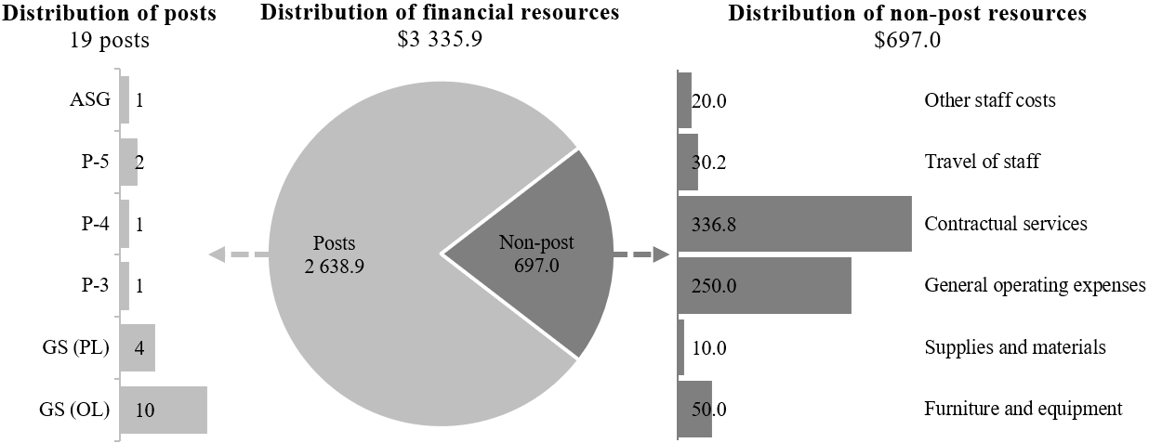

Programme of work

Subprogramme 1

Strategy and technology innovation

29C.70 The proposed regular budget resources for 2026 amount to $10,868,700 and reflect a decrease of $69,500 compared with the approved budget for 2025. The proposed change is explained in paragraph 29C.61 (b). Additional details on the distribution of the proposed resources for 2026 are reflected in table 29C.22 and figure 29C.VI.

Table 29C.22

Subprogramme 1: evolution of financial and post resources
(Thousands of United States dollars/number of posts)

 |  |  | Changes
 | 2024 expenditure | 2025 approved | Technical adjustments | New/expanded mandates | Other | Total | Percentage | 2026 estimate
Financial resources by main category of expenditure
Posts | 5 894.8 | 6 188.4 | – | – | (13.9) | (13.9) | (0.2) | 6 174.5
Non-post | 4 551.2 | 4 749.8 | – | – | (55.6) | (55.6) | (1.2) | 4 694.2
Total | 10 446.0 | 10 938.2 | – | – | (69.5) | (69.5) | (0.6) | 10 868.7
Post resources by category
Professional and higher |  | 24 | – | – | – | – | – | 24
General Service and related |  | 11 | – | – | – | – | – | 11
Total |  | 35 | – | – | – | – | – | 35

Figure 29C.VI

Subprogramme 1: distribution of proposed resources for 2026
(Number of posts/thousands of United States dollars)

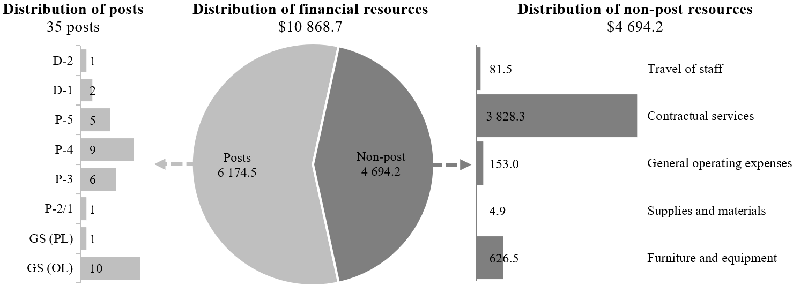

Subprogramme 2

Operations support

29C.71 The proposed regular budget resources for 2026 amount to $25,127,500 and reflect a net increase of $105,000 compared with the approved budget for 2025. The proposed change is explained in paragraphs 29C.59 and 29C.60. Additional details on the distribution of the proposed resources for 2026 are reflected in table 29C.23 and figure 29C.VII.

Table 29C.23

Subprogramme 2: evolution of financial and post resources
(Thousands of United States dollars/number of posts)

 |  |  | Changes
 | 2024 expenditure | 2025 approved | Technical adjustments | New/expanded mandates | Other | Total | Percentage | 2026 estimate
Financial resources by main category of expenditure
Posts | 9 681.2 | 9 467.4 | – | – | – | – | – | 9 467.4
Non-post | 14 768.6 | 15 555.1 | (144.3) | 249.3 | – | 105.0 | 0.7 | 15 660.1
Total | 24 449.8 | 25 022.5 | (144.3) | 249.3 | – | 105.0 | 0.4 | 25 127.5
Post resources by category
Professional and higher |  | 23 | – | – | – | – | – | 23
General Service and related |  | 48 | – | – | – | – | – | 48
Total |  | 71 | – | – | – | – | – | 71

Figure 29C.VII

Subprogramme 2: distribution of proposed resources for 2026
(Number of posts/thousands of United States dollars)

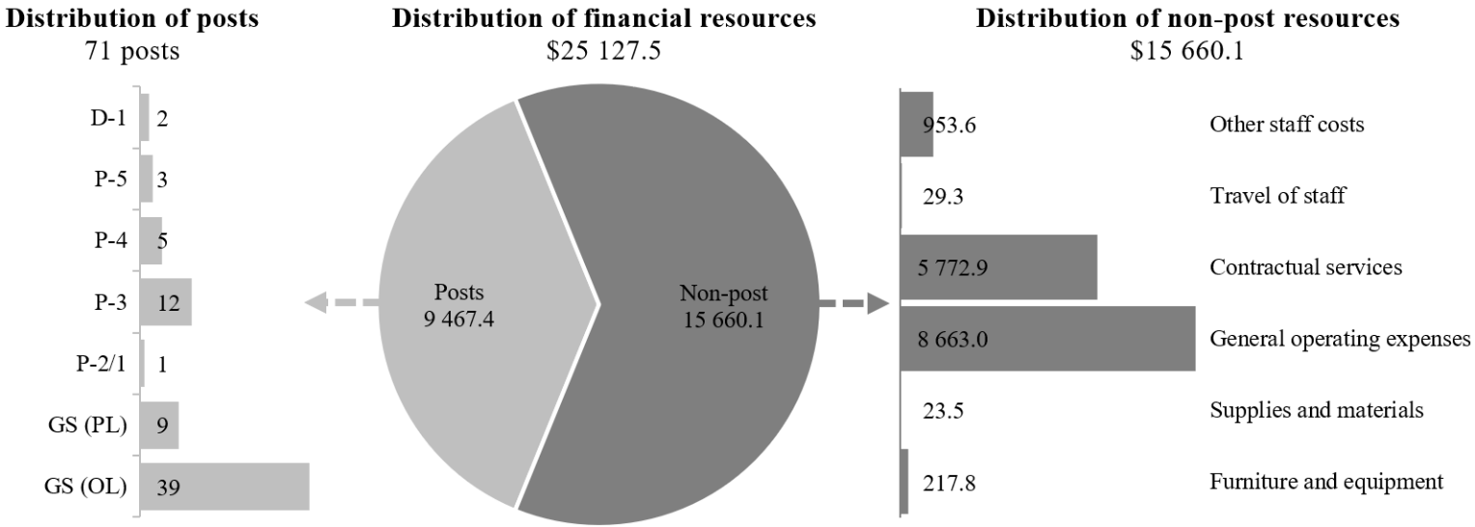

Subprogramme 3

Enterprise solutions

29C.72 The proposed regular budget resources for 2026 amount to $16,050,200 and reflect an increase of $55,600 compared with the approved budget for 2025. The proposed change is explained in paragraph 29C.61 (d). Additional details on the distribution of the proposed resources for 2026 are reflected in table 29C.24 and figure 29C.VIII.

Table 29C.24

Subprogramme 3: evolution of financial and post resources
(Thousands of United States dollars/number of posts)

 |  |  | Changes
 | 2024 expenditure | 2025 approved | Technical adjustments | New/expanded mandates | Other | Total | Percentage | 2026 estimate
Financial resources by main category of expenditure
Posts | 7 529.7 | 8 510.1 | – | – | – | – | – | 8 510.1
Non-post | 7 364.3 | 7 484.5 | – | – | 55.6 | 55.6 | 0.7 | 7 540.1
Total | 14 894.0 | 15 994.6 | – | – | 55.6 | 55.6 | 0.3 | 16 050.2
Post resources by category
Professional and higher |  | 39 | – | – | – | – | – | 39
General Service and related |  | 14 | – | – | – | – | – | 14
Total |  | 53 | – | – | – | – | – | 53

Figure 29C.VIII

Subprogramme 3: distribution of proposed resources for 2026
(Number of posts/thousands of United States dollars)

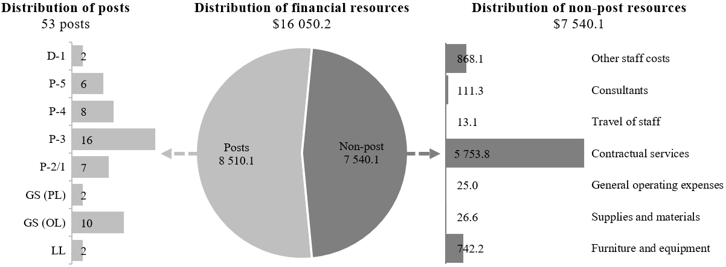

Annex I

Organizational structure and post distribution for 2026

Office of Information and Communications Technology

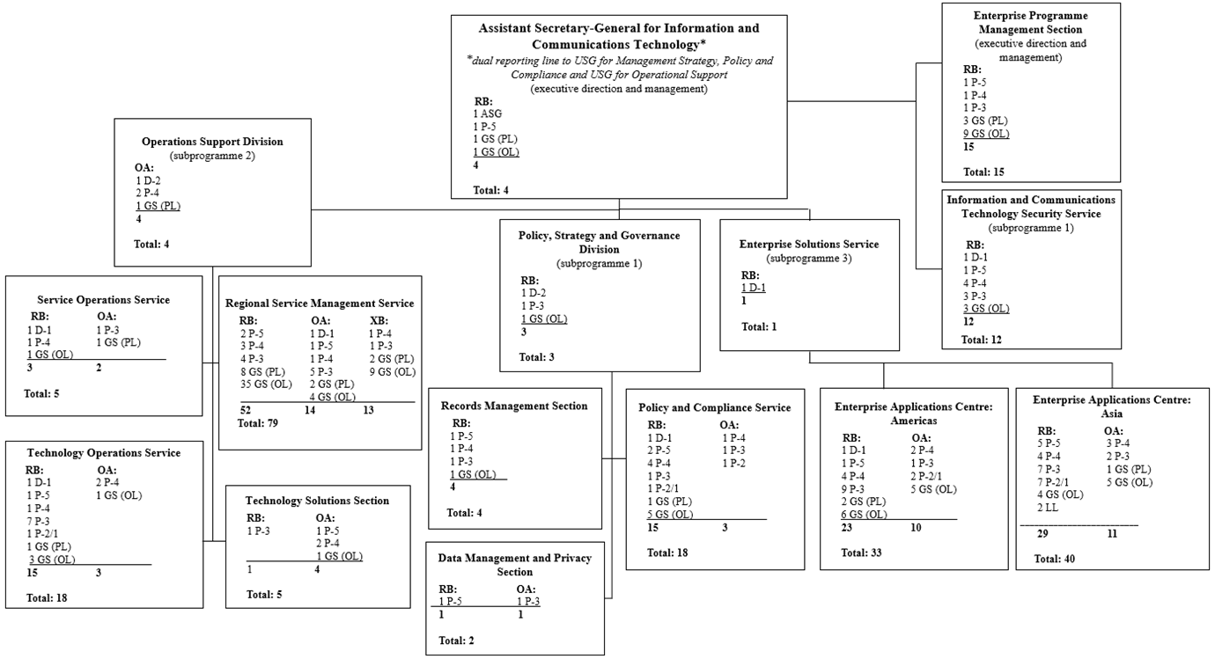

Annex II

Summary of proposed post changes, by component and subprogramme

Component/subprogramme | Posts | Grade | Description | Reason for change
Subprogramme 1, Strategy and technology innovation | 2 | P-4 | Redeployment (geographical) of two posts of Cyber Security Officer from Nairobi and Bangkok to Valencia, Spain | It is proposed that two existing P-4 posts be redeployed from Nairobi and Bangkok to Valencia. Consolidating some of the ICT security positions in one location would enable reinforcement of the centralized capacity for ICT security in the Enterprise Data Centre in Valencia in order to more effectively address both the continuous growth of the global threats affecting the Secretariat and the evolution of technology and cybersecurity operations. This would also enable efficient adaptation to a rapidly changing and expanded ICT security risk map and strengthen core capacity for proactive vulnerability and threat and incident management Secretariat-wide. Local ICT security operations in Nairobi and Bangkok would continue to be supported by the remaining existing ICT security capacity at those locations.

