Eightieth session
Items 137 and 138 of the preliminary list*

Proposed programme budget for 2026

Programme planning

Proposed programme budget for 2026

Part VIII

* A/80/50.
** In keeping with paragraph 10 of General Assembly resolution 77/267, the part consisting of the programme plan and programme performance information (part II) is submitted through the Committee for Programme and Coordination for the consideration of the Assembly.
*** In keeping with paragraph 10 of General Assembly resolution 77/267, the part consisting of the post and non-post resource requirements (part III) is submitted through the Advisory Committee on Administrative and Budgetary Questions for the consideration of the Assembly.

Common support services

Section 29D

Administration, Nairobi

Programme 25

Management and support services

Contents
 |  |  | Page
- Proposed programme plan for 2026 and programme performance in 2024** |  |  | 3
Overall orientation |  |  | 3
Programme of work |  |  | 6
Subprogramme 1. Programme planning, finance and budget |  |  | 6
Subprogramme 2. Human resources management |  |  | 9
Subprogramme 3. Support services |  |  | 13
Subprogramme 4. Information and communications technology operations |  |  | 17
- Proposed post and non-post resource requirements for 2026*** |  |  | 21
Overview |  |  | 21
Executive direction and management |  |  | 26
Programme of work |  |  | 27
Subprogramme 1. Programme planning, finance and budget |  |  | 27
Subprogramme 2. Human resources management |  |  | 28
Subprogramme 3. Support services |  |  | 29
Subprogramme 4. Information and communications technology operations |  |  | 30
Annexes
- Organizational structure and post distribution for 2026 |  |  | 32
- Summary of proposed post changes, by component and subprogramme |  |  | 33

A. Proposed programme plan for 2026 and programme performance in 2024

Overall orientation

Mandates and background

29D.1 The United Nations Office at Nairobi was established by the Secretary-General on 1 January 1996 as a successor to the United Nations Common Services Unit at Nairobi and the two separate divisions of administration of the United Nations Environment Programme (UNEP) and the United Nations Human Settlements Programme (UN-Habitat). In its resolution 53/242, the General Assembly requested the Secretary-General to strengthen the Office and encouraged the Director-General of the United Nations Office at Nairobi to take steps to increase the level of utilization of the Office. The Office was established to strengthen the United Nations presence in Nairobi and to achieve economies of scale, and provides management, information and communications technology (ICT) and administrative services to the United Nations complex in Nairobi. Under a memorandum of understanding and specific service arrangements, the Office provides the Nairobi-based headquarters and globally dispersed offices of UNEP and UN-Habitat with a full range of administrative and other support services. As a designated global and regional service provider, the Office provides human resources administration, payroll and finance services, international travel, recruitment of consultants and procurement services to the resident coordinator system and to Secretariat offices with a regional presence, such as the Office of the United Nations High Commissioner for Human Rights (OHCHR), the International Residual Mechanism for Criminal Tribunals, the United Nations information centres in the Africa region and the International Court of Justice. In total, the Office provides services to United Nations entities in 166 countries. With the introduction of the Kenya Common Back Office, the United Nations Office at Nairobi provides administrative, ICT, local procurement and local recruitment services to more than 80 offices of United Nations agencies, funds and programmes operating in or from Kenya and other United Nations system entities, including special political missions and peacekeeping support operations operating from Kenya. In 2024, the United Nations Children’s Fund initiated a relocation of some of its staff with global functions to Nairobi from New York, the United Nations Office for Project Services relocated its Regional Office for Africa from Copenhagen to Nairobi and OHCHR strengthened its presence in Nairobi.

Strategy and external factors for 2026

29D.2 In 2026, the Office will support its clients within the existing inter-agency and governance frameworks, increase its client portfolio and forge stronger partnerships in the region. It will advance its engagement in promoting the principles of the Pact for the Future, the efficiency agenda, including in common back office, common premises and the global shared services architecture, working closely with the Department of Operational Support. The Office will increase its level of utilization through partnerships with other United Nations entities.
29D.3 For 2026, the Office will maintain optimal service delivery and strengthen monitoring of key performance indicators. To increase the efficiency and effectiveness of its services, the Office will strengthen its financial management, internal control systems, risk framework and communication strategy, including through regular key performance indicator reporting, qualitative surveys and a client relations management platform.
29D.4 The United Nations Joint Medical Service will serve United Nations personnel and other patients, and the Office will provide medical and logistical support, including for evacuations, to United Nations entities in the region.
29D.5 The major infrastructure project on the conference facilities remains high on the programme agenda, with the project main works projected to commence in 2026. The Office will make greater use of the 142-acre Gigiri compound through increased use of outdoor and new office space. The efficient management of the increased number of United Nations entities and personnel in Nairobi will require sustainable funding for the common premises and adequate expertise in engineering, sustainability and technology after completion of the replacement of office blocks A–J at the United Nations Office at Nairobi.
29D.6 The Office will deepen its engagement with the host country Government in support of its mandate and the clients that it serves, representing all United Nations entities operating in or from Kenya. As the main interlocutor with the Government of Kenya, the Office will play a key coordination role in the establishment of humanitarian hubs for United Nations entities in the region.
29D.7 With regard to inter-agency coordination and liaison, the Office will continue to work with the United Nations system organizations based in Nairobi, including through the common back office governance framework, in support of the efficiency agenda that is part of the reform of the United Nations development system.
29D.8 With regard to the external factors, the overall plan for 2026 is based on the following planning assumptions:
(a) Nairobi-based organizations of the United Nations common system maintain a commitment to collaborate with the United Nations Secretariat on ongoing activities;
(b) The extrabudgetary funding situation of client offices continues to allow for planning and implementation of the Office’s activities.
29D.9 The Office integrates a gender perspective in its operational activities, deliverables and results, as appropriate. It continues to support the Secretary-General’s system-wide strategy on gender parity, provides guidance to clients on how to integrate gender parity throughout the recruitment process and keeps client entities informed of the impact of selection decisions. The Office also works to promote geographical representation and diversity, including by providing client entities with information on Member States that are unrepresented or underrepresented.
29D.10 In line with the United Nations Disability Inclusion Strategy, the Office will ensure that all major repairs and replacements at the United Nations complex in Nairobi consider and address accessibility concerns. The Office will strengthen an inclusive organizational culture that is supportive of staff members with disabilities and staff who have dependants with disabilities, offering regular training opportunities on disability inclusion, organizing awareness-raising events and communicating available benefits and entitlements with regard to disabilities. These activities will be pursued with the active involvement of persons with disabilities and their representative organizations.

Legislative mandates

29D.11 The list below, which was reviewed in the preparation of the proposed programme budget, provides all mandates entrusted to the programme.

General Assembly resolutions

53/242 | Report of the Secretary-General on environment and human settlements
77/280 | Progress towards an accountability system in the United Nations Secretariat
79/226 | Quadrennial comprehensive policy review of operational activities for development of the United Nations system
79/258 | Special subjects relating to the proposed programme budget for 2025

Subprogramme 1

Programme planning, finance and budget

General Assembly resolutions

41/213 | Review of the efficiency of the administrative and financial functioning of the United Nations
77/267 | Shifting the management paradigm in the United Nations: review of changes to the budgetary cycle
42/211 | Implementation of General Assembly resolution 41/213

Subprogramme 2

Human resources management

General Assembly resolutions

59/164 | Improvement of the status of women in the United Nations system
73/281 | Shifting the management paradigm in the United Nations
77/278 | Human resources management
78/275 | Amendments to the Staff Regulations and Rules
79/252 A–B | United Nations common system
79/254 | Administration of justice at the United Nations

Subprogramme 3

Support services

General Assembly resolution

69/273 | Procurement

Subprogramme 4

Information and communications technology operations

General Assembly resolutions

63/262 | Information and communications technology, enterprise resource planning, and security, disaster recovery and business continuity
63/269 | Information and communications technology, disaster recovery and business continuity for the United Nations: arrangements for the secondary data centre at Headquarters
69/262 | Questions relating to the programme budget for the biennium 2014–2015 (sect. II, Information and communications technology in the United Nations)
71/272 B | Special subjects relating to the programme budget for the biennium 2016–2017 (Sect. III, Status of implementation of the information and communications technology strategy for the United Nations)
78/243 | Information and communications technology strategy

Deliverables

29D.12 Table 29D.1 lists all cross-cutting deliverables of the programme.

Table 29D.1

Cross-cutting deliverables for the period 2024–2026, by category and subcategory

Category and subcategory | 2024 planned | 2024 actual | 2025 planned | 2026 planned
A. Facilitation of the intergovernmental process and expert bodies
Substantive services for meetings (number of three-hour meetings) | 7 | 7 | 7 | 7
Meetings of:
1. The Advisory Committee on Administrative and Budgetary Questions | 3 | 3 | 3 | 3
2. The Committee for Programme and Coordination | 1 | 1 | 1 | 1
3. The Fifth Committee | 3 | 3 | 3 | 3

Evaluation activities

29D.13 An evaluation by the Office of subprogramme 2, Human resources management (Joint Medical Service) is planned for 2026.

Programme of work

Subprogramme 1

Programme planning, finance and budget

Objective

29D.14 The objective, to which this subprogramme contributes, is to ensure the sound, effective and efficient financial management and reporting by client offices.

Strategy

29D.15 To contribute to the objective, the subprogramme will:
(a) Oversee the financial management and internal control of the regular budget and extrabudgetary funds of the programme and that of its clients;
(b) Streamline the financial procedures and workflows of client offices and ensure strict adherence to the Financial Regulations and Rules of the United Nations, including through assurance and visibility of United Nations resources management, monitored by improved financial dashboards for the programme and client entities;
(c) Maintain the financial accounts of its clients, improve the financial integrity of data, prepare the financial statements in compliance with the International Public Sector Accounting Standards (IPSAS), support the internal and external audit processes, produce accurate and timely financial reports for donors and manage funding arrangements with implementing partners;
(d) Support client offices on results-based management and to implement the enhanced delegation of authority framework;
(e) Establish appropriate service rates and service requirements and monitor service statistics and client satisfaction;
(f) Monitor and manage the financial risks of reform initiatives mandated to the United Nations Office at Nairobi.
29D.16 The above-mentioned work is expected to result in:
(a) Operational efficiency and improved stewardship of donor funds and other resources, through increased transparency and accountability, in accordance with the enhanced delegation of authority framework;
(b) An unqualified audit opinion of the Board of Auditors for UNEP and UN-Habitat;
(c) Enhanced visibility for Member States on the impact of their contributions to the programme and the project implementation of client entities.

Programme performance in 2024

Closure of pass-through grants

29D.17 Since the implementation of the Umoja Extension 2 Grantor Management module, all new implementing partner agreements have been processed and managed in this module. However, a significant number of partner agreements continue to be managed by the Office’s client entities using the pass-through grants modality in an older module. The closure of all pass-through grants will ensure better management of grantor agreements from inception to closure within a unified platform, while providing transparency regarding the performance of these partnerships. By processing implementing partner agreements through the Grantor Management module, entities can have better management and oversight of the grantor agreements. The subprogramme assisted client entities with the closure of 7,570 pass-through grants, representing the closure of 99 per cent of all pass-through grants.
29D.18 Progress towards the objective is presented in the performance measure below (see figure 29D.I).

Figure 29D.I

Performance measure: percentage of pass-through grants closed (cumulative)

Planned results for 2026

Result 1: improved management of resources and operational efficiency of clients through the provision of dashboards

Programme performance in 2024 and target for 2026

29D.19 The subprogramme’s work contributed to clients using improved dashboards integrated with Umoja Analytics, including dashboards related to grants, accounts payable and payroll and separation payments, and contributed to increased transparency and accuracy through an automated billing system that generates the billing data of the Kenya Common Back Office, which met the planned target.
29D.20 Progress towards the objective and the target for 2026 are presented in the performance measure below (see table 29D.2).

Table 29D.2

Performance measure

2022 (actual) | 2023 (actual) | 2024 (actual) | 2025 (planned) | 2026 (planned)
Clients use the status of position funding dashboard | Grants and accounts payable key performance indicator dashboards developed but client access not yet provisioned | Clients use improved dashboards integrated with Umoja Analytics and additional key performance indicators on payroll and separation payments  Increased transparency and accuracy through automation in billing statistics collection and processes | Improved reporting on facility projects and assets of the United Nations Office at Nairobi through dashboards integrated with Umoja Analytics (phase 2) | Improved reporting on cost recovery of the United Nations Office at Nairobi through dashboards integrated with Umoja Analytics

Result 2: improved assets accounting for United Nations Office at Nairobi buildings, facilities and infrastructure

Programme performance in 2024 and target for 2026

29D.21 The subprogramme’s work contributed to the recording of 95 per cent of capitalizable assets, which met the planned target.
29D.22 Progress towards the objective and the target for 2026 are presented in the performance measure below (see figure 29D.II).

Figure 29D.II

Performance measure: comprehensiveness of recording of capitalizable assets under construction in the financial statements
(Percentage of capitalizable assets recorded)

Result 3: improved timeliness in the resolution of rejected and returned payments

Proposed programme plan for 2026

29D.23 The United Nations Office at Nairobi is responsible for processing over 80,000 payments annually from multiple bank accounts on behalf of its clients. An analysis of payments for Office clients from the period 2022–2024 showed that there was a need to further improve the timeliness of the reissuance of payments returned from the global banking system due to various bank errors and challenges.

Lessons learned and planned change

29D.24 The lesson for the subprogramme was the importance of establishing a mechanism for tracking, investigating and recalling funds, and reprocessing payments. In applying the lesson, the subprogramme, in close collaboration with the United Nations Treasury network, will enhance its investigative capacity to address rejected and returned payments, including by obtaining access to banking system investigative tools and developing an internal tracking system. The subprogramme will also further streamline its internal processes and procedures for review and investigation to enable the prompt reprocessing of payments and ensure that service providers and vendors are not adversely affected by the non-receipt or late receipt of payments.
29D.25 Expected progress towards the objective is presented in the performance measure below (see figure 29D.III).

Figure 29D.III

Performance measure: average time taken for resolution of rejected and returned payments (annual)

Deliverables

29D.26 Table 29D.3 lists all deliverables of the subprogramme.

Table 29D.3

Subprogramme 1: deliverables for the period 2024–2026, by category and subcategory

Category and subcategory | 2024 planned | 2024 actual | 2025 planned | 2026 planned
B. Generation and transfer of knowledge
Seminars, workshops and training events (number of days) | 30 | 29 | 30 | 20
1. Training events on financial topics | 30 | 29 | 30 | 20
Publications (number of publications) | 2 | 12 | 2 | 12
2. Publications on financial statement volumes for UNEP and UN-Habitat | 2 | 12 | 2 | 12
D. Communication deliverables
Digital platforms and multimedia content: quarterly Programme Planning, Finance and Budget Section newsletter for client offices.
E. Enabling deliverables
Administration: financial management, including risk management, preparation and implementation of budgets and resource proposals; management of posts and 22,000 grants; financial reporting and accounting, including 1,700 donor reports; cash and revenue management; accounting services; cost recovery services; payment services; payroll and disbursements for 4,250 personnel; guidance on all financial matters; management of after-service health insurance claims for approximately 400 staff and their dependants and beneficiaries.

Subprogramme 2

Human resources management

Objective

29D.27 The objective, to which this subprogramme contributes, is to ensure the acquisition, development and retention of a competent, diverse, adaptable and healthy workforce with the highest standards of efficiency and integrity.

Strategy

29D.28 To contribute to the objective, the subprogramme will:
(a) Facilitate the recruitment process of personnel for its clients, ensuring fair and competitive recruitment processes;
(b) Develop and refine tools to streamline the recruitment process and assist hiring managers in their evaluation of candidates, in collaboration with United Nations Headquarters and other offices away from Headquarters;
(c) Foster greater interest from women and applicants from unrepresented and underrepresented countries, including through guidance to client entities to promote the selection of qualified candidates from these categories;
(d) Develop and implement diverse training programmes for staff skills and competencies, in collaboration with other United Nations entities and external partners through jointly held training sessions;
(e) Implement outreach programmes for all staff members, through briefings and intranet platforms, on benefits and entitlements and the related authorization processes;
(f) Deliver a comprehensive health and well-being programme, including through promotion and awareness-raising on staff mental health and physical well-being, health assessments and advice.
29D.29 The above-mentioned work is expected to result in:
(a) Increased knowledge and skills of staff members;
(b) Standardized services for clients across geographically dispersed locations;
(c) Improved ability of client entities to respond to their shifting operational requirements;
(d) Increased staff productivity.

Programme performance in 2024

Increased efficiency in access to health and well-being services

29D.30 With a continued focus on improving client access to services, in 2024 the subprogramme rolled out a new platform for in-person and online access to health and well-being services. The new platform went live in May 2024 at the medical services located in Nairobi, Kakuma and Dadaab. This has led to increased simplicity for clients and higher speed of access to health services, and transparency in the different operations that the subprogramme supports in Kenya. The platform, which is also available as a mobile application, has enhanced clinical services visibility and accessibility for personnel and has improved the client experience, reducing the time spent booking appointments and subsequently reducing waiting time as appointment times are slotted according to doctor and nurse availability, with clinical operations adjusted to ensure efficiency.
29D.31 Progress towards the objective is presented in the performance measure below (see figure 29D.IV).

Figure 29D.IV

Performance measure: average time taken to secure and process appointments
(Minutes)

Planned results for 2026

Result 1: increased effectiveness and efficiency of the staff recruitment process

Programme performance in 2024 and target for 2026

29D.32 The subprogramme’s work contributed to the timely completion of 99 per cent of offer management processes and 97 per cent of processes for the development and posting of job openings, which exceeded the planned targets of 70 and 95 per cent, respectively. The subprogramme’s work also contributed to the timely completion of 89 per cent of post classification processes, which did not meet the planned target of 90 per cent. The target was not met because of the complexity of some of the requests. However, the subprogramme introduced changes in the process and the training sessions offered to clients have resulted in improvement compared with 2023.
29D.33 Progress towards the objective and the target for 2026 are presented in the performance measure below (see figure 29D.V).

Figure 29D.V

Performance measure: percentage of recruitment processes completed within established timelines

Note: The established timelines are 15 days for post classification; 15 days for development and posting of job openings; and 31 days for offer management.

Result 2: staff and personnel acquire new knowledge and skills to improve organizational effectiveness

Programme performance in 2024 and target for 2026

29D.34 The subprogramme’s work contributed to a mandatory learning completion rate of 94 per cent among personnel in Nairobi, which exceeded the planned target of 90 per cent. The subprogramme’s work also contributed to the completion of language programmes by 820 personnel and of instructor-facilitated classes by 4,138 personnel, which exceeded the planned targets of 788 and 2,325 participations, respectively.
29D.35 Progress towards the objective and the target for 2026 are presented in the performance measure below (see figure 29D.VI).

Figure 29D.VI

Performance measure: number of personnel completing instructor-facilitated classes and language programmes, and mandatory course compliance rate (annual)

Result 3: improved timeliness of staff benefits and entitlements services for all clients

Proposed programme plan for 2026

29D.36 Accurate and timely delivery of staff benefits and entitlements services is critical for the global clientele of the United Nations Office at Nairobi.

Lessons learned and planned change

29D.37 The lesson for the subprogramme was that a comprehensive key performance indicator system can help to ensure sustained improvements in service delivery for its clients. In applying the lesson, the subprogramme has developed a new key performance indicator system and a quality assurance system for clients’ records to ensure transparency and accountability in service delivery. The subprogramme will collaborate closely with stakeholders to implement the new systems, which are expected to improve adherence to established timelines for the processing of staff benefits and entitlements.
29D.38 Expected progress towards the objective is presented in the performance measure below (see figure 29D.VII).

Figure 29D.VII

Performance measure: percentage of staff benefits and entitlements processes completed within established timelines

Note: The established timelines are 30 days for the education grant; 5 days for travel; and 15 days for other staff entitlements.

Deliverables

29D.39 Table 29D.4 lists all deliverables of the subprogramme.

Table 29D.4

Subprogramme 2: deliverables for 2026, by category and subcategory

Category and subcategory
E. Enabling deliverables
Administration: first-level review in administration of justice process; training and career development made available to 7,192 United Nations common system staff; performance management; inter-agency learning coordination of Nairobi-based entities; administration of 85 tests; 25 health campaigns; expert advice and guidance on staff selection processes and staff and non-staff hiring; annual staff survey on local salaries; administration of staff benefits and entitlements; outreach activities and guidance on human resources policies; administration of onboarding and separation from service; contract management; medical consultations; staff counselling services.

Subprogramme 3

Support services

Objective

29D.40 The objective, to which this subprogramme contributes, is to ensure the efficient, environmentally sound and effective functioning of client offices with regard to conference and facilities management, host country services, asset management, travel and transportation, mail and pouch services, commercial activities and procurement services, as well as archives and records management.

Strategy

29D.41 To contribute to the objective, the subprogramme will:
(a) Provide sustainable and efficient solutions with a specific focus on the management of waste, energy, water and wastewater in accordance with International Organization for Standardization (ISO) 14001; and maintain the Office’s environmental management system, including requisite ISO 14001 pre-certification external audit and post-certification annual surveillance activities, training and awareness;
(b) Manage clients’ changing workspace needs by optimizing usage and working conditions in the available office space, including through redesign, in consultation with client entities, and through revisions of office space standards, to support the operational requirements of each tenant;
(c) Provide staff transport solutions through an efficient distribution between internal and external transport service providers;
(d) Provide immediate and effective travel services, especially leading up to major scheduled meetings;
(e) Provide client-centric and solution-oriented procurement services to client entities and continuously strive to maximize value for money with due consideration to whole-life costs and effective international competition.
29D.42 The above-mentioned work is expected to result in:
(a) Improved physical infrastructure, optimized use of space and enhanced environmental management to support a sustainable, safe and flexible working environment;
(b) Efficient and convenient host country services for all clients, including remote service options to keep clients and staff safe;
(c) Efficient and convenient transport solutions in use by all clients;
(d) Efficient and convenient procurement services available virtually to all global clients.

Programme performance in 2024

Reforestation of the United Nations complex in Nairobi

29D.43 The subprogramme undertook a key initiative aimed at reforesting large parts of the United Nations Office at Nairobi complex. As part of the subprogramme’s reforestation strategy, the original dry upland forest environment is being restored in as much of the complex as possible through the planting of over 34 species of indigenous biodiversity-supporting trees. This reforestation strategy has already reached the milestone of 2,806 trees planted by 2024. The strategy also simplifies the maintenance of the 140-acre complex, as large lawned areas require extensive irrigation during dry seasons and mowing during and after rainy seasons. Moreover, experience has shown that shade from trees is far more effective at protecting and cooling outdoor areas, staff, vehicles and buildings, and that moisture in the soil is retained for longer in shaded areas.
29D.44 Progress towards the objective is presented in the performance measure below (see figure 29D.VIII).

Figure 29D.VIII

Performance measure: number of trees planted (cumulative)

Planned results for 2026

Result 1: improved energy efficiency of the United Nations premises in Nairobi

Programme performance in 2024 and target for 2026

29D.45 The subprogramme’s work contributed to completion of the construction and installation of solar photovoltaic systems as part of the new office blocks comprising six office blocks and four logistics blocks, which met the planned target. The planned target of two blocks in the annex (logistics building) confirmed as energy-neutral following a full year of operation was not met, as that building is still being used as a temporary space in the context of the ongoing office renovation. Although the building is producing solar energy, its energy neutrality can be confirmed only once it reverts to its designed purpose as a logistics and security operations building, anticipated in mid-2025.
29D.46 Progress towards the objective and the target for 2026 are presented in the performance measure below (see table 29D.5).

Table 29D.5

Performance measure

2022 (actual) | 2023 (actual) | 2024 (actual) | 2025 (planned) | 2026 (planned)
Solar photovoltaic installation completed on the new annex (logistics building) | Annex (logistics building) with solar photovoltaic systems in operation and used temporarily as swing space | Complete construction/ installation of solar photovoltaic systems as part of the new office blocks comprising six office blocks and four logistics blocks | Full operation of newly constructed office blocks and refurbished blocks using solar photovoltaic systems | New office blocks (six office blocks and four logistics blocks) confirmed as energy-neutral following a full year of operation

Result 2: new meeting and collaboration areas for delegates, staff and personnel

Programme performance in 2024 and target for 2026

29D.47 The subprogramme’s work contributed to the availability of an additional 222 seats for meetings and collaboration, for a total of 452 additional seats, which exceeded the planned target of 380 seats.
29D.48 Progress towards the objective and the target for 2026 are presented in the performance measure below (see figure 29D.IX).

Figure 29D.IX

Performance measure: number of additional seats available for meeting and collaboration (cumulative)

Result 3: United Nations personnel in Kenya and the region receive smooth and efficient host country services

Proposed programme plan for 2026

29D.49 The subprogramme provides a range of residency-related services to all personnel of United Nations agencies, funds and programmes working in Kenya and across the region. This facilitates the smooth and efficient residency of new personnel in Kenya, ensuring they have all required documentation to reside and work legally in Kenya. The number of personnel being provided with such services is expected to increase based on growth of existing regional, Kenya and headquarters functions and expanded services agreed upon with the host country to enable personnel working in hardship locations to reside in Kenya.

Lessons learned and planned change

29D.50 The lesson for the subprogramme was the need to address the needs of a number of client entities based in and working from across the region that require staff and dependants to be based in Kenya. In applying the lesson, the subprogramme is working with the host country to identify mechanisms to allow for residency for these personnel.
29D.51 Expected progress towards the objective is presented in the performance measure below (see figure 29D.X).

Figure 29D.X

Performance measure: number of United Nations personnel who receive efficient provision of host country services when onboarding in Kenya and the region (annual)

Deliverables

29D.52 Table 29D.6 lists all deliverables of the subprogramme.

Table 29D.6

Subprogramme 3: deliverables for 2026, by category and subcategory

Category and subcategory
E. Enabling deliverables
Administration: management and maintenance of United Nations-owned land/buildings (142 acres), including its newly built 6 office blocks and 4 logistics blocks, 11 refurbished M–X office blocks and 8 office blocks for the UNEP and UN-Habitat facilities, totalling 75 office floors, and 14 conference rooms; management of office space and redesign of office layouts and configurations to serve the needs of the United Nations offices, other Secretariat departments and offices of other entities in Nairobi.
Logistics: receipt and inspection for 11 United Nations entities; issuance of 400 laissez-passer and 18,000 travel requests; travel arrangements for staff and meeting participants; handling of privileges and immunities for 71 United Nations entities; procurement, sourcing and issuance support of 5,000 lines of purchase orders; inventory advice, warehousing and disposal for 15 United Nations entities; shipment of official property, bulk consignments including for conferences, and the removal of personal effects; mail, pouch, distribution, registry and archiving services.

Subprogramme 4

Information and communications technology operations

Objective

29D.53 The objective, to which this subprogramme contributes, is to advance the efficient and effective implementation of client entities’ substantive programmes through innovative technology solutions, while maintaining secure, coherent and resilient technology services and infrastructure backbone.

Strategy

29D.54 To contribute to the objective, the subprogramme will:
(a) Develop proposals for end-to-end software and hardware solutions in consultation with client entities and provide advice and technical support on the implementation of new technologies;
(b) Support the roll-out of the Kenya Common Back Office and establish and maintain business relationships with clients to manage needs and requests;
(c) Develop and enhance existing innovative processes to enable testing and adoption of new technologies and solutions while supporting the accessibility, reliability, consistency and sustainability of those solutions;
(d) Collaborate closely with the Department for General Assembly and Conference Management in Nairobi, and with other subprogrammes to align and centralize under this subprogramme the end-to-end responsibilities of technical audiovisual services, engineering support and ICT infrastructure services for conference services at the Office.
29D.55 The above-mentioned work is expected to result in:
(a) Fulfilment of client entities’ business needs through the agile implementation of new and innovative technologies;
(b) Empowerment of client entities to make effective decisions through access to more timely and responsive services;
(c) Effective and efficient implementation of client entities’ substantive programmes.

Programme performance in 2024

Network optimization aligned with relocation and flexible workspace requirements

29D.56 The subprogramme implemented an optimized system of campus-wide cabled LAN (local area network) and Wi-Fi network coverage to meet the evolving business requirements of flexible working spaces and accommodate the new entities moving in. This improvement facilitates quicker technology configurations, aligned with the movement of agencies, funds and programmes, new clients and co-located United Nations agencies. The project’s scale was substantial, with a 42 per cent reduction in cabling across the premises, and it enabled enhanced mobility across the Gigiri campus and significantly reduced the time needed to relocate clients.
29D.57 Progress towards the objective is presented in the performance measure below (see table 29D.7).

Table 29D.7

Performance measure

2022 (actual) | 2023 (actual) | 2024 (actual)
– | – | Improvements in the campus-wide Wi-Fi network and virtual routing and forwarding enabled clients to relocate in just 3 days (compared with 14 days in previous years). Thirty-six United Nations agencies were successfully relocated within the campus

Planned results for 2026

Result 1: strengthened security of information and communications technology for the Office and its clients

Programme performance in 2024 and target for 2026

29D.58 The subprogramme’s work contributed to clients adopting best practices to improve ICT security, leading to a 45 per cent reduction in information security-related risk and breaches, which exceeded the planned target of 10 per cent.
29D.59 Progress towards the objective and the target for 2026 are presented in the performance measure below (see table 29D.8).

Table 29D.8

Performance measure

2022 (actual) | 2023 (actual) | 2024 (actual) | 2025 (planned) | 2026 (planned)
Nairobi-based ICT systems’ security maturity strengthened by several security maturity level assessments and addressing the related critical recommendations | Nairobi-based ICT systems further strengthened by implementing the remaining recommendations and findings from 2022 | The Office’s ICT clients adopted information security best practices, resulting in a 45 per cent reduction in information security-related risk and breaches | Information technology governance, information security and enterprise risk management are fully aligned with Secretariat security standards, policies, procedures and guidelines | The Office’s technology processes and people comply with Secretariat security policies and standards, resulting in a reduction of at least 50 per cent in information security-related risk and breaches

Result 2: improved alignment of information and communications technology policies and practices in the United Nations

Programme performance in 2024 and target for 2026

29D.60 The subprogramme’s work contributed to onboarding 69 United Nations offices under the common back office, with 78 per cent of Secretariat entities and 48 per cent of non-Secretariat entities adopting common back office ICT service lines, which did not meet the planned targets of 95 and 50 per cent, respectively. The targets were not met due to the use of different cloud technology platforms and limited administrative rights, as well as the need to adopt a phased approach in order to provide adequate time for entities to transition from existing contracts.
29D.61 Progress towards the objective and the target for 2026 are presented in the performance measure below (see figure 29D.XI).

Figure 29D.XI

Performance measure: percentage of Nairobi-based United Nations Secretariat and non-Secretariat entities adopting all standard information and communications technology service lines

Result 3: smooth intergovernmental deliberations through upgrade and maintenance of conference technology

Proposed programme plan for 2026

29D.62 The subprogramme, in collaboration with the Department for General Assembly and Conference Management in Nairobi, provides technical audiovisual services, engineering support and ICT infrastructure services for calendar and non-calendar conference services at the Office.

Lessons learned and planned change

29D.63 The lesson for the subprogramme was the need for a reliable interim conference management system that will support conferencing until the Office’s Gigiri master plan project is operational in 2029. Current conference technology has reached end-of-life and end-of-support status, which presents a significant risk for the servicing of meetings over the next four years. In applying the lesson, the subprogramme will work towards a limited technology solution that is cost-effective, easy to maintain and timely before the next major event, while the Gigiri master plan project is working out a future-proof, state-of-the-art technology solution. As a short-term risk mitigation measure aimed at ensuring business continuity, conference room 1 will undergo a partial technology upgrade in 2025, and the equipment released from this project will be used to maintain the other large conference rooms before the next major event, the seventh session of the United Nations Environment Assembly, and the numerous other conferences taking place until 2029.
29D.64 Expected progress towards the objective is presented in the performance measure below (see table 29D.9).

Table 29D.9

Performance measure

2022 (actual) | 2023 (actual) | 2024 (actual) | 2025 (planned) | 2026 (planned)
– | Business continuity risk for conference operations identified | Conference room 1 technology upgrade project initiated | Calendar and non-calendar meetings, including the seventh session of the United Nations Environment Assembly, successfully held without technological disruptions, through planned upgrades | Calendar and non-calendar meetings successfully held without technological disruptions, through ongoing maintenance

Deliverables

29D.65 Table 29D.10 lists all deliverables of the subprogramme.

Table 29D.10

Subprogramme 4: deliverables for 2026, by category and subcategory

Category and subcategory
E. Enabling deliverables
Information and communications technology: technical support to over 3,700 end users; personal computing, voice, Internet, data and communication services for 3,663 users; information security compliance, software distribution and printing services for over 2,783 users; network connectivity services support to over 70 entities campus-wide through Wi-Fi and/or LAN (local area network) ports; cloud and data centre hosting services covering 232 physical server units and 152 virtual machines; preventive maintenance for 1,477 devices and equipment; operation and maintenance of 21 application systems in a secure cloud environment; 11 outreach campaigns to clients.

B. Proposed post and non-post resource requirements for 2026

Overview

29D.66 The proposed regular budget resources for 2026, including the breakdown of resource changes, as applicable, are reflected in tables 29D.11 to 29D.13.

Table 29D.11

Overall: evolution of financial resources by object of expenditure
(Thousands of United States dollars)

 |  |  | Changes |  |  |  |  | 2026 estimate
Object of expenditure | 2024 expenditureª | 2025 approved | Technical adjustments | New/expanded mandates | Other | Total | Percentage | 2026 estimate
Posts | 11 878.5 | 13 087.9 | – | – | 280.0 | 280.0 | 2.1 | 13 367.9
Other staff costs | 255.6 | 496.7 | – | – | (280.0) | (280.0) | (56.4) | 216.7
Contractual services | 329.6 | 512.0 | – | 14.4 | 4.7 | 19.1 | 3.7 | 531.1
General operating expenses | 3 495.3 | 4 719.7 | – | – | – | – | – | 4 719.7
Supplies and materials | 56.2 | 69.4 | – | – | – | – | – | 69.4
Furniture and equipment | 206.6 | 18.3 | – | – | – | – | – | 18.3
Improvement of premises | 19.0 | 92.1 | – | – | – | – | – | 92.1
Grants and contributions | 2 861.4 | 4 516.2 | (4 516.2) | – | – | (4 516.2) | (100.0) | –
Total | 19 102.2 | 23 512.3 | (4 516.2) | 14.4 | 4.7 | (4 497.1) | (19.1) | 19 015.2

ª At the time of reporting, the expenditures presented in this table and in subsequent tables are not final and may be subject to adjustments that could result in minor differences between the information contained in the present report and the financial statements to be issued by 31 March 2025.

Table 29D.12

Overall: proposed posts and post changes for 2026
(Number of posts)

 | Number | Details
Approved for 2025 | 112 | 1 D-2, 4 D-1, 7 P-5, 9 P-4, 17 P-3, 7 P-2/1, 1 NPO, 66 LL
Conversion from general temporary assistance | 2 | 1 P-4 and 1 LL in executive direction and management
Proposed for 2026 | 114 | 1 D-2, 4 D-1, 7 P-5, 10 P-4, 17 P-3, 7 P-2/1, 1 NPO, 67 LL

Note: The following abbreviations are used in the tables and figures: ASG, Assistant Secretary-General; FS, Field Service; GS (OL), General Service (Other level); GS (PL), General Service (Principal level); LL, Local level; NPO, National Professional Officer; USG, Under-Secretary-General.

Table 29D.13

Overall: proposed posts by category and grade
(Number of posts)

Category and grade | 2025 approved | Changes |  |  |  | 2026 proposed
Category and grade | 2025 approved | Technical adjustments | New/expanded mandates | Other | Total | 2026 proposed
Professional and higher
USG | – | – | – | – | – | –
ASG | – | – | – | – | – | –
D-2 | 1 | – | – | – | – | 1
D-1 | 4 | – | – | – | – | 4
P-5 | 7 | – | – | – | – | 7
P-4 | 9 | – | – | 1 | 1 | 10
P-3 | 17 | – | – | – | – | 17
P-2/1 | 7 | – | – | – | – | 7
Subtotal | 45 | – | – | 1 | 1 | 46
General Service and related
FS | – | – | – | – | – | –
NPO | 1 | – | – | – | – | 1
GS (PL) | – | – | – | – | – | –
GS (OL) | – | – | – | – | – | –
LL | 66 | – | – | 1 | 1 | 67
Subtotal | 67 | – | – | 1 | 1 | 68
Total | 112 | – | – | 2 | 2 | 114

29D.67 Additional details on the distribution of the proposed resources for 2026 are reflected in tables 29D.14 to 29D.16 and figure 29D.XII.
29D.68 As shown in tables 29D.14 (1) and 29D.15 (1), the overall resources proposed for 2026 amount to $19,015,200, reflecting a net decrease of $4,497,100 (or 19.1 per cent) compared with the approved budget for 2025. Resource changes result from technical adjustments, new and expanded mandates and other changes, and are further explained in paragraphs 29D.69 to 29D.71. The proposed level of resources provides for the full, efficient and effective implementation of mandates.

Table 29D.14

Overall: evolution of financial resources by source of funding, component and subprogramme
(Thousands of United States dollars)

(1) Regular budget

Component/subprogramme | 2024 expenditure | 2025  approved | Changes |  |  |  |  | 2026 estimate
Component/subprogramme | 2024 expenditure | 2025  approved | Technical adjustments | New/expanded mandates | Other | Total | Percentage | 2026 estimate
A. Executive direction and management | 922.7 | 1 132.5 | – | – | 0.2 | 0.2 | 0.0 | 1 132.7
B. Programme of work
1. Programme planning, finance and budget | 3 543.0 | 3 781.4 | – | – | 1.3 | 1.3 | 0.0 | 3 782.7
2. Human resources management | 3 061.2 | 3 397.6 | – | – | 0.9 | 0.9 | 0.0 | 3 398.5
3. Support services | 9 734.2 | 13 069.5 | (4 516.2) | – | 1.8 | (4 514.4) | (34.5) | 8 555.1
4. Information and communications technology operations | 1 841.1 | 2 131.3 | – | 14.4 | 0.5 | 14.9 | 0.7 | 2 146.2
Subtotal, B | 18 179.5 | 22 379.8 | (4 516.2) | 14.4 | 4.7 | (4 497.3) | (20.0) | 17 882.7
Subtotal, 1 | 19 102.2 | 23 512.3 | (4 516.2) | 14.4 | 4.7 | (4 497.1) | (19.1) | 19 015.2

(2) Extrabudgetary

Component/subprogramme | 2024 expenditure | 2025  estimate |  | Change | Percentage | 2026  estimate
A. Executive direction and management | 463.5 | 468.3 |  | – | – | 468.3
B. Programme of work
1. Programme planning, finance and budget | 6 990.2 | 7 438.8 |  | – | – | 7 438.8
2. Human resources management | 6 489.9 | 7 244.8 |  | – | – | 7 244.8
3. Support services | 9 884.0 | 10 761.2 |  | – | – | 10 761.2
4. Information and communications technology operations | 4 090.1 | 4 647.0 |  | – | – | 4 647.0
Subtotal, B | 27 454.2 | 30 091.8 |  | – | – | 30 091.8
Subtotal, 2 | 27 917.7 | 30 560.1 |  | – | – | 30 560.1
Total (1+2) | 47 019.9 | 54 072.4 |  | (4 497.1) | (8.3) | 49 575.3

Table 29D.15

Overall: proposed posts for 2026 by source of funding, component and subprogramme
(Number of posts)

(1) Regular budget

Component/subprogramme | 2025  approved | Changes |  |  |  | 2026 proposed
Component/subprogramme | 2025  approved | Technical adjustments | New/expanded mandates | Other | Total | 2026 proposed
A. Executive direction and management | 3 | – | – | 2 | 2 | 5
B. Programme of work
1. Programme planning, finance and budget | 31 | – | – | – | – | 31
2. Human resources management | 23 | – | – | – | – | 23
3. Support services | 43 | – | – | – | – | 43
4. Information and communications technology operations | 12 | – | – | – | – | 12
Subtotal, B | 109 | – | – | – | 2 | 109
Subtotal, 1 | 112 | – | – | 2 | 2 | 114

(2) Extrabudgetary

Component/subprogramme | 2025 estimate |  | Change | 2026 estimate
A. Executive direction and management | 4 |  | – | 4
B. Programme of work
1. Programme planning, finance and budget | 96 |  | – | 96
2. Human resources management | 78 |  | – | 78
3. Support services | 83 |  | – | 83
4. Information and communications technology operations | 38 |  | – | 38
Subtotal, B | 295 |  | – | 295
Subtotal, 2 | 299 |  | – | 299
Total (1+2) | 411 |  | 2 | 413

Table 29D.16

Overall: evolution of financial and post resources
(Thousands of United States dollars/number of posts)

 | 2024 expenditure | 2025 approved | Changes |  |  |  |  | 2026  estimate
 | 2024 expenditure | 2025 approved | Technical adjustments | New/expanded mandates | Other | Total | Percentage | 2026  estimate
Financial resources by main category of expenditure
Posts | 11 878.5 | 13 087.9 | – | – | 280.0 | 280.0 | 2.1 | 13 367.9
Non-post | 7 223.7 | 10 424.4 | (4 516.2) | 14.4 | (275.3) | (4 777.1) | (45.8) | 5 647.3
Total | 19 102.2 | 23 512.3 | (4 516.2) | 14.4 | 4.7 | (4 497.1) | (19.1) | 19 015.2
Post resources by category
Professional and higher |  | 45 | – | – | 1 | 1 | 2.2 | 46
General Service and related |  | 67 | – | – | 1 | 1 | 1.5 | 68
Total |  | 112 | – | – | 2 | 2 | 1.8 | 114

Figure 29D.XII

Distribution of proposed resources for 2026
(Number of posts/thousands of United States dollars)

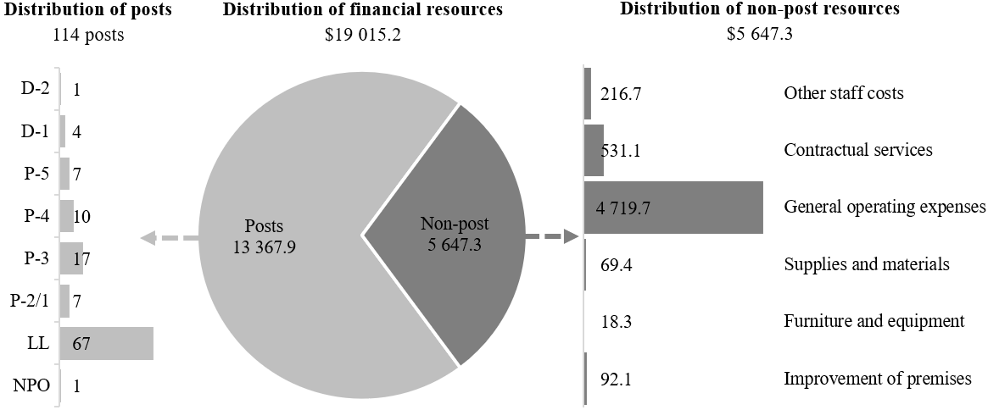

Explanation of variances by factor, component and subprogramme

Overall resource changes

Technical adjustments

29D.69 As shown in table 29D.14 (1), resource changes reflect a decrease of $4,516,200, as follows:
Subprogramme 3, Support services (decrease of $4,516,200). This decrease relates to the removal of non-recurrent requirements approved for 2025 by the General Assembly in its resolution 79/258 relating to the provision for project management costs of the major construction projects for: (a) the replacement of office blocks A to J ($906,100); and (b) addressing the deteriorating conditions and limited capacity of the conference services facilities ($3,610,100). The related requirements for 2026 will be presented later in the year as part of the progress reports on the construction projects.

New and expanded mandates

29D.70 As shown in table 29D.14 (1), resources changes reflect an increase of $14,400, as follows:
Subprogramme 4, Information and communications technology operations (increase of $14,400). This increase relates to additional requirements under contractual services pursuant to General Assembly resolution 79/235.

Other changes

29D.71 As shown in table 29D.14 (1), resource changes reflect a net increase of $4,700, as follows:
(a) Executive direction and management (net increase of $200). An increase under post costs ($280,000) is offset by a decrease under other staff costs ($280,000) relating to the proposed cost-neutral conversions of one temporary position of Programme Management Officer (P-4) and one temporary position of Administrative Assistant (LL) to posts (see annex II). An increase under contractual services ($200) reflects higher ICT rates;
(b) Subprogramme 1, Programme planning, finance and budget (increase of $1,300). An increase of $1,300 under contractual services reflects higher ICT rates;
(c) Subprogramme 2, Human resources management (increase of $900). An increase of $900 under contractual services reflects higher ICT rates;
(d) Subprogramme 3, Support services (increase of $1,800). An increase of $1,800 under contractual services reflects higher ICT rates;
(e) Subprogramme 4, Information and communications technology operations (increase of $500). An increase of $500 under contractual services reflects higher ICT rates.

Extrabudgetary resources

29D.72 As reflected in tables 29D.14 (2) and 29D.15 (2), extrabudgetary resources amount to $30,560,100. The resources would complement regular budget resources and would be used mainly to provide for 299 posts (1 P-5, 9 P-4, 15 P-3, 10 National Professional Officer and 264 Local level) and non-post resources that would be used to perform administrative support, facilities management, common services, commercial operations and conference technology support for the United Nations Secretariat entities, agencies, funds and programmes operating in or from Kenya, UNEP, UN-Habitat and the resident coordinator system.
29D.73 The extrabudgetary resources under the present section are subject to the oversight of the Director-General of the Office, who has delegated authority from the Secretary-General.

Executive direction and management

29D.74 The executive direction and management component comprises the Office of the Director of Administration and the Organizational Resilience Management Unit.
29D.75 The main responsibilities of the executive direction and management component include the overall direction, supervision and management of administrative and related support services provided by the Office to its client organizations. It is also responsible for ensuring resilience, business continuity and risk mitigation for the Office, and conference technology support services in Nairobi.
29D.76 In accordance with the 2030 Agenda for Sustainable Development, in particular target 12.6 of the Sustainable Development Goals, in which organizations are encouraged to integrate sustainability information into their reporting cycles, and in compliance with the cross-cutting mandate set out in paragraph 19 of General Assembly resolution 72/219, the Office is integrating environmental management practices into its operations. The Office broadened its waste management and recycling management initiatives by obtaining ISO 14001:2015 certification in environmental management systems in January 2023. The certification is focused on operations such as energy, water, wastewater and waste management in relation to facilities, safety, catering, medical, conferencing, printing and publication services on which the Office will continue to focus from an environmental sustainability perspective.
29D.77 Information on the timely submission of documentation and advance booking for air travel is reflected in table 29D.17. Apart from factors such as medical evacuations or urgent requirements, the Office continues to enforce official travel planning and monitoring to fully comply with the advance booking policy for air travel. The Office did not submit parliamentary documents to the Department for General Assembly and Conference Management and does not plan to submit any such reports in 2026.

Table 29D.17

Compliance rate
(Percentage)

 | 2022 actual | 2023 actual | 2024 actual | 2025 planned | 2026 planned
Air tickets purchased at least 2 weeks before the commencement of travel | 62 | 60 | 79 | 100 | 100

29D.78 The proposed regular budget resources for 2026 amount to $1,132,700 and reflect a net increase of $200 compared with the approved budget for 2025. The proposed increase is explained in paragraph 29D.71 (a) and in table 29D.18 and figure 29D.XIII.

Table 29D.18

Executive direction and management: evolution of financial and post resources
(Thousands of United States dollars/number of posts)

 | 2024 expenditure | 2025 approved | Changes |  |  |  |  | 2026  estimate
 | 2024 expenditure | 2025 approved | Technical adjustments | New/expanded mandates | Other | Total | Percentage | 2026  estimate
Financial resources by main category of expenditure
Posts | 634.6 | 598.5 | – | – | 280.0 | 280.0 | 46.8 | 878.5
Non-post | 288.1 | 534.0 | – | – | (279.8) | (279.8) | (52.4) | 254.2
Total | 922.7 | 1 132.5 | – | – | 0.2 | 0.2 | 0.0 | 1 132.7
Post resources by category
Professional and higher |  | 2 | – | – | 1 | 1 | 50.0 | 3
General Service and related |  | 1 | – | – | 1 | 1 | 100.0 | 2
Total |  | 3 | – | – | 2 | 2 | 66.7 | 5

Figure 29D.XIII

Executive direction and management: distribution of proposed resources for 2026
(Number of posts/thousands of United States dollars)
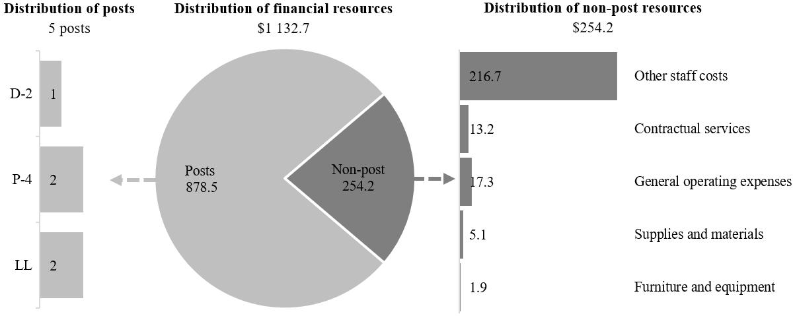

Programme of work

Subprogramme 1

Programme planning, finance and budget

29D.79 The proposed regular budget resources for 2026 amount to $3,782,700 and reflect an increase of $1,300 compared with the approved budget for 2025. The proposed change is explained in paragraph 29D.71 (b) and in table 29D.19 and figure 29D.XIV.

Table 29D.19

Subprogramme 1: evolution of financial and post resources
(Thousands of United States dollars/number of posts)

 | 2024 expenditure | 2025 approved | Changes |  |  |  |  | 2026  estimate
 | 2024 expenditure | 2025 approved | Technical adjustments | New/expanded mandates | Other | Total | Percentage | 2026  estimate
Financial resources by main category of expenditure
Posts | 3 427.3 | 3 609.4 | – | – | – | – | – | 3 609.4
Non-post | 115.6 | 172.0 | – | – | 1.3 | 1.3 | 0.8 | 173.3
Total | 3 543.0 | 3 781.4 | – | – | 1.3 | 1.3 | 0.0 | 3 782.7
Post resources by category
Professional and higher |  | 13 | – | – | – | – | – | 13
General Service and related |  | 18 | – | – | – | – | – | 18
Total |  | 31 | – | – | – | – | – | 31

Figure 29D.XIV

Subprogramme 1: distribution of proposed resources for 2026
(Number of posts/thousands of United States dollars)

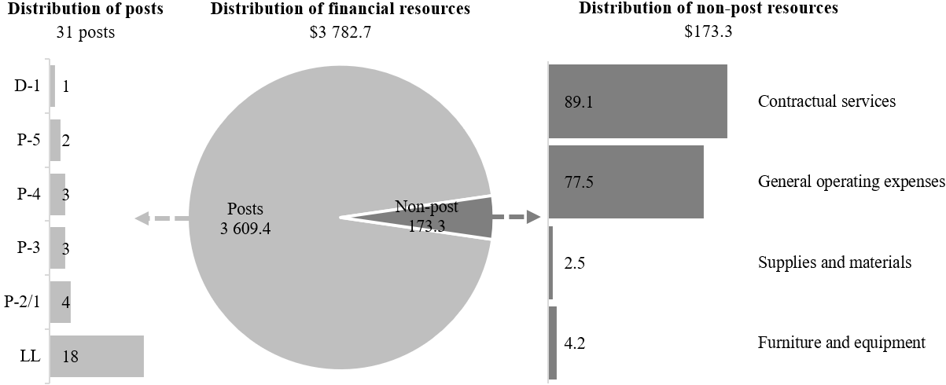

Subprogramme 2

Human resources management

29D.80 The proposed regular budget resources for 2026 amount to $3,398,500 and reflect an increase of $900 compared with the approved budget for 2025. The proposed change is explained in paragraph 29D.71 (c) and in table 29D.20 and figure 29D.XV.

Table 29D.20

Subprogramme 2: evolution of financial and post resources
(Thousands of United States dollars/number of posts)

 | 2024 expenditure | 2025 approved | Changes |  |  |  |  | 2026  estimate
 | 2024 expenditure | 2025 approved | Technical adjustments | New/expanded mandates | Other | Total | Percentage | 2026  estimate
Financial resources by main category of expenditure
Posts | 2 891.2 | 3 178.6 | – | – | – | – | – | 3 178.6
Non-post | 170.0 | 219.0 | – | – | 0.9 | 0.9 | 0.4 | 219.9
Total | 3 061.2 | 3 397.6 | – | – | 0.9 | 0.9 | 0.0 | 3 398.5
Post resources by category
Professional and higher |  | 12 | – | – | – | – | – | 12
General Service and related |  | 11 | – | – | – | – | – | 11
Total |  | 23 | – | – | – | – | – | 23

Figure 29D.XV

Subprogramme 2: distribution of proposed resources for 2026
(Number of posts/thousands of United States dollars)

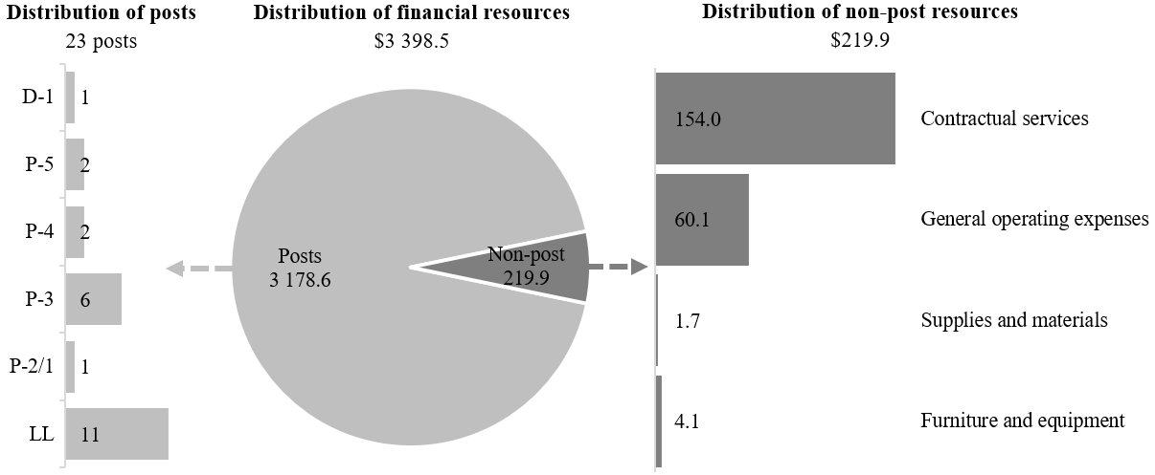

Subprogramme 3

Support services

29D.81 The proposed regular budget resources for 2026 amount to $8,555,100 and reflect a net decrease of $4,514,400 compared with the approved budget for 2025. The proposed decrease is explained in paragraph 29D.69 and paragraph 29D.71 (d). Additional details on the distribution of the proposed resources for 2026 are reflected in table 29D.21 and figure 29D.XVI.

Table 29D.21

Subprogramme 3: evolution of financial and post resources
(Thousands of United States dollars/number of posts)

 | 2024 expenditure | 2025 approved | Changes |  |  |  |  | 2026  estimate
 | 2024 expenditure | 2025 approved | Technical adjustments | New/expanded mandates | Other | Total | Percentage | 2026  estimate
Financial resources by main category of expenditure
Posts | 3 136.0 | 3 667.4 | – | – | – | – | – | 3 667.4
Non-post | 6 598.2 | 9 402.1 | (4 516.2) | – | 1.8 | (4 514.4) | (48.0) | 4 887.7
Total | 9 734.2 | 13 069.5 | (4 516.2) | – | 1.8 | (4 514.4) | (34.5) | 8 555.1
Post resources by category
Professional and higher |  | 10 | – | – | – | – | – | 10
General Service and related |  | 33 | – | – | – | – | – | 33
Total |  | 43 | – | – | – | – | – | 43

Figure 29D.XVI

Subprogramme 3: distribution of proposed resources for 2026
(Number of posts/thousands of United States dollars)

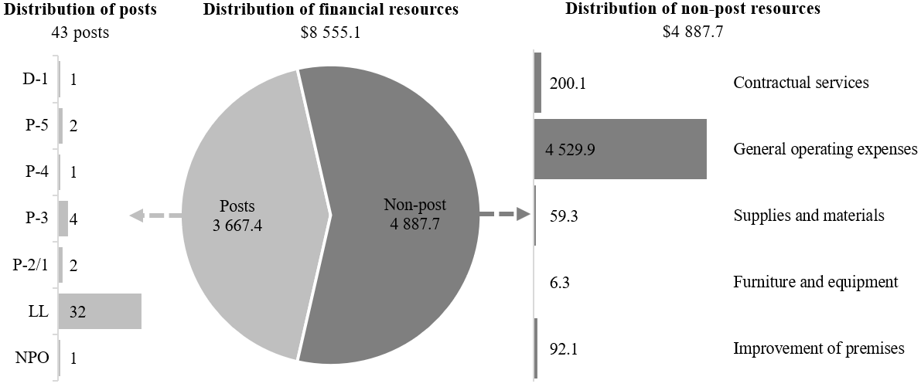

Subprogramme 4

Information and communications technology operations

29D.82 The proposed regular budget resources for 2026 amount to $2,146,200 and reflect an increase of $14,900 compared with the approved budget for 2025. The proposed change is explained in paragraph 29D.70 and paragraph 29D.71 (e). Additional details on the distribution of the proposed resources for 2026 are reflected in table 29D.22 and figure 29D.XVII.

Table 29D.22

Subprogramme 4: evolution of financial and post resources
(Thousands of United States dollars/number of posts)

 | 2024 expenditure | 2025 approved | Changes |  |  |  |  | 2026  estimate
 | 2024 expenditure | 2025 approved | Technical adjustments | New/expanded mandates | Other | Total | Percentage | 2026  estimate
Financial resources by main category of expenditure
Posts | 1 789.4 | 2 034.0 | – | – | – | – | – | 2 034.0
Non-post | 51.7 | 97.3 | – | 14.4 | 0.5 | 14.9 | 15.3 | 112.2
Total | 1 841.1 | 2 131.3 | – | 14.4 | 0.5 | 14.9 | 0.7 | 2 146.2
Post resources by category
Professional and higher |  | 8 | – | – | – | – | – | 8
General Service and related |  | 4 | – | – | – | – | – | 4
Total |  | 12 | – | – | – | – | – | 12

Figure 29D.XVII

Subprogramme 4: distribution of proposed resources for 2026
(Number of posts/thousands of United States dollars)

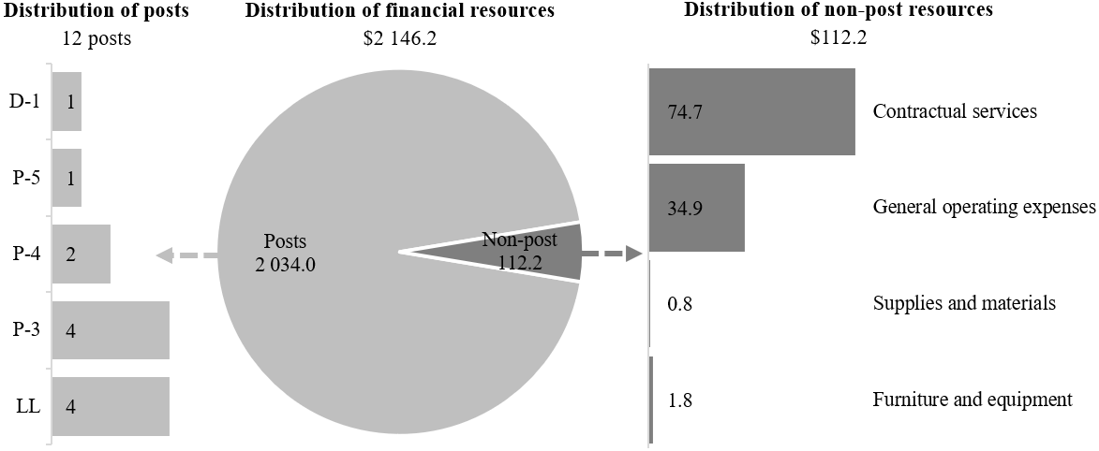

Annex I

Organizational structure and post distribution for 2026

Director-General
Office of the Director of Administration
(executive direction and management)

RB: XB:
1 D-2 1 P-4
1 P-4 3 LL
1 P-4ª
1 LL
1 LLª
5 4
Total: 9
Human resources management
(subprogramme 2)
RB: XB:
1 D-1 1 P-4
2 P-5 5 P-3
2 P-4 7 NPO
6 P-3 65 LL
1 P-2/1
11 LL
23 78

Total: 101
Support services
(subprogramme 3)
RB: XB:
1 D-1 3 P-4
2 P-5 2 P-3
1 P-4 2 NPO
4 P-3 76 LL
2 P-2/1
1 NPO
32 LL
43 83

Total: 126
Programme planning, finance and budget
(subprogramme 1)
RB: XB:
1 D-1 1 P-5
2 P-5 3 P-4
3 P-4 4 P-3
3 P-3 88 LL
4 P-2/1
18 LL
31 96
Total: 127
Information and communications technology operations
(subprogramme 4)
RB: XB:
1 D-1 1 P-4
1 P-5 4 P-3
2 P-4 1 NPO
4 P-3 32 LL
4 LL
12 38

Total: 50

Abbreviations: LL, Local level; NPO, National Professional Officer; RB, regular budget; XB, extrabudgetary.
ª Conversion from general temporary assistance positions.

Annex II

Summary of proposed post changes, by component and subprogramme

Component/subprogramme | Posts | Grade | Description | Reason for change
Executive direction and management | 1 | P-4 | Conversion of Programme Management Officer from temporary position to post | These two temporary positions, funded under general temporary assistance, were established in the Organizational Resilience Management Unit in June 2013, over 10 years ago, following the approval by the General Assembly of the organizational resilience management system in section II of its resolution 67/254 A. The establishment of the two positions was an essential ongoing requirement for the United Nations Office at Nairobi to ensure resilience, business continuity and risk mitigation.  The ongoing criticality of the functions has been proven, especially during critical security threats and health emergencies. Taking into account the proven need for the functions undertaken under the temporary positions for a long period of time, it is proposed that they be established as posts.
Executive direction and management | 1 | LL | Conversion of Administrative Assistant from temporary position to post

Abbreviation: LL, Local level.

