Eightieth session
Items 137 and 138 of the preliminary list*

Proposed programme budget for 2026

Programme planning

Proposed programme budget for 2026

Part VIII

Common support services

Section 29E

Administration, Geneva

Programme 25

Management and support services

Contents
 |  |  | Page
- Proposed programme plan for 2026 and programme performance in 2024** |  |  | 3
Overall orientation |  |  | 3
Programme of work |  |  | 6
Subprogramme 1. Programme planning, finance and budget |  |  | 6
Subprogramme 2. Human resources management |  |  | 9
Subprogramme 3. Support services |  |  | 13
Subprogramme 4. Information and communications technology operations |  |  | 16
Subprogramme 5. Library services |  |  | 20
* A/80/50.
** In keeping with paragraph 10 of General Assembly resolution 77/267, the part consisting of the programme plan and programme performance information (part II) is submitted through the Committee for Programme and Coordination for the consideration of the Assembly.
- Proposed post and non-post resource requirements for 2026*** | 24
Overview | 24
Executive direction and management | 29
Programme of work | 31
Subprogramme 1. Programme planning, finance and budget | 31
Subprogramme 2. Human resources management | 32
Subprogramme 3. Support services | 33
Subprogramme 4. Information and communications technology operations | 34
Subprogramme 5. Library services | 35
Annexes
- Organizational structure and post distribution for 2026 | 37
- Summary of proposed post changes, by component and subprogramme | 38
*** In keeping with paragraph 10 of General Assembly resolution 77/267, the part consisting of the post and non-post resource requirements (part III) is submitted through the Advisory Committee on Administrative and Budgetary Questions for the consideration of the Assembly.

A. Proposed programme plan for 2026 and programme performance in 2024

Overall orientation

Mandates and background

29E.1 The United Nations Office at Geneva was established in 1947 pursuant to General Assembly resolution 24 (I) and successive resolutions of the Assembly. The Office is responsible for providing administrative and support services to entities in Geneva and their field offices, and to other organizations of the United Nations common system, in accordance with policies, procedures and practices established by the Under-Secretary-General for Management Strategy, Policy and Compliance, the Under-Secretary-General for Operational Support and the Assistant Secretary-General/Chief Information Technology Officer. The Office is also responsible for providing support services to the intergovernmental processes of the Organization in line with its role as a major conference centre for international diplomacy. This includes providing technical conference support services as part of the conferencing ecosystem, which enables the work of Member States and client entities.

Strategy and external factors for 2026

29E.2 In compliance with General Assembly resolution 2 (I), the Office will offer administrative and support services in English and French. These services will include direction, management and coordination in the areas of human resources, financial and budgetary resources, information and communications technology (ICT), central support services, and library and archives services at the Office. The Office will function as landlord and manage the United Nations premises, which accommodate almost 70 tenants. The Office will also play a critical role in supporting United Nations meetings and events. From providing audiovisual and ICT support to maintaining conference rooms and equipment, the Office will remain an essential component of the conferencing network in Geneva. The Office is in advanced planning with United Nations Headquarters to establish the Office as the principal backup for Headquarters payroll, vendor payments and cashier services in the context of business continuity and disaster recovery, and will implement policy and other functions, as determined by the Under-Secretaries-General referred to in paragraph 29E.1 above.
29E.3 The Office will provide financial, budgetary and accounting services, as well as guidance and advice, in accordance with the Financial Regulations and Rules of the United Nations and relevant standards. In addition, the Office will provide staff development and learning services, career support and coaching, staff mental health and well-being activities, and medico-administrative occupational safety and health, human resources and legal advisory services. The Office will provide procurement, commercial activities, transportation, travel and other central support services for the Secretariat and the specialized agencies. It will also provide travel, procurement support and assistance in hiring consultants to 18 resident coordinator offices in Europe in support of the development pillar. In addition, the Office will provide regional ICT services and library, records, archives and knowledge services in support of the implementation of the mandated programmes and activities of the Secretariat. The Office will further ensure coordination and implementation of recommendations of oversight bodies at the Office, as well as the business continuity of administrative support and guidance for other entities in Geneva in emergency cases.
29E.4 Physical renovation works at the historic buildings of the Palais des Nations under the strategic heritage plan will continue throughout 2026. These works will modernize the information technology, broadcast and conferencing infrastructure, and ensure that buildings comply with host country building codes for fire safety, energy and accessibility while preserving the principles of the original design and historical features of existing buildings.
29E.5 The Office will analyse operation and maintenance requirements of the buildings post-strategic heritage plan to ensure the best mix of internal and contractual resources to efficiently manage these buildings and their technologically advanced components. Lastly, the Office will move forward with introducing modern preventive and regular building maintenance to safeguard Member States’ investment through the strategic heritage plan.
29E.6 Client service will remain a priority in 2026. Client board meetings will be held quarterly to promote open and transparent service delivery. The Office will further improve operations in administration and support in collaboration with Geneva-based Secretariat and United Nations system entities, as well as other Secretariat service providers. To maximize client support effectiveness, the Office will further develop its Client Support Centre, which delivers tier-2 level support and accommodates 20,000 client visits and 12,000 client calls annually. Growing demand for and the escalating technical complexity of delivering side events, cultural events and activities require a more efficient event support model. To achieve this, the Office will continue its work to establish an event support centre for these types of events. Subprogramme 4 will deliver phase I (design and development of the centre) and, concurrently, subprogramme 3 will deliver phase II (establishing centralized audiovisual support for client entities and Member States). In addition, the Office will offer dedicated support for client entities moving to or relocating from the Palais des Nations (subprogramme 1) and will also implement the United Nations System Mental Health and Well-being Strategy for 2024 and Beyond (subprogramme 2). The Office will use its comprehensive communications strategy to bolster these initiatives and will conduct annual client entity and end-user surveys to monitor effectiveness and drive improvements.
29E.7 The Office will implement activities across all subprogrammes to support the Secretary-General’s reform initiatives, including providing expertise in support of global administrative operational processes; supporting digital transformation, the Secretary-General’s strategy on new technologies and the Data Strategy of the Secretary-General for Action by Everyone, Everywhere; providing capacity-building to the resident coordinator system; and strengthening financial management and internal control systems and the risk management framework.
29E.8 With regard to inter-agency coordination and liaison, the Office will collaborate with other Geneva-based United Nations system organizations and international governmental organizations, coordinating the Common Procurement Activities Group. The Office will continue to own and administer global United Nations contracts, conduct annual daily subsistence allowance surveys, coordinate periodic cost of living surveys, conduct place-to-place surveys and monitor the consumer price index at Geneva. The Office will work closely with other facilities managers of international organizations in Geneva to enhance inter-agency coordination on relevant policies and procedures. The Office will further collaborate with other United Nations libraries to digitize the official documents of the United Nations and will advance the streamlining of library activities, which will benefit from a common library management system used by the libraries at the Office, United Nations Headquarters, the Economic Commission for Latin America and the Caribbean, the Economic Commission for Africa and the Economic and Social Commission for Asia and the Pacific.
29E.9 With regard to the external factors, the overall plan for 2026 is based on the planning assumption that client offices will have sufficient extrabudgetary resources to pay for services provided by the Office, when applicable.
29E.10 The Office integrates a gender perspective into its operational activities, deliverables and results, as appropriate. It will contribute to improving gender equality in 2026 in offices that it supports, in line with the Secretary-General’s system-wide strategy on gender parity, through consultations and briefings to hiring managers and human resources focal points in client entities regarding the impact of selection decisions, including advice on targeted outreach of job openings through established human resources networks and the targeted promotion of career opportunities in the United Nations.
29E.11 In line with the United Nations Disability Inclusion Strategy, the Office will continue to implement its disability inclusion action plan and support the strategic heritage plan in its efforts to incorporate accessibility features in renovation works.

Legislative mandates

29E.12 The list below, which was reviewed in the preparation of the proposed programme budget, provides all mandates entrusted to the programme.

General Assembly resolutions

24 (I) | Transfer of certain functions, activities and assets of the League of Nations
77/280 | Progress towards an accountability system in the United Nations Secretariat

Subprogramme 1

Programme planning, finance and budget

General Assembly resolutions

41/213 | Review of the efficiency of the administrative and financial functioning of the United Nations
42/211 | Implementation of General Assembly resolution 41/213
77/267 | Shifting the management paradigm in the United Nations: review of changes to the budgetary cycle

Subprogramme 2

Human resources management

General Assembly resolutions

58/144 | Improvement of the status of women in the United Nations system
73/281 | Shifting the management paradigm in the United Nations
77/256 A–B | United Nations common system
77/278 | Human resources management
78/248 | Administration of justice at the United Nations
78/275 | Amendments to the Staff Regulations and Rules

Subprogramme 3

Support services

General Assembly resolutions

58/263 | Report of the Joint Inspection Unit on the revenue-producing activities of the United Nations system
58/276 | Outsourcing practices
58/277 | Report of the Joint Inspection Unit on the management audit review of outsourcing in the United Nations and the United Nations funds and programmes
69/273 | Procurement

Subprogramme 4

Information and communications technology operations

General Assembly resolutions

63/262 | Information and communications technology, enterprise resource planning, and security, disaster recovery and business continuity
63/269 | Information and communications technology, disaster recovery and business continuity for the United Nations: arrangements for the secondary data centre at Headquarters
71/272 B | Special subjects relating to the programme budget for the biennium 2016–2017 (sect. III, Status of implementation of the information and communications technology strategy for the United Nations)
78/243 | Information and communications technology strategy

Subprogramme 5

Library services

General Assembly resolution

356 (IV) | Budget appropriations for the financial year 1950

Deliverables

29E.13 Table 29E.1 lists all cross-cutting deliverables of the programme.

Table 29E.1

Cross-cutting deliverables for the period 2024–2026, by category and subcategory

Category and subcategory | 2024 planned | 2024 actual | 2025 planned | 2026 planned
A. Facilitation of the intergovernmental process and expert bodies
Substantive services for meetings (number of three-hour meetings) | 5 | 5 | 5 | 5
Meetings of:
1. The Advisory Committee on Administrative and Budgetary Questions | 2 | 2 | 2 | 2
2. The Committee for Programme and Coordination | 1 | 1 | 1 | 1
3. The Fifth Committee | 2 | 2 | 2 | 2

Evaluation activities

29E.14 An evaluation on the activities supporting mental health and well-being at the Office was conducted the Office in 2024 and has guided the proposed programme plan for 2026.
29E.15 In response to the preliminary results of the evaluation referenced above, the Office incorporated recommendations and lessons learned to inform its work referenced in paragraph 29E.6 above to implement the United Nations System Mental Health and Well-being Strategy for 2024 and Beyond.
29E.16 An evaluation to be conducted by the Office on the usage of internal meetings rooms and collaboration spaces is planned for 2026.

Programme of work

Subprogramme 1

Programme planning, finance and budget

Objective

29E.17 The objective, to which this subprogramme contributes, is to ensure sound, effective and efficient financial management by client offices.

Strategy

29E.18 To contribute to the objective, the subprogramme will:
(a) Monitor budget implementation, report budget and financial information and conduct financial management and accounts control by coordinating with Headquarters and providing timely advice to client entities regarding a broad range of financial services, spanning from payments and disbursements services to payroll, accounting, medical insurance, and trust funds and budget management;
(b) Provide assistance, guidance and training to programme managers and administrative units of client organizations on financial management and budgetary matters;
(c) Perform financial and administrative procedures, including internal financial controls and monitoring strict compliance with the Financial Regulations and Rules of the United Nations and the financial policies of the United Nations;
(d) Identify ways to achieve a faster and more efficient client response, including through digital transformation and innovative tools in line with the Secretary-General’s strategy on new technologies;
(e) Monitor the implementation of oversight bodies’ recommendations.
29E.19 The above-mentioned work is expected to result in improved integrity of financial data and enhanced overall management of programme budget and extrabudgetary resources.

Programme performance in 2024

Faster processing times for insurance claim requests requiring medical authorization

29E.20 Improvements were needed to address inefficiencies in the turnaround time of insurance claim requests that require prior authorization from a medical adviser. The subprogramme identified that technology could modernize the practice of printing and manually signing such requests. In coordination with subprogramme 4, the subprogramme developed a tool to automate and streamline the process. Operators now enter requests for prior authorization with relevant documentation directly into the tool, where medical advisers review and authorize the claim requests online. Since the introduction of the new system, average processing times of prior authorization requests have been almost five times faster.
29E.21 Progress towards the objective is presented in the performance measure below (see figure 29E.I).

Figure 29E.I

Performance measure: average processing time of client requests for prior authorization from a medical adviser (annual)
(Number of days)

Planned results for 2026

Result 1: improved client service at Client Support Centre

Programme performance in 2024 and target for 2026

29E.22 The subprogramme’s work contributed to clients benefitting from a streamlined telephone system that ensures more efficient call routing, which did not meet the planned target of clients having more optimized service offerings. The target was not met due to competing priorities of staff involved in the initiative who were also helping to manage the liquidity crisis.
29E.23 Progress towards the objective and the target for 2026 are presented in the performance measure below (see table 29E.2).

Table 29E.2

Performance measure

2022 (actual) | 2023 (actual) | 2024 (actual) | 2025 (planned) | 2026 (planned)
Clients have access to both in-person and remote services | Clients have access to improved telephone support, as illustrated by a 24 per cent decrease in dropped calls | Clients benefit from more streamlined telephone system | Clients have improved access to support and additional resources through enhancements made to Client Support Centre website | Clients have more optimized service offerings

Result 2: entities have access to dedicated support when moving to or relocating from the Palais des Nations

Programme performance in 2024 and target for 2026

29E.24 The subprogramme’s work contributed to the Office of the Secretary-General’s Envoy on Technology having access to the new pilot centralized support model, which met the planned target.
29E.25 Progress towards the objective and the target for 2026 are presented in the performance measure below (see table 29E.3).

Table 29E.3

Performance measure

2022 (actual) | 2023 (actual) | 2024 (actual) | 2025 (planned) | 2026 (planned)
– | Clients have access to guidance documentation for entity onboarding/ offboarding | Office of the Secretary-General’s Envoy on Technology has access to the new pilot centralized support model | All client entities moving to or leaving the Palais des Nations use the new centralized support model | Client entities participate in survey and provide feedback to improve support model

Result 3: resilient and efficient treasury transaction processes

Proposed programme plan for 2026

29E.26 The subprogramme processes payroll for over 7,500 staff globally and executes more than 300,000 payments and disbursements annually. Recently, the number of payment rejections and investigations has nearly tripled, rising from 785 cases in 2021 to 2,176 cases in 2024, and resulting in additional bank charges for clients. The subprogramme has identified that the increase in bank payment rejections and investigations is driven by factors such as stricter sanctions compliance, enhanced “know your customer” requirements, evolving anti-money-laundering regulations and the introduction of automated compliance monitoring systems. Those changes have heightened the need for detailed payment verification and strict adherence to regulatory frameworks.

Lessons learned and planned change

29E.27 The lesson for the subprogramme was that proactive engagement with clients to help them understand banking requirements can improve the accuracy of client master data update submissions and significantly reduce payment disruptions. In applying the lesson, the subprogramme will conduct a review of the most frequent causes of payment rejections and investigations, focusing on the largest clients, accounting for 83 per cent of cases. On the basis of the findings, tailored workshops will be developed to inform and educate clients, equipping them with the knowledge and tools needed to meet evolving banking expectations, minimize payment delays and foster more secure and efficient transaction processes.
29E.28 Expected progress towards the objective is presented in the performance measure below (see table 29E.4).

Table 29E.4

Performance measure

2022 (actual) | 2023 (actual) | 2024 (actual) | 2025 (planned) | 2026 (planned)
– | – | Generic training available on banking requirements | One client entity pilots a tailored workshop to improve the quality of payment transactions | Three additional client entities benefit from tailored workshops to improve the quality of payment transactions

Deliverables

29E.29 Table 29E.5 lists all deliverables of the subprogramme.

Table 29E.5

Subprogramme 1: deliverables for 2026, by category and subcategory

Category and subcategory
E. Enabling deliverables
Administration: financial management, risk management and internal control, and preparation and implementation of resource proposals; management of more than 700 posts; financial reporting and accounting; cash and revenue management; management of service arrangements with 50 client entities across 120 service lines; processing of payroll for more than 7,500 staff members across the world and more than 300,000 payments and disbursements annually; guidance and advice on all budgetary and financial matters; provision of medical insurance to more than 36,000 staff, retirees and dependents; processing of more than 490,000 medical invoices annually; administration of compensation claims; and delivery of quarterly client board meetings.

Subprogramme 2

Human resources management

Objective

29E.30 The objective, to which this subprogramme contributes, is to ensure a competent, diverse, adaptable and healthy workforce, to advance the highest standards of efficiency, competence and integrity and to ensure resilient organizational change.

Strategy

29E.31 To contribute to the objective, the subprogramme will:
(a) Provide expert support to clients to attract, recruit and retain talent, including women and applicants from unrepresented and underrepresented countries, by leveraging efficient workforce planning and internal human resources analytics capabilities;
(b) Strengthen tailored advisory services and adopt a cross-functional approach to case management, and promote staff well-being and an inclusive work culture;
(c) Provide learning and development activities, such as training sessions and briefings on performance management, innovation and navigation of workplace changes, as well as through language programmes to promote multilingualism;
(d) Promote a harmonious workplace with zero tolerance for prohibited conduct;
(e) Promote knowledge- and information-sharing about the work of the Office and the United Nations, and encourage intergenerational dialogue and inclusive youth engagement in those efforts.
29E.32 The above-mentioned work is expected to result in:
(a) Improved client experience, satisfaction and decision-making, on the basis of enhanced business insight using human resources data;
(b) Enhanced ability of staff to navigate workplace changes, embrace innovation and adopt new ways of working in a more agile and flexible manner;
(c) Increased awareness of the mechanisms to address prohibited conduct and of the responsibility of individual staff and management to foster an inclusive and harmonious work environment;
(d) Strengthened youth engagement and intergenerational partnership to widen the pool of young applicants and encourage and support the development of innovative ideas.

Programme performance in 2024

General Service staff empowered through the Game Shifter leadership programme

29E.33 The United Nations system leadership framework emphasizes that leadership exists across various contexts and levels. All personnel within the United Nations system, regardless of their position, duties or location, are called upon to demonstrate leadership in their work. In 2022, the subprogramme launched the Game Shifter leadership programme, specifically designed for General Service staff. As a 12-week experiential learning programme, participants engaged in blended learning and personalized coaching from business strategists, change leaders and organizational psychologists to uncover their strengths, enhance self-awareness and acquire practical skills to elevate their professional trajectories. In 2024, due to the liquidity crisis, the programme had to limit the number of participants in the programme.
29E.34 Progress towards the objective is presented in the performance measure below (see figure 29E.II).

Figure 29E.II

Performance measure: percentage of programme participants rating the programme as excellent/good

Planned results for 2026

Result 1: a more inclusive and supportive work environment

Programme performance in 2024 and target for 2026

29E.35 The subprogramme’s work contributed to staff having increased access to mental health and well-being support, including webinars and materials in English and French focused on burnout and burnout prevention, which met the planned target.
29E.36 Progress towards the objective and the target for 2026 are presented in the performance measure below (see table 29E.6).

Table 29E.6

Performance measure

2022 (actual) | 2023 (actual) | 2024 (actual) | 2025 (planned) | 2026 (planned)
Staff have access to reasonable accommodation guidelines | Staff have an increased awareness of signs of burnout and have access to resources to help to prevent it | Staff have increased access to mental health and well-being support | Staff have access to on-demand, tailored programmes and trainings on mental health and well-being issues | Staff and managers receive an action plan to improve mental health and well-being, informed by their survey participation

Result 2: staff and external applicants better understand the United Nations recruitment process and make informed career-related decisions

Programme performance in 2024 and target for 2026

29E.37 The subprogramme’s work contributed to over 12,000 end-users participating in the “Career Tips Thursday” series, a 20 per cent increase from 2023, which exceeded the planned target of a 3 per cent increase. The Career Tips Thursday initiative also won an award in the 2024 International Organizations Career Development Roundtable, in the “staff engagement” category.
29.E.38 Progress towards the objective and the target for 2026 are presented in the performance measure below (see table 29E.7).

Table 29E.7

Performance measure

2022 (actual) | 2023 (actual) | 2024 (actual) | 2025 (planned) | 2026 (planned)
– | Approximately 10,000 end users (staff and public globally) participated in the Career Tips Thursday series | 20 per cent increase in end-users participating in the Career Tips Thursday series, and award received | Staff have access to career development initiatives, which respond to United Nations Staff Engagement Survey results | Young and external applicants actively use resources on United Nations career development

Result 3: expanded youth engagement and intergenerational dialogue

Proposed programme plan for 2026

29E.39 To improve geographical representation, foster intergenerational dialogue and leverage emerging trends from academia, the subprogramme has made the Office’s internship programme more inclusive and accessible. In 2023, five outreach events were held with students and university representatives, followed by seven more in 2024.

Lessons learned and planned change

29E.40 The lesson for the subprogramme was that targeted outreach improves equitable access to information about internship opportunities, particularly for candidates from unrepresented and underrepresented countries, whose participation in internship programmes increased from 23 per cent in 2023 to 25 per cent in 2024. In applying the lesson, the subprogramme will build on this success by expanding the programme while strengthening partnerships with academia, Governments and the host country to attract a more diverse pool of candidates.
29E.41 Expected progress towards the objective is presented in the performance measure below (see figure 29E.III).

Figure 29E.III

Performance measure: percentage of interns from unrepresented and underrepresented countries (annual)

Deliverables

29E.42 Table 29E.8 lists all deliverables of the subprogramme.

Table 29E.8

Subprogramme 2: deliverables for 2026, by category and subcategory

Category and subcategory
D. Communication deliverables
Outreach programmes, special events and information materials: job fairs and career presentations to identify prospective candidates, including female candidates, from unrepresented and underrepresented Member States; and knowledge-sharing in the area of human resources and staff health and well-being.
E. Enabling deliverables
Administration: talent management and job classification; administration of approximately 3,150 staff contracts; advice and guidance on human resources policies, including on the Staff Regulations and Rules and staff selection system; 500 learning activities, including training on organizational and managerial competencies, substantive and technical skills, language and communications, and career development for 13,000 staff members and others annually; administration of assessment tests; staff counselling services and psychological support; conduct of staff surveys, including on cost of living and daily subsistence allowance; 8,400 host country residence permits obtained in liaison with local authorities; occupational health and medico-administrative services for 15,000 client staff in Geneva and field offices, medical consultations and advice, medical emergency preparedness, health and well-being campaigns; and learning, career development and performance management.
Internal justice and oversight: legal services provided to the Office and 20 client entities; act as legal counsel for the Organization before the United Nations Dispute Tribunal; act as Office legal adviser in human resources matters, including in cases of alleged misconduct; defend the Organization’s position before the Management Advice and Evaluation Section; negotiate settlement agreements on behalf of the Organization and work with the United Nations Ombudsman and Mediation Services; act as conduct and discipline focal point at the Office, provide regular information updates on legal and ethical topics to Office staff and client entities; and provide regular briefings for managers on best practices and lessons learned from current legal jurisprudence to increase awareness and compliance.

Subprogramme 3

Support services

Objective

29E.43 The objective, to which this subprogramme contributes, is to ensure the efficient, environmentally responsible and effective functioning of the United Nations Office at Geneva with regard to premises, office and conference facilities management; asset management; travel and transportation; mail and pouch services; procurement; and commercial activities.

Strategy

29E.44 To contribute to the objective, the subprogramme will:
(a) Provide services in the areas of facilities management, security infrastructure maintenance, assistance with conference activities, special events, project management, and property and space management;
(b) Equip meeting and conference rooms with advanced technologies, infrastructure and equipment to support virtual and blended meetings, in accordance with available funding;
(c) Provide procurement services, including collaborative procurement activities with other United Nations organizations and agencies based in Geneva through the Common Procurement Activities Group;
(d) Provide services in the areas of contract management, travel, administration of diplomatic privileges, visas, United Nations travel documents, transportation, mail and pouch services, and warehousing;
(e) Support the implementation of the strategic heritage plan, ensuring that solutions are in place to minimize the impact of any potential disruptions during renovation of the historic buildings of the Palais des Nations and operation of the new building H.
29E.45 The above-mentioned work is expected to result in:
(a) Optimized use of space and the provision of high-quality logistical services and support to client entities;
(b) Modern, high-quality conference support services, including the availability of conference rooms equipped for multilingualism;
(c) Clients’ procurement needs being met;
(d) Improved workplace safety and conditions in the Palais des Nations and its annexes.

Programme performance in 2024

Continued provision of core services at the Palais during the liquidity crisis

29E.46 The subprogramme’s work contributed to enabling clients and staff to continue to work from the Palais and implement their core mandate while the Office adapted to funding constraints due to the financial situation of the United Nations regular budget. The subprogramme achieved this by optimizing space to move over 1,000 staff and clients into more energy-efficient buildings, allowing advance closure of the E building office tower and temporarily closure of less energy-efficient annex buildings, closing the Palais on weekends, reducing heating and cooling in all buildings and postponing some maintenance work while providing only minimum services. As a result, the Office maintained core operations, including providing technical services for conferences and meetings, albeit with some negative impacts on users and requiring adjustments from all stakeholders.
29E.47 Progress towards the objective is presented in the performance measure below (see figure 29E.IV).

Figure 29E.IV

Performance measure: average square metres of open space at Palais versus average number of staff on campus

Planned results for 2026

Result 1: United Nations Office at Geneva campus preserved for future generations

Programme performance in 2024 and target for 2026

29E.48 The subprogramme’s work contributed to facilitating an energy audit for building S1 in 2024, which did not meet the planned target of protecting Member States’ investment through an assessment study of all renovated areas of the Palais des Nations delivered by the strategic heritage plan that identifies long-term preventive maintenance requirements. The target was not met due to delays in completing renovations and handing the buildings over to the subprogramme.
29E.49 Progress towards the objective and the target for 2026 are presented in the performance measure below (see table 29E.9).

Table 29E.9

Performance measure

2022 (actual) | 2023 (actual) | 2024 (actual) | 2025 (planned) | 2026 (planned)
– | Availability of a study to assess the ongoing preventive maintenance and operational costs for building H | Energy audit conducted for building S1 | Long-term maintenance strategy for buildings fully handed over by strategic heritage plan in place to protect Member States’ investment | Long-term maintenance strategy for additional buildings fully handed over by strategic heritage plan in place to protect Member States’ investment

Result 2: event support centre, phase II: improved audiovisual support used by Member States and client entities

Programme performance in 2024 and target for 2026

29E.50 The subprogramme’s work contributed to the identification of Member States’ and client entities’ audiovisual needs and scenarios, which did not meet the planned target of Member States’ and client entities’ audiovisual needs and scenarios identified and incorporated into the event support centre process road map. The target was not met due to the additional time and capacity required to incorporate identified needs and scenarios into the process road map.
29E.51 Progress towards the objective and the target for 2026 are presented in the performance measure below (see table 29E.10).

Table 29E.10

Performance measure

2022 (actual) | 2023 (actual) | 2024 (actual) | 2025 (planned) | 2026 (planned)
– | – | Member State and client entity audiovisual needs and scenarios identified | Member States and client entities use the centralized, improved and proactive audiovisual support for side events, cultural events and activities | Member States and client entities have access to optimized support informed by a client survey

Result 3: clients benefit from modern building facilities following strategic heritage plan renovations

29E.52 Under the strategic heritage plan, the historic buildings of the Palais des Nations are being renovated and transferred to the subprogramme for ongoing management and maintenance. In 2021, the subprogramme assumed responsibility for the newly completed building H under the strategic heritage plan and relocated staff to the building in May 2021. While certain aspects of the transition proceeded smoothly, related operational challenges continue, in particular regarding incomplete maintenance documentation and issues with the building’s new electrical systems, which led to disruptions for staff.

Lessons learned and planned change

29E.53 The renewed lesson for the subprogramme was the importance of comprehensive maintenance documentation for the advanced technologies and electrical systems introduced during renovations. Such documentation is core to the maintenance strategy and ensures that each building is operational and ready for occupancy upon transfer. In applying the lesson, the subprogramme will develop and implement detailed maintenance plans for the daily operations of newly renovated buildings as they are handed over from the strategic heritage plan, including documentation of installed technologies and electrical systems. This proactive approach will help to support staff and client comfort in the modernized spaces, while safeguarding the significant investment made by Member States in upgrading the Palais.
29E.54 Expected progress towards the objective is presented in the performance measure below (see table 29E.11).

Table 29E.11

Performance measure

2022 (actual) | 2023 (actual) | 2024 (actual) | 2025 (planned) | 2026 (planned)
– | Clients utilize renovated facilities in buildings D and AC | Clients utilize renovated facilities in building S1 | Clients utilize renovated facilities in buildings A and AB | Clients utilize renovated facilities in building C

Deliverables

29E.55 Table 29E.12 lists all deliverables of the subprogramme.

Table 29E.12

Subprogramme 3: deliverables for 2026, by category and subcategory

Category and subcategory
E. Enabling deliverables
Administration: travel arrangements (27,600), visas and laissez-passer for Geneva-based United Nations Secretariat entities and other entities based at the Geneva campus; audiovisual support (6,100 meetings and 150 events); and management and maintenance of Office campus (215,381 m² containing 2,871 offices, 49 conference rooms, and 85 meeting rooms).
Logistics: full procurement services (amounting to $54.5 million); physical verification of 36,000 serialized equipment items and fixed assets; shipment of official property, bulk consignments for conferences (102,900 kg) and distribution services (approximately 128,400 items) for United Nations offices and other United Nations entities.

Subprogramme 4

Information and communications technology operations

Objective

29E.56 The objective, to which this subprogramme contributes, is to advance the efficient and effective implementation of client entities’ substantive programmes through technologies, including a coherent enterprise ICT system and enterprise architecture; access to ICT-related technological innovations; and a secure, coherent and resilient technology application hosting and infrastructure landscape.

Strategy

29E.57 To contribute to the objective, the subprogramme will:
(a) Manage a portfolio of end-to-end hardware and software solutions and implement new technologies for clients on the basis of their business objectives;
(b) Build resilient technological capacity to meet client objectives by acquiring knowledge and expertise on relevant solutions, migrating to the most cost-effective sourcing options, exploiting economies of scale, adopting innovative technologies and discontinuing legacy systems;
(c) Manage the use of ICT resources by engaging and leading the ICT community and entities of the United Nations system in Geneva and elsewhere in Europe in the definition, adoption and deployment of ICT governance policies and procedures, as well as oversee and support ICT strategy implementation and provide security in the use of ICT services.
29E.58 The above-mentioned work is expected to result in:
(a) A safe and reliable ICT environment for all United Nations Secretariat entities in Geneva;
(b) Clients whose administrative and management decision-making processes are facilitated and empowered by new and innovative information technology solutions;
(c) Client entities with access to cost-effective services and solutions that optimize the use of resources to achieve business goals.

Programme performance in 2024

Clients benefit globally from cost-effective access to Adobe licenses

29E.59 In 2024, the Office received the United Nations procurement award for collaborative procurement for securing an enterprise license agreement for Adobe products. Since 2018, the subprogramme has centrally managed this global agreement that now covers 26 United Nations entities, reducing administrative burdens and enabling rapid license allocation. Clients benefit from competitive pricing, streamlined operations and inclusive tools, ensuring they have the means to fulfil their mandates effectively. Since 2022, the agreement has resulted in a 40 per cent increase in Adobe Admin Consoles – the centralized platforms used by client entities to manage licenses, allocate resources and streamline access to Adobe products, providing staff across the United Nations with greater access to cost-effective Adobe licenses.
29E.60 Progress towards the objective is presented in the performance measure below (see figure 29E.V).

Figure 29E.V

Performance measure: number of Adobe Admin Consoles used by client entities under the global enterprise license agreement for Adobe products (cumulative)

Planned results for 2026

Result 1: experience of conference participants and organizers improved through technology

Programme performance in 2024 and target for 2026

29E.61 The subprogramme’s work contributed to the phased availability of new features for conference participants in building AC and the integration of new functionality for conference participants into the design of building E, which met the planned target.
29E.62 Progress towards the objective and the target for 2026 are presented in the performance measure below (see table 29E.13).

Table 29E.13

Performance measure

2022 (actual) | 2023 (actual) | 2024 (actual) | 2025 (planned) | 2026 (planned)
Design and conduct of a mock-up for simulation of new features for conference participants and validation of the new architecture | Phased availability of the new features for conference participants in buildings A, AB and C | Conference participants have full access to the new features in conference rooms for building AC  New functionality for conference participants is integrated into the design of building E | Conference participants have full access to new features in all buildings completed by the strategic heritage plan in 2025 | Conference participants have access to new features in all buildings completed by strategic heritage plan in 2026

Result 2: event support centre, phase I: clients utilize a single point of contact and online tool to organize cultural events, side events and activities

Programme performance in 2024 and target for 2026

29E.63 The subprogramme’s work contributed to the design of a digital platform and a support data model, incorporating client requirements and feedback, which met the planned target.
29E.64 Progress towards the objective and the target for 2026 are presented in the performance measure below (see table 29E.14).

Table 29E.14

Performance measure

2022 (actual) | 2023 (actual) | 2024 (actual) | 2025 (planned) | 2026 (planned)
Staff book meeting rooms in building H including for blended in-person and virtual meetings | Staff have access to automated technology to facilitate the holding of blended meetings in building H | Design of digital platform and a support data model incorporating client requirements and feedback | Clients have access to single point of contact and online tool to request event services and support | Clients utilize online tool to manage supported event types, enabling stakeholders to interact with and efficiently oversee event services

Result 3: enhanced efficiency and security through the Internet of things for a better client experience

Proposed programme plan for 2026

29E.65 The rapid evolution of Internet of things technology offers opportunities in building management (such as smart heating ventilation air conditioning systems, lighting controls and energy monitoring), predictive maintenance, conference management (such as Internet of things-powered kiosks, digital badges, room occupancy optimization and environmental controls) and safety and security (such as connected surveillance cameras and sensors enhancing security and disaster response). The subprogramme recognizes that Internet of things solutions can enhance campus operations by improving efficiency, enabling better decision-making and providing more effective resource management. However, to harness the full potential of the Internet of things, such technologies must be integrated into the Office’s information security framework to address risks such as system vulnerabilities, data breaches and privacy violations.

Lessons learned and planned change

29E.66 The lesson for the subprogramme was that the uncoordinated adoption of Internet of things technologies across campus service areas has hindered the ability of the Office to maximize their value. In addition, information security risks associated with these solutions have grown significantly. In applying the lesson, the subprogramme will develop, in coordination with subprogramme 3, a comprehensive Internet of things implementation plan for 2026. This plan will outline how Internet of things technologies can be systematically deployed and managed to enhance operational efficiency while mitigating security and privacy risks, to provide a safer, more efficient and comfortable client experience.
29E.67 Progress towards the objective and the target for 2026 are presented in the performance measure below (see table 29E.15).

Table 29E.15

Performance measure

2022 (actual) | 2023 (actual) | 2024 (actual) | 2025 (planned) | 2026 (planned)
– | – | Client experience improved through ad hoc adoption of Internet of things technologies such as digital badges | Stakeholders participate in study of Internet of things adoption that identifies opportunities to enhance operational efficiency and improve client experience | Stakeholders participate in development of implementation plan to integrate proposed Internet of things technologies into information security framework to mitigate related security risks for clients

Deliverables

29E.68 Table 29E.16 lists all deliverables of the subprogramme.

Table 29E.16

Subprogramme 4: deliverables for 2026, by category and subcategory

Category and subcategory
E. Enabling deliverables
Information and communications technology: provision of security for information technology systems and data; connectivity services; hosting services; voice, video and data communications services; operation and maintenance of application systems in a secure environment; technical support for approximately 5,000 end users; and advisory services on business solutions and ICT governance coordination.

Subprogramme 5

Library services

Objective

29E.69 The objective, to which this subprogramme contributes, is to ensure the preservation of and enhanced access to past, present and future knowledge of the United Nations, to mobilize this knowledge and to increase knowledge-sharing, education and dialogue among Member States and between Member States and the international community.

Strategy

29E.70 To contribute to the objective, the subprogramme will:
(a) Provide access to United Nations documents, archives and publications, including both online and paper-based resources, and to external knowledge resources that provide information about the Organization’s areas of work; and guarantee access to paper-based resources stored in the building, and online resources and services;
(b) Coordinate with the strategic heritage plan to ensure the safe storage of all collections and the accessibility of core collections during the planned closure of the Library building for strategic heritage plan renovations;
(c) Provide knowledge tools that bring together key information resources on United Nations issues and global agendas, manage the Office’s art collection and digitize and preserve archives and official documents, in collaboration with other United Nations libraries and archives;
(d) Provide guidance on records management standards and best practices across the Office and at other Secretariat entities in Geneva through the provision of staff training, advisory services and records management services;
(e) Transfer official records of the United Nations, both physical and digital, to the Records Management Unit for long-term preservation;
(f) Provide support for cultural diplomacy, connect diplomats with United Nations staff, experts and global citizens through discussion and learning events, and organize learning events and cultural activities, including virtual and blended events.
29E.71 The above-mentioned work is expected to result in:
(a) More informed participation and subsequent decision-making by diplomats and staff;
(b) Improved transparency and accountability for the Organization;
(c) Preservation of institutional and historical memory;
(d) A vibrant online and on-site cultural activities programme that enables Member States to showcase their art and culture through exhibitions, film screenings and other events;
(e) Alternative learning opportunities for United Nations staff and diplomats on topics that support career development and the implementation of United Nations policies and agendas.

Programme performance in 2024

Learning the essentials of multilateralism at the United Nations Museum Geneva

29E.72 The subprogramme designs and implements exhibitions and tours featuring archives, rare books and multimedia artworks at the United Nations Museum Geneva to help visitors learn about the essentials of the work of multilateralism and its impact on humanity.
29E.73 In 2024, as part of cost-saving measures in response to the liquidity crisis, the Library building and Museum were temporarily closed for three months. To mark the reopening of the Museum, the subprogramme launched an outreach campaign featuring special guided tours for permanent missions. The tours showcased the contributions of Member States to the United Nations and their role in shaping modern multilateralism. The initiative gained popularity and was integrated into permanent mission learning and educational programmes, serving as both an informative experience and an opportunity for reflection.
29E.74 Progress towards the objective and the target for 2026 are presented in the performance measure below (see Table 29E.17).

Table 29E.17

Performance measure

2022 (actual) | 2023 (actual) | 2024 (actual)
– | – | 181 permanent mission staff participate in United Nations Museum Geneva special guided tours and expand knowledge of multilateralism

Planned results for 2026

Result 1: improved access to information for achieving the Sustainable Development Goals

Programme performance in 2024 and target for 2026

29E.75 The subprogramme’s work contributed to providing enhanced access to digital collections and United Nations Conference on Trade and Development (UNCTAD) paper archives, in partnership with the Geneva Graduate Institute, through the establishment of the Centre for Digital Humanities and Multilateralism, which met the planned target.
29E.76 Progress towards the objective and the target for 2026 are presented in the performance measure below (see table 29E.18).

Table 29E.18

Performance measure

2022 (actual) | 2023 (actual) | 2024 (actual) | 2025 (planned) | 2026 (planned)
Online availability of a further enhanced Sustainable Development Goals research guide  Digitization of League of Nations archives finalized, with 14 million pages | Recipients have access to improved search features for online Sustainable Development Goal research guide and to a customized digital archives platform | Enhanced access to digital collections and UNCTAD paper archives through the establishment of the Centre for Digital Humanities and Multilateralism | Clients of other information management institutions and networks use packaged Sustainable Development Goal information and metadata | Enhanced access to curated and verified information resources from across the United Nations Secretariat on the Sustainable Development Goals

Result 2: increased availability of tools for clients to gain access to and use information resources efficiently and responsibly

Programme performance in 2024 and target for 2026

29E.77 The subprogramme’s work contributed to the availability of 10 new customized tools for clients, which met the planned target.
29E.78 Progress towards the objective and the target for 2026 are presented in the performance measure below (see figure 29E.VI).

Figure 29E.VI

Performance measure: number of new tools (literacy guidance and learning products and services) available to clients (cumulative)

Result 3: Enhanced access to more United Nations knowledge

Proposed programme plan for 2026

29E.79 The subprogramme aims to broaden access to United Nations knowledge, making it more accessible to diplomats, staff and researchers. To achieve this, the subprogramme preserves and digitizes paper archives, official documents and publications; offers information services; and trains users in navigating online catalogues and repositories. However, as more digitized United Nations knowledge becomes available, users increasingly struggle to search for and retrieve the specific archives, documents or publications they need. This challenge has been consistently highlighted by clients during training sessions.

Lessons learned and planned change

29E.80 The lesson for the subprogramme was that improving the quality of online search results is essential to enable users to locate information independently through digital catalogues and repositories. In applying the lesson, the subprogramme will review its metadata processes, which are crucial for producing accurate search results. Metadata systematically organizes information and describes archives and documents by capturing key themes, subjects and concepts. The review will incorporate current best practices and standards for metadata creation, including exploring the use of artificial intelligence prompting. By applying these findings, the subprogramme will enhance its processes, increase metadata output and ensure users benefit from faster, more accurate and comprehensive access to United Nations archives and official documents.
29E.81 Progress towards the objective and the target for 2026 are presented in the performance measure below (see table 29E.19).

Table 29E.19

Performance measure

2022 (actual) | 2023 (actual) | 2024 (actual) | 2025 (planned) | 2026 (planned)
– | – | Access to training on navigating online catalogues and repositories | Improvements to user experience identified through study on current metadata processes, and best practices for metadata creation | Library and archives users benefit from improved and more accurate online search results when using digital catalogues and repositories

Deliverables

29E.82 Table 29E.20 lists all deliverables of the subprogramme.

Table 29E.20

Subprogramme 5: deliverables for the period 2024–2026, by category and subcategory

Category and subcategory | 2024 planned | 2024 actual | 2025 planned | 2026 planned
B. Generation and transfer of knowledge
Seminars, workshops and training events (number of days) | 40 | 33 | 25ª | 25
Events for diplomats and United Nations staff on the processes, working mechanisms and rules of the Secretariat and for career development | 40 | 33 | 25ª | 25
C. Substantive deliverables
Consultation, advice and advocacy: advisory services on records management for 400 clients.
Outreach programmes, special events and information materials: cultural activities, including exhibitions, concerts and films; guided tours of the Library, Archives and exhibitions of the United Nations Museum Geneva; discussion panels and conferences for cultural exchange, education and dialogue on key United Nations issues; and exhibitions in the Library and at the United Nations Museum Geneva.
Library services: knowledge services to enable evidence-based policymaking and research for 12,000 diplomats, delegates, United Nations staff and academics worldwide; creation and maintenance of web pages of official records and documents; unified resource management system for the Office and three United Nations Secretariat libraries; print and electronic information resources; management of 15,000 linear metres of United Nations and League of Nations archives and records in paper form; and access to on-site and online archives and records.

ª As per the current scope and schedule of the strategic heritage plan renovations, library spaces will be closed for part of the year. Therefore, some events will be held online.

B. Proposed post and non-post resource requirements for 2026

Overview

29E.83 The proposed regular budget resources for 2026, including the breakdown of resource changes, as applicable, are reflected in tables 29E.21 to 29E.23.

Table 29E.21

Overall: evolution of financial resources by object of expenditure
(Thousands of United States dollars)

Object of expenditure | 2024 expenditureª | 2025 approved | Changes |  |  |  |  | 2026 estimate
Object of expenditure | 2024 expenditureª | 2025 approved | Technical adjustments | New/expanded mandates | Other | Total | Percentage | 2026 estimate
Posts | 49 610.3 | 53 072.0 | – | – | 236.2 | 236.2 | 0.4 | 53 308.2
Other staff costs | 4 091.9 | 5 319.9 | – | – | (99.0) | (99.0) | (1.9) | 5 220.9
Hospitality | 0.2 | 0.6 | – | – | – | – | – | 0.6
Contractual services | 1 978.7 | 2 481.8 | – | – | (242.3) | (242.3) | (9.8) | 2 239.5
General operating expenses | 19 911.1 | 25 149.9 | (25.1) | 56.5 | 624.4 | 655.8 | 2.6 | 25 805.7
Supplies and materials | 433.4 | 555.9 | – | 2.2 | 10.2 | 12.4 | 2.2 | 568.3
Furniture and equipment | 2 135.5 | 1 667.2 | – | – | 128.3 | 128.3 | 7.7 | 1 795.5
Improvement of premises | 1.1 | 18.7 | – | – | – | – | – | 18.7
Grants and contributions | 1 906.3 | 2 024.8 | – | – | – | – | – | 2 024.8
Total | 80 068.5 | 90 290.8 | (25.1) | 58.7 | 657.8 | 691.4 | 0.8 | 90 982.2

ª At the time of reporting, the expenditures presented in this table and subsequent tables are not final and may be subject to adjustments that could result in minor differences between the information contained in the present report and the financial statements to be issued by 31 March 2025.

Table 29E.22

Overall: proposed posts and post changes for 2026
(Number of posts)

 | Number | Details
Approved for 2025 | 298 | 1 D-2, 4 D-1, 10 P-5, 16 P-4, 22 P-3, 22 P-2/1, 16 GS (PL), 207 GS (OL)
Conversion | 1 | P-4 under subprogramme 2, Human resources management
Reassignment | – | 1 P-3 under subprogramme 5, Library services
Proposed for 2026 | 299 | 1 D-2, 4 D-1, 10 P-5, 17 P-4, 22 P-3, 22 P-2/1, 16 GS (PL), 207 GS (OL)

Note: The following abbreviations are used in the tables and figures: GS (OL), General Service (Other level); GS (PL), General Service (Principal level).

Table 29E.23

Overall: proposed posts by category and grade
(Number of posts)

Category and grade | 2025 approved | Changes |  |  |  | 2026 proposed
Category and grade | 2025 approved | Technical adjustments | New/expanded mandates | Other | Total | 2026 proposed
Professional and higher
D-2 | 1 | – | – | – | – | 1
D-1 | 4 | – | – | – | – | 4
P-5 | 10 | – | – | – | – | 10
P-4 | 16 | – | – | 1 | – | 17
P-3 | 22 | – | – | – | – | 22
P-2/1 | 22 | – | – | – | – | 22
Subtotal | 75 | – | – | 1 | – | 76
General Service and related
GS (PL) | 16 | – | – | – | – | 16
GS (OL) | 207 | – | – | – | – | 207
Subtotal | 223 | – | – | – | – | 223
Total | 298 | – | – | 1 | – | 299

29E.84 Additional details on the distribution of the proposed resources for 2026 are reflected in tables 29E.24 to 29E.26 and figure 29E.VII.
29E.85 As shown in tables 29E.24 (1) and 29E.25 (1), the overall resources proposed for 2026 amount to $90,982,200 before recosting, reflecting a net increase of $691,400 (or 0.8 per cent) compared with the approved budget for 2025. Resource changes result from technical adjustments, new and expanded mandates and other changes and are further explained in paragraphs 29E.86 to 29E.88. The proposed level of resources provides for the full, efficient and effective implementation of mandates.

Table 29E.24

Overall: evolution of financial resources by source of funding, component and subprogramme
(Thousands of United States dollars)

(1) Regular budget

Component/subprogramme | 2024 expenditure | 2025 approved | Changes |  |  |  |  | 2026 estimate
Component/subprogramme | 2024 expenditure | 2025 approved | Technical adjustments | New/expanded mandates | Other | Total | Percentage | 2026 estimate
A. Executive direction and management | 963.2 | 1 137.9 | – | – | – | – | – | 1 137.9
B. Programme of work
1. Programme planning, finance and budget | 5 643.0 | 5 894.7 | – | – | – | – | – | 5 894.7
2. Human resources management | 10 249.7 | 10 854.6 | – | – | – | – | – | 10 854.6
3. Support services | 41 959.1 | 50 052.3 | (25.1) | 42.5 | 642.9 | 660.3 | 1.3 | 50 712.6
4. Information and communications technology operations | 13 134.8 | 13 278.0 | – | 16.2 | 12.4 | 28.6 | 0.2 | 13 306.6
5. Library services | 8 118.7 | 9 073.3 | – | – | 2.5 | 2.5 | – | 9 075.8
Subtotal, B | 79 105.3 | 89 152.9 | (25.1) | 58.7 | 657.8 | 691.4 | 0.8 | 89 844.3
Subtotal, 1 | 80 068.5 | 90 290.8 | (25.1) | 58.7 | 657.8 | 691.4 | 0.8 | 90 982.2

(2) Extrabudgetary

Component/subprogramme | 2024 expenditure | 2025 estimate | Change | Percentage | 2026 estimate
A. Executive direction and management | 1 881.0 | 1 854.1 | – | – | 1 854.1
B. Programme of work
1. Programme planning, finance and budget | 14 270.7 | 14 773.1 | – | – | 14 773.1
2. Human resources management | 11 168.1 | 11 598.6 | (267.0) | (2.3) | 11 331.6
3. Support services | 12 218.9 | 11 676.4 | – | – | 11 676.4
4. Information and communications technology operations | 14 869.1 | 15 156.7 | – | – | 15 156.7
5. Library services | 857.2 | 1 132.8 | 128.8 | 11.4 | 1 261.6
Subtotal, B | 53 384.0 | 54 337.6 | (138.2) | (0.3) | 54 199.4
Subtotal, 2 | 55 265.0 | 56 191.7 | (138.2) | (0.2) | 56 053.5
Total | 135 333.5 | 146 482.5 | 553.2 | 0.4 | 147 035.7

Table 29E.25

Overall: proposed posts for 2026 by source of funding, component and subprogramme
(Number of posts)

(1) Regular budget

Component/subprogramme | 2025 approved | Changes |  |  |  | 2026 proposed
Component/subprogramme | 2025 approved | Technical adjustments | New/expanded mandates | Other | Total | 2026 proposed
A. Executive direction and management | 3 | – | – | – | – | 3
B. Programme of work
1. Programme planning, finance and budget | 30 | – | – | – | – | 30
2. Human resources management | 33 | – | – | 1 | – | 34
3. Support services | 135 | – | – | – | – | 135
4. Information and communications technology operations | 51 | – | – | – | – | 51
5. Library services | 46 | – | – | – | – | 46
Subtotal, B | 295 | – | – | 1 | – | 296
Subtotal, 1 | 298 | – | – | 1 | – | 299

(2) Extrabudgetary

Component/subprogramme | 2025 estimate |  | Change | 2026 estimate
A. Executive direction and management | 2 |  | 1 | 3
B. Programme of work
1. Programme planning, finance and budget | 74 |  | – | 74
2. Human resources management | 43 |  | – | 43
3. Support services | 23 |  | – | 23
4. Information and communications technology operations | 34 |  | – | 34
5. Library services | 5 |  | (2) | 3
Subtotal, B | 179 |  | (2) | 177
Subtotal, 2 | 181 |  | (1) | 180
Total | 479 |  | – | 479

Table 29E.26

Overall: evolution of financial and post resources
(Thousands of United States dollars/number of posts)

 | 2024 expenditure | 2025 approved | Changes |  |  |  |  | 2026 estimate
 | 2024 expenditure | 2025 approved | Technical adjustments | New/expanded mandates | Other | Total | Percentage | 2026 estimate
Financial resources by main category of expenditure
Posts | 49 610.3 | 53 072.0 | – | – | 236.2 | 236.2 | 0.4 | 53 308.2
Non-post | 30 458.2 | 37 218.8 | (25.1) | 58.7 | 421.6 | 455.2 | 1.2 | 37 674.0
Total | 80 068.5 | 90 290.8 | (25.1) | 58.7 | 657.8 | 691.4 | 0.8 | 90 982.2
Post resources by category
Professional and higher |  | 75 | – | – | 1 | 1 | 1.3 | 76
General Service and related |  | 223 | – | – | – | – | – | 223
Total |  | 298 | – | – | 1 | – | 0.3 | 299

Figure 29E.VII

Distribution of proposed resources for 2026
(Number of posts/thousands of United States dollars)
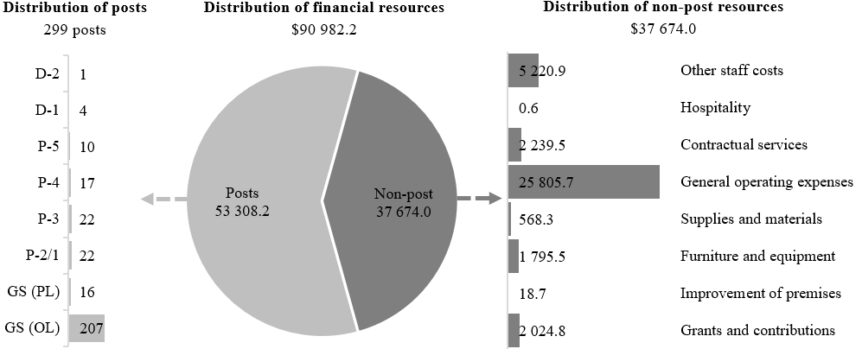

Explanation of variances by factor, component and subprogramme

Overall resource changes

Technical adjustments

29E.86 As reflected in table 29E.24 (1), resource changes reflect a decrease of $25,100, as follows:
Subprogramme 3, Support services (decrease of $25,100): this decrease relates to the removal of non-recurrent provisions for meeting support for 2025 in relation to mandates from the General Assembly and resolutions and decisions adopted by the Human Rights Council.

New and expanded mandates

29E.87 As reflected in table 29E.24 (1), resource changes reflect an increase of $58,700, as follows:
(a) Subprogramme 3, Support services (increase of $42,500): an increase of $42,500 reflecting additional requirements under general operating expenses for contractual sound operators and accessibility services ($28,900) and operating costs for office accommodation ($11,400), as well as under supplies and materials for office accommodation ($2,200), pursuant to Human Rights Council resolutions 55/29, 56/5 and 57/23, and decision 56/115;
(b) Subprogramme 4, Information and communications technology operations (increase of $16,200): an increase of $16,200 reflecting additional requirements under general operating expenses for information and communications technology services pursuant to Human Rights Council decision 56/115.

Other changes

29E.88 As reflected in table 29E.24 (1), resource changes reflect a net increase of $657,800 as follows:
(a) Subprogramme 2, Human resources management (no change): an increase under post costs ($236,200) offset by a decrease under other staff costs ($236,200) relating to the proposed cost-neutral conversion of a temporary position of Legal Officer (P-4) to a post (see annex II). In addition, the resources reflect a cost-neutral redeployment from contractual services ($137,200) to other staff costs ($137,200);
(b) Subprogramme 3, Support services (increase of $642,900): an increase under furniture and equipment ($18,500) reflecting anticipated increased office furniture costs, as well as under general operating expenses ($624,400) reflecting higher anticipated costs of facilities and equipment maintenance, as well as an increase in the cost of the office cleaning contract;
(c) Subprogramme 4, Information and communications technology operations (increase of $12,400): an increase of $12,400 under contractual services reflecting higher information and communications technology rates. In addition, the resources reflect cost-neutral redeployments from contractual services ($117,500) to furniture and equipment ($117,500) and from furniture and equipment ($7,700) to supplies and materials ($7,700);
(d) Subprogramme 5, Library services (increase of $2,500): an increase under furniture and equipment reflecting higher costs for the library management system.

Extrabudgetary resources

29E.89 As reflected in tables 29E.24 (2) and 29E.25 (2), extrabudgetary resources amount to $56,053,500. The resources would complement regular budget resources and would be used mainly to provide for 180 posts (3 P-5, 20 P-4, 36 P-3, 2 P-2, 3 General Service (Principal level) and 116 General Service (Other level)) and $26,228,300 non-post resources to perform the various functions in the areas of finance and budget services (e.g. accounting services, grant support and payroll processing and disbursement), human resources management (e.g. staff and recruitment administration, staff development and learning, medico-administrative services and human resources legal and policy advisory services), support services (e.g. travel processing, mail and pouch handling, procurement, conference support, ground transportation and facilities management), information and telecommunication technology services (e.g. personal computing, communications, conference support, hosting and storage) and record-keeping and library advisory services.
29E.90 The projected decrease of $138,200 is related mainly to the removal of non-recurrent requirements under subprogramme 2.
29E.91 The extrabudgetary resources under the present section are subject to the oversight of the United Nations Office at Geneva, which has delegated authority from the Secretary-General.
29E.92 In-kind contributions would provide for government-provided rent-free premises with an estimated value of $4,774,700.

Executive direction and management

29E.93 The United Nations Office at Geneva, in particular the Division of Administration, is responsible for the implementation of the programme of work under section 29E. The core functions of the Division include providing direction and coordination in human resources management, financial resources management, information and communications technology, central support services and library services at the United Nations Office at Geneva, including the management and utilization of United Nations premises and the coordination of human resources, finance and administrative policies with other Geneva-based organizations.
29E.94 The Division of Administration continues to provide administrative and other support services to Secretariat departments and offices and other entities of the United Nations system. Such services are provided to the United Nations funds and programmes, specialized agencies and other organizations of the United Nations system on a reimbursable basis, and a number of Geneva-based operations rely on the aforementioned services, in particular in the context of expanding humanitarian and human rights activities.
29E.95 In accordance with the 2030 Agenda for Sustainable Development, in particular target 12.6 of the Sustainable Development Goals, in which organizations are encouraged to integrate sustainability information into their reporting cycles, and in compliance with the cross-cutting mandate set out in paragraph 19 of General Assembly resolution 72/219, the Office has an environmental sustainability steering group and an environmental management system in line with the guidelines and best practices of the United Nations system. In 2024, the steering group met twice to oversee and drive forwards progress on implementation of the environmental management system. The steering group, newly established in 2023, comprises senior representatives from the Office’s main divisions. The two main points for review in 2024 were the Office’s progress towards meeting the environmental objectives of the United Nations system and the Secretariat, and the Office’s new environmental action plans. Action plans are a key component of an environmental management system, and the Office has drafted these for its three main environmental impact areas: the use of energy at the Palais des Nations; waste management at the Palais; and the preservation of biodiversity in Ariana Park. The steering group will continue to meet twice annually until the Office’s environmental management system is fully established. The action plans are also a deliverable under the 2050Today charter, which the Office signed in 2023. In 2024, work continued on the energy centre, the project to heat the Palais des Nations using heat pumps that extract thermal energy from Lake Geneva water. Once completed, the energy centre is forecast to provide around 80 per cent of the heat requirement of the Palais des Nations from renewable sources, leading to substantial reductions in greenhouse gas emissions. In line with the Secretary-General’s vision for United Nations 2.0, the Office is committed to introducing a forward-thinking culture with regards to environmental management. The Office has therefore been improving the collection and management of environmental data, to better support decision-making. Going forwards, the aim is to apply behavioural science to enable staff and visitors to contribute to environmental management at the Palais. The Office was also selected by the Sustainable United Nations team as a pilot entity to test a waste audit methodology for the United Nations system. Three days’ worth of office waste was analysed in detail, providing crucial insights into staff habits. The results of the audit should make it possible to reduce waste disposal costs and the impact on the environment.
29E.96 Information on the timely submission of documentation and advance booking for air travel is reflected in table 29E.27. The Office continues to make every effort to comply in full with the advance purchase policy directive and has undertaken a number of steps to ensure that air travel is booked as early as possible. Travel requests that are not submitted for certification 21 days before travel are routed to the Director of Administration for validation of mitigating circumstances before final review and approval. The Office did not submit parliamentary documents to the Department for General Assembly and Conference Management and does not plan to submit any such reports in 2026.

Table 29E.27

Compliance rate
(Percentage)

 | Actual 2022 | Actual 2023 | Actual 2024 | Planned 2025 | Planned 2026
Air tickets purchased at least 2 weeks before the commencement of travel | 68 | 86 | 81 | 100 | 100

29E.97 The proposed regular budget resources for 2026 amount to $1,137,900 and reflect no change compared with the approved budget for 2025. Additional details on the distribution of the proposed resources for 2026 are reflected in table 29E.28 and figure 29E.VIII.

Table 29E.28

Executive direction and management: evolution of financial and post resources
(Thousands of United States dollars/number of posts)

 | 2024 expenditure | 2025 approved | Changes |  |  |  |  | 2026 estimate
 | 2024 expenditure | 2025 approved | Technical adjustments | New/expanded mandates | Other | Total | Percentage | 2026 estimate
Financial resources by main category of expenditure
Posts | 676.1 | 676.9 | – | – | – | – | – | 676.9
Non-post | 287.1 | 461.0 | – | – | – | – | – | 461.0
Total | 963.2 | 1 137.9 | – | – | – | – | – | 1 137.9
Post resources by category
Professional and higher |  | 1 | – | – | – | – | – | 1
General Service and related |  | 2 | – | – | – | – | – | 2
Total |  | 3 | – | – | – | – | – | 3

Figure 29E.VIII

Executive direction and management: distribution of proposed resources for 2026
(Number of posts/thousands of United States dollars)

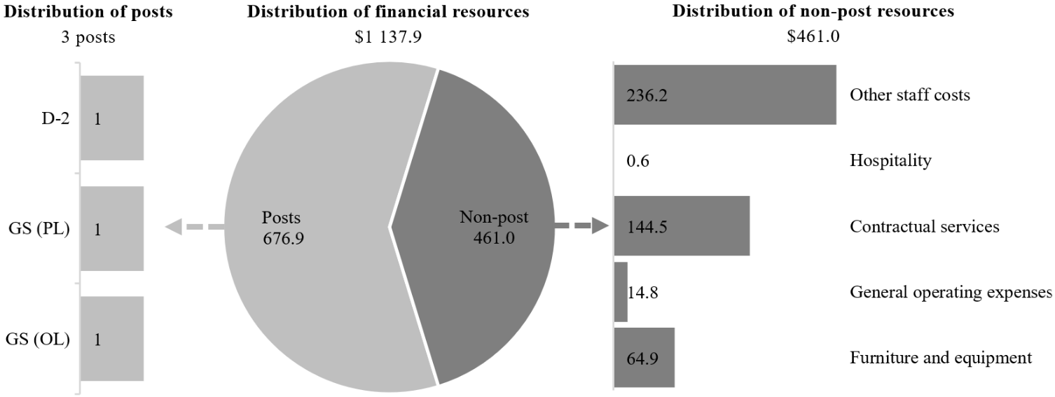

Programme of work

Subprogramme 1

Programme planning, finance and budget

29E.98 The proposed regular budget resources for 2026 amount to $5,894,700 and reflect no change compared with the approved budget for 2025. Additional details on the distribution of the proposed resources for 2026 are reflected in table 29E.29 and figure 29E.IX.

Table 29E.29

Subprogramme 1: evolution of financial and post resources
(Thousands of United States dollars/number of posts)

 | 2024 expenditure | 2025 approved | Changes |  |  |  |  | 2026 estimate
 | 2024 expenditure | 2025 approved | Technical adjustments | New/expanded mandates | Other | Total | Percentage | 2026 estimate
Financial resources by main category of expenditure
Posts | 5 643.0 | 5 813.0 | – | – | – | – | – | 5 813.0
Non-post | – | 81.7 | – | – | – | – | – | 81.7
Total | 5 643.0 | 5 894.7 | – | – | – | – | – | 5 894.7
Post resources by category
Professional and higher |  | 11 | – | – | – | – | – | 11
General Service and related |  | 19 | – | – | – | – | – | 19
Total |  | 30 | – | – | – | – | – | 30

Figure 29E.IX

Subprogramme 1: distribution of proposed resources for 2026
(Number of posts/thousands of United States dollars)

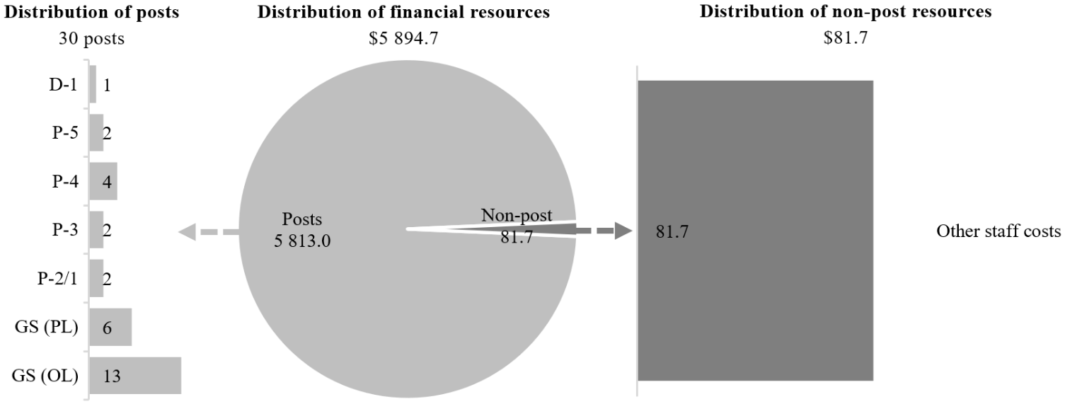

Subprogramme 2

Human resources management

29E.99 The proposed regular budget resources for 2026 amount to $10,854,600 and reflect no change compared with the approved budget for 2025. The proposed cost-neutral changes are explained in paragraph 29E.88 (a). Additional details on the distribution of the proposed resources for 2026 are reflected in table 29E.30 and figure 29E.X.

Table 29E.30

Subprogramme 2: evolution of financial and post resources
(Thousands of United States dollars/number of posts)

 | 2024 expenditure | 2025 approved | Changes |  |  |  |  | 2026 estimate
 | 2024 expenditure | 2025 approved | Technical adjustments | New/expanded mandates | Other | Total | Percentage | 2026 estimate
Financial resources by main category of expenditure
Posts | 5 934.9 | 6 215.2 | – | – | 236.2 | 236.2 | 3.8 | 6 451.4
Non-post | 4 314.8 | 4 639.4 | – | – | (236.2) | (236.2) | (5.1) | 4 403.2
Total | 10 249.7 | 10 854.6 | – | – | – | – | – | 10 854.6
Post resources by category
Professional and higher |  | 12 | – | – | 1 | – | 8.3 | 13
General Service and related |  | 21 | – | – | – | – | – | 21
Total |  | 33 | – | – | 1 | – | 3.0 | 34

Figure 29E.X

Subprogramme 2: distribution of proposed resources for 2026
(Number of posts/thousands of United States dollars)

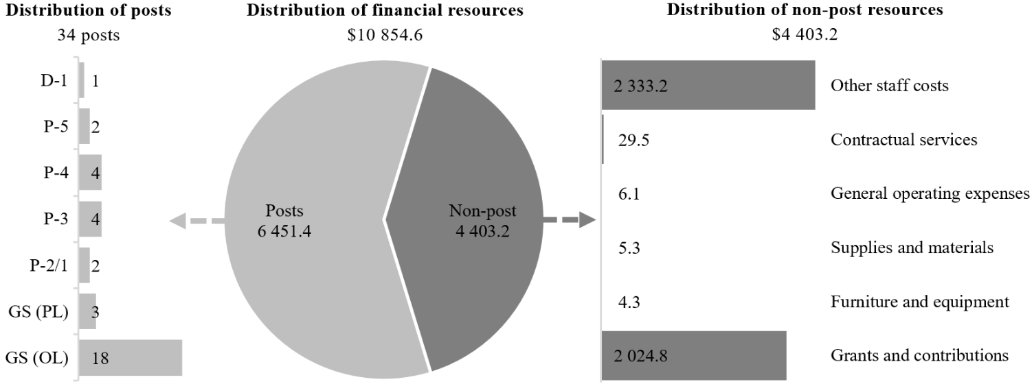

Subprogramme 3

Support services

29E.100 The proposed regular budget resources for 2026 amount to $50,712,600 and reflect an increase of $660,300 compared with the approved budget for 2025. The proposed changes are explained in paragraphs 29E.86, 29E.87 (a) and 29E.88 (b). Additional details on the distribution of proposed resources for 2026 are reflected in table 29E.31 and figure 29E.XI.

Table 29E.31

Subprogramme 3: evolution of financial and post resources
(Thousands of United States dollars/number of posts)

 | 2024 expenditure | 2025 approved | Changes |  |  |  |  | 2026 estimate
 | 2024 expenditure | 2025 approved | Technical adjustments | New/expanded mandates | Other | Total | Percentage | 2026 estimate
Financial resources by main category of expenditure
Posts | 20 742.3 | 23 125.7 | – | – | – | – | – | 23 125.7
Non-post | 21 216.8 | 26 926.6 | (25.1) | 42.5 | 642.9 | 660.3 | 2.5 | 27 586.9
Total | 41 959.1 | 50 052.3 | (25.1) | 42.5 | 642.9 | 660.3 | 1.3 | 50 712.6
Post resources by category
Professional and higher |  | 19 | – | – | – | – | – | 19
General Service and related |  | 116 | – | – | – | – | – | 116
Total |  | 135 | – | – | – | – | – | 135

Figure 29E.XI

Subprogramme 3: distribution of proposed resources for 2026
(Number of posts/thousands of United States dollars)
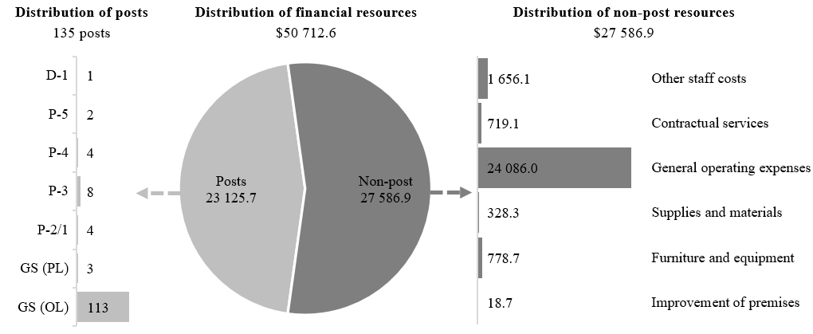

Subprogramme 4

Information and communications technology operations

29E.101 The proposed regular budget resources for 2026 amount to $13,306,600 and reflect an increase of $28,600 compared with the approved budget for 2025. The proposed changes are explained in paragraphs 29E.87 (b) and 29E.88 (c). Additional details on the distribution of the proposed resources for 2026 are reflected in table 29E.32 and figure 29E.XII.

Table 29E.32

Subprogramme 4: evolution of financial and post resources
(Thousands of United States dollars/number of posts)

 | 2024 expenditure | 2025 approved | Changes |  |  |  |  | 2026 estimate
 | 2024 expenditure | 2025 approved | Technical adjustments | New/expanded mandates | Other | Total | Percentage | 2026 estimate
Financial resources by main category of expenditure
Posts | 9 142.4 | 9 001.5 | – | – | – | – | – | 9 001.5
Non-post | 3 992.4 | 4 276.5 | – | 16.2 | 12.4 | 28.6 | 0.7 | 4 305.1
Total | 13 134.8 | 13 278.0 | – | 16.2 | 12.4 | 28.6 | 0.2 | 13 306.6
Post resources by category
Professional and higher |  | 13 | – | – | – | – | – | 13
General Service and related |  | 38 | – | – | – | – | – | 38
Total |  | 51 | – | – | – | – | – | 51

Figure 29E.XII

Subprogramme 4: distribution of proposed resources for 2026
(Number of posts/thousands of United States dollars)

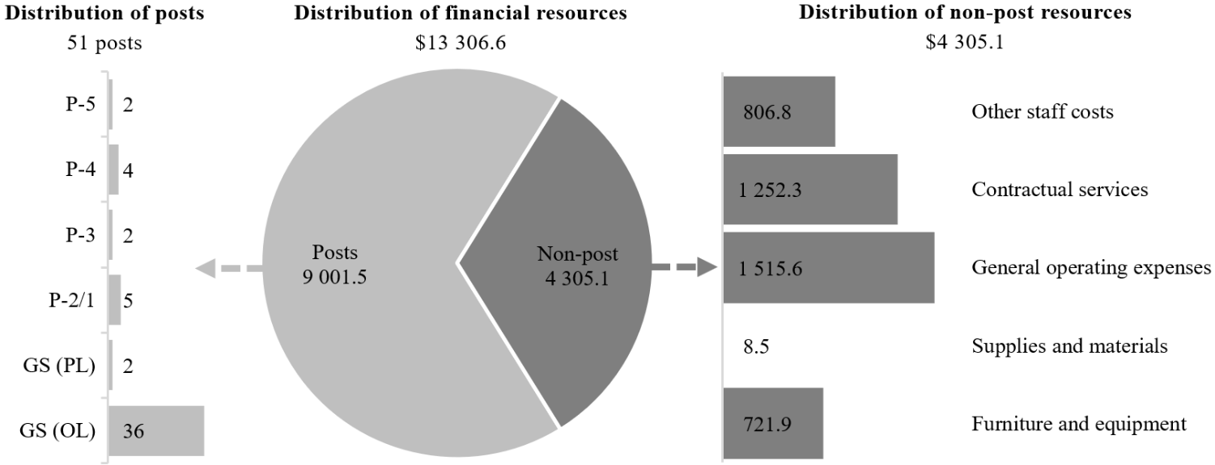

Subprogramme 5

Library services

29E.102 The proposed regular budget resources for 2026 amount to $9,075,800 and reflect an increase of $2,500 compared with the approved budget for 2025. The proposed change is explained in paragraph 29E.88 (d). Additional details on the distribution of the proposed resources for 2026 are reflected in table 29E.33 and figure 29E.XIII.

Table 29E.33

Subprogramme 5: evolution of financial and post resources
(Thousands of United States dollars/number of posts)

 | 2024 expenditure | 2025 approved | Changes |  |  |  |  | 2026 estimate
 | 2024 expenditure | 2025 approved | Technical adjustments | New/expanded mandates | Other | Total | Percentage | 2026 estimate
Financial resources by main category of expenditure
Posts | 7 471.6 | 8 239.7 | – | – | – | – | – | 8 239.7
Non-post | 647.1 | 833.6 | – | – | 2.5 | 2.5 | 0.3 | 836.1
Total | 8 118.7 | 9 073.3 | – | – | 2.5 | 2.5 | – | 9 075.8
Post resources by category
Professional and higher |  | 19 | – | – | – | – | – | 19
General Service and related |  | 27 | – | – | – | – | – | 27
Total |  | 46 | – | – | – | – | – | 46

Figure 29E.XIII

Subprogramme 5: distribution of proposed resources for 2026
(Number of posts/thousands of United States dollars)

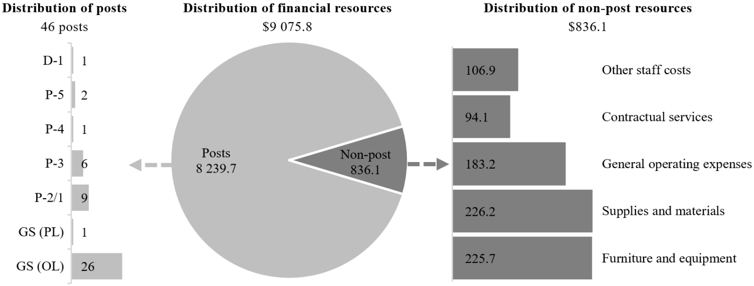

Annex I

Organizational structure and post distribution for 2026
Programme planning, finance and budget
(subprogramme 1)
RB: | XB:
1 D-1 | 1 P-5
2 P-5 | 3 P-4
4 P-4 | 14 P-3
2 P-3 | 2 P-2
2 P-2 | 1 GS (PL)
6 GS (PL) | 53 GS (OL)
13 GS (OL)
30 | 74
Total: 104

Human resources management
(subprogramme 2)
RB: | XB:
1 D-1 | 1 P-5
2 P-5 | 9 P-4
3 P-4 | 1 P-3
1 P-4ª | 2 GS (PL)
4 P-3 | 30 GS (OL)
2 P-2
3 GS (PL)
18 GS (OL)
34 | 43
Total: 77

Information and communications technology operations
(subprogramme 4)
RB: | XB:
2 P-5 | 1 P-5
4 P-4 | 6 P-4
2 P-3 | 13 P-3
5 P-2 | 14 GS (OL)
2 GS (PL)
36 GS (OL)
51 | 34
Total: 85

Support services
(subprogramme 3)
RB: | XB:
1 D-1 | 1 P-4
2 P-5 | 6 P-3
4 P-4 | 16 GS (OL)
8 P-3
4 P-2
3 GS (PL)
113 GS (OL)
135 | 23
Total: 158

Library services
(subprogramme 5)
RB: | XB:
1 D-1 | 1 P-4
2 P-5 | 2 GS (OL)
1 P-4
5 P-3
1 P-3^{b}
9 P-2
1 GS (PL)
26 GS (OL)
46 | 3
Total: 49

Office of the Director of Administration
(executive direction and management)

RB: | XB:
1 D-2 | 2 P-3
1 GS (PL) | 1 GS (OL)
1 GS (OL)
3 | 3
Total: 6

Office of the
Director-General

Abbreviations: GS (OL), General Service (Other level); GS (PL), General Service (Principal level); RB (regular budget); XB (extrabudgetary).
ª Conversion.
^{b} Reassignment.

Annex II

Summary of proposed post changes, by component and subprogramme

Component/subprogramme | Posts | Grade | Description | Reason for change
Subprogramme 2, Human resources management | 1 | P-4 | Conversion of 1 Legal Officer | The temporary position of Legal Officer (P-4), originally proposed as an established post, was approved by the General Assembly in its resolution 66/237 in 2012 as a general temporary assistance position on the recommendation of the Advisory Committee on Administrative and Budgetary Questions. A recent review of the long-term needs of the United Nations Office at Geneva, as requested by the Advisory Committee in its report on the 2023 proposed programme budget (A/77/7, para. VIII.96), confirmed the permanent nature of the position. The Legal Officer plays a critical role in ensuring the Office’s capacity to represent and defend the Organization in the internal justice system, and this need is expected to continue. It is therefore proposed that it be converted from general temporary assistance to a post.  There are 2 P-4 Legal Officers in the Office, one being a regular budget-funded temporary position and the other being an extrabudgetary-funded post. The analysis of the distribution of functions between these two positions and the overall workload of the Legal Unit over a six-year period showed that the percentage of extrabudgetary-related workload is lower than 50 per cent in all categories. It further demonstrates the constant workload of handling 100 cases per annum. The main case categories include appeals to the United Nations Appeals Tribunal, United Nations Dispute Tribunal proceedings, conduct and discipline cases, and management evaluation requests. The incumbent of the P-4 Legal Officer post funded through extrabudgetary resources also handles cases involving staff members supported by the regular budget. This highlights the critical need for stable and long-term regular budget funding for the Unit. A summary table is provided below.
Subprogramme 5, Library services | 1 | P-3 | Reassignment of 1 post of Information Management Officer to Librarian | The P-3 post was vacated on 31 March 2024 due to a retirement. The post requires reassignment, as the generic functions of the Information Management Officer no longer correspond to the expected functions. The post is one of the management posts within the Library Services Section, which has undergone an internal review, the results of which reveal the need for a repositioning and strengthening of library services to enable the optimization of the use of digital technology, strategic communication with library clients, reinforced collection preservation and the facilitation of access to United Nations-produced knowledge. The incumbent of the post proposed to be reassigned will be responsible for a team that leads connections with clients and access to collections. The tasks of the generic job profile for P-3 Librarian correspond to these functions, whereas the tasks of the P-3 Information Management Officer no longer correspond.

Category | 2019 | 2020 | 2021 | 2022 | 2023 | 2024 | Total | Percentage of extrabudgetary workload
Appeals to the United Nations Appeals Tribunal | 1 | – | 1 | – | 2 | 8 | 12 | 44
United Nations Dispute Tribunal proceedings | 40 | 47 | 49 | 46 | 49 | 41 | 272 | 40
Conduct and discipline | 7 | 24 | 27 | 37 | 83 | 49 | 227 | 19
Management evaluation requests | 15 | 8 | 27 | 14 | 14 | 14 | 92 | 41
Total | 63 | 79 | 104 | 97 | 148 | 112 | 603

