Eightieth session
Items 137 and 138 of the preliminary list*

Proposed programme budget for 2026

Programme planning

Proposed programme budget for 2026

Part VIII

Common support services

Section 29F

Administration, Vienna

Programme 25

Management and support services

Contents
 |  |  | Page
- Proposed programme plan for 2026 and programme performance in 2024** |  |  | 3
Overall orientation |  |  | 3
Programme of work |  |  | 5
Subprogramme 1. Programme planning, finance and budget |  |  | 5
Subprogramme 2. Human resources management |  |  | 9
Subprogramme 3. Support services |  |  | 12
Subprogramme 4. Information and communications technology operations |  |  | 16
- Proposed post and non-post resource requirements for 2026*** |  |  | 20
Overview |  |  | 20
* A/80/50.
** In keeping with paragraph 10 of General Assembly resolution 77/267, the part consisting of the programme plan and programme performance information (part II) is submitted through the Committee for Programme and Coordination for the consideration of the Assembly.
*** In keeping with paragraph 10 of General Assembly resolution 77/267, the part consisting of the post and non-post resource requirements (part III) is submitted through the Advisory Committee on Administrative and Budgetary Questions for the consideration of the Assembly.
Executive direction and management | 24
Programme of work | 26
Subprogramme 1. Programme planning, finance and budget | 26
Subprogramme 2. Human resources management | 27
Subprogramme 3. Support services | 27
Subprogramme 4. Information and communications technology operations | 28
Annexes
- Organizational structure and post distribution for 2026 | 30
- Summary of proposed post changes, by component and subprogramme | 31

A. Proposed programme plan for 2026 and programme performance in 2024

Overall orientation

Mandates and background

29F.1 The United Nations Office at Vienna was established in 1979 pursuant to General Assembly resolution 31/194 with the objective of providing administrative support to the United Nations Secretariat units located in Vienna, including the United Nations Office on Drugs and Crime (UNODC), the Office for Outer Space Affairs, the International Trade Law Division of the Office of Legal Affairs, the secretariat of the United Nations Scientific Committee on the Effects of Atomic Radiation, the United Nations Information Service, the Office of Internal Oversight Services, the Office for Disarmament Affairs, the regional office of the Office of the United Nations Ombudsman and Mediation Services and the United Nations Register of Damage Caused by the Construction of the Wall in the Occupied Palestinian Territory. Under the terms of the tripartite memorandum of understanding of 1977 and subsequent amendments to it, the Office also provides support and administrative services, garage operations, language training and communication services on a common services basis to other international organizations based in the Vienna International Centre, namely the International Atomic Energy Agency (IAEA), the United Nations Industrial Development Organization (UNIDO) and the Preparatory Commission for the Comprehensive Nuclear-Test-Ban Treaty Organization. The Office provides safety and security and conference management services to the Vienna-based organizations, as reflected in section 34 and section 2, respectively, of the proposed programme budget. Building management services at the Vienna International Centre are provided by UNIDO, and medical services are provided by IAEA.

Strategy and external factors for 2026

29F.2 The Office will continue to provide administrative services, including the provision of an enabling policy framework and enhanced decision-making through continuous monitoring, data analysis and reporting. The strategy for 2026 will continue to include: (a) coordinating with Headquarters and providing timely advice to the entities serviced on all policy and administrative matters; (b) strengthening internal financial controls and streamlining financial procedures and guidelines to ensure effective financial management; (c) targeting enhancement of leadership, learning and career support activities guided by a performance management system supporting increased accountability, staff engagement, workplace flexibility and empowerment while ensuring a diverse and inclusive workplace; (d) maintaining efficient and cost-effective travel and transportation services through best practices; (e) promoting environmental sustainability in coordination with all departments and offices; (f) strengthening the capacity of procurement staff through online training and guidance notes to procurement practitioners; (g) monitoring significant pronouncements of the International Public Sector Accounting Standards Board and improving financial data integrity; (h) integrating new technologies into the organizational business toolkit; and (i) increasing compliance with technology standards, guidelines and methodologies, information and communications technology (ICT) policies and enterprise architecture.
29F.3 Under the leadership of the Department of Operational Support, the Office will continue to support the harmonization and improvements across the global operational support architecture to increase overall satisfaction with client services.
29F.4 With regard to the external factors, the overall plan for 2026 is based on the planning assumption that the extrabudgetary funding available to client offices and the support requirements for services provided by the Office remain stable.
29F.5 The Office integrates a gender perspective in its operational activities, deliverables and results, as appropriate, including through the implementation of the Strategy for Gender Equality and the Empowerment of Women (2022–2026) of the United Nations Office at Vienna and UNODC. It will also support clients in attaining gender parity targets and will track and report on progress in promoting gender equality and the empowerment of women, in line with the Secretary-General’s system-wide strategy on gender parity.
29F.6 In line with the United Nations Disability Inclusion Strategy, the Office and other organizations based in Vienna, as members of the joint committee responsible for managing the Common Fund for Financing Major Repairs and Replacements at the Vienna International Centre, will ensure that the accessibility report commissioned by the host country is used to prioritize the necessary renovations, updates and repairs within the Common Fund. The Office will work towards creating a more inclusive and supportive culture for staff members who have disabilities and staff who have dependants with disabilities. This will specifically involve offering training on disability inclusion and organizing events to raise awareness about disability inclusion. The Office will engage with and involve persons with disabilities and their representative organizations in these efforts.

Legislative mandates

29F.7 The list below, which was reviewed in the preparation of the proposed programme budget, provides all mandates entrusted to the programme.

General Assembly resolutions

31/194 | Utilization of office accommodation and conference facilities at the Donaupark Centre in Vienna
58/278 | Report of the Joint Inspection Unit on common and joint services of United Nations system organizations at Vienna
77/280 | Progress towards an accountability system in the United Nations Secretariat

Subprogramme 1

Programme planning, finance and budget

General Assembly resolutions

41/213 | Review of the efficiency of the administrative and financial functioning of the United Nations
42/211 | Implementation of General Assembly resolution 41/213
77/267 | Shifting the management paradigm in the United Nations: review of changes to the budgetary cycle

Subprogramme 2

Human resources management

General Assembly resolutions

59/164 | Improvement of the status of women in the United Nations system
63/271 | Amendments to the Staff Regulations
73/281 | Shifting the management paradigm in the United Nations
77/278 | Human resources management
78/275 | Amendments to the Staff Regulations and Rules
79/252 | United Nations common system
79/254 | Administration of justice at the United Nations

Subprogramme 3

Support services

General Assembly resolutions

58/276; 58/277 | Report of the Joint Inspection Unit on the management audit review of outsourcing in the United Nations
58/278 | Report of the Joint Inspection Unit on common and joint services of United Nations system organizations at Vienna
69/273 | Procurement

Subprogramme 4

Information and communications technology operations

General Assembly resolutions

63/262 | Information and communications technology, enterprise resource planning, and security, disaster recovery and business continuity
63/269 | Information and communications technology, disaster recovery and business continuity for the United Nations: arrangements for the secondary data centre at Headquarters
71/272 B | Special subjects relating to the programme budget for the biennium 2016–2017 (sect. III, Status of implementation of the information and communications technology strategy for the United Nations)
78/243 | Information and communications technology strategy

Deliverables

29F.8 Table 29F.1 lists all cross-cutting deliverables of the programme.

Table 29F.1

Cross-cutting deliverables for the period 2024–2026, by category and subcategory

Category and subcategory | 2024 planned | 2024 actual | 2025 planned | 2026 planned
2026 planned
A. Facilitation of the intergovernmental process and expert bodies
Substantive services for meetings (number of three-hour meetings) | 3 | 3 | 3 | 3
1. Meetings of the Advisory Committee on Administrative and Budgetary Questions | 1 | 1 | 1 | 1
2. Meetings of the Committee for Programme and Coordination | 1 | 1 | 1 | 1
3. Meetings of the Fifth Committee | 1 | 1 | 1 | 1

Evaluation activities

29F.9 An evaluation on the client support portal conducted by the United Nations Office at Vienna and completed in 2024 has guided the proposed programme plan for 2026.
29F.10 In response to the results of the evaluation referenced above, subprogramme 1 enhanced the information available on the portal and implemented a comprehensive quality management system driving continuous improvements.
29F.11 In support of multilingualism, an evaluation of the United Nations language programme within the context of the United Nations Language Framework, to be conducted by the Office, is planned for 2026.

Programme of work

Subprogramme 1

Programme planning, finance and budget

Objective

29F.12 The objective, to which this subprogramme contributes, is to ensure sound, effective and efficient financial management by client offices.

Strategy

29F.13 To contribute to the objective, the subprogramme will:
(a) Strengthen the monitoring of budget performance, financial management and control, and improve reporting;
(b) Provide advice, assistance, guidance and training to programme managers and administrative units of client offices on financial management and budgetary matters;
(c) Streamline financial processes and guidelines and regularly review workflow procedures to identify ways to achieve a more efficient and faster client response;
(d) Strengthen internal financial controls, monitor financial performance and risks and ensure integrity of organizational financial data;
(e) Monitor the implementation of recommendations from oversight bodies and ensure strict compliance with the Financial Regulations and Rules of the United Nations and the financial policies of the United Nations.
29F.14 The above-mentioned work is expected to result in:
(a) Improved accessibility and understanding of financial information by client offices;
(b) Increased accountability by client offices;
(c) Improved integrity of financial data;
(d) Enhanced overall management of programme budget and extrabudgetary financial resources.

Programme performance in 2024

Improved efficiency in processing airline ticket invoices

29F.15 The subprogramme supports its clients in the processing and payment of airline tickets issued by 53 travel agents worldwide. The volume of ticket invoices has increased following the coronavirus disease (COVID-19) pandemic, from 21,000 in 2021 to 60,000 in 2024. To handle the increasing workload, the subprogramme undertook a systematic review to improve the efficiency of processes by analysing and resolving issues that previously hindered the automatic posting and clearing of ticket invoices in Umoja. Common issues included errors in trip and traveller numbers, delays in ticket issuance or exchange rate variations, causing costs to exceed tolerance levels.
29F.16 As a result, the subprogramme successfully managed the increased volume of ticket invoices within existing capacities while increasing timely and accurate processing. This improvement has significantly reduced the number of automatic posting exceptions requiring manual intervention by client offices and expediting payments to ticket providers. In 2024, 85 per cent of airline ticket invoices were processed automatically without exception, compared with 60 per cent in 2022, leading to faster payments to ticket providers, with 97 per cent of ticket providers of the United Nations Office at Vienna being paid within 7 calendar days in 2024, compared with 73 per cent in 2022.
29F.17 Progress towards the objective is presented in the performance measure below (see figure 29F.I).

Figure 29F.I

Performance measure: average payment processing time of provider invoices and volume of tickets (annual)

Planned results for 2026

Result 1: improved stewardship of resources

Programme performance in 2024 and target for 2026

29F.18 The subprogramme’s work contributed to the certification of an additional 11 staff members, for a cumulative total of 42, from substantive offices as focal points in budgetary and accounting matters and the financial regulations and rules of the organization, which exceeded the planned target of 40.
29F.19 Progress towards the objective and the target for 2026 are presented in the performance measure below (see figure 29F.II).

Figure 29F.II

Performance measure: number of substantive staff certified as focal points in budgetary and accounting matters and the financial regulations and rules of the organization (cumulative)

Result 2: improved financial accounting and reporting through implementation of IPSAS 47: Revenue

Programme performance in 2024 and target for 2026

29F.20 The subprogramme’s work contributed to clients having access to entity-specific policies and adopting revised procedures for the implementation of International Public Sector Accounting Standards (IPSAS) 47: Revenue, on the basis of guidance developed by the Task Force on Accounting Standards, which met the planned target.
29F.21 Progress towards the objective and the target for 2026 are presented in the performance measure below (see table 29F.2).

Table 29F.2

Performance measure

2022 (actual) | 2023 (actual) | 2024 (actual) | 2025 (planned) | 2026 (planned)
– | System-wide policy guidance on IPSAS 47 established | Clients have access to entity-specific policies and adopt revised procedures on the basis of system-wide guidance | 90 per cent of clients’ donor agreements assessed for accounting treatment under IPSAS 47, ensuring readiness for transition in 2026 | 100 per cent implementation of IPSAS 47 across all client entities, ensuring compliance and enhanced reporting transparency

Result 3: reduced unresolved financial issues in field offices

Proposed programme plan for 2026

29F.22 Effective financial management in field offices is critical to ensuring accountability and the proper use of donor funding. Field offices face recurring challenges, including high staff turnover, physical distance and time difference from headquarters, resulting in delays in resolving financial issues, which affect the closure of expired grants and the management of open accounting items.

Lessons learned and planned change

29F.23 The lesson for the subprogramme was that generalized support to field offices does not adequately address their unique challenges. In applying the lesson, the subprogramme will provide customized reports and dashboards, tailored support and knowledge-sharing updates designed to support local financial management and improve issue resolution. This will enable the more effective and timely resolution of financial issues and enhance stewardship of resources.
29F.24 Expected progress towards the objective is presented in the performance measure below (see table 29F.3).

Table 29F.3

Performance measure

2022 (actual) | 2023 (actual) | 2024 (actual) | 2025 (planned) | 2026 (planned)
– | – | Field offices face inefficiencies due to staff being unclear on policies, procedures and focal points in headquarters Financial Resources Management Service | Field offices’ staff are equipped with clear guidance and are actively supported by the technical team for complex issues | Reduction in open accounting items by 20 per cent due to improved capacity of field offices’ staff in financial management

Deliverables

29F.25 Table 29F.4 lists all deliverables of the subprogramme.

Table 29F.4

Subprogramme 1: deliverables for the period 2024–2026, by category and subcategory

Category and subcategory | 2024 planned | 2024 actual | 2025 planned | 2026 planned
A. Facilitation of the intergovernmental process and expert bodies
Parliamentary documentation (number of documents) | 2 | 2 | 2 | 2
1. Consolidated budget for UNODC for the biennium | – | – | 1 | –
2. Performance report for UNODC for the biennium | 1 | 1 | – | 1
3. Annual financial report and audited financial statements for UNODC | 1 | 1 | 1 | 1
E. Enabling deliverables
Administration: financial management, including risk management and internal control, preparation and implementation of budgets and other resource proposals; management of approximately 2,600 posts; financial reporting and accounting, including 1,700 donor reports; cash and revenue management; cost recovery; issuance of 26,200 UNDP financial authorizations, payments, payroll and disbursements for 1,760 staff members; administration of 13,700 banking details for business partners; guidance and advice on all financial matters; management of after-service health insurance claims for 800 beneficiaries; and management of 7,300 grants.

Subprogramme 2

Human resources management

Objective

29F.26 The objective, to which this subprogramme contributes, is to ensure the attraction, development and retention of a competent, diverse, adaptable and healthy workforce with the highest standards of efficiency, competence and integrity, giving due regard to geographical representation, inclusivity and gender balance.

Strategy

29F.27 To contribute to the objective, the subprogramme will:
(a) Foster and reinforce an enabling working environment for its clients with regard to service delivery, talent management and organizational culture, through human resources services to clients in Vienna and in UNODC field offices;
(b) Implement talent outreach and attraction initiatives to enhance gender equality, geographical representation and disability inclusion;
(c) Support personnel through talent development initiatives and promoting workplace flexibility;
(d) Reinforce a culture of zero tolerance against prohibited conduct, including through the implementation of multiple initiatives of the United Nations System Chief Executives Board for Coordination.
29F.28 The above-mentioned work is expected to result in improved staff engagement, motivation, productivity and well-being, thereby contributing to the delivery of the Organization’s mandates.

Programme performance in 2024

Staff benefits and entitlements made simple

29F.29 Ensuring staff have a clear understanding of their entitlements and benefits is critical to fostering a supportive work environment, reducing administrative errors and enhancing overall satisfaction. The subprogramme actively contributed to enhancing staff awareness related to entitlements and benefits and introduced a targeted video initiative in 2024. The initiative consisted of five informative videos covering the following five topics: (a) flexible working arrangements; (b) education grant; (c) rest and recuperation; (d) danger pay; and (e) home leave. The videos were carefully designed to address common challenges that staff members face and were published on the internal client support portal. The videos provide concise, accessible and clear explanations of entitlement processes for staff members, with 91 per cent of staff respondents to a client satisfaction survey who watched one of the videos indicating that they found them helpful.
29F.30 Progress towards the objective is presented in the performance measure below (see table 29F.5).

Table 29F.5

Performance measure

2022 (actual) | 2023 (actual) | 2024 (actual)
– | – | Staff found the entitlement processes easier to understand and were more satisfied with the support provided, leading to a decrease in submission errors and improved processing times

Planned results for 2026

Result 1: an agile organization with a culture of learning and innovation

Programme performance in 2024 and target for 2026

29F.31 The subprogramme’s work contributed to a culture of learning and innovation, with 41 clients out of 43 reporting improved confidence in applying innovative approaches to their work, which exceeded the planned target of 40 clients.
29F.32 Progress towards the objective and the target for 2026 are presented in the performance measure below (see figure 29F.III).

Figure 29F.III

Performance measure: number of clients reporting improved confidence in applying innovative approaches to their work (annual)

Result 2: towards inclusion of persons with disabilities in the workforce

Programme performance in 2024 and target for 2026

29F.33 The subprogramme’s work contributed to staff exit surveys showing that persons with disabilities do not report higher dissatisfaction than the general staff body or dissatisfaction resulting from their disability status. They further indicated that no disability-related items were among the reasons for leaving, and physical and mental health issues were among the least relevant reasons to leave the organization, with persons with disabilities reporting satisfaction and well-being levels comparable to those of the general staff body, which met the planned target.
29F.34 Progress towards the objective and the target for 2026 are presented in the performance measure below (see table 29F.6).

Table 29F.6

Performance measure

2022 (actual) | 2023 (actual) | 2024 (actual) | 2025 (planned) | 2026 (planned)
Network of persons with disabilities established | Election of the first executive committee of the network of persons with disabilities | Persons with disabilities do not report higher levels of dissatisfaction than the general staff body, nor do they report dissatisfaction specifically related to their disability status | The United Nations Office at Vienna achieves “meets requirements” rating for indicator 14, “capacity development for staff”, of the United Nations Disability Inclusion Strategy | The United Nations Office at Vienna increases its attractiveness as an employer for persons with disabilities by achieving “meets requirements” rating for indicator 13, “employment”, and 14, “capacity development for staff” of the United Nations Disability Inclusion Strategy

Result 3: clients are informed and aware of all relevant human resources policies and developments

Proposed programme plan for 2026

29F.35 Readily available access to timely, updated and relevant human resources information is essential for enhancing engagement, ensuring compliance, supporting talent development and contributing to a positive workplace environment, thus facilitating effective delivery of the Organization’s mandates. To support this, the subprogramme publishes a monthly human resources newsletter aimed at keeping staff and personnel consistently informed and aware of relevant human resources updates.

Lessons learned and planned change

29F.36 The lesson for the subprogramme was derived from the data gathered in the 2024 client satisfaction survey, where only 60 per cent of respondents indicated that they read the newsletter. In applying this lesson, the subprogramme will focus on increasing readership among its clients. This will be achieved by implementing a more engaging format, publishing on the first working day of each month to establish a routine and generate anticipation. The structure will be redesigned to be concise, prioritizing relevant information, and will include quick links to the client support portal. In addition, it will feature information for hiring managers on gender parity and geographical diversity and will adopt a personal approach by highlighting staff voices.
29F.37 Expected progress towards the objective is presented in the performance measure below (see figure 29F.IV).

Figure 29F.IV

Performance measure: number of views recorded on the human resources newsletter (annual)

(Total annual number)

Deliverables

29F.38 Table 29F.7 lists all deliverables of the subprogramme.

Table 29F.7

Subprogramme 2: deliverables for 2026, by category and subcategory

Category and subcategory
D. Communication deliverables
Outreach programmes, special events and information materials: 25 targeted outreach programmes, including special events aligned with the system-wide strategy, information and broadcast materials, job fairs and career presentations for approximately 2,500 potential candidates.
E. Enabling deliverables
Administration: human resources services to 4,000 personnel; classification and reclassification of over 400 posts, outreach and recruitment for 380 staff posts, 2,300 non-staff engagement processes, human resources policies and legal advice; staff counselling; talent management; issuance and renewal of appointments and contracts; training on organizational and managerial competencies; facilitate access to the global orientation programme (Go2UN); medical services in collaboration with other Vienna-based entities; awareness-raising programmes on prohibited conduct and the Enabling Environment Guidelines for the United Nations System for all staff.
Internal justice and oversight: 1,000 requests for legal and policy advice to colleagues in the discharge of their official functions, and advice to senior officials and staff on the application of the Staff Regulations and Rules of the United Nations and other administrative issuances, including legal positions for administrative reviews and cases brought by staff to the Management Advice and Evaluation Section and the Office of the United Nations Ombudsman and Mediation Services; assistance in receiving, assessing and processing complaints and reports of alleged misconduct; discharging the role of the conduct and discipline focal point; awareness-raising on matters related to the administration of justice at the United Nations.

Subprogramme 3

Support services

Objective

29F.39 The objective, to which this subprogramme contributes, is to ensure the efficient, environmentally sound and effective functioning of client offices with regard to conference and facilities management, property management, travel and transportation, mail and pouch services, procurement, engagement of implementing partners, commercial activities, records management and library services.

Strategy

29F.40 To contribute to the objective, the subprogramme will:
(a) Manage an effective supply chain by building on the related Umoja functionality;
(b) Implement an environmental management system in line with the United Nations Secretariat environmental policy;
(c) Continue to improve the business continuity approach through further integration with other parts of the organizational resilience management system;
(d) Provide property management services, diplomatic pouch and mail services and manage records;
(e) Provide various travel-related services, including advice, training and policy guidance;
(f) Provide process and policy guidance on engagement of implementing partners;
(g) Provide regular support to clients on changing workspace needs within the constraints of limited office space;
(h) Engage in outreach on library services.
29F.41 The above-mentioned work is expected to result in:
(a) Effective and sustainable use of United Nations property, including office space;
(b) Effective management of clients’ travel resources;
(c) An effective environmental management system;
(d) Increased use of information resources contained in the library for informed decision-making by clients and Member States;
(e) Improved planning and sourcing of all goods and services;
(f) A robust business continuity plan;
(g) Timely and accurate management of documents and mail.

Programme performance in 2024

Improved operational efficiency in administration of travel

29F.42 The subprogramme provides travel services for the organization. Travel plays a vital role in the organization’s operations, enabling personnel and meeting participants to carry out activities to deliver its mandate effectively. Significant progress has been made in ensuring that travel demands are met seamlessly and on time. In 2024, the organization processed 53,268 travel requests, exceeding the 2019 pre-pandemic level of 46,553. Notably, 68 per cent of those trips were undertaken by meeting participants, mostly experts from Member States, ensuring more active engagement and participation in key discussions and decision-making processes. This achievement underscores the organization’s commitment to supporting its beneficiaries and delivering on its objectives through effective operational support.
29F.43 Progress towards the objective is presented in the performance measure below (see figure 29F.V).

Figure 29F.V

Performance measure: percentage of United Nations Office at Vienna client entities’ travel requests processed in less than two days (annual)

Planned results for 2026

Result 1: improved supply chain management

Programme performance in 2024 and target for 2026

29F.44 The subprogramme’s work contributed to clients gaining access to a procurement tracker, thereby increasing the up-to-date visibility of the status and costs of their procurement requests, which met the planned target.
29F.45 Progress towards the objective and the target for 2026 are presented in the performance measure below (see table 29F.8).

Table 29F.8

Performance measure

2022 (actual) | 2023 (actual) | 2024 (actual) | 2025 (planned) | 2026 (planned)
– | Clients have access to contract administration tracking tool for supply chain planning and contract management | Clients have increased and up-to-date visibility of the status and costs of their procurement requirements | Simplified procurement process for vendors and Tender Opening Committee members through an e-tendering platform | Virtual access for vendors and Tender Opening Committee members, with full traceability of cases in archived access

Result 2: improved monitoring of implementing partners

Programme performance in 2024 and target for 2026

29F.46 The subprogramme’s work contributed to improvements in the management of external partners. Following training in four locations (Kenya, Pakistan, Panama and Thailand), 60 per cent of reports by external partners were delivered on time, which exceeded the planned target of 40 per cent.
29F.47 Progress towards the objective and the target for 2026 are presented in the performance measure below (see figure 29F.VI).

Figure 29F.VI

Performance measure: percentage of reports by external partners delivered on time (annual)

Result 3: a streamlined workflow for registering and distributing official correspondence

Proposed programme plan for 2026

29F.48 The subprogramme currently uses two systems for official correspondence: one for registration and one for distribution. In order to streamline the workflow and better serve both the United Nations Office at Vienna/UNODC and Member States, a new combined system is required to improve the speed and accuracy of delivery, as well as traceability.

Lessons learned and planned change

29F.49 The lesson for the subprogramme was that the method of using two independent systems was prone to errors and lacked an adequate overview of the history of registered correspondence. In addition, one of the current systems in use is a legacy system that is no longer supported. In applying the lesson, the subprogramme will develop a new system that will cover both the registration and the distribution of official correspondence. The result will be a solution that provides a comprehensive traceability of actions related to official correspondence.
29F.50 Expected progress towards the objective is presented in the performance measure below (see table 29F.9).

Table 29F.9

Performance measure

2022 (actual) | 2023 (actual) | 2024 (actual) | 2025 (planned) | 2026 (planned)
– | – | Duplication of data in two independent systems | Development and testing of new streamlined system | Four client entities pilot the new system

Deliverables

29F.51 Table 29F.10 lists all deliverables of the subprogramme.

Table 29F.10

Subprogramme 3: deliverables for 2026, by category and subcategory

Category and subcategory
D. Communication deliverables
Library services: knowledge services for 3,000 library clients; digitized official documents available online; print and electronic information resources with on-site and online access.
E. Enabling deliverables
Administration: travel arrangements (53,300), visas (360) and laissez-passer (300) for staff and meeting participants for Vienna-based United Nations Secretariat entities and more than 140 UNODC field office locations; active agreements with implementing partners (260); management and maintenance of the United Nations Office at Vienna (total footprint of approximately 16,500 square metres).
Logistics: full procurement services for 2,600 items; physical verification of 12,500 assets and equipment; monitoring of United Nations property records at the Vienna International Centre and 140 UNODC field office locations; shipment of official property, bulk consignments for conferences and removal of personal effects and related insurance requirement for staff; and mail, pouch and distribution services of around 90,000 items (or 114 tons).

Subprogramme 4

Information and communications technology operations

Objective

29F.52 The objective, to which this subprogramme contributes, is to advance the efficient and effective implementation of client entities’ substantive programmes through technologies, including a coherent enterprise ICT system and enterprise architecture, access to ICT-related technological innovations and a secure, coherent and resilient technology application hosting and infrastructure landscape.

Strategy

29F.53 To contribute to the objective, the subprogramme will:
(a) Place client offices’ programme objectives and business needs at the centre of decisions involving ICT service offerings and the implementation of new technologies;
(b) Support enterprise application deployments and integrate local service delivery mechanisms to avoid replication of globally available services;
(c) Strengthen security in the use of ICT and data protection through the implementation of vulnerability management, continuous monitoring, the protection of classified information and related policies and procedures;
(d) Promote cloud computing through using Secretariat-wide systems contracts and increase compliance with technology standards, guidelines and methodologies by cooperating with the Office of Information and Communications Technology.
29F.54 The above-mentioned work is expected to result in:
(a) Clients having improved user experience in ICT service delivery;
(b) Conformance with global United Nations Secretariat standards and technical procedures;
(c) Clients who are empowered during the decision-making process and whose administrative and management tasks are facilitated through access to appropriate information technology tools;
(d) Reduced fragmentation of digital tools and services, with staff incorporating tools and services seamlessly into their daily business workflows with increased effectiveness, efficiency and satisfaction;
(e) Greater scalability, with systems that are more adaptable to changing needs.

Programme performance in 2024

Improved information management across the United Nations Office at Vienna/UNODC

29F.55 The use of digital collaboration and common office tools has expanded significantly, boosting productivity and collaboration across the Organization. The United Nations Office at Vienna and UNODC experience continued growth in the volume of digital files and data, which could pose potential risks to information security, the loss of critical information and unauthorized file sharing. In response, the subprogramme established an information management champions community, bringing together 28 United Nations Office at Vienna and 61 UNODC focal points to reduce redundancies in online storage and avoid the use of outdated information. As a result, the Office and UNODC optimized online storage and strengthened information security.
29F.56 Progress towards the objective is presented in the performance measure below (see figure 29F.VII).

Figure 29F.VII

Performance measure: volume of online data storage (annual)

(Gigabytes)

Planned results for 2026

Result 1: improved information and communications technology security of the United Nations Office at Vienna and its clients

Programme performance in 2024 and target for 2026

29F.57 The subprogramme’s work contributed to strengthened security maturity of field office ICT systems through dedicated security assessments of UNODC field offices in Colombia, Mexico and Senegal, as well as the UNODC Regional Centre for Combating Cybercrime, in Doha, which met the planned target.
29F.58 Progress towards the objective and the target for 2026 are presented in the performance measure below (see table 29F.11).

Table 29F.11

Performance measure

2022 (actual) | 2023 (actual) | 2024 (actual) | 2025 (planned) | 2026 (planned)
Vienna-based ICT systems security maturity strengthened by several security maturity level assessments and addressing critical recommendations | Improved ICT security of Vienna-based ICT systems through implementation of remaining recommendations from 2022 | Strengthened security maturity of field office ICT systems by dedicated security assessments of UNODC field offices in Colombia, Mexico and Senegal, as well as the UNODC Regional Centre for Combating Cybercrime, in Doha | Users comply with additional security controls, processes and procedures in both the Vienna headquarters and field offices | Complex ICT risks are mitigated by streamlining information security processes for threat hunting, vulnerability management and incident response

Result 2: strengthened information security in the field

Programme performance in 2024 and target for 2026

29F.59 The subprogramme’s work contributed to 79 per cent of field personnel being able to identify common scenario threats and a total of 16 security incidents reported, which exceeded the planned targets of 25 per cent and 12 security incidents reported.
29F.60 Progress towards the objective and the target for 2026 are presented in the performance measure below (see figure 29F.VIII).

Figure 29F.VIII

Performance measure: percentage of field personnel able to identify common scenario threats and number of reports by personnel of potential serious security incidents

Result 3: digital transformation by client entities for improved mandate delivery

Proposed programme plan for 2026

29F.61 The United Nations is only beginning to fully embrace digital opportunities. By transforming technologies, skills and processes towards digitally enabled solutions, the subprogramme can support its client entities in improving connectivity, service delivery, stakeholder collaboration and decision-making. Building on its existing capabilities, and in line with action 45 of the Pact for the Future (see General Assembly resolution 79/1, para. 73 (a)), the subprogramme will leverage its innovation network to generate, test and scale up digital solutions to enable client entities to improve its mandate delivery.

Lessons learned and planned change

29F.62 The lesson for the subprogramme was that ensuring the success of digital transformation and innovation initiatives requires new skills, changes in work practices and routines, and a change in culture. In applying the lesson, the subprogramme will organize a series of initiatives, including training and information sessions, aimed at proactively managing the introduction and impact of new technologies and processes, enhancing adoption rates, fostering engagement and ensuring that personnel are equipped with the skills and knowledge needed to increase the effectiveness of digital transformation initiatives and, ultimately, enhance mandate delivery. To guide those efforts, in 2025, the subprogramme will develop a road map for innovation and digital transformation, providing a structure for integrating new technologies, aligning digital initiatives with strategic objectives and fostering a culture of continuous improvement.
29F.63 Expected progress towards the objective is presented in the performance measure below (see figure 29F.IX).

Figure 29F.IX

Performance measure: number of digital transformation initiatives established by client entities (cumulative)

Deliverables

29F.64 Table 29F.12 lists all deliverables of the subprogramme.

Table 29F.12

Subprogramme 4: deliverables for 2026, by category and subcategory

Category and subcategory
E. Enabling deliverables
Information and communications technology: information security for information technology systems and data; connectivity services for remote devices; hosting services; voice, video and data communications services; operation and maintenance of existing and new application systems in a secure environment; technical support for approximately 3,000 end users; and advisory services on business solutions.

B. Proposed post and non-post resource requirements for 2026

Overview

29F.65 The proposed regular budget resources for 2026, including the breakdown of resource changes, as applicable, are reflected in tables 29F.13 to 29F.15.

Table 29F.13

Overall: evolution of financial resources by object of expenditure
(Thousands of United States dollars)

Object of expenditure | 2024 expenditureª | 2025 approved | Changes |  |  |  |  | 2026 estimate
Object of expenditure | 2024 expenditureª | 2025 approved | Technical adjustments | New/expanded mandates | Other | Total | Percentage | 2026 estimate
Posts | 10 512.4 | 11 093.2 | – | – | 216.8 | 216.8 | 2.0 | 11 310.0
Other staff costs | 310.7 | 804.1 | – | – | (216.8) | (216.8) | (27.0) | 587.3
Hospitality | – | 0.2 | – | – | – | – | – | 0.2
Consultants | – | 7.1 | – | – | – | – | – | 7.1
Travel of staff | 1.9 | 10.7 | – | – | – | – | – | 10.7
Contractual services | 541.2 | 797.3 | – | – | 3.4 | 3.4 | 0.4 | 800.7
General operating expenses | 814.6 | 926.6 | – | – | – | – | – | 926.6
Supplies and materials | 12.9 | 27.3 | – | – | – | – | – | 27.3
Furniture and equipment | 134.2 | 412.3 | – | – | – | – | – | 412.3
Grants and contributions | 7 270.2 | 8 235.8 | – | 46.1 | 44.0 | 90.1 | 1.1 | 8 325.9
Other | – | – | – | – | – | – | – | –
Total | 19 598.1 | 22 314.6 | – | 46.1 | 47.4 | 93.5 | 0.4 | 22 408.1

ª At the time of reporting, the expenditures presented in this table and in subsequent tables are not final and may be subject to adjustments that could result in minor differences between the information contained in the present report and the financial statements to be issued by 31 March 2025.

Table 29F.14

Overall: proposed posts and post changes for 2026
(Number of posts)

Note: The following abbreviations are used in the tables and figures: GS (OL), General Service (Other level); GS (PL), General Service (Principal level).

 | Number | Details
Approved for 2025 | 83 | 1 D-2, 1 D-1, 4 P-5, 5 P-4, 6 P-3, 3 P-2/1, 6 GS (PL), 57 GS (OL)
Conversion from general temporary assistance | 2 | 1 GS (OL) under subprogramme 3 and 1 GS (OL) under subprogramme 4
Proposed for 2026 | 85 | 1 D-2, 1 D-1, 4 P-5, 5 P-4, 6 P-3, 3 P-2/1, 6 GS (PL), 59 GS (OL)

Table 29F.15

Overall: proposed posts by category and grade
(Number of posts)

Category and grade | 2025  approved | Changes |  |  |  | 2026  proposed
Category and grade | 2025  approved | Technical adjustments | New/expanded mandates | Other | Total | 2026  proposed
Professional and higher
D-2 | 1 | – | – | – | – | 1
D-1 | 1 | – | – | – | – | 1
P-5 | 4 | – | – | – | – | 4
P-4 | 5 | – | – | – | – | 5
P-3 | 6 | – | – | – | – | 6
P-2/1 | 3 | – | – | – | – | 3
Subtotal | 20 | – | – | – | – | 20
General Service and related
GS (PL) | 6 | – | – | – | – | 6
GS (OL) | 57 | – | – | 2 | 2 | 59
Subtotal | 63 | – | – | 2 | 2 | 65
Total | 83 | – | – | 2 | 2 | 85

29F.66 Additional details on the distribution of the proposed resources for 2026 are reflected in tables 29F.16 to 29F.18 and figure 29F.X.
29F.67 As shown in tables 29F.16 (1) and 29F.17 (1), the overall resources proposed for 2026 amount to $22,408,100, reflecting a net increase of $93,540 (or 0.4 per cent) compared with the approved budget for 2025. Resource changes result from new and expanded mandates and other changes. The proposed level of resources provides for the full, efficient and effective implementation of mandates.

Table 29F.16

Overall: evolution of financial resources by source of funding, component and subprogramme
(Thousands of United States dollars)

(1) Regular budget

Component/subprogramme | 2024 expenditure | 2025 approved | Changes |  |  |  |  | 2026 estimate
Component/subprogramme | 2024 expenditure | 2025 approved | Technical adjustments | New/expanded mandates | Other | Total | Percentage | 2026 estimate
A. Executive direction and management | 538.3 | 438.9 | – | – | – | – | – | 438.9
B. Programme of work
1. Programme planning, finance and budget | 2 362.6 | 2 656.7 | – | – | – | – | – | 2 656.7
2. Human resources management | 3 376.6 | 3 375.7 | – | – | 44.0 | 44.0 | 1.3 | 3 419.7
3. Support services | 10 508.4 | 12 468.2 | – | 46.1 | – | 46.1 | 0.4 | 12 514.3
4. Information and communications technology operations | 2 812.2 | 3 375.1 | – | – | 3.4 | 3.4 | 0.1 | 3 378.5
Subtotal, B | 19 059.8 | 21 875.7 | – | 46.1 | 47.4 | 93.5 | 0.5 | 21 969.2
Subtotal, 1 | 19 598.1 | 22 314.6 | – | 46.1 | 47.4 | 93.5 | 0.5 | 22 408.1

(2) Extrabudgetary

Component/subprogramme | 2024 expenditure | 2025 estimate |  | Change | Percentage | 2026 estimate
A. Executive direction and management | 476.0 | 503.7 |  | (17.1) | (3.4) | 486.6
B. Programme of work
1. Programme planning, finance and budget | 5 805.1 | 6 635.5 |  | (325.3) | (4.9) | 6 310.2
2. Human resources management | 3 785.0 | 4 373.4 |  | (45.6) | (1.0) | 4 327.8
3. Support services | 5 405.0 | 6 601.6 |  | 7.4 | 0.1 | 6 609.0
4. Information and communications technology operations | 8 184.7 | 10 729.9 |  | (2 230.0) | (20.8) | 8 499.9
Subtotal, B | 23 179.8 | 28 340.4 |  | (2 593.5) | (9.2) | 25 746.9
Subtotal, 2 | 23 655.8 | 28 844.1 |  | (2 610.6) | (9.1) | 26 233.5
Total (1+2) | 43 253.9 | 51 158.7 |  | (2 517.1) | (4.9) | 48 641.6

Table 29F.17

Overall: proposed posts for 2026 by source of funding, component and subprogramme
(Number of posts)

(1) Regular budget

 |  | Changes
Component/subprogramme | 2025  approved | Technical adjustments | New/expanded mandates | Other | Total | 2026  proposed
A. Executive direction and management | 2 | – | – | – | – | 2
B. Programme of work
1. Programme planning, finance and budget | 17 | – | – | – | – | 17
2. Human resources management | 18 | – | – | – | – | 18
3. Support services | 29 | – | – | 1 | 1 | 30
4. Information and communications technology operations | 17 | – | – | 1 | 1 | 18
Subtotal, B | 81 | – | – | 2 | 2 | 83
Subtotal, 1 | 83 | – | – | 2 | 2 | 85

(2) Extrabudgetary

Component/subprogramme | 2025 estimate |  | Change | 2026 estimate
A. Executive direction and management | – | – | – | –
B. Programme of work
1. Programme planning, finance and budget | 39 |  | – | 39
2. Human resources management | 22 |  | – | 22
3. Support services | 19 |  | – | 19
4. Information and communications technology operations | 10 |  | – | 10
Subtotal, B | 90 |  | – | 90
Subtotal, 2 | 90 |  | – | 90
Total (1+2) | 173 |  | 2 | 175

Table 29F.18

Overall: evolution of financial and post resources
(Thousands of United States dollars/number of posts)

 | 2024 expenditure | 2025 approved | Changes |  |  |  |  | 2026 estimate
 | 2024 expenditure | 2025 approved | Technical adjustments | New/expanded mandates | Other | Total | Percentage | 2026 estimate
Financial resources by main category of expenditure
Posts | 10 512.5 | 11 093.2 | – | – | 216.8 | 216.8 | 2.0 | 11 310.0
Non-post | 9 085.6 | 11 221.4 | – | 46.1 | (169.4) | (123.3) | (0.9) | 11 098.1
Total | 19 598.1 | 22 314.6 | – | 46.1 | 47.4 | 93.5 | 0.4 | 22 408.1
Post resources by category
Professional and higher |  | 20 | – | – | – | – | – | 20
General Service and related |  | 63 | – | – | 2 | 2 | 3.2 | 65
Total |  | 83 | – | – | 2 | 2 | 2.4 | 85

Figure 29F.X

Distribution of proposed resources for 2026
(Number of posts/thousands of United States dollars)

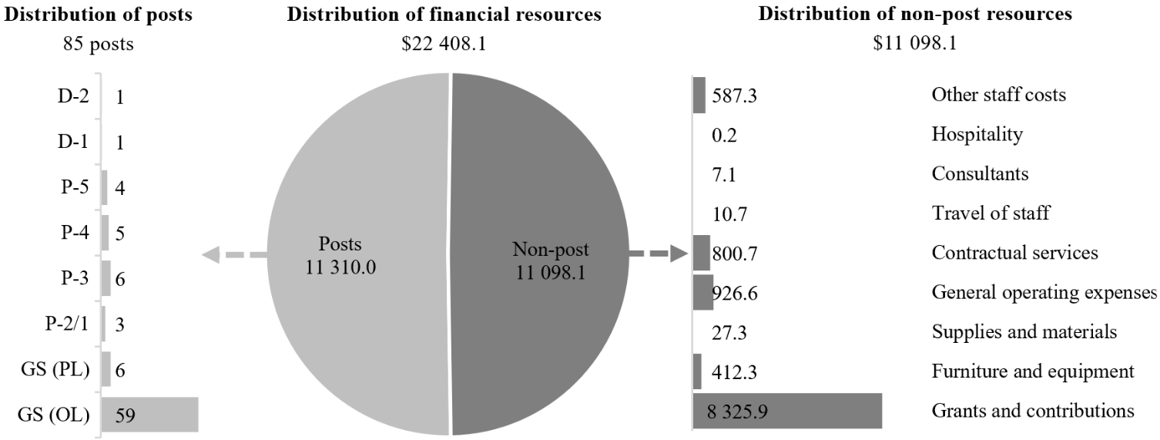

Explanation of variances by factor, component and subprogramme

Overall resource changes

New and expanded mandates

29F.68 As shown in table 29F.16 (1), resource changes reflect an increase of $46,100, as follows:
Subprogramme 3, Support services (increase of $46,100). This increase relates to additional requirements under grants and contributions pursuant to General Assembly resolutions 79/234 and 79/243.

Other changes

29F.69 As shown in table 29F.16 (1), resource changes reflect a net increase of $47,400, as follows:
(a) Subprogramme 2, Human resources management (increase of $44,000). An increase under grants and contributions reflects the higher cost of the joint medical services at the Vienna International Centre, which are managed by the IAEA under common services arrangements;
(b) Subprogramme 3, Support services (no change). An increase under post costs ($108,400) is offset by a decrease under other staff costs ($108,400) relating to the proposed cost-neutral conversion of a temporary position of Library Assistant (GS (OL)) to a post (see annex II);
(c) Subprogramme 4, Information and communications technology operations (increase of $3,400):
(i) An increase under post costs ($108,400) is offset by a decrease under other staff costs ($108,400) relating to the proposed cost-neutral conversion of a temporary position of Programme Management Assistant (GS (OL)) to a post (see annex II);
(ii) An increase under contractual services ($3,400) reflects higher rates for ICT.

Extrabudgetary resources

29F.70 As reflected in tables 29F.16 (2) and 29F.17 (2), extrabudgetary resources amount to $26,233,500. The resources would complement regular budget resources and would be used mainly to provide for 90 posts (58 GS (OL), 4 GS (PL), 4 P-2 or P-1, 14 P-3, 8 P-4 and 2 D-1) to perform the functions of implementing activities related to overall coordination and business transformation, as well as providing indirect support to the extrabudgetary activities of UNODC, the Office for Outer Space Affairs and the United Nations Register of Damage Caused by the Construction of the Wall in the Occupied Palestinian Territory. The anticipated reduction of $2,610,600 takes into account the adjusted level of cost-recovery activities expected in 2026, mainly in the area of information technology.
29F.71 The extrabudgetary resources under the present section are subject to the oversight of the United Nations Office at Vienna in accordance with the delegated authority from the Secretary-General.

Executive direction and management

29F.72 The executive direction and management component comprises the Office of the Director of the Division for Management.
29F.73 The main responsibilities of the executive direction and management component include the provision of leadership and direction regarding the management of administrative, conference and related services for United Nations entities located in Vienna.
29F.74 In accordance with the 2030 Agenda for Sustainable Development, in particular target 12.6 of the Sustainable Development Goals, in which organizations are encouraged to integrate sustainability information into their reporting cycles, and in compliance with the cross-cutting mandate set out in paragraph 19 of General Assembly resolution 72/219, the United Nations Office at Vienna and UNODC are integrating environmental management practices into their operations. Since 2020, the Vienna-based organizations of the United Nations common system have started to renew entrances, replaced existing air curtains and upgraded or refurbished all elevator cabins. While some of these projects have been completed in parts of the compound, they are still ongoing in others, will continue throughout 2026 and beyond, and will result in a further reduction in the environmental impact of the Vienna International Centre as they will increase energy efficiency. Moreover, the Centre is powered by carbon-neutral electricity from 100 per cent renewable resources.
29F.75 Information on the timely submission of documentation and advance booking for air travel is reflected in table 29F.19. Compliance rates continued to be monitored through a tailor-made mission travel request application, and awareness-raising sessions were held with staff to boost compliance rates.

Table 29F.19

Compliance rate
(Percentage)

 | 2022 actual | 2023 actual | 2024 actual | 2025 planned | 2026 planned
Timely submission of documentation | 100 | 100 | 100 | 100 | 100
Air tickets purchased at least two weeks before the commencement of travel | 71 | 73 | 77 | 100 | 100

29F.76 The proposed regular budget resources for 2026 amount to $438,900 and reflect no change compared with the approved budget for 2025. Additional details on the distribution of the proposed resources for 2026 are reflected in table 29F.20 and figure 29F.XI.

Table 29F.20

Executive direction and management: evolution of financial and post resources
(Thousands of United States dollars/number of posts)

 | 2024 expenditure | 2025 approved | Changes |  |  |  |  | 2026 estimate
 | 2024 expenditure | 2025 approved | Technical adjustments | New/expanded mandates | Other | Total | Percentage | 2026 estimate
Financial resources by main category of expenditure
Posts | 512.2 | 394.7 | – | – | – | – | – | 394.7
Non-post | 26.1 | 44.2 | – | – | – | – | – | 44.2
Total | 538.3 | 438.9 | – | – | – | – | – | 438.9
Post resources by category
Professional and higher |  | 1 | – | – | – | – | – | 1
General Service and related |  | 1 | – | – | – | – | – | 1
Total |  | 2 | – | – | – | – | – | 2

Figure 29F.XI

Executive direction and management: distribution of proposed resources for 2026
(Number of posts/thousands of United States dollars)

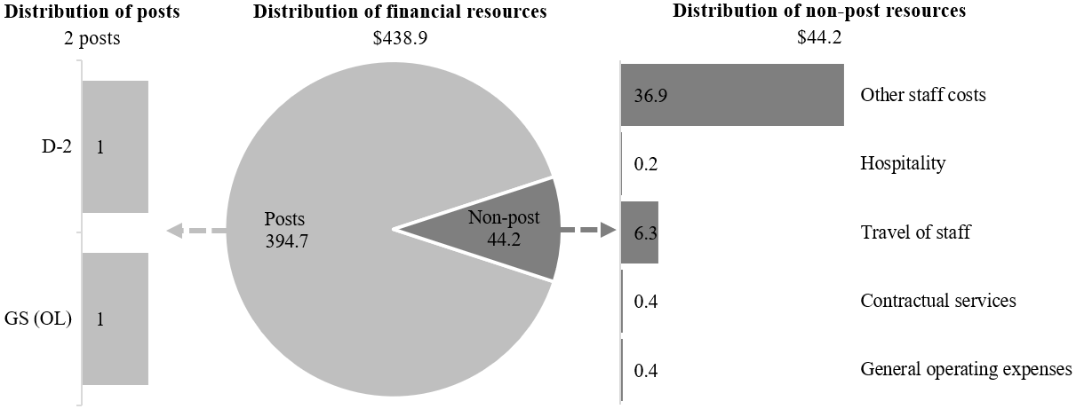

Programme of work

Subprogramme 1

Programme planning, finance and budget

29F.77 The proposed regular budget resources for 2026 amount to $2,656,700 and reflect no change compared with the approved budget for 2025. Additional details on the distribution of the proposed resources for 2026 are reflected in table 29F.21 and figure 29F.XII.

Table 29F.21

Subprogramme 1: evolution of financial and post resources
(Thousands of United States dollars/number of posts)

 | 2024 expenditure | 2025 approved | Changes |  |  |  |  | 2026 estimate
 | 2024 expenditure | 2025 approved | Technical adjustments | New/expanded mandates | Other | Total | Percentage | 2026 estimate
Financial resources by main category of expenditure
Posts | 2 333.0 | 2 500.4 | – | – | – | – | – | 2 500.4
Non-post | 29.6 | 156.3 | – | – | – | – | – | 156.3
Total | 2 362.6 | 2 656.7 | – | – | – | – | – | 2 656.7
Post resources by category
Professional and higher |  | 7 | – | – | – | – | – | 7
General Service and related |  | 10 | – | – | – | – | – | 10
Total |  | 17 | – | – | – | – | – | 17

Figure 29F.XII

Subprogramme 1: distribution of proposed resources for 2026
(Number of posts/thousands of United States dollars)

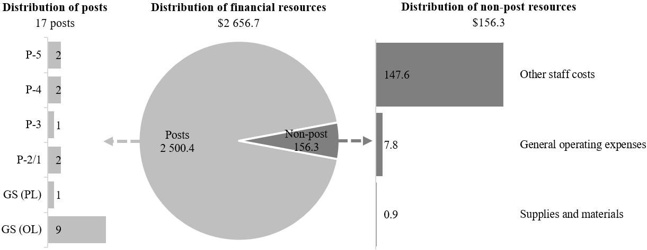

Subprogramme 2

Human resources management

29F.78 The proposed regular budget resources for 2026 amount to $3,419,700 and reflect a net increase of $44,000 compared with the approved budget for 2025. The proposed change is explained in paragraph 29F.69 (a). Additional details on the distribution of the proposed resources for 2026 are reflected in table 29F.22 and figure 29F.XIII.

Table 29F.22

Subprogramme 2: evolution of financial and post resources
(Thousands of United States dollars/number of posts)

 | 2024 expenditure | 2025 approved | Changes |  |  |  |  | 2026 estimate
 | 2024 expenditure | 2025 approved | Technical adjustments | New/expanded mandates | Other | Total | Percentage | 2026 estimate
Financial resources by main category of expenditure
Posts | 2 576.2 | 2 490.2 | – | – | – | – | – | 2 490.2
Non-post | 800.4 | 885.5 | – | – | 44.0 | 44.0 | 5.0 | 929.5
Total | 3 376.6 | 3 375.7 | – | – | 44.0 | 44.0 | 1.3 | 3 419.7
Post resources by category
Professional and higher |  | 4 | – | – | – | – | – | 4
General Service and related |  | 14 | – | – | – | – | – | 14
Total |  | 18 | – | – | – | – | – | 18

Figure 29F.XIII

Subprogramme 2: distribution of proposed resources for 2026
(Number of posts/thousands of United States dollars)

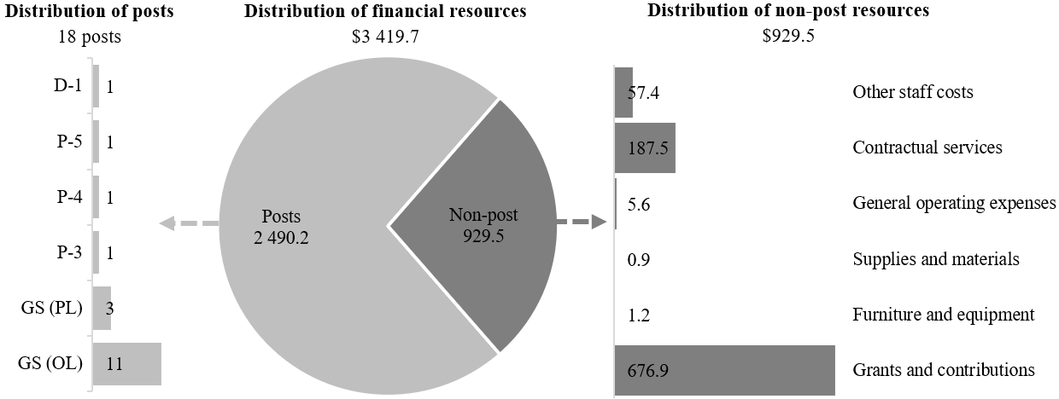

Subprogramme 3

Support services

29F.79 The proposed regular budget resources for 2026 amount to $12,514,300 and reflect a net increase of $46,100 compared with the approved budget for 2025. The proposed changes are explained in paragraphs 29F.68 (a) and 29F.69 (b). Additional details on the distribution of the proposed resources for 2026 are reflected in table 29F.23 and figure 29F.XIV.

Table 29F.23

Subprogramme 3: evolution of financial and post resources
(Thousands of United States dollars/number of posts)

 | 2024 expenditure | 2025 approved | Changes |  |  |  |  | 2026 estimate
 | 2024 expenditure | 2025 approved | Technical adjustments | New/expanded mandates | Other | Total | Percentage | 2026 estimate
Financial resources by main category of expenditure
Posts | 2 887.8 | 3 477.5 | – | – | 108.4 | 108.4 | 3.1 | 3 585.9
Non-post | 7 620.6 | 8 990.7 | – | 46.1 | (108.4) | (62.3) | (0.7) | 8 928.4
Total | 10 508.4 | 12 468.2 | – | 46.1 | – | 46.1 | 0.5 | 12 514.3
Post resources by category
Professional and higher |  | 3 | – | – | – | – | – | 3
General Service and related |  | 26 | – | – | 1 | 1 | 3.8 | 27
Total |  | 29 | – | – | 1 | 1 | 3.4 | 30

Figure 29F.XIV

Subprogramme 3: distribution of proposed resources for 2026
(Number of posts/thousands of United States dollars)

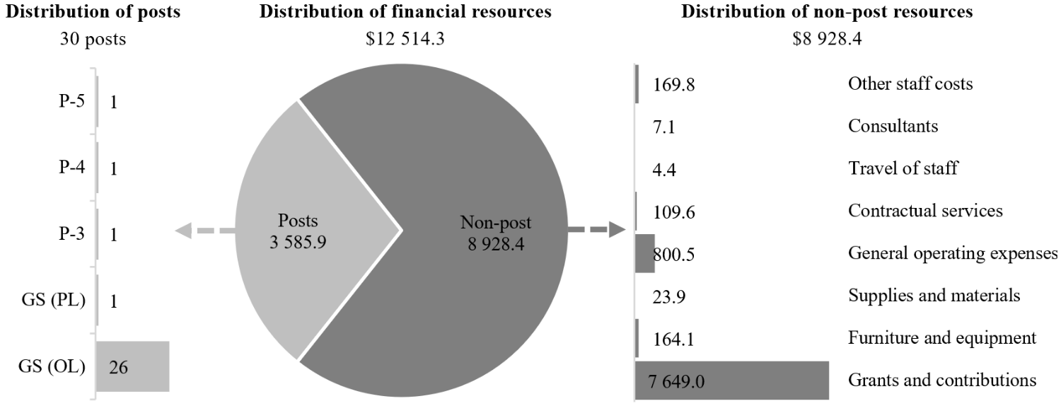

Subprogramme 4

Information and communications technology operations

29F.80 The proposed regular budget resources for 2026 amount to $3,378,500 and reflect a net increase of $3,400 compared with the approved budget for 2025. The proposed changes are explained in paragraph 29F.69 (c). Additional details on the distribution of the proposed resources for 2026 are reflected in table 29F.24 and figure 29F.XV.

Table 29F.24

Subprogramme 4: evolution of financial and post resources
(Thousands of United States dollars/number of posts)

 | 2024 expenditure | 2025 approved | Changes |  |  |  |  | 2026 estimate
 | 2024 expenditure | 2025 approved | Technical adjustments | New/expanded mandates | Other | Total | Percentage | 2026 estimate
Financial resources by main category of expenditure
Posts | 2 203.3 | 2 230.4 | – | – | 108.4 | 108.4 | 4.9 | 2 338.8
Non-post | 608.9 | 1 144.7 | – | – | (105.0) | (105.0) | (9.2) | 1 039.7
Total | 2 812.2 | 3 375.1 | – | – | 3.4 | 3.4 | 0.1 | 3 378.5
Post resources by category
Professional and higher |  | 5 | – | – | – | – | – | 5
General Service and related |  | 12 | – | – | 1 | 1 | 8.3 | 13
Total |  | 17 | – | – | 1 | 1 | 5.9 | 18

Figure 29F.XV

Subprogramme 4: distribution of proposed resources for 2026
(Number of posts/thousands of United States dollars)

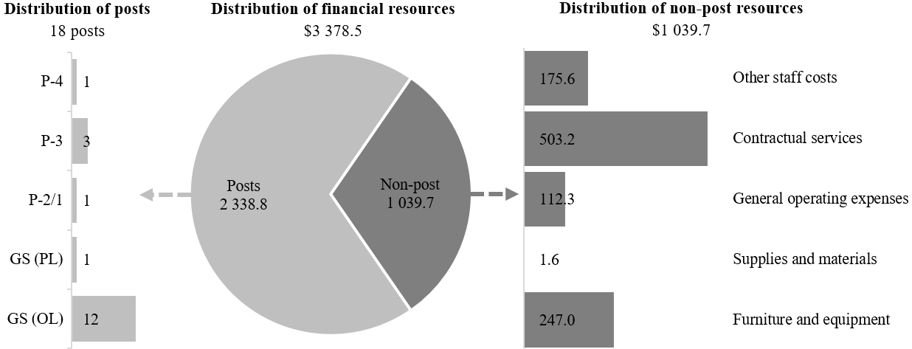

Annex I

Organizational structure and post distribution for 2026

Information and communications technology operations
(subprogramme 4)

RB: XB:
1 P-4 1 D-1
3 P-3 1 P-4
1 P-2 8 GS (OL)
1 GS (PL)
11 GS (OL)
1 GS (OL)ª

18 10
Total: 28
Office of the
Director-General
Office of the Director
(executive direction and management)

RB:
1 D-2
1 GS (OL)

Total: 2
Programme planning, finance and budget service
(subprogramme 1)

RB: XB:
2 P-5 1 D-1
2 P-4 3 P-4
1 P-3 7 P-3
2 P-2 1 P-2
1 GS (PL) 4 GS (PL)
9 GS (OL) 23 GS (OL)

17 39
Total: 56

Human resources management service
(subprogramme 2)

RB: XB:
1 D-1 3 P-4
1 P-5 1 P-3
1 P-4 1 P-2
1 P-3 17 GS (OL)
3 GS (PL)
11 GS (OL)

18 22
Total: 40
Support services
(subprogramme 3)

RB: XB:
1 P-5 1 P-4
1 P-4 6 P-3
1 GS (PL) 2 P-2
24 GS (OL) 10 GS (OL)

27 19
Library Service

RB:
1 P-3
1 GS (OL)
1 GS (OL)ª

3
Total: 49

Abbreviations: GS (OL), General Service (Other level); GS (PL), General Service (Principal level); RB, regular budget; XB, extrabudgetary.
ª Conversion.

Annex II

Summary of proposed post changes, by component and subprogramme

Component/subprogramme | Posts | Grade | Description | Reason for change
Subprogramme 3  Support services | 1 | GS (OL) | Conversion of one Library Assistant from temporary position to post | The temporary position of Library Assistant was established in December 2015, nearly 10 years ago, to meet the needs of the growing client base of the library, which has further expanded from 800 in 2012 to over 3,000 in 2025. The Library Assistant provides support for cataloguing projects, as well as substantive support in the form of research assistance for client offices that are working towards mandated activities, such as preparing publications and reports. Given that the outputs of the United Nations Office on Drugs and Crime (UNODC) include an average of 30 publications per year in addition to the preparations for UNODC commissions and for missions involving staff members, the requirements for library and information services are ongoing and no longer follow peak periods of activity. The position is considered essential, given that the library closed for six weeks in 2024 due to the lack of sufficient staffing.
Subprogramme 4  Information and communications technology operations | 1 | GS (OL) | Conversion of one Programme Management Assistant from temporary position to post | The temporary position of Programme Management Assistant was established in April 2013, over 10 years ago, and provides support for procurements, contract management and payment of information technology-related contracts that support the information technology infrastructure. The position coordinates all requisitioning of information technology requirements and contract management activities and manages the licences and subscriptions necessary for the functioning of the information technology infrastructure and for the provision of information technology services to staff members, delegates, international organizations and Member States. These activities are ongoing and no longer follow peak periods of activity. The position is essential owing to the increasing demand for compliance with more rigorous information and communications technology security and for compatibility with information technology standards, as well as the increasingly complex and specific nature of information technology contracts.

Abbreviation: GS (OL), General Service (Other level).

