Eightieth session
Items 137 and 138 of the preliminary list*

Proposed programme budget for 2026

Programme planning

Proposed programme budget for 2026

Part IX

Internal oversight

Section 30

Internal oversight

Programme 26

Internal oversight

Contents
 |  |  | Page
- Proposed programme plan for 2026 and programme performance in 2024** |  |  | 3
Overall orientation |  |  | 3
Programme of work |  |  | 5
Subprogramme 1. Internal audit |  |  | 5
Subprogramme 2. Inspection and evaluation |  |  | 9
Subprogramme 3. Investigations |  |  | 14
- Proposed post and non-post resource requirements for 2026*** |  |  | 19
Overview |  |  | 19
Executive direction and management |  |  | 24
* A/80/50.
** In keeping with paragraph 10 of General Assembly resolution 77/267, the part consisting of the programme plan and programme performance information (part II) is submitted through the Committee for Programme and Coordination for the consideration of the Assembly.
*** In keeping with paragraph 10 of General Assembly resolution 77/267, the part consisting of the post and non-post resource requirements (part III) is submitted through the Advisory Committee on Administrative and Budgetary Questions for the consideration of the Assembly.
Programme of work | 26
Subprogramme 1. Internal audit | 26
Subprogramme 2. Inspection and evaluation | 27
Subprogramme 3. Investigations | 27
Programme support | 28
Annex
Organizational structure and post distribution for 2026 | 30

A. Proposed programme plan for 2026 and programme performance in 2024

Overall orientation

Mandates and background

30.1 The Office of Internal Oversight Services (OIOS) is responsible for assisting the Secretary-General in fulfilling his internal oversight responsibilities in respect of the resources and staff of the Organization through the provision of internal audit, inspection and evaluation, and investigation services. The mandate derives from the priorities established in relevant General Assembly resolutions and decisions, including resolutions 48/218 B, 54/244, 59/272, 64/263, 69/253 and 74/257. The Office will continue to maintain its operational independence in carrying out its objectives. The Independent Audit Advisory Committee provides the Office with advice to strengthen the programme’s risk-based planning and budgeting.

Strategy and external factors for 2026

30.2 In support of the Secretary-General’s focus on building a more sustainable and inclusive future and on reforming the Organization to better deliver against this vision, the strategy for 2026 prioritizes internal oversight coverage of the work of the Organization in the following management areas: (a) implementation of the reforms of the management, peace and security, and development pillars; (b) strengthening of organizational culture; (c) procurement and supply chain management, including management of fraud and corruption risks; (d) management of mission drawdown or transition; and (e) strengthening of the protection against retaliation (whistle-blower) system. The Office will also continue to cover the programmes and strategies of the Organization, including cross-cutting areas such as the provision of support to Member States on the achievement of the Sustainable Development Goals and the Pact for Future, as well as the implementation of the Secretary-General’s strategies on gender equality, racial equality, environmental sustainability, disability inclusion and data.
30.3 Effective engagement with the senior leadership of the Organization will help the programme to identify risks to the Organization and provide timely assurance and advice on issues relating to the efficient, economical, effective and ethical management of the Organization’s resources.
30.4 The Office will strengthen the delivery of its mandated activities by: (a) strengthening the use of enterprise risk management in planning internal audit and evaluation and inspection activities (subprogrammes 1 and 2); (b) enhancing the methodology for measuring the impact of audit recommendations (subprogramme 1); (c) enhancing guidance for thematic and outcome evaluations of programmes (subprogramme 2); and (d) enhancing guidance on using data analytics to improve investigation planning and the timeliness of investigations (subprogramme 3).
30.5 With regard to cooperation with other entities at the global, regional, national and local levels, the Office will consult closely on its programme of work with the Board of Auditors and the Joint Inspection Unit and liaise, as appropriate, with relevant offices involved in the internal justice system of the Organization.
30.6 With regard to inter-agency coordination and liaison, the Office will share knowledge on good practices and innovations in oversight methodologies with the other internal oversight functions of the United Nations system through the meetings of the Representatives of Internal Audit Services of the United Nations Organizations, the United Nations Representatives of Investigative Services and the United Nations Evaluation Group.
30.7 With regard to the external factors, the overall plan for 2026 is based on the planning assumption that the Office will have unimpeded access to the staff and records of the Organization and other required information.
30.8 The Office integrates a gender perspective into its operational activities, deliverables and results, as appropriate. Subprogrammes 1 and 2 will cover the management of risks relating to mainstreaming a gender perspective. Subprogramme 3 will continue to implement a gender perspective in its victim-centred methodology for all investigations, including sexual exploitation and abuse and workplace sexual harassment.
30.9 In line with the United Nations Disability Inclusion Strategy, the Office will further advance disability inclusion by covering the management of risks relating to implementation of the Strategy.

Legislative mandates

30.10 The list below, which was reviewed in the preparation of the proposed programme budget, provides all mandates entrusted to the programme.

General Assembly resolutions

48/218 B; 60/254 | Review of the efficiency of the administrative and financial functioning of the United Nations
59/272 | Review of the implementation of General Assembly resolutions 48/218 B and 54/244
60/1 | 2005 World Summit Outcome
61/245 | Comprehensive review of governance and oversight within the United Nations and its funds, programmes and specialized agencies
61/275 | Terms of reference for the Independent Audit Advisory Committee and strengthening the Office of Internal Oversight Services
72/266 A and B | Shifting the management paradigm in the United Nations
74/257 | Review of the implementation of General Assembly resolutions 48/218 B, 54/244, 59/272, 64/263 and 69/253

Subprogramme 1

Internal audit

General Assembly resolutions

67/244 B | Financing of the International Residual Mechanism for Criminal Tribunals
79/246 | Capital Master Plan

Subprogramme 2

Inspection and evaluation

General Assembly resolutions

55/231 | Results-based budgeting
79/247 | Programme planning

Subprogramme 3

Investigations

General Assembly resolutions

59/287 | Report of the Office of Internal Oversight Services on strengthening the investigation functions in the United Nations
62/247 | Strengthening investigations
77/278 | Human resources management

Deliverables

30.11 Table 30.1 lists all cross-cutting deliverables of the programme.

Table 30.1

Cross-cutting deliverables for the period 2024–2026, by category and subcategory

Category and subcategory | 2024 planned | 2024 actual | 2025 planned | 2026 planned
A. Facilitation of the intergovernmental process and expert bodies
Parliamentary documentation (number of documents) | 2 | 2 | 2 | 2
1. Report on the activities of the Office of Internal Oversight Services (Parts I and II) | 2 | 2 | 2 | 2
Substantive services for meetings (number of three-hour meetings) | 26 | 28 | 17 | 17
Meetings of:
2. The Fifth Committee | 8 | 11 | 8 | 8
3. The Committee for Programme and Coordination | 12 | 11 | 3 | 3
4. The Advisory Committee on Administrative and Budgetary Questions | 2 | 2 | 2 | 2
5. The Independent Audit Advisory Committee | 4 | 4 | 4 | 4
C. Substantive deliverables
Databases and substantive digital materials: comprehensive database and dashboard for monitoring the status of implementation of the approximately 1,000 open recommendations of the Office.
E. Enabling deliverables
Content on communications platforms, briefings and presentations on oversight activities; and refresher training to programme managers on the Office’s recommendation monitoring system.

Evaluation activities

30.12 The OIOS-commissioned quality assessment of the inspection and evaluation function (subprogramme 2, completed in 2024) has guided the proposed programme plan for 2026.
30.13 In response to the results of the quality assessment referenced above, OIOS has developed an action plan to improve areas such as work planning, the use of information and communications technology (ICT) and quality assurance.
30.14 An external quality assessment of the entire programme of OIOS is planned for 2026.

Programme of work

Subprogramme 1

Internal audit

Objective

30.15 The objective, to which this subprogramme contributes, is to improve the efficiency, economy, effectiveness and impact of the Organization’s programmes, in keeping with best management practices.

Strategy

30.16 To contribute to the objective, the subprogramme will:
(a) Conduct internal audit activities to recommend improvements to key controls and processes and identify accountability issues, with a strengthened focus on providing assurance as to whether Secretariat entities have adequately and effectively implemented the new delegation of authority, as well as on the effectiveness and efficiency of programme performance monitoring and reporting and service delivery;
(b) Support the efforts undertaken by the Department of Management Strategy, Policy and Compliance to strengthen the United Nations Secretariat accountability system, through assurance and advice to the Department;
(c) Focus on data governance and data security in the use of ICT in the Organization;
(d) Strengthen annual work-planning processes by identifying and monitoring audit assignments that systematically cover United Nations cross-cutting priorities in the management, programme and strategy areas (including reforms, organization culture, procurement and supply chain, mission drawdown or transition and Sustainable Development Goal support) and take into consideration a gender perspective, disability inclusion, racism, human rights and the environment, as appropriate;
(e) Implement recommendations resulting from the quality assessment of the internal audit function.
30.17 The above-mentioned work is expected to result in:
(a) Strengthened accountability and transparency in the use of resources by United Nations organizations and entities;
(b) Improved risk identification and mitigation by United Nations organizations and entities;
(c) High quality of internal audit assurance provided to the Secretary-General, heads of organizations and entities and Member States on the adequacy and effectiveness of risk management and internal control systems.

Programme performance in 2024

Strengthened data governance and data security in the Organization

30.18 To support the implementation of the Secretary-General’s data strategy, the subprogramme continued to cover the management of information, data governance and data security in the Secretariat.
30.19 In 2024, the subprogramme conducted 22 assurance engagements covering ICT security, governance, risk management and controls. The audits resulted in 162 recommendations aimed at strengthening the governance, risk management and controls to improve the protection of information and assets and ensure the continuity of the Organization’s operations.
30.20 Progress towards the objective is presented in the performance measure below (see figure 30.I).

Figure 30.I

Performance measure: number of audit recommendations accepted on data governance and data security (annual)

Planned results for 2026

Result 1: increased accountability through transparent exercise of the delegation of authority

Programme performance in 2024 and target for 2026

30.21 The subprogramme’s work contributed to the acceptance of 29 audit recommendations relating to strengthening the implementation of the delegation of authority framework, representing 5 per cent of the total recommendations accepted in 2024, which did not meet the planned target of 10 per cent. The target was not met because the subprogramme issued more recommendations than planned overall, and fewer recommendations were required on the thematic audits of the delegation of authority, evidencing more effective implementation of the framework by the Organization.
30.22 Progress towards the objective and the target for 2026 are presented in the performance measure below (see figure 30.II).

Figure 30.II

Performance measure: audit recommendations accepted that strengthen the implementation of the delegation of authority framework in the Organization (annual)

Result 2: strengthened monitoring systems to improve performance management to support programme delivery

Programme performance in 2024 and target for 2026

30.23 The subprogramme’s work contributed to the issuance of 56 recommendations relating to strengthening performance management monitoring systems. All of the recommendations were accepted by the respective programme managers, which met the planned target.
30.24 Progress towards the objective and the target for 2026 are presented in the performance measure below (see figure 30.III).

Figure 30.III

Performance measure: audit recommendations accepted that strengthen programme performance management

Result 3: enhanced delivery of United Nations mandates and programmes through strengthened organizational capabilities

Proposed programme plan for 2026

30.25 The subprogramme mainstreams assessment of the delivery of United Nations mandates and programmes, such as the support provided by the Secretariat entities to Member States on the implementation of the Sustainable Development Goals, through relevant audits and advisory assignments.

Lessons learned and planned change

30.26 The lesson for the subprogramme was that implementation of a transformed and modernized United Nations system was essential to improve support to Member States. In applying the lesson, the subprogramme will prioritize the review of implementation of approaches that enhance the work and capabilities of Secretariat entities for better programmatic and operational support to Member States, in line with action 45 of the Pact for the Future (see General Assembly resolution 79/1, para. 73 (a)), in areas such as innovation, data analytics, digital transformation, strategic foresight and behavioural science.
30.27 Expected progress towards the objective is presented in the performance measure below (see figure 30.IV).

Figure 30.IV

Performance measure: audit recommendations accepted that strengthen organizational capabilities in innovation, data analytics, digital transformation, strategic foresight and behavioural science (annual)

Deliverables

30.28 Table 30.2 lists all deliverables of the subprogramme.

Table 30.2

Subprogramme 1: deliverables for the period 2024–2026, by category and subcategory

Category and subcategory | 2024 planned | 2024 actual | 2025 planned | 2026 planned
2026 planned
A. Facilitation of the intergovernmental process and expert bodies
Parliamentary documentation (number of documents) | – | – | 1 | –
1. Biennial report on procurement (resolutions 72/266 B and 74/256) | – | – | 1 | –
B. Generation and transfer of knowledge
Publications (number of publications) | 150 | 113 | 140 | 140
2. Internal audit reports (assurance and advisory) | 150 | 113 | 140 | 140

Subprogramme 2

Inspection and evaluation

Objective

30.29 The objective, to which this subprogramme contributes, is to strengthen relevance, efficiency, effectiveness and impact in the implementation of programmes and legislative mandates of the Organization and improve decision-making, accountability and learning.

Strategy

30.30 To contribute to the objective, the subprogramme will:
(a) Focus, in conducting evaluations, on programmatic results and outcomes achieved by Secretariat entities in the areas of the peace and security, sustainable development, human rights and humanitarian assistance;
(b) Support accountability for programme improvement through the monitoring of the implementation of evaluation recommendations and their outcomes, including by conducting triennial reviews of OIOS evaluation reports;
(c) Integrate the Secretary-General’s cross-cutting strategies into evaluation design and implementation;
(d) Refine its inspection and evaluation methodology and further develop and strengthen evaluation design and data collection and analysis methods;
(e) Provide evaluation methodological guidance and quality assurance support to Secretariat entities and to the wider Organization, including through collaboration with the Department of Management Strategy, Policy and Compliance, and by developing and implementing community of practice workshops, methodology seminars and other capacity-building measures;
(f) Enhance evaluation knowledge-sharing through the production of the biennial report on strengthening evaluation, as well as evaluation newsletters and evaluation synthesis reports;
(g) Support system-wide evaluation through collaboration with the United Nations Sustainable Development Group System-wide Evaluation Office.
30.31 The above-mentioned work is expected to result in:
(a) Increased learning and accountability of Secretariat entities towards achieving their planned programmatic outcomes;
(b) Strengthened evaluation capacity and performance, and greater use of evaluation findings to inform programme planning and the achievement of results within the Organization.

Programme performance in 2024

Enhanced systematic reflection of programme performance by the Secretary-General and Member States

30.32 The subprogramme contributed to enhancing systematic reflection on programmatic performance and results through contributions to the reports of the Secretary-General on the work of the Organization, as well as through communication to intergovernmental bodies and Member States, which provided independent and objective findings on the relevance, quality and usefulness of programme and subprogramme activities. OIOS has conducted two evaluations annually over the past three years that have contributed to that goal.
30.33 Progress towards the objective is presented in the performance measure below (see table 30.3).

Table 30.3

Performance measure

2022 (actual) | 2023 (actual) | 2024 (actual)
Report of the Chair of the United Nations Sustainable Development Group on the Development Coordination Office incorporated OIOS findings on contributions of the resident coordinator system to country-level programme coherence | Report of the Chair of the United Nations Sustainable Development Group on the Development Coordination Office incorporated OIOS findings and recommendations on Development Coordination Office regional support | Report of the Secretary-General (A/79/72-E/2024/12), incorporated OIOS data on resident coordinator system support to United Nations policy advice
Department of Political and Peacebuilding Affairs report on United Nations engagement on the quota for women in Somalia elections, 2020–2022, drew from OIOS recommendations on women and peace and security to support positive outcomes for women in future elections | Office for the Coordination of Humanitarian Affairs reported OIOS findings and recommendations on coordination of humanitarian action and emergency response in briefings to donors | United Nations Human Settlements Programme (UN-Habitat) reported OIOS findings and recommendations on the UN-Habitat strategic plan in briefings to its Governing Council

Planned results for 2026

Result 1: strengthened programmatic performance and achievement of results

Programme performance in 2024 and target for 2026

30.34 The subprogramme’s work contributed to 71 per cent of recommendations aimed at improving programme delivery being implemented within 24 months of issuance, which did not meet the planned target of 85 per cent. The target was not met due to changes and increased complexities in the operational environment of evaluated entities that meant that some recommendations took longer than anticipated to be fully implemented.
30.35 Progress towards the objective and the target for 2026 are presented in the performance measure below (see figure 30.V).

Figure 30.V

Performance measure: percentage of recommendations implemented within 24 months of issuance

Result 2: strengthening the resident coordinator system

Programme performance in 2024 and target for 2026

30.36 The subprogramme’s work contributed to an effective resident coordinator system through independent evaluations that examined the results achieved, identified lessons learned and made recommendations for improvement in the support that is provided by Secretariat entities in conflict-affected countries, which met the planned target.
30.37 Progress towards the objective and the target for 2026 are presented in the performance measure below (see table 30.4).

Table 30.4

Performance measure

2022 (actual) | 2023 (actual) | 2024 (actual) | 2025 (planned) | 2026 (planned)
– | Recommendations accepted to enhance the achievement of the Sustainable Development Goals through more coherent United Nations policy advice | Recommendations accepted to ensure an effective resident coordinator system in conflict-affected countries, and leading and coordinating responses to humanitarian crises | Recommendations accepted by Development Coordination Office to improve global support for the resident coordinators | Recommendations accepted by Development Coordination Office to improve global support for the resident coordinators

Result 3: enhanced programme outcomes

Proposed programme plan for 2025

30.38 The subprogramme will enhance the performance of Secretariat entities in supporting Member States to achieve the pledges they made with the adoption in September 2024 of the Pact for the Future.

Lessons learned and planned change

30.39 The lesson for the subprogramme was the need to align its evaluation coverage with the Pact’s five broad focus areas of sustainable development, international peace and security, science and technology, youth and future generations, and transforming global governance, as well as to develop a robust approach to assessing programme performance in those five areas. In applying the lesson, the subprogramme will strengthen its work planning process to address the highest risks to non-performance in the five areas and continue to enhance its evaluation methodologies for assessing outcomes associated with Member State support on the Pact for the Future.
30.40 Expected progress towards the objective is presented in the performance measure below (see table 30.5).

Table 30.5

Performance measure

2022 (actual) | 2023 (actual) | 2024 (actual) | 2025 (planned) | 2026 (planned)
– | – | – | Strengthened programmatic performance in the five areas of the Pact for the Future through nine evaluation, inspection and synthesis reports, on: resident coordinator system support to least developed countries; the Office of Victims’ Rights Advocate and the Office of the Special Coordinator on Improving the United Nations Response to Sexual Exploitation and Abuse; UNCTAD; the Department of Economic and Social Affairs; digital transformation and capacity-building modality; the transfer of mandated activities from peacekeeping to development; peacekeeping regional partnerships; peacekeeping digital transformation; and the International Residual Mechanism for Criminal Tribunals | Strengthened programmatic performance in the five areas of the Pact for the Future through nine evaluation, inspection and synthesis reports, on programmatic and cross-cutting thematic areas

Deliverables

30.41 Table 30.6 lists all deliverables of the subprogramme.

Table 30.6

Subprogramme 2: deliverables for the period 2024–2026, by category and subcategory

Category and subcategory | 2024 planned | 2024 actual | 2025 planned | 2026 planned
A. Facilitation of the intergovernmental process and expert bodies
Parliamentary documentation (number of documents) | 10 | 5 | 1 | 4
1. Evaluation reports on various programmes for the Committee for Programme and Coordination | 6 | – | – | –
2. Evaluation reports on various programmes for the Fifth Committee | – | 1 | – | –
3. Triennial reviews of the implementation of the recommendations on the evaluations of various programmes | 3 | 3 | 1 | 3
4. Evaluation of the International Residual Mechanism for Criminal Tribunals for the Security Council | 1 | 1 | – | 1
B. Generation and transfer of knowledge
Publications (number of publications) | 11 | 14 | 12 | 13
5. Evaluation and inspection reports | 11 | 14 | 12 | 13
E. Enabling deliverables
Internal justice and oversight: advisory notes, memorandums and guidance to all Secretariat entities, including training programmes.

Subprogramme 3

Investigations

Objective

30.42 The objective, to which this subprogramme contributes, is to enhance accountability and ethical behaviour within the Organization.

Strategy

30.43 To contribute to the objective, the subprogramme will:
(a) Receive and record all complaints of possible violations of United Nations regulations, rules and pertinent administrative policies, and decide whether they warrant OIOS investigation or some other action;
(b) Investigate reports of possible violations of United Nations regulations, rules and pertinent administrative policies;
(c) Enable prevention of and response to complaints of misconduct, including: (i) sexual misconduct, including sexual exploitation and abuse, as well as sexual harassment; and (ii) fraud and corruption, including procurement fraud and medical insurance fraud;
(d) Support the investigative capacity and capability of: (i) members of troop contingents who are responsible for undertaking investigations into misconduct; and (ii) officials who are responsible for the appointment of investigative panels or entities into misconduct.
30.44 The above-mentioned work is expected to result in:
(a) Improved ability of the Secretary-General and his delegates to make appropriate decisions on jurisdictional or disciplinary action or corrective measures;
(b) Improved ability of United Nations entities to identify and address misconduct;
(c) Improved detection of issues and better control of risks such as sexual exploitation and abuse, sexual harassment, racial discrimination, fraud and corruption.

Programme performance in 2024

Strengthening the Organization’s ability to protect its resources and hold its personnel accountable by responding to all allegations of misconduct

30.45 The subprogramme saw a continued growth in the number of allegations of misconduct reported to OIOS, including, for example, relating to prohibited conduct (which includes racism and racial discrimination), entitlement fraud and sexual abuse. This resulted in a parallel increase in the number of investigations opened by OIOS and in the number of investigations completed that inform subsequent corrective action by the Organization to protect its financial and human resources and hold its personnel accountable. In 2024, the subprogramme completed 562 investigations and opened 574 new investigations.
30.46 Progress towards the objective is presented in the performance measure below (see figure 30.VI).

Figure 30.VI

Performance measure: number of allegations of misconduct addressed through investigations (annual)

Planned results for 2026

Result 1: strengthened response to misconduct through improved timeliness of investigations

Programme performance in 2024 and target for 2026

30.47 The subprogramme’s work contributed to a strengthened response by the Organization to misconduct through the completion of 40 per cent of all OIOS investigations within 12 months, which did not meet the planned target of 80 per cent. The target was not met due to a continued increase in the number of complaints reported to OIOS. Moreover, during 2024, the subprogramme utilized enhanced monitoring analytics to focus on completing the oldest investigations (that is, those that had been open for the longest duration), meaning that, although the average age of the cases closed in 2024 was temporarily increased, the average age of the cases remaining still open was reduced to 7.2 months (compared with 8.2 months at the end of 2023).
30.48 Progress towards the objective and the target for 2026 are presented in the performance measure below (see figure 30.VII).

Figure 30.VII

Performance measure: strengthened response to misconduct (annual)
(Percentage of all investigations completed in fewer than 12 months)

Result 2: strengthened response to misconduct investigations requiring a victim-centred response

Programme performance in 2024 and target for 2026

30.49 The subprogramme’s work contributed to 9 per cent of investigations into allegations of sexual exploitation and abuse being completed within the target of six months, which did not meet the planned target of 80 per cent. The target was not met due to a combination of factors, including a high number of reports relating to sexual exploitation and abuse and the complexity of investigations and operating environments in which such investigations are conducted, as well as due to some investigations being conducted jointly with national authorities that had differing processes and timelines for investigations. Moreover, many investigations relating to sexual exploitation and abuse also entail DNA forensic genetic analysis for the purposes of paternity testing, which further increase investigation timelines.
30.50 Progress towards the objective and the target for 2026 presented in the performance measure below (see figure 30.VIII).

Figure 30.VIII

Performance measure: OIOS investigations of sexual exploitation and abuse completed within six months
(Percentage)

Result 3: improved handling of and timely decision-making on misconduct complaints

Proposed programme plan for 2026

30.51 The trust of United Nations personnel in the Organization’s response to reports of misconduct relies on the subprogramme’s timely handling and appropriate actioning of complaints. The subprogramme receives complaints through various means, including via email and through its online reporting form, as well as through in-person contacts with complainants. The subprogramme’s intake process aims at ensuring the accurate recording and timely handling of reports of possible misconduct as the first step in ensuring reliable, efficient and responsive actioning and investigation of complaints.

Lessons learned and planned change

30.52 The lesson for the subprogramme was that inefficient or ineffective handling of reports of misconduct has the potential to undermine the timely and appropriate response to allegations of misconduct. In applying the lesson, the subprogramme will strengthen the quality and capacity of the intake processes, including through the use of enhanced data analytics tools, to support an increased responsiveness and more informed decision-making.
30.53 Expected progress towards the objective is presented in the performance measure below (see figure 30.IX).

Figure 30.IX

Performance measure: timely handling of misconduct complaints (annual)
(Number of days for intake decision and action)

Deliverables

30.54 Table 30.7 lists all deliverables of the subprogramme.

Table 30.7

Subprogramme 3: deliverables for the period 2024–2026, by category and subcategory

Category and subcategory | 2024 planned | 2024 actual | 2025 planned | 2026 planned
B. Generation and transfer of knowledge
Publications (number of publications) | 275 | 564 | 275 | 275
Investigation and closure reports | 275 | 564 | 275 | 275
E. Enabling deliverables
Internal justice and oversight: capacity-building relating to combating fraud and corruption, especially medical insurance fraud, focusing on peace operations.

B. Proposed post and non-post resource requirements for 2026

Overview

30.55 The proposed regular budget resources for 2026, including the breakdown of resource changes, as applicable, are reflected in tables 30.8 to 30.10.

Table 30.8

Overall: evolution of financial resources by object of expenditure
(Thousands of United States dollars)

 |  |  | Change
Object of expenditure | 2024 expenditureª | 2025  approved | Technical adjustments | New/expanded mandates | Other | Total | Percentage | 2026 estimate
Post | 21 832.4 | 22 215.1 | – | – | – | – | – | 22 215.1
Other staff costs | 1 226.6 | 2 596.2 | – | – | – | – | – | 2 596.2
Hospitality | – | 0.5 | – | – | – | – | – | 0.5
Consultants | 115.7 | 214.1 | – | – | (0.6) | (0.6) | (0.3) | 213.5
Travel of staff | 272.5 | 543.6 | – | – | (11.5) | (11.5) | (2.1) | 532.1
Contractual services | 375.1 | 491.9 | – | – | (40.1) | (40.1) | (8.2) | 451.8
General operating expenses | 111.4 | 155.6 | – | – | (11.2) | (11.2) | (7.2) | 144.4
Supplies and materials | 1.7 | 17.9 | – | – | – | – | – | 17.9
Furniture and equipment | 149.1 | 107.9 | – | – | 4.9 | 4.9 | 4.5 | 112.8
Total | 24 084.5 | 26 342.8 | – | – | (58.5) | (58.5) | (0.2) | 26 284.3

ª At the time of reporting, the expenditures presented in this table and in subsequent tables are not final and may be subject to adjustments that could result in minor differences between the information contained in the present report and the financial statements to be issued by 31 March 2025.

Table 30.9

Overall: proposed posts and post changes for 2026
(Number of posts)

Note: The following abbreviations are used in the tables and figures: ASG, Assistant Secretary-General; GS (OL), General Service (Other level); GS (PL), General Service (Principal level); LL, Local level; USG, Under-Secretary-General.

 | Number | Details
Approved for 2025 | 116 | 1 USG, 1 ASG, 3 D-2, 4 D-1, 13 P-5, 29 P-4, 22 P-3, 14 P-2/1, 8 GS (PL), 20 GS (OL), 1 LL
Proposed for 2026 | 116 | 1 USG, 1 ASG, 3 D-2, 4 D-1, 13 P-5, 29 P-4, 22 P-3, 14 P-2/1, 8 GS (PL), 20 GS (OL), 1 LL

Table 30.10

Overall: proposed posts by category and grade
(Number of posts)

 |  | Changes
Category | 2025 approved | Technical adjustments | New/expanded mandates | Other | Total | 2026 proposed
Professional and higher
USG | 1 | – | – | – | – | 1
ASG | 1 | – | – | – | – | 1
D-2 | 3 | – | – | – | – | 3
D-1 | 4 | – | – | – | – | 4
P-5 | 13 | – | – | – | – | 13
P-4 | 29 | – | – | – | – | 29
P-3 | 22 | – | – | – | – | 22
P-2/1 | 14 | – | – | – | – | 14
Subtotal | 87 | – | – | – | – | 87
General Service
Principal level | 8 | – | – | – | – | 8
Other level | 20 | – | – | – | – | 20
Subtotal | 28 | – | – | – | – | 28
Other
Local level | 1 | – | – | – | – | 1
Subtotal | 1 | – | – | – | – | 1
Total | 116 | – | – | – | – | 116

30.56 Additional details on the distribution of proposed resources for 2026 are reflected in tables 30.11 to 30.13 and figure 30.X.
30.57 As shown in table 30.11 (1), the overall resources proposed for 2026 amount to $26,284,300, reflecting a decrease of $58,500 compared with the approved budget for 2025. Resource changes result from other changes. The proposed level of resources provides for the full, efficient and effective implementation of mandates.

Table 30.11

Overall: evolution of financial resources by source of funding, component and subprogramme
(Thousands of United States dollars)

(1) Regular budget

 |  |  | Changes
 | 2024 expenditure | 2025 approved | Technical adjustments | New/expanded mandates | Other | Total | Percentage | 2026 estimate
A. Executive direction and management | 1 506.8 | 1 751.8 | – | – | 22.5 | 22.5 | 1.3 | 1 774.3
B. Programme of work
1. Internal audit | 10 224.1 | 10 132.0 | – | – | (17.5) | (17.5) | (0.2) | 10 114.5
2. Inspection and evaluation | 4 532.7 | 4 977.6 | – | – | – | – | – | 4 977.6
3. Investigations | 6 381.1 | 7 908.0 | – | – | – | – | – | 7 908.0
Subtotal, B | 21 137.9 | 23 017.6 | – | – | (17.5) | (17.5) | (0.1) | 23 000.1
C. Programme support | 1 439.9 | 1 573.4 | – | – | (63.5) | (63.5) | (4.0) | 1 509.9
Subtotal, 1 | 24 084.5 | 26 342.8 | – | – | (58.5) | (58.5) | (0.2) | 26 284.3

(2) Other assessed

 | 2024 expenditure | 2025 estimate |  | Change | Percentage | 2026 estimate
A. Executive direction and management | – | – |  | – | – | –
B. Programme of work
1. Internal audit | 18 653.2 | 15 532.3 |  | 1 317.8 | 8.5 | 16 850.1
2. Inspection and evaluation | 2 229.0 | 2 633.2 |  | 39.2 | 1.5 | 2 672.4
3. Investigations | 11 256.9 | 12 597.8 |  | 1 548.9 | 12.3 | 14 146.7
Subtotal, B | 32 139.2 | 30 763.3 |  | 2 905.9 | 9.4 | 33 669.2
C. Programme support | 640.4 | 752.6 |  | 81.2 | 10.8 | 833.8
Subtotal, 2 | 32 779.5 | 31 515.9 |  | 2 987.1 | 9.5 | 34 503.0

(3) Extrabudgetary

 | 2024 expenditure | 2025 estimate |  | Change | Percentage | 2026 estimate
A. Executive direction and management | – | – |  | – | – | –
B. Programme of work
1. Internal audit | 11 037.9 | 11 373.9 |  | – | – | 11 373.9
2. Inspection and evaluation | 478.6 | 466.6 |  | – | – | 466.6
3. Investigations | 2 068.0 | 3 124.9 |  | – | – | 3 124.9
Subtotal, B | 13 584.5 | 14 965.4 |  | – | – | 14 965.4
C. Programme support | – | – |  | – | – | –
Subtotal, 3 | 13 584.5 | 14 965.4 |  | – | – | 14 965.4
Total | 70 448.6 | 72 824.1 |  | 2 928.6 | 4.0 | 75 752.7

Table 30.12

Overall: proposed posts for 2026 by source of funding, component and subprogramme
(Number of posts)

(1) Regular budget

 |  | Changes
Component/subprogramme | 2025 approved | Technical adjustments | New/expanded mandates | Other | Total | 2026 proposed
A. Executive direction and management | 8 | – | – | – | – | 8
B. Programme of work
1. Internal audit | 44 | – | – | – | – | 44
2. Inspection and evaluation | 24 | – | – | – | – | 24
3. Investigations | 33 | – | – | – | – | 33
Subtotal, B | 109 | – | – | – | – | 109
C. Programme support | 7 | – | – | – | – | 7
Subtotal, 1 | 116 | – | – | – | – | 116

(2) Other assessed

Component/subprogramme | 2025 estimate |  |  |  | Change | 2026 estimate
A. Executive direction and management | – |  |  |  | – | –
B. Programme of work
1. Internal audit | 67 |  |  |  | – | 67
2. Inspection and evaluation | 11 |  |  |  | – | 11
3. Investigations | 48 |  |  |  | – | 48
Subtotal, B | 126 |  |  |  | – | 126
C. Programme support | 4 |  |  |  | – | 4
Subtotal, 2 | 130 |  |  |  | – | 130

(3) Extrabudgetary

Component/subprogramme | 2025 estimate |  |  |  | Change | 2026 estimate
A. Executive direction and management | – |  |  |  | – | –
B. Programme of work
1. Internal audit | 46 |  |  |  | – | 46
2. Inspection and evaluation | – |  |  |  | – | –
3. Investigations | – |  |  |  | – | –
Subtotal, B | 46 |  |  |  | – | 46
C. Programme support | – |  |  |  | – | –
Subtotal, 3 | 46 |  |  |  | – | 46
Total | 292 |  |  |  | – | 292

Table 30.13

Overall: evolution of financial and post resources
(Thousands of United States dollars/number of posts)

 |  |  | Changes
 | 2024 expenditure | 2025 approved | Technical adjustments | New/expanded mandates | Other | Total | Percentage | 2026 estimate
Financial resources by main category of expenditure
Posts | 21 832.4 | 22 215.1 | – | – | – | – | – | 22 215.1
Non-post | 2 252.1 | 4 127.7 | – | – | (58.5) | (58.5) | (1.4) | 4 069.2
Total | 24 084.5 | 26 342.8 | – | – | (58.5) | (58.5) | (0.2) | 26 284.3
Post resources by category
Professional and higher |  | 87 | – | – | – | – | – | 87
General Service and related |  | 29 | – | – | – | – | – | 29
Total |  | 116 | – | – | – | – | – | 116

Figure 30.X

Distribution of proposed resources for 2026
(Number of posts/thousands of United States dollars)

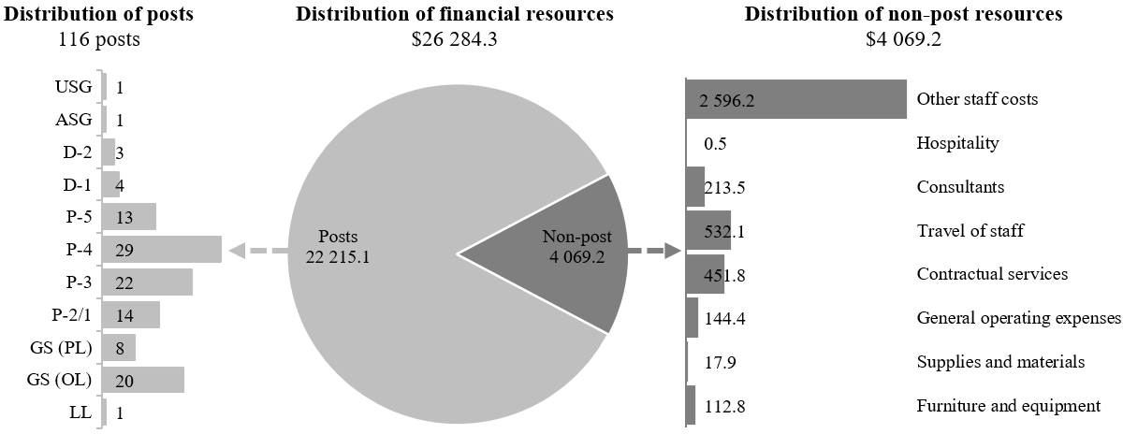

Explanation of variances by factor, component and subprogramme

Overall resource changes

Other changes

30.58 As shown in table 30.11 (1), resource changes reflect a net decrease of $58,500 as follows:
(a) Executive direction and management (increase of $22,500): The increase of $22,500 is due to additional requirements under contractual services to conduct the external quality assessment of the entire programme of OIOS referred to in paragraph 30.14 above;.
(b) Subprogramme 1, Internal audit (decrease of $17,500): The decrease of $17,500 reflects reduced requirements mainly under: (i) travel of staff, due to the increased use of videoconferencing and teleconferencing ($11,500); (ii) contractual services owing to reduced cost of audit software licenses ($4,100); and (iii) consultancy services resulting from increased use of in-house capacity and expertise ($600);
(c) Programme support (decrease of $63,500): The net decrease of $63,500 reflects reduced requirements under: (i) contractual services reflecting lower ICT rates ($58,500); and (ii) general operating expenses owing to reduced communications costs based on mobile phones usage ($10,400). The decrease is offset in part by increased requirements under furniture and equipment due to the planned replacement of laptops ($5,400).

Other assessed resources

30.59 As reflected in tables 30.11 (2) and 30.12 (2), other assessed resources amount to $34,503,000. The resources would complement regular budget resources and provide for the requirements indicated in the report of the Secretary-General on the budget for the support account for peacekeeping operations (A/79/783).

Extrabudgetary resources

30.60 As reflected in tables 30.11 (3) and 30.12 (3), extrabudgetary resources amount to $14,965,400. The resources would complement regular budget resources and would provide for 46 posts (1 D-1, 7 P-5, 15 P-4, 13 P-3, 3 GS (PL) and 7 GS (OL)), to perform mainly audit functions. In addition, non-post resources would provide for audit coverage, inspection and evaluations, and investigations in support of United Nations entities funded primarily by extrabudgetary resources. All extrabudgetary resources are provided to OIOS by United Nations agencies, funds and programmes for internal oversight services carried out by OIOS pursuant to mandates provided by the General Assembly or under the authority of the Secretary-General.
30.61 The extrabudgetary resources under the present section are subject to the oversight of OIOS, in accordance with the delegation of authority by the Secretary-General.

Executive direction and management

30.62 The Office of the Under-Secretary-General provides overall strategic planning and monitoring and ensures effective coordination of the workplan for OIOS. The Office of the Under-Secretary-General coordinates the work of the three subprogrammes, liaises with the Board of Auditors and the Joint Inspection Unit and maintains a close working relationship with the oversight functions of the other United Nations system organizations. Furthermore, it provides quality control for the reports of OIOS to the General Assembly, oversees resource utilization and serves as the focal point on performance management and for compliance monitoring of OIOS recommendations.
30.63 In accordance with the 2030 Agenda for Sustainable Development, in particular target 12.6 of the Sustainable Development Goals, in which organizations are encouraged to integrate sustainability information into their reporting cycles, and in compliance with the cross-cutting mandate set out in paragraph 19 of General Assembly resolution 72/219, the Office will continue to take steps to implement the environmental policy of the United Nations Secretariat, including by continuing to reduce its carbon footprint through the use of videoconference facilities for interviews and meetings, ensuring that all printers are set to double-sided printing and encouraging staff to turn off computers and monitors at the end of the workday.
30.64 Information on the timely submission of documentation and advance booking for air travel is reflected in table 30.14.
30.65 In order to comply with the advance purchase policy directive, the Office continues its efforts by implementing an internal standard operating procedure to ensure that staff schedule flights at least two weeks in advance of planned audits, inspections and investigations. OIOS continues to ensure that videoconferencing or teleconferencing facilities are utilized, if possible, for oversight assignments.

Table 30.14

Compliance rate
(Percentage)

 | 2022 actual | 2023 actual | 2024 actual | 2025 planned | 2026 planned
Timely submission of documentation | 100 | 100 | 100 | 100 | 100
Air tickets purchased at least 2 weeks before the commencement of travel | 88 | 89 | 86 | 100 | 100

30.66 The proposed regular budget resources for 2026 amount to $1,774,300 and reflect a net increase of $22,500 compared with the approved budget for 2025. The proposed change is explained in paragraph 30.58 (a). Additional details on the distribution of the proposed resources for 2026 are reflected in table 30.15 and figure 30.XI.

Table 30.15

Executive direction and management: evolution of financial and post resources
(Thousands of United States dollars/number of posts)

 |  |  | Changes
 | 2024 expenditure | 2025 approved | Technical adjustments | New/expanded mandates | Other | Total | Percentage | 2026 estimate
Financial resources by main category of expenditure
Posts | 1 470.9 | 1 689.5 | – | – | – | – | – | 1 689.5
Non-post | 35.8 | 62.3 | – | – | 22.5 | 22.5 | 36.1 | 84.8
Total | 1 506.8 | 1 751.8 | – | – | 22.5 | 22.5 | 1.3 | 1 774.3
Post resources by category
Professional and higher |  | 5 | – | – | – | – | – | 5
General Service and related |  | 3 | – | – | – | – | – | 3
Total |  | 8 | – | – | – | – | – | 8

Figure 30.XI

Executive direction and management: distribution of proposed resources for 2026
(Number of posts/thousands of United States dollars)

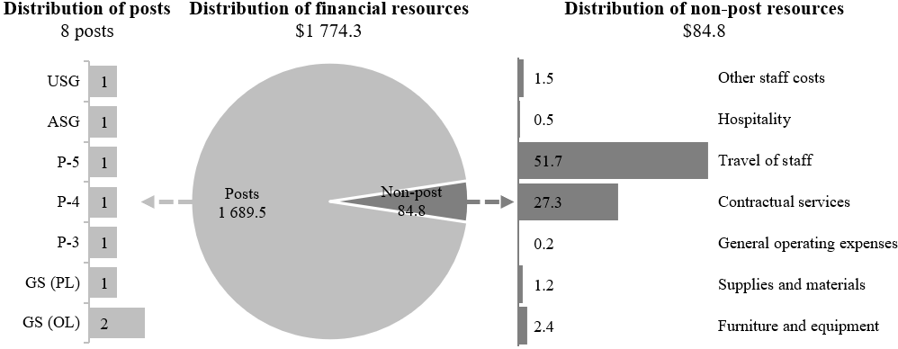

Programme of work

Subprogramme 1

Internal audit

30.67 The proposed regular budget resources for 2026 amount to $10,114,500 and reflect a net decrease of $17,500 compared with the approved budget for 2025. The proposed changes are explained in paragraph 30.58 (b). Additional details on the distribution of the proposed resources for 2026 are reflected in table 30.16 and figure 30.XII.

Table 30.16

Subprogramme 1: evolution of financial and post resources
(Thousands of United States dollars/number of posts)

 |  |  | Changes
 | 2024 expenditure | 2025 approved | Technical adjustments | New/expanded mandates | Other | Total | Percentage | 2026 estimate
Financial resources by main category of expenditure
Posts | 9 097.7 | 8 615.6 | – | – | – | – | – | 8 615.6
Non-post | 1 126.3 | 1 516.4 | – | – | (17.5) | (17.5) | (1.2) | 1 498.9
Total | 10 224.1 | 10 132.0 | – | – | (17.5) | (17.5) | (0.2) | 10 114.5
Post resources by category
Professional and higher |  | 34 | – | – | – | – | – | 34
General Service and related |  | 10 | – | – | – | – | – | 10
Total |  | 44 | – | – | – | – | – | 44

Figure 30.XII

Subprogramme 1: distribution of proposed resources for 2026
(Number of posts/thousands of United States dollars)

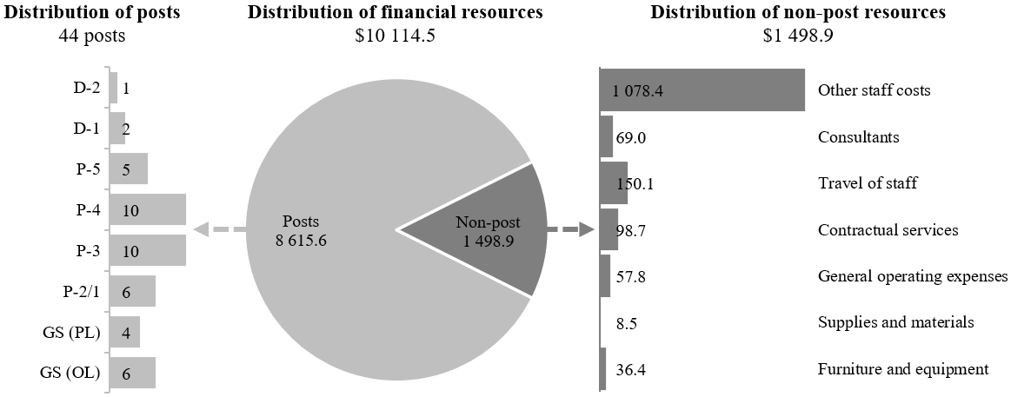

Subprogramme 2

Inspection and evaluation

30.68 The proposed regular budget resources for 2026 amount to $4,977,600 and reflect no change compared with the approved budget for 2025. Additional details on the distribution of the proposed resources for 2026 are reflected in table 30.17 and figure 30.XIII.

Table 30.17

Subprogramme 2: evolution of financial and post resources
(Thousands of United States dollars/number of posts)

 |  |  | Changes
 | 2024 expenditure | 2025 approved | Technical adjustments | New/expanded mandates | Other | Total | Percentage | 2026 estimate
Financial resources by main category of expenditure
Posts | 4 338.6 | 4 628.5 | – | – | – | – | – | 4 628.5
Non-post | 194.1 | 349.1 | – | – | – | – | – | 349.1
Total | 4 532.7 | 4 977.6 | – | – | – | – | – | 4 977.6
Post resources by category
Professional and higher |  | 20 | – | – | – | – | – | 20
General Service and related |  | 4 | – | – | – | – | – | 4
Total |  | 24 | – | – | – | – | – | 24

Figure 30.XIII

Subprogramme 2: distribution of proposed resources for 2026
(Number of posts/thousands of United States dollars)

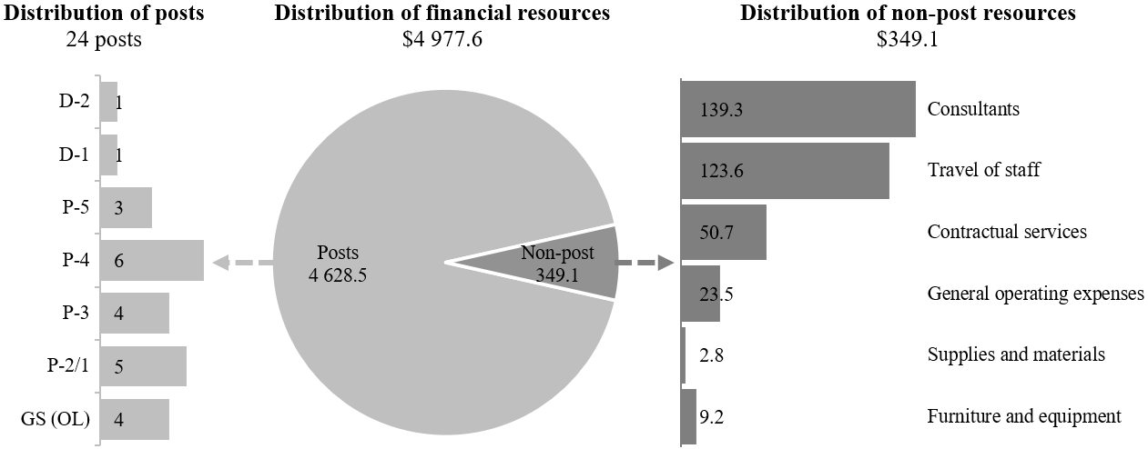

Subprogramme 3

Investigations

30.69 The proposed regular budget resources for 2026 amount to $7,908,000 and reflect no change compared with the approved budget for 2025. Additional details on the distribution of the proposed resources for 2026 are reflected in table 30.18 and figure 30.XIV.

Table 30.18

Subprogramme 3: evolution of financial and post resources
(Thousands of United States dollars/number of posts)

 |  |  | Changes
 | 2024 expenditure | 2025 approved | Technical adjustments | New/expanded mandates | Other | Total | Percentage | 2026 estimate
Financial resources by main category of expenditure
Posts | 5 767.1 | 6 168.0 | – | – | – | – | – | 6 168.0
Non-post | 614.0 | 1 740.0 | – | – | – | – | – | 1 740.0
Total | 6 381.1 | 7 908.0 | – | – | – | – | – | 7 908.0
Post resources by category
Professional and higher |  | 25 | – | – | – | – | – | 25
General Service and related |  | 8 | – | – | – | – | – | 8
Total |  | 33 | – | – | – | – | – | 33

Figure 30.XIV

Subprogramme 3: distribution of proposed resources for 2026
(Number of posts/thousands of United States dollars)

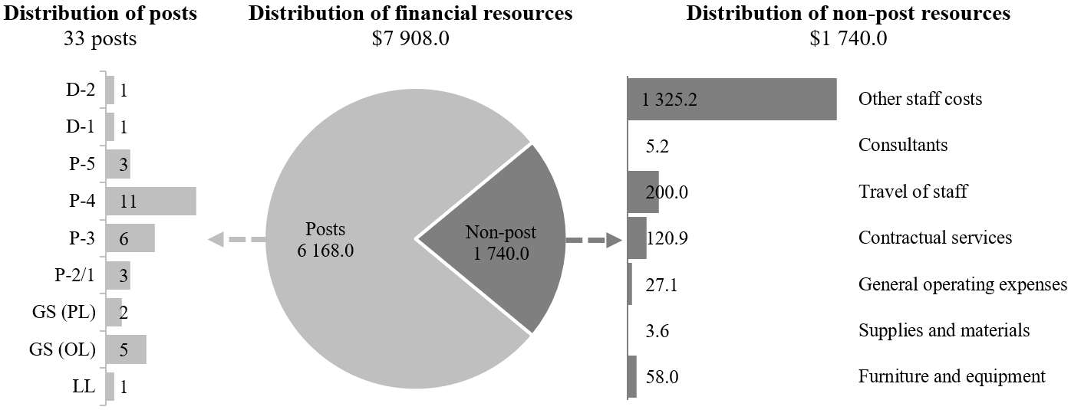

Programme support

30.70 The Executive Office provides central administrative services to the Office in the areas of human resources management and financial and general administration, including the provision of advice to senior managers of the Office on administrative, financial, personnel and budgetary matters. In addition, it administers the staff, as well as the financial resources of the Office, at Headquarters, Geneva, Vienna, Nairobi and other duty stations, including the various peacekeeping missions and the International Residual Mechanism for Criminal Tribunals, under the delegation of authority granted by the Secretary-General and in accordance with the regulations and rules of the United Nations.
30.71 The proposed regular budget resources for 2026 amount to $1,509,900 and reflect a net decrease of $63,500 compared with the approved budget for 2025. The proposed changes are explained in paragraph 30.58 (c). Additional details on the distribution of the proposed resources for 2026 are reflected in table 30.19 and figure 30.XV.
Table 30.19

Programme support: evolution of financial and post resources
(Thousands of United States dollars/number of posts)

 |  |  | Changes
 | 2024 expenditure | 2025 approved | Technical adjustments | New/expanded mandates | Other | Total | Percentage | 2026 estimate
Financial resources by main category of expenditure
Posts | 1 158.1 | 1 113.5 | – | – | – | – | – | 1 113.5
Non-post | 281.8 | 459.9 | – | – | (63.5) | (63.5) | (13.8) | 396.4
Total | 1 439.9 | 1 573.4 | – | – | (63.5) | (63.5) | (4.0) | 1 509.9
Post resources by category
Professional and higher |  | 3 | – | – | – | – | – | 3
General Service and related |  | 4 | – | – | – | – | – | 4
Total |  | 7 | – | – | – | – | – | 7

Figure 30.XV

Programme support: distribution of proposed resources for 2026
(Number of posts/thousands of United States dollars)

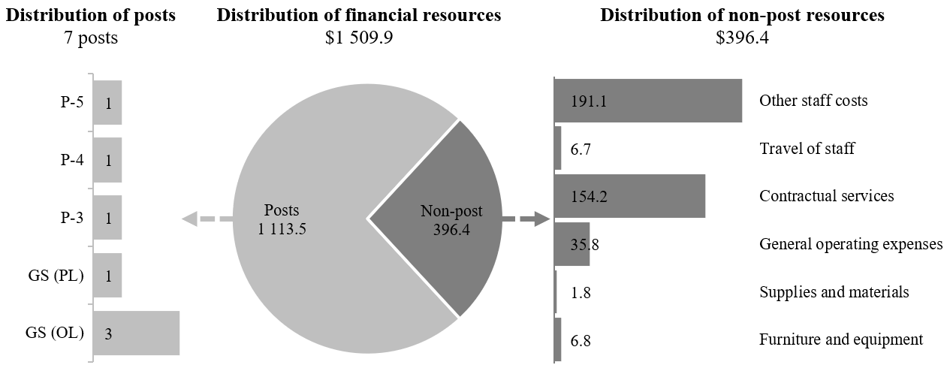

Annex

Organizational structure and post distribution for 2026

Executive Office  (programme support) |  |  |  | Office of the Under-Secretary General  (executive direction and management)
 | RB: | OA: |  |  | RB:
 | 1 P-5 | 1 P-3 |  |  | 1 USG
 | 1 P-4 | 1 GS (PL) |  |  | 1 ASG
 | 1 P-3 | 2 GS (OL) |  |  | 1 P-5
 | 1 GS (PL) |  |  |  | 1 P-4
 | 3 GS (OL) |  |  |  | 1 P-3
 | 7 | 4 |  |  | 1 GS (PL)
 | Total 11 |  |  |  | 2 GS (OL)
 |  |  |  |  | Total 8
Internal Audit Division  (subprogramme 1) |  |  |  | Inspection and Evaluation Division  (subprogramme 2) |  |  |  |  | Investigations Division  (subprogramme 3)
RB: | OA: | XB: |  |  | RB: | OA: |  |  |  | RB: | OA:
1 D-2 | 1 D-1 | 1 D-1 |  |  | 1 D-2 | 1 P-5 |  |  |  | 1 D-2 | 2 D-1
2 D-1 | 8 P-5 | 7 P-5 |  |  | 1 D-1 | 5 P-4 |  |  |  | 1 D-1 | 7 P-5
5 P-5 | 28 P-4 | 15 P-4 |  |  | 3 P-5 | 4 P-3 |  |  |  | 3 P-5 | 10 P-4
10 P-4 | 16 P-3 | 13 P-3 |  |  | 6 P-4 | 1 LL |  |  |  | 11 P-4 | 18 P-3
10 P-3 | 4 GS (OL) | 3 GS (PL) |  |  | 4 P-3 |  |  |  |  | 6 P-3 | 2 GS (PL)
6 P-2 | 2 LL | 7 GS (OL) |  |  | 5 P-2 |  |  |  |  | 3 P-2 | 4 GS (OL)
4 GS (PL) | 8 FS |  |  |  | 4 GS (OL) |  |  |  |  | 2 GS (PL) | 4 LL
6 GS (OL) |  |  |  |  | 24 | 11 |  |  |  | 5 GS (OL) | 1 FS
44 | 67 | 46 |  |  | Total 35 |  |  |  |  | 1 LL
Total 157 |  |  |  |  |  |  |  |  |  | 33 | 48
 |  |  |  |  |  |  |  |  |  | Total 81

Abbreviations: ASG, Assistant Secretary-General; FS, Field Service; GS (OL), General Service (Other level); GS (PL), General Service (Principal level); LL, Local level; OA, other assessed; RB, regular budget; USG, Under-Secretary-General; XB, extrabudgetary.

