Eightieth session
Items 137 and 138 of the preliminary list*

Proposed programme budget for 2026

Programme planning

Proposed programme budget for 2026

Part XII

Safety and security

Section 34

Safety and security

Programme 28

Safety and security

Contents
 |  |  | Page
- Proposed programme plan for 2026 and programme performance in 2024** |  |  | 3
Overall orientation |  |  | 3
Programme of work |  |  | 6
Subprogramme 1. Security and safety services |  |  | 6
Subprogramme 2. Field operations |  |  | 9
Subprogramme 3. Partnerships and specialized support |  |  | 13
- Proposed post and non-post resource requirements for 2026*** |  |  | 18
Overview |  |  | 18
Executive direction and management |  |  | 27
* A/80/50.
** In keeping with paragraph 10 of General Assembly resolution 77/267, the part consisting of the programme plan and programme performance information (part II) is submitted through the Committee for Programme and Coordination for the consideration of the Assembly.
*** In keeping with paragraph 10 of General Assembly resolution 77/267, the part consisting of the post and non-post resource requirements (part III) is submitted through the Advisory Committee on Administrative and Budgetary Questions for the consideration of the Assembly.
Programme of work | 29
Subprogramme 1. Security and safety services | 29
Subprogramme 2. Field operations | 31
Subprogramme 3. Partnerships and specialized support | 32
Programme support | 34
Annexes
- Organizational structure and post distribution for 2026 | 37
- Summary of proposed post changes, by component and subprogramme | 38

A. Proposed programme plan for 2026 and programme performance in 2024

Overall orientation

Mandates and background

34.1 The Department of Safety and Security is responsible for providing leadership, operational support and oversight of the United Nations security management system. The mandate derives from the priorities established in relevant General Assembly resolutions and decisions, including resolution 59/276, by which the Department was established. The Department enables the United Nations to carry out its operations and programmes globally and provides support to approximately 180,000 personnel and 400,000 of their dependants in more than 125 States and territories.
34.2 The security environment in which the United Nations operates remains highly complex and unpredictable, owing to multiple factors, including war, conflict, civil unrest and crime, as well as the expansion by non-State armed groups of their scope and capabilities by exploiting unaddressed grievances, the indifference to international humanitarian law of some actors and unprecedented levels of climate change-induced migration, in specific contexts, which interact with social, political and economic drivers in places where the United Nations is called to deliver its mandates.

Strategy and external factors for 2026

34.3 The Department will continue to implement its activities and strengthen its capabilities in support of United Nations mandates and objectives through a risk-based approach tailored to the needs of United Nations system entities in carrying out their programmes while keeping their personnel safe in challenging operating environments. To sustain ongoing reforms for increased resilience, efficiency and results, the Department will place greater emphasis on strategic coordination between subprogrammes and across United Nations Headquarters and field locations to enhance the coherence, timeliness and impact monitoring of the Department’s strategic initiatives.
34.4 The emphasis on resilience is driven by the risks that the operational environment poses to the Department’s ability to carry out its mission, as articulated in its enterprise risk management system. The Department will continue to strengthen its resilience through the development of country programmes that articulate the Department’s contributions to United Nations results as presented in the United Nations Sustainable Development Cooperation Framework and in humanitarian response plans, and by strengthening synergies between core strategic capacities for preparedness and emergency response and field operations. The Department will also maintain its capacities and partnerships to enhance its response to sudden, large-scale crises, drawing on rapidly deployable assets from across the Department’s varied sources of security expertise and in tandem with other United Nations entities for a cohesive response.
34.5 The Department will also pursue operational efficiency across its operations to meet increased demands within existing means, including through the continued implementation of a digital transformation project. This effort will focus on further digitizing relevant processes, accelerating analytical and reporting capabilities and building digital literacy skills across the Department’s workforce. Efficiency will also remain a central dimension in the Department’s conduct of thematic evaluations, compliance monitoring missions and lessons learned exercises.
34.6 The Department will continue to implement the multi-year standardized access control project to upgrade the United Nations security infrastructure, as presented in the report of the Secretary-General on capital investment planning (A/79/510).
34.7 The Department will update and enhance its training programme in support of integrated security workforce performance and its ability to tailor security services to the needs of United Nations programmes around the world. The Department’s advocacy and communication efforts will further stress, concretely and transparently, how security support contributes to the achievement of results by enabling the delivery of United Nations mandates. The Department will also continue to work towards reaching gender parity and pursue geographical representation and diversity in the profile of its workforce.
34.8 With regard to cooperation with other entities at the global, regional, national and local levels, the Department will continue its commitment to close collaboration with implementing partners of the United Nations, including non-governmental organizations, notably through the Saving Lives Together framework, which promotes security-related information-sharing and best practice exchanges between the United Nations and international non-governmental organizations.
34.9 With regard to inter-agency coordination and liaison, the Department will continue to play a leadership role, through the Inter-Agency Security Management Network, in the development, updating and implementation of system-wide security policies aimed at enabling United Nations operations within acceptable risk levels, and tactical measures, including personnel security training and awareness. In particular, the Department will collaborate with the Network to finalize and implement recommendations from an in-depth review of the United Nations security management system, initiated in 2025 at the request of the High-level Committee on Management of the United Nations System Chief Executives Board for Coordination (CEB). Furthermore, the Department will continue to participate in inter-agency coordination mechanisms, including the High-level Committee.
34.10 With regard to the external factors, the Department considered applicable risks identified in its risk register and, accordingly, the overall plan for 2026 is based on the following planning assumptions:
(a) Crises and security environments will evolve quickly and unpredictably, and the ability of the United Nations to gain safe access to areas and communities for programme delivery will continue to be challenged. Simultaneous large-scale and complex emergencies will continue to require agility, flexibility and rapid security responses to support the scale-up, and adjustment as required, of the United Nations presence and humanitarian programmes;
(b) Security needs will remain high during drawdowns and withdrawals of United Nations peace operations, and active engagement with Member States will be required when such transitions occur;
(c) Personnel of the United Nations and its premises will continue to face direct and indirect threats, including from threat actors using innovative and advanced techniques, which will require new and specialized responses from the United Nations security management system;
(d) Host Governments will continue to provide security support to the United Nations; and in some cases, this support may need to be supplemented depending on the security context and capacities;
(e) Demand for enhanced levels of security risk analysis, training, advice, responses and solutions to support the security needs and obligations of United Nations Designated Security Officials and of members of the Security Management Team will continue to be high;
(f) Adequate extrabudgetary resources are available for additional security capabilities to enable programming, notably in crisis settings.
34.11 The Department integrates a gender perspective into its operational activities, deliverables and results, as appropriate. The Department will continue to strengthen its gender-sensitive approach to security management. On the basis of regular engagement with its network of focal points and in close collaboration with the Inter-Agency Security Management Network, it will also continue to refine its approach to creating a safe working environment for United Nations staff and operations and increasing awareness of and taking action to prevent sexual exploitation and abuse, among other matters.
34.12 In line with the United Nations Disability Inclusion Strategy, the Department will build a supportive environment for persons with disabilities. It will continue to incorporate disability inclusion into its risk management process and engage with organizations of persons with disabilities when developing measures to enable the accessibility of premises and to ensure the safety and security of persons with disabilities. It will maintain a regular review of accommodation and accessibility for staff and delegates with disabilities and monitor their satisfaction with the level of support received.

Legislative mandates

34.13 The list below, which was reviewed in the preparation of the proposed programme budget, provides all mandates entrusted to the programme.

General Assembly resolutions and decisions

54/192; 55/175; 78/118; 79/138 | Safety and security of humanitarian personnel and protection of United Nations personnel
56/255, sect. VIII | Special subjects relating to the proposed programme budget for the biennium 2002–‍2003: safety and security of United Nations personnel
56/286 | Strengthening the security and safety of United Nations premises
Decision 57/567 | Inter-organizational security measures: framework for accountability for the United Nations field security management system
59/276, sect. XI | Questions relating to the programme budget for the biennium 2004–2005: strengthened and unified security management system for the United Nations
61/263 | Strengthened and unified security management system
78/290 | Improving global road safety

Security Council resolutions

1502 (2003)
2730 (2024)

Deliverables

34.14 Table 34.1 lists all cross-cutting deliverables of the programme.

Table 34.1

Cross-cutting deliverables for the period 2024–2026, by category and subcategory

Category and subcategory | 2024 planned | 2024 actual | 2025 planned | 2026 planned
A. Facilitation of the intergovernmental process and expert bodies
Parliamentary documentation (number of documents) | 1 | 1 | 1 | 1
1. Report on the safety and security of humanitarian personnel and protection of United Nations personnel | 1 | 1 | 1 | 1
Substantive services for meetings (number of three-hour meetings) | 3 | 3 | 3 | 3
Meetings of:
2. The Fifth Committee | 1 | 1 | 1 | 1
3. The Committee for Programme and Coordination | 1 | 1 | 1 | 1
4. The Advisory Committee on Administrative and Budgetary Questions | 1 | 1 | 1 | 1
B. Generation and transfer of knowledge
Technical materials (number of materials) | 2 | 2 | 2 | 2
5. Security Policy Manual | 1 | 1 | 1 | 1
6. Designated Official and Security Management Team Handbook | 1 | 1 | 1 | 1
E. Enabling deliverables
Safety and security: internal United Nations security management system policies, procedures and guidelines, technical support briefings on security policies, procedures and guidelines of the United Nations security management system for more than 150 designated officials for security and security decision makers and for 4,000 security professionals and United Nations personnel in the field and at Headquarters; and security-related platforms, including the United Nations Security Managers Information Network and the programme criticality database used in all 41 high- and very high-risk areas of operations.

Evaluation activities

34.15 The following evaluations are planned for 2026:
(a) Independent evaluation of capacities and systems for preparedness and resilience of the Department;
(b) Independent evaluation of the approach taken by the Department to risk management.

Programme of work

Subprogramme 1

Security and safety services

Objective

34.16 The objective, to which this subprogramme contributes, is to ensure a safe and secure environment for all United Nations personnel, delegates, dignitaries and other visitors while conducting activities at United Nations Headquarters, offices away from Headquarters and regional commissions and while attending special events hosted by the United Nations at external locations.

Strategy

34.17 To contribute to the objective, the subprogramme will provide strategic coordination and management of the security and safety services at eight duty stations, as well as operational guidance and technical supervision with regard to security risk management, physical security, close protection, crisis management, fire safety, recruitment, resilience, training and oversight of security and safety projects at those locations.
34.18 The above-mentioned work is expected to result in:
(a) Safe, secure and efficient access of delegates, staff and visitors to United Nations premises and external special events;
(b) Effective delivery of United Nations mandates and programmes at United Nations premises and external special events.

Programme performance in 2024

Conference participants and visitors utilize digital badges at the United Nations Office at Geneva

34.19 In the past, conference participants and other visitors to the Palais des Nations often had to wait in long lines to process their physical security badges before being admitted into the premises. In 2023, the subprogramme piloted a more efficient digital badging solution for delegates, conference participants and visitors to the United Nations Office at Geneva. In 2024, this solution was rolled out extensively to almost all visitors to the Palais des Nations. Registered conference participants and visitors now receive a digital badge by email, consisting of their photo, a Quick Response (QR) code, their name and the date of their meeting or appointment. Operating in a similar manner to an airline electronic boarding pass, the digital badge, once downloaded to any mobile device, enables faster entry to the premises by dispensing with the time needed to create a “physical” badge and provides visitors with an easy and convenient solution to access the premises. This solution has also contributed towards the elimination of paper, metal and plastic waste and reductions in the lead time for the processing and issuance of badges.
34.20 Progress towards the objective is presented in the performance measure below (see figure 34.I).

Figure 34.I

Performance measure: improved ease of access for visitors to the Palais des Nations (annual)

Planned results for 2026

Result 1: delegates and participants experience a uniform and consistent approach to security- and safety-related matters for conferences and special events held at external venues

Programme performance in 2024 and target for 2026

34.21 The subprogramme’s work contributed to delegates and participants at conferences and special events held at external venues receiving consistent safety and security services, with similar lengths of time for the collection of credentials and security screening as at Headquarters, which met the planned target.
34.22 Progress towards the objective and the target for 2026 are presented in the performance measure below (see table 34.2).

Table 34.2

Performance measure

2022 (actual) | 2023 (actual) | 2024 (actual) | 2025 (planned) | 2026 (planned)
Delegates receive security and safety services, including collection of credentials and physical security screening, according to the expertise and experience of the event security coordinator and interaction with the host country security counterpart | Delegates receive security and safety services that are consistent across conferences and are in line with benchmarks established at Headquarters | Delegates and participants at conferences and special events held at external venues receive consistent safety and security services, with similar lengths of time for the collection of credentials and security screening as at Headquarters | Efficient access for conference participants, with all conferences and special events at external venues having separate dedicated lanes for delegates, United Nations staff and external service staff for physical security screening and collection of credentials | Smooth physical security screening and efficient access to events held at Headquarters, with at least 50 per cent of delegates receiving their credentials in advance of the event

Result 2: improved ease of movement of delegates and staff across duty stations

Programme performance in 2024 and target for 2026

34.23 The subprogramme’s work contributed to six of the eight duty stations utilizing a common operating system and online infrastructure, which did not meet the planned target of a common operating system and online infrastructure established to support a common credential access control card across all eight duty stations for delegates and staff. The target was not met due to challenges with implementing foundational work for integration of the common operating system in two duty stations.
34.24 Progress towards the objective and the target for 2026 are presented in the performance measure below (see table 34.3).

Table 34.3

Performance measure

2022 (actual) | 2023 (actual) | 2024 (actual) | 2025 (planned) | 2026 (planned)
– | Delegates and staff members have credentials which allow access to premises at the issuing duty station only | Six of the eight duty stations utilize a common operating system and online infrastructure to support a common credential access control card for delegates and staff | Physical infrastructure is in place to facilitate the ease of access of delegates and staff travelling between the eight duty stations under a common platform for access control | Two duty stations implement new United Nations grounds pass credentials

Result 3: improved registration, badging and security facilities for persons with disabilities

Proposed programme plan for 2026

34.25 The subprogramme is responsible for engaging with and ensuring the safety and security of all delegates and other participants in events at United Nations premises. From their arrival to the premises and the conduct of physical security checking to their accreditation and badging processes, and their movements within United Nations premises, it is essential for persons with disabilities to share a similar, safe and respectful experience as all other persons entering, working in or visiting United Nations premises.

Lessons learned and planned change

34.26 The lesson for the subprogramme was that while it has adapted infrastructure to facilitate physical access for persons with disabilities, it needs to further engage with organizations of persons with disabilities to better understand their needs and requirements, integrate accessibility measures into registration and badging facilities and provide specialized training to its staff to ensure that persons with disabilities experience United Nations premises on an equal basis with others.
34.27 Expected progress towards the objective is presented in the performance measure below (see table 34.4).

Table 34.4

Performance measure

2022 (actual) | 2023 (actual) | 2024 (actual) | 2025 (planned) | 2026 (planned)
– | – | Limited facilities and procedures in place at registration and badging facilities for persons with disabilities | Improved procedures and facilities in place at registration and badging facilities for persons with disabilities in two duty stations | Improved procedures and facilities in place at registration and badging facilities for persons with disabilities in two additional duty stations

Deliverables

34.28 Table 34.5 lists all deliverables of the subprogramme.

Table 34.5

Subprogramme 1: deliverables for 2026, by category and subcategory

Category and subcategory
E. Enabling deliverables
Safety and security: security and access control for approximately 6 million people per year at United Nations Headquarters, offices away from Headquarters and regional economic and social commissions; security support for approximately 84 United Nations special events and conferences held away from United Nations premises; approximately 9,000 close protection operations for senior United Nations officials and visiting dignitaries; 2,600 security incident investigations; 2,400 fire safety checks.

Subprogramme 2

Field operations

Objective

34.29 The objective, to which this subprogramme contributes, is to ensure the safety and security of personnel and the security of United Nations premises and assets in the United Nations field duty stations to enable the implementation of United Nations mandates, programmes and activities worldwide.

Strategy

34.30 To contribute to the objective, the subprogramme will:
(a) Provide operational security support for United Nations field programme delivery and field programme personnel through effective and timely security coordination and advice;
(b) Provide consistent and integrated strategic and operational support to, and guidance for, field operations in the preparation for and management of security crises, including through the integration of core strategic capacities, specifically resilience and emergency response;
(c) Deploy security professionals in a rapid and timely fashion to countries, missions and areas, including those affected by crisis situations and security contingencies;
(d) Conduct security assessment missions to field locations to review and assess local security management processes and procedures;
(e) Conduct regional workshops and global conferences for all of the Department’s senior field security professionals to share operational best practices and lessons learned and to ensure consistent security management practices and procedures;
(f) Develop its capacity to capture and analyse data and deliver analytical products for security decision makers.
34.31 The above-mentioned work is expected to result in:
(a) Improved preparedness, effectiveness, efficiency, relevance and resilience of security risk management processes;
(b) Enhanced capacity to enable United Nations programmes to be carried out in high-risk environments, in line with the United Nations goal to stay and deliver;
(c) Enhanced ability of security decision makers to take risk-informed decisions;
(d) Enhanced and streamlined security management measures in the field.

Programme performance in 2024

United Nations programme delivery enabled in very high-risk areas

34.32 The subprogramme enables the United Nations to deliver its critical mandates, programmes and activities across the globe, including in areas characterized as high risk and very high risk. The year 2024 saw further increases in instability and deepening crises across every region, with associated increased needs of civilians for United Nations humanitarian programmes to assist them. The subprogramme enabled very high-risk missions in numerous locations, including Haiti, Israel and the Occupied Palestinian Territory, Lebanon and Ukraine. These included carrying out security assessments for operational readiness and enabling missions to deliver water, food and life-saving medicine to civilians in urgent need of humanitarian assistance, investigating human rights violations, facilitating high-level engagement and expanding humanitarian access.
34.33 Progress towards the objective is presented in the performance measure below (see figure 34.II).

Figure 34.II

Performance measure: number of very high-risk missions enabled (annual)

Planned results for 2026

Result 1: improved coherence and consistency of security management processes and procedures to better enable United Nations operations across field operations globally

Programme performance in 2024 and target for 2026

34.34 The subprogramme’s work contributed to improved quality, coherence and consistency of security management processes by field operations through the use of improved tools for risk assessment and security contingency planning; and to field operations using strategic foresight to identify possible emerging security threats to United Nations programme delivery and to design appropriate responses, which met the planned target.
34.35 Progress towards the objective and the target for 2026 are presented in the performance measure below (see table 34.6).

Table 34.6

Performance measure

2022 (actual) | 2023 (actual) | 2024 (actual) | 2025 (planned) | 2026 (planned)
Field operations adopted recommendations related to risk mitigation measures, such as in Somalia, where United Nations operations mainstreamed security analysis and operational responses into programming and budgeting, as well as the availability of timely and up-to-date information to Member States | Improved quality and consistency of local security management processes, procedures and tools, with local security decision makers using the Safety and Security Incident Recording System dashboard to gain real-time insights into the security and safety landscape | Improved quality, coherence and consistency of security management processes by field operations through the use of improved tools for risk assessment and security contingency planning  Field operations used strategic foresight to identify possible emerging security threats to United Nations programme delivery and to design appropriate responses | Improved accounting for United Nations personnel in the field during crisis incidents by local security decision makers, through enhanced data management and analysis | Improved quality, coherence and consistency of security risk management documents produced by field operations globally through the integration of quality cross-checking techniques into the online security risk management e-tool, and the development and piloting of online security planning systems

Result 2: improved preparedness and response to crises

Programme performance in 2024 and target for 2026

34.36 The subprogramme’s work contributed to United Nations Designated Officials for Security, security professionals and other members of crisis management teams utilizing security management processes and procedures, including by drawing on specialized response capabilities, to effectively respond to specific crises, which met the planned target.
34.37 Progress towards the objective and the target for 2026 are presented in the performance measure below (see table 34.7).

Table 34.7

Performance measure

2022 (actual) | 2023 (actual) | 2024 (actual) | 2025 (planned) | 2026 (planned)
– | A crisis coordination mechanism was established to improve information flow and ensure more efficient response to crises in high-risk countries | United Nations Designated Officials for Security, security professionals and other members of crisis management teams utilized security management processes and procedures, including by drawing on specialized response capabilities, to effectively respond to specific crises | Timely coordination and response, with a crisis coordination mechanism established, as required, within 72 hours of a specific crisis | Enhanced readiness through operational foresight and the analysis of humanitarian crisis risk criteria

Result 3: improved security decision-making

Proposed programme plan for 2026

34.38 The subprogramme provides operational security support for United Nations field programme delivery and field programme personnel through effective and timely security coordination and advice. Given the increased number of crises, and the expanding complexity and scope of operations globally, more data and analysis are required to better inform decision-making on the allocation of limited security resources.

Lessons learned and planned change

34.39 The lesson for the subprogramme was that the Department needed to utilize a more strategic, data-informed approach to identify the best allocation of its resources. In applying the lesson, the subprogramme has initiated the development of a data-based tool that integrates the security complexity of the operational environment as well as the scale and scope of operations. This tool will enable more informed analysis and decision-making by senior security leadership on the most effective and efficient allocation of security resources, ultimately enhancing the ability of the Organization to plan and operate in high-risk environments with greater confidence and security.
34.40 Expected progress towards the objective is presented in the performance measure below (see table 34.8).

Table 34.8

Performance measure

2022 (actual) | 2023 (actual) | 2024 (actual) | 2025 (planned) | 2026 (planned)
– | – | Data sets were identified and collected, with a tool being developed drawing on the data to better inform analysis and decision-making on the distribution of security resources | The new resource allocation process is conducted using a data-based tool | The Department’s field capacity is better aligned with security needs, using partner-approved criteria

Deliverables

34.41 Table 34.9 lists all deliverables of the subprogramme.

Table 34.9

Subprogramme 2: deliverables for 2026, by category and subcategory

Category and subcategory
E. Enabling deliverables
Safety and security: approximately 20 security assessment visits annually, as well as security services and surge deployments in response to emerging and newly identified needs; approximately 600 security risk management reviews; approximately 360 records per month entered into the Safety and Security Incident Recording System; approximately 5,500 premises records maintained in the premises database; workshops and training on crisis management/preparedness, analysis, security management, leadership and best practices for key security personnel of United Nations security management systems.

Subprogramme 3

Partnerships and specialized support

Objective

34.42 The objective, to which this subprogramme contributes, is to ensure the safety and security of United Nations operations, premises and personnel and to improve the efficiency and effectiveness of the security operations and security management system of the United Nations.

Strategy

34.43 To contribute to the objective, the subprogramme will:
(a) Implement an information management strategy to provide the United Nations security management system with the operational backbone required for efficient, data-driven approaches to security risk management and to build and manage business processes and technology for all aspects of security delivery, including personal protection services, emergency communications, critical incident stress management, physical security and road safety;
(b) Provide leadership, coordination and oversight for safety and security training, including on topics such as resilience-building, security risk management and operational safeguarding;
(c) Increase and diversify strategic partnerships with regional and global networks in the field of close protection expertise with the intention of benchmarking and aligning United Nations personal protection services to international best practices;
(d) Provide leadership and coordination for a rapid psychosocial support response in the aftermath of critical incidents and collaborate with the United Nations system and external partners to build the psychological resilience of United Nations security management system personnel;
(e) Lead the development of physical security guidance, standards and technical specifications and undertake physical security assessments of United Nations premises worldwide;
(f) Coordinate the development of United Nations system-wide security policy and guidance as the secretariat for the Inter-Agency Security Management Network.
34.44 The above-mentioned work is expected to result in:
(a) Effective prevention of and coherent response to security incidents by United Nations security management system actors, through timely and efficient decision-making and enhanced access to data;
(b) Effective management of risks for the movement of senior United Nations officials;
(c) Mitigation of the short- and long-term psychological impact of exposure to critical incidents on United Nations security management system personnel;
(d) Reduction of physical security risks to United Nations premises and personnel;
(e) Reduction of road crash fatalities for United Nations security management system personnel.

Programme performance in 2024

Strengthened security coordination and decision-making through digital transformation

34.45 The subprogramme has been working to modernize outdated platforms and deliver innovative digital tools and real-time insights, with a view to enhancing operational efficiency, enabling proactive security management and improving situational awareness and responsiveness for operational teams and field personnel. Key achievements included: (a) the conceptualization of a personal security profile system, including staff lists, to enhance the accuracy of information on staff presence; (b) the development of a conference management application and surge deployment dashboard to streamline the coordination of safety and security services; and (c) the phased deployment of an integrated country programme planning system to improve strategic decision-making across country operations. These scalable, secure and user-centric solutions have contributed to improving safety, crisis management and collaboration across the United Nations security management system.
34.46 Progress towards the objective is presented in the performance measure below (see table 34.10).

Table 34.10

Performance measure

2022 (actual) | 2023 (actual) | 2024 (actual)
Improved data accessibility and enhanced information-sharing across the United Nations security management system through an updated information-sharing system and security communication tool | Security professionals across the United Nations security management system have access to accurate staff presence information, enhanced situational awareness data and country resource details embedded in one integrated platform | Security professionals across the United Nations security management system have access to new information management tools, enabling informed decision-making

Planned results for 2026

Result 1: security personnel certified to enable programme delivery with an acceptable level of risk

Programme performance in 2024 and target for 2026

34.47 The subprogramme’s work contributed to an additional 4,074 security personnel having been certified to provide precise and effective security management advice, enabling programme delivery with an acceptable level of risk, for a total of 5,200 certified security personnel, which exceeded the planned target of 3,000.
34.48 Progress towards the objective and the target for 2026 are presented in the performance measure below (see figure 34.III).

Figure 34.III

Performance measure: number of security personnel certified to provide precise and effective security management advice, enabling programme delivery with an acceptable level of risk (cumulative)

Result 2: consistent and coherent operations across the United Nations security management system

Programme performance in 2024 and target for 2026

34.49 The subprogramme’s work contributed to security focal points’ and decision makers’ increased awareness of existing policies and guidelines, and gaps in existing guidance in the areas of fire safety, security clearance and the travel request information process being identified and addressed, which met the planned target.
34.50 Progress towards the objective and the target for 2026 are presented in the performance measure below (see table 34.11).

Table 34.11

Performance measure

2022 (actual) | 2023 (actual) | 2024 (actual) | 2025 (planned) | 2026 (planned)
United Nations security management system security focal points and security decision makers received regular briefings on emerging safety and security trends and timely assistance | United Nations security management system security focal points and security decision makers had expanded access to and were informed of changes to system policies and guidelines | United Nations security management system security focal points and security decision makers identified and addressed emerging gaps in existing guidance | All United Nations security management system security focal points and security decision makers are aware of and apply updated system policies and guidelines that take into account their operational realities | All United Nations security management system security focal points and security decision makers are aware of and share operationally informed good practices and lessons on the application of policies and guidelines

Result 3: strengthened personal protection services for senior United Nations officials

Proposed programme plan for 2026

34.51 Senior United Nations officials frequently encounter increasingly complex security environments, including direct threats, both at their duty stations and during travel. To ensure that these officials can effectively fulfil their mandates, personal protection officers provide dedicated security to over 150 senior officials, including approximately 40 officials operating in medium- to high-risk environments. The Department has established the Strategy for United Nations Personal Protection Services, 2024–2028, which encompasses training programmes, operational planning enhancements and technological tools designed to align United Nations protection services with global best practices while ensuring measurable results.

Lessons learned and planned change

34.52 The lesson for the subprogramme was that protecting senior United Nations officials requires effective global coordination and operational readiness based on the highest standards. To ensure that United Nations personal protection officers excel in their field, targeted capacity-building and data-driven decision-making are essential for enhancing situational awareness and operational efficiency. In applying this lesson, the subprogramme will implement the Strategy globally, taking concrete actions to support over 400 personal protection officers. The focus will be on specialized training programmes, operational planning improvements and the alignment of United Nations protection services with global best practices to ensure optimal preparedness, effectiveness, resilience and results in increasingly challenging environments.
34.53 Expected progress towards the objective is presented in the performance measure below (see figure 34.IV).

Figure 34.IV

Performance measure: percentage of senior United Nations officials expressing increased confidence in their personal protection (annual)

Deliverables

34.54 Table 34.12 lists all deliverables of the subprogramme.

Table 34.12

Subprogramme 3: deliverables for 2026, by category and subcategory

Category and subcategory
E. Enabling deliverables
Safety and security: emotional first aid and critical incident psychosocial support for United Nations security management system personnel; stress management training for personnel in field duty stations; technical supervision sessions for United Nations field counsellors; dedicated assessments of the physical security of United Nations premises globally; topical guidance, physical security training and analysis of data provided by the physical security assessment application; security training throughout the United Nations security management system; travel tracking and coordination of protective operations related to the movement of senior United Nations officials; planning and coordination of personal protection services with respective missions; mandatory certification training for close protection officers; training on digital tools, dashboard and site development and deployment services; technical secretariat services for the Inter-Agency Security Management Network and its steering group.

B. Proposed post and non-post resource requirements for 2026

Overview

34.55 Given the dual responsibility of the Department of Safety and Security to provide for both the safety and security of staff, delegates and visitors at the main locations of the United Nations, as well as at their premises, and the safety and security of the United Nations system field operations, the activities of the Department are financed both from the regular budget and on a cost-sharing basis with other organizations covered by the security management system in the field.
34.56 The functions and activities of the Department that are jointly financed with other organizations of the security management system are those under:
(a) Security and safety services (subprogramme 1);
(b) Field operations (subprogramme 2);
(c) Partnerships and specialized support (subprogramme 3);
(d) Programme support.
34.57 With regard to the jointly financed activities of the United Nations security management system, the financial responsibility of each participating organization is based on its proportional share of the personnel operating in the field. The principles of the cost-sharing arrangement were adopted by the General Assembly in its resolution 56/255. Following the recommendation of the Assembly, in its resolution 61/263, on achieving a workable cost-sharing arrangement, the High-level Committee on Management of CEB agreed that field-related security costs would be apportioned on the basis of actual percentages of staff according to data provided by CEB. Subsequently, the Secretary-General outlined revised cost-sharing arrangements for the cost of the United Nations security management system (see A/62/641). In October 2021, the High-level Committee on Management endorsed a revision of the cost-sharing arrangement (see CEB/2021/HLCM/FB/5), effective from 2023, which, while preserving the principles adopted by the Assembly in its resolution 56/255, updated the membership fee, which had not been changed since its establishment; addressed the principle of equitability by having all organizations pay a membership fee and reinforced the notion of shared ownership for the system; and ensured that organizations in countries of the Organisation for Economic Co-operation and Development pay their fair share of the security costs. To inform future decisions on the United Nations security management system in the light of recent operational and funding shifts, the High-level Committee on Management has initiated an in-depth review of the system, led by an independent expert. The review started in March 2025 and is expected to be completed by the end of the year, with preliminary findings and recommendations to be delivered by June 2025. The review will examine a range of dimensions, including the system’s governance, functions, division of responsibilities and operating modalities.
34.58 Based on the existing cost-sharing arrangement, the Secretariat share for security and safety services is 14.1 per cent for 2026, which is based on the CEB field staff census as at 31 December 2024, compared with 15.6 per cent for 2025, which was based on the census as at 31 December 2023. The level of resources proposed for 2026 for the jointly financed activities of the United Nations security management system presented in this budget fascicle was reviewed by the Finance and Budget Network of the High-level Committee on Management in March 2025. Taking into account the funding context within which United Nations system entities operate, including the ongoing significant financial constraints faced by participating entities, the Network endorsed a 2026 budget level for the United Nations security management system that reflects a 20 per cent reduction compared with the 2025 budget level for the system approved by the General Assembly in its resolution 79/258.
34.59 In addition to the jointly financed field activities described above, separate local cost-sharing arrangements govern the provision of security and safety services at the United Nations Office at Vienna, as well as other duty stations. The cost-sharing arrangements in Vienna are based on a formula agreed upon by the four organizations located at the Vienna International Centre; similarly, the cost-sharing arrangements at the other duty stations are agreed upon locally by the participating organizations. The Secretariat share for security and safety services at the United Nations Office at Vienna is 23.7 per cent for 2026, and reflects no change compared with 2025. Those security and safety services relate to subprogramme 1.
34.60 The proposed regular budget resources for 2026, including the breakdown of resource changes, as applicable, are reflected in tables 34.13 to 34.15. Similarly, the proposed gross budget for jointly financed activities is reflected in tables 34.16 to 34.20. The gross jointly financed budget of the Department is also presented to the General Assembly for its consideration and approval, in accordance with established practice.

Table 34.13

Overall: evolution of financial resources by object of expenditure (regular budget)
(Thousands of United States dollars)

 |  |  | Changes
Object of expenditure | 2024 expenditure | 2025 approved | Technical adjustments | New/expanded mandates | Other | Total | Percentage | 2026 estimate
Post | 91 495.8 | 108 757.1 | – | – | 451.7 | 451.7 | 0.4 | 109 208.8
Other staff costs | 8 850.0 | 5 142.9 | (23.1) | – | 1 048.3 | 1 025.2 | 19.9 | 6 168.1
Consultants | 38.9 | 62.7 | – | – | – | – | – | 62.7
Travel of staff | 2 308.1 | 1 272.5 | – | – | 500.0 | 500.0 | 39.3 | 1 772.5
Contractual services | 1 140.7 | 2 022.4 | – | – | (25.9) | (25.9) | (1.3) | 1 996.5
General operating expenses | 2 220.5 | 2 054.9 | – | – | 25.9 | 25.9 | 1.3 | 2 080.8
Supplies and materials | 791.8 | 1 073.3 | – | – | – | – | – | 1 073.3
Furniture and equipment | 722.2 | 594.5 | – | – | – | – | – | 594.5
Improvement of premises | 5.7 | – | – | – | – | – | – | –
Grants and contributions | 30 049.4 | 29 789.4 | (2 274.0) | – | (5 226.8) | (7 500.8) | (25.2) | 22 288.6
Other | 1.0 | – | – | – | – | – | – | –
Total | 137 624.2 | 150 769.7 | (2 297.1) | – | (3 226.8) | (5 523.9) | (3.7) | 145 245.8

Table 34.14

Note: The following abbreviations are used in tables and figures: ASG, Assistant Secretary-General; GS (OL), General Service (Other level); GS (PL), General Service (Principal level); LL, Local level; NPO, National Professional Officer; SS, Security Service; USG, Under-Secretary-General.

Overall: proposed posts and post changes for 2026 (regular budget)
(Number of posts)

 | Number | Details
Approved for 2025 | 1 075 | 1 USG, 1 ASG, 2 D-2, 4 D-1, 9 P-5, 25 P-4, 21 P-3, 9 P-2/1, 8 GS (PL), 170 GS (OL), 306 SS, 519 LL
Establishment | 4 | 1 P-5, 1 P-4, 1 P-3 and 1 GS (PL) under subprogramme 1
Proposed for 2026 | 1 079 | 1 USG, 1 ASG, 2 D-2, 4 D-1, 10 P-5, 26 P-4, 22 P-3, 9 P-2/1, 9 GS (PL), 170 GS (OL), 306 SS, 519 LL

Table 34.15

Overall: proposed posts by category and grade (regular budget)
(Number of posts)

 |  | Changes
Category and grade | 2025 approved | Technical adjustments | New/expanded mandates | Other | Total | 2026 proposed
Professional and higher
USG | 1 | – | – | – | – | 1
ASG | 1 | – | – | – | – | 1
D-2 | 2 | – | – | – | – | 2
D-1 | 4 | – | – | – | – | 4
P-5 | 9 | – | – | 1 | 1 | 10
P-4 | 25 | – | – | 1 | 1 | 26
P-3 | 21 | – | – | 1 | 1 | 22
P-2/1 | 9 | – | – | – | – | 9
Subtotal | 72 | – | – | 3 | 3 | 75
General Service and related
GS (PL) | 8 | – | – | 1 | 1 | 9
GS (OL) | 170 | – | – | – | – | 170
SS | 306 | – | – | – | – | 306
LL | 519 | – | – | – | – | 519
Subtotal | 1 003 | – | – | 1 | 1 | 1 004
Total | 1 075 | – | – | 4 | 4 | 1 079

Table 34.16

Overall: evolution of financial resources by object of expenditure (jointly financed activities)
(Thousands of United States dollars)

 |  |  | Changes |  |  |  |  | 2026 estimate
Object of expenditure | 2024 expenditure | 2025 approved | Technical adjustments | New/expanded mandates | Other | Total | Percentage | 2026 estimate
Post | 126 339.8 | 136 958.6 | – | – | (29 898.5) | (29 898.5) | (21.8) | 107 060.1
Other staff costs | 8 367.9 | 9 086.1 | – | – | – | – | – | 9 086.1
Consultants | 91.6 | 74.4 | – | – | – | – | – | 74.4
Travel of staff | 7 021.8 | 5 644.6 | – | – | – | – | – | 5 644.6
Contractual services | 4 675.8 | 4 006.5 | – | – | – | – | – | 4 006.5
General operating expenses | 14 791.8 | 9 720.8 | – | – | – | – | – | 9 720.8
Supplies and materials | 1 575.8 | 2 430.3 | – | – | – | – | – | 2 430.3
Furniture and equipment | 1 809.1 | 1 266.3 | – | – | – | – | – | 1 266.3
Improvement of premises | 3.6 | – | – | – | – | – | – | –
Grants and contributions | 4 418.9 | 4 048.8 | – | – | – | – | – | 4 048.8
Other | (78.2) | – | – | – | – | – | – | –
Total | 169 017.8 | 173 236.4 | – | – | (29 898.5) | (29 898.5) | (17.3) | 143 337.9

Table 34.17

Overall: evolution of financial resources by component and subprogramme (jointly financed activities)
(Thousands of United States dollars)

 |  |  | Changes
Component/subprogramme | 2024 expenditure | 2025 approved | Technical adjustments | New/expanded mandates | Other | Total | Percentage | 2026 estimate
A. Programme of work
1. Security and safety services | 18 456.3 | 18 786.8 | – | – | – | – | – | 18 786.8
2. Field operations | 140 106.7 | 143 930.6 | – | – | (28 414.2) | (28 414.2) | (19.7) | 115 516.4
3. Partnerships and specialized support | 9 126.8 | 9 073.3 | – | – | (1 484.3) | (1 484.3) | (16.4) | 7 589.0
Subtotal, A | 167 689.8 | 171 790.7 | – | – | (29 898.5) | (29 898.5) | (17.4) | 141 892.2
B. Programme support | 1 328.1 | 1 445.7 | – | – | – | – | – | 1 445.7
Total | 169 017.8 | 173 236.4 | – | – | (29 898.5) | (29 898.5) | (17.3) | 143 337.9

Table 34.18

Overall: proposed posts and post changes for 2026 (jointly financed activities)
(Number of posts)

 | Number | Details
Approved for 2025 | 958 | 1 D-2, 9 D-1, 28 P-5, 197 P-4, 116 P-3, 14 P-2/1, 4 GS (PL), 26 GS (OL), 153 SS, 405 LL, 5 NPO
Proposed for 2026 | 958 | 1 D-2, 9 D-1, 28 P-5, 197 P-4, 116 P-3, 14 P-2/1, 4 GS (PL), 26 GS (OL), 153 SS, 405 LL, 5 NPO

Table 34.19

Overall: proposed posts by category and grade (jointly financed activities)
(Number of posts)

 |  | Changes
Category and grade | 2025 approved | Technical adjustments | New/expanded mandates | Other | Total | 2026 proposed
Professional and higher
D-2 | 1 | – | – | – | – | 1
D-1 | 9 | – | – | – | – | 9
P-5 | 28 | – | – | – | – | 28
P-4 | 197 | – | – | – | – | 197
P-3 | 116 | – | – | – | – | 116
P-2/1 | 14 | – | – | – | – | 14
Subtotal | 365 | – | – | – | – | 365
General Service and related
GS (PL) | 4 | – | – | – | – | 4
GS (OL) | 26 | – | – | – | – | 26
SS | 153 | – | – | – | – | 153
LL | 405 | – | – | – | – | 405
NPO | 5 | – | – | – | – | 5
Subtotal | 593 | – | – | – | – | 593
Total | 958 | – | – | – | – | 958

Table 34.20

Overall: proposed posts for 2026 by component and subprogramme (jointly financed activities)
(Number of posts)

 |  | Changes
Component/subprogramme | 2025 approved | Technical adjustments | New/expanded mandates | Other | Total | 2026 proposed
A. Programme of work
1. Security and safety services | 160 | – | – | – | – | 160
2. Field operations | 764 | – | – | – | – | 764
3. Partnerships and specialized support | 34 | – | – | – | – | 34
Total | 958 | – | – | – | – | 958

Resource requirements for regular budget activities

34.61 Additional details on the distribution of the proposed resources for 2026 are reflected in tables 34.21 through 34.23 and figure 34.V.
34.62 As reflected in tables 34.22 (1) and 34.23 (1), the overall resources proposed for 2026 amount to $145,245,800 before recosting, reflecting a net decrease of $5,523,900 (or 3.7 per cent) compared with the approved budget for 2025. Resource changes result from technical adjustments and other changes. The proposed level of resources provides for the full, efficient and effective implementation of mandates.

Table 34.21

Overall: evolution of financial resources by source of funding, component and subprogramme
(Thousands of United States dollars)

(1) Regular budget

Component/subprogramme |  |  | Changes |  |  |  |  | 2026 estimate
Component/subprogramme | 2024 expenditure | 2025 approved | Technical adjustments | New/expanded mandates | Other | Total | Percentage | 2026 estimate
A. Executive direction and management | 4 447.7 | 7 137.0 | – | – | – | – | – | 7 137.0
B. Programme of work
1. Security and safety services | 101 977.6 | 112 702.8 | (88.6) | – | 2 000.0 | 1 911.4 | 1.7 | 114 614.2
2. Field operations | 23 610.0 | 23 254.6 | (2 052.9) | – | (5 016.9) | (7 069.8) | (30.4) | 16 184.8
3. Partnerships and specialized support | 4 624.6 | 4 057.4 | (134.2) | – | (209.9) | (344.1) | (8.5) | 3 713.3
Subtotal, B | 130 212.2 | 140 014.8 | (2 275.7) | – | (3 226.8) | (5 502.5) | (3.9) | 134 512.3
C. Programme support | 2 964.2 | 3 617.9 | (21.4) | – | – | (21.4) | (0.6) | 3 596.5
Subtotal, 1 | 137 624.2 | 150 769.7 | (2 297.1) | – | (3 226.8) | (5 523.9) | (3.7) | 145 245.8

(2) Other assessed

Component/subprogramme | 2024 expenditure | 2025  estimate | Change | Percentage | 2026 estimate
B. Programme of work
2. Field operations | 3 957.1 | 3 811.1 | 739.4 | 19.4 | 4 550.5
Subtotal, 2 | 3 957.1 | 3 811.1 | 739.4 | 19.4 | 4 550.5

(3) Extrabudgetary

Component/subprogramme | 2024 expenditure | 2025  estimate | Change | Percentage | 2026 estimate
B. Programme of work
1. Security and safety services | 15 884.2 | 17 883.5 | 4 641.6 | 26.0 | 22 525.1
2. Field operations | 5 106.1 | – | – | – | –
3. Partnerships and specialized support | 1 150.2 | 1 249.6 | (977.4) | (78.2) | 272.2
Subtotal, 3 | 22 140.5 | 19 133.1 | 3 664.2 | 19.2 | 22 797.3
Total | 163 721.8 | 173 713.9 | (1 120.3) | 0.6 | 172 593.6

Table 34.22

Overall: proposed posts for 2026 by source of funding, component and subprogramme
(Number of posts)

(1) Regular budget

 |  | Changes
Component/subprogramme | 2025 approved | Technical adjustments | New/expanded mandates | Other | Total | 2026 proposed
A. Executive direction and management | 34 | – | – | – | – | 34
B. Programme of work
1. Security and safety services | 1 012 | – | – | 4 | 4 | 1 016
2. Field operations | – | – | – | – | – | –
3. Partnerships and specialized support | 14 | – | – | – | – | 14
Subtotal, B | 1 026 | – | – | 4 | 4 | 1 030
C. Programme support | 15 | – | – | – | – | 15
Subtotal, 1 | 1 075 | – | – | 4 | 4 | 1 079

(2) Other assessed

Component/subprogramme | 2025 estimate | Change | 2026 estimate
B. Programme of work
2. Field operations | 16 | – | 16
Subtotal, 2 | 16 | – | 16

(3) Extrabudgetary

Component/subprogramme | 2025 estimate | Change | 2026 estimate
B. Programme of work
1. Security and safety services | 60 | (2) | 58
Subtotal, 3 | 60 | (2) | 58
Total | 1 151 | 2 | 1 153

Table 34.23

Overall: evolution of financial and post resources
(Thousands of United States dollars/number of posts)

 |  |  | Changes |  |  |  |  | 2026  estimate (before recosting)
 | 2024 expenditure | 2025 approved | Technical adjustments | New/expanded mandates | Other | Total | Percentage | 2026  estimate (before recosting)
Financial resources by main category of expenditure
Posts | 91 495.8 | 108 757.1 | – | – | 451.7 | 451.7 | 0.4 | 109 208.8
Non-post | 46 128.3 | 42 012.6 | (2 297.1) | – | (3 678.5) | (5 975.6) | (14.2) | 36 037.0
Total | 137 624.2 | 150 769.7 | (2 297.1) | – | (3 226.8) | (5 523.9) | (3.7) | 145 245.8
Post resources by category
Professional and higher |  | 72 | – | – | 3 | 3 | – | 75
General Service and related |  | 1 003 | – | – | 1 | 1 | – | 1 004
Total |  | 1 075 | – | – | 4 | 4 | – | 1 079

Figure 34.V

Distribution of proposed resources for 2026 (before recosting)
(Number of posts/thousands of United States dollars)
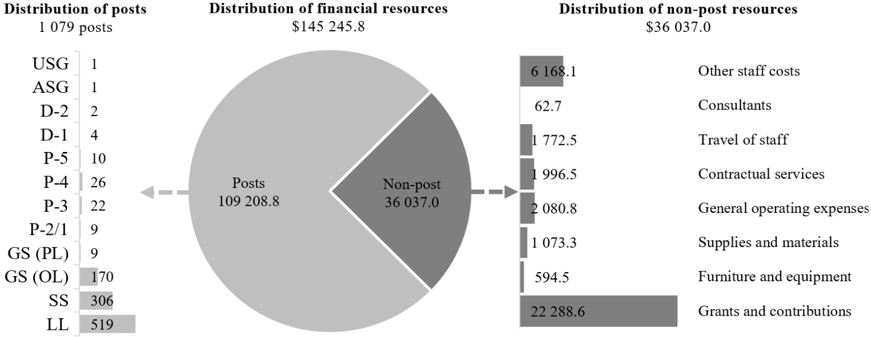

Explanation of variances by factor, component and subprogramme

Overall resource changes (regular budget)

Technical adjustments

34.63 As reflected in table 34.21 (1), resource changes reflect a decrease of $2,297,100, as follows:
(a) Subprogramme 1, Security and safety services. A decrease of $88,600 consisting of:
(i) A decrease of $23,100 under other staff costs relating to the removal of non-recurrent security personnel overtime requirements for the Preparatory Commission for the Entry into Force of the Agreement under the United Nations Convention on the Law of the Sea on the Conservation and Sustainable Use of Marine Biological Diversity of Areas beyond National Jurisdiction and the Convening of the First Meeting of the Conference of the Parties to the Agreement, pursuant to Assembly resolution 78/272;
(ii) A decrease of $65,500 under grants and contributions relating to the removal of the non-recurrent provision for three security officers deployed during the construction phase of the Gigiri master plan pursuant to General Assembly resolution 79/258 ($62,700); and a reduction in the Secretariat percentage share (14.1 per cent for 2026, compared with 15.6 per cent for 2025) in the cost of jointly financed field security operations, based on the CEB field staff census as at 31 December 2024 ($2,800);
(b) Subprogramme 2, Field operations, subprogramme 3, Partnerships and specialized support and programme support. A decrease of $2,208,500 under grants and contributions consisting of reductions under subprogramme 2 ($2,052,900), subprogramme 3 ($134,200) and programme support ($21,400), reflecting a lower Secretariat percentage share (14.1 per cent for 2026, compared with 15.6 per cent for 2025) in the cost of jointly financed field security operations, based on the CEB field staff census as at 31 December 2024.

Other changes

34.64 As reflected in table 34.21 (1), resource changes reflect a net decrease of $3,226,800 as follows:
(a) Subprogramme 1, Security and safety services. An increase of $2,000,000, which includes:
(i) The cost-neutral redeployment of $451,700 from other staff costs to posts, related to the proposed establishment of four posts (1 P-5, 1 P-4, 1 P-3 and 1 GS (Principal level)) under the global security systems, standards and projects team in the Division of Headquarters Security and Safety Services in New York, as explained in annex II;
(ii) A proposed increase of $500,000 under travel of staff for the travel of security officers who accompany senior United Nations officials during their travel, taking into account expenditure experience. One of the main functions of the Department of Safety and Security in New York is to ensure the protection of the Secretary-General, the Deputy Secretary-General and the President of the General Assembly, especially in relation to close protection during their travel. Similar to the approach in the context of the proposed programme budget for 2025, the increase of $500,000 is a step towards gradually bridging the gap between budgeted and actual expenditure for the above-mentioned travel;
(iii) A proposed increase of $1,500,000 under other staff costs for overtime requirements to provide uninterrupted security operations and services. The Department’s regular budget has a historical structural funding insufficiency with regard to covering overtime of the safety and security services. Overtime is an integral part of safety and security requirements because security personnel are required to provide uninterrupted security operations and services at the United Nations Headquarters compound, including annex locations. The Security and Safety Service in New York operates on a three-shift basis, 24 hours a day, seven days a week, all year long. For safety and security services at headquarters locations and the regional commissions, overtime and night differential are required for extended security coverage after normal working hours in order to undertake the activities required for security operations;
(b) Subprogramme 2, Field operations. The decrease of $5,016,900 under grants and contributions reflects the Secretariat share of the proposed decrease in resources for jointly financed field operations, as explained in paragraph 34.65 below, and an alignment of the provision for the United Nations share on the basis of the agreed cost apportionment;
(c) Subprogramme 3, Partnerships and specialized support. The decrease of $209,900 under grants and contributions reflects the Secretariat share of the proposed decrease in resources for jointly financed field operations, as explained in paragraph 34.65 below.

Overall resource changes (jointly financed activities)

Other changes

34.65 As reflected in table 34.17, resource changes reflect a decrease of $29,898,500 under subprogramme 2, Field operations ($28,414,200) and subprogramme 3, Partnerships and specialized support ($1,484,300). The decrease reflects adjustments in line with the level of resources endorsed by the Finance and Budget Network, taking into account the funding context within which United Nations entities operate, including the ongoing financial constraints faced by participating entities. The Network also agreed that no recosting or inflationary adjustments should be applied to the 2026 budget proposals for the United Nations security management system. Thus, the Department is planning significant adjustments to its footprint to comply with the recommendations and conclusions of the Network. In the field, these adjustments will translate into greater regionalization of functions, with more multi-country offices covering an expanded number of locations, increased nationalization of posts and the withdrawal of presence in the lowest-risk locations. At Headquarters, reductions may be achieved by consolidating both analytical and field support desk functions and pooling capacities where relevant and appropriate. Details of the footprint adjustments that will be required are not yet known, as the Department will be reviewing its presence in the coming months, location by location.

Other assessed

34.66 As reflected in tables 34.21 (2) and 34.22 (2), other assessed resources under the support account for peacekeeping operations amount to $4,550,500. The resources would complement regular budget resources and provide for the requirements indicated in the report of the Secretary-General on the 2025/26 budget for the support account for peacekeeping operations (A/79/783).

Extrabudgetary resources

34.67 As reflected in tables 34.21 (3) and 34.22 (3), extrabudgetary resources amount to $22,797,300. The resources would complement regular budget resources and be used mainly to provide security services to other agencies and organizations in various locations, special events within and surrounding the premises, and humanitarian operations amid unstable conditions in various locations, including in field offices, and for reimbursable services provided for the close protection officer certification programme, Safe and Secure Approaches in Field Environments training and other related activities.
34.68 The extrabudgetary resources under the present section are subject to the oversight of the Department, which has delegated authority from the Secretary-General.

Executive direction and management

34.69 The Under-Secretary-General for Safety and Security is responsible for the overall direction, supervision and management of the Department in the implementation of its mandates and its approved programme of work. The Under-Secretary-General is the Chair of the United Nations security management system and is assisted in the internal functioning and day-to-day management of the Department by the Assistant Secretary-General.
34.70 In managing the Department, the Under-Secretary-General is supported by the Strategic Planning Service, which is responsible for strategic planning and risk management, operational resilience and emergency response, strategic communications, gender and inclusivity, corporate governance, evaluation, compliance monitoring, lessons learned, best practices and innovation. Together, these areas enable the dissemination and implementation of a results-based focus across the Department, in line with United Nations mandates, objectives and values at the global and country levels.
34.71 In accordance with the 2030 Agenda for Sustainable Development, in particular target 12.6 of the Sustainable Development Goals, in which organizations are encouraged to integrate sustainability information into their reporting cycles, and in compliance with the cross-cutting mandate set out in paragraph 19 of General Assembly resolution 72/219, the Department is integrating environmental management practices into its operations, including in the requisition of goods and services that contribute to and support environmental stability, resilience and sustainability.
34.72 Information on the timely submission of documentation and advance booking for air travel is reflected in table 34.24.
34.73 The Department will continue to make efforts to implement advance travel planning and the early nomination of travellers. In the event of rapid security surge redeployment and close protection-related travel, the Department will work more closely with the travel unit and the agent to reserve tickets in advance on the basis of a preliminary itinerary. Despite an improvement in compliance in 2024 compared with 2022 and 2023, the low compliance rate in 2024 was attributable primarily to rapid security surges in volatile security environments, which made advance planning challenging. Compliance with documentation deadlines remained at 100 per cent.

Table 34.24

Compliance rate
(Percentage)

 | 2022 actual | 2023 actual | 2024 actual | 2025 planned | 2026 planned
Timely submission of documentation | 100 | 100 | 100 | 100 | 100
Air tickets purchased at least 2 weeks before the commencement of travel | 44 | 50 | 56 | 100 | 100

34.74 The proposed regular budget resources for 2026 amount to $7,137,000 and reflect no change compared with the approved budget for 2025. Additional details on the distribution of the proposed resources for 2026 are reflected in table 34.25 and figure 34.VI.

Table 34.25

Executive direction and management: evolution of financial and post resources
(Thousands of United States dollars/number of posts)

 |  |  | Changes |  |  |  |  | 2026  estimate
 | 2024 expenditure | 2025 approved | Technical adjustments | New/expanded mandates | Other | Total | Percentage | 2026  estimate
Financial resources by main category of expenditure
Posts | 3 904.8 | 6 295.3 | – | – | – | – | – | 6 295.3
Non-post | 543.0 | 841.7 | – | – | – | – | – | 841.7
Total | 4 447.7 | 7 137.0 | – | – | – | – | – | 7 137.0
Post resources by category
Professional and higher |  | 26 | – | – | – | – | – | 26
General Service and related |  | 8 | – | – | – | – | – | 8
Total |  | 34 | – | – | – | – | – | 34

Figure 34.VI

Executive direction and management: distribution of proposed resources for 2026 (before recosting)
(Number of posts/thousands of United States dollars)
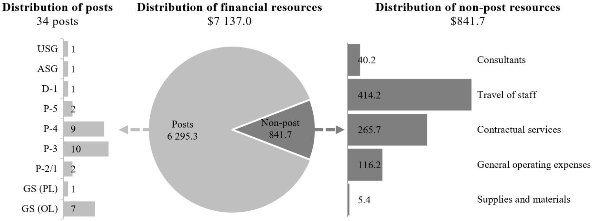

Programme of work

Subprogramme 1

Security and safety services

Regular budget resource requirements

34.75 The proposed regular budget resources for 2026 amount to $114,614,200 and reflect an increase of $1,911,400 compared with the approved budget for 2025. The proposed change is explained in paragraphs 34.63 (a) and 34.64 (a). Additional details on the distribution of the proposed resources for 2026 are reflected in table 34.26 and figure 34.VII.

Table 34.26

Subprogramme 1: evolution of financial and post resources (regular budget)
(Thousands of United States dollars/number of posts)

 |  |  | Changes |  |  |  |  | 2026  estimate
 | 2024 expenditure | 2025 approved | Technical adjustments | New/expanded mandates | Other | Total | Percentage | 2026  estimate
Financial resources by main category of expenditure
Posts | 82 089.2 | 97 378.3 | – | – | 451.7 | 451.7 | 0.5 | 97 830.0
Non-post | 19 888.4 | 15 324.5 | (88.6) | – | 1 548.3 | 1 459.7 | 9.5 | 16 784.2
Total | 101 977.6 | 112 702.8 | (88.6) | – | 2 000.0 | 1 911.4 | 1.7 | 114 614.2
Post resources by category
Professional and higher |  | 28 | – | – | 3 | 3 | 10.7 | 31
General Service and related |  | 984 | – | – | 1 | 1 | 0.1 | 985
Total |  | 1 012 | – | – | 4 | 4 | 0.4 | 1 016

Note: Resources include the Secretariat share for 2026 of the jointly financed Security and Safety Service in Vienna, amounting to $4,403,100, and the jointly financed activities relating to regional field security operations, amounting to $26,600.

Figure 34.VII

Subprogramme 1: distribution of proposed resources for 2026 (before recosting)
(Number of posts/thousands of United States dollars)

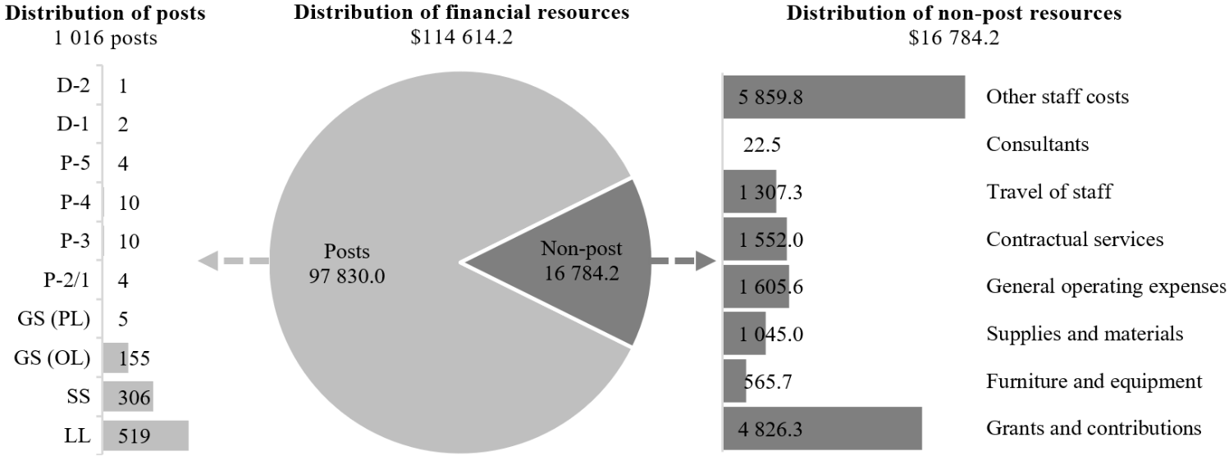

Resource requirements for jointly financed activities

34.76 The proposed jointly financed resources for 2026 amount to $18,786,800 and reflect no change compared with the approved budget for 2025. Additional details on the distribution of the proposed resources for 2026 are reflected in table 34.27 and figure 34.VIII.

Table 34.27

Subprogramme 1: evolution of financial and post resources (jointly financed activities)
(Thousands of United States dollars/number of posts)

 |  |  | Changes |  |  |  |  | 2026  estimate
 | 2024 expenditure | 2025 approved | Technical adjustments | New/expanded mandates | Other | Total | Percentage | 2026  estimate
Financial resources by main category of expenditure
Posts | 16 590.7 | 16 808.4 | – | – | – | – | – | 16 808.4
Non-post | 1 865.6 | 1 978.4 | – | – | – | – | – | 1 978.4
Total | 18 456.3 | 18 786.8 | – | – | – | – | – | 18 786.8
Post resources by category
Professional and higher |  | 5 | – | – | – | – | – | 5
General Service and related |  | 155 | – | – | – | – | – | 155
Total |  | 160 | – | – | – | – | – | 160

Note: Resources include the Secretariat share for 2026 of the jointly financed Security and Safety Service in Vienna, amounting to $4,403,100, and the jointly financed activities relating to regional field security operations, amounting to $26,600.

Figure 34.VIII

Subprogramme 1: distribution of proposed resources for 2026 (jointly financed activities)
(Number of posts/thousands of United States dollars)
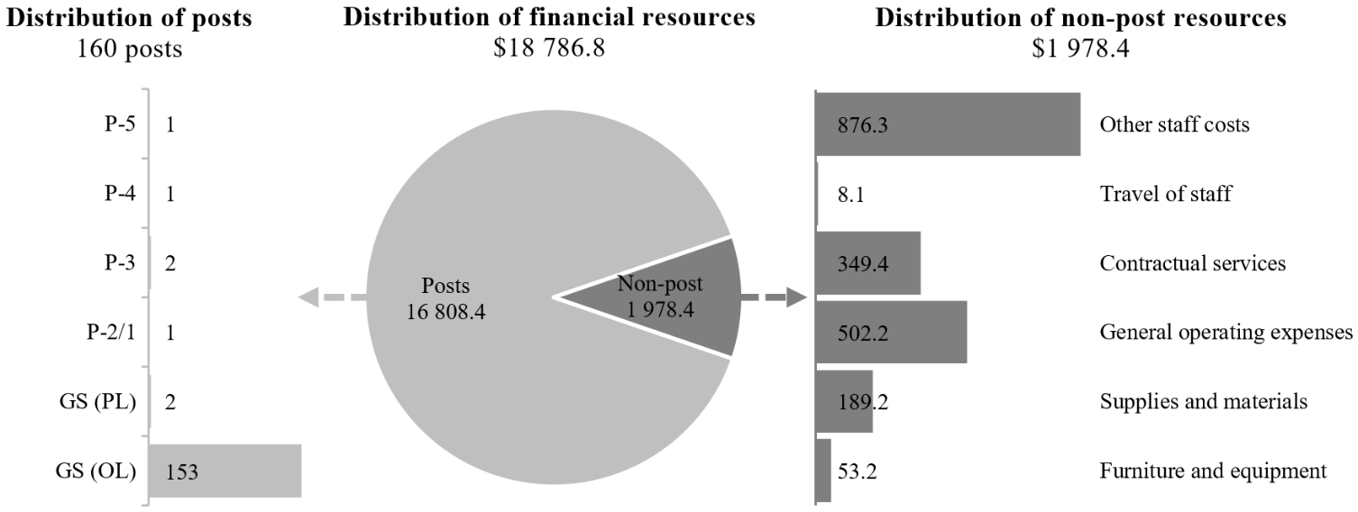

Subprogramme 2

Field operations

Regular budget resource requirements

34.77 The proposed regular budget resources for 2026 amount to $16,184,800 and reflect a decrease of $7,069,800 compared with the approved budget for 2025. The proposed change is explained in paragraphs 34.63 (b) and 34.64 (b). Additional details on the distribution of the proposed resources for 2026 are reflected in table 34.28.

Table 34.28

Subprogramme 2: evolution of financial and post resources
(Thousands of United States dollars/number of posts)

 |  |  | Changes |  |  |  |  | 2026  estimate
 | 2024 expenditure | 2025 approved | Technical adjustments | New/expanded mandates | Other | Total | Percentage | 2026  estimate
Financial resources by main category of expenditure
Non-post | 23 610.0 | 23 254.6 | (2 052.9) | – | (5 016.9) | (7 069.8) | (30.4) | 16 184.8
Total | 23 610.0 | 23 254.6 | (2 052.9) | – | (5 016.9) | (7 069.8) | (30.4) | 16 184.8

Note: Resources include the Secretariat share for 2026 of jointly financed activities relating to regional field security operations, amounting to $15,606,700, and the United Nations share of the malicious acts insurance policy, amounting to $578,100.

Resource requirements for jointly financed activities

34.78 The proposed jointly financed resources for 2026 amount to $115,516,400 and reflect a decrease of $28,414,200 compared with the approved budget for 2025. The proposed change is explained in paragraph 34.65. Additional details on the distribution of the proposed resources for 2026 are reflected in table 34.29 and figure 34.IX.

Table 34.29

Subprogramme 2: evolution of financial and post resources (jointly financed activities)
(Thousands of United States dollars/number of posts)

 |  |  | Changes |  |  |  |  | 2026  estimate
 | 2024 expenditure | 2025 approved | Technical adjustments | New/expanded mandates | Other | Total | Percentage | 2026  estimate
Financial resources by main category of expenditure
Posts | 103 360.8 | 114 175.8 | – | – | (28 414.2) | (28 414.2) | (24.9) | 85 761.6
Non-post | 36 745.7 | 29 754.8 | – | – | – | – | – | 29 754.8
Total | 140 106.7 | 143 930.6 | – | – | (28 414.2) | (28 414.2) | (19.7) | 115 516.4
Post resources by category
Professional and higher |  | 335 | – | – | – | – | – | 335
General Service and related |  | 429 | – | – | – | – | – | 429
Total |  | 764 | – | – | – | – | – | 764

Note: Non-post resources include a provision for the malicious acts insurance policy in the amount of $5,145,000 for 2026. The Secretariat share of jointly financed activities and the malicious acts insurance policy amounts to $15,606,700 and $578,100, respectively for 2026.

Figure 34.IX

Subprogramme 2: distribution of proposed resources for 2026 (jointly financed activities)
(Number of posts/thousands of United States dollars)

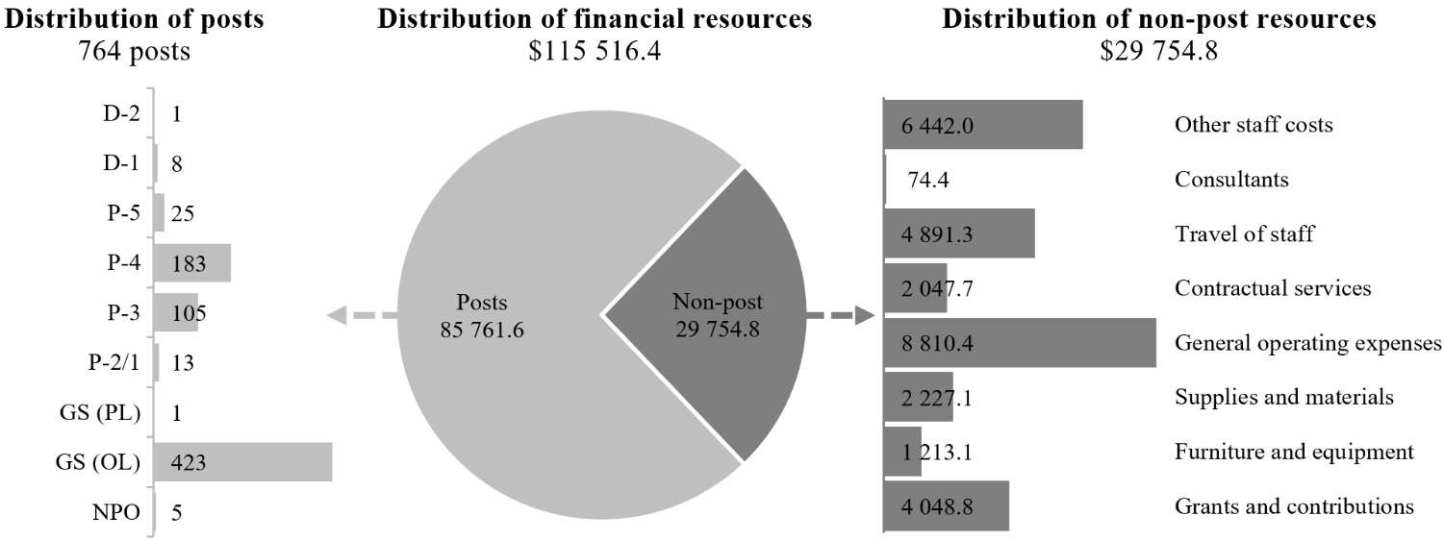

Subprogramme 3

Partnerships and specialized support

Regular budget resource requirements

34.79 The proposed regular budget resources for 2026 amount to $3,713,300 and reflect a decrease of $344,100 compared with the approved budget for 2025. The proposed change is explained in paragraphs 34.63 (b) and 34.63 (c). Additional details on the distribution of the proposed resources for 2026 are reflected in table 34.30 and figure 34.X.

Table 34.30

Subprogramme 3: evolution of financial and post resources
(Thousands of United States dollars/number of posts)

 |  |  | Changes |  |  |  |  | 2026  estimate
 | 2024 expenditure | 2025 approved | Technical adjustments | New/expanded mandates | Other | Total | Percentage | 2026  estimate
Financial resources by main category of expenditure
Posts | 3 050.2 | 2 620.5 | – | – | – | – | – | 2 620.5
Non-post | 1 574.5 | 1 436.9 | (134.2) | – | (209.9) | (344.1) | (23.9) | 1 092.8
Total | 4 624.6 | 4 057.4 | (134.2) | – | (209.9) | (344.1) | (8.5) | 3 713.3
Post resources by category
Professional and higher |  | 11 | – | – | – | – | – | 11
General Service and related |  | 3 | – | – | – | – | – | 3
Total |  | 14 | – | – | – | – | – | 14

Note: Resources include the Secretariat share for 2026 of jointly financed activities under the established cost-sharing arrangements in the estimated amount of $1,073,100.

Figure 34.X

Subprogramme 3: distribution of proposed resources for 2026 (before recosting)
(Number of posts/thousands of United States dollars)

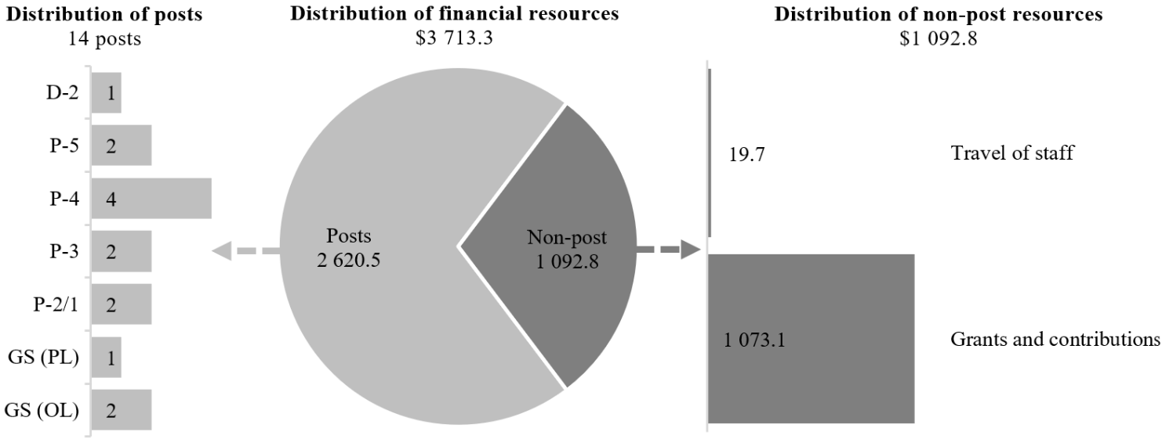

Resource requirements for jointly financed activities

34.80 The proposed jointly financed resources for 2026 amount to $7,589,000 and reflect a decrease of $1,484,300 compared with the approved budget for 2025. The proposed change is explained in paragraph 34.65. Additional details on the distribution of the proposed resources for 2026 are reflected in table 34.31 and figure 34.XI.

Table 34.31

Subprogramme 3: evolution of financial and post resources (jointly financed activities)
(Thousands of United States dollars/number of posts)

 |  |  | Changes |  |  |  |  | 2026  estimate
 | 2024 expenditure | 2025 approved | Technical adjustments | New/expanded mandates | Other | Total | Percentage | 2026  estimate
Financial resources by main category of expenditure
Posts | 6 274.9 | 5 974.4 | – | – | (1 484.3) | (1 484.3) | (24.8) | 4 490.1
Non-post | 2 851.8 | 3 098.9 | – | – | – | – | – | 3 098.9
Total | 9 126.8 | 9 073.3 | – | – | (1 484.3) | (1 484.3) | (16.4) | 7 589.0
Post resources by category
Professional and higher |  | 25 | – | – | – | – | – | 25
General Service and related |  | 9 | – | – | – | – | – | 9
Total |  | 34 | – | – | – | – | – | 34

Note: The Secretariat share for 2026 of jointly financed activities amounts to $1,073,100.

Figure 34.XI

Subprogramme 3: distribution of proposed resources for 2026 (jointly financed activities)
(Number of posts/thousands of United States dollars)
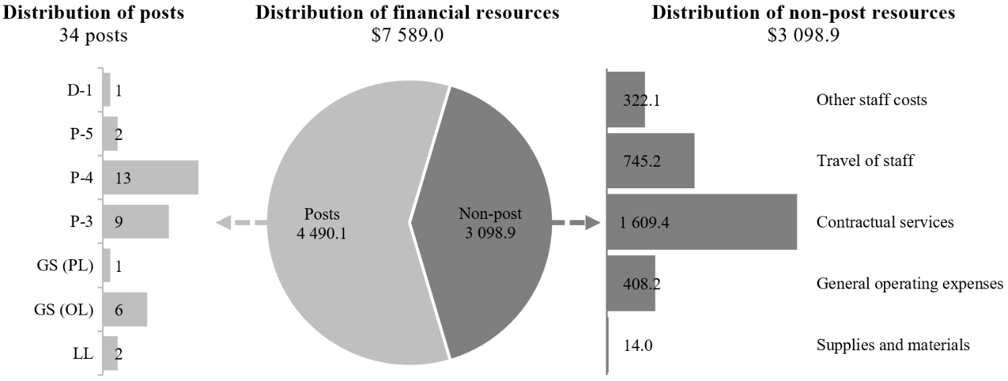

Programme support

Regular budget resource requirements

34.81 The proposed regular budget resources for 2026 amount to $3,596,500 and reflect a decrease of $21,400 compared with the approved budget for 2025. The proposed change is explained in paragraph 34.63 (b). Additional details on the distribution of the proposed resources for 2025 are reflected in table 34.32 and figure 34.XII.

Table 34.32

Programme support: evolution of financial and post resources
(Thousands of United States dollars/number of posts)

 |  |  | Changes |  |  |  |  | 2026  estimate
 | 2024 expenditure | 2025 approved | Technical adjustments | New/expanded mandates | Other | Total | Percentage | 2026  estimate
Financial resources by main category of expenditure
Posts | 2 451.7 | 2 463.0 | – | – | – | – | – | 2 463.0
Non-post | 512.5 | 1 154.9 | (21.4) | – | – | (21.4) | (1.8) | 1 133.5
Total | 2 964.2 | 3 617.9 | (21.4) | – | – | (21.4) | (0.6) | 3 596.5
Post resources by category
Professional and higher |  | 7 | – | – | – | – | – | 7
General Service and related |  | 8 | – | – | – | – | – | 8
Total |  | 15 | – | – | – | – | – | 15

Note: Resources include the Secretariat share for 2026 of jointly financed activities amounting to $204,400.

Figure 34.XII

Programme support: distribution of proposed resources for 2026 (before recosting)
(Number of posts/thousands of United States dollars)

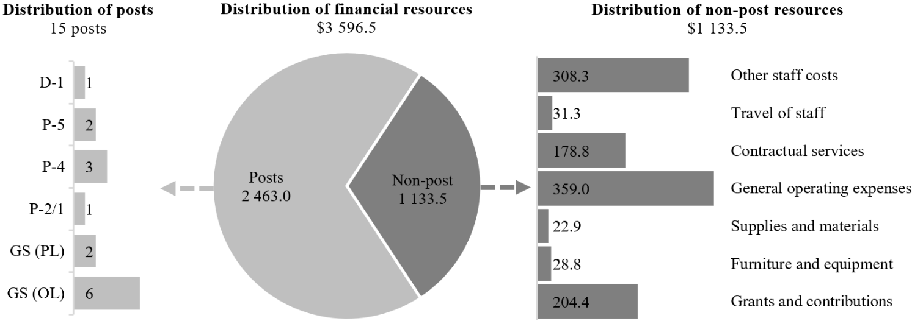

Resource requirements for jointly financed activities

34.82 The proposed jointly financed resources for 2026 amount to $1,445,700 and reflect no change compared with the approved budget for 2025. Additional details on the distribution of the proposed resources for 2026 are reflected in table 34.33.

Table 34.33

Programme support: evolution of financial and post resources (jointly financed activities)
(Thousands of United States dollars/number of posts)

 |  |  | Changes |  |  |  |  | 2026  estimate
 | 2024 expenditure | 2025 approved | Technical adjustments | New/expanded mandates | Other | Total | Percentage | 2026  estimate
Financial resources by main category of expenditure
Posts | 113.3 | – | – | – | – | – | – | –
Non-post
Other staff costs | 1 214.8 | 1 445.7 | – | – | – | – | – | 1 445.7
Total | 1 328.1 | 1 445.7 | – | – | – | – | – | 1 445.7

Note: The Secretariat share for 2026 of jointly financed activities amounts to $204,400.

Annex I

Organizational structure and post distribution for 2026
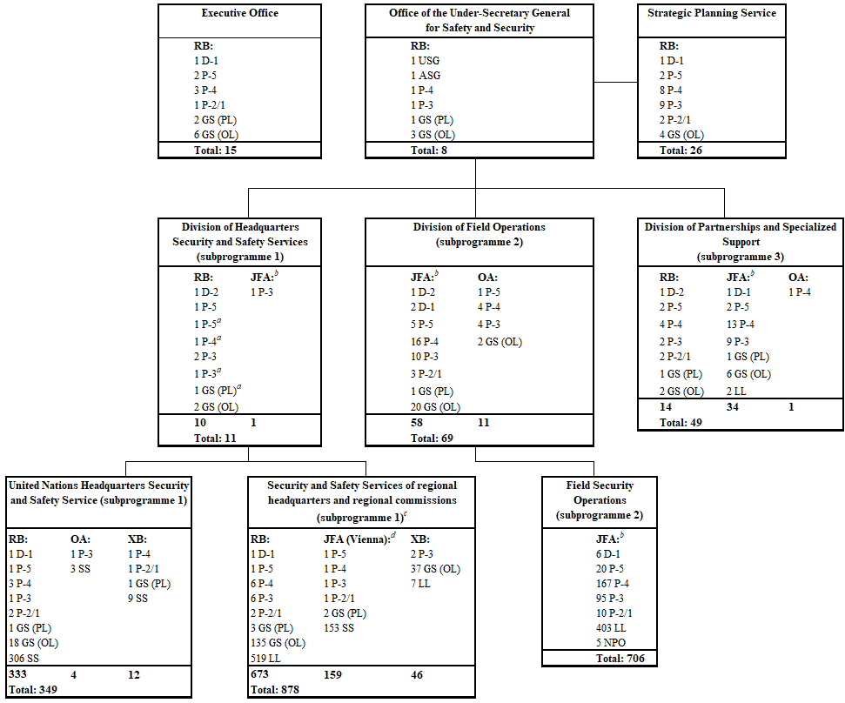

Abbreviations: ASG, Assistant Secretary-General; GS (OL), General Service (Other level); GS (PL), General Service (Principal level); JFA, jointly financed activities; LL, Local level; NPO, National Professional Officer; OA, other assessed; RB, regular budget; SS, Security Service; USG, Under-Secretary-General; XB, extrabudgetary.
ª Establishment.
^{b} Jointly financed by all the organizations participating in the security management system in the field.
^{c} Including the security and safety services at other Headquarters locations and the regional commissions.
^{d} Jointly financed by all Vienna International Centre-based organizations relating to the Security and Safety Service.

Annex II

Summary of proposed post changes, by component and subprogramme

Component/subprogramme | Posts | Grade | Description | Reason for change
Regular budget
Subprogramme 1  Security and safety services | 1 | P-5 | Establishment of 1 Senior Security Officer | The proposed establishment of four posts (1 P-5, 1 P-4, 1 P-3 and 1 GS (Principal level)) under the global security systems, standards and projects team in the Division of Headquarters Security and Safety Services in New York would support the implementation of the multi-year standardized physical security improvements project at United Nations Headquarters, offices away from Headquarters and regional commissions budgeted under section 33 of the proposed programme budget (A/80/6 (Sect. 33)). As indicated in the report of the Secretary-General on capital investment planning (A/79/510), a long-term dedicated team capacity is needed to centrally manage the project, provide technical oversight for security procurement processes, standardize security systems and components, and manage security assets at the global level. These requirements are crucial for safeguarding the Organization’s long-term security posture in an increasingly challenging environment, and represent a continuing requirement for the Organization beyond completion of the project, currently scheduled for 2031. Details of the functions to be performed by the incumbents of the above-mentioned posts are provided below.  The Senior Security Officer (P-5) would take the lead in the overall supervision and coordination of proposals for security projects, including functional and business requirements for safety and security, related system specifications and standardization, technical validation and project execution plans. The increasing scale, complexity and global scope of physical and electronic security investments necessitate dedicated, centralized leadership to ensure consistency, compliance with United Nations standards and the long-term sustainability of security infrastructure across all locations.  The Security Coordination Officer (P-4) would manage and coordinate the capital improvement projects, including upgrades to and major maintenance for security systems, from the design phase through the installation, monitoring and reporting phases. The incumbent would also identify and seek solutions to address any organizational gaps in managing common security projects and logistics, ensuring dedicated expertise and continuity in the financial, administrative and operational management of security enhancement projects across the United Nations in a consistent manner.
Subprogramme 1  Security and safety services | 1 | P-4 | Establishment of 1 Security Coordination Officer
Subprogramme 1  Security and safety services | 1 | P-3 | Establishment of 1 Security Coordination Officer
Subprogramme 1  Security and safety services | 1 | GS (PL) | Establishment of 1 Senior Programme Management Assistant
 |  |  |  | The Security Coordination Officer (P-3) would provide a focused capacity on systems architecture, the integration landscape and applications management (such as access control, video analytics, physical security, screening and detection and cybersecurity). The incumbent would also provide technical support on the review of local procurement authority, as well as on category and asset management and data security. The establishment of this post would ensure dedicated technical expertise and continuous oversight of physical and electronic security systems and technologies, and their integration across the Organization.
 |  |  |  | The Senior Programme Management Assistant (General Service (Principal level)) would provide the full range of administrative and operational support for the security projects team and its global activities in the delivery of outputs, including in the areas of data management, analytics, integrated reporting and communications.

Abbreviation: GS (PL), General Service (Principal level).

