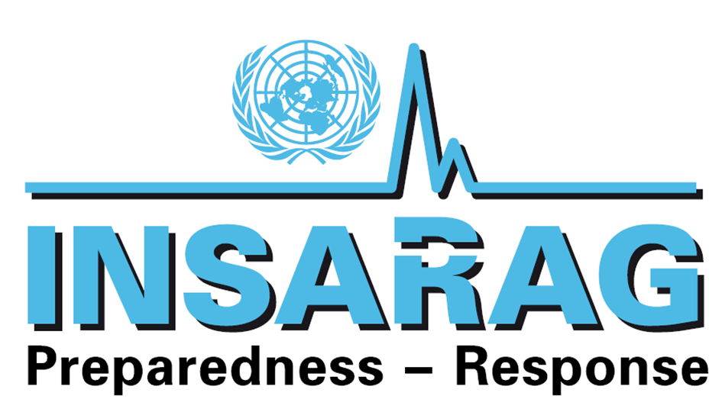

INSARAG Steering Group Meeting
Geneva, Switzerland
16-17 February 2012

DRAFT Chairman’s Summary

1 Opening Remarks
The 2012 meeting of the INSARAG Steering Group (ISG) was held in the Palais des Nations, Geneva, on 16-17 February 2012. 69 participants comprise of members from the INSARAG Regional Group Chairs/Vice Chairs, Working Group Chairs and IEC teams from a total of 28 States and OCHA (Annex A). OCHA’s Regional Offices, Coordination and Response Division and ESB Sections also participated.

The meeting was opened by the Director of OCHA Geneva Mr. Rashid Khalikov, INSARAG Chairman Ambassador Toni Frisch and Chief of the Emergency Services Branch of OCHA Geneva Mr Rudolf Müller.

A key focus of the 2012 ISG meeting was a review on the overall INSARAG Governance Structure, with the aim of it to become better fit for the future.

2 Adoption of Agenda and Review of Action Points of the 2011 Steering Group Meeting

The agenda was adopted unanimously (Annex B).

The ISG reviewed the Action Points from 2011 and expressed satisfaction with their implementation (Annex C).

3 Update from the INSARAG Secretariat on INSARAG Global Events

3a INSARAG Team Leaders Meeting
The ISG expressed satisfaction to the INSARAG Team Leaders Meeting in Costa Rica in April 2011. The ISG accorded recognition and appreciation to the kind generosity of the Member States for their support.

3b INSARAG Guidelines
The INSARAG Secretariat thanked the USA and Singapore for in kind support in printing of the INSARAG Guidelines.

The INSARAG Secretariat requested and encouraged INSARAG Members to translate and print the INSARAG Guidelines for wider distribution.

Action: INSARAG Members, INSARAG Secretariat

3c The INSARAG Webpage (Http: //www.insarag.org)
The ISG expressed satisfaction with the newly launched INSARAG web page available at http://www.insarag.org. The financial support of Sweden and Germany to provide the server, design of the web page and domain name for the web page was appreciated. The INSARAG Chairman has also personally thanked both contributing parties for this milestone initiative. The INSARAG Secretariat stressed the importance of an active utilization and development of the web site and encouraged members to provide feedback to further improve it.

Action: INSARAG Members, INSARAG Secretariat

4 INSARAG Regional Groups
The ISG expressed satisfaction on the briefings by the respective outgoing and current Chairs/Vice Chairs* on their regional activities covering 2011 and those planned for 2012.

*Americas: Costa Rica, Mexico. Africa, Europe Middle East: Sweden, Russia. Asia-Pacific: Indonesia, Nepal

Action: Member States, INSARAG Secretariat

5 INSARAG Working Groups
The ISG was briefed on the progress of the INSARAG Working Groups by the respective Chairs.

The ISG appreciated their work and thanked the respective chairs, Dewey Perks (USA), Trevor Glass (Australia) and David Norlin (Sweden) of the Training, Medical and Operations Working Group respectively.

Germany, Switzerland and Singapore were concerned if the outputs of the working groups were going beyond the scope of INSARAG in establishing minimum standards.

The Chair of the Training Working Group explained that the first set of minimum standards were established in 1999 and with improvements in technology and lessons from past earthquakes, the standards need have been adapted to current realities and the working groups formed by regional representatives, will continue to align their outputs to ensure this.

The INSARAG Chairman reiterated deep appreciation to the strong leadership and commitment of the working group chairs and their global members comprising professional experts in their respective fields, the concern that working groups are growing and pressure from new IEC teams wanting to also be a part of these groups create a need to discuss the governance system of working groups and this will be tabled later in the meeting.

In this regard, the ISG requested the INSARAG Secretariat, in close cooperation with the Working Group Chairs, to look into the team composition, working modalities, work plans, frequencies and venue of meetings, and conclusion of the group upon completion of the assigned tasks and the outcomes will be reported back to the INSARAG Chairman by mid-2012.

Following discussions, the ISG directed the Working Groups to align their work plans in 2012 as follows:

- to continue and produce outputs in 2012 as laid down in their respective Terms of Reference(ToRs)
- to meet where possible, back to back with the INSARAG Team Leaders Meeting 2012 and regional meetings. To utilise the INSARAG Earthquake Response Exercises, including relevant UNDAC events, to test their products i.e. proposed forms, procedures, etc;
- to contribute and upload relevant products to the INSARAG Web site, so that outputs can reach a wider global audience (e.g. the Medical technical guidance notes on crush injury)
- to actively participate in IEC/Rs and relevant INSARAG events, i.e. INSARAG IEC/R Trainers Course in UK.

The Terms of References of the respective working groups are in Annex D, Annex E and Annex F.

Action: Member States, INSARAG Working Group Chairmen, INSARAG Secretariat

4. INSARAG External Classification (IEC)
The ISG expressed satisfaction for the IEC system and its developments since the conception in 2005. The IEC Report 2012 developed by the INSARAG Secretariat provides a summary of the system (Annex G) .

To date, 28 USAR teams have successfully achieved INSARAG IEC Classification (17 Heavy, 11 Medium teams).

The presentation by the Netherlands on their IER was welcomed. The IER exercise was conducted in Denmark, demonstrating strong bilateral cooperation. (details of the IER can be found in the IEC/R Handbook 2012 , downloadable from the INSARAG website)

The ISG discussed and decided on the following:

- The ISG agreed on the importance of continued advocacy to promote the INSARAG IEC for teams with the mandate to deploy internationally in line with the INSARAG Hyogo Declaration item three that "urges and encourages all Member States...to take into account the IEC process" ;

- The ISG welcomed the IEC/IER Handbook 2012 version and the IEC and IER Checklist for 2012, to be further discussed in the TL meeting and used for the IEC events in 2012; Singapore commented that the IER requirements should factor in issues such as the number of past deployment and the improvements that the team has achieved due to such involvements;

- The ISG welcomed the IEC Team Leaders and Mentors Training Course 2012 to be held in the UK;

- The ISG welcomed the establishment of a reserve pool of ‘pre-approved’ IEC/IER classifiers for urgent short notice deployments to replace a classifier who may withdraw at the last minute, due to exigencies;

- The ISG encouraged the IEC/IER classified teams to budget for IEC/R classifier support to ensure the system continues strongly. As a guide, IEC teams are requested to provide a minimum of 5 suitable classifiers for Heavy teams, and 3 classifiers for Medium teams, 12 months ahead of the IEC/R;

- The ISG agreed to actively work with OCHA's regional and national offices to further advise disaster prone countries on the value of INSARAG and especially to advocate for requesting of IEC classified teams as a priority during major earthquakes in accordance with the INSARAG Hyogo Declaration item six: "offering priority access to such teams (IEC teams) that make a genuine and meaningful difference in the life saving ..phase...".

- Classified teams are strongly encouraged to assist teams who need mentoring assistance as they prepare for national standards classification or IEC respectively;

- In line with INSARAG Hyogo Declaration item five " urges and highly recommends that building national , local ..capacity is critical for effective response...and encourage Member States to support such efforts"; the Steering Group agreed on continued advocacy to promote the INSARAG Organisational and Operational Guidelines for Capacity Building of National USAR Teams implementation (in Chapter G of the INSARAG Guidelines) as the first choice of USAR teams, before deciding on going through an IEC process.

Action: Member States, IEC teams, INSARAG Secretariat

5. INSARAG at ECOSOC in 2012
To commemorate the 10th Anniversary of the GA 57/150 of 16 Dec 2002 on “Strengthening the effectiveness and coordination of international urban search and rescue assistance”, an INSARAG event is suggested to be conducted in the margins of the Economic and Social Council (ECOSOC) Humanitarian Segment, in July 2012 in New York.

The Americas Region, Germany, Japan, Sweden and USA pledged their full support of this initiative. The INSARAG Secretariat will provide more information and dates of the event.

The ISG welcomed the proposal and requested members states active support to mobilize for this event.

Action: Member States, IEC teams, INSARAG Secretariat

5. INSARAG Governance
The Secretariat together with an independent consultant, Piero Calvi-Parisetti, presented to the ISG an option paper which is a result of a study from November 2011 to January 2012 highlighting the current challenges of INSARAG’s governance (Annex H). Following the presentation the ISG broke up in four discussions groups with the following focuses:

- Global Governance
- Regional and Capacity Building Governance
- Operational Governance
- IEC/R Governance

The group discussion was facilitated by Thomas Peter, Gisli Olafsson, Joe Bishop and Jesper Lund.

The overall summary of discussions from day 1 of the meeting is listed in Annex I.

The ISG continued the discussion when convened again in the morning of day 2. Piero Calvi-Parisetti presented key issues for discussion and prioritization in a second round of discussion related to the governance of INSARAG. The ISG thereafter broke up in three groups facilitated by Thomas Peter, Gisli Johansson and Jesper Lund.

The feedback from the groups and suggested follow up actions are in Annex J.

The ISG agreed that the recommendations listed in the Annexes above, will be further discussed and deliberated in the team leaders and regional meetings in 2012, and their recommendations be tabulated by the INSARAG Secretariat, who will thereafter present the feedback to eventually be decided in the 2013 ISG Meeting.

7. INSARAG in 2012
The ISG welcomed the events planned for 2012 (Annex K) and encouraged active participation of Member States.

Action: Member States, INSARAG Secretariat

8. Announcements from Member States
The following announcements were made during the meeting by members of the ISG:

-Australia welcomed USAR teams to the 2012 INSARAG Team Leaders Meeting which will be held in Australia on 20-22 March 2012.

-Indonesia announced that the INSARAG Asia Pacific Regional Earthquake Response Exercise will take place in Indonesia from 28May to 01 June 2012 with support from USA and China and welcomed international participation.

9. Any Other Business
-A concern was raised by ISG members about the capacity of FCSS as the secretariat of INSARAG to keep up with its growing workload. The workload has increased dramatically reflecting the growth in INSARAG, the IEC process and other related activities. The meeting requested OCHA to increase FCSS resources so it can adequately meet expectations.

-Sweden informed that they are planning to conduct a study about the results and benefits of keeping an international USAR team and welcomed input to the Terms of Reference for such a study. UK, INSARAG Global Chairman and INSARAG Secretariat expressed their willingness to provide input to such a study.

-Japan suggested that the results of the UNDAC Review are shared within the INSARAG community.

-Argentina proposed to strengthen the exchange of experiences and lessons learned among Member countries regarding the development of capacity of on national certification of USAR teams with the aim of drawing on the experience of countries that have already developed certification tools and methodologies for this purpose.

The representative from UK suggested that FCSS reduce the resources it applies to the management of INSARAG due to the low impact of search and rescue compared to other mechanisms managed by OCHA and to allow for a stronger focus on UNDAC activities related to the implementation of the UNDAC review. The Swedish study can in this regard give further insights.

List of Attachments
- Annex A: List of Participants
- Annex B: Meeting Agenda
- Annex C: Action Points from ISG Meeting 2011
- Annex D: Training Working Group 2011 Annual Report
- Annex E: Medical Working Group 2011 Annual Report
- Annex F: Operations Working Group 2011 Annual Report
- Annex G: IEC/IER 2011-2012 Report
- Annex H: INSARAG Governance Discussion Study Paper
- Annex I: Summary of INSARAG Governance Workshop Discussions
- Annex J: INSARAG Governance Priority Areas for Follow Up
- Annex K: FCSS 2012 Activities Calendar

Annex A: List of Participants

Australia
Mr. Alan March
Humanitarian Coordinator
Director General
Humanitarian and Peace Building Branch
Australian Agency for International Development
GPO Box 887
Canberra ACT 2601
Australia
Tel: +612 6206 4627
Email: Alan.March@ausaid.gov.au

Mr. Raymond Bojczuk
Emergencies Operations Manager
Australian Agency for International Development
GPO Box 887
Canberra ACT 2601
Australia
Tel: +612 6100 5680
Fax: +612 6206 4880
Mobile: +612 47830 7898
Email: raymond.bojczuk@ausaid.gov.au

Mr. Trevor Glass
Consultant
Crisis Solutions International
P.O. Box 1854
Buderim, Queensland 4556
Australia
Tel: +61 7 5445 3334
Fax: +61 7 5445 8802
Mobile: +61 44 705 8553
Email: trevor@csinternational.com.au

Austria
Ms. Caroline Tomasch
Unit for International Civil Protection and Disaster Relief Affairs
Austrian Federal Ministry of the Interior
Minoritenplatz 9
Postfach
PO Box 100
1014 Vienna
Republic of Austria
Tel: +43-1-53126-3138
Fax: +43-1-53126-3129
Mobile: +43-664-264 06 51
Email: caroline.tomasch@bmi.gv.at , bmi-ii-4-b@bmi.gv.at

Belgium
Mr. Hans Heeman
B-FAST Secretariat
Belgium Ministry of Foreign Affairs
Egmont
Karmelietenstraat 15
1000 Brussels
Belgium
Tel: +32 494 28 72 37
Email: hans.heeman@diplobel.fed.be

Col Nicolas Remi Tuts
Chief of the Crisnée
Civil Protection Unit
Sécurité Civile
Service public fédéral Intérieur
Rue Vincent Bonnechère 30,
B-4367
Crisnée
Kingdom of Belgium
Tel: +32 4 257 6600
Fax: +32 4 257 4044
Mobile: +32 4 754 80224
Email: tuts@edpnet.be, Nicolas.tuts@ibz.fgov.be

China
Mr. Zhao Ming
Deputy Director
Department of International Cooperation
China Earthquake Administration
No 63 Fuxing Avenue
Beijing 100036
People's Republic of China
Tel: +86 10 880 15531
Fax: +86 10 682 10995
Mobile: +86 1391 0831 954
Email: zhaom@csb.sina.net

Costa Rica
Mr. Walter Gerardo Fonseca Bonilla
Jefe de Operaciones
Comisión Nacional de Prevención de Riesgos y Atención de Emergencias
INSARAG Operational Focal Point
Emergen de Costa Rica
100 metros norte del Aeropuerto Tobías Bolaños
San José
Costa Rica
Tel: + 506 2210 2731/ + 506 2210 2732
Fax: + 506 2296 3644
Mobile: + 506 88957412
Email: wfonseca@cne.go.cr, wfonsecabonilla@gmail.com

Mr. Sigifredo Perez Fernandez
Director
Dirección Administrativa Financiera
INSARAG Focal point & Co-Chair INSARAG Americas
Comisión Nacional de Prevención de Riesgos y Atención de Emergencias de Costa Rica
100 metros norte del Aeropuerto Tobías Bolaños
San José
Costa Rica
Tel: + 506 2210 2856 / 2210 2857
Fax: + 506-2296 3644
Mobile: + 506 8830 1878
Email: sperez@cne.go.cr, sperez-cne@hotmail.com

Czech Republic
Mr. Roman Francl
Fire Officer in Charge
Ministry of Interior
General Directorate of the Fire and Rescue Service of the Czeck Republic
Kloknerova 26
Post Box 69
14801 Praha 414
Czech Republic
Tel: + 420 950 81 9820
Fax: + 420 974 819964, +420 950 819 965
Mobile: + 420 724 178 410, +420 725 000 578
Email: roman.francl@grh.izscr.cz

Denmark
Mr. Torben Groenlund Hansen
Operations Coordinator
Danish Emergency Management Agency
Datavej 16
2460, Birkerod
Denmark
Tel: + 45906000
Fax: + 45 45 906 060
Mobile: +45 40 90 38 06
Email: thn@brs.dk

Mr. Jan Olsen
Programme officer, international section in DEMA (Danish Emergency Management Agency)
Danish Emergency Management Agency
Viaduktvej 28
DK-5500 Middelfast
Denmark
Tel: +4545906000
Fax: +45 4590 6060
Mobile: +4526242598
Email: jgo@brs.dk

France
Mr. Eric BRUDER
Head of COGIC
French Civil Protection Department
87-95 Quai du Docteur Dervaux
92600 Ansnières-sur-Seine
France
Tel: +33 1 5604 7240
Fax: +33 1 4211 5252
Mobile: +33 6 6215 7445
Email: eric.bruder@interieur.gouv.fr

Mr. Michel Bourgoin
Special program Officer in the head of International Relations
General Directorate for Civil Protection and Crisis Management
DGSCGC/COMFORMISC
87/95 quai du Dr. Dervaux
92600 Asnieres sur Seine
France
Tel: + 33 1 56 047022
Fax: + 33 1 56 04 7633
Email: michel.bourgoin@interieur.gouv.fr

Mr. Pierre Chevalier
Vice Président
Pompiers de l'urgence internationale
2 Avenue Vincent Avriol
87100 Limoges
France
Tel: + 33 555 394 842
Fax: + 33 555 768 330
Mobile: + 33 615 274 052
Email: pierre.chevalier@pompiers-urgence.org

Mr. Jeremy Lavergne
Pompiers de l'urgence internationale
2 Avenue Vincent Avriol
87100 Limoges
France
Tel: +33 6 86 61 75 36
Email: jeremy.lavergne@sdis87.fr

Germany
Mr. Achim Tröster
First Counselor
Special Coordinator German ODSG Chair
Germany Federal Foreign Office
Werderscher Markt 1
10117 Berlin
Germany
Mobile: + 49 (0)30 18 17 2932
Email: sk-odsg@auswaertiges-amt.de

Mr. Albrecht Broemme
President
German Federal Agency for Technical Relief (THW)
Provinzialstr. 93
53127 Bonn
Germany
Tel: +49 228 940 1000
Fax: +49 228 940 1144
Email: albrecht.broemme@thw.de

Dr. Thomas Hoenicke
International Relations
Federal Technical Emergency Relief Services
Provinzialstr. 93
D-53127 Bonn
Germany
Tel: +49 228 940 1815
Fax: +49 228 940 1144
Mobile: +49 172 240 6620
Email: Thomas.Hoenicke@thw.de, thwtfh@aol.com

Guatemala
Mr. Sergio Garcia Cabañas
Director del Sistema de Comando en Incidentes
Coordinadora Nacional para la Reducción de Riesgos
INSARAG operational focal point
Coordinadora Nacional para la Reducción de Desastrres (CONRED)
Avenida Hincapié 21-72, Zona 13
Guatemala City, 01013
Guatemala
Tel: +502 2385 4144 ext 1151
Fax: +502 2385 4162
Mobile: +502 5513 0021
Email: scabanas@conred.org.gt

Hungary
Mr. Arpad Keresztesy
Chief Desk Officer
Section for Operational
National Directorate General for Disaster Management
MoI NDGDM
Mogyorodi u.43
1149 Budapest
Hungary
Tel: +36 1 469 4152
Fax: +36 1 469 41 99
Email: arpad.keresztes@katved.gov.hu, Orsolya.Gerics@katved.gov.hu

I.S.A.R Germany

Dr. Daniela Lesmeister
President
International Search and Rescue
Kaiser-Friedrich-Strasse 291
47533
Duisburg
Germany
Tel: +49 203 393 429-92
Fax: +49 203 393 429-91
Mobile: +49 175 26737 41
Email: daniela.lesmeister@isar-germany.de

Mr. Reinhard Taken
Taubenstrasse 6a
45289 Essen
Germany
Tel: +49 201 572 354
Email: reinhard.taken@isar-germany.de

Indonesia
Mr. Max Ruland Boseke
Executive Secretary
BASARNAS (National SAR Agency of Indonesia)
National Search & Rescue Agency
J1. Angkasa Blok B15
KAV 2-3
Jakarta
Indonesia
Tel: +62 21 654 4458
Fax: +62 21 3483 2871
Mobile: +62 81 181 2647
Email: ebasarnas@gmail.com

Mr. Abdul Haris Achadi
Deputy Director for International Technical Cooperation
BASARNAS (National SAR Agency of Indonesia
National Search and Rescue Agency
JI Medan Merdeka Timur no. 5
Jakarta Pusat
Indonesia
Tel: +62 21 65701116
Fax: +62 21 6540638
Mobile: +62 81 7914 5504
Email: habasarnas@gmail.com, haris.achadi@basarnas.go.id,

Mr. Agus Haryono
Delegation of the National Search & Rescue Agency
J1. Angkasa Blok B15
KAV 2-3
Jakarta
Indonesia
Tel: +62 21 65701152
Fax: +62 21 65701152
Email: dewayani.sintaratna@gmail.com

Japan
Mr. Keiichi Takenaka
Deputy Director
Ministry of Foreign Affairs of Japan
2-2-1 Kasumigaseki
chiyoda-ku
Tokyo 100-8919
Japan
Tel: + 81 3 5501 8359
Fax: + 81 3 5501 8358
Mobile: + 81-90-53401768
Email: keiichi.takenaka@mofa.go.jp

Ms. Kae Yanagisawa
Director General
Secretariat of Japan Disaster Relief Team
Japan International Cooperation Agency
5-25 , Niban -cho, Chiyoda-ku,
Tokyo
102-8012
Japan
Tel: + 81 3 5226 6492
Fax: + 81 3 5226 6348
Email: Yanagisawa.Kae@jica.go.jp

Mr. Toshiya Wakabayashi
JICA
Japan International Cooperation Agency
5-25 Niban-cho Center Building, Chiyoda-Ku
Tokyo 102-8012
Japan
Tel: + 81352266499
Fax: + 81352266348
Email: Wakabayashi.Toshiya@jica.go.jp

Republic of Korea
Mr. Jonghwan Hyun
National Emergency Management Agency
Senjongro 55
#502 Government Complex Building
Jongro-Gu
Seoul
Korea
Republic of Korea
Tel: +82 2 2100 5370
Fax: +82 2 2100 5369
Email: fwjinauskorea@hotmail.de

Mrs Misuk Won
National Emergency Management Agency
190-2, Deoksong-ri, Byeollae-myeon
Namyangju-si, Gyeonggi-do 472-812
Republic of Korea
Tel: +82 31 570 2030
Fax: +82 31 528 8119
Email: fwjinauskorea@hotmail.de

Ms. Jeonghee Jin
National Emergency Management Agency
Senjongro 55
#502 Government Complex Building
Jongro-Gu
Seoul
Republic of Korea
Tel: +82-31-570-2036
Fax: +82-31-528-1119
Mobile: +82-18-752-0313
Email: jeongheee@hotmail.com

Mexico
Lic. Ana Lucia Hill
Directora General de Protección Civil
Secretaría de Gobernación
Av. Paseo de la Reforma no. 99
Col Tabacalera, Del Cuauhtémoc
México, DF 06030
Mexico
Tel: +52 55 51280000 ext 11420, +52 51 28 00 28/29 (directos)
Fax: +52 55 30032900 ext 11252
Mobile: + 52 1 55 39554128
Email: ahill@segob.gob.mx

Nepal
Mr. Lakshmi Prasad Dhakal
Joint Secretary
Ministry of Home Affairs
Singha durbar
Kathmandu, Nepal
Tel: 977-1-4211241
Fax: 977-1-4211281
Email: lxd321@gmail.com

Netherlands
Dr. Peter Bos
National Commander USAR NL
NL INSARAG Focal Point
Ministry of Security and Justice Netherlands
Engelandlaan 374
The Netherlands
Tel: + 31629671551
Fax: + 3179-3304630
Mobile: + 3161-2978551
Email: Yvonne.stilting@lfr.nl

Mr. Martin Evers
Deputy Commander USAR
USAR Netherlands
Engelandlaan 374
PO Box 7112
2701 AC Zoetermeer
The Netherlands
Tel: + 31655781004
Fax: + 31793304630
Email: martin.evers@brandweer.wh.nl

Nethope
Mr. Gisli Rafn Olafsson
Emergency Response Director
Route de Benex-dessus 22b
1197 Prangins
Switzerland
Mobile: +41 798115233
Email: gisli.olafsson@nethope.org

Norway
Mr. Ove Syslak
Team Leader
NORSAR
Kneika 10
1923 Sorum
Norway
Tel: +47 638 250 70
Fax: +47 638 25089
Mobile: +47 952 07608
Email: ove@blatt.no

OCHA
Mr. Abdul Haq Amiri
Head
Regional Office for the Middle East, North Africa, and Central Asia
Villa 10, Road 83,
Maadi, P.O. Box: 1182
Cairo
Egypt
Tel: +20 227 515 016
Fax: +20 227 750 0125
Mobile: +20 168 615 339
Email: amiri@un.org

Mr. Gerard Gomez
Head of Regional Office
OCHA Regional Office for Latin American and the Caribbean
Vicente Bonilla St., Building 119 A&B
Ciudad del Saber, Clayton
P.O. Box:
P.O. Box 0843-03096
Balboa, Ancón
Panama
República de Panamá
Tel: +507 317-1748 / 1749
Fax: +507 317-1744
Mobile: +507 66761682
Email: gomezg@un.org

Mr. Max Bonnel
Regional Disaster Response Advisor
Emergency Preparedness and Response Unit
OCHA Regional Office for Latin America
Gaillard Ave., Bldg. 808-B/a
Ciudad del Saber, Clayton
P.O. Box 0843-2076
Balboa
Ancon
República de Panamá
Tel: +507 317 1748/49
Fax: +507 317 0258, 317 0259
Mobile: +507 66761683
Email: bonnel@un.org

Mr. Oliver Lacey-Hall
Head, OCHA Regional Office for Asia-Pacific
OCHA Regional Office for Asia and the Pacific
Bangkok
Thailand
Tel: + 66 (0) 2288 2425
Fax: + 66 (0) 2288 1043
Mobile: +66 (0) 81806 9846
Email: lacey-hall@un.org

Mr. Ram Prasad Luetel
Disaster Response Specialist
OCHA Humanitarian Support Unit
OCHA Field Office in Nepal
UN House, Pulchowk
GPO Box 107
Kathmandu
Nepal
Tel: +977 1 5523200 ext 1523
Fax: +977 1 554 8589
Mobile: +977 98510 14276
Email: luetel@un.org

Mr. Jesper Holmer Lund
Field Coordination Support Section
Emergency Services Branch
Office for the Coordination of Humanitarian Affairs
Avenue de la Paix 8-14
1202 Genève
Switzerland
Tel: +41 22 917 1783
Fax: +41 22 917 0023
Mobile: +41 79 417 4166
Email: lund@un.org

Mr. Marcel Vaessen
UN OCHA Regional Officer
67, Tole bi str,
Almaty
Kazakhstan
Tel: +7 727 2582643 (ext 1511)
Fax: +7 727 2447148
Email: vaessen@un.org

Mr Khalikov Rashid
Director OCHA Geneva
Avenue de la Paix 8-14
1202 Genève
Switzerland
Tel: +41 22 917 2160
Fax: +41 22 917 0023
Email: khalikov@un.org

Mr Rudolf Müller
Chief, Emergency Services Branch
Office for the Coordination of Humanitarian Affairs
Avenue de la Paix 8-14
1202 Genève
Switzerland
Tel: +41 22 917 1352
Fax: +41 22 917 00 23
Email: mullerr@un.org

Mr. Terje Skavdal
Chief
Field Coordination Support Section and INSARAG Secretary
Office for the Coordination of Humanitarian Affairs
Avenue de la Paix 8-14
1202 Genève
Switzerland
Tel: +41 22 917 1758
Fax: +41 22 917 2203
Mobile: +41 79 500 0085
Email: skavdal@un.org, tskavdal@hotmail.com

Mr. Winston Wei Shen Chang
Humanitarian Affairs Officer
Office for the Coordination of Humanitarian Affairs
Avenue de la Paix 8-14
1202 Genève
Switzerland
Tel: +41 22 917 1173
Fax: +41 22 917 0023
Mobile: +41 79 46 98588
Email: changw@un.org

Ms. Nihan Erdogan
Humanitarian Affairs Officer
Office for the Coordination of Humanitarian Affairs
Avenue de la Paix 8-14
1202 Genève
Switzerland
Tel: + 4122 9171188
Fax: +41 22 917 0023
Mobile: + 4179 47708 13
Email: erdogann@un.org

Mr. Christophe Schmachtel
Humanitarian Affairs Officer, UNDAC & INSARAG Americas focal point
Field Coordination Support Section
Eemergency Services Branch
Office for the Coordination of Humanitarian Affairs
Avenue de la Paix 8-14
1202 Genève
Switzerland
Tel: +41 22 917 1684
Fax: + 41 22 917 0190
Mobile: +41 79 444 4223
Email: schmachtel@un.org

Mr. Thomas Peter
Manager
Emergency Relief Coordination Centre (ERCC)
Emergency Services Branch
Office for the Coordination of Humanitarian Affairs
Avenue de la Paix 8-14
1202 Genève
Switzerland
Tel: + 4122 917 3143
Fax: +41 22 917 0023
Mobile: + 41 79 417 41 69
Email: petert@un.org

Mr. Pierro Calvi-Parisetti
Independent Consultant
University Lecturer and Policy Adviser
177 Route de Ferney
1218 Grand-Saconnex
Switzerland
Tel: + 4122 320 0189
Fax: +41 22 917 00 65
Mobile: +41 79 201 10 62
Email: pcalvip@gmail.com

Mr. Albrecht Alexander Beck
Humanitarian Affairs Officer
Office for the Coordination of Humanitarian Affairs
Avenue de la Paix 8-14
1202 Genève
Switzerland
Tel: + 4122 917 4034
Fax: +41 22 917 0023
Mobile: + 41 79 4770812
Email: beck2@un.org

Mr. Joseph Bishop
Emergency Management Consultant
P.O. Box 1480
22 willow lodge
Montagu Gardens
Queensway
Gibraltar
Tel: +350 5843 0000
Fax: + 350 200 41125
Mobile: +350 5843 0000
Email: jabishop@gmail.com

Poland
Maj. Mariusz Feltynowski
Deputy Head of the National Center for the Rescue Coordination and Protection of Population
The National Headquarters of the State Fire Service
Podchorazych Street 38
00463 Warsaw
Poland
Tel: +48 22 523 3085
Fax: +48 22 523 3003, +48 22 628 6575 (24 hrs)
Mobile: +48 691 521 929
Email: mfeltynowski@kgpsp.gov.pl

Russian Federation
Mr. Alexander Romanov
Head of Russian Airmobile Rescue Service
Russian Airmobile Rescue Service
Emercom of Russia.
12 Mendeleev
str Zhukovsky
Moscow 140180
Russian Federation
Tel: +7 495 626 3625
Fax: +7 495 624 8410
Mobile: +7 915 132 61 16
Email: ralex17@yandex.ru, dms@mchs.gov.ru

Ms. Ksenia Yakovleva
International Cooperation Department
EMERCOM of Russia
3, Teatralny proezd
Moscow
Russian Federation
Tel: + 7 495 626 36 11
Fax: + 7 495 624 84 10
Email: jartseva@yandex.ru

Singapore
Col. Anwar Abdullah
Director Operations
Singapore Civil Defence Force
HQ, 91 Ubi Avenue 4 (S)
Singapore 408827
Tel: +65 6342 3300
Fax: +65 6848 3318
Email: anwar_abdullah@scdf.gov.sg

Mr. Zihua Cheng
SDCF Senior Officer
Singapore Civil Defence Force
HQ, 91 Ubi Avenue 4 (S)
Singapore 408827
Tel: + 65 68654189
Fax: + 65 68622344

Spain
Ms. Annika Coll Eriksson
Team Leader of ERICAM, Disaster Fast Response Group
Bomberos Comunidad de Madrid
Madrid
Spain
Tel: +34 690 633 669
Fax: +34 915 805 276
Mobile: +34 677 569 444
Email: annika.coll@madrid.org

Sweden
Mr. Kjell Larsson
Senior Adviser
Swedish Civil Contingencies Agency (MSB)
Norra Klaragatan 18,
SE-651 81 Karlstadt
Sweden
Tel: +46 10 240 50 23
Fax: +46 10 240 56 00
Mobile: +46 70-565 69 16
Email: kjell.larsson@msbmyndigheten.se

Ms. Stina Sjölin
Deputy Head of Operation Section
MSB
651 81 Karlstad
Sweden
Tel: +46 10-240 50 53
Fax: +46 550 22 76 00
Mobile: +46 70 565 35 47
Email: stina.sjolin@msbmyndigheten.se

Ms. Heidi Huusko
Advisor, Operations Section
MSB
651 81 Karlstad
Sweden
Tel: +46 102405452
Fax: +46 102405600
Mobile: +46 703 734 9077
Email: heidi.huusko@msb.se

Mr. David Norlin
USAR Programme Officer
Swedish Civil Contingencies Agency
Operational Section
SE-651 81 Karlstad
Sweden
Tel: +46 10 240 5148
Fax: +46 10 240 5600
Mobile: +46 703 856 650
Email: david.norlin@msb.se

Switzerland
Ambassador Manuel Bessler
Vice Director
Deputy Director-General and
Head of the Humanitarian Aid Department
Swiss Agency for Development and Cooperation SDC
Swiss Humanitarian Aid
Sägestrasse 77 CH-3003 Bern
Switzerland
Tel: +41 31 322 35 61
Fax: +41 31 324 16 94
Email: manuel.bessler@deza.admin.ch

Mr. Bernard Jayet
Programme Officer
Department of Humanitarian Aid and Swiss Humanitarian Aid Unit
Swiss Agency for Development and Cooperation
Humanitarian Aid + SHA
Sägestrasse 77, Köniz
CH 3003 Bern.
Switzerland
Tel: +41 31 323 09 25
Fax: + 41 31324 16 94
Mobile: +41 79 292 4019
Email: bernard.jayet@deza.admin.ch, jayetbernard@bluewin.ch

Tunisia
Major Ramzi Dhafer
Chief, INSARAG Regional Antenna
National Office for Civil Protection
Caserne de la Garde Nationale
Route de la Marsa 2045
TN - Tunis
Tunisia
Tel: +216 79 390 220
Fax: +216 79 390 241
Mobile: +216 98 34 6555
Email: insarag.tunisia@email.ati.tn, dhafero7o@yahoo.fr

United Kingdom
Ms. Jo de Serrano
Response Officer DFID
Department for International Development
DFID 1 Palace Street
London, SW1E 5HE
United Kingdom
Tel: + 44 207 023 14 60
Fax: + 44 207 023 1461
Mobile: + 44 7901 55 37 09
Email: j-deserrano@dfid.gov.uk, j-deserrano@opsteam.org

Mr. Peter Crook
UK-ISAR National Co-ordinator
Hampshire Fire & Rescue Service
Leigh Road
Eastleigh-Hampshire
SO50 9 SJ
United Kingdom
Tel: + 44 2380626800
Fax: + 44 2380643178
Mobile: + 44 7918 888001
Email: peter.crook@hantsfire.gov.uk

Mr. David Ramscar
UKISAR National Lead
Chief Fire Officer
UKISAR
Lincolshire Fire & Rescue
South Park Avenue
Lincol
United Kingdom
Tel: + 441522582205
Fax: +441522582239
Mobile: +447799110432
Email: Dave.ramscar@lincol.fire-uk.org

United States of America
Mr. Dewey Hindman Perks
Field Coordinator
INSARAG Operational Focal Point
Disaster Resources Unit
U.S. Agency for International Development
1300 Pennsylvania Avenue N.W.
Washington, DC 20523-8602
United States of America
Tel: +1 202.712.5316
Fax: +1 202.216.3191
Mobile: +1 703.981.5345
Email: INSARAG@gmail.com, dperks@usaid.gov

INSARAG Chairman
Ambassador Toni Frisch
Chairman INSARAG
c/o Humanitarian Aid + SHA
Sägestrasse 77, Köniz
CH 3003 Bern.
Switzerland
Tel: +41 31 889 04 84
Fax: +41 31 324 1694
Email: toni.frisch@deza.admin.ch

Annex B: Meeting Agenda

INSARAG Steering Group Meeting 2012
Thursday 16 & Friday 17 February 2012
Room XXV, Palais des Nations, Geneva, Switzerland

Agenda

Wednesday 15 February 2012

Arrival of Participants (excluding those already attending the UNDAC Advisory Board Meeting)

Thursday 16 February 2012

0800-0830 Arrival and Registration at Pregny Entrance

0900-0930 Opening Statements
Mr. Rashid Khalikov, Director OCHA Geneva
Ambassador Toni Frisch, INSARAG Chairman
Mr. Rudolf Müller, Chief, Emergency Services Branch, OCHA Geneva

0930-1015 Updates of Key Global Developments in INSARAG in 2011 (including reports from the Regional Groups and Team Leaders Meetings)
Ambassador Toni Frisch , INSARAG Chairman
Mr. Terje Skavdal, INSARAG Secretary, FCSS/INSARAG Secretariat, OCHA Geneva

1015-1045 Coffee Break

1045-1130 INSARAG Working Groups –Reporting Work Accomplished in 2011
Working Group Chairs or Representatives and INSARAG Secretariat

1130-1210 IEC and IER Process: Updates and Discussion
- Statistical Analysis
- IEC/IER Handbook and Checklist 2012
INSARAG Chairman and Secretariat

1210-1230 INSARAG in ECOSOC (United Nations Economic and Social Council) side-event in 2012
INSARAG Chairman, Regional Chairpersons and Vice-Chairpersons

1230-1400 Lunch Break (own arrangements)

1400-1500 The INSARAG Governance “Option Paper” - Concept Overview and Discussions
INSARAG Chairman, Secretariat and Piero Calvi-Parisetti (Consultant) and facilitators

1500-1530 Coffee Break

1530-1730 INSARAG Governance “Option Paper” Discussions (Continued)

1730 Meeting Adjourned

1830-2000 Reception, hosted by the Government of Switzerland
(Hotel Royal Manotel)

Evening Dinner (own arrangements)
Friday 17 February 2012

0900-1030 INSARAG Governance (Option Paper) Summary from yesterday, and
Recommendations on the Next Steps
INSARAG Chairman, Secretariat, FCSS and Piero Calvi-Parisetti (Consultant)

1030-1100 Coffee Break

1100-1115 Upcoming Global Events - Discussions
INSARAG Chairman and Secretariat

1115-1200 Review of the Summary of Action Points and Closing Remarks
INSARAG Chairman and Secretariat

1200 Meeting Closure

Lunch (own arrangements)

Annex C: Action Points from ISG Meeting 2011
ISSUE | ACTION TAKEN
INSARAG Web Page:  - Expressed satisfaction with the proposed approach of development of the INSARAG webpage. | - The web page is now accessible at www.insarag.org .
INSARAG Hyogo Declaration:  - This will be a main agenda item for discussion during the regional and USAR team leaders meeting in 2011. | - The implementation of Hyogo Declaration was discussed at all the regional and USAR team leaders meetings in 2011.  Summary of the implementation will be shared in the INSARAG Global Directions for 2012
10th Anniversary of the UN GA 57/150 of 16 December 2002 in 2012:  - The Steering Group suggested that a side event be organized in the margins of the Economic and Social Council (ECOSOC) in 2012 and requested the INSARAG Secretariat to explore its feasibility. | - The Secretariat requested the Policy Development and Studies Branch of OCHA New York who organises the Humanitarian Affairs Segment of ECOSOC to cater for a side-event for INSARAG. On-going discussions are taking place with NY and a confirmation will be made in late February 2012.
Regular Teleconferences with Regional Chairs, INSARAG Chairman and INSARAG Secretariat:  - The Steering Group welcomed the initiative from the Secretariat to coordinate regular teleconferences amongst the Regional Chairs and the INSARAG Chairman for the purpose of information sharing. | - Teleconferences were organised at the regional level due to the challenges associated with time zone practicalities.
INSARAG Working Groups:  - It was agreed that the Working Groups should develop INSARAG Technical Guidance notes.  - It was agreed that the MWG will now be represented in all IECs as a medical classifier and requested member countries to make their MWG members available. | - On-going work.  - On-going.
Capacity Building:  - It was agreed that each Regional Group will develop a catalogue of capacity building initiatives at the regional level.  - The Steering Group requested the Secretariat to develop a concept document to detail the framework and approach to capacity assessment missions. The Steering Group also encouraged the donor countries that already implemented USAR capacity building projects to share their experiences and provide input to the development of the framework.  - The INSARAG AMEE Chair proposed that a meeting be organized by the Secretariat with the head of ISDR to further explore how to synergise and promote this initiative jointly. | - A capacity building directory is now available at the INSARAG web page. Closer engagement needed to ensure best practices are shared, and duplications avoided.  - USAR capacity assessment guidelines developed.  - ISDR was contacted and as a result it was represented in the INSARAG Asia Pacific Meeting where a "SAR goes to school" disaster preparedness campaign was initiated.  - More of such initiatives to better prepare the local community and national disaster preparedness will continue to be advocated( also together with OCHA country and regional offices
IEC:  - The INSARAG Secretariat will test a new IEC classifier notification system on the VOSOCC platform, from July 2011, to facilitate IEC planning.  - The Steering Group endorsed the 1st IEC Classifiers Workshop hosted by Singapore from 25-29 July 2011. The objective of the workshop are to develop discipline specific IEC classifiers ToRs, to focus on leading IECs- IEC Team Leaders and to understand the overall IEC framework and expectations, including pre- IEC responsibilities. | - In light of the strong support and positive responses from IEC countries in nominating suitable classifiers, there was no need to activate the IEC alert system via the VOSOCC. IEC Team Leaders were instead actively engaging their team, the USAR team and mentor through intensive teleconferences facilitated by the INSARAG Secretariat.  - Done. The workshop is conducted and the objectives are achieved.
ISO Standards for USAR:  - The Steering Group directed the INSARAG Secretariat and Working Groups to study the proposal and provide feedback. | - The INSARAG Chairman and members of the Asia Pacific regional group discussed this topic and the general feedback from organisations who have gone through the process is that while it can be a very costly activity, with time and resources needed over a period of time, it is nonetheless a mark of meeting international standards in a specific area.
Annex D: Training Working Group 2011 Annual Report

INSARAG TRAINING WORKING GROUP
2011 ANNUAL REPORT

Terms of Reference for 2011
The TWG Terms of Reference (2011) were endorsed by the INSARAG Steering Group and can be found on the Virtual OSOCC (http://vosocc.unocha.org/VODiscussions.aspx).

Participants -
Africa/Europe/Middle East:
Sean Moore (UK)
Claus Höllein (Germany)
Dave Dickson (UK)
Jacques Du Plessis (South Africa)
Chris Pritchard (IRO)
Urs Amiet (Switzerland)
Mohamed Al Ansari (United Arab Emirates)
Americas:
Dewey Perks; Chair (USA INSARAG/UNDAC Operations Focal Point)
Santiago Baltodano (OFDA/LAC)
Asia/Pacific:
Yosuke Okita (Japan)
Clayton Abel (Australia)

Work Schedule for 2011-2012
Because of international deployments and other constraints, the TWG met only twice in 2011. It is thought however that the TWG, should its continuation be approved, may need to meet three times in 2012 to complete development and handover of the IEC/IER Training Program.

Working Group Meeting 1: San Jose, Costa Rica (30 March – 3 April 2011) (Chairman Summary can be found on the Virtual OSOCC (http://vosocc.unocha.org/VODiscussions.aspx).
Working Group Meeting 2: Abu Dhabi, UAE (10-14 October 2011) Chairman Summary can be found on the Virtual OSOCC (http://vosocc.unocha.org/VODiscussions.aspx).

In addition to its own meetings, the TWG participated in and contributed to the following INSARAG activities in 2011:
- USAR Team Leaders Meeting - San Jose, Costa Rica;
- INSARAG Asia Pacific Regional Meeting - Bali, Indonesia;
- INSARAG Africa-Europe-Middle East Regional Meeting - Tunis, Tunisia;
- INSARAG Americas Regional Meeting – Brasilia, Brazil
- IEC Workshop, Singapore;
- Meetings with the Secretariat and Steering Group Chair
- Numerous IECs

2011 Outputs
 | Task Description | Status:
1. | Update training Strategy Discussion Document (SDD) | Strategy discussion document to be shared with TWG members, FCSS and donor organizations during 2011 INSARAG Regional Group meetings - Pending

2. | Review and update USAR team position descriptions. | Publish updated Position descriptions including Roles and responsibilities onto the VO - Completed
3. | Training standards and competencies | Develop detailed competency standards for all USAR team positions.  Publish outcomes as a generic product available to the INSARAG membership via the VO - Completed
4. | Production of training technical guidance notes. | Define the list of notes required  Prioritise key notes for 2011 - Pending
5. | Complete development of USAR Light Course | Course Programme and content including medical inputs – Pending; awaiting output from MWG
6 | Introduction TWG webpage on the new INSARAG website | Define webpage content in consultation with FCSS - Pending
7 | Ongoing development of INSARAG iPhone/android applications | Pending; to be discussed during 2012 TWG Meeting - 2

Proposed Work Plan/Terms of Reference for 2012
The development of training standards for IEC team leaders and functional experts. | Introduce training packages to support outputs of IEC workshop; awaiting input from the OWG
Development of USAR assessment & search training package | Provide assistance to the OWG as required
USAR Operations Cell training course | Provide assistance to the OWG as required
Training packages associated with USAR standard documents & templates. | Provide assistance to the OWG as required
Revision to the INSARAG 1st Responder and USAR Light Training Programs | Once input from the MWG is received
Complete Technical Guidance Notes as requested by the Secretariat

Proposed Composition of the Working Group and Terms of Reference for 2012
There are no proposed changes to the TWG composition or its Terms of Reference for 2012, pending ISG approval.

Annex E: Medical Working Group 2011 Annual Report

INSARAG MEDICAL WORKING GROUP
2012 ANNUAL REPORT

Terms of Reference for 2011
The MWG TOR 2011, endorsed by the INSARAG Steering Group is included as Annex A.

Participants:
Americas:
Dr. Abraham Villasenor (OFDA, LAC)
Prof. Anthony Macintyre (USA)
Africa/Europe/Middle East:
Dr Erich Wranze-Bielefeld & Mr Matthias Leister (Germany)
Dr Demetrios Pyrros (Greece)
Dr. Kobi Peleg (Israel)
Dr Thomas Eckhardt (Netherlands)
Prof. Efraim Kramer (South Africa)
Dr. Olivier Hagon (Switzerland)
Dr. Riadh Chalgham & Lt. Adel Alyammahi (UAE)
Dr Iain McNeil & Dr Judith Highgate (UK)
Asia/Pacific: Name Surname (country)
Dr. Peng Bibo (China)
Dr Jun-ichi Inoue (Japan) – formerly Dr. Shigeki Asahi
Dr Mohan Tiru (Singapore)
World Health Organisation (WHO)
Dr Rudi Coninx (WHO, Geneva)
Chairman:
Mr. Trevor Glass (Australia)
Note: Although there are a relatively large number of participants on the MWG, due to professional commitments, on average there were 8 participants at the two meetings in 2011. This number is both manageable and provides a representative quorum of participants.

Work Schedule for 2011
Cognizant of financial constraints, and in an effort to provide medical classifiers for the IEC system, the MWG decreased its annual meeting schedule from three to two meetings per year. It is anticipated that the MWG, should its continuation be approved, will meet twice in 2012.

Working Group Meeting 1: San Jose, Costa Rica, 30 March – 3 April 2011 (Chairman Summary attached at Annex B). Meeting was schedule to run over the weekend to reduce down-time between the MWG meeting and the USAR Team Leaders meeting.
Working Group Meeting 1: Cape Town, South Africa, 18-22 November 2011 (Chairman Summary attached at Annex C). Meeting was schedule to run over the weekend to reduce down time between the MWG meeting and the Third Biennial Conference of Disaster Medicine in the Developing World.

In addition to its own meetings, the MWG participated in and contributed to the following INSARAG activities in 2011:
- USAR Team Leaders Meeting, San Jose, Costa Rica;
- Asia Pacific INSARAG Regional Meeting, Bali, Indonesia;
- Africa Europe Middle East Regional Meeting, Tunis, Tunisia;
- IEC Workshop, Singapore;
- Training Working Group Meeting, Abu Dhabi, UAE;
- Third Biennial Conference of Disaster Medicine in the Developing World, Cape Town, South Africa.
- Confined Space Medicine Workshop, Cape Town, South Africa.
- WHO Foreign Medical Teams Advisory Group (FOMETAG) meeting Geneva, Switzerland and Beijing, China.
- Members of the MWG participated in several of the 2011 IEC’s.
Note: MWG feedback at the America’s INSARAG Regional Group Meeting was provided by the INSARAG Secretariat.

Outputs of 2011
Fully Completed:
- Development of MWG outputs approved by the ISG 2011 into the standardised Technical Guidance Note format required by the INSARAG Secretariat.
- Developed Draft Technical Guidance Note _The Medical Management of the Entrapped Patient with Crush Injury_Pending ISG Approval (Annex D). Similar to the 05 MWG_Amputations and Dismemberment_ISG Approved Feb 2011, medical science requires that the development of any clinical document requires that it be evidence-based on current medical literature on the topic. Therefore, this scope of work included conducting a comprehensive medical literature review on crush injury and crush syndrome. The draft document was then sent to an acknowledged and published subject matter expert for a peer review as is customary with medical literature publication requirements. The subject matter expert selected was Dr Nikolas A Jagodzinski, principal author of “Crush injuries and crush syndrome – a review. Part 1: the systemic injury” (Trauma, 2010) and Crush injuries and crush syndrome – a review. Part 2: the local injury” (Trauma, 2010). Dr Jagodzinski feedback stated “As a whole, I agree with it all and the few minor comments I have made are probably points you already know but chose to leave out so as not to confuse matters.” The minor comments he alluded to have subsequently been incorporated in t the draft document.
- Developed Draft Technical Guidance Note_Draft INSARAG Patient Treatment Record_Pending ISG Approval (Annex E);
- Developed Draft OSOCC Victim Extrication Form_Pending ISG Approval (refer OWG). Note: The MWG has completed its activity on this document. This draft from was handed over to the Operations Working Group (OWG) for inclusion in the package of forms it is developing to ensure there is a central repository of forms that will be required for use by USAR teams and thee OSOCC as well as to ensure the use of s standardised form template.
- Developed the IEC discipline specific Terms of Reference for medical classifiers. (This document has not been included as an annex as it forms part of the Draft IEC IER Handbook which will be submitted to the ISG for consideration as a stand-alone submission.)
- Review and clarification of medical aspects of the Draft IEC Checklist 2012. (This document has not been included as an annex as it forms part of the Draft IEC IER Handbook which will be submitted to the ISG for consideration as a stand-alone submission.)
- Update of the USAR teams vaccination list (Annex F).

In Progress:
- USAR First Responders Course_Module6_Basic Medical Rescue. This activity is a work-in-progress. The MWG has developed the Draft Learning Outcomes (Annex G). The work required to complete this scope of work is as follows:
  - Obtain approval from the TWG regarding the Draft Learning Outcomes;
  - Continue development of the lesson plans;
  - Continue development of the lectures;
  - In conjunction with the TWG, adjust the existing practical session of the current course, developed by the TWG, to include the practical aspects of the Basic Medical rescue module.

Issues Requiring Endorsement/Guidance of the INSARAG Steering Group:
- Endorsement Draft Technical Guidance Note _The Medical Management of the Entrapped Patient with Crush Injury_Pending ISG Approval (Annex D).
- Endorsement Draft Technical Guidance Note_MWG Medical Handover Form_Pending ISG Approval (Annex E).
- Endorsement Draft OSOCC Victim Extrication Form_Pending ISG Approval (refer OWG).
- Endorsement IEC discipline specific Terms of Reference for medical classifiers. (Draft IEC IER Handbook).
- Endorsement medical aspects of the Draft IEC Checklist 2012. (Draft IEC IER Handbook).
- Endorsement continuation of MWG for 2012.
- Guidance: The recent experience in South Africa of combing a MWG meeting with another scheduled relevant event e.g.; a medical conference and disaster medicine workshop served to highlight the synergies and benefits of how the MWG can contribute to improving the awareness and quality of medical aspects of USAR. The MWG currently meets twice a year with one meeting occurring alongside the annual USAR Team leaders meeting in conjunction with the Training Working Group (TWG) and the Operations Working Group (OWG). It was unanimously agreed that this should continue if the MWG is granted continuation by the ISG. However, the MWG suggests exploring options for the second meeting where the presence of the MWG in a particular country can contribute to that country as well as countries in the region through potentially hosting a workshop or training seminar on the medical aspects of USAR. This provides an opportunity for the MWG to make an additional contribution to the INSARAG community.
- Guidance: Several members of the MWG are academic professionals who regularly publish in scientific journals on aspects of international USAR and medical response. The MWG would however, like to potentially publish academic articles under the auspices of the MWG. It is understood however that there is an approvals process within the United Nations to be adhered top in order to do so. The MWG is seeking guidance on this process so as to determine whether it would be feasible for it to publish under the auspices of the MWG.
- Guidance: Dr Rudi Coninx is actively involved in the WHO Foreign Medical teams Advisory Group (FOMETAG). Accordingly, it would potentially be valuable for the FOMETAG process for Dr Coninx to attend and IEC as an observer to learn firsthand about the process and how this could be adapted to aid the FOMETAG initiative of formalising the internal response of medical teams.

Proposed Work Plan/Terms of Reference for 2012
- Completion of USAR First Responders Course_Module6_Basic Medical Rescue.
- Develop Technical Guidance Notes on current evidenced based Critical Incident Stress Management-this task was requested at the Asia Pacific INSARAG Regional; Group Meeting, 2011.
- Issues raised during the USAR Team Leaders meeting and other INSARAG events, based on lessons learned from the USAR responses to Christchurch, New Zealand and Japan, develop technical guidance notes on:
- International USAR response to disasters with the potential for radiation exposure;
- International USAR response to disasters with the potential for asbestos exposure;
- International USAR response to disasters in extreme climate environments;
- Medical aspects of decontamination;
- International USAR response to earthquakes that result in tsunami’s e.g., water contamination, hypothermia, HAZMAT;
- Medical considerations when responding to a developed country compared to developing and less developed countries.
Note: Given the fact that the MWG meets twice annually, the professional commitments of its members and the amount of work involved in the above, it is unlikely, that is approved, the MWG will be able to deliver on all of the abovementioned tasks in 2012.

Proposed Composition of the Working Group for 2012
There are no proposed changes to the composition of the MWG for 2012.
-END-

Annex F: Operations Working Group 2011 Annual Report

INSARAG OPERATIONS WORKING GROUP
2011 ANNUAL REPORT
Terms of Reference for 2011:
The INSARAG Operations Working Group (OWG) was established with the endorsement of the INSARAG Steering Group in February 2011. The OWG Terms of Reference (attached as Annex 1) for two years was also endorsed by the INSARAG Steering Group at this meeting. The overall scope of work is operational planning and coordination of international USAR teams being deployed outside their country of origin. Work Packages for the first work cycle (2011) are:
1. Methodology for USAR operational planning
2. USAR assessment and search

Participants:
Americas: Sebastian Mocarquer (Chile); Mauricio Toro (Colombia)
Africa/Europe/Middle East: Peter Crook (UK); Ulf Langemeier (Germany)
Asia/Pacific: Alan Toh (Singapore); Tsukasa Katsube (Japan); Stephen Smith (Australia)
Chairman: David Norlin (Sweden)

Work Schedule for 2011:
Working Group Meeting 1: San Jose, Costa Rica, 29th March -3rd April
(Chairman Summary attached at Annex 2)
Working Group Meeting 2: Istanbul, Turkey, 8th - 12th July (Chairman Summary attached at Annex 3)
Working Group Meeting 3: Cape Town, South Africa, 18th - 22nd November
(Chairman Summary attached at Annex 4)
Workshops were conducted at the 2011 Team Leaders Meeting and progress reports delivered to the three Regional Meetings in order to promote discussion and receive feedback from the INSARAG community. Training and Medical Working Groups were also consulted for their input.

Outputs of 2011:
Fully Completed:
Changes proposed are aimed at facilitating a more completely integrated USAR Methodology by delivering;
- Introduction of USAR Coordination Cell (UCC) concept and definition of its role;
- Formalised Sector Coordination (SC) concept and definition of its role;
- Development of seven Coordination Guides – (LEMA, OSOCC, Sub-OSOCC, RDC, UCC, SC, USAR Teams);
- New standardised USAR team identification system for all teams;
- Developed definition of six USAR assessment, search and rescue levels;
- Developed a system for Sectorisation of USAR operations;
- Developed Sector Identification protocol;
- Developed Worksite Identification protocol;
- Developed a framework for USAR Information Management tools;
- Developed a draft Operational Guidance Note on the processing of reports from citizens of people stuck in collapsed buildings (Annex 6).

Deliverables #1-9 above are all integrated in the Technical Guidance Notes on “Assessment, Search and Coordination Methodologies” (Annex 5)
In Progress:
- Guidance for the application of revised Coordination Methodology;
- Development of the suite of Information Management Tools;
- Development of a potential concept for the modification of the Virtual OSOCC to enhance its coordination functionality;
- Revised Marking system.
Deliverables #1-4 are subject to discussions and feedback during 2012 TL meeting before finalisation.

Issues Requiring Endorsement/Guidance of the INSARAG Steering Group:
- Endorsement of all the aforementioned fully completed outputs of this year (Technical Guidance Notes on Assessment, Search and Coordination Methodologies)
- Endorsement of all the aforementioned outputs in progress
- Support - FCSS to allocate resource person to support OWG to ensure the aforementioned proposed changes are well integrated with the UNDAC methodology
- Support – entrust Americas Region Chair to appoint one person to fill vacant seat
- Endorsement of Work Plan 2012.

Proposed Work Plan/Terms of Reference for 2012:
- Technical Guidance Notes on “Communications in USAR Operations”-this task was given at the INSARAG Steering Group Meeting of 2011.
- Technical Guidance Notes on “Roles and Responsibilities of USAR Operations Staff ”-this task was given at the INSARAG Steering Group Meeting of 2011.

In addition follow up work of the first years outputs will be required in order to complete these topics after receiving feedback from the INSARAG community. For this purpose the following actions are proposed for the endorsement of the INSARAG Steering Group 2012:
- Team Leaders Meeting – Presentations and Workshops to obtain real and practical feedback from the end users;
- All INSARAG regional exercises and major planned exercises to test the proposed methodology and tools;
- All Regional Meeting – Presentations to brief delegates;
- Coordination with INSARAG Working Groups – TWG and MWG, to discuss cross cutting issues in order to streamline integration;

The OWG will also look at and plan an implementation strategy. This is due to be completed by February 2013.
A number of issues have been identified that fall outside of the scope of the current OWG ToR. Should the aforementioned outcomes of OWG’s first work cycle be endorsed by the INSARAG Steering Group, this would have a potential domino effect on the following issues:
- 2015 Revision of INSARAG Guidelines;
- Update of IEC/IER Guidelines and checklist;
- Implementation of UNDAC Review outputs and training;
- Update of OSOCC Guidelines.
The OWG would like to request the necessary follow up actions to be undertaken by the relevant entities.

Proposed Composition of the Working Group for 2012:
Americas: Sebastian Mocarquer (Chile); 1 seat vacant; to be appointed by Americas Region Chair
Africa/Europe/Middle East: Peter Crook (UK); Ulf Langemeier (Germany)
Asia/Pacific: Alan Toh (Singapore): Tsukasa Katsube (Japan); Stephen Smith (Australia)
Chairman: David Norlin (Sweden).
-END-

Annex G: IEC/IER 2011/2012 Report

OVERVIEW
The INSARAG External Classification (IEC) process classifies international USAR teams according to their operational capabilities as Medium and Heavy Teams through a unique peer review procedure which strengthens and shapes best practices amongst USAR practitioners globally. This ensures that only qualified and appropriate USAR resources that met globally recognized USAR standards are deployed to an emergency. To date, 28 international teams have achieved successful classification. Three of these teams have already been reclassified, as IEC classifications are valid for five years.

Since 2005, a total of 11 teams have met the Medium classification requirements and 17 teams have met the Heavy classification requirements (Annex 1).

CLASSIFICATIONS AND RECLASSIFICATIONS IN 2011
In 2011, a total of 10 IEC classification exercises took place, 5 teams were classified under the Medium classification level and 2 teams met the Heavy operational capability requirements. In addition to the IEC exercises, 2 teams were reclassified under the Heavy capability level (See Annex 1 in blue).

The General Directorate of Civil Defence of Turkey did not meet INSARAG’s Heavy classification requirements during their IEC in July 2011. This issue will be revisited in 2012. INSARAG is in contact with the Turkish USAR team so that a process can take place for them to meet the Heavy classification level.

INSARAG also conducted various activities to enhance the IEC classification process, these events included:
- The IEC workshop held in Singapore in July 2011;
- A meeting led by the Training Working Group in Abu Dhabi in October 2011 to develop a revised edition of the IEC IER handbook;
- A clearer IEC IER checklist; and,
- A new IEC monitoring system from the Secretariat

CLASSIFICATION AND RECLASSIFICATION PLANS FOR 2012
INSARAG plans to conduct 12 IEC/IER exercises in 2012, 6 teams will undergo classification exercises and 4 teams will participate in reclassification exercises. Two additional exercises will be joint classifications allowing teams to work alongside one another and this will provide additional opportunities to close ranks amongst the USAR community. Discussions are also underway with regard to an added joint classification exercise which may also take place with Rapid UK and SARAID in November in the UK.

INSARAG intends to classify 7 teams under the Heavy classification level and 5 teams under the Medium classification requirements (Annex 2) for 2012.

Pending the outcome of future discussions and relevant training support for the team from the General Directorate of Civil Defence of Turkey, this team may also be classified in 2012.

CLASSIFICATION AND RECLASSIFICATION EXERCISES IN THE FUTURE
Classification and Reclassification exercises are already being scheduled into 2015. At the moment we currently have 15 new USAR teams in the IEC queue and this number is steadily increasing. Beginning next year, we will also see a steady increase in the amount of reclassifications taking place (Annex 2, Table B). To ensure each USAR team’s preparedness for reclassification exercises, we encourage IEC teams to send classifiers and observers for upcoming IEC and IER exercises.

CLASSIFIERS
The contribution of classifiers by IEC teams in IEC exercises for 2011-2012 has been very encouraging and we are hopeful that this trend will continue in the future (Tables C, D, and E). As more teams are becoming classified, there is increasing participation amongst classifiers from most regions. In addition, we see that the overall pool of global classifiers is growing. This not only strengthens the global connections amongst the INSARAG community, but encourages teams to stay up to date and be well prepared for future IEC exercises, and in the event of an earthquake or collapsed structure disaster. To further streamline the consistency and quality of IEC evaluations, suitable classifiers are encouraged to participate in the IEC Trainers course in the UK in June 2012.

CONCLUSION
We would like to thank all classifiers and their member states and sponsoring agencies for their contributions in 2011 and their commitment to participate in 2012 and future IECs. Their participation is instrumental in upholding the high standards of this unique peer review system.

_________________________________________________________________________
Prepared by: INSARAG Secretariat

Annex 1

Overview of IEC & IER Classified USAR Teams from 2005 through 2011
(Updated as of 1 February 2012)
Number | Year of IEC | Team name | Classification level
1 | 2005 | CRSB (Hungary) | Heavy
2 | 2006 | UK ISAR | Heavy
3 | 2007 | USAID Fairfax County USAR TF#1 | Heavy
4 | 2007 | USAID LA County Fire Dpt. USAR TF #2 | Heavy
5 | 2007 | USAR.NL | Heavy
6 | 2007 | THW (Germany) | Heavy
7 | 2007 | ISAR Germany | Medium
8 | 2008 | Disaster Assistance and Rescue Team (Singapore) | Heavy
9 | 2008 | SWIFT (Sweden) | Heavy
10 | 2008 | NORSAR (Norway) | Medium
11 | 2008 | Queensland Fire and Rescue Service TF#1 (Australia) | Heavy
12 | 2008 | Swiss Rescue | Heavy
13 | 2009 | USAR Poland | Heavy
14 | 2009 | UK ISAR | Reclassification (Heavy)
15 | 2009 | ICE-SAR (Iceland) | Medium
16 | 2009 | CISAR (China) | Heavy
17 | 2009 | Abu Dhabi Police USAR Team | Medium
18 | 2010 | JDR (Japan) | Heavy
19 | 2010 | DEMA (Denmark) | Heavy
20 | 2010 | B-Fast (Belgium) | Medium
21 | 2010 | CZERT (Czech Republic) | Heavy
22 | 2010 | Pompieres de l'urgence (France) | Medium
23 | 2011 | LERT (Lithuania) | Medium
24 | 2011 | SARUV (Austria) | Medium
25 | 2011 | EMERCOM (Russia) | Heavy
26 | 2011 | Gen. Directorate of Civil Defense (Turkey) | Not yet ready
27 | 2011 | AKUT (Turkey) | Medium
28 | 2011 | USAR.NL | Reclassification (Heavy)
29 | 2011 | KDRT (Korea) | Heavy
30 | 2011 | USAID Fairfax County USAR TF#1 | Reclassification (Heavy)
31 | 2011 | ERICAM (Emergencia Respuesta Inmediata Comunidad de Madrid) Spain | Medium
32 | 2011 | UME (Unidad Militar de Emergencia) | Medium
Medium IECs: |  |  | 11
Heavy IECs: |  |  | 17
Not Classified: |  |  | 1
Total Successful IECs |  |  | 28
Total Successful IERs: |  |  | 3
Total Successful IECs and IERs |  |  | 31

Annex 2

Table A: Classification and Reclassification Plans for 2012
Classification Number | Date | USAR Team | Mentor
1 | 23-28 March | IEC: Sultanate of Oman National Search and Rescue Team -Medium | Yazid Abdullah, SGP
2 | 16-20 April | IEC: FinnRescue FRF (Finland) -Heavy | Alan Pellowe, UK
3 | 17-21 May | IER: USAID LA County Fire Dpt. TF#2 (USA) – Heavy | Peter Crook, UK
 | 11-17 June | IEC: Classifier ToT Course, UK | Focal Point: UK
4 | 2-6 September | Joint IER: THW (Germany)- Heavy | Urs Amiet,Switzerland
5 | 2-6 September | Joint IER: I.S.A.R. Germany – Medium | Ted Pearn,UK
6 | 10-14 September | IEC: Australia NSWTF#1- Heavy | Trevor Glass
7 | 24-28 September | IEC: Austrian Forces Disaster Relief Unit - Heavy | Peter Wolff, THW Ger
8 | Late October | Joint IEC/R: Hungarian National Organisation for Rescue Services (IER)- Heavy | Per Anders Berthlin, SWE
9 | Late October | Joint IEC/R: Hungarian Medium Urban Search and Rescue Team (IEC) –Medium | Per Anders Berthlin, SWE
10 | 26-30 November | Joint IEC: Rapid-UK – Medium | Gisli Olafsson, ICE
11 | 26-30 November (Tbc) | Joint IEC: SARAID- Medium (Tbc) | Dave Dickson(tbc), UK
12 | Tbc | TURK USAR (Heavy) | THW, Ted Pearn,UK

Table B: Future Classifications and Reclassifications
2013 | 2014 | 2015
Classification | Classification | Classification
1. Belarus | 1. Armenia (tbc) | 1. Estonia
3. Jordan USAR Team | 2. Indonesia (BASARNAS) | 2. India (tbc)
4. Romania | 3. Ukraine | 3. Saudi Arabia
5. Secouristes sans Frontieres (France) (tbc) | 4. Tunisia | 4. SMART Malaysia
Reclassification | 5. Morocco | 5. Intervencion Ayuda y Emergencias (Spain) (tbc)
6. Singapore | 6. UAE Team (Abu Dhabi) upgrade for Heavy classification | Reclassification
7. Sweden | Reclassification | 6. Japan
8. Norway | 7. Poland | 7.Denmark
9. Queensland Australia TF#1 | 8. UK ISAR | 8. Belgium
10. Switzerland | 9. Iceland | 9. Czech Republic
 | 10. China | 10. France (PUI)
Summary of new classifications: | Americas | 1
 | Asia Pacific | 3
 | Europe and Middle East | 12

Table C: Classifier Contributions for 2011
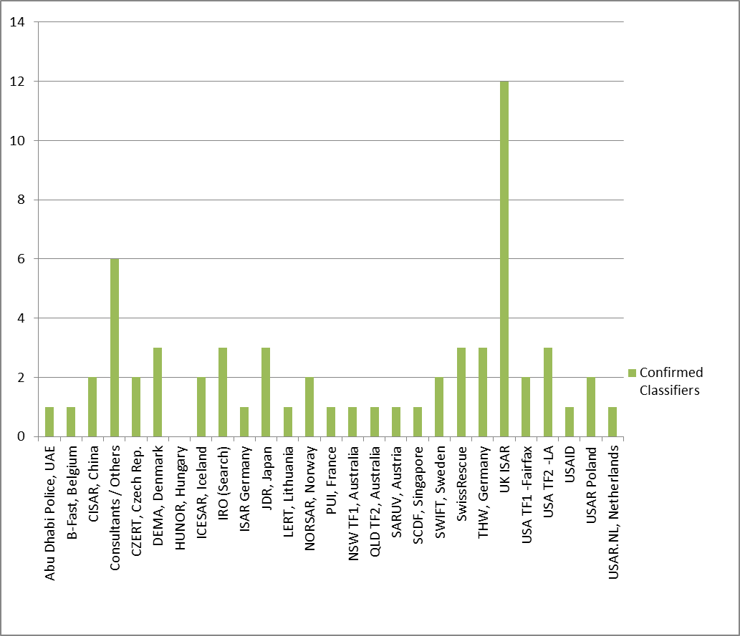
Total teams and organizations who contributed classifiers for 2011: 27
Total classifiers deployed: 61

Table D: Classifier Contributions for 2012
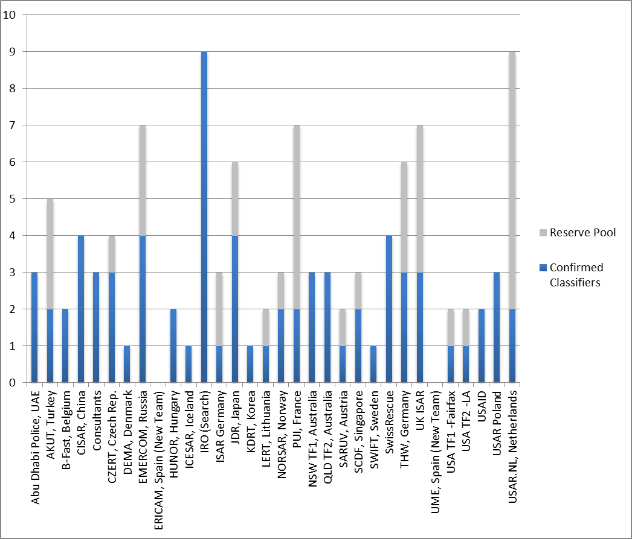

Total teams and organizations contributing classifiers for 2012: 31
Total classifiers provided: 110
Projected classifiers needed: 81
Total classifiers in reserve pool: 29

Table E: Classifier Contributions 2011 v. 2012

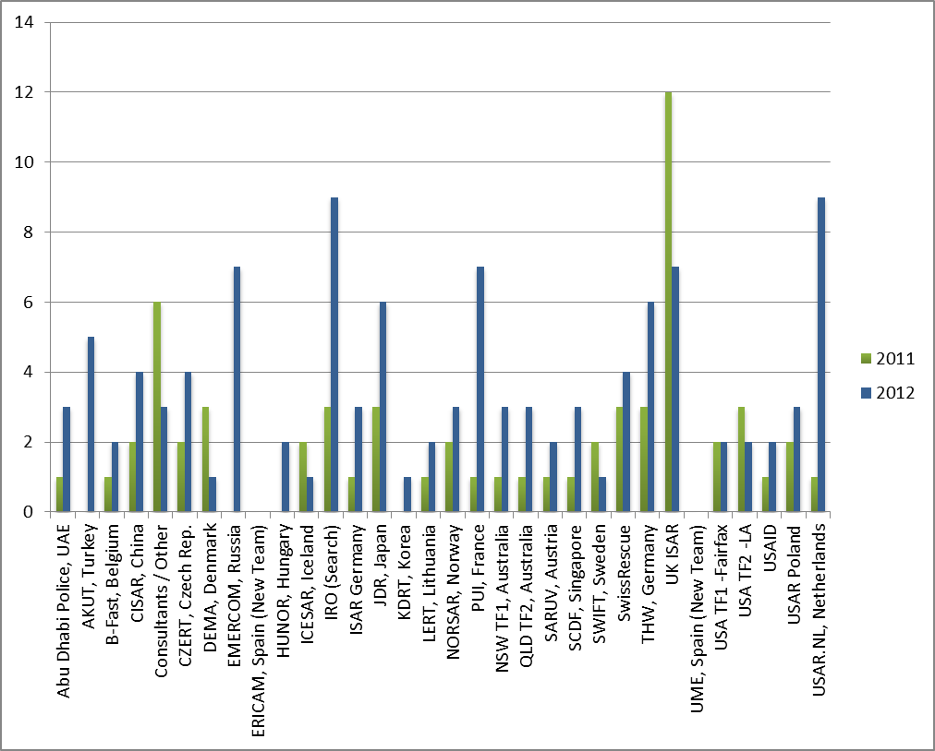

There has been an increase in IEC team membership from 21 to 28, 7 new teams, an increase of 33%.
There has also been a marked increase in classifier contributions by 80%!

Annex H: INSARAG Governance Discussion Study Paper

INSARAG GOVERNANCE
A strategic discussion paper

January 2102

Introduction

This study was commissioned by the INSARAG Secretariat at the end of 2011 to Prof. Piero Calvi-Parisetti of the Institute for International Political Studies of Bocconi University in Milan, Italy.

For some time, certain features of the INSARAGs governance structure had been called into question in light of the momentous changes that had taken place in recent years in terms of the Group’s membership and range of activities. This document, based on desk research and on interviews with a selected group of experts, looks at the mechanisms and structures through which the Group makes decisions, and the very nature of such decisions. A number of issues are identified as requiring attention. It is important to stress that this review is neither exhaustive nor final. Its aim is to provide a common basis for discussion, starting with the meeting scheduled for 16/17 February 2012. This document also presents some “options for consideration”. These should not be viewed as recommendations, but rather as an outline of some of the key ideas that have been put forward by interviewees on how some of the most important issues identified. The author would like to express thanks to all those who have contributed to this study.

1. The structure

INSARAG- a network of what? | To the non-initiated, INSARAG may appear as a network of practitioners and response organisations – a community of practices where experts exchange experiences and agree on technical standards and procedures. In reality, already from the inception, INSARAG is considerably more than this. In fact, INSARAG was primarily created as “a cooperative effort by countries […] and organisations that are providers of international USAR assistance, the UN, the IFRC and other international responders”. It is therefore evident that, in its deliberations, the Group is expected to deal with issues well beyond the intricacies of the technical USAR work. A full range of concerns pertaining to the relationship between countries affected by disasters and governmental/non-governmental providers of international assistance are therefore on the table for decision, as well as broader, non-technical policy issues of concern to the responders. Understanding the full breadth and diversity of the stakeholders in INSARAG is essential when considering the current state and future prospects of its governance.
An expanding agenda | Furthermore, a relatively new area of activity has emerged in recent years that substantially broadened the policy mandate and scope of action of the Group. Today, the development of national and local response capacities is viewed as critical for the effective response to earthquakes, and local preparedness capacity development accounts for a significant portion of what INSARAG oversees and promotes. This expansion in the policy and technical mandate comes together with an inevitable expansion in the number and diversity of stakeholders. Earthquake-prone countries do not participate any more just as potential recipients of international assistance, but have a full stake as partners in the capacity development process. This development too has to be taken into account when considering governance arrangements.

The current governance structure … | INSARAG is currently governed by a rather complex structure of bodies supported by a Secretariat based in the Field Coordination Support Section of UN OCHA in Geneva. According to the original formulation in the INSARAG Guidelines, the top policy making body is the Steering Group (previously named the Steering Group), which consists of a chairperson, Secretary (which is held by the Chief, FCSS, UN OCHA), Chairpersons of Regional Groups, Deputy Chairpersons of Regional Groups, and a representative of the IFRC and Chairs of any relevant Ad-hoc working groups. The Steering Committee meets annually to determine the strategic direction and policies of INSARAG.  Ad-hoc  Working  Groups  Steering  Group  Regional Group  Africa/Europe/Middle East  Regional Group  Asia/Pacific  Regional Group  Americas  INSARAG Secretariat  UN OCHA  Geneva (FCSS)  International  USAR  Team Leaders  Regional Antenna  The INSARAG Regional Groups (Africa/Europe, Americas and Asia/Pacific) meet annually to take measures to strengthen regional USAR response and ensure the strategic direction and policies from the Steering Group are implemented, and to assimilate relevant information from participating countries for submission to the Steering Group.  Below the Regional Groups, in the governance organizational chart, lie “regional antennas”. At the moment, one Regional Antenna exists in Tunisia to cover the North Africa sub-region.  At the same level as Regional Groups we also find Ad Hoc Working Groups. These task-specific bodies may be established from time to time at the request of the Steering Group, the Regional Groups or the USAR Team Leaders’ Meeting. These groups are staffed with personnel who have the relevant experience and qualifications to address the issues under discussion and include a representative from the INSARAG Secretariat. The purpose of these working groups is to develop solutions to specific issues identified by the requesting party (INSARAG Guideline revision, training, etc.). On completion of the task, the groups are expected to disband. Normally, the members of this group are part of or have experience as member of a USAR team and their membership in the WG is endorsed by the national INSARAG focal point. The costs associated with their participation in the WG (i.e.: travel, accommodation, etc.) is entirely funded by their home organisation / country.  Yet another entity that reports directly to the Steering Group is the International USAR Team Leaders’ Meeting. This is labelled here as an “entity” as it is not a formal group, committee or formal body but just an annual meeting. The INSARAG Guidelines describe it as a “network of experienced USAR professionals […] whose input, advice and experience serve to improve operational capabilities of international USAR response”. The INSARAG Secretariat convenes the annual USAR Team Leaders meeting. Invitations go out to INSARAG operational focal points and USAR team leaders of IEC-classified teams. It is also open to team leaders from non-IEC classified teams. These meetings provide a forum to discuss technical issues relating to training and best practice based on lessons learned from previous USAR operations and exercises.
…with recent changes… | If the structure outlined above was not complex enough, in 2009 the then Steering Committee decided that the decision-making structure “needed to be made more participatory and broad-based, to include Member States that have demonstrated commitment to the INSARAG standards”. It was therefore agreed to expand the INSARAG Steering Committee to include, in addition to the original membership, INSARAG Focal Points of all the countries whose USAR teams have successfully undergone the INSARAG External Classification, and to rename the Steering Committee Steering Group. As a result of this decision, the body saw its membership nearly triple to include 28 Focal Points from IEC countries. It is important to note, however, that the latest revision of the Guidelines contains no mention of such enlargement. To complicate matters even further, it should also be noted that practice has not been entirely in line with the change decided in the 2009 Steering Committee meeting, i.e. not only focal points of countries with classified teams but also focal points from classified teams were invited and participated in the Steering Group meeting, further enlarging the participation.
…is probably not best suited | In general, there is a strong sense that the way the INSARAG governance is currently set up may not be the best to suit its many purposes. The multiplication of fora and the escalation in the number of participants (e.g.: regional meetings with over 100 people in attendance) severely offset the needed balance between inclusiveness and the effectiveness of the decision making process. At the same time, a large, complicated and possibly redundant governance structure imposes significant requirements in terms of resources, and it is not clear how these can be met on a sustainable basis. Furthermore, the current setup makes it difficult for the Secretariat to follow the process, let alone to follow-up on decisions. It has also been argued that the inclusion of the IEC countries into the Steering Group leads to the marginalisation of the Regional Chairs and therewith of many other, non-IEC countries which in fact are becoming a primary focus of INSARAG through preparedness activities. Finally, although this may be a matter of perception rather than a real issue, according to some the size, membership and activities of some regional groupings has reached such a level that it actually puts into question the existence of a single, unified INSARAG.
2. The issues

2.1 No clear demarcation between operational, policy and institutional issues | In addition to the structural problems outlined above, a brief review of the issues dealt with by the current various levels of governance shows that they can be broadly classified under three distinct categories. Firstly, there are operational issues, eminently technical matters of concern for those directly involved in preparedness and response operations (e.g.: the use of particular tools or techniques). Secondly there are policy issues, “common answers to common problems” concerning the broader conduct of preparedness and response operations, of concern to USAR teams and affected/assisting governments (e.g.: timeline for deployment, self-sufficiency or the use of interpreters). Lastly there are institutional issues, which deal with the interface between preparedness and response operations and the government of the country where they take place or the government(s) of the country(ies) which funds them (e.g.: involvement of national civil protection in an international USAR exercise, relationship between LEMA and international USAR teams, legal responsibility and immunities). Currently, these different kinds of issues are all dealt with, at least to some extent, by all different governance structures, without clear attribution of responsibility for decision making.
2.2 National focal points… | The INSARAG Guidelines prescribe that in countries that are earthquake-prone and/or are providers of international assistance, two national focal points should be identified. One, defined Country Focal Point, should be a “senior officer in the Government Ministry responsible for the management of international and/or national disaster response”. This individual should act as a single point of contact with the Government for the INSARAG Secretariat and international responders, promote the INSARAG methodology nationally, ensure that the methodology for receiving international assistance is included in the national disaster management plan, represents the country in the respective Regional Group, ensures that the teams to be deployed internationally meet the classification standards and, in case of a disaster, feed the virtual OSOCC with information from the national level. The Guidelines also give the Country Focal Point a series of responsibilities vis-à-vis preparedness, including, possibly, the organisation of simulation exercises with international participation. The second, defined Operational Focal Point, “could be the same person as the Country Focal Point if appropriate”. This individual is responsible to act as a counterpart to the INSARAG Secretariat during response operations of international significance, both in case the country is affected and in case the country is providing assistance internationally.
…whose appointment process is not clear… | Although rather detailed in the description of the duties and responsibilities of national focal points, the INSARAG Guidelines are silent on the process and modalities for their appointment. In particular, although the national focal points are expected to be a civil servant, nowhere it is specified how the Government determines – or at least influences – the selection of one particular candidate. This creates the possibility of quite unclear situations, with individuals wearing different “hats” at the same time and entrusted with significant responsibilities vis-à-vis the national administration possibly without having strong – or at least formal – ties with the Government. Furthermore, it is not clear whether INSARAG should have any role in the selection of the Focal Points and, if so, whether this role should only be of formulation suggestions/recommendations or almost prescriptive. Finally, the question was raised of whether an NGO representative should/could be appointed as Focal Point in countries in which the government is not engaged.  It should be noted that over the last two years, all focal points from countries in the Americas region have been designated by their relevant national authorities and the INSARAG Secretariat was informed by official letter, to which the Secretariat replied by copying the country’s permanent mission in Geneva, the UN Resident Coordinator in country, the INSARAG Regional Chair and the OCHA regional office in order to keep all relevant entities informed.
…and whose profile should match the assigned role | Furthermore, when looking in details at what is expected form national focal points, it becomes apparent that the list of responsibilities is huge and covers at least two distinct areas (briefly described above as “policy” and “institutional” issues) and possibly three (including “technical” issues). It has been repeatedly argued that such responsibilities should be clearly divided between two focal points, the Country and Operational Focal Point, and that these two officials should have a role in the administration and an experience specifically matching the two distinct categories of tasks.

2.3 Regional Groups that have evolved somewhat independently | As it was to be expected given the differences in membership and history, the three Regional Groups have today somewhat different governance structures and arrangements. In the Americas, a strong bond exists between the Regional Group and the USAID-OFDA-LAC regional office, which was instrumental in its creation and which supported it handsomely. The head of USAID-OFDA-LAC has in fact been the Chair of the Regional Group since its creation over 10 years ago. With the official nomination of focal points and growing ownership of countries in the INSARAG network, the Regional Group decided to nominate Mexico and Costa Rica as Co-chairs for 2012 which is the first change in regional chairmanship since the group’s inception.  The Asia-Pacific Regional Group is unique in that it includes members from both disaster prone developing countries and donor countries with a high disaster preparedness and response capacity. The regional Chairmanship has traditionally been and rotated amongst countries providers of international assistance, but in recent years disaster prone countries have indicated a keen interest and have taken on the chairmanship function. The tenure of the chair has also changed with the introduction of a rotation arrangement: after one year, the Chairperson becomes the Vice Chair for an additional year.  The Africa/Europe/Middle East Group is the oldest regional group of INSARAG, dating back to the first years of INSARAG and has a very diverse composition. Europe has the highest number of donor countries in USAR context with a strong regional organisation (EU), Africa has very few countries and USAR teams involved in INSARAG actively and the Middle East has been engaging in the recent years. The Group also has the only Regional Antenna in the INSARAG system. It also has the highest number of IEC classified teams in the world. The regional group has four of the six UN official languages relatively widely spoken in the group that also creates challenges to ensure the best intra-regional communication. The group's governance is implemented through a Regional Chair and Vice-Chair. Every year a new Vice-Chair is elected. The Vice-Chair becomes the Chair the next year. There is no rotation or similar system in the region to elect the Vice-Chairs. Any member state interested in can be nominated.

2.4 Unclear role and appointment process of the leadership of the Regional Groups | According to the Guidelines, regional groups should have a Chairman and a Vice-Chairman, both serving for one year. The conditional is needed, as there are exceptions in reality and one Group has to two-Chairpersons and two Vice Chairpersons. The current arrangements, though, are not without problems. First of all, the role and functions of the two positions are not specified. It is not clear if these positions are of pure representation, or if – and to what extent – they have actual governance or management roles. Nor it is clear if the two positions have different roles or if they are somewhat one the double of the other. Secondly, there are no established procedures for the election of these two officials. Can these be issued from USAR teams, or should they only represent governments? And, what is the relationship between the chairmanship and the fact that a particular country is a strong provider of resources for INSARAG activities? In the same line, should a country with no current USAR capacity be considered for an elected position in a Regional Group? Lastly, it has been observed that one-year mandates are possibly a) too short to enable the elected officials to make any impact and b) very work- and resource-intensive in terms of elections. The principle of rotating chairmanship, however, is seen as healthy as it fosters wider ownership and participation in the network and shared responsibilities.

2.5 Subsidiary bodies with a life of their own? | The INSARAG Guidelines are rather clear on the fact that ad-hoc Working Groups should be task- and time-bound arrangements, and that they are created “to develop solutions to specific issues identified by the requesting party”. In reality, some of the Working Groups have been in existence for a long time, and are now more akin to permanent bodies. Their relationship with the “requesting party” may be unclear, and one may be under the impression that the Working Groups “develop solutions to problems that they have identified themselves”, or that they function as further platforms for the exchange of experiences. An additional challenge is that in some cases these Groups have grown quite large, and meet frequently, thereby consuming a significant amount of resources. This may become at some point difficult to justify vis-à-vis the contributing governments.

2.6 Lack of clarity about the INSARAG Directory… | One of the responsibilities of the Secretariat is to maintain the INSARAG Directory. Currently, the requirements for being included into the Directory are not clearly specified, apart from a generic responsibility given to the national focal points to provide data. This also creates the possibility for considerable lack of clarity, with top teams of utmost capacity and professionalism listed alongside smaller ones of uncertain reputation. At the same time, the ultimate purpose of the Directory is neither agreed nor specified. Is this to be a simple, comprehensive database of what exists in terms of USAR capacity? What are the links with the IEC process? How is the Directory to be used in emergency situations?
…reflects a lack of clarity on INSARAG membership as such | Such lack of clarity concerning the Directory is but a reflection of a larger, more fundamental issue concerning the concept of membership in INSARAG. Although this appears rather clear to the insiders, it has the potential to be a source of considerable problems. Apparently, nowhere in the Guidelines it is mentioned what a “member” of INSARAG actually is. Furthermore, there are no established admission criteria. It is clear that countries are members, and it is as clear that response organisations – and in particular USAR teams – are members. But - are both of them “members on an equal footing”? Some more equal than others? What are the requirements to become a member? This is particularly relevant for teams, some of which are a governmental, some non-governmental and others are listed in the Directory as “volunteers”. Some countries take upon themselves the responsibility of identifying who can be considered a national team and who cannot, but many other countries have neither the will nor the capacity to get into a potentially troublesome process. And, whilst the Guidelines are clear in terms of what is expected by affected and assisting countries both during response and preparedness interventions, there is no mention of any responsibility of an INSARAG “member” vis-à-vis the network itself.

2.7 The absence of the Red Cross | The International Federation of Red Cross and Red Crescent Societies (IFRC) was among the founding organisations of INSARAG, and is repeatedly cited throughout the Guidelines as a key partner. This comes as no surprise, as the primary role in disaster preparedness and response of national Red Cross and Red Crescent societies around the world is well known. Despite all that, however, the IFRC is conspicuously absent in practice from all governance and technical structures of INSARAG.

2.8 Global chairmanship – a delicate issue | Since the inception, INSARAG has been blessed with the remarkable leadership of Ambassador Toni Frisch of Switzerland. This extraordinary individual, considered by many the moral and intellectual founder of INSARAG, embodies all the qualities of a true global leader: from high international standing, as the Head of Swiss Humanitarian Aid, to vision, from the capacity to inspire to a leadership style that is decisive and consultative at the same time. Last but certainly not least, a direct access to significant financial resources has helped INSARAG achieving many goals which would have been without reach otherwise. Ambassador Frisch was again elected as Global Chairman in 2009, with a five year mandate. His succession presents the network with quite a number of additional challenges. Firstly, this important position has no established Terms of Reference. The network has to decide whether this position should be more executive (“making things happen”), governing (“setting the vision”) or representative. Secondly, no election modalities are specified. The network should decide whether the Global Chairman must be selected from within the membership – and with what criteria – or if an outsider can be considered as well. Voting rights amongst the members also has the potential to be a particularly sensitive issue. Finally, the issue was raised of the functional relationship between the Global Chair of INSARAG and the UNDAC system, particularly the UNDAC Advisory Board.

2.8 A difficult role for the Secretariat | The INSARAG Secretariat was originally set up to provide support to the then Steering Committee, the Regional Bodies and the Team Leaders’ Meeting. This included administrative support, policy guidance and advice. This part of the work of the Secretariat does not present particular difficulties. More difficult is the follow-up work to the subsidiary bodies, as they deal with considerably more technical issues and the style of work is peculiar. Today, however, a major part of the work of the Secretariat consists in dealing with the IEC process. This requires a heavy administrative workload "just to keep the system together". A big chunk is devoted to the selection and composition of the teams, in order to provide quality assurance for the classification process, and to long-term planning (up to 2 years planning cycle). In addition to all this, the Secretariat deals with the collection of lessons learned, promotes operational learning and shares knowledge amongst the members. The Secretariat maintains the INSARAG webpage as well as the USAR directory.  Besides these more visible components of its work, the Secretariat engages in considerable work "behind the scenes". This has to do with mediation between the political and strategic interests of various members and sub groups, networking with a range of stakeholders, fundraising and the management of sizeable resources, primarily through the management of the UNDAC account. Finally, it must not be forgotten that the Secretariat provides a 24/7 function of emergency response support, overlapping but separate from what it does for UNDAC.  That is considerable preoccupation amongst the persons interviewed for this review that the Secretariat is currently under resourced to deal with such a broad range of tasks. Been fully occupied with these care and maintenance activities, it is hardly possible for the Secretariat to engage in any strategic thinking. Looking at the future, it is obvious that the expectations on the Secretariat are going to be quite different depending on whether INSARAG is considered primarily as a normative body (not unlike what happens with the SPHERE Project), or primarily as a centre of excellence dealing with knowledge management.
2.9 Question marks about Regional Antennas | Questions are often raised about the opportunity to maintain the institute of Regional Antennas. Their very role, as well as functioning, sustainability and funding are put into question and there seems to be considerable lack of clarity amongst experts.

3. Options for consideration

3.1 Ideas for further discussion | It is important to stress that this Review was not commissioned with the aim to formulate recommendations. Rather, through desk research and, especially, by speaking with a number of highly experienced individuals, the consultant was asked to gather a number of ideas on how some of the issues outlined in the previous section could be addressed. These ideas are offered for further consideration by INSARAG simply as a basis for discussion, under the understanding that the suggestions and possible solutions presented hereafter are neither the only ones possible, nor necessarily the best or most fitting for the problems identified.
3.2 Recognising the double nature of INSARAG | During the interviews, one of the respondents brought up an idea that, whilst difficult to define in precise conceptual terms, is actually quite powerful and may have the possibility of solving a number of the issues. This idea basically consists of recognising that INSARAG is both a “group”, as a gathering of member states with an interest in USAR activities, and a “network”, as a gathering of practitioners and experts from governments, NGOs, voluntary associations and other sources. As a group, INSARAG is expected to make policy decisions, and as a network to exchange information, collect and disseminate good practices, advance technical thinking and make recommendations for the policy level to endorse. Should this distinction between the two “souls” of INSARAG be accepted and better defined, by reflecting it into governance structures a number of problems would simply go away:  - The Steering Group would remain as the top policy making body and embody the “group” nature of INSARAG. It would drop the recent enlargement to IEC countries (a recommendation made by practically all the interviewees) and be composed of government representatives. It would decide on policy and institutional issues as described in earlier sections of this report.  - The Team Leaders Meeting would remain as the main technical body and embody the “network” nature of INSARAG. It should formally be elevated at the level of the Regional Groups, in as it formulates recommendations for the Steering Group to decide upon. It would discuss and decide upon operational issues and make recommendations to the Steering Group on policy issues.  - The subsidiary bodies would be brought under the control of the Team Leaders Meeting, which would decide on their creation, duration and work plan. The subsidiary bodies would discuss operational issues and make recommendations for the higher levels of governance to decide upon.
   | Institutional Issues | Policy Issues | Operational Issues
  Steering Group | DECIDE | DECIDE | DECIDE
  Team Leaders Meeting |  | RECOMMEND | DECIDE
  Subsidiary bodies |  |  | RECOMMEND
A rotating chairmanship for the Regional Groups… | Several of the interviewees agreed on two fundamental points concerning the leadership of the Regional Groups. On the one hand, one year in office for the Chairman appears too short a time, and on the other a mechanism should be devised to ensure a smooth transition between office holders. To address both these requirements, there seems to be consensus among the selected group of interviewees that a system of rotating chairmanship over a period of three years is potentially a good option. In such system, an official would be elected as Vice-Chairman for the duration of one year, and this would be a sort of “induction” period, during which the individual would become familiar with the leadership functions and requirements. After that, the person would become Chairman for another year. During this time he or she could make the commitments that would characterize his/her chairmanship. Finally, the person would go into a third year in office as Past-Chairman. This would be the time for following up and seeing about the implementation of the commitments made during the previous year, and to ensure a smooth transition to the following elected officials.
…with a pragmatic election system… | In the absence, for the time being, of precise rules and procedures concerning the election of officials for the Regional Groups, a pragmatic system, not unlike the one currently in use, was mentioned. This system is the one in use, for example, to elect the leadership of the UNHCR Executive Committee. In this case, officials are proposed by one or more sponsoring countries (following negotiations care of the Secretariat) and then accepted by acclamation/consensus.  There seems to be consensus on the fact that elected officials for the Regional Groups do not necessarily have to be issued by countries which are either providers of international USAR assistance or particularly endowed with resources. Although this would create potential problems in the case of the election of officials from resource-challenged countries, this approach seems to be more fitting with the expansion of INSARAG’s mandate towards the development of national capacities. It was also suggested that the resources issues for the Regional Groups (for instance, the support to a Chair issued by a resource-challenged country) should be dealt with directly at the regional level, whilst the Secretariat should limit itself to addressing resources issues at the global level.
…and clearer ToR | There appears to be consensus that, whilst INSARAG has to remain a global enterprise, its regional footprint has to become heavier. This could also be achieved through better defined Terms of Reference for the Regional Groups. These would have to deal with, inter alia;  -development of a strategy for INSARAG in the region with a 1 and 5 year time span. Such strategy would encompass all the INSARAG related activities, including trainings, exercises and all capacity development initiatives.  -collection of lessons learnt and best practices from emergencies which have happened within the region,  -support to regional simulation exercises and  -organisation of meetings.

Annex I Summary of INSARAG Governance Workshop Discussions

INSARAG Governance ‘Open Space’ Discussion Outcomes

Day 1
Group 1 – Global Governance
Topics:
- What should the mandate of INSARAG be?
- The role of steering/ management and ensure coherence of INSARAG network.
- Facilitate coordination of activities in capacity building and response.
Facilitator:
- Jesper Lund
Recommendation:
Advocacy
- Messaging and linking with other organizations at humanitarian community level and role of INSARAG as a new feature of assisting countries in contingency planning.
Activities to be carried out
- Guidelines are needed for capacity building and response coordination where INSARAG serves as a check and balances system on a global level and supports global branding as well as future strategies for IECs and on a global level.
- Conflict management within INSARAG network.
Structures
- There should be a Chairman and to ensure capacity and strength through a Vice Chair.
- Steering Group composition was addressed with different viewpoints.
- We need to have structures (global, regional, local) in place before we decide overall structure of the steering group.
Secretariat
- The role should be clarified through TORs and to support activities through the global and regional level and manage facilitation of different networks.
- Should not have any role in policy development.

Group 2- Regional and Capacity Building Governance
Topic:
- Capacity Building
Facilitator:
- Joe Bishop
Recommendation:
There were teams with USAR teams developed, and teams that were still in the process of developing capabilities.
- Main guidelines with regional specific requirements, continuity of regional leadership are must. Chairmanship possibly 3-5 years
- Highlights that OCHA regional offices must buy into the system and would like to decentralize FCSS IEC work. But can region take on these requirements without funding?
- Work plans divided into short-medium- and long term aims which relate to risk profiling of countries based on vulnerability.
- Regional exercises- there are many going on that don’t involve INSARAG at all.
- Promotion of IECs overshadowing national classifications? Are we making basic classification for domestic use attractive enough? Must identify a way forward and associated criterias.
- How do we ensure buy-in in basic skills such as light capacities. Must ensure that pool of urban responders remains available when building teams. Use other exercises to promote INSARAG exercises and get more buy-in.

Group 3 – Operational Governance
Topic:
- the role of leadership
Facilitator:
- Thomas Peter
Recommendation:
- Agreement reached that the current Team Leaders meeting could act as a clearing house between operational matters and policy. The Team Leaders is open to all interested parties, IEC and non-IEC, specifics to be determined.
- Decision level: consensus building in the Team Leaders meeting; Decision in the ISG. Team Leaders meeting represented in the ISG by the IOG (see below).
- The Working Groups should be as originally envisaged: small, time bound, task-specific and based on interest which is discontinued on completion of the task.
- The Team Leaders meeting should be supported by an operational group (IOG) to govern and supervise the work of the Working Groups. The IOG is composed of members from the Team Leaders meeting (concrete procedures to be defined). IOG reports to the Steering Group.
- Although recognizing the value of face-to-face meeting, efforts should be made by Working Groups to use new technologies where possible.
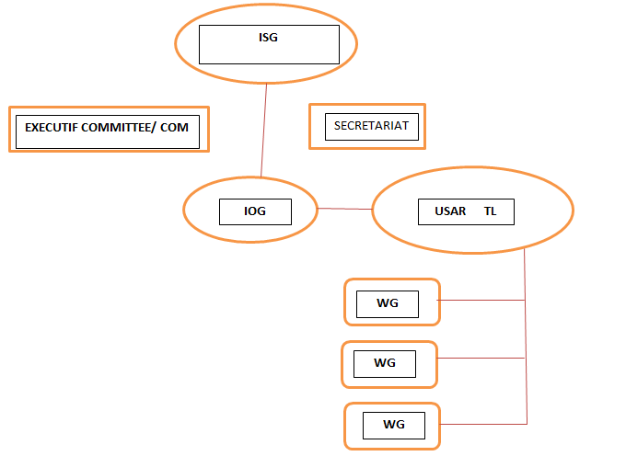

Proposed structure for INSARAG

Group 4 – IEC/IER Governance
Topic:
- IEC/ IER Handbook
Facilitator:
- Gisli Olafsson
Recommendation:
- Presentation of IEC/IER Handbook and Checklist as a great step forward providing clarification, including an example of how many people are needed for medium and heavy team.
- Clarifies that necessary measures are taken place for a successful IEC classification or assessment to postpone.
- FCSS capacity to deal with classifications and reclassifications is too small and more resources are needed. There are multiple ways to do this- members can be seconded from countries; jobs can be provided for longer period; funding can be provided to FCSS;

Annex J: INSARAG Governance Priority Areas for Follow Up

- Develop definitions for “operational”, “policy” and “political” issues in order to assign them to the appropriate levels of governance, and include such definitions (and examples) in the INSARAG Guidelines.

- Decide on the membership of the Steering Group, particularly with respect to the participation of the focal points of IEC countries.

- Develop detailed criteria for Chairman and Vice-Chairman of Regional Groups, and specify the procedure for their election. Decide on the proposal of having a three-year rotating chairmanship for Regional Groups (Vice-Chairman –> Chairman -> Past-Chairman).

- Define what “membership” of INSARAG consists of for different categories of stakeholders, and at the same time formulate a definition of both the “group” and “network” aspects of INSARAG. Includes funding responsibilities. Decide on the nature and ultimate purpose of the INSARAG Directory, and, based on that, decide on its overall management.

- Develop detailed criteria for the Team Leaders Meeting, including its placement within the overall INSARAG governance structure. Develop detailed criteria for each of the Working Groups, including membership, working modalities, reporting lines, expected results, sunset clauses.

- Decide on governance arrangements for Capacity Development

- Decide on governance arrangement for IEC/IER process

- Global Chairmanship (possibly including Vice/Chairmanship)

Annex K: FCSS 2012 Activities Calendar (updated 20 February 2012)
