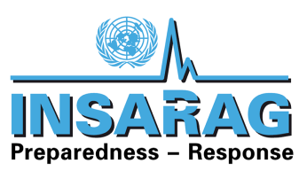

Working Group Meeting
12-15 September 2013
Provisional Agenda
- INSARAG Updates
- Progress of work on Guideline revision
  - UNDAC Handbook Review (old Chapters G/H; new D1 Coordination/D2 OSOCC/ D3 USAR Coordination); coordinate with OWG
  - Capacity Building Handbook (start on the 13th)
- E-Learning: Urs to arrange, including a VTC for the afternoon of the 13th
  - Levels of Learning
- Review of presentation for the TL Meeting
- Prepare handover of ToT for TL and Mentors and 1st Responder Courses to Secretariat
  - Have side discussion with Jordan about hosting

12th | Arrival of all TWG; register on VO prior to 15 August
13th | - Chapter G revision  - Capacity Building Handbook  - 1330-hrs Session on E-Learning and Learning Levels (VTC)
14th | Plenary Session of OWG, MWG, and TWG
15th | - IEC/R TL and Mentor Course (2014)  - 1st Responder Course (2014)  - Handover of both to Secretariat
16-18th | INSARAG TL Meeting
19th | - Update UNDAC Handbook  - 2. Design minimal standards for Technical Reference
20th | - INSARAG Webpage - how to provide access to those that have a need
21th | TWG Departure

