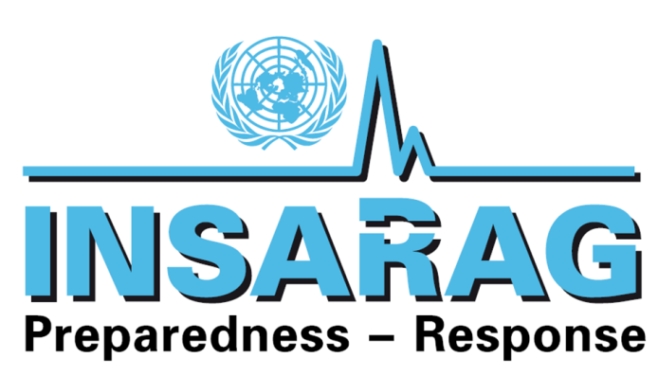

Medical Working Group

Gold Coast, Australia

19-23 March 2012

Chairman’s Summary

- Official Opening

The Medical Working Group (MWG) was hosted by the Australian Agency for International Development (AusAID) and the Queensland Fire and Rescue Service (QFRS). The meeting was held in parallel with the Annual USAR Team Leaders Meeting, the Training Working Group Meeting (TWG) and Operations Group Meeting (OWG) on the Gold Coast of Queensland, Australia.

- Chairman’s Welcome

The Chairman welcomed all participants to the first MWG meeting of 2012.

The list of meeting participants is attached (Annex A).

- Apologies

Apologies were received from the following MWG participants:
- Demetrios Pyrros (Greece);
- Kobi Peleg (Israel);
- Efraim Kramer (South Africa);
- Riadh Chalgam (UAE);
- Judith Highgate (UK);
- Iain McNeil (UK);
- Anthony Macintyre (USA);
- Rudi Coninx (WHO)

- Adoption of Agenda

The draft MWG Meeting Agenda was reviewed, amended and adopted as the final MWG Meeting Agenda for the meeting. For a copy of the agenda, refer to Annex B.

- Review of the 2012 ISG Meeting Chairman’s Summary

Mr Terje Skavdal, Chief of the Field Coordination Support Section (FCSS) provided an overview of the 2012 INSARAG Steering Group Meeting. The Chairman’s Summary refers to the following with regard to Working Groups.

“The INSARAG Chairman reiterated deep appreciation to the strong leadership and commitment of the working group chairs and their global members comprising professional experts in their respective fields, the concern that working groups are growing and pressure from new IEC teams wanting to also be a part of these groups create a need to discuss the governance system of working groups and this will be tabled later in the meeting.

In this regard, the ISG requested the INSARAG Secretariat, in close cooperation with the Working Group Chairs, to look into the team composition, working modalities, work plans, frequencies and venue of meetings, and conclusion of the group upon completion of the assigned tasks and the outcomes will be reported back to the INSARAG Chairman by mid-2012.

Following discussions, the ISG directed the Working Groups to align their work plans in 2012 as follows:

- to continue and produce outputs in 2012 as laid down in their respective Terms of Reference(ToRs)
- to meet where possible, back to back with the INSARAG Team Leaders Meeting 2012 and regional meetings. To utilise the INSARAG Earthquake Response Exercises, including relevant UNDAC events, to test their products i.e. proposed forms, procedures, etc;
- to contribute and upload relevant products to the INSARAG Web site, so that outputs can reach a wider global audience (e.g. the Medical technical guidance notes on crush injury)
- to actively participate in IEC/Rs and relevant INSARAG events, i.e. INSARAG IEC/R Trainers Course in UK.”

Action: MWG; INSARAG Secretariat

- Review of the final 2011 MWG Meeting Chairman’s Summary

The Chairman’s Summary of the MWG held in Cape Town South Africa was reviewed. Outstanding issues from that meeting were identified for completion for this meeting. The priority task was to complete the Basic Medical Rescue (BMR) module.

Action: MWG

- Review of the MWG Guidance Notes

The MWG reviewed the two medical guidance notes that were submitted to the 2012 ISG Meeting for approval. These medical guidance documents are:

- The Medical Management of the Entrapped Patient with Crush Injury. Similar to the 05 MWG_Amputations and Dismemberment_ISG Approved Feb 2011, medical science requires that the development of any clinical document requires that it be evidence-based on current medical literature on the topic. Therefore, this scope of work included conducting a comprehensive medical literature review on crush injury and crush syndrome. The draft document was then sent to an acknowledged and published subject matter expert for a peer review as is customary with medical literature publication requirements. The subject matter expert selected was Dr Nikolas A Jagodzinski, principal author of “Crush injuries and crush syndrome – a review. Part 1: the systemic injury” (Trauma, 2010) and Crush injuries and crush syndrome – a review. Part 2: the local injury” (Trauma, 2010). Dr Jagodzinski feedback stated “As a whole, I agree with it all and the few minor comments I have made are probably points you already know but chose to leave out so as not to confuse matters.” The comments Dr Jagodzinski alluded to have subsequently been reviewed by the MWG and where relevant, incorporated in the document. See Annex C
- INSARAG Patient Treatment Record. See Annex D

These two documents have been approved for use by the INSARAG Secretariat and will be added to the INSARAG webpage along with the other medical documents produced by the MWG. To access these documents online visit www.insarag.org

Action: MWG; INSARAG Secretariat

- Basic Medical Rescue (BMR) Module

The MWG completed the development of the Basic Medical Rescue (BMR) module. This module is NOT intended to be a stand-a-alone training package but is to be incorporated into the existing USAR First Responders Course, developed by the Training Working Group (TWG).

This module was handed over the TWG and includes:
- Overview of the BMR Module;
- Lesson Plans
- Summary Sheet
- PowerPoint Lectures

The complete package has been handed over to the TWG. It is recommended that the BMR module be piloted when the USAR First Responders Course is next presented with members of MWG being involved in the module delivery. This will enable the MWG to make any amendments to the module if required.

Action: TWG; MWG

- Review of the Crush Syndrome Algorithm

Based on the Medical Management of the Entrapped Patient with Crush Injury document developed by the MWG, the UK has developed a draft Crush Injury Algorithm for its internal use. This draft algorithm was submitted to the MWG for review. The MWG has offered several comments to the algorithm which are currently under discussion.

Action: MWG

- Interaction with the USAR Team Leaders Meeting

The MWG participated in the following USAR Team Leader activities:

- Provided an update of the MWG composition, achievements and potential future activities;
- Facilitated a workshop focusing specifically on the medical aspects of USAR operations. The purpose of this workshop was to:
  - Provide an overview of medical guidance notes developed to date and show where and how they can be accessed on the INSARAG webpage;
  - Review medical aspects of lessons learned from recent USAR responses
  - Obtain input from Team Leaders on medical aspects of USAR operations that need to be addressed by the MWG.
- Delivered a report out of the result of the MWG Facilitated workshop.

The participants of the USAR Team Leaders Meeting 2012 provided their input into issues that they feel should be addressed by the MWG. There was unanimous support from all present that the work of the MWG is important, that it is producing valuable outputs and that it should continue to address the issues highlighted by the USAR Team Leaders.
The USAR Team Leaders recommended that the MWG prioritize its work schedule based on activities that have the most impact on the well being of the USAR team e.g., addressing the medical aspects of USAR operations in extreme climates and altitude.

The USAR Team Leaders recommended that in addition to the work that has already been completed by the MWG, the list of current activities it is working on should also be posted on the web so that USAR teams are aware of what is on the agenda and can therefore contribute to the development of guidance notes.

The MWG will submit this proposed list of activities compiled from the input of the USAR Team Leaders to the INSARAG Secretariat for consideration.

The summary of the MWG Workshop is available in Annex E

- Interaction with the Operations Working Group (OWG)

Although the MWG formally concluded on Friday 23 March 2012, representatives from the MWG stayed on until the 25 March 2012 to participate in joint session with the OWG and TWG.

One of the key benefits of co-locating and running various working group meeting in parallel is that it creates opportunities for collaboration and integration of activities. The MWG and OWG took the opportunity to meet jointly to review the respective tasking and identify areas of cooperation.

The MWG and OWG reviewed two documents which have relevance for the OWG, namely:
- INSARAG Patient Treatment Record (Annex D)
- Draft OSOCC Victim Extrication Form (Annex F)

The INSARAG Patient Treatment Record has been handed over to the OWG to add to its database of generic forms. The purpose of this form is to be able to record patient and clinical information and is to be provided to teams that do not have a form of their own to capture this information. The objective of this form is to improve the recording of clinical interventions provided on-site and to have a more reliable and accurate way of handing over patient information. As this form contains confidential information, it is NOT intended for public distribution once it has been completed. It is intended that the clinical provider will keep one copy and the clinical provider receiving the patient will keep one copy in the patient’s clinical records.

The Draft OSOCC Victim Extrication Form was reviewed and handed over to the OWG for inclusion in its standardised package of forms used in its information management system. The OWG will convert the content of this form into its standardised document template and this form will be tested along with other similar forms, modified as required and following approval, utilised during operational activities.

Action: MWG; OWG

- Interaction with the Training Working Group (TWG)

Although the MWG formally concluded on Friday 23 March 2012, representatives from the MWG stayed on until the 25 March 2012 to participate in joint session with the OWG and TWG.

As per item 8 above, the MWG participated in a joint review of the BMR module. This module was accepted by the TWG and will now incorporate this module into the existing USAR First Responders Package.

In addition to the BMR module, the MWG was asked by the TWG to review the medical aspects of the IEC Checklist 2012 with the view to providing clarification where required. The TWG emphasized that the purpose of this review was not to change the current checklist with regard to content but the amend wording, if necessary, to provide greater clarity to classifiers. Accordingly, the MWG provided the TWG with its comments which have been captured as an output of the TWG Meeting.

Action: MWG; TWG

- Any Other Business

13.1 Germany: Requested the opportunity to discuss what should be included in a 3-day medical training program to assist THW mentoring of the Romanian USAR team

THW Germany has been assigned the responsibility of being the IEC Mentor for the Romania USAR team. In this regard, Dr Erich Wranze-Bielefeld, TWH representative on the MWG has been requested to provide a short-duration training course on the medical aspects of USAR operations. To this end, Dr Wranze-Bielefeld requested the opportunity to discuss this matter with the MWG and seek input on how best a training course of this nature could be structured. Dr Wranze-Bielefeld indicated that it is his intention to base the didactic lectures on the medical supplement of the INSARAG Guidelines (Section F11) as well as the medical guidance documents produced by the MWG to date.

The MWG suggested that an assessment of the current structure of the medical component of the USAR team and the level of medical care within the USAR team be undertaken prior to developing the course content. The results of this assessment would identify gaps, if any, and this would aid in determining the USAR medical training needs. Thereafter the course content could be developed using the MWG outputs as a reference. The MWG also suggested allowing sufficient time on the course for participants to participate in practical scenarios where they would be required to physically practice the methodology imparted during the didactic sessions.

This initiative serves to reinforce the need for medical guidance notes as they play a significant part with regard to USAR capacity building initiatives.

Action: THW

13.2 Netherlands: USAR NL offered to share their experience from their recent IER with specific reference to medical aspects of USAR

The medical manager Dr Thomas Eckhardt of USAR.NL requested the MWG to review the medical recommendations it received during its IER in September 2011.

The MWG were of the opinion that some of the recommendations were appropriate even though there implementation would exceed the minimum standards of INSARAG e.g., having a heating capacity for the medical tent and having access to oxygen concentrators.

However, the MWG unanimously agreed that the other recommendations offered were neither relevant nor practical for the medical element of a USAR team. One recommendation in particular was deemed to be associated with a high level of risk in the context of USAR medical operations.

13.3 CISAR experience responding to extreme altitude

Dr Peng Bibo, Medical Team Leader of CISAR, shared the experience of the CISAR response to the Yushu Qinshai earthquake, 14 April 2010 (magnitude 7.1 on Richter scale). The altitude of this response was to approximately 4000m above sea level. CISAR is located in Beijing which is at a very low altitude. As example, the altitude at the Beijing International Airport is 35m above sea level. The team deployed by air directly to the affected area, a flight of approximately 4 hours. The team therefore underwent a rapid change in altitude.

Members of CISAR team faced several challenges due to the high altitude. Almost all members of the 70 team members suffered from altitude induced insomnia, headache and vomiting. Two team members suffered severe symptoms, one presenting with acute cerebral oedema and the other presented with acute pulmonary oedema. Both of these team members required urgent evacuation to low altitude.

The effects of altitude also required the working shift to be reduced to 2 hours as rescuers were physically exhausted after this time. The response was further complicated by effects of extreme cold i.e. -20° Celsius excluding wind chill factor.

This experience confirms the need highlighted by the USAR Team Leaders for developing a medical guidance note on the USAR response to high altitude as well as extreme weather environments.

Action: MWG

- Review status of MWG meeting scheduled for 2012

The MWG has not scheduled any additional meetings as yet. The MWG will submit the proposed list of action items compiled with the input and endorsement of the USAR Team Leaders meeting to the INSARAG Secretariat for consideration. Pending the decision of the INSARAG Secretariat, the MWG will schedule additional meetings as required to deliver on its mandated tasks.

Action: INSARAG Secretariat; MWG

- Acknowledgements

The MWG would like to acknowledge and extend its appreciation to the Australian Agency for International Development (AusAID) and the Queensland Fire and Rescue Service (QFRS) for their efforts in organizing and hosting the meeting as well as their warm and generous hospitality.

The MWG would also like to acknowledge and thank the sponsoring agencies of all the participants without whose support, this meeting would not have been possible.

- Meeting Closure

The meeting was officially closed by the Chairman.

Annex A - Meeting Participants

MWG Participants

Name | Country | Sponsor
Dr Peng Bibo | China | CEA
Dr Erich Wranze-Bielefeld | Germany | THW
Dr Jun-ichi Inoue | Japan | JICA; MoFA
Dr Thomas Eckhardt | Netherlands | USAR.NL
Dr Beng Hoong Poon | Singapore | SCDF
Dr Olivier Hagon | Switzerland | SDC
Mr Trevor Glass | MWG Chairman | AusAID

Annex B - Meeting Agenda

INSARAG Medical Working Group
Gold Coast, Australia
19 – 23 March 2012

AGENDA

- Opening and Welcome.
- Apologies.
- Review of meetings administrative arrangements and meeting plan.
  - Interaction with USAR Team Leaders Meeting
  - Interaction with TWG Meeting
  - Interaction with OWG Meeting
- Review of the INSARAG Steering Group Meeting Chairman’s Summary.
- Review of the last MWG Meeting Chairman’s Summary.
- Review MWG Guidance Notes.
- Continue work on MWG TOR activities, specifically the Crush Syndrome Algorithm.
- Develop Module 6 Basic Medical Rescue of the Training Working Group (TWG) USAR First Responder’s Course.
- Review status of MWG meeting scheduled for 2012.
- Any Other Business:
  - Germany: Requested the opportunity to discuss what should be included in a 3-day medical training program to assist THW mentoring of the Romanian USAR team;
  - Netherlands: USAR NL offered to share their experience from their recent IER with specific reference to medical aspects of USAR;
  - China requested the opportunity to discuss USAR response to extreme altitudes.
  - China: CISAR experience responding to extreme altitude.
- Update Participants List.
- Completion of MWG Chairman’s Summary.
- Meeting Closure.

Annex C

Title: | THE MEDICAL MANAGEMENT OF THE ENTRAPPED PATIENT WITH CRUSH SYNDROME
Last revised: | February 2012

- INTRODUCTION

- The following clinical guideline has been developed by the INSARAG Medical Working Group (MWG) which consists of medical professionals actively involved in the urban search and rescue discipline. The MWG is comprised of representatives from 15 countries and organisations drawn from the three INSARAG regional groups.

- This clinical guideline outlines a recommended approach to crush syndrome in the austere environment of collapse structure response. As such it is to be considered as a consensus statement by members of the MWG based on current medical literature and experience; it is not intended to be a prescriptive medical protocol. In addition it must be understood that these guidelines have been developed for application in an environment which may be complicated by factors such as:
  - Hazards to rescuers and patients e.g., secondary collapse; hazardous material;
  - Limited access to entrapped patient;
  - Limitations of medical and rescue equipment within the confined space;
  - Prolonged extrication and evacuation of patient;
  - Delayed access to definitive care.

- DEFINITION
- Crush Injury: Entrapment of parts of the body due to a compressive force that results in physical injury and or ischaemic injury to the muscle of the affected area, most commonly discussed in the context of collapsed structure incidents. If significant muscle mass is involved, it can lead to crush syndrome following release of the compressive force.

- Crush Syndrome: A potentially life-threatening, systemic condition that can occur after release of a compressive force that has been applied to a muscle mass. The factors that lead to the development crush syndrome include:

  - Degree of compressive force;
  - Amount of muscle mass involved;
  - Duration of compression.

- The compressive force can be from one’s own body weight in a static position or from an external source.

- The onset of crush syndrome occurs following reperfusion of injured muscle when the compressive force is released. This may result in acute and or delayed-onset clinical sequelae.

- The three primary acute pathophysiological concerns are:
- Hypovolaemia which may result in shock;
- Electrolyte imbalances including hyperkalaemia which may result in acute cardiac dysrhythmias;
- Metabolic acidosis which may result in shock.

- Delayed-onset pathophysiological concerns include:
- Renal failure;
- Adult Respiratory Distress Syndrome (ARDS);
- Coagulopathy;
- Severe sepsis.

- Delayed medical care and or inappropriate rescue management e.g., uncontrolled rapid removal of the compressive force before initiation of medical care e.g.; fluid administration, may result in rapid clinical deterioration and death of the patient.

- CLINICAL PRESENTATION

- All patients entrapped within a structural collapse environment should be considered to have some element of crush syndrome until proven otherwise. Rescuers and medical personnel should maintain a high index of suspicion of the potential for crush syndrome taking into account the following:

- There may be no obvious physical signs of crush injury and the patient’s vital signs may initially be normal;
- Physical signs, when present, may include:
  - Mottled or blistered skin;
  - Oedema;

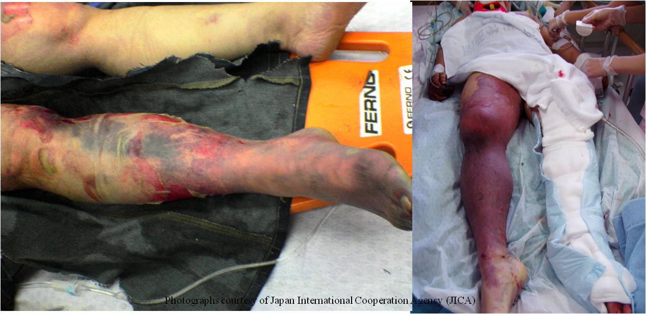

  - Reddish-brown urine;
  - Absent or diminished pulses in affected limbs;
  - General signs of shock;

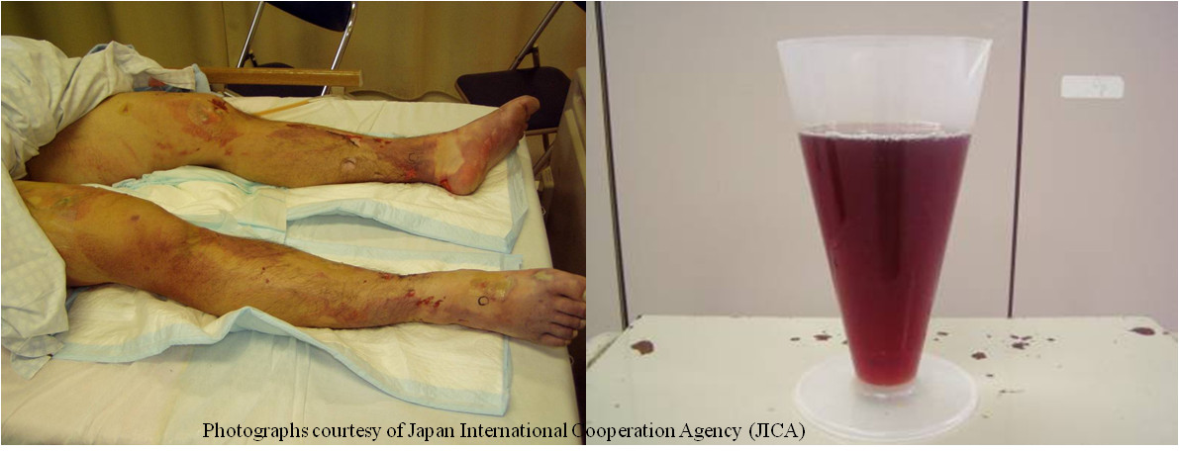

- Symptoms:
  - Dysaesthesia (e.g.; paraesthesia; hypoaesthesia; hyperaesthesia);
  - Anaesthesia;
  - Pain:
    - Presence and level of pain may not reflect the level of severity of injury;
    - May be exacerbated on movement/release;
- Paralysis or paresis of the affected limbs.

- Note: Crush syndrome may be incorrectly diagnosed as a spinal cord injury. This is an important differential diagnosis to make as the treatment regimes differ significantly. If in any doubt, treat as for crush syndrome whilst protecting the spine until spinal injury can be excluded.

- Hyperkalaemia should be anticipated in crush injury. It should be identified and managed as early as possible. See Section 4.2.2 below.

- MANAGEMENT STRATEGY

- For the general approach to patient treatment in the confined space environment see 01 MWG_Provision of Medical Care in an Austere Environment Specifically in a Confined Space_ISG Approved Feb 2011. If relevant, see also 05 MWG_Amputations and Dismemberment_ISG Approved Feb 2011.

4.1. General Management

- It is imperative that the rescue team recognise the dangers of not treating the patient prior to release of the compressive force;
- The method and timing of the removal of the compressive force should be closely coordinated between the rescue technicians and the medical personnel.
- Removal of the compressive force should not be delayed as the severity of crush syndrome and compartment syndrome is proportional to the duration the area is crushed for;
- The method and route out of the rubble pile should be prepared prior to the removal of the compressive force;
- The required extrication equipment should be immediately available;
- Method of transport should be established early;
- Receiving healthcare facility should be identified as soon as possible.

4.1.2 Medical Management

- Entrapped patients may appear stable whilst the compressive force is in place;
- Anticipate what medical equipment and medicines may be required to treat the patient and ensure that these are immediately available prior to removal of the compressive force.

4.1.2.1 Fluid Management in Crush Syndrome

Important Considerations:

- Currently there is no strong scientific evidence to support any single definitive fluid regime for the collapsed structure environment.
- However, fluid administration remains the cornerstone of therapy for the medical management of crush syndrome and establishing adequate intravenous access and providing fluid is therefore of critical importance.
- In the USAR environment, fluid loading of the patient is recommended as one of the most important actions prior to release of any compressive force.
- The USAR environment usually precludes an ability to definitively monitor haemodynamic, electrolyte and metabolic status of the patient.
- Special consideration should be given to the administration of lower rates and doses of fluid administration which may apply to:
  - Those with lower muscle mass:
    - Paediatrics;
    - Elderly;
    - Chronically malnourished;
  - Patient with known co-morbid conditions e.g.; heart failure.

Fluid Administration

- Fluid administration routes:
  - Consider the following methods of venous access:
    - Peripheral;
    - Intraosseous (IO);
    - Venous cutdown;
    - Central (least desirable, consider the risks associated with central venous access within a confined space);
  - If intravenous (IV) access is not possible, consider alternative routes of fluid administration recognising their limited effectiveness (poor absorption) and potential side effects e.g., regurgitation:
    - Orogastric;
    - Nasogastric;
    - Rectal;
    - Subcutaneous (avoid administration in crushed area);
- Intravenous Fluid type:
  - Preferably use warm, isotonic, potassium free solutions.
- Fluid volume:
  - Fluid administration is not simply aimed at replacing what is lost. There are multiple reasons for fluid administration during various stages of the extrication:
    - Volume replacement as required to achieve haemodynamic stability;
    - Fluid loading to compensate for the sequestration of intravascular fluid into the interstitial space;
    - To maintain adequate renal perfusion and prevention of renal damage. This may require the use of volumes of fluids that may exceed volumes usually administered to a trauma patient.
    - To address maintenance fluid requirements.
  - Volume:
    - There is no strong scientific evidence to support any particular dose of administration. However, the literature supports the use of high volume fluids during extrication.
    - Many authors recommend 1 to 1.5 litres per hour for the adult patient until hydration status can be verified.
    - This may be augmented by intravenous fluid boluses.
    - The principles of damage control resuscitation (e.g.; permissive hypotension) may not necessarily apply.
- Other General recommendations:
  - Insulate fluids in cold environments;
  - Use pressure infuser devices in conjunction with rate control devices to aid with fluid administration. The confined space environment often precludes being able to place the intravenous fluid container above the level of the patients heart thereby preventing fluid flow or resulting in blood back flow up the administration set. Do not delay fluid administration waiting for equipment as manually squeezing the bag is an effective interim measure;
  - Ensure IV sites are adequately secured;
  - Use IV extension tubing to facilitate easier administration of fluid and medication;
  - Use two sites of intravenous access, if possible;
  - Adhere to sterile procedures as far as possible;
  - Monitoring haemodynamic status using urinary output can be difficult to assess in the USAR environment, however:
    - Encourage patient to urinate into a container if possible if they feel the need;
    - Make note of times patient urinates;
    - Observe the colour and estimate the volume, if possible;
    - It is not generally advisable to attempt bladder catheterization within a confined space. As an alternative consider the use of a condom catheter in a male patient.
    - Be aware of the patient with a full bladder who is no longer producing urine i.e. a single collection of urine is not always a reliable confirmation of ongoing renal function.

4.1.2.2 Medications

Important Considerations:

      - As crush syndrome is associated with acute renal failure, medications with known nephrotoxic effects must be avoided if at all possible e.g.; non-steroidal anti-inflammatory drugs (NSAIDs).
      - Patients presenting with possible acute renal failure may accumulate excessive doses of an administered drug due to inability of urinary excretion leading to toxicity.

Recommendations

- The medical literature and USAR experience support the early administration of the following medications:
  - Sodium Bicarbonate 8.4% (e.g.; 50 ml IV in an average adult patient) prior to removal of the compressive force. Although there is no strong scientific evidence to support additional bolus doses, this may be considered in a prolonged extrication. Subsequent slow intravenous infusion may assist with alkaline diuresis which is thought to aid renal protection.
  - Analgesia: Appropriate and adequate analgesia is not only important for patient comfort, it may assist with patient extrication. Selection of analgesic may be influenced by the scope of practice, duration of action, renal elimination, effect on the haemodynamic profile and need for airway support.
  - Antibiotics: preferably broad spectrum (including anaerobes) intravenous or intramuscular in non-damaged tissue; avoid nephrotoxic antibiotics.
  - Medications for the treatment of hyperkalaemia may include:
    - Sodium Bicarbonate 8.4%;
    - Calcium 10% (in the presence of ECG changes indicative of hyperkalaemia);
    - Beta-2 agonist;
    - Intravenous dextrose and insulin;
    - Polystyrene sulfonate or resonium calcium (when practical and if prolonged transfer to tertiary care is expected).

Notes:
- Mannitol 20%: May be considered once ongoing urinary production and output has been verified. Note: Mannitol is contraindicated in anuric states.
- Although the use of allopurinol has been described in patients with non-crush syndrome rhabdomyolysis, its use in crush syndrome is not described.
- Acetazolamide has also been recommended for treatment, however its use in the confined space environment is restricted due to the inability to measure blood chemistry.
- Furosemide has unfavorable heamodynamic side effects. Furthermore, it causes acidification of the urine which counteracts attempts to alkalinize the urine through the administration of sodium bicarbonate. Therefore it use in this environment is strongly discouraged.
- Suxamethonium chloride is contra-indicated due to its exacerbation of hyperkalaemia.

4.1.2.3 Tourniquets

      - There is currently no scientific evidence to support the use of tourniquets in the prevention of crush syndrome following release of the compressive force.
      - The use of tourniquets should be reserved for otherwise uncontrollable life-threatening haemorrhage. Tourniquets used in this environment should be appropriately designed for arterial occlusion.

4.2 Post-release of the compressive force

- During and immediately following removal of the compressive force, reassess the patient’s clinical condition as it may rapidly deteriorate.
- Coordinate the extrication and evacuation with the rescue team as per pre-planned strategy.
- Continuously monitor the ECG for signs of acute hyperkalaemia as soon as practical.
- Continuously monitor the patient’s hemodynamic status.

4.3 Compartment Syndrome

Following the release of the compressive force, patients may develop a compartment syndrome. Current evidence in the medical literature discourages the use of fasciotomies in the field environment due to the high rates of sepsis and bleeding complications, which may be life-threatening. The literature supports the use of mannitol as a non-surgical approach to reducing intracompartmental pressures.

- REFERENCES

- Jagodzinski NA, Weerasinghe C, Porter K. Crush injuries and crush syndrome - a review. Part 1: the systemic injury. Trauma. 2010;12:69-88.
- Jagodzinski NA, Weerasinghe C, Porter K. Crush injuries and crush syndrome - a review. Part 2: the local injury. Trauma. 2010;[online]. Available at http://tra.sagepub.com/content/early/2010/07/08/1460408610372441 [Accessed 18 November 2011]
- Greeves I, Porter K. Consensus statement on crush injury and crush syndrome. Accident and Emergency Nursing. 2004;12:47-52.
- Smith J, Greeves I. Crush Injury and Crush Syndrome: A Review. Journal of Trauma. 2003;54:S226-S30.
- Gonzalez D. Crush syndrome. Critical Care Medicine. 2005;33:S34-S41.
- Demirkiran O, Dikmen Y, Utku T, Urkmez S. Crush syndrome patients after the Marmara earthquake. Emerg Med J. 2003;20:247-50.
- Sever M, VanHolder R, Lameire N. Management of Crush-Related Injuries after Disasters. N Engl J Med. 2006;354:1052-63.
- Ashkenazi I, Isakovich B, Kluger Y, Alfici R, Kessel B, Better O. Prehospital management of earthquake casulaties buried under rubble. Prehosp Disast Med. 2005;20(2):122-33.

Annex D – Patient Report Form

This document has been developed in Excel. It has therefore been submitted as a stand-a-lone document.
Annex E - Summary MWG workshop

- The MWG provided an overview of the medical guidance notes produced to date and where they can be located on the web i.e. www.insarag.org
- The MWG provided an overview of medically related issues that have been submitted through various INSARAG activities to the MWG for potential future attention.
- There was unanimous agreement by the USAR Team Leaders that the MWG should address the issues as highlighted below.
  - Current evidenced-based Critical Incident Stress Management (CISM) for USAR
  - USAR response to disasters with the potential for radiation exposure
  - USAR response to disasters with the potential for asbestos exposure
  - USAR response to disasters in extreme environments (extreme heat; extreme cold; altitude)
  - USAR response to earthquakes that result in tsunami’s
  - Medical issues with regard to ethical and medico-legal considerations when responding to a developed country versus a developing country
  - Medical aspects of “Beyond the Rubble”
- It was recommended that the MWG prioritize its work schedule based on activities that have the most impact on the well being of the USAR team e.g., addressing the medical aspects of USAR operations in extreme climates and altitude
- In addition to the issues highlighted above, the MWG was requested to address the following:
  - Transportation of patients extricated from the rubble pile in the absence of local ambulance services (requested by USA)
  - Expanding point 3 above to include other inorganic compounds e.g., carbon fiber (requested by QLD, Australia)
  - Impacts of extreme climate of search dogs (requested by IRO)
  - Combining points 2 & 3 above into one guidance note that addresses the medical aspects of HAZMAT in USAR operations (requested by Austria)
  - Medical evacuation of ill or injured USAR personnel (requested by INSARAG Secretariat). This would need to be done in consultation with the OWG as it has an influence on USAR Coordination Cell (UCC) activities
  - Nutrition and hydration during USAR operations (requested by NSW, Australia).
- It was recommended that in addition to the work that has already been completed by the MWG, the list of current activities it is working on should also be posted on the web so that USAR teams are aware of what is on the agenda and can therefore contribute to the development of guidance notes.
- Queensland Fire and Rescue Service (QFRS) made the MWG aware of two research projects it is currently involved in i.e. the use of negative pressure respiratory protection in USAR operations and USAR operations in tropical environments. It offered to share the results of these projects with the MWG and assist in the development of guidance notes pertaining to these two issues.

ANNEX F - OSOCC Victim Extrication Form

USAR Team

Name: ________________________________________
Contact person: ________________________________________
Contact number: ________________________________________
Email: ________________________________________

Victim

Name (if known): ________________________________________
Age (estimated if not known): _____________________________
Gender: Male □ Female □
Location (Building name; site identification number; GPS Coordinates):

GPS (Latitude): ________________________________________
GPS (Longitude): ________________________________________
Site ID ________________________________________
Building Name: ________________________________________

How were they located: ___________________________________?
Date & Time of Extrication: ___________________________________
Live/deceased:
Live: □ Deceased: □

Handed over to:
Name: ______________________________________________
Contact details _________________________________________

Additional Information

________________________________________________________
________________________________________________________
________________________________________________________
________________________________________________________
________________________________________________________

