
INSARAG Asia/Pacific Regional Group Meeting
Kobe, Japan
13/14 November 2003

Chairman Summary

The meeting of the INSARAG Regional Group Asia/Pacific was chaired by Mr. Eiichi Suzuki, Director, Overseas Disaster Assistance Division, Economic Cooperation Bureau, Ministry of Foreign Affairs, Japan. 62 participants from 22 countries and organisations attended the meeting. The list of participants is attached as Annex I.

The Chairman opened the meeting with a welcome address to participants, which was followed by introductory remarks from the Vice Chair of the Regional Group, Mr Liu Yuchen of China, Director- General China Seismological Bureau, Mr. Gerhard Putman Cramer, Deputy Director, Natural Disaster Policy and Chief, Emergency Branch, OCHA-Geneva, and Mr. Nobuo Kimura, Managing Director, Secretariat of the Japan Disaster Relief Team, JICA.

The Agenda of the meeting is attached as Annex II. The discussions following presentations, which were held during the meeting resulted in Conclusions and Recommendations as given below. The meeting then developed a Work Plan for the Regional Group for 2004. The work plan is also enclosed below.

Thereafter Commissioner James Tan, Singapore Defence Force was unanimously elected as Chairman of the INSARAG Regional Group Asia/Pacific for the next year from 31 March 2004 to 30 March 2005.

Please note that this report is also published on the INSARAG website at www.reliefweb.int/insarag following the link “Events” or “Reports”.

Conclusions/Recommendations

- All INSARAG Regional member states should assist each other in building and enhancing national USAR capacity.

- The Category 1 USAR Course proposed to be conducted for Pacific Island Countries in 2004 could be considered for support by donor countries of the region.

- USAR teams on international response missions are advised to seek out and coordinate their operations through the OSOCC and not directly with LEMA.

- Member states and USAR teams are encouraged to use the Virtual OSOCC on occurrence of an emergency.

- INSARAG should establish a system of advising international USAR teams to stop deployment when additional capacity is not needed in the field. Awareness of this issue should be raised amongst decision makers in Governments.

- There is no need for an INSARAG regional working group on LEMA-OSOCC relations. The revised INSARAG Guidelines should provide relevant guidance.

- Member countries are encouraged to ensure that procedures for integration and facilitation of international assistance i.e. USAR teams, UNDAC team, OSOCC and Reception/Departure Centre are included in their national disaster management plans at all levels (state, district or equivalent) - GA Res 57/150 of 16 Dec 2002 refers. A suggested template for border controls based on the New Zealand document should be placed on the INSARAG website for reference by interested countries.

- The revision of the INSARAG Guidelines should take place in a 4 day inter regional working group meeting to be organized by the INSARAG Secretariat in early Feb., 2004 in Geneva under the chairmanship of New Zealand. The Asia-Pacific Region will be represented by Japan, Singapore and Korea. All participants will bear their own travel, boarding and lodging expenses.

- The Regional Working Group on training’s revised TOR are endorsed and the Working Group is directed to proceed with Phase 1 to start with i.e. to prepare an inventory of USAR training facilities in countries of the region and what can be offered for international training.

- The concept of a self-evaluation procedure as being developed in the INSARAG Americas region is endorsed. External evaluation and accreditation is left for discussion in the future in the Asia/Pacific Regional Group.

- The utility of international USAR Exercises in which skeleton USAR teams (max 5 persons from the team management) and an UNDAC team participate in national disaster management exercises was acknowledged and endorsed.

- The following INSARAG Exercises are planned for the region in 2004 in which regional countries are encouraged to participate with skeleton USAR teams (max 5 persons each).
    - Manila, Philippines, 19-23 Jan., 2004 (Australia, China, Indonesia, India, Japan, Korea, Malaysia, Pakistan, and USA indicated interest in participating) The last date for confirming participation in the Exercise to the INSARAG Secretariat is 15 Dec 2003.
    - Kathmandu, Nepal, Mar., 2004 (provisional)
    - Australia, end 2004

- GA Resolution 57/150 of 16 Dec., 2002 is a very useful document for facilitating international USAR operations and member countries should ensure it is distributed beyond the Foreign Ministry to the entities responsible for disaster management at the national, state and district levels (or equivalent).

- Member Countries should forward details of their national INSARAG focal points to the INSARAG Secretariat at the earliest.

- INSARAG member states should ensure that relevant authorities in their countries that deal with terrorist events resulting in collapsed structures are made aware of INSARAG procedures and capabilities.

- When possible, regional events should be planned 18 months prior to the scheduled date.

INSARAG Asia-Pacific Regional Group Work Plan – 2004

- Regional Working Group on training to send questionnaire and establish database of USAR-training capacity in the region by 1 Jul., 2004.

- Regional Working Group on training representatives to participate in INSARAG inter-regional USAR training discussions.

- Contact details of member country INSARAG focal points to be sent to INSARAG Secretariat by 31 Jan., 2004.

- New Zealand to send draft INSARAG Guidelines outline to members by 15 Dec., 2003 and receive any comments by 15 Jan., 2004.

- Japan, Korea and Singapore to participate as representatives of the Asia/Pacific Regional Group in the inter-regional workshop on revision of INSARAG Guidelines in Feb. 2004 in Geneva chaired by New Zealand.

- INSARAG Regional Exercise with skeleton USAR teams and UNDAC team to be held as under:
(a) Philippines 19-23 Jan., 2004
(b) Nepal Mar., 2004 (provisional)
(c) Australia end 2004

- Member States to ensure distribution of GA Res 57/150 to State, District level (or equivalent) authorities by 31 Mar., 2004.

- Next Asia Pacific INSARAG Regional meeting to be held in end 2004.

- Chairman to ensure the Asia-Pacific region is represented at INSARAG inter-regional Working Group meetings when requested.

- Cat 1 USAR training course to be held in the Pacific (Samoa) in June/July 2004.

ANNEX I

Meeting of the INSARAG Regional Group Asia/Pacific

13-15 November 2003 - Kobe, Japan

Agenda

TIME | EVENT | RESPONSIBLE

Wednesday, 12 November 2003
Until 19.00 | Arrival and registration | Host Country
18.00-19.00 | Welcome Cocktail at JICA Hyogo International Centre (HIC) | Host Country

Thursday, 13 November 2003
09.00-10.00 | Registration | Host Country
10.00-10.15 | Opening remarks by Chairman and others | Host Country  INSARAG Chairman
10.15-10.45 | Introduction of participants including members’ status and adoption of the  Agenda | Host Country  INSARAG Chairman
10.45-11.30 | Update of recent INSARAG meetings and latest INSARAG activities | INSARAG Secretariat
11.30-12.30 | Presentation and discussion of USAR operations in the recent earthquake in Algeria (May 2003) | INSARAG  Secretariat  China  Korea  Japan
12.30-14.00 | Lunch | Seminar Room4,5,6
14.00-14:30 | Progress report and discussion of Regional Working Group on Training | Australia
14.30-14.45 | Report on Meeting of ASEAN Regional Forum on management of a terrorist event leading to collapse urban structure | New Zealand
14.45-15.30 | Progress report and discussion of Regional Working Group on  Local Emergency Management Authority (LEMA) and On-Site Operations Coordination Centre (OSOCC) Relationship | Australia  Singapore
15.30-16.00 | Coffee
16.00-16.45 | Progress report and discussion of Regional Working Group on INSARAG Guidelines revision | New Zealand
16.45-17.15 | Presentation and discussion of the USAR classification/verification concept, as proposed by the Americas INSARAG Regional Group | INSARAG Secretariat
19.00-20.30 | Welcome Dinner by Disaster Reduction Alliance and JICA | Host Country

Friday, 14 November 2003
08.30-08.50 | Group Photo
09.00-10.30 | Observe Hyogo Prefecture Disaster Management Center | Host Country
11.00-12.30 | Visit Disaster Reduction and Human Renovation Institution | Host Country
12.30-14.00 | Lunch | Seminar Room4,5,6
14.00-14.30 | Debriefing on Japan-Singapore Joint SAR Training Program in Singapore | Japan  Singapore
14.30-15.00 | Briefing on proposed INSARAG regional exercise in the Philippines | Philippines  INSARAG Secretariat
15.00-15.30 | Coffee
15.30-16.00 | Presentation and discussion on the implementation of the GA Resolutions 57/150 of December 16, 2002 | INSARAG  Secretariat  Chair
16.00-17.00 | Development of the work-plan of the INSARAG Regional Group Asia/Pacific for 2004 | Chair
17.00-17.15 | Election of Chairman and Vice-chairman for the next year | Chair
17.15-17.45 | Any other business and closure | Chair
19.00-20.30 | Welcome Dinner by MOFA | Host Country

Saturday, 15 November 2003
10.00-12.00 | International Symposium “Emergency Relief Activities and Lessons Learnt from the Great Hanshin-Awaji Earthquake in 1995” | Host Country
12.00-13.00 | Lunch
13.00-23.30 | Observation tour | Host Country

Sunday, 16 November 2003
 | Departure of participants | Host Country

ANNEX II
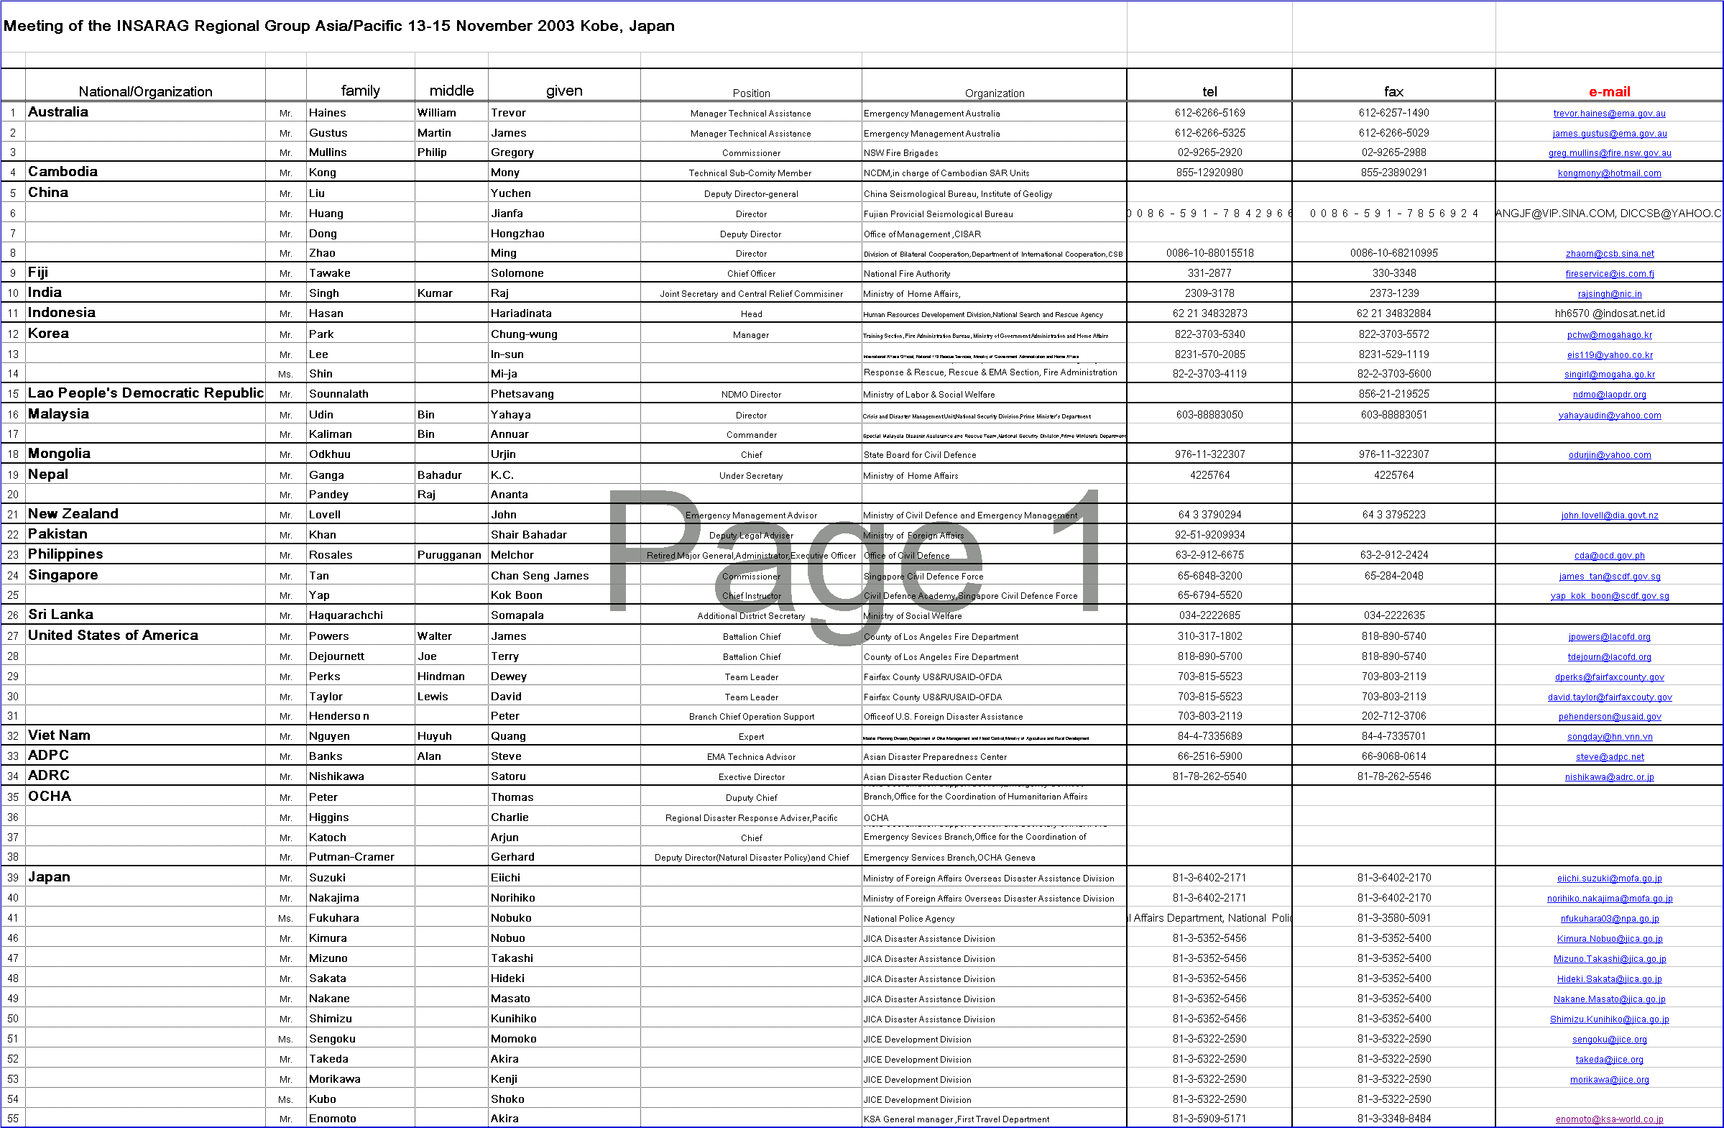
LIST OF PARTICIPANTS

