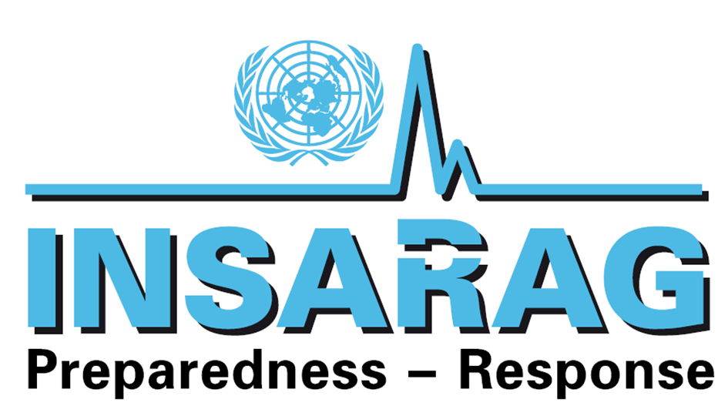

INSARAG Steering Group Meeting
Geneva, Switzerland
15-16 February 2011

Chairman’s Summary

Opening Remarks

The 2011 meeting of the INSARAG Steering Group was held in the Palais des Nations, Geneva, on 16 February 2011. The 47 participants comprised members of IEC classified USAR teams as well as INSARAG Regional and Working Group chairs/vice-chairs from a total of 22 countries and 3 organizations (Annex A).

The meeting was opened by the Chief of OCHA’s Emergency Services Branch, Mr. Rudolf Müller, who welcomed participants and On behalf of the Director of OCHA GVA Mr. Rashid Khalikov, he expressed OCHA’s gratitude to Ambassador Toni Frisch for his leadership as Chairman of INSARAG. and thanked colleagues from OCHA’s Field Coordination Support Section (FCSS) who provide the INSARAG Secretariat.

The Chairman welcomed all participants and expressed his thanks for OCHA’s leadership, to FCSS staff and to the INSARAG Regional Chairs and Working Groups.

The new Chief of FCSS, Mr. Terje Skavdal, also expressed thanks for member states’ support and stressed the challenges for INSARAG in promoting preparedness at all levels, from local to global.

The opening speakers recorded their appreciation to Mr. Jesper Holmer Lund for his leadership and commitment to INSARAG as Officer-in-Charge of FCSS during the past year.

Adoption of Agenda

The agenda was adopted unanimously (Annex B)

Review of Action Points of the 2010 Steering Group Meeting

The Steering Group reviewed the Action Points from 2010 and expressed satisfaction with their implementation (Annex C).

1. Update from the INSARAG Secretariat & Regional Chairs

1.1 Updates on 2010 INSARAG activities were provided by Regional Chairs/Vice Chairs, the INSARAG Regional Antenna and FCSS, as INSARAG Secretariat. The Chairman commended on the implementation of the many activities requested the INSARAG community to implement the “INSARAG Hyogo Declaration” to promote professionalism and strengthen international search and rescue standards.

1.2 The Steering Group supported the proposed management of the INSARAG Antenna by the Africa - Middle East - Europe Regional Group. The Steering Group also welcomed Indonesia as a recent member of INSARAG and Costa Rica for its first participation in the meeting as Vice-Chair of the Americas Regional Group and representing the Regional Chair in his absence.

Action: Member Countries, INSARAG Secretariat

2. INSARAG Guidelines Update

2.1 The electronic version of the 2010 INSARAG Guidelines, with additions from the INSARAG Working Groups as well as Chapter G on Capacity Building, will be made available on the Virtual OSOCC. The Steering Group welcomed Indonesia’s offer to translate the Guidelines into Bahasa Indonesian. A complete review of the INSARAG Guidelines will be carried out once every 5 years, with the next review coinciding with the Second INSARAG Global Meeting in 2015.

Action: Member Countries, INSARAG Secretariat

3. INSARAG Web Page (Http://www.insarag.org)

3.1 The INSARAG Steering Group expressed satisfaction with the proposed approach of development of the INSARAG webpage. Sweden has offered to support with the initial consultancy fees of USD$10,000 for the development and web design of the homepage.

3.2 Other interested donor countries are expected to share the costs of future maintenance of the website. (UAE confirmed that they will support with USD$10,000.- a trial version of the web page can be expected at the INSARAG Team Leaders Meeting(in March) .

4. INSARAG Global Meeting 2010 (14 -16 September Kobe, Japan)

4.1 The Steering Group participants gave positive feedback on the 2010 INSARAG Global Meeting, and adopted the INSARAG Hyogo Declaration 2010 “Recognition and Strengthening of International Urban Search and Rescue Operational Standards”.

4.2 This meeting and the outcomes have been included in the UN Secretary General’s annual report on natural disasters discussed during the UN General Assembly.

4.3 Japan thanked the Steering Group for their support and guidance in preparing and hosting the global meeting. The Regional Chairs shared their approach to implementing the Declaration, and this will be a main agenda item for discussion during the regional and USAR team leaders meeting in 2011. Costa Rica, Vice-Chair from the Americas Region, also presented the draft Strategic Plan for Urban Search and Rescue of Central America as once example working towards the implementation of the INSARAG Hyogo Declaration.

Action: Member Countries, Regional Chairs and Vice- Chairs, INSARAG Secretariat

5. 10th Anniversary of the UN GA 57/150 of 16 December 2002 in 2012
5.1 The Steering Group suggested that a side event be organized in the margins of the Economic and Social Council (ECOSOC) in 2012 and requested the INSARAG Secretariat to explore its feasibility.

Action: INSARAG Secretariat

6. Regular Teleconferences with Regional Chairs, INSARAG Chairman and INSARAG Secretariat

The Steering Group welcomed the initiative from the Secretariat to coordinate regular teleconferences amongst the Regional Chairs and the INSARAG Chairman for the purpose of information sharing.

Action: INSARAG Chairman, Regional Chairs, INSARAG Secretariat

7. INSARAG Working Groups

The Steering Group was briefed on the progress in the INSARAG Working Groups by the respective Chairmen present and the INSARAG Secretariat. The Steering Group agreed that the Working Groups should develop INSARAG Technical Guidance Notes for the purpose of information sharing and learning amongst the INSARAG community.

Following discussions, the Steering Group agreed as follows:

  - Training Working Group (TWG)

7.1.1 The Steering Group thanked the Chairman, Dewey Perks and members of the TWG for their work so far. The Steering Group also endorsed along with his continuation as Chairman.

7.1.2 The Steering Group acknowledged the commitment of the TWG in developing capacity building training initiatives at the community level, as well as developing Chapter G of the INSARAG Guidelines which focuses on the USAR framework for capacity building.

7.1.3 TWG should continue and produce outputs as laid down in the TWG Terms of Reference, and its continuation will be reviewed annually.

  - Medical Working Group (MWG)

7.2.1 The Steering Group thanked the Chairman, Trevor Glass and members of the TWG for their work so far. The Steering Group also endorsed along with his continuation as Chairman. The Steering Group welcomed the engagement/participation of the World Health Organisation (WHO) and PAHO and the development of medical and clinical technical guidance notes to be shared with the INSARAG community for reference.

7.2.2 The Steering Group also welcomed the 2011 MWG meetings in Costa Rica and in South Africa, in conjunction with the 3rd Biennial Emergency Medicine in the Developing World Conference. Participants are advised to ensure they secure funding early to attend the meetings.

7.2.3 The Steering Group agreed that the MWG will now be represented in all IECs as a medical classifier and requested member countries to make their MWG members available.

7.2.4 The MWG should continue and produce outputs as laid down in the MWG Terms of Reference. These outputs will be reviewed annually and its continuation determined following each review.

  - Operations Working Group (OWG)

7.3.1 The Steering Group endorsed the Terms of Reference and Chairman (David Norlin from Sweden) of this new Working Group that will focus on USAR operational planning, assessment and search, communications and roles and responsibilities of USAR operations staff. Interested countries can through the regional chairs, nominate qualified resource persons to the working group.

7.3.2 On the topic of “beyond the rubble” (as a future task of the OWG), Germany suggested that the “DACH” group (Germany, Austria, Switzerland Luxembourg) continue its ongoing discussions on the topic and present their recommendations in the USAR Team Leader’s Meeting in Costa Rica. The TWG also suggested that the team make reference to a discussion paper on this topic, which they have developed.

7.3.3 On the topic of “Earthquake Disaster Site Security Planning” (as a future task of the OWG), the Steering Group directed the Secretariat to facilitate the development the methodology in consultation with UN DSS protocols and procedures. UK also announced their interest to support this project development.

Action: Member Countries, INSARAG Working Group Chairmen, INSARAG Secretariat

8. INSARAG Capacity Building

The Steering Group discussed the capacity building as a key priority for INSARAG. It was agreed that each Regional Group will develop a catalogue of capacity building initiatives at the regional level.

Following discussions, the Steering Group agreed as follows:

  - INSARAG Capacity Building Assessment Missions

8.1.1 Based on past lessons learned and in line with the INSARAG Hyogo Declaration paragraph 5 and 6, the objective of such missions should be to assess the USAR capacities of the requesting country and to identify how that capacity can be improved to INSARAG standards.

8.1.2 At the request of countries interested in receiving such missions, the Secretariat will coordinate the assessment mission together with interested donor countries and experts.

8.1.3 The Steering Group requested the Secretariat to develop a concept document to detail the framework and approach to such missions. The Steering Group also encouraged the donor countries that already implemented USAR capacity building projects to share their experiences and provide input to the development of the framework.

Action: Donor Countries, INSARAG Secretariat

  - INSARAG First Responder Training

8.2.1 The Chairman of the TWG explained the scope and roll-out of this training activity and the positive feedback from the participants.

8.2.2 The training package is available on the Virtual OSOCC/INSARAG web page and interested countries can contact the Secretariat or the TWG for more information.

8.2.3 On how best this “product” can be promoted and benefit more communities, there are various global platforms such as ISDR, IFRC with the mandate and experience to make it more accessible.

Action: Member Countries, INSARAG Training Working Group, INSARAG Secretariat

  - Capacity Building of National USAR Teams

8.3.1 In furtherance of paragraph 5 of the INSARAG Hyogo Declaration, the Steering Group endorsed the Guidelines for Capacity Building of National USAR Teams, now incorporated in Chapter G (Capacity Building) of the INSARAG Guidelines, with the recommendation to countries to adopt them as a target achievement for its national USAR teams and to adopt appropriate processes for the confirmation of achievement of these standards.

8.3.2 The INSARAG AMEE Chair proposed that a meeting be organized by the Secretariat with the head of ISDR to further explore how to synergise and promote this initiative jointly.

8.3.3 China highlighted the importance of preparedness and outreach to schools , a project that selected Asia Pacific Regional countries will focus on in 2011.

Action: Member Countries, INSARAG Training Working Group, INSARAG Secretariat

9. International Rescue Dog Organisation (IRO) Proposal

9.1 The IRO presented a paper on “Offer of assistance to the INSARAG Community” covering capacity building training of search dogs and the supply of trained rescue dog teams for disaster response.

9.2 The Steering Group welcomed this offer and interested parties are requested to contact the IRO office directly.

Action: Interested Member Countries, IRO

10. INSARAG External Classification (IEC)

10.1 The Secretariat updated the Steering Group on latest developments in the IECs. To date, 21 USAR teams have successfully achieved INSARAG IEC Classification (15 Heavy, 6 Medium).

10.2 Following discussion on some IEC issues, the Steering Group agreed as follows:

- IEC Teams postponing their reclassification will be allowed an extension up to 1 year, (provided there is no change to their organisational structure and response procedures) Should teams be unable to be reclassified following the extension, the issue will be raised to the INSARAG Steering Group for a decision.

- On the issue of prioritising teams on the IEC queue, and new teams requesting for an IEC, the regional group during their regional meetings will discuss and present recommendations in the next SG meeting on the geographical spread of the IEC and recommend the priority of teams to be classified in their region

- Teams from the same country who wish to have separate classifications at the Medium level and reconfigure to classify together at the Heavy level, should they respond as a joint national team, under their country flag, may do so, provided all requirements and arrangements for both medium and heavy are satisfied during the combined IEC.

- The INSARAG Secretariat will test a new IEC classifier notification system on the VOSOCC platform, from July 2011, to facilitate IEC planning.

- The IEC/IER Guidelines have been endorsed and are available in the VOSOCC, to guide new teams requesting for IECs and for IEC/IER classifiers.

- The Steering Group endorsed the 1st IEC Classifiers Workshop hosted by Singapore from 25-29 July 2011. The objective of the workshop are:
- Develop discipline specific IEC Classifiers ToRs
- Focus on Leading IECs - IEC Team Leaders
-Understanding the Overall IEC Framework and Expectations, including pre- IEC responsibilities
10.3 The UK suggested having the next IEC training event in 2012 to be conducted in Europe.
The INSARAG Chairman strongly reiterated that IEC teams have to actively participate in future IECs as classifiers and those countries awaiting classification are strongly encouraged to attend future IECs as observers.

Action: Member Countries, IEC teams, INSARAG Secretariat

11. INSARAG in 2011

The Steering Group endorsed the events planned for 2011 (Annex D) and encouraged participation of Member States.

Action: Member Countries, INSARAG Secretariat

12. ISO Standards for USAR

The representative from ISO provided the meeting with an update on the ISO framework and how INSARAG can benefit from it. The participants felt that the costs involved could be of primary concern. The Steering Group directed the INSARAG Secretariat and Working Groups to study the proposal and provide feedback.

Action: Member Countries, ISO, INSARAG Secretariat

13. Announcements from Member States

The following announcements were made during the meeting:

- Switzerland announced that they will hold a USAR simulation exercise (SIMEX) codenamed “COUNTDOWN” to be held in Switzerland from 3 to 7 October 2011 and welcomed participation from the INSARAG global community.

- Japan announced their co-sponsorship with Indonesia to conduct a disaster relief exercise on the Indonesian island of Sulawesi in March 2011 involving members of the ASEAN Regional Forum (ARF).

- Germany on behalf of DACH welcomed the INSARAG community to the DACH working group meeting regarding "beyond the rubble" concept on 9-10 May in Vienna, Austria.

- Germany announced to continue in-kind support of the INSARAG Africa/Europe/Middle East Regional Antenna.

- The INSARAG Asia/Pacific Regional Group Meeting will be held in Bali, Indonesia, July 2011.

- Indonesia plans to launch the National “SAR Goes to School” Program during the INSARAG AP Regional Meeting.

- United States welcomed participants to access their e-learning sites for USAR courses:
- Http://www.Fireservicetraining.com
- Http://www.Fema-elearning.com

List of Attachments
- Annex A List of Participants;
- Annex B Meeting Agenda;
- Annex C Action Points from SG Meeting 2010;
- Annex D FCSS Activities in 2011

Pan American Health Organisation, the regional office of the World Health Organisation.

